Master Thesis

A comparative performance study of public sector and private

sector of mutual funds

FOR THE PARTIAL FULFILLMENT OF THE REQUIREMENT

FOR THE AWARD OF

MASTER OF BUSINESS ADMINISTRATION

UNDER THE GUIDANCE OF

Neha Verma



Submitted By

Prabhat Rai -22GSOB2010051
MBA 2022-2024
School of Business

CERTIFICATE

This is to certify that the thesis entitled " A comparative performance study of public sector and private sector of mutual funds," submitted by Prabhat Rai, bearing Registration Number 22GSOB2010051, is a record of an original work done by him/her under my guidance and supervision. The thesis has not formed the basis for the award of any other degree, diploma, or similar title to any candidate.
The work embodied in this thesis is original and has been carried out by the candidate under my supervision. The thesis is fit for submission for examination and meets the institutional standards.

Signature of the Supervisor
Neha Verma
Assistant Professor
School of Business Introduction

ACKNOWLEDGEMENT

I would like to express my sincere gratitude to all those who have helped me in the completion of this thesis on " A comparative performance study of public sector and private
sector of mutual funds”
First and foremost, I would like to thank my supervisor Neha Verma , for her in valuable guidance, support, and encouragement throughout the course of this study. His expertise and insights have been instrumental in shaping this thesis.
I would like to extend my heartfelt thanks to my family and friends for their unwavering support and encouragement throughout this journey.
Lastly, I would like to thank Galgotias University for providing me with the opportunity to undertake this study and for the resources and facilities extended to me.

Prabhat Rai - 22GSOB2010051

Table of Content
S.No. | Chapter Name | Page No.
1 | Introduction | 05-13
2 | Research Methodology | 14-20
3 | The functioning and customs of mutual funds in India | 21-29
4 | Financial Plan For mutual Funds | 30-40
5 | Performance Measurement | 41-46
6 | Conclusion | 47-50
7 | Bibilography | 51-53

CHAPTER-1 INTRODUCTION
  - A OVERVIEW OF THE FINANCIAL INDIAN MARKET

Every nation's financial system has a significant impact on its economy. The current institutional structure, distribution method, and other elements of long-term changes all demonstrate the intimate connection between financial structure and economic development.
According to Guerley and Shaw (1955), financial institutions have a role in helping an economy realize its potential for savings and meaningful investment. The ability to mobilize funds, which is a definite transition from self-funding to direct financing and ultimately to indirect financing, is also made possible by a certain degree of financial development. Financial intermediaries that serve as a bridge between savers and fund borrowers include banks, insurance, and other financial firms. This type of financing is known as indirect finance. In order to remove market flaws brought about by the non-dissemination of borrower information, financial intermediaries are also crucial. According to Kaizuka (1987), there are a number of institutional tools that can be used to reduce or remove market distortions. Financial arrangements, such as securities markets and financial intermediaries, are important in this regard. Financial laws have always been an element of economic progress because, in Kaufman's words (1986), financial institutions are required to exemplify the essence of integrity and have an entrepreneurial drive that is well-balanced by a strong sense of fiduciary duty.
Mutual funds are vibrant financial organizations (FIs) that mobilize assets and invest them in the stock market, creating a direct connection between capital and savings. As such, they are vital to an economy Market. As a result, the operations of mutual funds affect the economy, capital market expansion, and saving habits over the long and short terms. Thus, mutual funds support the process of financial intermediation and deepening. To use the money in the capital market, they mobilize it from the savings market. Mutual funds compete with banks and other financial institutions while also serving as a complement to banking. Mutual funds play a major role in this process by dramatically boosting stock market activity. Very few areas of the financial market are unaffected by the presence and activities of mutual funds, either directly or indirectly. But general economic fundamentals—the way the real and financial sectors interact, the way the capital and savings markets are developing, the structure of the market, institutional arrangements, and the overall financial policy framework—have an impact on the reach and effectiveness of mutual funds.
The financial sector's reforms have also expanded India's access to global capital markets, and the inflow of foreign savings into the country has paved the way for the country's market to be integrated with the world's capital markets. Globalization has expanded the field for competition, technological advancement, and investor-friendly research, all of which should eventually improve the efficiency of Indian institutions, lower operating costs, and promote more effective resource allocation.

  - MUTUAL FUNDS' IMPACT IN INDIA'S FINANCIAL MARKET

The financial institutions in India have been instrumental in the creation and management of assets, and they have made significant contributions to the macroeconomic advancement of our nation. During this period, Indian mutual funds have become powerful financial intermediaries and are contributing significantly to the financial system's stability and resource allocation efficiency.
For investors, mutual funds have created new opportunities and gave the system much-needed liquidity. In the process, they have questioned the commercial banks' formerly prevailing position in the financial sector and the overall economy of the country.

1.2.1 Mutual Funds and Household Savings

The household savings sector's fastest-growing institutions are mutual funds. Rising tax rates, rising inflation, and growing stock market difficulties and hazards have forced households onto mutual funds. Currently, mutual funds account for more than 17% of household financial assets in the United States, 10% in Germany, 8% in Japan, 4% in Italy, and roughly 8% in India. The proportion of mutual funds in individual household savings is a measure of their significance in the savings market, but the rate at which this percentage is increasing is more crucial.

Financial assets held 58% of the personal sector wealth in the United States in 1980; by 1992, that number had increased to 63%. In the meantime, mutual funds for stocks and bonds increased dramatically, rising from less than 1% in 1980 to almost 6% in October 1993. Compared to 0.7% in 1980, mutual funds accounted for 54% of all financial assets in the United States in 1992. Other instruments such as insurance, thrifts, and commercial banks had a sharp fall in share. The US financial markets were feeling optimistic in 1999 and 2000. By the end of 1999, mutual funds accounted for 17% of all financial assets in the United States. Bank deposits have drastically decreased as a result of the mutual fund industry's and the banking sector's intense competition in the United States. According to Laderman and Simth (1993), mutual funds have essentially "evolved into America's alternative banking system—freely moving capital around in ways that banks still hobbled by antiquated regulatory structures cannot."

1.2.2 Indian Scenario

Since 1988–1989, the proportion of mutual funds in household savings (financial assets) in India has steadily increased; from Rs 12,118 crore, the gross savings of the household sector in financial assets from 1980–81 to 1994–95, it reached Rs 1,35,348 crore. Although it still maintains the largest share of the savings market, the banking industry has seen a drop in importance. The Unlit Trust of India (UT1) units saw the most increase between 1980–1981 and 1992–1993; they went from accounting for 0.3 percent of all household savings in 1980–1981 to 70 percent in 1992–1993 (before declining to 2.8 percent). Between 1994 and 1995 Together, the percentage share of debentures and equity shares grew from 3.4% to 10.2%. Nonetheless, the proportion of bank deposits fell from 45.8 percent in 1980–1981 to 33.2 percent in 1993–1994 before increasing by a further 40.2% in 1994–1995.

Although it still maintains the largest share of the savings market, the banking industry has seen a drop in importance. The Unlit Trust of India (UT1) units saw the most increase between 1980–1981 and 1992–1993; they went from accounting for 0.3 percent of all household savings in 1980–1981 to 70 percent in 1992–1993 (before declining to 2.8 percent). Between 1994 and 1995 Together, the percentage share of debentures and equity shares grew from 3.4% to 10.2%. Nonetheless, the proportion of bank deposits fell from 45.8 percent in 1980–1981 to 33.2 percent in 1993–1994 before increasing by a further 40.2% in 1994–1995.

Due to the fundamental characteristics of the mutual fund sector, the performance of mutual funds is closely linked to both the capital market and the general state of the economy. The last ten years have seen mixed results for the Indian economy. In 1988–89, it achieved the highest real growth rate of more than 10 percent ever. However, things quickly turned around in 1990, leading to the slowest GDP growth in the country's history and a foreign exchange crisis in 1991. That is, economic pressures had a major role in the start of the liberalization process. The nation has grown steadily on average by about 6%. during the last six years in real GDP. The economy's total household savings rose from a pitiful 7.4% in 1950–1951 to 18.5 percent in 1998–1999 From 1992 to 1995, the main market had remarkable expansion as the financial industry recovered. The amount raised annually through stock issuance surpassed Rs 36,000 crore. compared to the Rs 18,100 crore realized in 1992–1993.
Throughout 1993–1995, mutual fund mobilization remained strong despite soaring expectations from the stock market. With the increase in the quantity of equity-based mutual funds, they were aggressively marketed to individual investors with little regard for informing them of the volatility inherent in this market segment. There was a new surge in resource mobilization in 1998. Mutual funds participate in the savings market and have a strong position in the money and capital markets, both of which demonstrate their active involvement in fostering economic development. The general health of the economy depends on a developed financial system, and mutual funds are essential for fostering a robust capital market. The money market is more liquid when mutual funds are used.

In India, there are currently more than 47 mutual fund companies that oversee more than Rs 8,142 billion across numerous schemes.

  - THE DEVELOPMENT & ACTIVITIES OF INDIAN MUTUAL FUNDS
The mutual fund industry in India got its start in 1963 when the Reserve Bank of India and the Indian government decided to establish Unit Trust of India. The history of mutual funds in India has been divided into four main eras.
1.4 Mutual Funds vs Company Fixed Deposits.

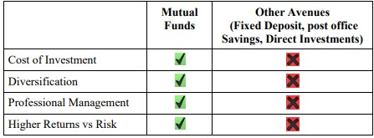

Fixed deposits are uninsured loans made by the business that accepts them. The fixed deposit program's credit rating serves as a barometer of the investment's inherent default risk.
The AMC allocates investor funds in mutual fund schemes to particular investments made inside the plan. Investors in schemes benefit from these investments being held and managed in trust. However, there is no such direct relationship between the channels via which a corporation deploys its stationary mobilization and these resources.
As a result of this connection between investment and mobilization, investors bear full responsibility for the profits and losses incurred by the mutual fund schemes. Consequently, yield cannot be guaranteed unless a guarantee is provided by a guarantor or, to a lesser extent, by an investment in a series of gilt schemes. However, the return on a fixed deposit is guaranteed, subject solely to the borrower's default risk.

1.4.1 Mutual funds vs bank fixed deposits
Fixed deposits offered by banks and firms are comparable; the main distinction is that banks are subject to stricter regulations than companies. Although the aforementioned are reasons for solace, bank accounts are also vulnerable to default risk. The Deposit Insurance and Credit Guarantee Corporation (DICGC) also protects bank deposits up to Rs 1 Lakh, provided the bank has paid the required insurance fee of 5 Paise annually for every Rs 100 in deposits.

1.4.2 Mutual Funds vs 1Bonds and Debentures
The bond's or debenture's credit rating, like it is for fixed deposits, indicates the default risk that comes with the investment. Debentures and bonds, however, are transferable securities, not like FDs. Although the issuer may grant an investor an early encashment option (such as a "PUT" option), market listing is often the means of obtaining liquidity.

The following are the implications of this: If the securities is not traded on the market, the liquidity is retained on paper. Market risk affects the value that an investment might gain from an early departure. This feature bears resemblance to an MF scheme. In all actuality, an unsecured bond is similar to a fixed deposit. directly investing in the debt market and actively managing the positions. Debt securities could be backed by a hypothecation or mortgage of identified assets to cover the default risk. An unsecured bond is for all practical. purposes like a fixed deposit. For the advantage of the plan participants, a custodian holds the investments in mutual fund schemes. For the advantage of the scheme's investors, the securities related to it are ring-fenced.
1.4.3 Mutual funds against life insurance
Life insurance is not actually an investment opportunity; rather, it is a hedge against risk. Therefore, comparing life insurance to any other financial product would be incorrect. Occasionally, life insurance products have offered a return that is higher than a comparable "safe" fixed return security due to market inefficiencies and product mispricing in India; as a result, you are essentially compensated for becoming insured. These kinds of prospects are not long-term viable.

1.5 TYPES OF INDIA MUTUAL FUNDS

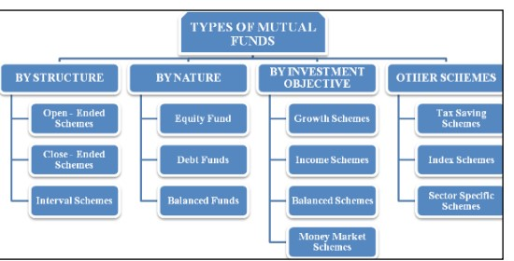

1.6 BENEFITS OF PARTNERING FUNDS

The benefits of mutual funds include diversification and expert management. scale economies, ease of use, and quick liquidity. Professional fund managers who commit time, apply knowledge, and investigate investment options for managing public funds are advantageous to investors. The fund management makes prudent investments in a combination of debt and equity based on the needs of the investor, including equity investments in a collection of equities to reduce risk.

1.7 MUTUAL FUNDS' FUNCTIONS
A mutual fund has various benefits that work in tandem to draw investors, particularly small ones. The purposes of reciprocal funding are:
1.Organizing Minimal Savings
2. Cost-effectiveness
3. Expert Administration
4.The act of diversification
5.Variety of Investments based on the Investor's Financial Situation
6.greater ratio of return on risk.
7.Adaptability
8. Openness
9. Tax Advantages
10. Availability of liquid assets
11. Having access to pricey stocks.
1.8 MUTUAL FUNDS LIMITATIONS
Investors are unable to control expenses as long as the limits set by SEBI are followed.
As long as they continue to invest in the fund, investors pay management fees. Not customized portfolios. Investing decisions are ultimately left to fund managers, over whom investors have no influence or say. A lot of mutual fund schemes are available, so unless you're an experienced investor, most people need help choosing a fund that best suits their investing goals.

1.9 USED INDIA COMMON PRACTICES
Less than 10% of Indian families have invested in mutual funds, despite the fact that they have been accessible on the market for more than 20 years and have assets under administration totaling Rs 8,142 billion across different schemes (Source: Association of Mutual Funds, India). According to a recent study on mutual fund investments in India by Boston Analytics, a research and analytics business, investors are hesitating to invest in mutual funds because they believe the products to be very risky and because they lack knowledge about how mutual funds operate. This study is based on a survey conducted in March 2010 among about 10,000 respondents in 15 Indian cities and towns.

1.9.1 Arguments against Indian mutual fund investing
The size of the city seems to be a key factor in the lack of investment. Nearly 40% of respondents with high savings rates who reside in metro areas and Tier I cities thought such investments were extremely dangerous, while 33% of respondents who live in Tier II cities stated they had no idea where or how to invest in such assets.

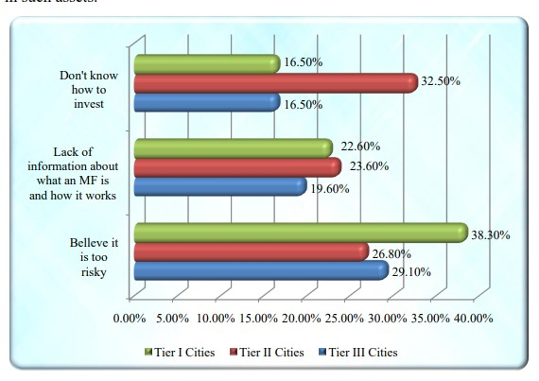

Conversely, nearly 90% of respondents who made investments did so because they thought these assets were managed more expertly than other asset classes. A few of the elements that influence investment in mutual funds are listed in Exhibit 2. It's interesting to note that although non-investors primarily avoid mutual funds due to risk, those who do so do so primarily because they believe mutual funds to be more diverse and competently managed than other types of investments.

1.10 HOW TO DESIGN A PORTFOLIO

Generally speaking, the total value of all the assets you hold makes up your portfolio. This covers the whole worth of your holdings, deposits, and investments. Although your net worth is displayed in this portfolio, it isn't very helpful in helping you plan your finances to reach your objectives.

1.11 In India, mutual funds are organized into three tiers:
The first tier is a sponsor who is considering launching the fund. As per SEBI, the sponsor must have a solid track record and at least five years of expertise in the financial services industry. The trustee, who sits at the second tier, is responsible for keeping an eye on the mutual fund's goal and making sure it's being used for the intended purposes. Trustees are thought of as the mutual fund industry's internal regulators. The third-tier asset management firm, or AMC, is chosen by the Trustee to oversee investor funds. In addition to the trustees and SEBI, the AMC operates under the guidance of its board of directors.
Investors bear the cost of the fee that the AMC charges for the services rendered in exchange. The AMC is responsible for initiating new schemes in the trust's name and overseeing them through the purchase and sale of securities. To carry out several tasks such calculating net asset value, keeping an eye on books and records, creating investment strategies, and conducting market and securities analysis, AMC employs fund accountants, lead managers, and investment advisers.

Creating a Fund Manager
A fund manager is in charge of overseeing the AMC's funds by selecting the kind, quantity, time, and rate at which securities should be purchased and sold.

Research and planning

The AMC research and planning cell conducts research on securities and potential investors to help in the development of future investment regulations.

Setting Investment goals

Every mutual fund has a target that is determined by taking into account the scheme's characteristics, risk and return, market conditions, legal requirements, issue size, and investor protection.
Determining Particular Security
To choose which security the fund should invest in, security analysis is done and risk and return characteristics are assessed.

Creating a Portfolio
It entails creating the perfect blend of government, corporate, and debt securities. It deals with choices about what kind of security to purchase, how much, and when to offer it. To lower the portfolio's overall risk, it is important to have a well-diversified portfolio. This is an ongoing activity that is done to develop new strategies based on stock market research and analysis.

1.12 Rebalancing and revising the portfolio
In a dynamic investing environment, the portfolio should be examined on a regular basis with consideration for the shifting market conditions, political dynamics, competitive dynamics, risk-return characteristics, and many other aspects. The best way to evaluate a mutual fund's performance is to look at how well it can generate returns for investors in the form of dividends or income and capital growth.

Budgetary Objectives
Many of us enter the world of investing with the vague notion that we ought to maximize the value of our investments. A financial goal is to have the appropriate amount of money for a certain purpose in life at the appropriate moment. Here are a few instances of financial objectives:
- I would like to have Rs 10 Lakh saved up for a down payment on an apartment that will cost Rs 50 Lakh in six to eight years.
- I should have Rs 2 lakh in hand as soon as possible to cover any unforeseen costs.
- I would want Rs 3 Lakh year from 2011 to 2014 to finance my daughter's further education.
- my family on a vacation to Europe sometime in the next two or three years, which will cost Rs 5 Lakh.

There are distinct time horizons for debt and equity:

I would like to take The most crucial thing to realize is that every kind of mutual fund has a specific time range that works best for it. Essentially, portfolio planning consists of matching each goal-oriented portfolio's time horizon and risk level to the appropriate fund type, and once you have done that, you are practically done.
Generally speaking, monies needed for the next three to five years must come from debt funds, and funds needed after that can mostly come from equity funds. Money that is intended to be used for a very long time—more than ten years—should always be invested in equity funds. When investing in stocks, or at least a reputable equity fund, over extended periods of time, the risk is low and the returns are substantial.

1.13 What Amount of funds ?
How many funds, in a perfect world, would be in your portfolio? Ultimately, investing in a single balanced fund and calling it a day can be accomplished with your portfolio. Although there are benefits to this extremely straightforward strategy, you should diversify in reality because fund managers are fallible individuals. Diversification also aids in protecting you from making such errors. For each sort of fund you require, two to four equity funds and one or two debt funds should be sufficient, in our opinion. Therefore, large-cap diversified equity funds, mid-cap funds, and floating rate debt funds are sufficient for a portfolio that requires short-term debt funds. Beyond this, you are increasing the management of the portfolio's complexity without gaining any more stability.

1.13.1 Keeping an Eye on a Portfolio
Even an excellent portfolio needs to be watched over and adjusted to account for shifting circumstances. One important factor is that previously strong funds may begin to perform poorly on a regular basis. Naturally, you shouldn't terminate a fund for brief instances of underperformance before you're ready. But you should consider moving to a better performing fund if it has been performing noticeably lower than other funds of the same sort for longer than a year.
When the time comes to need money, that's another reason to switch up your portfolio. Four years from now, a portfolio that was initially intended to be a medium-term investment for five years will become a short-term portfolio. The answer is obvious: as the time to sell investments approaches, portfolios must be revised to avoid having your hard-earned equity returns completely destroyed in a bear market, precisely when you need the money. To safeguard your returns, you must begin transferring the funds into debt funds gradually as the deadline draws nearer—possibly a year or two ahead of time.

CHAPTER-2

RESEARCH METHODOLOGY

2.1 DETAILS OF THE PROBLEM

Mutual funds function as financial intermediaries, facilitating the mobilization of surplus income from individuals and supplying funds to areas where demand exists .A newer category of investments is mutual funds. There are numerous mutual fund plans that are accessible for investing in India today. For the uninitiated, choosing the finest mutual fund for investment can be a challenging task, since there are many factors to consider. They choose mutual funds that actively market themselves and make aggressive sales without considering how well they are doing.

The purpose of this study is to evaluate mutual fund schemes and determine which performs best by taking risk and return into account. The four public and private sector mutual fund schemes that are the subject of this study are the Unit Trust of India Mutual Fund, HDFC Mutual Funds, Birla Sun life Mutual Funds, and State Bank of India Mutual Fund.
The performance of public and private sector mutual funds is analyzed in this study to show how these funds use their resources to combine low risk, consistent returns, high liquidity, and capital appreciation through diversification and skilled management in a way that is affordable for investors.

2.2 The Study's Objective
The following are the main goals of the research study:
- To examine the mutual fund selection's return pattern.
- To assess the effectiveness of particular mutual funds in the public and private sectors.
- To assess the performance of particular mutual funds using the Jensen, Treynor, and Sharpe method.
- To research and contrast the funds' growth rates.
- To use the performance measuring models that are currently in use.

2.3 APPROACHES TO RESEARCH
This study, which is exploratory in nature, is based on secondary data that was gathered from government publications, journals, valuation research books, etc.
With the use of statistical procedures including regression analysis, range, standard deviation, least square trend, and analysis of variance test, a thorough study of the data would be done.
2.4 DATA SOURCE

Secondary sources are the source of the data collection. The information was gathered from published sources, books, journals, magazines, the internet, and historical records.

2.5 STATISTICAL TECHNIQUES

The simple statistical techniques like percentage and growth rates are calculated. For the purpose of evaluation the popular methods such as Sharpe,Treynor and Jensen are applied.
2.6MUTUAL FUNDS'S FUTURE PROSPECTS IN INDIA
Experts in finance predict that mutual funds in India would have a very promising future. By the end of March 2020, the Indian mutual fund industry is expected to account for a significant share of all the commercial banks' assets in the country. The annual composite growth rate is predicted to increase by 15% over the next ten years.
- 100% growth during the previous six years.
- Several international asset management companies (AMCs) with multitrillion dollar global assets under management are lining up to join the Indian market.
- We have the greatest savings rate in the world, over 23%. We have about 100 mutual funds, which is far fewer than the US, which has over 800. There is room for growth.
- The majority of mutual funds are currently focused on Tier 1 cities, but as Tier 2 and Tier 3 cities grow quickly, they will eventually find opportunities in the expanding cities.

Based on an analysis of historical trends and contemporary developments, it is evident that mutual funds in India have a bright future ahead of them, with plenty of opportunities for investors.

2.7 METHODS OF RESEARCH

The entire strategy is split into two parts:
1. The quantitative method
2. The Qualitative Method

The quantitative approach entails the production of quantitative data that can be rigorously analyzed quantitatively using a formula and a hard solution.
A quantitative method will involve measuring an amount or quantity. Here, one or more quantities are used to express or characterize a process .Research using a qualitative approach focuses on the subjective evaluation of attitudes, opinions, and impressions .It is made up of quality-related qualitative phenomena. It is descriptive, non-numerical, reasoning-based, and verbal. Its objectives are to convey the situation's meaning, emotion, and circumstances.

2.8 ANALYZATIONS

The goal of the current study is to assess mutual fund performance in a particular industry. Additionally, the study makes an effort to gauge and contrast mutual fund performance.
The following theories are investigated during the study:

1) Throughout the review period, mutual funds are doing well.
2) During the review period, mutual funds are not performing adequately.
3) Mutual funds are a superior option compared to stock markets.
4) The security markets are not a superior option than mutual funds.
5) Private sector mutual funds outperform public sector mutual funds in terms of performance.
6) Public sector mutual funds outperform private sector mutual funds in terms of performance.

2.9 RESTRICTIONS OF THE RESEARCH
- There are several restrictions on the study. Mutual fund theory is similar to the ocean. Due to the time constraints, it is not possible to conduct a thorough analysis of every element of this notion.

- Investments in securities and mutual funds are vulnerable to market risk, and there is no assurance or guarantee that the scheme's goal will be met.
- A limited number of mutual fund plans from the public and commercial sectors have been analyzed.

2.10 ANALYZATION OF DATA

The most crucial step is to format the data so that the researcher can use it to make decisions more effectively. Tools from mathematics and statistics are employed.

2.11 LITERATURE REVIEW
Using monthly returns, Jayadev (1996) assessed the performance of Magnum Express and Mastergain, two growth-oriented mutual funds. Jensen, Sharpe, and Treynor measurements were used in the study, and it was found that Magnum did poorly on all three measures, while Gain fared better on the Jensen and Treynor measures.

Afza and Rauf (2009) used quarterly data from 1996 to 2006 to examine the performance of Pakistani open-ended mutual funds. Using pooled timeseries and cross-sectional data, the study calculated the fund's Sharpe ratio and examined a number of other factors, including size, expenditures, age, turnover, and liquidity. Significant impact on fund performance was discovered by the results.

Debasish (2009) examined the results of a few mutual fund schemes using models and metrics for risk and return. The study's nine-year timeframe ran from April 1996 to March 2005. According to the report, Birla Sun Life, HDFC, and LIC mutual funds performed poorly, while Franklin Templeton and UTI were the top performers.

In their study, Ali, Naseem, and Rehman (2010) used Sharpe and Treynor measures to analyze the performance of ten mutual funds, five of which were Islamic and five of which were conventional, over the years 2006 to 2008. The findings showed that Pakistani funds might bring more value, whether it was conventional or Islamic. The analysis also discovered that certain funds underperformed, indicating that during the research period these funds had issues with diversification.

Garg (2011) looked studied the performance of the top ten mutual funds, which were chosen based on past performance. The performance was examined using the Treynor, Jensen, and Sharpe indices in addition to return, standard deviation, and beta. Carhart's four-factor model was also utilized in the study to examine mutual fund performance. According to the results, Canara Robeco Infra had the lowest final score in the one-year category, and Reliance Regular Saving Scheme Fund received the highest final score.

The market risk and investment performance of Indian equity mutual funds were studied by Sondhi and Jain (2010). Over a three-year period, the study used a sample of 36 equity funds. The study looked at whether high beta funds during the study period really generated high returns. The study also looked at how size of the fund, ownership structure, and open-ended versus closed-ended categories affected risk-adjusted investment performance of equity funds. The study's findings supported the actual data presented by Fama (1992) showing that high beta funds, or market risks, may not always result in high returns. According to the study, the category, size, and ownership of mutual funds had a substantial impact on how well they performed over the study period.

(2010) Prabakaran and Jaya bal assessed mutual fund schemes' performance. The Dharmapuri district respondents' priorities were taken into consideration when selecting a sample of 23 projects for the study, which was performed between April 2002 and March 2007. The research employed Sharpe, Jensen, and Fama's technique to assess mutual fund performance. According to the study's findings, 13 of the 23 schemes that were chosen performed better than the benchmark portfolio in terms of the Sharpe ratio, 13 schemes performed better in terms of the Treynor ratio, and 14 schemes performed better in terms of the Jensen measure. The study's use of the Fama's measure revealed lower returns from diversity. Consequently, the India Mutual funds weren't correctly.

Numerous research on the expansion and financial results of Mutual funds have been used in both industrialized and underdeveloped nations in the past. A quick analysis of the ensuing research projects shows the abundance of contributions made to the assessment of mutual fund performance, fund managers' stock selection skills, and market timing.

The National Council of Applied Economics Research (NCAER) conducted one of the first household surveys in India in 1964 in an effort to learn more about people's attitudes toward and reasons for saving money. In 1996, a different NCAER study examined the capital market's structure and provided the opinions and attitudes of individual investors. The SEBI-NCAER Survey (2000) was conducted to determine the number of households and individual investors in the population, as well as their economic and demographic characteristics, portfolio size, and preference for investing in equities and other savings products. Thirty thousand geographically separated rural and urban households provided the data.

The study's pertinent findings include the following: Bank deposits are appealing to all income levels; 43% of non-investor households, or roughly 60 million households, reportedly do not know anything about the stock market; higher income groups have a higher share of mutual fund investments than do lower income groups, indicating that mutual funds have not yet fully become the go-to investment vehicle for small investors.

Since 1986, a number of short essays and articles have appeared in professional, academic, and financial publications explaining the principles of mutual funds and emphasizing their importance in relation to the Indian capital market. They covered a wide range of subjects, such as laws pertaining to mutual funds, investor protection, investor expectations, mutual fund expansion, and certain facets of mutual fund operation and performance.
A thorough and methodical analysis of 152 mutual fund schemes was carried out in 1962 by Friend and colleagues. The results showed that the schemes produced an average annual return of 12.4 percent, while the composite benchmark returned 12.6 percent. Their alpha was twenty basis points negative. The majority of the results did not indicate that the industry was generally inefficient.
Irwin, Brown, and FE (1965) examined matters of investment strategy, portfolio turnover rate, mutual fund performance, and its influence on the markets for stocks. They discovered that mutual funds significantly influenced how much the stock market's prices moved. They came to the conclusion that there was no consistent correlation between portfolio turnover and fund performance, and that on average, funds did not perform better than the composite markets.Even though previous study has only addressed a small portion of this important topic, there is still much need for more effort.
A few research are devoted exclusively to the review of Sharpe and Jensen Treynor
Treynor (1965) employed the "characteristic line" to establish a relationship between the predicted return of a fund and the return of an appropriate market average. He developed a fund performance metric that considered investment risk. Additionally, the "portfolio-possibility line" was utilized to tie predicted return to the risk choice of the portfolio owner while dealing with a portfolio.
It can be expressed symbolically as follows: Treynor's Index

(Ti) = (Ri - Rf)/Bi.
where Rf stands for risk-free rate of return, Bi is the fund's beta, and Ri stands for return on investment. The goal of all risk-averse investors is to optimize this value. A low and negative Treynor's Index is a sign of poor performance, whereas a high and positive Treynor's Index indicates a superior risk-adjusted performance of a fund.

In 1966, William F. Sharpe created a composite risk and return metric. He assessed thirty-four open-end mutual funds between 1944 and 1963.Each scheme's reward to variability ratio, which varied from 0.43 to 0.78, was substantially lower than the DJIA (Dow Jones Industrial Average). The correlation coefficient between the expense ratio and fund performance was 0.0505, indicating an adverse relationship. The findings showed that low expense ratio, not size, was the key to good performance. The risk measure was consistent across the sample schemes.

It can be expressed symbolically as follows:
Sharpe Index
(Si) = (Ri - Rf)/Si
where Si is the fund's standard deviation. A fund with a high and positive Sharpe Ratio has performed better when adjusted for risk; conversely, a fund with a low and negative Sharpe Ratio has performed poorly. By mobilizing assets and investing them in the stock market, mutual funds—dynamic financial institutions (FIs)—play a critical role in an economy by creating a direct connection between savings and the capital market.

A method for evaluating composite portfolios based on risk-adjusted returns was created by Jensen in 1968. He assessed 115 fund managers' proficiency in picking stocks between 1945 and 1966. 39 funds had returns that were above average according to an analysis of net returns, while 76 funds produced returns that were abnormally low. 48 funds had above-average results using gross returns, while 67 funds had below-average results. Jensen came to the conclusion that since fund managers were unable to predict changes in the price of securities, there was little evidence that funds were able to perform appreciably better than anticipated. is computed as
Ri = Rf + Bi (Rm - Rf)

where Rm is the average market return for the specified time frame. Alpha can be computed and then produced by deducting the needed return from the fund's actual return.
Greater alpha indicates better fund performance, and vice versa. This model's limitation is that it only takes systematic risk into account, not all of the fund's risk, and an average investor cannot reduce unsystematic risk because of his limited market expertise.

Fama (1972) created techniques to separate observed return from market price movement projections based on the capacity to select the best assets at a given degree of risk. He presented a multi-period approach that enables examination both cumulatively and period-by-period. He came to the conclusion that portfolio return is made up of return on risk taken and return on securities chosen. In his contributions, traditional notions of sound portfolio management were blended with ideas from contemporary theories of capital market equilibrium and portfolio selection.

Since net selectivity is the extra return above and above the return necessary to offset the fund manager's entire risk exposure, it serves as a proxy for the fund manager's stock selection expertise. A higher value of which suggests that the fund manager has generated returns that are significantly higher than the return appropriate for the amount of risk he has assumed.

The required return is computed as follows:
Ri = Rf + Si/Sm*(Rm - Rf),
where Sm is the market return standard deviation. The required return is then deducted from the fund's actual return to determine the net selectivity.

Williamson (1972) examined 180 funds' ranks from 1961–1965 to 1966–1970. The rankings from the two periods showed no relationship. The majority of the fund managers had similar investment skills. He emphasized how volatility is becoming more and more important in determining investment risk.

Based on quarterly returns, Klemosky (1973) examined the investment performance of 40 funds from 1966 to 1971. He conceded that, in contrast to the composite measures generated from the CAPM (Capital Asset Pricing Modal), biases in the measurements of Jensen, Treynor, and Sharpe may be eliminated by employing mean absolute deviation and semi-standard deviation as risk surrogates.
McDonald and John (1974) found a positive correlation between objectives and risk after looking at 123 mutual funds. The study found that there is a positive correlation between risk and return. The correlation between risk-adjusted performance and objective performance showed that more aggressive funds performed better.

Baruan Varuan (1991) attempted to assess the UTI master share system with data spanning from 1987 to 1980. They came to the conclusion that the Master Share Scheme (MSS) favored large investors more than small investors and that it performed better than the market in terms of net assets value (NAV).

Borensztein, E. and Gelos, G. (2001) use a unique database that covers individual fund holdings from January 1996 to March 1999 to investigate the behavior of emerging market mutual funds. An analysis of specific crises reveals that funds withdrew money on average one month before the occurrences. Although moderate, the degree of fund herding is statistically significant. Herding is more common in open-ended funds than in closed-end funds, although it is not more common in times of crisis than in peacetime. Although funds frequently use momentum strategies—selling previous losers and purchasing previous winners—their total actions are more nuanced than is commonly assumed.

According to Byrne's (2005) research, there is typically a positive association between risk and investment experience. A successful investment history raises an investor's risk tolerance. On the other hand, a poor historical performance lowers one's risk tolerance. As a result, investing behavior in the past influences conduct in the future. According to research by Corter and Chen (2006), conduct is significantly influenced to one's investment experience. Experienced investors build greater risk portfolios and have a relatively high risk tolerance.
Kum Martin's paper "Basics about Mutual Funds" from October 2007 Funds talked about the many kinds of mutual funds. He said that only common stock investments are made through the equity funds. They are really dangerous yet has the potential to be very profitable. He came to the conclusion that investments with little risk would not yield large returns. Mutual fund managers are required to employ diverse investment methods based on the needs of their investors. The majority of the empirical data demonstrated that prior performance has an impact on mutual fund investors' decisions to buy.

Researchers John C. Kozup, Elizabeth Howlett, and Michael Pagano (2008) investigated the potential effects on investors' fund evaluations and investment intentions of a one-page extra information disclosure. The findings showed that although investors still focus too much on past performance, the availability of additional information—especially in a graphical format—interacts with performance and financial knowledge to affect investors' perceptions and assessments of mutual funds.

CHAPTER-3
THE FUCTIONING AND CUSTOMS OF MUTUAL FUNDS IN INDIA

Small investors' money are gathered by a mutual fund and invested in capital market assets like corporate and government securities. Unit holders split the capital gains made from these investments, as well as interest and dividend income, according to the number of units they own. The net asset value (NAV) of the relevant scheme reflects any increase or decrease in the value of investments.
A mutual fund is created in accordance with SEBI requirements using a trust deed. The mutual fund industry is comprised of three distinct entities: the sponsor, who promotes the fund; the asset management company, which oversees the fund's operations and launches and runs its schemes; and the trustees of the mutual fund.
3.1 Describe AMC.

Asset management firms oversee pension schemes, hedge funds, and mutual funds. These businesses get money from the services that their customers pay.

Because they have access to a wider range of resources than an individual investor, AMCs provide their clients with greater diversity. Investors can bypass minimum investment limitations that are frequently necessary when buying securities on their own and can invest in a bigger variety of securities with a smaller investment by pooling assets and paying out proportionate profits.

Asset management firms oversee pension schemes, hedge funds, and mutual funds. These businesses get money from the services that their customers pay.

Because they have access to a wider range of resources than an individual investor, AMCs provide their clients with greater diversity. Investors can bypass minimum investment limitations that are frequently necessary when buying securities on their own and can invest in a bigger variety of securities with a smaller investment by pooling assets and paying out proportionate profits.

The asset management firm is chosen by the trustees with SEBI's prior consent. The asset management company is required by SEBI standards to keep a net worth of Rs 100 million. Furthermore, an AMC must adhere to specific duties including.

The AMC is required to take reasonable steps to guarantee that no scheme violates the terms of the trust agreement. It should also make sure that any scheme's fund investing provisions don't conflict with laws or trust agreements.

The trustees must receive a quarterly report from AMC .The trustees have the authority to end AMC's appointment .AMC is not allowed to trade securities through any broker connected to a sponsor in any way more than five percent of the mutual fund's daily gross turnover.

It is against the law for AMC to use the sponsor's, any of its associates', or workers' services for any kind of securities transaction, distribution, or sale of securities without first disclosing such information to unit holders.

When a new fund offer (NFO) is made, the asset management company, or AMC, charges the entry load. They charge this in order to cover their costs, such as those associated with advertisements or other upfront investments. The collected entry load is not refundable. The asset management business may also charge the costs they have expended as recurrent expenses if the fund is an open ended fund.

When an investor wishes to withdraw from the scheme, the asset management business further charges the exit load. Periodically, the fraction of the exit burden may change. If an investor wishes to withdraw from the mutual fund early, he will have to pay a higher exit load. Nevertheless, the exit load will be lower if he has invested over a longer period of time. The length of the investment has a significant impact on the exit load.

The entrance burden has been completely eliminated by the Securities and Exchange Board of India, or SEBI. The mutual fund companies used to charge roughly 2.25% of the fund's total value as entry load prior to this. Even though entrance loads are prohibited, some distributors claim that the small profit they receive from investors goes toward funding the fund house. Thus, in order to address this, the Securities and Exchange Board of India included a language in the circular stating that openness is required, meaning the distributor must disclose the amount of commission that must be paid to the fund house. Therefore, the investor needs to exercise caution and carefully study the paper.

Some standards on the exit load have also been established by the Securities and Exchange Board of India. It is also attempting to lower the burden at exit. The Securities and Exchange Board of India's primary goal is to safeguard investors, particularly small or retail investors. The Securities and Exchange Board of India eliminated the entrance load as a first step in that direction. According to a recent circular from the Securities and Exchange Board of India, investors who make larger investments would not be assessed a low exit cost, while those who make smaller investments will be required to pay a high exit load.
In the past, exit loads were waived for investors making investments between three and five crores, but the Securities and Exchange Board of India changed this in a recent circular.

3.2 NET asset value, or NAV

NET asset value, or NAV According to SEBI regulations, the buying and selling prices of a mutual fund scheme's units on a daily basis are based on the NAV of the units once it has been floated. It's critical that investors comprehend the idea of NAV.

Every day, a mutual fund must calculate its net asset value (NAV) by valuing all of its assets and liabilities at their current values, based on the closing market prices. NAV for each unit.

The following are the steps that go into calculating the NAV per unit:

(a) Determine the total assets of the fund at their present valuations.
(b) Determine the total liabilities using the present values.
(c) Subtract (b) from (a) to get the total NAV.
(d) Divide the total by the unit NAV to get the per unit NAV.

NAV divided by the total amount of outstanding units.
That is: NAV per unit equals the aggregate NAV/Number of unclaimed units
In the same way that stock investors monitor share prices to gauge the performance of their investment, mutual fund investors can monitor the fund's advancement by observing changes in the net asset value per unit.
Recall that an equity fund's NAV per unit is correlated with the portfolio value of the fund, which is correlated with stock market fluctuations. Investors in mutual funds are impacted by the volatility of the equity market overall, which has an impact on the NAV per unit. This kind of erratic behavior can occasionally verge on insanity because it is unrelated to underlying causes. Movements are the best way to bring it out.

NAV is the sum that a unit owner would get in the event that the mutual Funds had run out. A mutual fund investor owns a portion of both the company's assets and liabilities. The interaction of two factors determines the investor's return. components Mutual fund costs and net asset value. The calling card of the mutual fund is its net asset value. It serves as the foundation for determining the return on an investor's investment. Certain factors are important to emphasize:

(i) The net worth of all assets minus liabilities is what it is. The net asset value (NAV) of the fund is the market value of all of its assets less all of its obligations related to those assets.
(ii) NAV varies every day. Every day, the value of assets and liabilities varies.
NAV now won't be NAV tomorrow or the day after that.
(iii) The value per holding unit is used to calculate NAV.

Investing the capital generated from unit holders is the primary function of mutual funds. Investments are either assets that increase in value or assets that offer advantages that can be distributed to unit holders. The stated outcomes of this type of activity are mostly used to assess a mutual fund's success. Mutual fund investments are long-term. According to recommendations from the RBI and SEBI, mutual funds should use the market value approach and should not credit gains from appreciation in value until they are realized.

3.3 NAV COMPUTATION

The value of the funds' net assets is known as their net asset value, or NAV. On the fund's balance sheet, the investor's subscription is regarded as unit capital, and the investments made on their behalf are regarded as assets. The assets less the liabilities is the definition of the fund's net assets.

NAV is the scheme's net asset/The quantity of unclaimed units

Where the scheme's net assets are defined as follows:

Market value of investments plus receivables, other accrued income, and other assets less accrued expenses, other payables, and other liabilities equals the scheme's net asset value.
Calculating the NAV for a chosen group of Public and Private Sector Mutual Funds in 2012.
The value of an equity fund will plummet in the event of a stock market collapse. There is no such thing as a crash-proof portfolio, as Peter Lynch has stated. In such a case, the investor is not protected even by the best fund manager. Stock markets all exhibit cyclical and short-term swings. throughout the globe. Instead of using mutual fund equity schemes as a means of making speculative short-term investments, investors should see them as long-term investments.

3.4 NAV MYTHS VS REALITY IMPLICATIONS

Despite the phrase NAV's seeming simplicity, there are a lot of misconceptions about it. To help us better grasp this idea, let's address a few of them now:

MYTH-1: Better funds are indicated by a higher NAV, and cheaper funds are indicated by a lower NAV.

FACT: The NAV by itself cannot provide you with performance information about a fund. Rather, what you should be measuring is the variation in NAV over a certain period of time, or the returns. Agents would frequently commit fraud by passing off a Rs. 10 NAV new fund as a "cheap" one, until the regulator took action against them.
You shouldn't be at all concerned with the NAV number as a savvy investor. Most fund reports and statements include the returns parameter, which is a figure that can be used to assess the fund.

MYTH-2: NAV in an insurance plan and a mutual fund are the same.

FACT: NAV in an insurance plan and a mutual fund are the same .A unit linked insurance plan (ULIP) and a mutual fund may or may not have comparable NAVs. The NAV of an equity mutual fund often moves in lockstep with stock market indices. The NAV of a ULIP's complete equity option moves in lockstep with the Sensex or Nifty.
But in more intricate ULIPs, like the well publicized "highest NAV scheme," the NAV might not fluctuate in tandem with the markets. In fact, on occasion, its NAV might more closely approximate a fixed deposit. You will see that these plans are not the one-way street they seem to be if you fully comprehend this.

MYTH-3: The stock price of a share is comparable to the NAV of a mutual fund.

FACT: Despite their similar appearance, they are not. The market's participants' opinions are used to independently determine the worth of the stock price. It involves a great deal of subjectivity. Even while there is no immediate impact on profitability, the stock price of the company may drop nearly instantly, for example, if the CEO quits.
The NAV is not a stand-alone number, though. It is only computed using the current stock values held by that mutual fund. The NAV increases as stock prices rise, and vice versa. The NAV won't change right away if the fund management leaves. Naturally, the NAV may deteriorate if the new fund manager ends up selecting poor stocks over time.

MYTH-4: I can determine with accuracy how my investments will perform by examining changes in NAV.

FACT: This is applicable to mutual funds now that entry loads have been removed. The NAV includes the cost of mutual funds as well. Therefore, only by looking at NAV, you may accurately determine how your investment would have done.
However, under an insurance plan, this is not at all the case. Even before your premium is placed in the fund, a number of fees are deducted, including the Premium Allocation Fee and the Policy Administration Fee.
You will mistakenly believe that you will receive more returns than you actually will if you only look at NAV. These expenses must be deducted from your premium before you can calculate returns using the NAV.

3.5 The relationship between market prices and naval

There are five key differences between market pricing and NAVs.

- Throughout the trading day, market prices fluctuate, but mutual fund NAVs are determined only once a day, based on the closing market value of their bonds or equities. When you buy shares in a mutual fund, you do so at the closing day's NAV. As a result, when you place your order to purchase or sell, you might not be aware of the fund's exact NAV. You will probably receive the fund's closing price if you place an order early in the day. Orders placed after the close of trading or later in the day will be filled at the closing price of the next day.

- Typically, stock buyers indicate how many shares they would want to purchase and purchase a certain stock in even quantities, such as fifty Microsoft shares or one Coca-Cola share. On the other hand, the majority of fund investors buy funds in dollars rather than shares, and fund companies are happy to issue fractional shares. For instance, you will receive precisely 89.286 shares if you invest Rs. 1,250 in a fund with a NAV of Rs. 14.

- There is a set quantity of shares accessible for stocks. A business can either issue new shares or use the market to buy back its own shares to alter the number of shares it owns. In contrast, the number of shares in mutual funds is often unlimited and varies daily based on the quantity of shares that investors buy and sell.

- Based on data like cash flows and estimated earnings, you can compare a stock's current price to its "fair value" price to assess if it is a good deal or not. (This method is called "valuing" a stock.) However, in the case of mutual funds, NAV is dependent on the current market value of the underlying assets of the fund. Although it is theoretically feasible, determining a fair price for a mutual fund's whole portfolio would be difficult, especially given that many funds hold well over 100 equities or bonds.

- Market price fluctuations are frequently a useful tool for assessing a stock's performance. Conversely, mutual funds' NAVs fluctuate since they pay out dividends to shareholders in the form of income or capital gains. By focusing only on a fund's NAV, you run the risk of underestimating its true performance unless you take these distributions into consideration. A fund's total return, which accounts for both the growth of its assets and any payments the fund has made, is the best way to determine how well it has performed.

3.6 Mutual Funds: How to Align Return and Risk for Maximum Benefit

Mutual funds are primarily designed to provide small investors with two key advantages: (a) risk diversification and (b) expert investment management.
Regarding
(a), small investors are unable to distribute their capital among dozens or even hundreds of enterprises, unlike mutual funds. Diversification lowers the danger.
Regarding
(b), it should be mentioned that in order to succeed in the investment game,
(1) One needs to have the time necessary to choose their investments.

(2) The requisite abilities must also be present.

Most average investors lack the necessary expertise or are unable to dedicate the necessary time. Mutual funds provide a solution to the aforementioned issues because they have full-time, professionally certified managers on staff who watch firms often and are likely to choose assets more skillfully than average investors. That being said, not every mutual fund is a good investment. Their performances differ greatly from one another. These variations don't become apparent for some years, five to ten years. In brief intervals of one to two years, a specific fund can rank among the greatest at one point and among the worst at another! Therefore, you ought to pick mutual funds with a track record of reliable performance and attributes (such the industry distribution of investments) that will contribute to strong long-term performance. When it comes to equities funds, the fluctuations in the equity market have a direct impact on the funds' performance. In the case of equities funds, this is an inherent source of risk throughout the long run as well as the short run. An investor in equity funds ought to be somewhat knowledgeable about the actions of the equity market.

3.7 CHARGEABLE ACCESSORIES AND FEES
The mutual fund is assessed an investing advice fee by the asset management company, or AMC. Moreover, the mutual fund is also responsible for the daily operating costs. The AMC's net return to investors will suffer if it engages in extravagant, irresponsible, or unscrupulous spending. Therefore, certain guidelines regarding what and how much can be paid to the mutual fund in the form of advising fees and expenditures have been established by SEBI rules. Sub-limits for (a) investment adviser fees and (b) other recurrent charges have been established by SEBI regulations, along with an overall cap for the two taken together. Any costs that are not specifically permitted must be covered by the AMC. For instance, the AMC is in charge of account maintenance costs. Others might exist, such as office space rentals.) The maximum amount that the AMC may charge the fund for advising fees and ongoing costs is specified as a percentage of the average weekly net assets, as shown below.

First-Time Launching Costs

SEBI additionally regulates the scheme's initial launch costs as a distinct category. According to SEBI regulations, these costs are permitted up to 6% of the initial funds collected. Until recently, the regulations mandated that the AMC would be responsible for paying any excess if the initial expenses were more than 6%. A recent modification prohibits starting costs above 6%, even in cases when the AMC is willing to cover the difference. This modification was ostensibly meant to curb unfavorable mutual fund competition.

Funds for Loading and Not Loading

Funds that do not impose an initial entry fee on investors are known as no-load funds. However, load funds impose an admission fee. When schemes are introduced on a "no load basis," the AMC may raise the investment management advisory fee by a little amount, up to 1% of the average weekly net assets, in order to pay the launching costs. The absence of an entry fee may draw some investors to a scheme, but this benefit is essentially offset by higher advisory and exit fees.

Do No-Load Funds Have a Preference?

If an investor pays a load-fund with an entry fee of, say, 6%, the amount actually invested on their behalf will only be Rs. 94 for every Rs. 100 they pay. Alternatively, in the event of a no-load fund, the investor may invest the entire Rs. 100 provided by them; however, the fund may charge an extra 1% in advising fees in lieu of not collecting an entrance fee.
Thus, a trade-off exists. From a long-term perspective, there doesn't seem to be much of a difference between the two options. When it comes to no-load funds, investors typically have to pay an exit price if they leave the fund too soon and an additional advising cost of up to 1%. Load funds that have an entrance cost typically don't have an exit fee.

3.8 SYSTEMATIC INVESTMENT PLAN(SIP)

An investor who participates in a systematic investment plan (SIP) commits to investing a predetermined amount in the equity scheme units of a fund each month or every quarter. According to the plan, the investor would purchase a certain number of units each month based on the prevailing price: at high prices, fewer units will be purchased, and at low prices, more. This is a benefit that SIPs have by default. It takes the average of the investor's purchase price throughout the duration of the holding. Due to fluctuations in market prices, investors frequently face a conundrum that the SIP solves. Deciding when to invest in the equity scheme presents a challenge for the investor.
As little as Rs. 500 or Rs. 1000 can be invested on a monthly or quarterly basis. Mutual funds list the schemes that they permit SIP for. While some funds do not differentiate between entry loads charged under SIP and one-time investments, others do. If an investor exits the plan before a predetermined amount of time, they will be assessed an exit burden under SIP.

When Is SIP Beneficial ?

It is not always the case that a lump sum investment is less favorable than a systematic investment plan. Everything is dependent on the direction of equity prices, which serve as the foundation for determining unit pricing.
In the event that prices have usually declined during the holding period, the SIP would result in a loss for the investor since the redemption amount (based on the account's net asset value at the conclusion) would be less than the entire cost. Conversely, if prices were to rise, the SIP would benefit.

Assumption-1: (Declining Prices): For the first eight months, the price per unit was Rs. 16, and for the final four months, it was Rs. 10. (This is oversimplifying. Normally, the cost would vary for every month.) Based on this supposition, 500 units will be bought in the first 8 months and 400 in the last 4 months, against the investor's monthly payment of Rs. 1000.

At a total cost of Rs. 12,000, 900 units will be acquired over the course of a year. At the closing NAV, the accumulated units are always redeemed. Our estimates state that the 900 total units will only bring in Rs. 9000 at the closing NAV of Rs. 10 per unit. On the entire amount invested (Rs. 12000 – 9000), the investor loses Rs. 3000.

Assumption-2: (Rising Prices): The unit ruling prices are inverted; they are Rs. 10 for the first eight months and Rs. 16 for the final four. The investor will purchase 800 apartments over the first eight months and 250 units during the final four months. For Rs. 12,000, the total number of units accrued over the course of a year will be 1050. At the closing price of Rs. 16 per unit, these 1050 units will bring in Rs. 16800. The investor has made a total gain of Rs. 4800 (Rs. 16800 – 12000).

The aforementioned example highlights the importance of the governing price's behavior during the SIP period. In the actual world, nobody is able to forecast the price pattern that will dominate over the course of the following 12 months or many years. When an investor's total cost of acquisition is the lowest and their realisable price upon completion of the investment plan is the greatest, that is when they will benefit the most.

If an investor joins the SIP at the incorrect moment, that is, when equity prices are at their highest point ever, they will find themselves in a difficult scenario unless prices go up much higher in the future. Thus, it is evident that small investors are not always protected from the volatility of the market by the price averaging throughout the SIP period.

By commencing SIP at the right time, one can minimize the risk of losing money (i.e. when share prices are too high). It is important to remember that the Indian stock market is significantly more erratic than established markets such as the United States and the United Kingdom. If we examine the BSE's moves

For the Sensex, a notable decline or increase of 20–25% in a few months is not unusual. The issue raised by the extreme volatility of the market is only partially resolved by the SIP.

Use caution.

It is important for investors to remember that SIP is not always beneficial. As the previous examples show, the initial price level is especially crucial. Another crucial factor is the price level at the conclusion of the selected time. For investors, the rigidity of most SIP programs can be a negative as well as an inconvenience. By allowing for some flexibility in the redemption date selection, the investor can reduce the risk of being compelled to redeem accumulated units at an unreasonably low price.

CHAPTER-4
Financial Plan for Mutual Funds
4.1 ADVANTAGES OF PARTICIPATING IN MULTIPLE FUNDS
4.1.1 The Seven Fundamentals of Investing in Mutual Funds
These seven CSI-promoted investing guidelines will give you confidence in your investments, regardless of whether you presently own mutual funds or are thinking about doing so. You will learn:
- Why it's more crucial to consider the track record of the fund management rather than the fund itself
- How not to invest in the "hot" fund of yesterday
- When to sell and when to maintain a mutual fund that is underperforming
- How to design a personal investment strategy to select funds whose goals align with your own

Rule 1: Choose the Correct Mutual Fund Manager

Examining the fund's management—the experts who choose and oversee the investments in the fund—is the first thing you should do when determining whether or not to invest in a specific mutual fund. Four key factors are necessary to evaluate a fund manager: stability, discipline, style, and experience.

Experience
The following are important considerations when examining a manager's prior experience:
- A manager must to have five years of experience minimum. Most temporary performance anomalies brought on by a manager's unique approach eventually level out throughout this period.
- A manager needs to have overseen a fund for at least five years, or the duration of a full market cycle. In this manner, you may assess the manager's performance across the board.
- A manager ought to have overseen funds with similar investing mandates for at least five years. Consider contrasting some growth funds with other growth funds.
- What happens if the mutual fund's investing mandate has changed within the previous five years?

- Examine the manager's prior experience in this situation with a fund that has a mandate comparable to the new mandate. The past expertise of a manager is only significant if it pertains to a fund with comparable goals.

What Happens if a New Manager Joins the Mutual Fund ?

Just because a mutual fund gets a new manager doesn't mean you should ignore it. Examine the new manager's prior experience and give it more weight than the mutual fund's performance history.

Style: Every fund manager has a unique approach to investing. Some people would rather put their money into stocks that are rising. Some people would rather purchase discounted stocks. There are actually dozens of distinct investment approaches. When assessing a fund, keep in mind that these different types fluctuate in value along with the stock market but generally level out over the course of a whole market cycle.

Rules and Regulations: "Discipline" in the context of fund management refers to the capacity to maintain a consistent investment strategy in the face of fluctuating market and economic conditions. Sometimes, an inexperienced manager will deviate from the fund's declared investing strategy in an attempt to maximize short-term profits. Nonetheless, over time, managers that exhibit high discipline tend to achieve better success.
Consistency: How stable is the management of the fund? While some employee turnover is normal, excessive turnover—especially if it happens suddenly—can be a red flag. It's important to consider the new manager's performance whenever a fund's management changes.
Rule 2: Allocate Your Investments Based on Your Goals

It's critical to comprehend your investing requirements and objectives prior to selecting a mutual fund. This assists you in choosing funds whose goals coincide with your own. You must, however, draft a personal investment policy statement, or your "blueprint" for mutual fund investing, in order to acquire this understanding. To create your customized investment roadmap, follow these three steps:

1.Determine your objectives and needs for investments: Enumerate your motivations for investing. This covers both your basic financial need and your aspirations. Do you require growth (via capital gains) or safety of principal? Can you leave your money invested for a number of years, or will you need to retrieve it soon?
2. Define your time horizons for investments: How much time do you have to meet your investing goals? Your investment time horizons can typically be split into three periods:

- goals that take time, like retirement savings.
car.
- Investment Strategy of Mutual Funds 70
Medium-term objectives, such as saving for a house or a child's
education.
- Long-term objectives, such as saving for retirement.

Generally speaking, equity funds are the greatest option for your long-term goals. In comparison to other investment categories like bonds and cash, equities, which have more short-term ups and downs, make up a higher part of equity funds. However, equities have performed substantially better in the long run than bonds and cash.

Generally speaking, you should have a larger percentage of equity funds in your portfolio the longer you have to reach your goals. On the other hand, you should allocate a larger portion of your portfolio to lower-risk bond and cash-equivalent funds and less to equity funds when you are short on time to reach your goals.

Assess your comfort level with risk: Your investment time horizons will mostly dictate the kind of funds that are ideal for your portfolio, but you should also consider your level of comfort with risk. Consider allocating a larger portion of your portfolio to more conservative funds, such income or balanced funds, if you have trouble managing price swings.

Rule 3: Establish a Personal Style

Each mutual fund has an own "style" or philosophy of investing. Equity funds are often divided into two categories: growth and value, or a combination of the two. These investment styles are subject to fads and can be "in" or "out" at any moment. As a result, diversifying the styles in your mutual fund portfolio is a smart move. Like other diversification techniques, "diversification by style" is a method that can assist you in lowering risk. These are summaries of the many investment approaches that fund managers employ.

Rotation of sectors: This strategy is predicated on the passage of whole industrial sectors through their own business cycles. When investing in sectors that are experiencing growth, fund managers allocate a larger percentage of their assets to these companies while decreasing their commitment to others that are experiencing a downturn. This strategy is known as sector rotation investing.

Rule 4:

Don't Focus on Performance It's critical to consider a mutual fund's prior success in addition to its current performance. If not, you risk "chasing" performance and never catching up, as many mutual funds have exceptionally strong returns one year, followed by poor returns the following. Furthermore, a single exceptional year has the potential to distort the fund's compound returns, giving the impression that it has produced consistently better outcomes. However, it might not be the case.

Assessing the Consistency of a Fund
Your best bet is to look at a mutual fund's annual performance in addition to its compound annual performance to see how stable the fund is over the long run. Compounded yearly returns may not always accurately reflect how consistently a fund performs. A fund might, for instance, have outperformed a comparable fund over the course of five years, but just one of those five years' returns might have been above average. As a result, a strong one-year number may distort the performance.

Rule 5:
Recognize When to Sell Investing in mutual funds usually requires a long-term strategy. There are occasions when you could feel inclined to sell your money in favor of more cautious investments amid brief spikes in the market. This can lead to needless losses, as Principle Three explains, which is why it's critical to establish and adhere to a realistic investment plan over the long run.

A Modification to the Fund's Management or Approach:

Investing in a mutual fund entails hiring a manager to look after your portfolio of financial assets. Reevaluating the situation is only fair in the event that a fund management departs. Should a capable and established substitute be available, you may want to adopt a "wait-and-see" strategy. However, you should think about selling the fund if its management style or strategy materially alters, particularly if your portfolio already includes investments in the new investment style.

Rule 6: Larger Doesn't Always Mean Better It isn't always the case that larger mutual funds are better. In actuality, every size fund has some benefits.
The Benefits of Limited Resources:
Since smaller funds are often more liquid than larger funds, one of their main advantages is greater flexibility. It is typically easier for the manager of a small fund to find buyers than it is for managers of larger funds if the manager of the fund wishes to sell the fund's investment in a particular equity, especially one that is thinly traded. This increases the flexibility for small fund managers to allocate their capital across a wider variety of stocks.
The benefits of large funds:
Large funds are frequently more efficient, which lowers administrative expenses, even when smaller funds have more flexibility. Because larger companies can usually afford the fees, most major funds also have a reputation for producing better research. Furthermore, a greater team size fosters the management team's inventiveness and ingenuity. The quality of the investment strategy employed by the fund is influenced by both points. Additionally, the most promising fund managers are typically drawn to larger funds.

Rule 7: Avoid Being Too Diverse
The inherent diversity of mutual funds is one of their main benefits. By distributing your investments across different asset classes and investment philosophies, diversification helps lower risk. But can owning an excessive number of different mutual funds put you at risk of over-diversification?

An average of 40 distinct companies are held by each Canadian fund, while many international funds have an average of 200 companies. A portfolio with an excessive number of funds may contain duplicate companies, as well as representation from the same industry or geographic area. You can also be investing in different ways. You could only require one value fund rather than two separate ones. You may be paying management fees on two funds with comparable holdings and investment philosophies as a result of this redundancy.
The bottom line is to make as many investments as necessary to meet your financial goals. Examine your holdings and think about selling less appealing funds if you discover that you are overly diversified.

4.2 PARTNERSHIPS IN MARKETING
4.2.1 Context

1.Mutual fund units can be bought and sold by investors via a variety of intermediaries, including distribution firms, individual agents, assets managed companies (AMCs), such as the Unit Trust of India, as well as directly from national and regional brokers, banks, post offices, etc.
2. Mutual fund investors can be broadly divided into three groups:
i. People looking for product details, financial planning guidance, and investment strategy assistance.
ii. People who just need rudimentary execution support and service, such as delivering and picking up application forms, checks, and other little amounts of paperwork and post-sale tasks
iii. Those who would rather handle everything themselves, including the process and paperwork involved in making investing decisions.

3. Currently, the mutual fund sector, which consists of intermediaries and AMCs, provides the following two tiers of services to accommodate various investor types:
i. Services with added value
ii. Essential Services

4.2.2 Guidelines for Intermediaries' Behavior

Make the required preparations to guarantee the protection of the clients' interests.
Respect the rules and regulations set forth by SEBI Mutual Funds regarding the sale, distribution, and advertising of your funds. Know the essential terms of the offer paper by heart, as well as the operating specifications of the different schemes. Offer investors complete and up-to-date scheme information through offer documents, performance reports, fact sheets, portfolio disclosures, and brochures. You should also suggest schemes that are suitable for the client's needs and circumstances.

Maintain the infrastructure required to help AMCs continue to provide investors with high-quality service. Also, make sure that crucial tasks like sending forms and checks to AMCs and registrars and sending investors' redemption checks and account statements are completed within the deadlines specified in the offer document and SEBI Mutual Fund Regulations.

4.2.3 Procedure to be Followed by the Intermediate in the Event of a Breach of the Above "Code of Conduct"

In the event that an investor or an AMC notifies AMFI in writing of any violation of the aforementioned Code of Conduct for Intermediaries, AMFI will take the following actions:
Write to the middleman and request an explanation within three weeks, attaching copies of the complaint and other supporting documentation. If an explanation is not provided within the allotted time frame, or if the reason is deemed inadequate, AMFI will send out a warning letter outlining the consequences of future infractions, which will include the cancellation of AMFI Registration. Should the intermediary be found to have committed a second infraction, notification will be sent to all AMCs and the registration will be canceled.

4.2.4 Allocating Dynamic Assets

Dynamic asset allocation is another active asset allocation technique that allows you to continuously modify the mix of assets in response to changes in the economy and market conditions. The sharp contrast between a constant-weighting approach and dynamic asset allocation is achieved by selling decreasing assets and buying growing ones. In the event of a weak stock market, one would sell stocks with the expectation of additional declines, and in the event of a great market, one would buy stocks with the expectation of ongoing profits.

4.2.5 Allocation of Insured Assets

You specify a base portfolio value using an insured asset allocation plan, below which the portfolio shouldn't be permitted to decline. You engage in active management to strive to maximize the value of the portfolio as long as it generates a return greater than its basis. You invest in risk-free assets, though, so that the base value is fixed in the event that the portfolio ever drops to that amount. At that point, you would discuss asset reallocation and possibly even a complete change to your investing strategy with your advisor.

Either a portfolio insurance technique or a formula approach can be used to implement an insured asset allocation strategy. The formula approach is a graded strategy in which you buy more and more risk-free assets as the value of your portfolio declines. This way, when the portfolio reaches its base level, all of your investments are made up of risk-free assets. To protect the basic capital while using the portfolio insurance technique, you would use put options and/or futures contracts. Although you are using a passive strategy when the base amount is reached, both ways are still regarded as active management strategies.

4.2.6 Conclusion

Allocating assets can be a purely passive process or, to varied degrees, an active one. Depending on their objectives, age, expectations for the market, and risk tolerance, investors may select a combination of methods or a specific asset allocation plan .However, keep in mind that this article only provides broad recommendations on how investors might include asset allocation into their primary strategies. Be mindful that allocation strategies that entail foreseeing and responding to market fluctuations necessitate a high degree of skill and knowledge in the use of certain instruments for predicting these fluctuations. According to some, that's accurate Since it's nearly difficult to time the market, make sure your plan isn't overly susceptible to unforeseen mistakes.

THE PORTFOLIO UNDER STUDY'S DESIGN

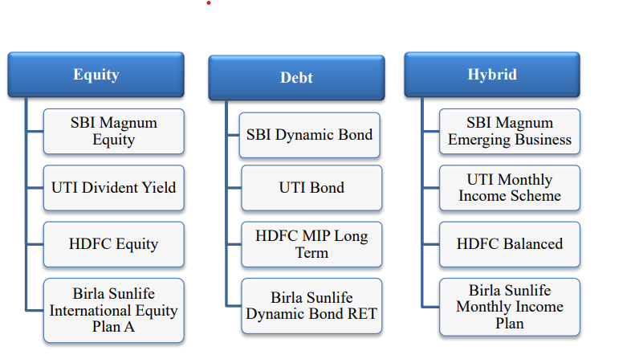

Magnum Equity SBI
With a history spanning more than 23 years, this Open-Ended Equity diversified scheme holds the unique distinction of being among the oldest equity schemes. It is marketed as a large-cap focused fund with concentrated holdings in a few different industries. It provides capital appreciation and growth possibilities, which can assist you in making medium- to long-term plans for your needs.

Summary of Funds a targeted large cap fund at the moment a concentrated portfolio with 25–40 stocks that nonetheless provides a sufficient level of diversification uses a top-down strategy to investing, first examining the prospects for the economy as a whole, then determining the sectors, and last focusing on stock selection. SBI Magnum Equity UTI Divident Yield Equity HDFC Stock The International Equity Plan of Birla Sunlife A Debt HDFC MIP UTI Bond SBI Dynamic Bond Extended Duration Birla Sunlife RET Hybrid Dynamic Bond SBI Magnum Emerging Business Monthly Income Scheme by UTI
HDFC Balanced Birla Sunlife Monthly Income Plan: Mutual Fund Investment Strategy 90
Investors with a long investing horizon should consider this fund.

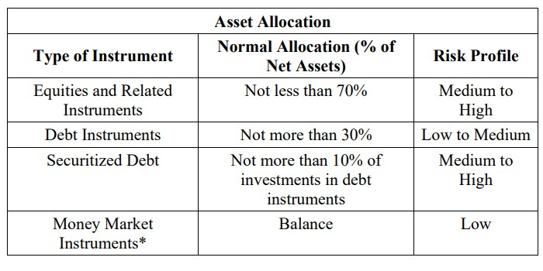

Yield on UTI Dividends
The Scheme's investment goal is to generate medium- to long-term capital gains and/or dividend distributions by primarily investing in high-yielding equity and equity-related instruments. There can be no guarantee that the scheme's investment goals will be met.
All stock investors should consider a diversified large-mid cap fund managed in a conservative manner. This product is appropriate for those looking to invest in:
Long-term increase in capital investment mostly in equities assets with strong dividend yields
elevated risk

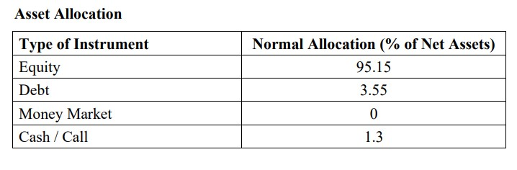

HDFC Equity Fund
The investment objective of the scheme is to achieve capital appreciation. This Product is suitable for the investors who are seeking: Capital Appreciation over long term. Investment predominantly in equity and equity related instruments of medium to large sized companies. High Risk (investors understand that their principal will be at high risk) Elevated Risk (investors recognize that there will be a significant risk to their principal).

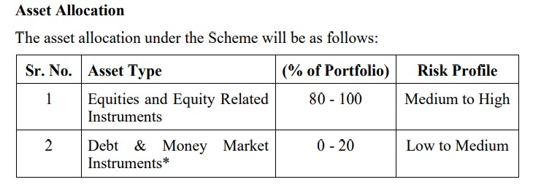

International Equity Plan A of Birla Sunlife
This is an open-ended, diversified equity scheme that offers: Global stock investments free from regional prejudice. Make the most of each nation's unique advantages worldwide.
The fund finds high-performing stocks, even in markets with weak growth rates.
Leveraging their global expertise of over 11 years in equity research, BSLAMC has hired Standard& Poor's Investment Advisory Services LLC (SPIAS) to provide investment advice on the international portion of the fund. This product is appropriate for investors who are looking for long-term capital growth, primarily in international markets through investments in equity and equity-related securities.

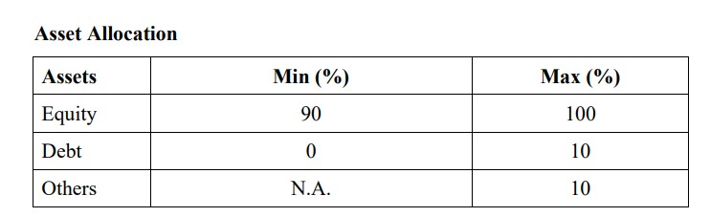

SBI Dynamic Bond
The SBI Dynamic Bond Fund actively realigns its portfolio in an attempt to track changes in different curves over time. The SBI Dynamic Bond Fund actively switches between G-sec, corporate bond, and money market instruments in addition to making aggressive calls on duration. The main goal is to attempt to time-lapse-capture each of these curves' short-term volatility. Investors with investment horizons of at least one year should consider this portfolio.

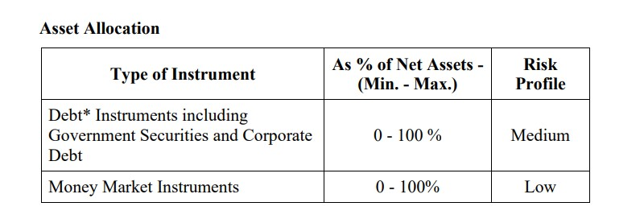
UTI Debt
The Scheme will be able to invest across the whole spectrum of money market and debt instruments. In order to keep risks within controllable bounds, the flexibility to modify the portfolio in reaction to a shift in the asset investment strategy of Mutual Funds' 93 classes under investment is being preserved. The product is appropriate for those looking to invest in:
Consistent returns on long-term investments, mostly in money market instruments and medium- to long-term debt Low risk (investors are aware that there won't be much danger to their principal).

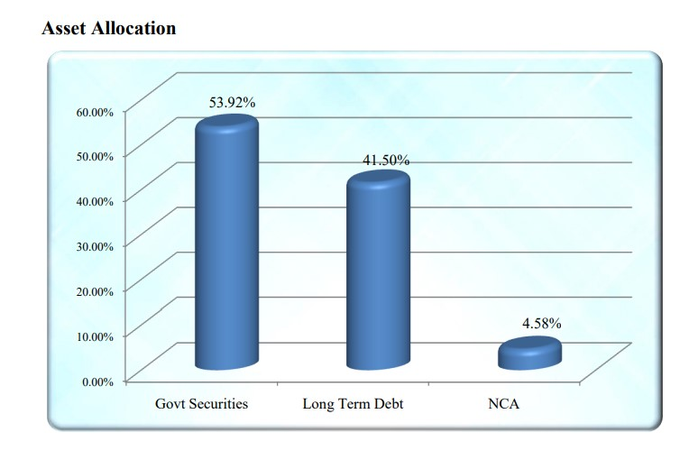
Long-Term HDFC MIP
The principal aim of the Scheme is to produce consistent returns by means of investments mainly in Debt and Money Market Instruments. By allocating a portion of its assets to equity and equity-related instruments, the Scheme seeks to generate long-term capital appreciation as a secondary goal. Nevertheless, there can be no guarantee that the Scheme's investment goal will be met.

This product is appropriate for those looking to invest in: Consistent revenue over a medium- to long-term period of time Investments in debt, money market, and equity-related instruments Investors recognize that their principal will be at a medium risk level.

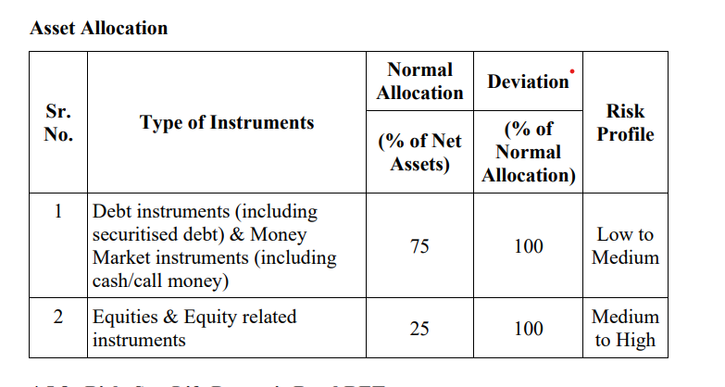

CHAPTER-5
PERFORMANCE MEASUREMENT
5.1 Sharpe's Index of Performance
William F. Sharpe, the Nobel laureate, created a ratio to gauge risk-adjusted performance. The Sharpe ratio is computed by deducting the risk-free rate from the rate of return for a portfolio, such as the yield on a 10-year U.S. Treasury bond, and dividing the result by the standard deviation of the portfolio returns.
The Sharpe ratio indicates whether the returns on a portfolio are the consequence of prudent investment choices or excessive risk. This metric is very helpful because, even though a portfolio or fund can outperform its peers in terms of returns, it is still only a good investment if the higher returns are not accompanied by an excessive amount of risk. A portfolio has performed better when adjusted for risk when its Sharpe ratio is higher.
5.2 THE PERFORMANCE INDEX FOR TREYNOR
A Jack Treynor-created ratio that assesses returns above what would have been obtained on a risk-free investment for each proportion of market risk. Put differently, the Treynor ratio represents a risk-adjusted return metric that takes systematic risk into account. It is comparable to the Sharpe ratio, but differs in that given that beta is the volatility measure used by the Treynor ratio. As the "reward-to-volatility ratio" as well.
5.3 JENSEN'S INDEX OF PERFORMANCE
a risk-adjusted performance metric that, given the beta of the portfolio and the average market return, shows the average return on an investment over and above that which is predicted by the capital asset pricing model (CAPM). The portfolio's alpha version is this. In fact, the idea is occasionally called "Jensen's alpha. "The fundamental idea is that you need to consider a portfolio's risk in addition to its total return when evaluating an investment manager's performance. An investor who is rational would choose the less risky mutual fund, for instance, if both have a 12% return. One technique to assess whether a portfolio is profitable is to use Jensen's measure.
5.4 Measuring the Return of Mutual Funds
To ascertain the investing portfolio's risk-adjusted returns, Since the 1960s, a number of distinguished writers have worked to create composite performance indices that compare alternative portfolios within a specific risk category in order to assess a portfolio. The most significant and popular metrics for evaluating mutual fund performance are: The change in the per unit net asset value (NAV) plus the per unit cash disbursements (D) and per unit capital gains disbursements (C), such as bonus shares, can then be used to calculate the one period rate of return (r) for a mutual fund.

Rap = DT + C + (NAVt - NAVt-1) NAVt-1
At the conclusion of the holding term, was NAVt equal to NAV per unit?
NAVt-1 is equal to NAV per unit at the start of the holding term.
Dt = Amounts paid out in cash for each unit while it is being held
Ct = Disbursements for capital gains made per unit while the asset is being held The rate of return or holding period yield on a mutual fund is calculated using this formula. A percentage could be used to describe this. ADJUSTED RISK RETURNS
Index Treynor = (Rp – Rf) ÷ Bp
Whereas
Rp is the portfolio return over time.
Rf is the risk-free return over time.
Bp= beta coefficient and market risk. Better portfolio performance is indicated by a higher Treynor's index value, and vice versa. Treynor's measure, which rates funds according to risk (market risk) and return, is a relative indicator of portfolio performance. Another name for the index is the reward to volatility ratio. Index of Sharpe's = (Rp – Rf) ÷ σp
where Rp is the portfolio return over time. Rf is the risk-free return over time. σp = Total risk plus the portfolio return standard deviation. Better portfolio performance is indicated by a higher Sharpe's index value, and vice versa. The performance of a portfolio as measured by Sharpe is additionally a relative metric that rates the funds according to return and risk (total risk). The reward to variability ratio is another name for the ratio.
Given the portfolio's beta and the average market return, Jensen's Measure is a risk-adjusted performance metric that shows the average return on a portfolio above and beyond what the capital asset pricing model (CAPM) predicts. This is the alpha of the portfolio. In fact, the idea is occasionally called "Jensen's alpha."
5.4.1 Measurement of Performance
An attempt is made to gauge the performance of particular mutual funds in this section. The model created by Sharpe, Trynor, and Janson was used for this purpose. The information regarding the chosen mutual fund's return is provided before proceeding. In addition to providing insight into the funds' volatility relative to market return, the values of beta and standard deviation are compute.

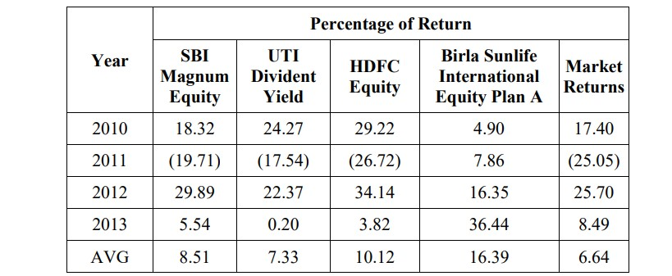
Figure 5.1 Equity funds
SBI Magnum Equity has an average return of 8.51%, based on a fluctuating return distribution with the highest return at 29.89% and the lowest at 19.71%). According to the UTI Dividend Yield fund's return, its investments produced the highest return in 2010, at 24.27%. On average, it produced a return of 7.33% between 2010 and 2013. The average return on HDFC Equity is 10.12%; the highest return was 34.14% in 2012, and the lowest was 26.72% in 2011. According to Birla Sun Life International Equity Plan A's return on investment, the year 2013 saw the largest return of 36.44%. 2010 had the lowest at 4.90%. It has a 16.39 AVG generated return.

2011 saw a downturn in the market, with negative returns on all assets. lessons. The returns in 2010 and 2012 were above average (>15%), but the returns in 2013 were comparable to the risk-free rate of return. The four-year average market return for all four funds has outperformed the market. Birla, a private sector company, has managed to record the highest average return, at 16.39%.

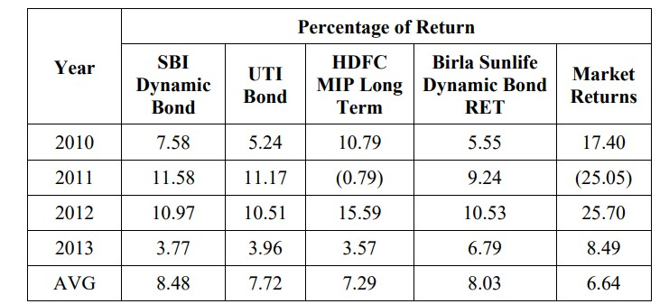
Figure:5.2 Debt fund
According to the above table, SBI Dynamic Bonds had the greatest return on investment in 2011 (11.58%) and the lowest return in 2013 (3.77%). Nonetheless, over the years 2010–13, it generated an average return on investment of 8.48%. UTI Bond had the greatest return on investment in 2011 (11.17%) and the lowest in 2013 (3.96%). On average, the fund returned 7.72% between 2010 and 2013. The HDFC MIP Long Term Fund had its greatest return of 15.59% in 2012 and its lowest return of (0.79%) in 2011. Nonetheless, the fund's average return from 2010 to 2013 was 7.29%.

In 2012, Birla Sun Life Dynamic Bond RET achieved the highest return on its investments, yielding 10.53%. In 2010, it yielded the lowest return of 5.55% on an average return of 8.03% over the 2010–13 period. The market return peaked in 2012 at 25.70% and peaked in 2011 at 25.05%. An average return of 6.64% over this time frame. After comparing these four funds, it can be seen that SBI Dynamic bond had the highest average return (8.48%) on investment from 2010 to 2013.

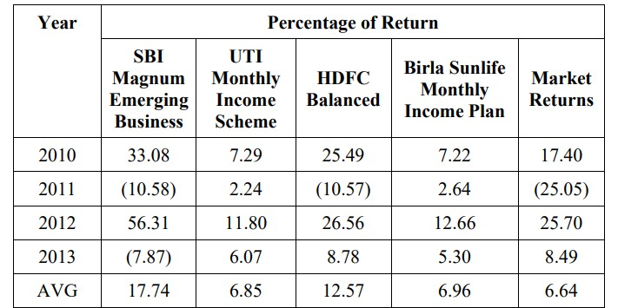
Figure 5.3 Hybrid fund
SBI Magnum Emerging Business experienced a low of (10.58%) in 2011 and a maximum return of 56.31% on its investment in 2012. Nonetheless, the fund's average return over this to the UTI Monthly Income Scheme's return on investment, it made the most money—11.80%—in 2012 and the least—2.24%—in 2011. Its average return from 2010 to 2013 is 6.85%. In 2012, the HDFC Balanced Fund produced the highest return on investment, returning 26.56%. In 2011, it also reached a low point of 10.57 percent. Over the years 2010–13, it has produced returns of 12.57% on average.
The Birla Sun Life Monthly Income Plan's returns indicate that it had a low return of 2.64% in 2011 and a maximum return of 12.66% on investment in 2012. Over this time, the fund has returned 6.96% on average. Over this time frame, market returns have fluctuated, peaking at 25.70% and falling to 2.505 percent in 2011. The four-year average market return for all four funds has exceeded the market. The public sector SBI Magnum Emerging Business fund has achieved the highest average return of 17.74%.

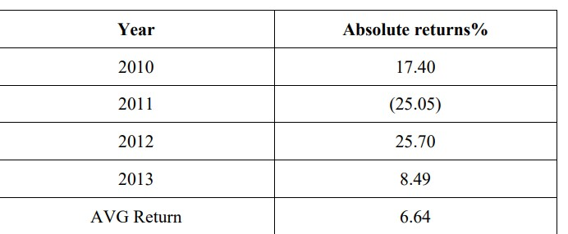
Figure 5.4 Index Return
The table above indicates that the market index experienced a decline of (25.05%)% in 2011 and reached a maximum of 25.70% for the year 2012 in terms of index return. Between 2010 and 2013, the index returned 6.64% on average.
5.5 Standard Deviation Table
We can analyze the return vs. risk for each mutual fund over a four-year period with the aid of the table below (higher standard deviation = higher risk).
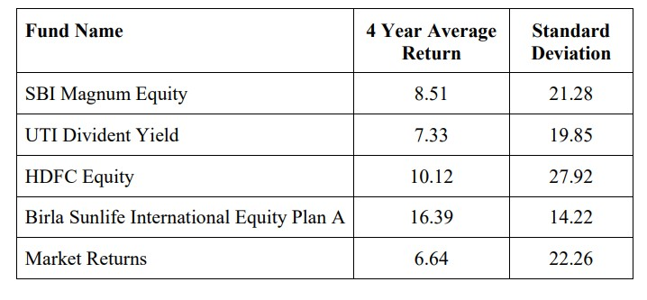
Figure 5.5 Equity fund

The table shows that, over the period, Birla Sunlife International Equity Plan A has generated the highest average return of 16.39%. Of the four funds, it also shows the lowest standard deviation, at 14.22.

5.6 PRIVATES VS PUBLICS DUE TO THE SHARPE

5.6.1 MEASUREMENT EQUITY FUND SCHEME: According to the Sharpe ratio, the Birla Fund is rated #1. While HDFC Fund secured the second position, SBI and UTI are lagging behind. This indicates a trend in which mutual funds in the private sector are investing wisely in equity, which entails greater risk and better returns.
5.6.2 Scheme for Debt Funds : First-ranked SBI Fund, second-ranked Birla Fund, third-ranked HDFC Fund, and fourth-ranked UTI Fund are all listed below. While all four funds have performed similarly when compared to market returns, the public sector mutual fund has, predictably, topped the charts with the highest return on investment. This is consistent with the market's belief that government-backed funds are reliable sources of debt.

5.6.3 HYBRID FUND SCHEME : SBI is ranked first, HDFC fund is ranked second, Birla fund is ranked third, and UTI fund is ranked fourth in terms of Sharpe measurement. Historically, hybrid funds have had a high debt load and are designed for passive investors who wish to assume market risk in a regulated setting. When debt is involved, the Sharpe measurement confirms the performance of public sector funds, but HDFC in the private sector has been able to achieve the ideal ratio of returns to risk.

CHAPTER-6

CONCLUSION

Financial markets develop as a result of the mobilization, distribution, and channeling of savings as well as the implementation of a risk management system. A more developed financial market guarantees a higher rate of return, which encourages saving. The phenomena of globalization and liberalization have played a significant role in the quick development of India's financial market. When foreign capital rules were first liberalized, changes were made to the financial sector to make it more dynamic and effective. This led to the rise of mutual funds in both the public and private sectors, which helped to revitalise the flagging and depressed economy. A more competitive environment now faces the historically protected mutual fund industry as a result of financial sector reforms and the liberalized economy's opening up.

Money is raised and directed toward the securities market through mutual funds. A decade after the private sector's entry, in June 2003, the aggregate assets under management (AUM) of India's mutual fund houses surpassed Rs. 1 trillion. Within just two years, the September 2005 saw the industry reach Rs. 2 trillion, and by August 2006, it had reached Rs. 3 trillion. This amount had reached Rs. 9 trillion as of June 2014. The funds have increased so quickly, mostly because of the economy's growth, the changing demographics, and the rise in the number of young people with surplus money to invest.

Mutual fund participation in the secondary market was approximately 70–75 percent attributed to the inflows into fixed income schemes. Nonetheless, the industry remains dominated by the major players, with the top five fund houses holding 48% of the total AUM. The enormous amount of money under management reveals two unavoidable truths:

First off, investors continue to hold the view that mutual funds offer a combination of a respectable level of investment safety and a better return potential. Second, thanks to SEBI and AMFI's active participation through a number of laws and regulations, the climate is becoming more and more favorable for mutual funds.

Despite the steady growth of mutual funds, only five percent of investors. There is still a long way to go since mutual funds are invested in by of the households. Additionally, the penetration level is not very deep because the industry has not reached out to India's rural areas, where the income gap is closing. In the next seven to eight years, the mutual fund industry is predicted to grow five to six times, drawing in a larger portion of household savings as it has grown into a major player on the global stage. As more international players prepare to set up shop, the Indian mutual fund industry, which currently ranks among the top 15 in the world in terms of AUM, is predicted to reach $500–600 billion by 2015.

The mutual fund business has a enormous room for development in the Indian context. To truly establish a market for mutual funds, an objective perspective is required. of the mutual fund business in hindsight, as options for higher risk and better returns, budgetary support, declining interest rates, and other factors have already prepared the way for mutual funds' long run. Comparative Analysis of Mutual Fund Performance in India (A Case Study of Responses to the Following Questions).

- Throughout the review period, mutual funds are doing well.
2) During the review period, mutual funds are not performing well.
3) Mutual funds are a superior option compared to stock markets.
4) The security markets are not a better option than mutual funds.
5) Private sector mutual funds outperform public sector mutual funds in terms of performance.
6) Public sector mutual funds outperform private sector mutual funds in terms of performance.

Are mutual funds doing well during the review period, according to hypotheses #1 and #2?

Are mutual funds underperforming compared to the period under review?

The study's time frame is from 2010 to 2013. The selected funds' performance over this time span ranges from 0.20% to 36.44%. We have situations during this time where the market has underperformed, which has an impact on all of the funds. The study has benefited from this variable return because it allowed us to evaluate the relationship between the funds and the market and the relative impact of the market on the funds using the different Sharpe, Jensen, and Terynor tools.

PUBLIC SECTOR:

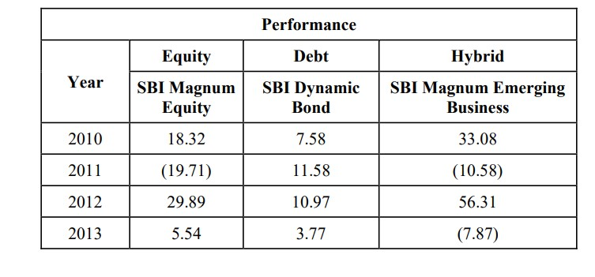

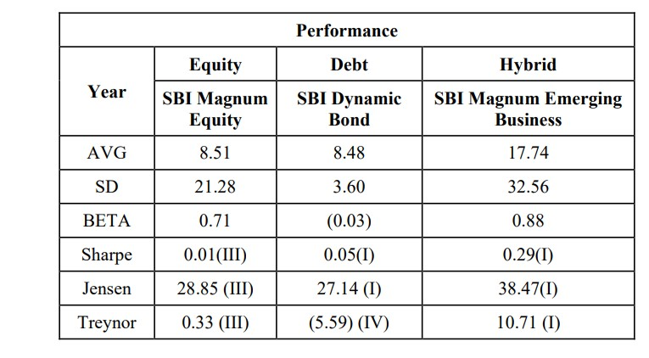
The equity fund performed well in 2010, 2012, and 2013. In 2010 and 2012, it produced returns on the market that were above average. Although the market has indicated that the fund has performed poorly in 2011, the fund has managed to contain the decline when compared to the market return, making mutual funds a superior choice for investors. This demonstrates how the equity mutual fund performed during the evaluation period. Throughout the review period (2010-2013), the debt fund has performed well.

The hybrid fund performed well in 2010 and 2012, yielding returns that were higher than average. While the market saw a positive return in 2013, the fund showed a declining trend. The fund's performance in 2011 was lower than the market's, but it was still able to limit the decline when compared to the market return, indicating that the fund did well during the review period.

Over the course of the review period, the equity funds have done well. Even though 2011 saw a decline in performance, one of the study's funds managed to outperform the market and provide a positive return. Throughout the review period, the debt funds have done well. All of the funds have shown a higher return than the market. The hybrid funds have done well over the course of the review period. Although the market saw a decline in HDFC's performance in 2011, the fund was able to contain the decline when compared to the market return, indicating that it had performed well during the review period.

Over the course of the review period, the equity funds have done well. Even though 2011 saw a decline in performance, one of the study's funds managed to outperform the market and provide a positive return. Throughout the review period, the debt funds have done well. All of the funds have shown a higher return than the market. The hybrid funds have done well over the course of the review period. Although the market saw a decline in HDFC's performance in 2011, the fund was able to contain the decline when compared to the market return, indicating that it had performed well during the review period.

Over the course of the review period, the equity funds have done well. Even though 2011 saw a decline in performance, one of the study's funds managed to outperform the market and provide a positive return. Throughout the review period, the debt funds have done well. All of the funds have shown a higher return than the market. The hybrid funds have done well over the course of the review period. Although the market saw a decline in HDFC's performance in 2011, the fund was able to contain the decline when compared to the market return, indicating that it had performed well during the review period. The study unequivocally demonstrates that when it comes to investing, mutual funds are superior to the security markets.

Five and Six Hypotheses

Both the performance of public mutual funds and the performance of private mutual funds are superior. The former is superior to the latter. The researcher's goals in conducting this study are to: (i) assess the performance of the mutual fund industry in India in a regulated setting; (ii) investigate the relationship between market index performance and fund performance managed by the public and private sectors; and (iii) assess performance using portfolio evaluation metrics such as Treynor, Jensen, and Sharpe.

The aforementioned goals were statistically tested using the following hypotheses: (i) there is no significant difference between the Sharpe, Treynor, and Jensen performance evaluation tools; (ii) index returns and scheme returns are not significantly related; and (iii) there is no significant relationship between the scheme's past performance and current performance. The study examines three distinct funds' returns in relation to market risk, their capacity to build intelligent portfolios, and the advantages of making non-market investments. The logical framework for the conclusion is provided by the theories of Jensen, Treynor, and Sharpe.

The results clearly show that public sector funds, with their appropriate stock mix, are the best choices for long-term investments with fixed returns. They are the best assets to invest in to get high returns over an extended period of time and serve as the benchmark when risk is taken into account with debt.
It was noted that the equity fund is good with private sector funds because they provide higher returns than the public sector funds, according to the Sharpe Performance measurement of the equity fund scheme. Private sector mutual funds are the only option for investors seeking returns above the market's risk-free rate of return when it comes to equities. Only these funds can match the market's aggressiveness. They possess the aggressiveness to continually keep the proper balance of stocks, capitalize on market movements, and deliver greater returns. Everything is carried out within a predetermined risk range.
When it comes to hybrid funds, a combination of the public and private sectors are providing profitable returns. As a result, investors with a higher tolerance for risk can choose equity through private sector funds, where they can obtain larger returns at the expense of a slightly higher risk. Public sector mutual funds offer investors seeking regular, guaranteed results with an appropriate balance of risk and return through debt funds. The market competition that has produced this particular market niche of customers seeking a higher return at a lower risk is what gave rise to hybrid funds. Both the public and private sectors have made significant contributions to the creation of hybrid portfolios that meet the needs of these investors.

BIBILOGRAPHY
- Agarwal, R., & Dahiya, S. (2018). Comparative analysis of performance of mutual funds in India. International Journal of Advance Research, Ideas and Innovations in Technology, 4(2), 283-289.

- Bala, S., & Kumar, A. (2019). A comparative analysis of performance of mutual funds in India: An empirical study. Journal of Accounting and Finance, 19(5), 28-35.

- Chandra, P., & Sharma, R. (2020). Comparative study of mutual funds in India: A case of selected private and public sector mutual funds. International Journal of Management Studies, 7(2), 32-45

- Gupta, A., & Singh, S. (2017). Performance evaluation of mutual funds in India: A comparative study of selected private and public sector mutual funds. Journal of Finance and Economics, 5(3), 67-78.

- Jain, S., & Sharma, M. (2016). A comparative study of performance of selected mutual funds in India. Asian Journal of Research in Banking and Finance, 6(2), 45-55.

- Kapoor, R., & Singh, N. (2019). Comparative analysis of performance of mutual funds in India: A study of selected private and public sector mutual funds. Journal of Economics and Finance, 12(4), 72-83.

- Mishra, S., & Gupta, R. (2018). Performance evaluation of mutual funds in India: A comparative study of private and public sector mutual funds. Global Journal of Finance and Management, 10(3), 45-56.

- Patel, H., & Shah, D. (2021). Comparative analysis of mutual funds in India: A study of selected private and public sector mutual funds. Journal of Investment and Portfolio Management, 9(1), 112-125.

- Sharma, A., & Verma, R. (2017). Comparative study of mutual fund schemes: An analysis of selected private and public sector mutual funds in India. International Journal of Research in Finance and Marketing, 7(2), 89-98.

- Tiwari, S., & Mishra, S. (2020). Performance evaluation of mutual funds in India: A comparative study of selected private and public sector mutual funds. International Journal of Commerce and Management Research, 6(3), 55-64

- Arora, V., & Singh, R. (2018). A comparative analysis of performance of selected private and public sector mutual funds in India. Journal of Management Research, 18(2), 45-56.

- Das, S., & Das, S. (2019). Comparative study of mutual funds: A case study of selected private and public sector mutual funds in India. International Journal of Financial Management and Economics, 3(1), 78-87.

- Gupta, M., & Agarwal, A. (2017). Comparative analysis of mutual funds in India: A study of selected private and public sector mutual funds. International Journal of Business and Management Studies, 5(2), 112-123.

- Joshi, R., & Sharma, P. (2020). Performance evaluation of mutual funds in India: A comparative study of selected private and public sector mutual funds. Journal of Financial Planning and Analysis, 8(3), 67-78.

- Khanna, A., & Mittal, P. (2018). Comparative analysis of mutual funds: A study of selected private and public sector mutual funds in India. Journal of Financial Management and Analysis, 25(2), 56-67.

- Mehra, S., & Kapoor, G. (2019). A comparative study of performance of selected private and public sector mutual funds in India. Journal of Banking and Financial Research, 15(4), 112-125.

- Singh, H., & Kumar, A. (2017). Performance evaluation of mutual funds: A comparative study of selected private and public sector mutual funds in India. Global Journal of Management and Business Research, 17(3), 45-56.

- Varma, A., & Sharma, D. (2020). Comparative analysis of mutual funds in India: A study of selected private and public sector mutual funds. International Journal of Financial Markets and Derivatives, 5(1), 89-98.

- Yadav, R., & Gupta, S. (2018). A comparative study of mutual funds: An analysis of selected private and public sector mutual funds in India. International Journal of Commerce and Economic Studies, 6(2), 34-45.

- Zaveri, H., & Mehta, K. (2019). Comparative analysis of mutual funds in India: A study of selected private and public sector mutual funds. Journal of Investment Management and Financial Innovations, 16(2), 112-125.

