E- NOTICE BOARD PORTAL
Dhivya Dharshini G B  Department of Artificial Intelligence and Data Science  Erode Sengunthar Engineering College  Erode, India  dhivya230902@gmail.com  Harisudhan S  Department of Artificial Intelligence and Data Science  Erode Sengunthar Engineering College | Swetha T Y  Department of Artificial  Intelligence and Data Science  Erode Sengunthar Engineering College  Erode, India swethayokanantham@gmail.com  SenthilKumar M  Department of Artificial Intelligence and Data Science  Erode Sengunthar Engineering College | Visanth A  Department of Artificial Intelligence and Data Science  Erode Sengunthar Engineering College  Erode, India  Vs9994244409@gmail.com

Erode, India Erode, India
Harisudhan080220@gmail.com
Abstract— The Web-Based Notice Board Portal is a dynamic and user-friendly online platform designed to facilitate efficient communication and information dissemination within organizations, institutions, and communities. The project is concerned with managing notice board information through online. The project contains department, circulars, events, holidays, functions, seminars, sports, competitions and placement information processing through web pages.The administrator logins to the web site and adds all the department details. Various day-to-day activities to be announcement to all staff and students are stored as records instead on printing the information and placing in physical notice board as hard copies. During the notices entry like function or seminars, the details can be mail alerted to given staffs. Various search options are provided for easy data retrieval to administrator and staff, students.
Keywords—ubiquitous life and learning, smart campus, digital notice boards, context aware IoE, GSM Module, Control Centre.
I. INTRODUCTION
Notice board is an important information gathering system in our life. In our day to day life we see notices boards in many places like schools, colleges, banks etc. Notice board is a mode to communicate between teaching staff, non-teaching staff and students. Now-a-days a separate person is needed to print and stick the notices on the notice board. Maintaining the notices manually creates wastage of paper, ink and manpower. Smart notice board will play vital role in displaying notices digitally. The problems faced by this traditional type of notice board are resolved by the smart notice board. Smart Notice Board is a concept of sending the notices digitally to the screen at real time. This project is implemented by using the concept of digital signage. Digital signage is a concept of displaying notices on the screen digitally. This project is implemented using a web application to control the notices and cloud for storage. An authenticated user will be sending the notice with the help of web application and this notice will get displayed on screen. The notice can be in the form of text, images or videos. The admin can perform Create, Read, Update, and Delete operations and can schedule the notices as required. Thus it will result in an advanced and efficient method for sending notices
Now a days, human beings are turning into accustomed for easy access to information. Whether it’s with the aid of the net or television, human beings pick themselves to be up to date with the modern-day activities going on around the world. In today’s world human beings pick wi-fi connection due to the reality they can have interplay with people without problems and it require an awful lot much less time. Design and Implementation of noticee board with the resource of the usage of raspberry pi board.
The GUI which will be used via users which has been established and equipped to use on the pc, an internet server is used to display textual content on exhibit device. The important objective of this device is to give a boost to a wi-fi digital word board that exhibit message sent from the consumer and to format a simple, easy to install, purchaser pleasant system, which can obtain and show word in a unique order with respect to date and time which will assist the user to except issues preserve the music of note board each day and every time he/she makes use of the system. It is a modern-day way to launch your data to your customers, website visitors or college students Target your audience: You pick out how to ship your information, ensuring that your message is getting throughout to the appropriate people, in the perfect place, at the ideal time. The versatility of the digital notice board platform permits you to use all the present day Power point displays except making any changes or alterations.
II. LITERATURE REVIEW

A literature review on web-based notice board portals would typically involve summarizing and analyzing existing research and publications on the topic. Here's a broad overview of some key themes and findings you might consider including in your literature review:

A) INTRODUCTION TO WEB BASED NOTICE BOARD PORTAL
Define what a web-based notice board portal is and its significance. Highlight the role of such portals in modern communication and information dissemination. Discuss the historical context and evolution of web-based notice boards.
Mention how the internet and web technologies have transformed traditional bulletin boards.Explore various sectors and organizations where these portals are used, such as educational institutions, businesses, and communities. Provide examples of successful implementations and case studies Review research on the design principles and usability factors that contribute to the effectiveness of notice board portals.Highlight user experience (UX) considerations.Discuss the technology stack commonly used to develop web based notice board portal Explore mobile responsiveness and cross-platform compatibility. Explore mobile responsiveness and cross-platform compatibility. Identify common challenges in implementing and maintaining such portals. Discuss issues related to information security and privacy. Discuss emerging trends and potential areas for further research and development. Consider the impact of technologies like AI, machine learning, and blockchain on notice board portals.

Many attempts have been done in the case of digital notice board beforehand. All systems previously proposed have their own limitations and benefits . It was SMS based which will increase the recurring cost and also it was not convenient for long notices due to limited number of character support. Likewise, Small and medium range wireless electronic notice board using Bluetooth and ZigBee introduces a wireless electronic notice board using Arduino and Bluetooth module Wireless Electronics Display Board Using GSM Technology is more or less similar project to the previous one. Another paper on Electronic notice board with multiple output display deals with developing a wireless electronic noticeboard to control information display within a given range on multiple displays.

The use of online notice boards in various organizations has become increasingly popular over the years due to its numerous benefits, such as efficiency, accuracy, and accessibility. Many studies have been conducted to explore the different aspects of online notice boards, including their features, benefits, and limitations. In a study [1], the authors investigated the effectiveness of an online notice board system in improving communication within a university. The study found that the system significantly improved communication among students, faculty, and staff, and helped to reduce the time and effort required to manage notice board messages. The authors concluded that online notice board systems are an effective tool for improving communication within universities

Disadvantages and problems:
A notice board portal, while useful, can come with its own set of disadvantages and problems:
- Limited Visibility: Not everyone may check the notice board regularly, leading to some missing important announcements or updates.
- Information Overload: If not organized properly, a notice board portal can become cluttered with too much information, making it difficult for users to find what they need.
- Maintenance: Keeping the notice board updated with relevant information requires regular maintenance and oversight, which can be time-consuming.
- Security Concerns: If the notice board portal contains sensitive information, there may be security risks involved, such as unauthorized access or data breaches.
- Accessibility: Depending on the design and technology used, the notice board portal may not be accessible to all users, including those with disabilities or those using older technology.
- Dependency on Technology: If the notice board portal relies heavily on technology, any technical issues or downtime could disrupt communication and cause inconvenience.
- Resistance to Change: Some users may prefer traditional methods of communication and may be resistant to using the notice board portal, leading to adoption challenges.
- Language and Cultural Barriers: In multicultural environments, language barriers or cultural differences may affect the effectiveness of communication through the notice board portal.
- Lack of Engagement: Users may become disengaged if they feel that the information on the notice board portal is not relevant or useful to them, leading to decreased usage over time.
- Cost: Developing, maintaining, and upgrading a notice board portal can incur costs, especially if custom features or integrations are required.
Addressing these issues requires careful planning, effective communication strategies, user training, and ongoing evaluation and improvement of the notice board portal system.

B) RFID:
Radio Frequency Identification, or RFID, is a wireless technology that can be used to track, identify, and manage people, animals, and other objects. It is made up of RFID tags and RFID readers. RFID tags have a microchip and an antenna, while RFID readers emit radio waves and process data that has been received. A tag activates and transmits its specific identification information to the reader when it comes within range of an RFID reader. Applications in inventory management, retail, access control, transportation, logistics, animal tracking, healthcare, passport systems, and waste management are made possible thanks to the processing and transmission of this data to a central database or system. RFID improves tracking, security, and operational effectiveness in a variety of sectors.

Hardware components:
The hardware components required for an online notice board portal are relatively minimal since the primary infrastructure is digital and hosted online. However, here are some essential hardware components that play a role in supporting the functionality of the notice board portal:
- Servers: These are computers or systems that host the online notice board portal. They store and serve web pages, handle user requests, and manage data storage and retrieval.
- Networking Equipment: This includes routers, switches, and network cables that enable communication between servers, user devices, and the internet. A stable network connection is crucial for users to access the notice board portal reliably.
- Storage Devices: These devices, such as hard disk drives (HDDs) or solid-state drives (SSDs), store the data and files associated with the notice board portal, including announcements, documents, images, and videos.
- Backup Systems: Backup hardware components, such as external hard drives or cloud storage services, ensure that data on the notice board portal is regularly backed up to prevent loss in case of hardware failures or other disasters.
- Firewalls and Security Appliances: These hardware devices protect the notice board portal and its data from unauthorized access, malware, and other security threats. Firewalls, intrusion detection systems (IDS), and antivirus appliances are examples of such components.
- Load Balancers: In cases of high traffic or to ensure high availability, load balancers distribute incoming web traffic across multiple servers hosting the notice board portal, optimizing performance and preventing server overload.
- Power Backup Systems: Uninterruptible Power Supply (UPS) units or backup generators provide power continuity to the hardware components hosting the notice board portal, minimizing downtime during power outages.
- Client Devices: While not directly part of the notice board portal infrastructure, client devices such as desktop computers, laptops, tablets, and smartphones are necessary for users to access and interact with the portal.
These hardware components work together to ensure the availability, performance, and security of the online notice board portal, facilitating seamless communication and information sharing between administrators and users.

Feasibility Study
The feasibility study deals with all the analysis that takes up in developing the project. Each structure has to be thought of in the developing of the project, as it has to serve the end user in a user-friendly manner. One must know the type of information to be gathered and the system analysis consist of collecting, Organizing and evaluating facts about a system and its environment.
The main objective of the system analysis is to study the existing operation and to learn and accomplish the processing activities. The notice board management through web application need to be analyzed well. The details are processed through coding themselves. It will be controlled by the programs alone.

Operational Feasibility

The Proposed system accessing process to solves problems what occurred in existing system. The current day-to-day operations of the organization can be fit into this system. Mainly operational feasibility should include on analysis of how the proposed system will affects the organizational structures and procedures. Operational feasibility is one of the key aspects to consider when evaluating the viability of a proposed project or system. It assesses whether a project or system can be effectively and efficiently implemented and integrated into the existing operations of an organization. This feasibility study is conducted to determine if the project can meet its objectives while working within the constraints of the organization, including its technology, resources, and operational processes.
Technical Feasibility
The cost and benefit analysis may be concluded that computerized system is favorable in today’s fast moving world. The assessment of technical feasibility must be based on an outline design of the system requirements in terms of input, output, files, programs and procedure. The project aims to manage notice board activities such as circulars, events, holidays, functions, seminars, sports, competitions and placement information processing to all departments in web application’s forms. The current system aims to overcome the problems of the existing system. The current system is to reduce the technical skill requirements so that more number of users can access the application.

The process involved in an online notice board portal typically includes several steps, from creation to usage. Here's an overview:
- Planning and Design:
  - Identify the purpose and target audience of the notice board portal.
  - Determine the types of information to be shared (announcements, events, news, etc.).
  - Define the features and functionalities required (user registration, content management, search functionality, etc.).
  - Design the user interface and user experience (UI/UX) to be intuitive and user-friendly.
- Development:
  - Develop the backend infrastructure, including servers, databases, and APIs.
  - Implement user authentication and authorization mechanisms to control access to the portal.
  - Create the frontend components using web development technologies such as HTML, CSS, and JavaScript.
  - Integrate any additional features or third-party services as needed (e.g., email notifications, social media sharing).
- Content Management:
  - Set up an admin interface for managing and publishing content to the notice board portal.
  - Develop tools for administrators to create, edit, and delete announcements and other information.
  - Implement version control and approval workflows if multiple administrators are involved.
- Testing:
  - Conduct thorough testing of the notice board portal to ensure functionality, usability, and security.
  - Test for compatibility with various web browsers and devices.
  - Perform load testing to assess performance under different traffic conditions.
  - Address any bugs or issues identified during testing.
- Deployment:
  - Deploy the notice board portal to a web server or hosting platform.
  - Configure domain settings and DNS records if a custom domain is used.
  - Set up SSL/TLS certificates for secure HTTPS connections if required.
  - Monitor deployment for any issues and ensure a smooth transition to production.
- User Adoption and Training:
  - Promote awareness of the notice board portal among the target audience.
  - Provide training and resources for users on how to access and use the portal effectively.
  - Encourage feedback from users to identify areas for improvement.
- Maintenance and Updates:
  - Regularly monitor and maintain the notice board portal, including software updates and security patches.
  - Continuously evaluate user feedback and usage metrics to make improvements and add new features.
  - Back up data regularly to prevent loss in case of hardware failures or other incidents.
By following these steps, organizations can create and maintain an effective online notice board portal to facilitate communication and information sharing with their users.

D) DATA ENTRY
Data entry in an online notice board portal involves the process of inputting, updating, and managing information to be displayed on the platform. Administrators or authorized users typically access the portal's backend interface, where they can create new announcements, events, news articles, or other relevant content. This involves filling out forms or fields with details such as title, description, date, time, and any attachments like images or documents. Depending on the portal's features, administrators may also have options to categorize or tag the content for easier organization and retrieval. Once entered, the data undergoes validation checks to ensure accuracy and consistency before being published to the portal for users to view. Regularly updating and maintaining the content ensures that the notice board portal remains current and informative for its audience, facilitating effective communication within the organization or community.
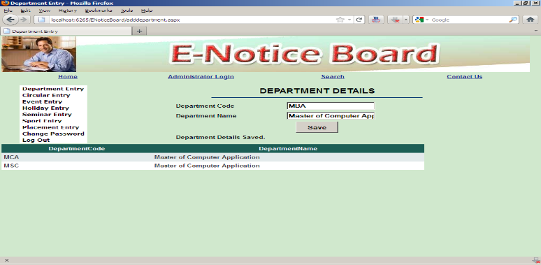
Disadvantages:
Data entry in an online notice board portal, while essential for keeping information up to date, can also present several disadvantages:
- Time-consuming: Inputting data into the portal can be a manual and time-consuming process, especially if there is a large volume of information to be entered or updated regularly.
- Human Error: Data entry is prone to human error, such as typos, incorrect formatting, or inaccurate information, which can lead to confusion or misinformation for users.
- Training Requirements: Users responsible for data entry may require training to use the portal effectively, which can incur additional time and resource costs for organizations.
- Security Risks: Data entry involves accessing and manipulating sensitive information, which increases the risk of unauthorized access, data breaches, or accidental disclosure if proper security measures are not in place.
- Duplication of Effort: In organizations with multiple departments or users managing different sections of the portal, there may be duplication of effort or inconsistencies in data entry practices, leading to confusion or discrepancies in information.
- Limited Accessibility: Users with disabilities or those unfamiliar with technology may face challenges in accessing or using the portal for data entry, potentially excluding certain individuals from participating in the process.
- Dependency on Administrators: The efficiency and accuracy of data entry depend on the diligence and availability of administrators or authorized users responsible for managing the portal, creating a potential bottleneck in the update process.
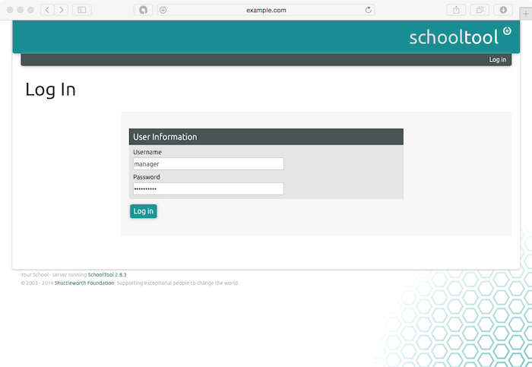
- Maintenance Overhead: Regular maintenance and oversight are required to ensure that the data entered into the portal remains relevant, accurate, and up to date, which can increase the administrative overhead for organizations.
Addressing these disadvantages may require implementing automation tools for data entry, providing training and support for users, enforcing strict data validation checks, implementing robust security measures, and establishing clear guidelines and procedures for maintaining the portal's content.

III. PROPOSED SYSTEM
A. SYSTEM OVERVIEW :
The main objective of the proposed system is to enter and retrieve the data that are saved for viewing purpose. Input Design is one of the most expensive phases of the operation of computerized system and it is often the major problem of a system. A large number of problems with a system can usually be tracked backs to fault input design and method. Needless to say, therefore, that the input data is the life blood of a system and have to be analyzed and designed with utmost case and consideration. The decisions made during the input design are,



- To provide cost effective method of input.
- To achieve the highest possible level of accuracy.
- To ensure that the input is understand by the user.

System analysis decide the following input design details like, what data to be as input, what medium to use, how the data should be arranged or coded, data items and transactions needing validations to detect errors and at last the dialogue to guide user in providing input.

Input data of a system may not be necessarily be raw data captured in the system from scratch. These can also be the output of another system or sub system. The design of input covers all phases of input from the creation of initial data to actual entering the data to the system for processing. The design of inputs involves identifying the data needed, specifying the characteristics of each data item, capturing and preparing data for computer processing and ensuring correctness of data

Designing the input system for a notice board portal involves creating a user-friendly and efficient way for authorized users to submit and post notices or announcements
The following input forms are present in the project.

ADMINISTRATOR LOGIN
In this form, the administrator logins to the web application using the given username and password. A number of username and password are saved in the database and of which one of the username, password need to be given.

DEPARTMENT ADDITION
In this form, the administrator adds the department code, name and head of the department along with section information.

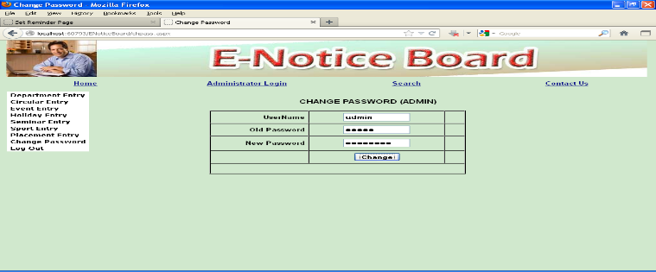

ANNOUNCEMENTS
a) Circulars
In this form, circular details such as date and time, details such as last date for application, fees details, scholarships, etc are saved.
b) Events
In this form, event details such as date and time, location of event, type of events such as inter-college meets, marketing events, etc are saved.
c) Holidays
In this form, holiday date, name and description along with number of days are added. The details are viewed using grid view control.

d) Seminars
In this form, seminar date, name and company which conducts’ the seminar, conducted by persons, helpers and college staff allotted to management along with items given as projector, MIC, etc are saved. The details are viewed using grid view control.

e) Sports
In this form, sports date, name, location (inside-college or other-college) and sports type, conducted by persons, and college staff allotted to management along with food and other expense details are saved. The details are viewed using grid view control.

f) Placement (On/Off) Campus
In this form, placement details such as date, companies visited, type, domain in which interview is conducted, company staffs details, vacancies and exam conducted details are saved. The details are viewed using grid view control

B. METHODOLOGY :
The methodology involved in developing an online notice board portal typically follows a structured approach to ensure the successful implementation of the system. Here's a generalized methodology that can be adapted to suit the specific needs of the project:
- Requirement Analysis
- Planning
- Design
- Development
- Testing
- Deployment
- Training and Adoption
- Maintenance and Support

C. OUTPUT DESIGN
Computer output is the most important direct source of information to the user. Outputs computers are required primarily to communicate the results of processing to the users. They are also used to provide permanent copy of these results for rate reference. Thus it is designed in a user –friendly way to avoid user burden.
The output design refers to the results and information that are generated by the system form many end users. To produce the outputs which are displayed in a screen. Efficient and intelligent output design improves the system relationships with the users and help in decision making. The output of the system is in the form of reports. The following reports are generated in the system.
Department Options
In this form, department users are logged in to the web site and view circular details and event details. The records are viewed using grid view control.

Search
In this form, date wise or keyword based search is provided. The administrator or users (staffs/ students) enters two dates or type few words and search the past information. The upcoming events can also be tracked. All the tractions records are viewed separately such as events list and sports list

D. CODE DESIGN
The code design should be such that with less amount of coding we can achieve more results. The speed of the system will be more if the coding is less. Whether the data in the system is usable and readable by the system is depending on the coding.

Designing the code depends on the programming language chosen and mostly they are not specified while outlining the design of the system. The system uses Micro Soft Visual Basic .Net with ASP.Net to develop its code. The goal of coding is to translate the design of the system in to code in a given programming language. The aim of the code design is to implement the system in best possible manner.

In the project, the coding is being done such that proper validations are made to get the perfect input. No error inputs are accepted. In addition care is taken such that the data integrity and referential integrity is not violated in the database.

Checking the id, date and time, authorized by details are checked properly before saving records in database.
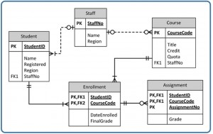

D. SYSTEM TESTING AND IMPLEMENTATION
Testing
After the source code has been completed, documented as related data structures. Completion of the project has to undergo testing and validation where there is subtitle and definite attempt to get errors. The project developer treats lightly, designing and execution of the project test that will demonstrates that the program works rather than uncovering errors, unfortunately errors will be present and if the project developer doesn’t found errors, the user will find out.

The project developer is always responsible for testing the individual units i.e. modules of the program. In many cases, developer should conduct the integration testing i.e. the testing step that leads to the construction of the complete program structure.

This project has undergone the following testing procedures to ensure its correctness. The following testing is carried out.

- UNIT TESTING
- USER ACCEPTANCE TESTING
- INTEGRATION TESTING
- VALIDATION TESTING

Unit Testing
In unit testing, it has to test the programs making up the system. For this reason, Unit testing sometimes called as Program testing. The software units in a system are the modules and routines that are assembled and integrated to perform a specific function, Unit testing first on the modules independently of one another, to locate errors.

This enables, to detect errors in coding and logic that are contained with the module alone. The testing was carried out during programming stage itself.

User Testing
In these testing procedures the project is given to the customer to test whether all requirements have been fulfilled and after the user is fully satisfied. The project is perfectly ready. If the user makes request for any change and if they found any errors those all errors has to be taken into consideration and to be correct it to make a project a perfect project.

Integration Testing
Integration testing is a systematic technique for constructing the program structure. While at the same time conducting tests to uncover errors associated with interfacing. The objective is to take unit tested modules and build a program structure that has been dictated by design.

In this integration testing its done using the main module and based on the type of integration testing the subordinate tables and other criteria along with their path, is replaced one at a time with actual modules. In the project, after integrating the image selection modules, they are tested with their integration in layer wise hide and layer wise extraction modules.

Validation Testing
It is said that validation is successful when the software functions in a systematic manner that can be reasonably accepted by the customers. This type of testing is very important because it is the only way to check whether the requirements given by user have been completely fulfilled.
The input given to various forms are validated effectively. The validated input is given for all modules. Each module is tested independently.
Implementation
When the initial design was done for the system, the client was consulted for the acceptance of the design so that further proceedings of the system development can be carried on. After the development of the system a demonstration was given to them about the working of the system. The aim of the system illustration was to identify any malfunction of the system.

After the management of the system was approved the system implemented in the concern, initially the system was run parallel with existing manual system. The system has been tested with live data and has proved to be error free and user friendly. Implementation is the process of converting a new or revised system design into an operational one when the initial design was done by the system; a demonstration was given to the end user about the working system. This process is uses to verify and identify any logical mess working of the system by feeding various combinations of test data.

After the approval of the system by both end user and management the system was implemented. A product software implementation method is a blueprint to get users and/or organizations running with a specific software product. The method is a set of rules and views to cope with the most common issues that occur when implementing a software product: business alignment from the organizational view and acceptance from the human view.

The implementation of product software, as the final link in the deployment chain of software production, is in a financial perspective of a major issue. The Implementation methodology includes four phases - Discovery, System Development, User Acceptance Testing and Production Rollout. It’s easy to be overwhelmed by slick marketing presentations, particularly when the sales force is talking about things that most people don’t completely understand. Showmanship gets in the way of real capabilities.

Unless the review team is judging each vendor against the same list of needs, with the same understanding of the significance of each rating, “likeability” can win over capability.

These implementation phases are designed to provide clients with a seamless transition from an existing electronic or paper-based system to Sigmund while ensuring all aspects of a client’s operations are accounted for by the software. The Sigmund project team, comprised of individuals with clinical, billing and operations experience, is equipped with the skills and tools to manage the entire process from system requirements gathering to deployment. Sigmund provides various levels of support, depending on client needs, including client-side Project Management.

The Discovery Phase is preceded by a Project Kick-off Work-session that includes application demonstrations, completion and review of requirements and configuration questionnaires, identification of key client documentation, as well as consultation on possible process re-engineering needs. The Project Kick-off provides your organization with the opportunity to not only introduce the Sigmund Project Team to your organization, but also to define and structure your organization’s Project Team.

System implementation is made up of many activities. The six major activities are as follows.

Coding
Coding is the process of whereby the physical design specifications created by the analysis team turned into working computer code by the programming team.
Testing
Once the coding process is begin and proceed in parallel, as each program module can be tested. The implementation of product software, as the final link in the deployment chain of software production, is in a financial perspective of a major issue.
Installation
Installation is the process during which the current system is replaced by the new system. This includes conversion of existing data, software, and documentation and work procedures to those consistent with the new system.
Documentation
It is result from the installation process, user guides provides the information of how the use the system and its flow.
Training and Support
Training plan is a strategy for training user so they quickly learn to the new system. The development of the training plan probably began earlier in the project. The best-suited application package to develop the system is ASP .NET under Windows XP’ environment.
As part of the proven implementation methodology, every customer gets Administrator Training for each of the applications they're implementing. The trainer will deliver the Administrator Training on-site, face-to-face, to a maximum of system administrators, so each learner gets personalized attention and can ask and get specific answers to questions. If it's more convenient for them and they can be offered the training facilities.
The system is very flexible and user-friendly, so the maintenance based on the changing environment and requirements can be incorporated easily. Any changes that are likely to cause failures are prevented with security and preventive measures could be taken.
The coding is done in understandable and flexible method program which helps easy changing. Since MS-SQL Server and .NET are very flexible tools, user can easily incorporate any modular program in the application.

It helps the user to view the notice board contents easily. Facilitate administrators to update contents as soon as possible.In future, the application can be added with features such as send SMS to principal, HOD and other staffs regarding the events. The website is created for user to interact with system while updating notices. . Here, website provides a simple Graphical User Interface which enables user to login as well as input notices to the different notice boards by selecting their respective placeholders designated previously for those notice boards. In case of Arduino, the complexity of coding considerably increases as compared with computer, but once programmed the micro controller works at its best since it is a committed embedded system

IV) RESULT AND CONCLUSION
The online notice board portal project has yielded significant positive outcomes, showcasing its prowess in revolutionizing communication and collaboration within the organization or community it serves. By effectively achieving its objectives, which encompass improved dissemination of information and heightened user engagement, the portal has seamlessly facilitated access to timely and pertinent updates. User feedback underscores high satisfaction levels, with commendations directed towards the portal's intuitive interface and its efficacy in streamlining communication channels. Despite encountering challenges throughout development and implementation, the project has served as a learning opportunity, offering valuable insights for future enhancements and optimizations. These insights pave the way for a roadmap focused on further elevating the portal's utility and impact, ensuring its continued relevance and effectiveness in the evolving landscape of digital communication platforms.
VI. REFERENCES
- Peng-Wen Chen, Yung-Hui Chen, Yung-Hui Chen - “Pushing the Digital Notice Board toward Ubiquitous Based on the Concept of the Internet of Everything”
- N. Jagan, Mohan Reddy et al., "Wireless electronic display board using GSM technology", International Journal of Electrical Electronics and Data Communication, vol. 1, no. 10, pp. 50-54, 2013.
- Gamini Jayasinghe et al., "A GSM alarm device for disaster early warning", IEEE conference on Industrial and Information Systems, pp. 383-387, 2006.
- F. Andreas and Molisch, "Wireless communications" in , Wiley, Nov. 2010.
- N. Bawne, A. Nimbalkar, D. Dubey and R. Khan, "Digital Notice Board Using Raspberry Pi", International Journal on Future Revolution in Computer Science & Communication Engineering, vol. 4, no. 4, pp. 211-214, April 2018.
- Priyasha Durge, P., K.M. Sunil and P.K. Rajendra, "Digital Display Board Using Cloud", International Journal of Advance Research and Innovative Ideas in Education, vol. 2, no. 2, pp. 498-502, 2016.
- S. M. Nasution, E. M. Husni and A. I. Wuryandari, "Prototype of train ticketing application using near field communication (nfc) technology on android device", System Engineering and Technology (ICSET) 2012 International Conference on, pp. 1-6, Sept 2012.

