DATA VISUALIZATION USING POWER BI
ABINAYA S
II - M.B.A., Department of Management Studies, School of Management,
Vel Tech Rangarajan Dr. Sagunthala R&D Institute of Science and Technology
E-mail: vtp3356@veltech.edu.in Contact: 6380701651

MS. ASHLIN NIMO .R
Assistant Professor, Department of Management Studies
Vel Tech Rangarajan Dr. Sagunthala R&D Institute of Science and Technology
E-mail: ashlinnimo@veltech.edu.in Contact: 9206371776
ABSTRACT:
This paper discusses Power BI, a Microsoft-developed business intelligence tool, for data visualization. It discusses its components, such as charts, maps, matrices, and custom visuals, and its process of connecting and importing data from various sources. The paper also discusses the advanced data modeling and transformation features, allowing users to shape and prepare their data for effective visualization. It also discusses the collaboration and sharing capabilities of Power BI, enabling teams to work together on data visualizations and distribute them to stakeholders. The paper also highlights best practices for creating effective data visualizations, such as selecting appropriate chart types, applying proper formatting, and incorporating interactivity and drill-down capabilities.

INTRODUCTION:
In today's data-driven world, businesses rely on data visualization to extract insights and make informed decisions. However, the complexity of data can make it difficult to derive meaningful conclusions. Data visualization involves graphical representation of data to uncover patterns, trends, and relationships. Power BI is a powerful and user-friendly platform that enables users to create compelling visualizations effortlessly. This introduction explores the fundamentals of data visualization using Power BI, including its intuitive interface, robust features for data exploration, analysis, and presentation. Mastering Power BI can enhance the ability to harness data power and drive informed decision-making within an organization. This introduction provides a deeper understanding of data visualization with Power BI.
REVIEW OF LITERATURE:
Marija Blagojevic et al. conducted a study on the web-based intelligent reports of e-learning systems using data mining techniques. The study focused on the Plan-Do-Check-Act (PDCA) method for improving web-based intelligent reports of eLearning S.B. Gayke et al. / ESP JETA 3 (Special Issue), 24-27, 2023 26 system. The researchers concluded that their proposed system has an improvement because it predicts behavior patterns, which increases the number of participants. Additionally, their study demonstrated the improvements their proposed system has in terms of report system in the field of LMS (learning management system) or e-learning. In addition, the creation and execution of fresh modules.

Daniel J. Power studied data-driven decision support systems and wrote about their benefits for business intelligence. He came to the conclusion that web-based or web-enabled systems would need to take the place of mainframe-based systems for data-driven decision support, and that new hardware, web technologies, open source software, and other accessibility tools would be needed to make data-driven decision support systems more accessible.

Zhijun Ren investigated the characteristics and benefits of Microsoft's business intelligence stack when delivering a comprehensive business intelligence solution. He came to the conclusion that integrating a number of technologies, including databases, connectors, SharePoint servers, and business intelligence tools, would speed up the delivery of a comprehensive business intelligence solution within an organization.
Williams (2011); Chen et al. (2010); Chaudhuri et al. (2011)). There are numerous BI&A solutions available to convert unprocessed data into insightful knowledge that can be utilized to support decision-making at all organizational levels. Through the use of visual aids, such as data visualization (Baltzan, 2014; Iliinsky & Steele, 2011; Rodeh et al., 2013), visual business intelligence, also known as data visualization, facilitates consumers' rapid comprehension of vast volumes of data. "Data visualization is a new area that was created to combat the exponential increase of databases in terms of size and complexity. created to make sense of the massive quantitative data sets available in databases, drawing from the fields of statistics, probability, and data representation.
(Al-Azmi & Al-Azmi, 2012, page 297). When transforming information into a business viewpoint, data visualization technologies assist people in visualizing data (Baltzan, 2014). According to Alazmi and Alazmi (2012), a lot of companies rely a lot on these technologies for business intelligence and decision assistance.

OBJECTIVES:
- To Evaluate the effectiveness of Power BI in creating visually appealing and insightful data visualizations.
- To Identify the key features and capabilities of Power BI that contribute to effective data visualization.
- To Explore best practices in designing and implementing data visualizations using Power BI.
- To Assess user preferences and experiences with Power BI visualizations.
RESEARCH METHODOLOGY:
Data Collection - In order to analyze results and respond to pertinent inquiries, data collection is the process of obtaining and evaluating information on specific variables in systems that have already been designed.
Data Storage – Two main repositories are used by Power BI for data management and archiving: Users upload data, which is transmitted to an excel sheet.
Data Cleaning - Before creating any reports or visualizations, it is crucial to clean and transform the data that has been imported into Power BI.Building a high-quality visualization requires completing this crucial step. It is possible to create sound and clean data visualizations by cleaning and modifying the data. If it is not done carefully, the visualization will not behave as we would expect.
Data Analysis - The process of examining, purifying, converting, and modeling data in order to find relevant information, guide judgments, and assist in decision-making is known as data analysis. While working with and manipulating data, we employ DAX (Data Analysis Expressions).
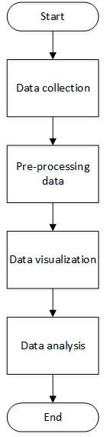
Visualization- During this process, we manually transform the data into visualizations, which use different charts, graphs, or other visualization formats to graphically present the collected data.
RESULTS AND DISCUSSION:

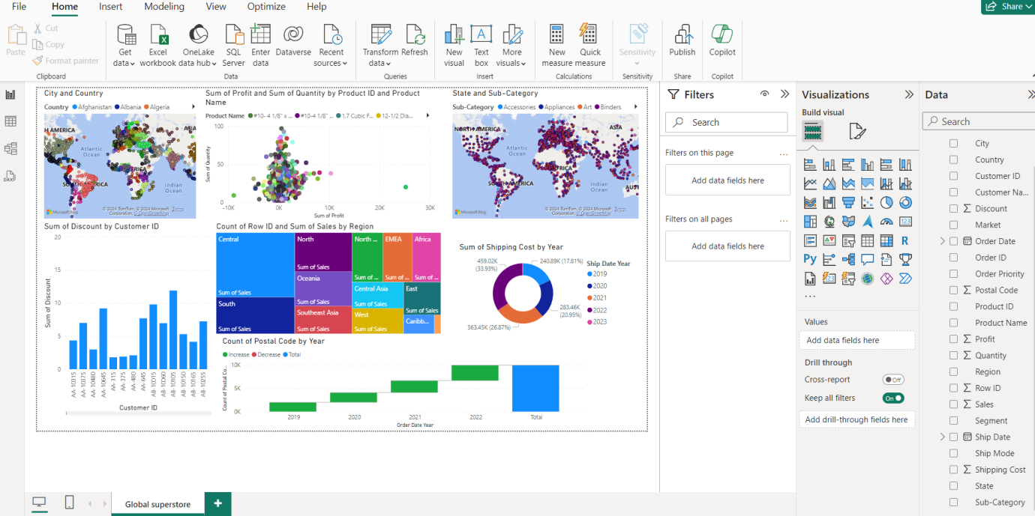

Fig 1 : Dashboard for Global Superstore
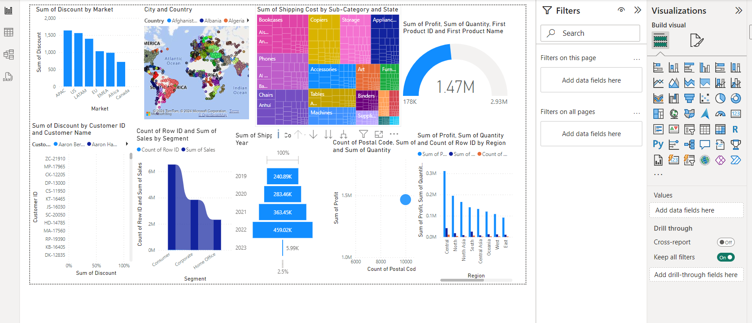
Fig 2 Dashboard 2 for Global Superstore
In the above Power BI dashboard offers a comprehensive overview of global superstore’s performance including sales figures, profit margins and product categories. Its interactive visualizations help users identify key areas of interest enabling data-driven decision-making and strategic planning. The dashboards user-friendly interface promotes data literacy and encourages a data-driven culture within the organization, allowing stakeholders to access interpret data effectively.
CONCLUSION:
Power BI is a powerful data visualization tool that transforms raw data into visually appealing reports and dashboards. Its user-friendly interface, robust data modeling, and customizable visualizations enable data exploration from multiple sources. Its integration with other Microsoft tools enhances functionality and scalability, making it a comprehensive solution for business intelligence.

REFERENCE:
[1 Marija Blagojevic and Zivadin Micic developed a web-based intelligent report e-learning system using data mining technique, published in Computers and Electrical Engineering in 2013.

[2] Daniel J. The article by Power discusses the concept of data-driven decision support systems in Information Systems Management, which was published in 2008; 25: 2, 149-154
[3] Zhijun Ren presented a comprehensive BI solution using Microsoft Business Intelligence Stack at the 2010 International Conference on Challenges in Environmental Science and Computer Engineering.2010; 183, 278-281

