Deep Learning Classification using MRI for Alzheimer’s Disease Detection
Dr. Sreenivasa Murthy V¹, Anusha Mahesh², Deepti R³, Rachana D Shetty⁴
¹Associate Professor, Department of Information Science and Engineering, Raja Rajeswari College of Engineering, Bangalore, India
^{2,3,4}B.E. Student, Department of Information Science and Engineering, Raja Rajeswari College of Engineering, Bangalore, India
Abstract
Alzheimer's disease is an incurable, progressive brain disorder that gradually destroys memory and cognitive function, and eventually the ability to perform even te most basic tasks. It is now considered to be one of the most common illnesses worldwide. Furthermore, there is no known cure for Alzheimer's disease. Convolutional Neural Networks (CNNs), a type of deep learning technique, are used to work on interaction for the identification of Alzheimer's infection. CNN has made great strides recently in the analysis of MRI images and medical research. Much research has been done to determine the exact location of Alzheimer's disease based on brain MRI images that are processed by CNN. However, a fundamental limitation is that there was no demonstration of a valid link between a suggested model and pre-trained models. Thus, utilizing the ADNI MRI dataset, we present a 6-layer CNN model for binary classification in this study to identify Alzheimer's. Our model's presentation is compared to a few other CNN-based models in terms of review, F1 score, ROC bend, and accuracy, precision, and accuracy on the Alzheimer Disease Neuroimaging Initiative (ADNI) dataset. The focus of the paper is our CNN model, which has an accuracy of 98.83%, better than the other previously proposed CNN-based models that are provided on the ADNI. The trial output demonstrates our model's supremacy over the other models.
Keywords: CNN, MRI, ADNI, Alzheimer, Deep Learning, Machine Learning.
Introduction
ADNI Datasets
The ADNI datasets are an essential resource in te field of neuroscientific research, specifically in te study of Alzheimer's disease (AD) and related neurodegenerative disorders. Since its launch in 2004, ADNI has been dedicated to collecting, validating, nd sharing data to expedite te development of effective treatments for AD. These datasets contain a comprehensive range of clinical, imaging, genetic, nd biomarker data from participants at different stages of cognitive health, mild cognitive impairment (MCI), nd AD. The meticulous curation nd stndardization of these datasets enable researchers worldwide to make cross-study comparisons nd investigate various aspects of AD pathology, progression, nd potential interventions. By utilizing te ADNI datasets, researchers can identify biomarkers that indicate te onset nd progression of te disease, uncover neuroimaging patterns associated with AD pathology, nd create predictive models for early diagnosis nd personalized treatment approaches. Furthermore, te ADNI datasets play a crucial role in advancing computational methods in neuroscience, fostering innovation in machine learning, data mining, nd artificial intelligence techniques for analysing complex multidimensional datasets. Through collaborative efforts nd te sharing of open data, ADNI continues to drive breakthroughs in our understanding of AD, leading to te development of more effective diagnostic tools nd therapeutic interventions to mitigate the devastating impact of this neurodegenerative disease.
Deep Learning
Deep learning is a branch of artificial intelligence in which artificial neural networks—layers of interconnected nodes that imitate te structure of te human brain—help algorithms identify patterns nd make judgments. To train nd perform better on tasks like image recognition, natural language processing, nd autonomous driving, these networks consume enormous volumes of data. Deep learning models maximize predictions nd reduce mistakes by adjusting parameters using techniques like gradient descent nd backpropagation. Advances in technology nd creativity have been fuelled by popular architectures like convolutional neural networks (CNNs) nd recurrent neural networks (RNNs), which have changed sectors including computer vision, speech recognition, nd healthcare.
CNN Algorithm
Convolutional Neural Networks (CNNs) are a type of deep learning algorithms that are mainly utilized for te analysis of visual data, such as images nd videos. CNNs are specifically designed to learn spatial hierarchies of features from te input data in an automatic nd adaptive manner. By employing convolutional layers, they apply filters across te input data to extract relevant features through convolutions. Additionally, pooling layers are employed to reduce spatial dimensions while preserving crucial information. The advent of CNNs has brought about a significant transformation in tasks like image classification, object detection, nd image segmentation, rendering them indispensable in various fields, including computer vision, medical imaging, nd autonomous driving. The six phases of a typical Convolutional Neural Network (CNN) algorithm are:
- Input Layer: The network receives input data, usually images or other multidimensional arrays.
- Convolutional Layers: These layers are made up of multiple filters that slide over te input data, carrying out convolution operations. Each filter identifies different features in te input, capturing patterns like edges, textures, or shapes.
- Activation Function: Following each convolution operation, an activation function such as ReLU (Rectified Linear Unit) is applied element-wise to introduce non-linearity into te network, allowing it to learn more intricate patterns.
- Pooling Layers: Pooling layers downsample te feature maps generated by te convolutional layers, decreasing their spatial dimensions while preserving te most important information. Common pooling operations include max pooling or average pooling.
- Fully Connected Layers: These layers combine te high-level features extracted by te convolutional layers nd make predictions based on them. Each neuron in a fully connected layer is linked to all te neurons in the previous layer.
- Output Layer: The final layer generates te network's output, which could be class probabilities for classification tasks or continuous values for regression tasks. The selection of activation function in this layer depends on te problem's nature, such as softmax for classification or linear for regression.
These phases collectively form te fundamental architecture of a Convolutional Neural Network, which has demonstrated significant effectiveness in various tasks, particularly in computer vision.
Algorithm
from keras.models import Sequential
from keras.layers import Conv2D, MaxPooling2D, Flatten, Dense
# Step 1: Input Layer
input_shape = (32, 32, 3) # Example input shape for an image of size 32x32 with 3 channels
model = Sequential()
# Step 2: Convolutional Layers
model.add(Conv2D(32, kernel_size=(3, 3), activation='relu', input_shape=input_shape))
model.add(Conv2D(64, kernel_size=(3, 3), activation='relu'))
# Step 3: Activation Function (ReLU)
# Activation functions are typically applied implicitly after convolutional layers in Keras.
# Step 4: Pooling Layers
model.add(MaxPooling2D(pool_size=(2, 2)))
# Step 5: Fully Connected Layers
model.add(Flatten())
model.add(Dense(128, activation='relu'))
# Step 6: Output Layer
num_classes = 10 # Example number of classes for a classification task
model.add(Dense(num_classes, activation='softmax'))
The World Health Organization (WHO) states that Alzheimer's is te most serious infection globally. It is estimated that 50 million people worldwide suffer from dementia, including Alzheimer's disease nd other types. The total number of cases of dementia that occur annually is close to 9 million, indicating an additional case every few years. Te number of people who have Alzheimer's is predicted to increase to 83 million in 2031 nd 153 million in 2051. Cognitive deterioration is te primary cause of Alzheimer's disease. Over time, patients lose te ability to remember teir own personalities, which are comparable to names nd become mature. Because this is an ongoing cycle, patients eventually lose te ability to remember their family members.

Review of Literature
Deep learning methods have been used increasingly recently to classify patients with Alzheimer's disease (AD) utilizing multimodal brain imaging data. Using te rich data from many imaging modalities, several research have proposed enhanced deep convolutional neural networks (CNNs) for te categorization of Alzheimer's disease.
Khagi et al. [1] used pre-made CNN models in 2019—specifically, Alexnet, GoogleNet, nd Resnet50—to distinguish between Alzheimer's patients (e.g., Unhinged) nd solid patients (e.g., non-demented). They employed 27 Alzheimer's patients nd 27 Normal Controls in their evaluation. Wang et al. [2] discussed te issue of Alzheimer's disease in 2019 when considering a 9-layer CNN. For teir assessment, tey used 99 AD patients nd 99 Normal Controls. The accuracy of te CNN with seven layers was 98.75%. In 2018, Hosseini et al. [3] used motion learning to understnd Alzheimer's disease. Additionally, Islam et al. set up a major mind association to perceive at roughly te same time. A CNN model called "Alzheimer Network" (AlzNet) was proposed by Al-Khuzaie et al. [4] to aid in te binary classification of AD nd CN. The AlzNet model consists of a max-pooling layer with a kernel size of 2 * 2, nd five convolution layers, each with a ReLU activation function. A total of 15,200 200 × 200 image datasets from OASIS were used to train nd evaluate their model. To solve te overfitting issue, te model was optimized using te Adadelta optimizer with a ratio of 0.2 dropouts. To get te greatest performance, te model was trained with varying numbers of dense units in te hidden layer; this was accomplished at 121 units. 99.53% testing accuracy nd 97.99% training accuracy are attained by te model. Two models, VGG16 nd VGG19, were proposed by Antony et al. [5] for te diagnosis of AD. The 780-image dataset from te ADNI was used to train their model. Prior to training te model, te skull underwent augmentation nd decomposition during te preprocessing phase. The size of te input image is 224 × 224. Two classes were classified in VGG16 models using te sigmoid activation function in te last layer. Two classes were classified in VGG19 models using te SoftMax activation function in te last layer. In contrast, VGG19 has 64, 128 nd 256 kernel sizes, whereas VGG16 has 64 nd 128 kernel sizes. Both models' accuracy (81% for VGG-16 nd 84% for VGG-19) was insufficient. A 3D multi-scale CNN (3DMSCNN) model was created by Ge et al. [6] 3DMSCNN was a revolutionary architecture for AD diagnosis. Tey also suggested feature fusion nd an enhancement technique for multi-scale features. Song et al. [7] proposed te Graph Convolutional Neural Network (GCNN) classifier, which is based on graph-theoretic methods. Structural connection graphs representing a multi-class model were used to train nd evaluate the network to categorize te AD spectrum into four groups. Liu et al. [8] put up a unique model for AD categorization. First, a CNN model was created from te ground up. It has two fully connected layers, three convolutional layers, three pooling layers, nd SoftMax as te activation function in te final layer. Furthermore, transfer learning was used to address overfitting problems nd enhance classification accuracy in AlexNet nd GoogLeNet models. Te models did not, however, produce notably high categorization accuracy. It should be noted that 500 training iterations nd 5-fold cross-validation are used by both te AlexNet nd GoogleNet models during transfer learning. Te CNN, AlexNet, nd GoogleNet models all achieved classification accuracy rates of 78.02%, 91.4%, nd 93.02%, in that order. Given that GoogleNet contains deeper layers nd more convolutions than AlexNet it achieves a higher classification accuracy rate. Impedovo et al. [9] introduced a protocol. To assess te connection between cognitive processes nd handwritten processes in both healthy subjects nd patients with cognitive impairments, this methodology provided a cognitive model. Te main objective was to develop a simple, non-invasive method for monitoring nd diagnosing neurodegenerative dementia during screening nd follow-up. Harshit et al. [10] identified four AD stages (AD, EMCI, LMCI, nd NC) using a 3D CNN architecture on 4D FMRI images. Silvia et al. [11] nd Dan et al. [12] have also proposed additional CNN structures that deal with 3D MRI for distinct AD stage categorization. In 3D MRI photographs, a 3D Densely Connected Convolutional Network (3D DenseNets) is used for 4-way classification by Juan Ruiz et al. [13]. Savaş et al. [14] classified te 2182 picture objects that were collected from te ADNI database using several CNN models. Te research provided a thorough methodology for evaluating te effectiveness of 29 models that had previously undergone image training photos were subjected to preprocessing, which involved dividing te photos, cleaning te data, nd converting te image format. Te models receive image input after preprocessing procedures have been applied. Te EfficientNetB0 model had te greatest accuracy rate of 92.98% during te test phase. Te EfficientNetB2 nd EfficientNetB3 models, with rates of 94.42% nd 97.28%, respectively, acquired te highest accuracy, sensitivity, nd specificity values for te Alzheimer's disease class, according to te confusion matrix during te comparative evaluation stage. Sahumbaiev et al. [15] presented a HadNet architecture to investigate Alzheimer's spectrum MRI. For improved training, te MRI image collection is skull-stripped nd spatially normalized using te Statistical Parametric Mapping (SPM) toolbox. It is anticipated that sensitivity nd specificity would increase in tandem with improvements in HadNet architecture. Payan et al. [16] employed 3D convolutional neural networks nd a sparse autoencoder. Tey developed an algorithm that uses a brain magnetic resonance imaging (MRI) scan to determine te disease state of an affected individual.
Proposed Methodology
To fully address the research objectives, the proposed methodology for this study uses a mixed-methods approach that integrates both qualitative nd quantitative techniques. First, semi-structured interviews with important stakeholders will be used to collect qualitative data, enabling a thorough examination of their viewpoints, experiences, nd ideas pertaining to te topic. To find repeating themes nd patterns in te qualitative data, thematic analysis will also be used. Second, surveys with a bigger sample size will be used to gather quantitative data, which will provide statistical insights into more general trends nd relationships. To get useful conclusions, this data will be evaluated statistically using both descriptive nd inferential techniques.
This section looks at a suggested approach that includes an additional 6-layer CNN model, nd compares te model's display to the pre-made models. The underlying steps of te proposed methodology are as given below:
- Dataset Collection
- Data Pre-processing
- Data Labelling
- Applying CNN Algorithm
- Loading pre-trained CNN models
- Comparison
A block diagram illustrating our proposed approach is presented, showcasing te workflow of te technique from start to finish. This block diagram also highlights te seven main stages of our proposed strategy.
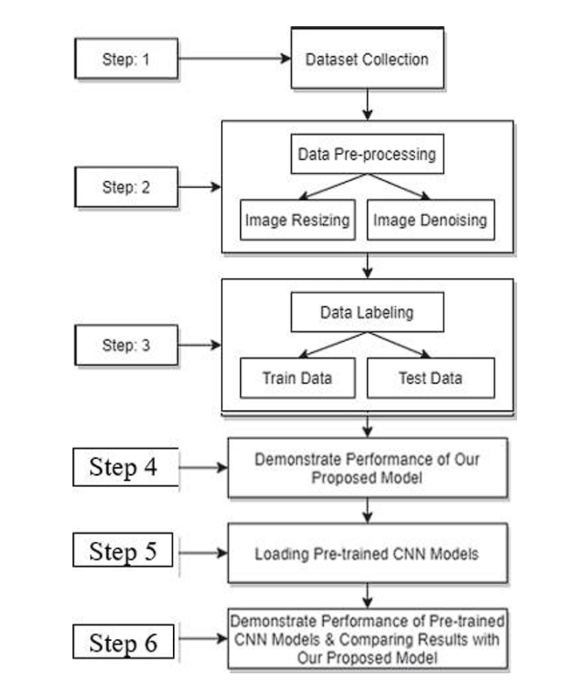
Fig 1: Block diagram of proposed methodology
- Dataset Collection
The Dataset has been collected from ADNI (Alzheimer’s Disease Neuroimaging Initiative). The Alzheimer's Disease Neuroimaging Initiative (ADNI) is a groundbreaking project that uses neuroimaging, genetics, and clinical data to improve our understanding of Alzheimer's disease (AD). Since its inception over 10 years ago, this successful public-private partnership has been dedicated to advancing AD research by facilitating data sharing among researchers worldwide. The main objectives of ADNI are:
- Identifying biomarkers for te early detection and tracking of Alzheimer's disease (AD) progression
- Describing te course of AD nd mild cognitive impairment (MCI) through longitudinal studies
- investigating the connections between clinical, cognitive, imaging, genetic, nd biochemical biomarkers
- developing better techniques for AD clinical trials
- providing information to researchers globally to expedite AD research nd foster collaboration.
The all-encompassing strategy of ADNI encourages cooperation between scientists nd medical professionals, leading to improvements in Alzheimer's disease diagnosis, treatment, nd prevention.
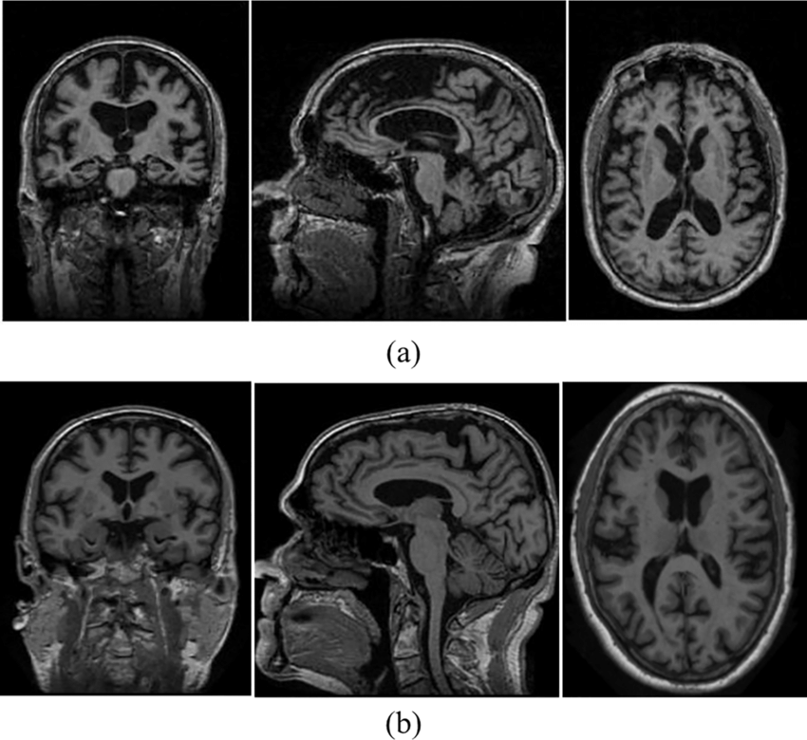
Fig 2: Sample MRI image from ADNI dataset

- Data Pre-processing
The raw images collected form te ADNI dataset are available in various forms nd sizes. These images used directly would lead to low accuracy nd sometimes inaccurate results. Hence preprocessing is done to make te data ready to use. Three main steps are followed during data pre-processing. These are:
- Conversion and Formatting: MRI machines often produce their own proprietary formats for te acquisition of MRI pictures. To enable interoperability with various analytic software, te initial step is to transform these pictures into standard formats like as DICOM or NITI (Neuroimaging Informatics Technology Initiative).
- Noise reduction: MRI scans can contain artifacts from te scanner nd thermal noise, among other kinds of noise. Filtering nd denoising algorithms are two examples of noise reduction techniques that are used to increase signal-to-noise ratio nd enhance image quality. This is accomplished through Median filters which is a digital filtering technique.
- Image Resizing: Resizing images shortens te training processing time. With CV2 Python, resizing is accomplished.

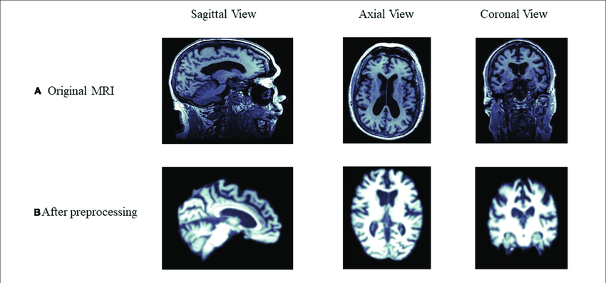
Fig 3: Comparison image of MRI images before and after pre-processing
- Data Labelling
Following preprocessing, we name our data for a double request nd set the model size. Because we use twofold presentation, te dataset's images are labeled with a Clinical Dementia Ratio (CDR) of either 0 or 1. Considering that CDR 1 denotes severe Alzheimer's disease nd CDR 0 indicates strong, or no dementia. With CDR 1, there are 27 patients. We had 27 individuals with Alzheimer's nd 27 people without te disease. We take two photos to accomplish this. After that, we separated the photos into an 8:2 extent while taking inconsistent decisions into account. This implies that a maximum of 80% of te data is used as training data nd the remaining portion is used for testing.
- Proposed CNN Model
The CNN model proposed by us consists of 5 layers. These are:
- Input Layer: In te case of CNNs, this layer typically represents te input data, which are images. Every image is represented as a grid of pixels, with intensity values for each colour channel (red, green, blue, etc.) assigned to each pixel.
- Convolution Layer (Convolution + Activation): Convolutional filters are used in this layer to extract features from te input image.
To introduce non-linearity nd enable te network to learn intricate relationships in te data, te activation function (such as ReLU) is implemented.
- Pooling Layer: The feature maps by te convolutional layers are down sampled by te pooling layers. Pooling lowers the computational cost of te network nd aids in making te representations invariant to slight distortions nd translations in te input data. MaxPool2D is used for this purpose.
- Flatten Layer: Convolutional nd pooling layers create multi-dimensional feature maps, which te CNN's flatten layer transforms into a one-dimensional vector. This conversion makes it possible for the extracted features to be seamlessly integrated into fully linked layers for further classification or regression tasks, which speeds up information processing within te network.
- Fully Connected Layer (Dense Layer): This layer connects a classic feedforward neural network to te flattened feature maps from te preceding layers. Because every neuron in this layer is connected to every other neuron in te layer before it, te network can understand intricate correlations between different features. In classification tasks, te output of this layer is frequently run through a softmax activation function to generate class probabilities.
The Rectified Linear Unit (ReLU) activation function is defined mathematically as:
f(x) = max (0, x)
In this formula, x represents te input to the function, nd f(x) represents te output. The ReLU function returns te input value if it is positive, nd zero otherwise, effectively introducing non-linearity to te network's activations.

Leaky ReLU is used to address the "Dying ReLU" issue, providing a small negative slope when x < 0.
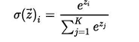
𝜎 = SoftMax
$\vec{Z}$ = input vector
e^{z}_{i} = exponential function of input vector
K = numbers of classes in classifier
e^{z}_{j} = exponential function of output vector
- Loading Pre-trained CNN Models
We load our pre-prepared CNN models in this stage, including VGG19 nd InceptionV3. It is evident that we added two thick layers nd a straight layer to each pre-prepared model after stacking them. With every thick layer, initial capacities ReLu nd softmax have also been used.
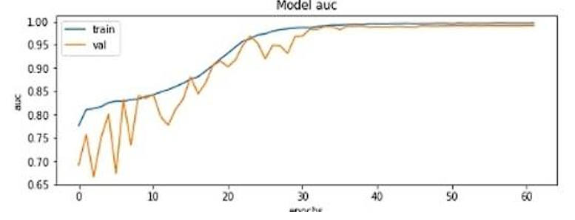
Fig 4: Accuracy of the model
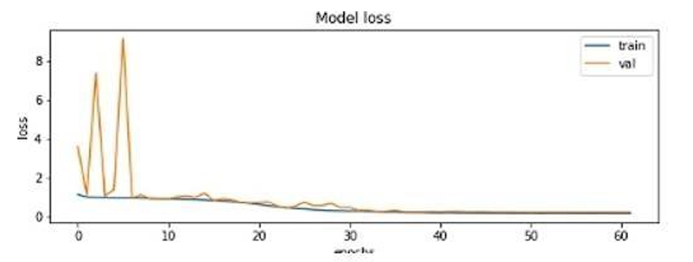
Fig 5: Loss of Data
The graph illustrating te data's accuracy nd loss is displayed in te figure. In figure 4, a straight line is produced after te accuracy continues to rise with te number of iterations until it reaches te stable point. Figure 5 shows how the loss decreases as te number of repetitions increases until it reaches a stable position, at which time a straight line is produced.
- Execution and Comparison
On executing pre-prepared CNN models, we observed varying outcomes in terms of accuracy, computational efficiency, nd generalization performance. In contrast, our proposed model exhibits superior performance, achieving higher accuracy, faster execution times, nd improved robustness, highlighting its efficiency in addressing te task at hand.
Experimental Results
The goal is accomplished by employing 6-layer CNN to achieve an accuracy of 98.87% in te identification nd portrayal of Alzheimer's disease across all dimensions. Please take note that te ADNI dataset helps us accomplish our goal of te maximum accuracy. Evidently, 98.67% accuracy is now te highest achievable precision for a 6-layer CNN model on te OASIS dataset. As a result, we conclude that, in terms of survey nd accuracy, our suggested CNN model performs better than te predetermined models. We may conclude from te exploratory results that te suggested 6-layer CNN model performs better than all other pre-trained models nd standards that we evaluated. Patient-provided MRI brain scans serve as te input in this case. An input image can be one or more pictures taken from various perspectives. After processing te provided image, te type of dementia is identified. Mild Dementia, Moderate Dementia, Severe Dementia, nd Non-Dementia are the classifications.
Mild Dementia: MCI, or mild cognitive impairment, lies between te more official rot of dementia nd the common mental corrosion of natural aging. It manifests as problems with thinking, language, memory, or judgment. In te elderly, mild dementia nd mental weakness are common problems. Important things to think about. Most patients with these issues primarily rely on their suppliers, who should be fully informed on their findings, visualizations, nd the board. Genuine evidence of mental impairment can be used to characterize both mild mental disability nd gentle dementia.
Moderate Dementia: Mild dementia is characterized by transient memory loss, character changes, such as fury or melancholy, forgetting things, being absent-minded, having difficulty completing challenging homework, or having difficulty expressing emotions or ideas.
Severe Dementia: In older adults, modest cognitive impairment nd mild dementia are common problems. Important to keep in mind: Since suppliers are most patients with these issues' main source of support, tey should be fully aware of their resolve, judgment, nd executives. True evidence of mental weakness characterizes both mild mental disability nd mild dementia.
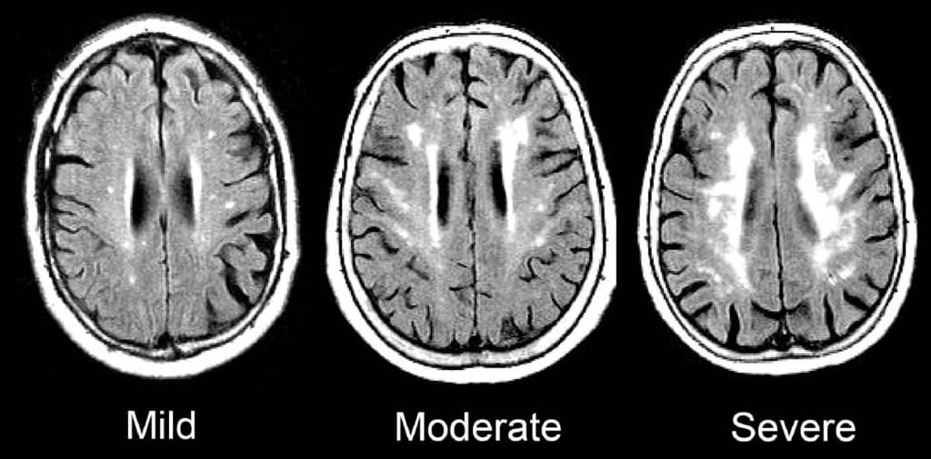
Fig 6: Comparison of Mild, Moderate and Severe Dementia
Non-Dementia: Conditions such as depression, nutritional deficiencies, medication side effects, nd localized pain can all produce symptoms that resemble early signs of dementia, such as difficulties with correspondence nd memory nd behavioural abnormalities. The important components of te brain MRI image that are extracted during pre-handling are displayed.
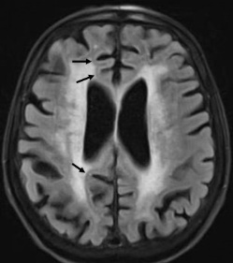
Fig 7: Early Onset of Dementia
Following feature analysis, a result based on te dementia kinds previously described is provided. This result is displayed below. If te patient needs any additional criteria or confirmations, tey can also obtain te report. The report includes te name of te dementia that was identified nd the acquired brain MRI image.

Fig 8: Final output
Conclusion
AD is one of te most prevalent forms of irreversible dementia in te world, with a high fatality rate that ultimately results in death. Improved medication outcomes nd increased patient survival rates may result from early identification of AD. We looked closely at te use of deep learning models with various architectures in AD diagnosis in this study. Here, we suggested using a 5-layer CNN algorithm to identify dementia symptoms nd provide equal request. Our attention was fully engaged with te ADNI dataset. Therefore, te dataset used is not only freely available to us but also it is vast nd provides for a variety of input images which leads to te best accuracy. Provided CNN model is dependent on AI estimations nd substantial learning. In comparison to four pre-arranged models nd a continuing 8 CNN model, our suggested model performs better. We will be doing numerous inspections as part of our planned inquiry.
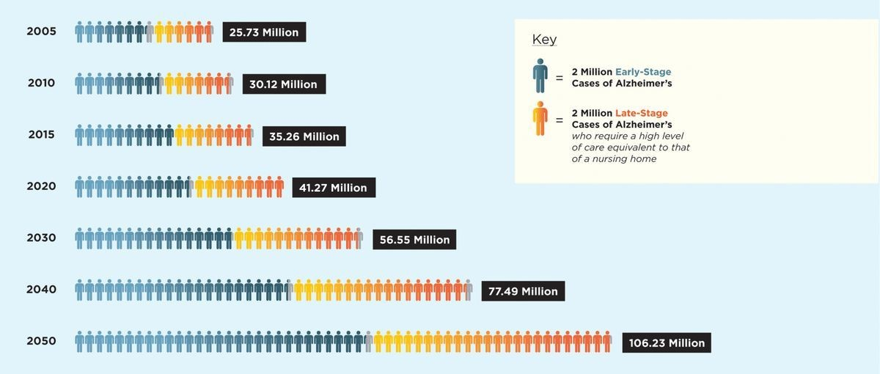
Fig 9: World-wide projection of Alzheimer’s prevalence for the years 2005-2050

Future Scope
Deep Learning in AD research is always being upgraded for better efficiency nd openness. Deep learning algorithms are being used exclusively in a model that replaces hybrid techniques in research on te diagnostic categorization of AD. One of te main challenges is getting sufficient, reliable, nd cognitively balanced information about Alzheimer's disease. Nevertheless, methods for integrating completely other types of data into a deep learning network still need to be developed. Given that high-quality, noise-free data is a major challenge, we suggest the following strategies for further research:
- Research techniques that emphasized te use of feature selectors prior to CNNs.
- Methods utilizing deep learning algorithms based on manifolds.
- Using sparse regression models to classify AD.
- Techniques that identify te areas of activity by introducing deep learning segmentation into te process.
The previously mentioned approaches may all pave te way for novel developments in te prediction nd classification of AD.
References
- Khagi, Bijen & Kwon, Goo-Rak. (2019). CNN Model Performance Analysis on MRI Images of an OASIS Dataset for Distinction Between Healthy nd Alzheimer’s Patients. IEIE Transactions on Smart Processing & Computing. 8. 272-278. 10.5573/IEIESPC.2019.8.4.272.
- Wang SH, Phillips P, Sui Y, Liu B, Yang M, Cheng H. Classification of Alzheimer’s disease based on an eight-Layer convolutional neural network with leaky rectified linear unit nd max pooling. J Med Syst. 2018;42(5):85.
- Hosseini-asl E, Keynton R, El-baz A. Alzheimer’s disease diagnostics by adaptation of 3d convolutional network Electri cal nd Computer Engineering Department, University of Lou isville, Louisville, KY, USA, Proc. - Int Conf Image Process ICIP. 2016;(502).Wang Y, et al. A novel multimodal MRI analysis for Alzheimer’s disease based on convolutional neural network. 2018 40th Annu Int Conf IEEE Eng Med Biol Soc 2018;754–757.
- Arafa, Doaa & Moustafa, Hossam El-Din & Ali, Hesham & Ali-Eldin, Amr & Saraya, Sabry. (2023). A deep learning framework for early diagnosis of Alzheimer’s disease on MRI images. Multimedia Tools nd Applications. 83. 1-33. 10.1007/s11042-023-15738-7.
- Antony F, Anita HB, George JA (2023) Classification on Alzheimer’s Disease MRI Images with VGG-16 nd VGG-19, vol. 312. https://doi.org/10.1007/978-981-19-3575-6_22.
- Ge C, Qu Q. Multiscale deep convolutional networks for characterization nd detection of Alzheimer’s disease using MR images Dept. of Electrical Engineering, Chalmers University of Technology, Sweden Inst. of Neuroscience nd Physiology, Sahlgrenska Academy. 2019 IEEE Int Conf Image Process. 2019;789–793.
- Song T, et al. Graph convolutional neural networks for Alzhei mer’s disease. 2019 IEEE 16th Int Symp Biomed Imaging (ISBI 2019), no. Isbi. 2019;414–417.
- Liu J, Li M, Luo Y, Yang S, Li W, Bi Y (2021) Alzheimer’s disease detection using depth wise separable convolutional neural networks. Comput Methods Prog Biomed 203:106032. https://doi.org/10. 1016/J.CMPB.2021.106032.
- Impedovo D, Pirlo G, Vessio G, Angelillo MT. A hndwriting based protocol for assessing neurodegenerative dementia. Cognit Comput. 2019;11(4):576–86.
- Parmar H, Nutter B, Long R, Antani S, Mitra S. Spatiotemporal feature extraction nd classification of Alzheimer’s disease using deep learning 3D-CNN for fMRI data. J Med Imaging. 2020;7(05):1–14. doi: 10.1117/1.JMI.7.5.056001.
- Basaia S, et al. Automated classification of Alzheimer’s disease nd mild cognitive impairment using a single MRI nd deep neural networks. Neuro Image Clin. 2019;21(2018):101645.
- Pan D, Zeng A, Jia L, Huang Y, Frizzell T, Song X. Early detection of Alzheimer’s disease using magnetic resonance imaging: a novel approach combining convolutional neural networks nd ensemble learning. Front Neurosci. 2020;14(May):1–19.
- Vassanelli S, Kaiser MS, Eds NZ, Goebel R. 3D DenseNet ensemble in te 4-way classification of Alzheimer’s disease. Series Editors. 2020.
- Savaş S (2022) Detecting te Stages of Alzheimer’s Disease with Pre-trained Deep Learning Architectures. Arab J Sci Eng 47(2):2201–2218. https://doi.org/10.1007/s13369-021-06131-3.
- Sahumbaiev I, Popov A, Ram J, Górriz JM, Ortiz A. 3D - CNN HadNet classification of MRI for Alzheimer’s disease diagnosis. 2018;3–6.
- Payan A, Montana G. Predicting Alzheimer’s disease: a neuroim aging study with 3D convolutional neural networks. 2015;1–9.
- Kavitha C, Mani V, Srividhya SR, Khalaf OI, Tavera Romero CA. Early-Stage Alzheimer's Disease Prediction Using Machine Learning Models. Front Public Health. 2022 Mar 3; 10:853294. doi: 10.3389/fpubh.2022.853294. PMID: 35309200; PMCID: PMC8927715.
- Liu L, Zhao S, Chen H, Wang A. A new machine learning method for identifying Alzheimer’s disease. Simul Model Pract Teory. 2020; 99:102023.
- Liu M, et al. A multi-model deep convolutional neural network for automatic hippocampus segmentation nd classification in Alzheimer’s disease. Neuroimage. 2018;208(August):2020.
- Pruthviraja, Dayananda & Nagaraju, Sowmyarani & M., Niranjanamurthy & Raisinghani, Mahesh & Bhatia, Surbhi & Alkhaldi, Nora & Malibari, Areej. (2023). Detection of Alzheimer’s Disease Based on Cloud-Based Deep Learning Paradigm. Diagnostics. 13. 2687. 10.3390/diagnostics13162687.

