ENHANCING STRENGTH OF EXISTING R.C.C. OVERHEAD WATER TANKS WITH Y TYPE STEEL BRACINGS UTILIZING NDT
Devendra Bankhede¹, Hitesh Kodwani²
¹ Research Scholar, Civil Engineering Dept., Sam Global University, Raisen-464551, Madhya Pradesh, India (corresponding author).

² Assistant Professor, Civil Engineering Dept., Sam Global University, Raisen-464551, Madhya Pradesh, India

Abstract
Reinforcing of R.C.C. overhead tank greatly improved choice to upgrade the security and increment the existence time of design and furthermore it requires less economy and time. Steel bracing have demonstrated to give greater stability and sturdiness to any design. These bracing would bear both horizontal and vertical load in an exceptionally protected way.
In this research, application of Y shapes steel bracing at every stage of RCC elevated Water tank was investigated to strengthen the model. Such bracing are generally used to strengthen the structure in high intensity seismic zones. This dissertation mirrors the utilization of non-destructive tests for appraisal of existing R.C.C. Overhead tank, trailed by examination through STAAD-Pro, with or without Y bracing to comprehend the impact of bracing on existing damaged R.C.C. Overhead Water Tank.
Keywords: Staad.Pro, RCC water Tank, Y Bracing, Non Destructive Test (NDT).

I. Introduction
Concrete has proven to be the most appropriate material of construction in tropical zones covering a maximum part of the globe which can provide trouble free service throughout its expected design life. Such ideal outcomes have not been delivered in many developments in light of structural deficiency, material damage, tremendous over loadings or physical damage. Early material disintegration could occur by a number of causes, the most well-known reason, when the construction guidelines are abused or when the facility may be presented to a more outrageous assistance climate than those normal during the preparation and configuration stages. Physical Damage could likewise emerge from fire, blast – just as from limitations, both interior and outer, against underlying movement of structure. Besides in outrageous cases, the vast majority of the structures expect rebuilding to meet its utilitarian necessities by suitable methods of repair.
Inspection is done for the restoration and strengthening of RCC concrete structures. In case of inspection, their have been numerous concerns in civil industry. It has been found that maintenance of structure is quite an integral and important aspect and may need repairs if needed. At the present scenario, safety is the primary element of any civil project besides repair and maintenance of old structure is necessary. Hence, outrageous prerequisite has been emerge for fix, rebuilding and fortifying of RCC structures. New and useful procedures have been produced for the fixes of substantial constructions.
Since 1950s, the construction in India has been increasing significantly without increasing quality inputs, i.e. materials and skilled workmen. The difference between the quality planned and the quality achieved continues to become wider. The factors participating in damages in buildings have, thus, become immense right from the construction stage. Construction documents contain exact specifications and instructions required to do quality works. But in reality, they remain as formal document without getting the desired results, because of less understanding of their significance by the field engineers. Structures made of RCC need regular inspection and maintenance. Water stagnation, paint stripping, mortar sever, parasite development, breaking of outer delivering and covering concrete have been normal and inescapable. Inclusion of dampness into built up substantial parts advances the erosion process and further damage the substantial cover.
Three different stages have to be recognized while taking up a repair job. The first stage involves classification of damage, its type and extent, suggestion on repair methods. For major jobs it will be beneficiary to hire an independent consultant to do this job. The second stage demands preparation of drawings, sketches, material and works specifications and tender document for starting the work. The tender document should cover various elements to the most extent possible. Specific provisions in terms of material specifications should be included. It should clearly define modes of payment, works measurements and records. The third stage is actual initiation of repairs. This would be a specialized job and those who have the necessary skills and resources in terms of tools and plants should be engaged. The supervising engineer should have a good understanding of the work and give precise supervision. In some cases it may become important to monitor the outcomes of repairs by various tests before and after the repairs have been done.

II. Objectives
a) Assessment of existing R.C.C. Overhead water tanks with non destructive testing.
b) Strengthening of existing R.C.C. Overhead Water Tank.
c) Cost comparison between Strengthening of Tanks & Construction of New Tanks.
III. Literature review
Manish Kumar (2016), This review closes supported concrete cement is getting broadly utilized for development of various kind of constructions throughout the previous one century. It is fundamental to keep up with those constructions in useful condition. Since decay in RCC Structures is a typical and regular peculiarity it is needed to have a definite arrangement, philosophy for primary fix and restoration will be set up for managing such issues. Significant finding of this review is that to secure construction, need to have support recurrence and right material to be picked for fix. Additionally workmanship during fix should be taken extreme attention to detail for quality fix. Following points shall be considered as per this study while deciding preventive maintenance, Degradation Mechanism, Credible effect and consequences, Determine Condition Status (at most recent inspection), Estimate Remaining Functional Life (as of most recent inspection date).
Shirley Susan Varughese and Vivek Philip (2017), Study shows that, elevated water tanks have been substantial structures based on their serviceability performance during and after strong earthquakes. Hence, design of new tanks and safety evaluation of existing tanks should be carried out at most accuracy because the failure of such structures, particularly during an earthquake, may be disastrous and could lead to substantial economic loss. Elevated Water tank consist of a configuration highly vulnerable to earthquake forces due to the large mass concentrated over slender supporting structures. Since, the elevated tanks are frequently used in seismic active regions hence; seismic behavior of these structures should be investigated properly. When liquid containing tank is subjected to horizontal seismic acceleration, sloshing waves are generated which exerts hydrodynamic forces on wall as well on the base of water tank. Main features of this study, The dynamic analysis of rectangular elevated RC water tank should comprise of hydrodynamic effect, hence the elevated water tank should be taken analyzed as two mass spring model. The base shear and overturning moment in full condition is more than base shear and overturning moment in empty condition. Hence forth, elevated rectangular water tank should be designed for full condition. With the introduction of braces, the time period considerably decreases. This indicates that the structure gets stiffer with braces compared to without braced structure. Among different bracing system, X bracing provides less time period and more base shear as well as overturning moment followed by diagonal braces. The base shear and overturning moment of the Rectangular Elevated Water tank increases due to the weight of the bracing system.
Premesh S. Lowe, et. al.(2017), research stated that, there was an expanding interest in utilizing ultrasonic directed waves to evaluate the primary debasement of over the ground stockpiling tank floors. Study examines the capability of utilizing the tank divider to bond the transducer rather than the tank annular ring. Both ordinary and shear type transducers were explored mathematically; and results have been approved utilizing a 4.1 m breadth over the ground stockpiling tank. The review results show shear mode type transducers attached to the tank divider would be utilized to evaluate the primary strength of the over-the-ground tank floors utilizing a ultrasonic directed wave. It has additionally shown that for the cases considered there had a 7.4 dB signal-to-commotion proportion improvement at 45 kHz for the directed wave excitation on the tank divider utilizing shear mode transducers.
Ankit Agarwal and Pooja Semwal (2017), Study shows that the structural stability and behavior of different shapes and sizes of reinforced concrete cement overhead water tanks during the penetrable force like earthquake. This study shows the shapes of water tanks as per different seismic zones II, III, IV and V in India. The modelling has been done by using advanced design software STAAD Pro (Structural Analysis and Designing Professionally) which is advanced design software. Study concludes, when earthquake occur major failures of elevated water tank take place due to failure of tank walls, as they are to take care for seismic forces. Therefore, tank wall of elevated water tanks have been extremely vulnerable under lateral forces due to an earthquake. This study summarise the analyse structure of water tank at different seismic zones and also of different shapes and sizes. The extensive change in seismic conduct of raised tanks with thought of reactions like uprooting, base shear, base second, sloshing, torsional weakness and so forth when supporting framework is utilized with suitable adjustments.
Civil handbook on Repair, Restoration and Strengthening of Buildings, CPWD (1996), concludes that the issues of fixes, reclamation and seismic reinforcing of structures are-Before the event of the plausible quake, the necessary fortifying of seismically frail structures is still up in the air by a study and investigation of the constructions, Just after a harming tremor, impermanent backings and crisis fixes are to be conveyed so that dubiously standing structures may not implode during consequential convulsions and the less harmed ones could be immediately brought once again into utilization, The genuine fix and reinforcing issues are looked at the stage after the tremor when things begin settling down. At this stage differentiation must be made in the sort of activity required, that is, fixes, reclamation and reinforcing, since the expense, time and ability needed in the three might be very unique.
IV. Methodology

Collection of Data

Selection of Topic &

Aim and
Objective

Collection of Literature
Review

Selection of Water Tank

NDT Test

STAAD
-
Pro Modelling for
Existing Water Tank

Providing Y Bracing at
Stagings

STAAD
-
Pro Modelling
with Y Bracing

Conclusion

Fig 2: Flow Chart

VI. Analysis Results
Comparison of Tank A model is done with Braced model of Tank A, and same goes for Tank B, Tank C, Tank D and Tank E

(i) TANK A
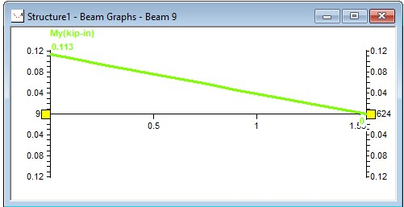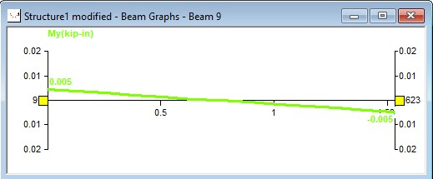

Figure 5.1 : Bending YY Diagram tank A without bracing Figure 5.2 : Bending YY Diagram Tank A With Y Bracing

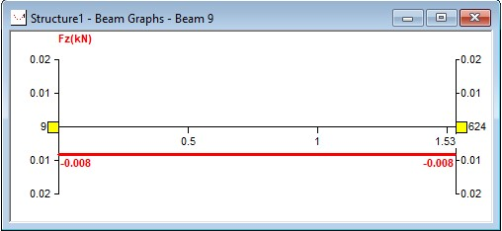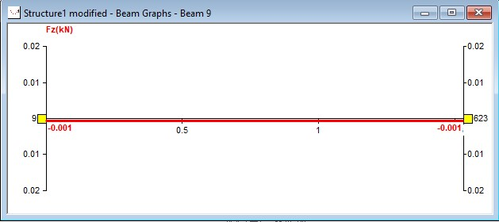

Figure 5.3 : Shear ZZ Diagram Tank A Without Bracing Figure 5.4 : Shear ZZ Diagram Tank A With Y Bracing

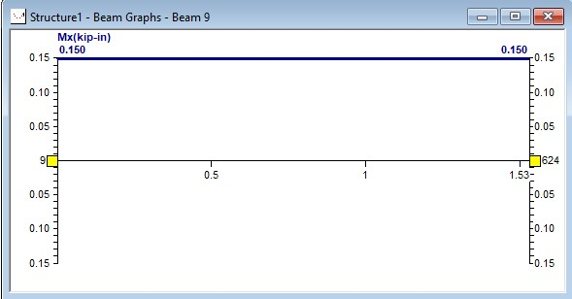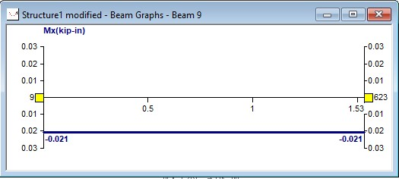

Figure 5.5 :Torsion Diagram Tank A Without Bracing Figure 5.6 : Torsion Diagram Tank A With Y Bracing

(ii) TANK B
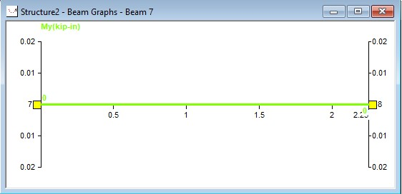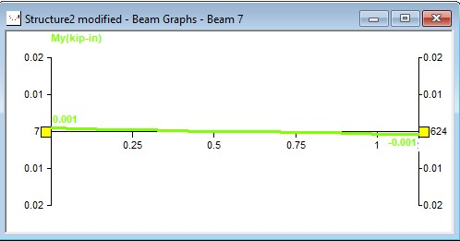

Figure 5.7 : Bending YY Diagram Tank B Without Bracing Figure 5.8 : Bending YY Diagram Tank B With Y Bracing

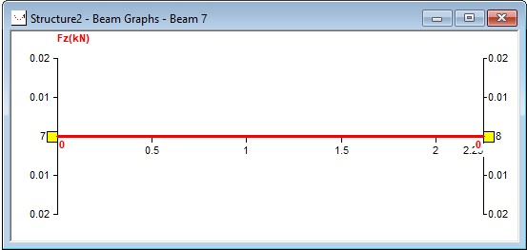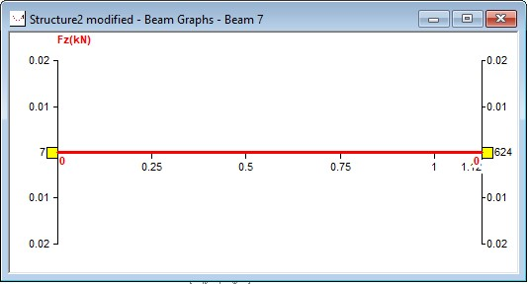

Figure 5.9 : Shear ZZ Diagram Tank B Without Bracing Figure 5.10 : Shear ZZ Diagram Tank B With Y Bracing

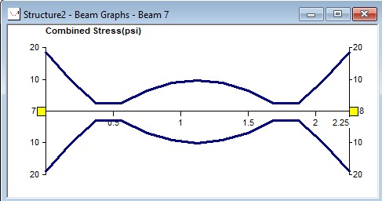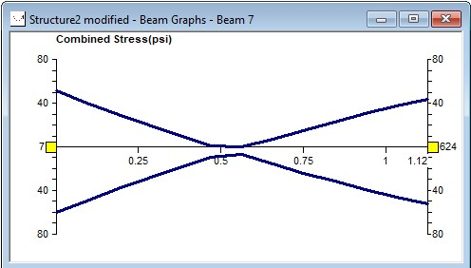

Figure 5.11 :Stress Diagram Tank B Without Bracing Figure 5.12 : Stress Diagram Tank B With Y Bracing

(iii) TANK C
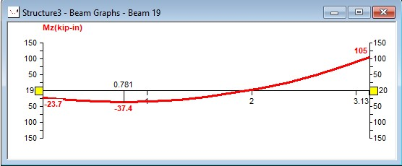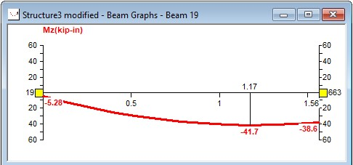

Figure 5.13 : Bending ZZ Diagram Tank C Without Bracing Figure 5.14 : Bending ZZ Diagram Tank C With Y Bracing

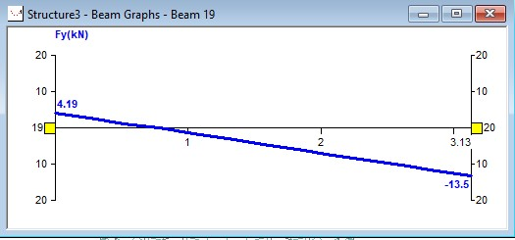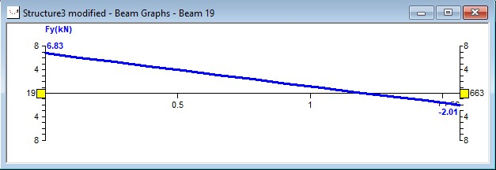

Figure 5.15 : Shear YY Diagram Tank C Without Bracing Figure 5.16 : Shear YY Diagram Tank C With Y Bracing

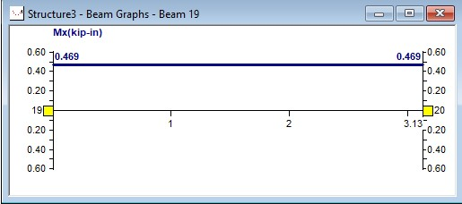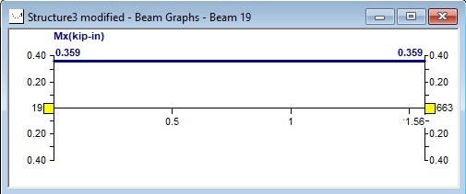

Figure 5.17 :Torsion Diagram Tank C Without Bracing Torsion Diagram Figure 46 : Tank C With Y Bracing
(iv) TANK D
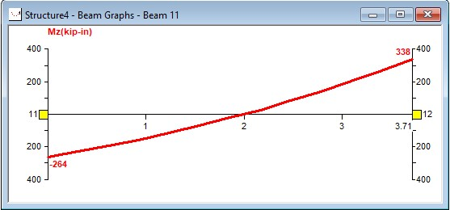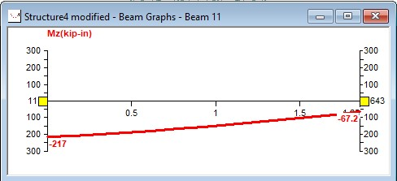

Figure 5.18 : Bending ZZ Diagram Tank D Without Bracing Figure 5.19 : Bending ZZ Diagram Tank D With Y Bracing

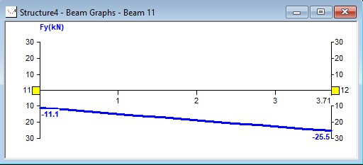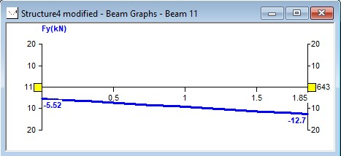

Figure 5.20 : Shear YY Diagram Tank D Without Bracing Figure 5.21 : Shear YY Diagram Tank D With Y Bracing
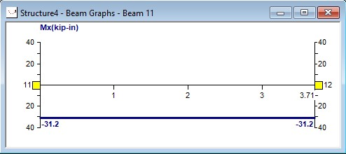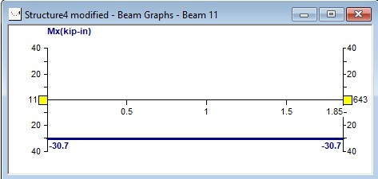

Figure 5.22 :Torsion Diagram Tank D Without Bracing Figure 5.23 : Torsion Diagram Tank D With Y Bracing

(v) TANK E
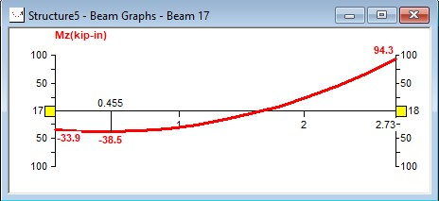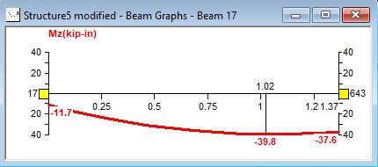

Figure 5.24 : Bending ZZ Diagram Tank E Without Bracing Figure 5.25 :Bending ZZ Diagram Tank E With Y Bracing

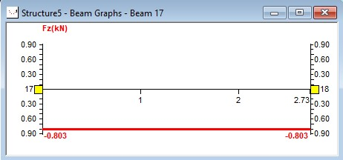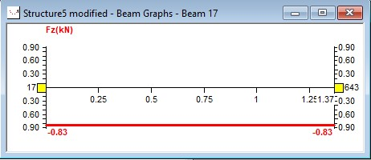

Figure 5.26 : Shear ZZ Diagram Tank E Without Bracing Figure 5.27 : Shear ZZ Diagram Tank E With Y Bracing

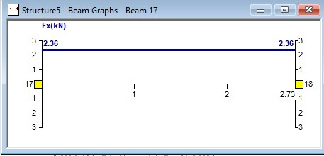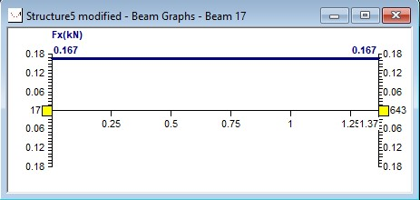

Figure 5.28 :Axial Diagram Tank E With Y Bracing Figure 5.29 : Axial Diagram Tank E Without Bracing

VII. Conclusion
Following are the ends according to the examination
- By the results of Rebound Hammer Test and Ultrasonic Pulse Velocity Test, it has been seen that Column and Beams at the first staging level are immensely damaged. And also cylindrical portion of tanks are weaker in comparion to whole structure.
- By placing Y Bracing at stagings difference between loads and reaction has been reduced significantly for each tank. Also Y bracing act as extra supports at ground level which results in better stability of structure.
- By strengthening R.C.C. overhead water tanks with steel bracings i.e. Y type bracing, it reduces the nodal displacement, rotational displacement, reactions, and no of instable elements. Y bracing give better stiffness to structure to perform better under dynamic loading. Stresses on beams, ring beams and cylindrically part also have been decreased. Torsion and axial moments also have been reduced at joints which results in better stability and ductility for structure.
- Tank A, Tank C and Tank D models with Y bracing shows significant change in bending, shear and torsion. This decrease in bending, shear, torsion and reaction makes structure more durable and strong. These three tanks models have shown better strength configuration after placing Y bracing at staging.
- Tank D and Tank E models with Y bracing shows decrease in axial forces and stresses but nodal displacement, torsion and bending moments varies differently and asymmetrically.
- Cost for strengthening of R.C.C. water tanks has been significantly less [approximately one third] than the construction of whole new structure. Also for the construction of new structure, demolition of existing structure has to be done, which also cost lacks of rupees.
- By strengthening the R.C.C. overhead water tanks with steel bracing [Y bracing] dead load of structure increases identically. Therefore selection of steel section for bracing should be done carefully.
References:
- Manish Kumar [2016], Structural Rehabilitation, Retrofitting And Strengthening of Reinforced Concrete Structures. International Journal of Structural And Construction Engineering.
- Shirley Susan Varughese And Vivek Philip [2017], Effect of Bracing System On Seismic Behavior of Rectangular Elevated Rc Water Tank. International Research Journal of Engineering And Technology (IRJET).
- Premesh S. Lowe, WenboDuan, Jamil Kanfoud And Tat-Hean Gan [2017], Structural Health Monitoring of Above-Ground Storage Tank Floors By Ultrasonic Guidedwave Excitation On The Tank Wall. Web Source - www.Mdpi.Com/Journal/Sensors.
- Ankit Agarwal, And Pooja Semwal [2017], Seismic Analysis of Overhead Water Tanks. International Journal of Research In Technology And Management (Ijrtm).
- Criteria For Design of Rcc Staging For Overhead Water Tanks (First Revision of Is 11682). Bureau of Indian Standards. Handbook On Repair And Rehabilitation of Rcc Structures Cpwd. [2002]

