IOT Based dumpster monitoring system
Totkar Pranjal¹| Shinde Shivkanya²| Swami Sakshi³|Swami Mahesh V.⁴
¹Electronics & Telecommunication Engineering & Vishweshwarayya Abhiyantriki Padvika Mahavidyalaya
²Electronics & Telecommunication Engineering & Vishweshwarayya Abhiyantriki Padvika Mahavidyalaya ³Electronics & Telecommunication Engineering & Vishweshwarayya Abhiyantriki Padvika Mahavidyalaya
⁴Electronics & Telecommunication Engineering & Vishweshwarayya Abhiyantriki Padvika Mahavidyalaya

ABSTRACT
As the globe moves closer to a digital era, technology is being used more wisely to bring about breakthroughs and improve human lifestyles. It's like rowing a boat without a paddle if you don't incorporate these technology improvements into your current lifestyle. The main goal is for smart sensors to work together without the need for human intervention to create a new class of applications. The use of a smart bin is an unavoidable part of this procedure. The goal of this project is to create a smart dustbin utilising an esp8266 wi Fi module with two primary pins attached to the sensor: the trigger pin and the echo pin. It helps to keep the environment clean while also reducing the need for human labour. When the smart bin detects the level of thrash. This is due to the ultrasonic sensor, which is located on bottom of the lid. When the trash exceeds the set threshold value, the information is sent to another node, which is a Nodemcu, and this node, using socket programming, shows exact location and status of a dustbin with a colour code.
Keywords:- Blyank,Ulatr, Ultrasonic Sensor, ESP 8266
- INTRODUCTION

In this post we are going to make an IOT based garbage bin level monitoring system or simply IOT smart dustbin where real time garbage fill level can be monitored via internet. The proposed system uses non-contact method (ultrasonic based) for measuring garbage level and it can detect solid, semi-solid and liquid waste. The proposed project can send garbage level data at a fixed interval to an IOT cloud server called Thing speak.
The introduction of the IOT-based dumpster monitoring system addresses the growing need for smarter and more efficient waste management solutions. With the rise of urbanization, traditional waste collection methods face challenges in terms of cost, resource allocation, and environmental impact. This system integrates Internet of Things (IOT) technology into dumpsters, allowing for real-time monitoring of their fill levels. By deploying sensors within the dumpsters, the system continuously.
This DIY, we are going to make an IOT based dumpster/garbage Monitoring System which will tell us that whether the trash can is empty or full through the webserver and you can know the status of your ‘Trash Can’ or 'Dumpsters' from anywhere in the world over the Internet. It will be very useful and can be installed in the Trash Cans at public places as well as at home.
In this IOT Project, an Ultrasonic Sensor is used for detecting whether the trash can is filled with garbage or not. Here Ultrasonic Sensor is installed at the top of Trash Can and will measure the distance of garbage from the top of Trash can and we can set a threshold value according to the size of trash can. If the distance will be less than this threshold value, means that the Trash can is full of garbage and we will print the message “Basket is Full” on the webpage and if the distance will be more than this threshold value, then we will print the message “Basket is Empty”. Here we have set the Threshold value of 5cm in the Program code.
Monitoring IOT based garbage level monitoring system is an emerging technology that is utilized for monitoring waste fill level of public and industrial garbage bins. The fundamental purpose of a garbage level monitoring system is to help the municipal services to pick the trash at the right time before a garbage bin overflows and cause discomfort to general public.
An advanced garbage monitoring system can not only measure garbage level, it can also detect toxic chemical substances, flammable gases and even radioactive materials using advanced sensors and alert the authorities immediately via internet before any disastrous incident occurs.
Installing these IOT based garbage monitoring systems helps the government to work efficiently when it comes to keeping the city clean and saving millions of dollars a year by saving fuel / energy, labour cost and time, on top of this improvement in general public health which could save millions of lives and billions of dollars around the world otherwise which would have spent on health due to poor management of waste.

- METHODOLOGY

This particular system consists of a garbage bin connected with sensors and motors for proper waste management. The system has an IR sensor that detects the presence of the garbage on the plank of the dustbin and the moisture sensor detects if it is dry or wet waste. Depending on the type of waste is detected, the motor attached to the plank will rotate it to segregate it into dry and wet waste. The Ultrasonic sensor monitors a garbage bin continuously and when the amount of garbage reaches the threshold level, it instantly notifies the local authority with the help of a WiFi module and android app, which will help them to be informed about when the garbage should be collected. This manages the effort to check the area by visiting there. Hence, our proposed system will help in waste segregation as well as waste monitoring. This will effectively reduce the manpower, the cost, and the required resources. This system will be helpful for both the municipal corporation and the residents in the area.
This system can be divided into 4 phases-
Phase 1: It is the initial phase in which the bin is not used at all. At this point the bin is empty.
Phase 2: The user places the garbage onto the plank. The IR sensor senses the garbage and the moisture sensor detects if the garbage is dry or wet. Depending on the type of garbage, the motor driver will rotate the motor to segregate the waste.
Phase 3: This phase describes the monitoring part. The ultrasonic sensor will sense the garbage in the bin continuously. When the garbage reaches the threshold level, the LCD will display that the "Dustbin is full".
Phase 4: It is the final phase in which the local authority is informed about the level of the dustbin. The android app continuously updates the authority the level of the dustbin, i.e., low/medium/full.

- BLOCK DIAGRAM
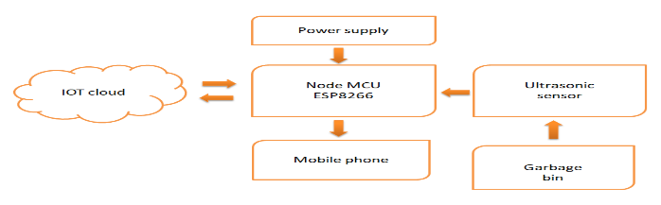
OVERVIEW of the Monitoring System :-
The idea struck us when we observed that the garbage truck use to go around the town to collect solid waste twice a day. Although this system was thorough it was very inefficient. For example let's say street A is a busy street and we see that the garbage fills up really fast whereas maybe street B even after two days the bin isn't even half full. This example is something that actually happens thus it lead us to the ''Eureka'' moment!

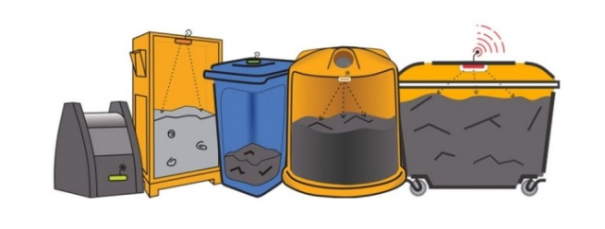
What our system does is it gives a real time indicator of the garbage level in a trashcan at any given time. Using that data we can then optimize waste collection routes and ultimately reduce fuel consumption. It allows trash collectors to plan their daily/weekly pick up schedule.
COMPONENTS IN OUR SYSTEM
The basic Model works like so...
To start with you will first have to enter the height of the dustbin. This will help us generate the percentage of trash in the trashcan. We then have two criterias which needs to be satisfied to show that the particular bin needs to be emptied :
The amount of trash, in other words let's say if your bin is half full you don't really need to empty it. Our thresh, or maximum amount that we permit of trash, is 75% of the bin. (You could alter the thresh according to your preference.)
If supposing a particular trashcan fills up 20% and then for a week doesn't change, it comes into our second criteria, time. With time even the little amount will start rotting leading to a smelly surrounding. To avoid that our tolerance level is 2 days, so if a trashcan is less than 75% but it is two days old it then will also need to be emptied.
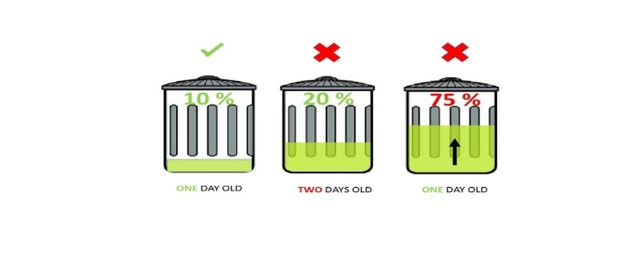
With these criterias in mind let's understand the technical part:
An ultrasonic sensor (A.K.A a distance sensor) will be placed on the interior side of the lid, the one facing the solid waste. As trash increases, the distance between the ultrasonic and the trash decreases. This live data will be sent to our micro-controller.
Our micro- controller then processes the data and through the help of WiFi sends it to an app.
What the app does it visually represents the amount of trash in the bin with a small animation.
This process will indicate all the bins which require attention, leading the user to take the most effective route.

- MATERIALS NEEDED
HARDWARE :-
  - Dustbin:-


  - Ultrasonic Sensor :-
An ultrasonic sensor measures distance. It will be attached to the lid indicating the quantity of trash. Our system's key component.
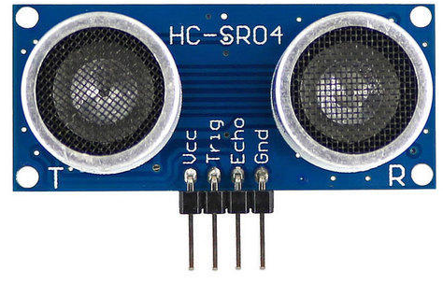
  - Node MCU ESP 8266 :-
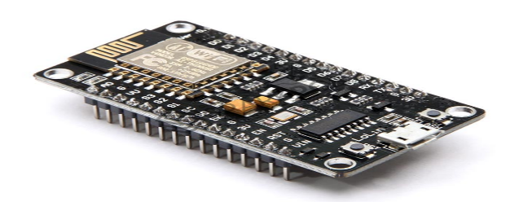
The NodeMCU ESP8266 is an extensively employed development board in IoT applications, providing a versatile and cost-effective approach to connect devices to the internet. It features Wi-Fi and programming capabilities, facilitating speedy prototyping and deployment of IoT solutions.
  - Jumper wires :-
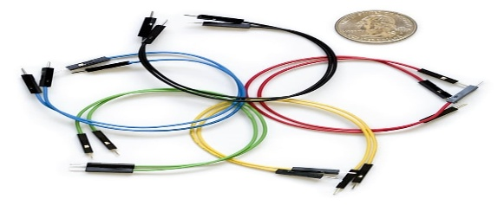
SOFTWARE

Blynk :- An android app that allows communication with WiFi compatible micro-controllers.
Everything you need to build and manage connected hardware: device provisioning, sensor data visualization, remote control with mobile and web applications, Over-The-Air firmware updates, secure cloud, data analytics, user and access management, alerts, automations and much much more…
Blynk platform powers manufacturers of smart home products, complex HVAC systems, agricultural equipment, and everyone in between. These companies build branded apps with no code and get the full back-end IoT infrastructure through one subscription.
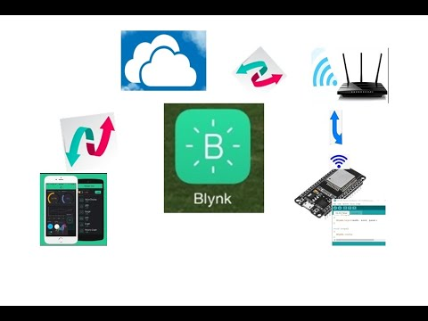
ACTUAL CUNSTRUCTION
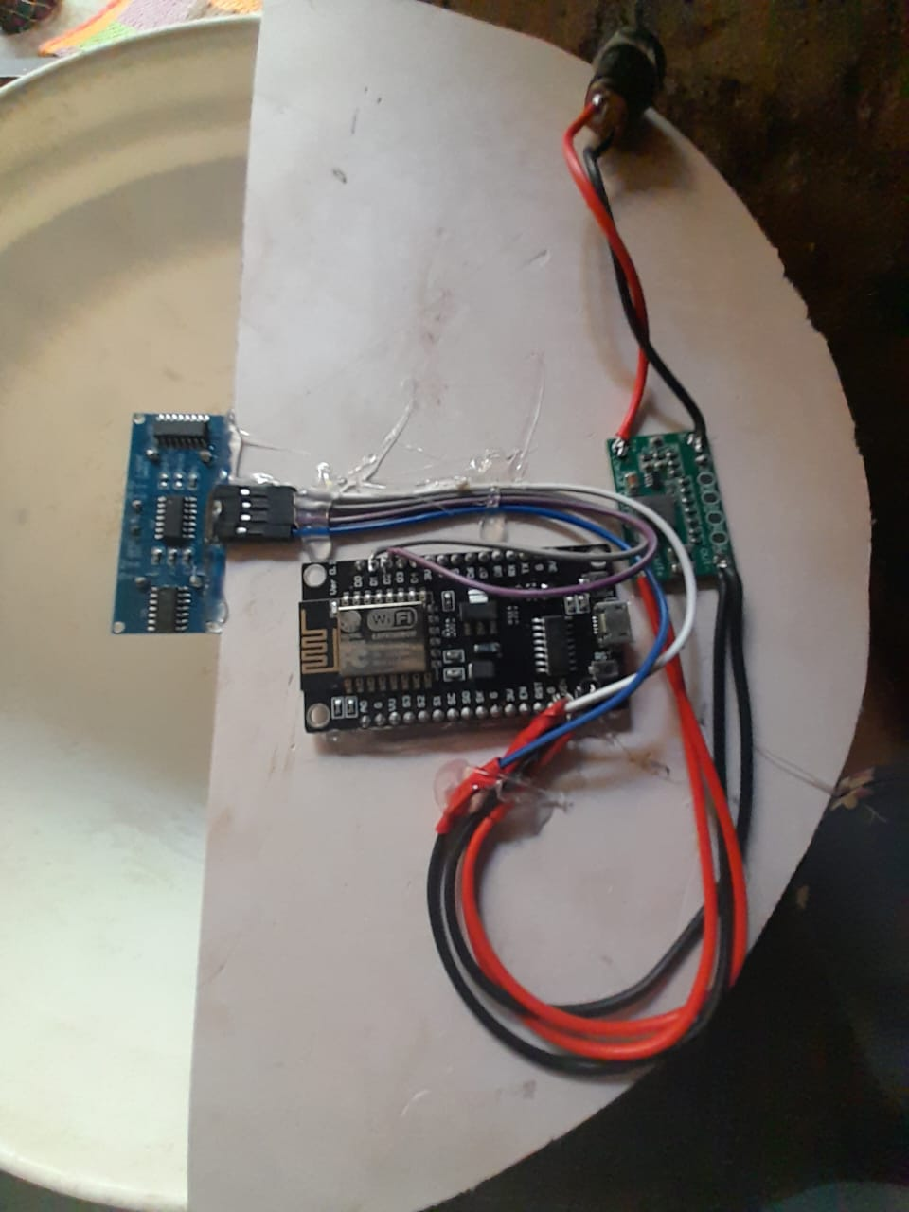
- CONCLUSION
In conclusion solid waste management is an essential practice for protecting human health & environment. The impacts of improper waste disposal are far-reaching and can have long-lasting effects on the health of our planet. The main objective is to maintain the level of cleanliness in the city and form an environment which is better for living. By using this system we can constantly check the level of the garbage in the dustbins which are placed in various parts of the city. If a particular dustbin has reached the maximum level then the employees can be informed and they can immediately take certain actions to empty it as soon as possible. The employees can check the status of these bins anytime on their mobile phones. This can prove to be a very useful system if used

- Reference

- S. N. Swamy and S. R. Kota, “An empirical study on system level aspects of internet of things,” IEEE Access, vol. 8, pp. 188082–188134, 2020, doi: 10.1109/ACCESS.2020.3029847.

- F. Meneghello, M. Calore, D. Zucchetto, M. Polese, and A. Zanella, “IoT: internet of threats? a survey of practical security vulnerabilities in real IoT devices,” IEEE Internet of Things Journal, vol. 6, no. 5, pp. 8182–8201, 2019, doi: 10.1109/JIOT.2019.2935189.

- K. K. Patel, S. M. Patel, and P. G. Scholar, “Internet of things-IoT: definition, characteristics, architecture, enabling technologies, application and amp; future challenges,” International Journal of Engineering Science and Computing, vol. 6, no. 5, pp. 1–10, 2016, doi: 10.4010/2016.1482.

- E. A. Tunggadewi, E. I. Agustin, and R. T. Yunardi, “A smart wearable device based on internet of things for the safety of children in online transportation,” Indonesian Journal of Electrical Engineering and Computer Science, vol. 22, no. 2, pp. 708–716, May 2021, doi: 10.11591/ijeecs.v22.i2.pp708-716.

- S. H. Talib, L. A. Abdul-Rahaim, A. J. Alrubaie, and I. M. Raseed, “Design smart hospital system based on cloud computing,” Indonesian Journal of Electrical Engineering and Computer Science, vol. 29, no. 2, pp. 797–807, Feb. 2023, doi: 10.11591/ijeecs.v29.i2.pp797-807.

