A Review on
GASTRO-RETENTIVE DRUG DELIVERY SYSTEM

Sadanand Chauhan, Pooja Chauhan, Pratima Chauhan, Shweta Mishra, Jitendra Jena
^{1,2,3,} Research Scholar, Pharmacy College, Itaura, Chandeshwar, Azamgarh, U.P. India.
³Assistant Professor, Pharmacy College, Itaura, Chandeshwar, Azamgarh, U.P. India.
⁴Associate Professor, Pharmacy College, Itaura, Chandeshwar, Azamgarh, U.P. India
Corresponding Author: sadanandchauhan321@gmail.com
Abstract
The aim of this review is to focus on the various gastro retentive approaches by investigate, compile, and present in most concise way, where the gastroretentive has gained immense popularity in the field of oral drug delivery. In the field of oral drug delivery gastro-retentive drug delivery play an important role. There are various types of GRDDS approaches which can be utilized to retain the dosage form in the stomach and release the drug slowly for an extended period of time. The various GRDDS approaches include high density, low density, mucoadhesive, expandable, magnetic systems and superporous hydrogel system. GRDDS has proved to be effective in both local and systemic actions to treat gastric or duodenal ulcers. Gastro-retentive drug delivery system can be utilized to prolong the residence time of delivery system in the stomach. Where the stomach and duodenum are separated by the pylorous, which has an important role in residence time of the ingested substances in the stomach. GRDDS can be used to overcome challenges related with conventional oral dosage forms.
Keywords
Gastro-retentive, GRDDS, Oral route, GIT, various approaches, floating system, non-floating system, bioadhesive system.
Introduction
In 1968, Davis firstly discovered the concept of floating drug delivery system (FDDS) after experience gagging or chocking by some persons while swelling medicinal pills. The GI-Tract is the most important route for the delivery of drugs to the systemic circulation. (Vishwanath Reddy M, 2011). Oral administration is the most convenient and popular despite continuous improvement

in drug delivery approaches owing to patient comfort and ease of administration. Oral controlled release drug delivery system has recently been of increasing interest in pharmaceutical field to achieved therapeutic advantages. These drug delivery systems release medication in a predetermined, predictable and controlled way.
Gastro-retentive drug delivery is an approach to prolong gastric residence time by targeting site- specific drug release in the upper gastrointestinal tract for local or systemic effect. It improved therapeutic patient compliance by reducing the frequency of dosing. (kuldeep VINCHURKAR, 2022).
GRDDS are feasible for drugs that have low absorption in the lower part of GIT, are unstable and poorly soluble at alkaline pH, it show local activity at the upper part of the intestine for eradication of Helicobacter pylori. (Fujimori J.). It including super-porous hydrogel, bio/ mucoadhesive, raft forming, ion exchange, low and high density systems, expandable. (Thapa P.)
Physiology of GIT
The GIT can be divided in to three main regions: stomach, small intestine (duodenum, jejunum, and ileum), large intestine. The GIT is a continuous muscular tube, extending from the mouth to anus, which functions to take in nutrients and eliminate waste by such physiological processes as secretion, motility, digestion, absorption, and excretion.
The organization of the GIT from stomach to large intestine. The stomach is J- shaped enlargement of GIT, which can be divided in to four anatomical regions: Cardia, Fundus, Body and Antrum.
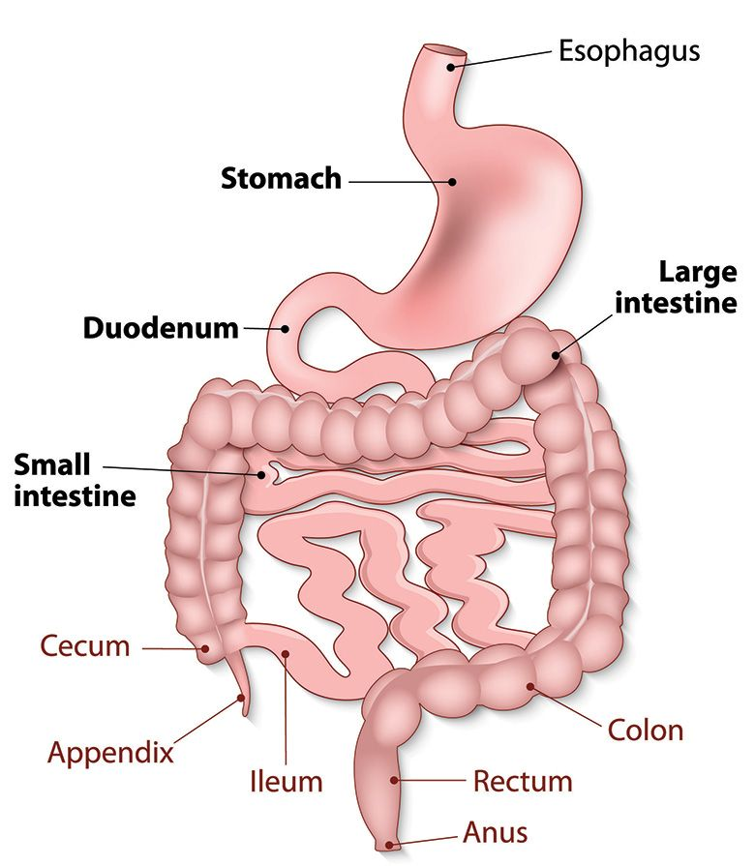
The main functions of stomach are to store and mix food with gastric secretions before emptying its load through pyloric spinchter and into small intestine at a controlled rate suitable for digestion and absorption. Gastro-retentive dosage forms release the drug in a controlled manner to their and absorption. Gastro-retentive dosage forms release the drug in a controlled manner to their specific site of action. It is one of the site specific delivery of the drugs at stomach. (Hemendrasinh J Rathod).
Figure 1: Anatomy of GI Tract
Advantages of GRDDS:
- One of safest route of administration.
- Reduces dose and dose frequency.
- It helps in targeting of drugs.
- It reduces the side effect.
- Improved bio-availability.
- Sustained release can be achieved.
- It can be used for wide range of drugs.
- Minimizes fluctuation of drug concentration in blood. (Satinderkakar, 2015).
Disadvantages of GRDDS:
- Drugs having stability and solubility problems in highly acidic gastric environment.
- Swellable dosage form must be capable to swell fast before it exits from stomach and achieve size larger than pylorous.
- Presence of food is preferable, food delays emptying time of food and dosage form.
- Floating system require high level of fluids in stomach for floating. Therefore, more water intake is prescribed with such dosage forms. (Meenakshi jassal, 2015).
Need for GRDDS
- Drugs that are less soluble or are degraded by the alkaline pH, they encounter at the lower part of GIT.
- Drugs that are absorbed from the proximal part of the GIT.
- Drugs that are absorbed due to variable gastric emptying time.
- There are local or sustained drug delivery to the stomach. (S. Satish babu, 2017)
Application for GRDDS
- Enhanced bioavailability
- Sustained drug delivery
- Site specific drug delivery system
- Absorption enhancement
- Reduced fluctuation of drug concentration
Approaches of GRDDS
- High density system
- Low density system
- Mucoadhesive system
- Raft forming system
- Swellable system

Table 1: Gastro-retentive drug delivery system

Density controlled system

Floating system Non floating system
(low density system) (High density system)

Bioadhesive High density Magnetic Size increasing Raft forming
System system system system system

Hydration-mediated adhesion Swelling system

Bonding-mediated adhesion Expandable
system
Receptor-mediated adhesion Unfolding
system

Effervescent Non-effervescent
Systems systems

High density system
In this type of system, drug can be coated or mixed with heavy non-toxic materials such as Barium sulphide and Titanium dioxide etc. the high density system uses its weight as mechanism. To enhance the gastric residence of drug in stomach its density must exceed the normal stomach content (1.004g/ml).
Low density system
Lower density system lowers the density of dosage form than the normal gastric content. It comes under the low density approach. Which is also called as Hydrodynamically balanced system. In this the density of pellets should be less than 1g/ml.
Floating system
This system remains buoyant due to lower density and provide continuous drug release. It increases GIT of drug and improve its bioavailability. This system was first introduced by Davis in 1968. It is helpful in the drug which have locally action in the proximal portion of GIT. (Mandar J Bhandwalkar, 2020).

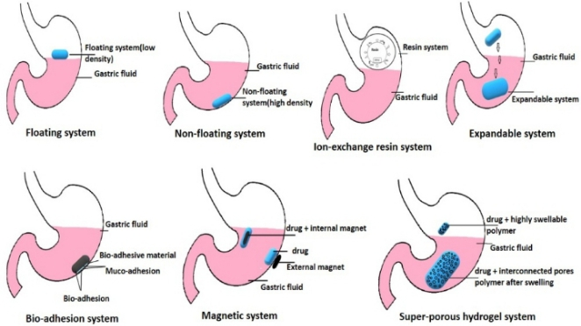

Mucoadhesive / bioadhesive system
In this system mucoadhesive polymers are used which hold the epithelial surface in the stomach. These some theories have been used to explain the fundamental mechanism of bio-adhesion / muco-adhesion.
- Wetting theory: to spread and develop immediate attachment with the mucous membranes.
- Electronic theory: there are attractive electrostatic forces in between glycoprotein mucin network and bio/mucoadhesive polymers.
- Adsorption theory: surface forces resulting in chemical boding. etc. (Vikram kumar sahu, 2011).
Swelling and Expandable system:
This system is capable of expanding and retain in the stomach for longer periods. It is usually formulated as a capsule containing dosage form folded and compact form. (Shailaja Pant, 2016). Swelling drug delivery system meant to prolong the stay of a drug inside the stomach. So as to achieve controlled blood plasma level. It becomes larger in size.
Non-effervescent system:
It is based on the mechanism of swelling of polymer or bioadhesion to mucosal layer in GI tract. In this highly swellable cellulose derivatives or gel forming polymers are used. It mixing the drug with forming polymer. After oral administration these dosage form swells in contact with gastric fluids and attains a bulk density of less than 1g/ml. (Shivram Shinde, 2013).
Effervescent system:
It includes a gas generating agent volatile liquids. Effervescent system has been applied for single or multiple unit systems. When this system comes into contact with gastric field, CO2 is liberated due to the reaction of effervescent agent with gastric fluid.
It is divided into two types:
- Volatile liquid or vacuum containing system.
- Gas generating system.

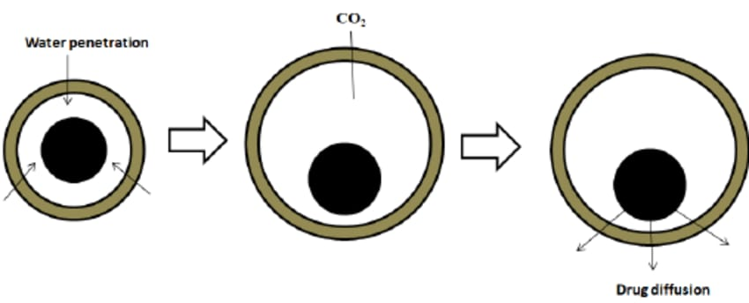

Figure 2: Drug release from effervescent system

Microballons / hollow microsphere: It loaded with drugs in their other polymers. In this system shelf were prepared by simple solvent evaporation or solvent diffusion.

O/W emulsion rapid diffusion of slow diffusion of hollow microsphere
Dichloromethane ethanol or microballon

Figure 3: microballons

Table 2: COMMONLY USED DRUG IN FORMULATION OF GRDDS
Tablets | Ziduvudine, Pentoxyfillin, Chlorpheniramine Maleate, Nemodipine, Amoxicillin Trihydrate, Ciprofloxacin, Atenolol, Diltiazem, Verapamil HCL, Nimodipine, Ampicillin, Theophylline, Sotalol, Furosemide.
Capsules | Furosemide, Propranolol, Pepstatin, Celiprolol HCL, Diazepam, Misoprostal, Urodeoxycholic Acid,.
Microspheres | Verapamil, Aspirin, Iboprufen, Nicardipine, Theophylline, Nifedipine, Griseofulvin, Terfenadine.
Powders | Several Basic Drugs-Riboflavin, Sotalol, Theophylline.
Granules | Diltiazam, Isosorbide Mononitrate, Indomethasin, Diclofenac Sodium, Ranitidine Hcl, Fluorouracil.
Beads | Loratadine, Ranitidine, Diltiazem Hcl.
Bilayer Tablets | Diltiazem HCL, Lovastatin, Metoprolol Succinate, Atenolol.
Films | Albendazole, Prednisolone, Quinidine Gluconate, Cinnarizine.

Table 3: Good drugs for GRDDS
S.No | Drug and category | Bioavailability
1 | Propranolol Antihypertensive | 4-26%
2 | Atenolol Antihypertensive | 40-50%
3 | Verapamil Calcium Channel Blocker | 20-30%
4 | Nifedipine Calcium Channel Blocker | 45-65%
5 | Omeprazole Proton Pump Inhibitor | 35-60%
6 | Verapamil Antihypertensive | 18-35%
7 | Ramipril ACE Inhibitor | 28%

Table 4: GRDDS products available in markets
Drugs | Brand Name
Ciprofloxacin | Cifran OD
Diazepam | Valrelease
Ferrous Sulfate | Conviron
L-DOPA And Benserazide | Madopar
Aluminum-Magnesium Antaacid | Almagate Flatcoat
Aluminum Hydroxide | Liquid Gavison

Conclusion:
We have seen many drugs have been formulated as floating drug delivery system with an objective of sustained release and restricting the region of drug release to stomach.
In this GRDDS the most important criteria which has to be looked into for the production of a floating drug delivery system is that the density of the dosage form should be less than that of gastric fluid.
The GRDDS dosage forms serve the best in the treatment of disease related to the GIT and for extracting a prolonged action from a drug with a short half-life.

References:
- Fujimori J., M. Y. (n.d.). effect of magnetically controlled gastric residence of sustained release tablets on bioavailability of acetaminophen. google scholar.
- Hemendrasinh J Rathod, D. P. (n.d.). A Review on Gastro retentive drug delivery system.
- kuldeep VINCHURKAR, J. S. (2022). gastroretentive drug delivery system . Turkish Journal of Pharmaceutical Sciences.
- Mandar J Bhandwalkar, P. S. (2020). Review on gastroretentive drug delivery system. Asian Journal of Pharmaceutical and Clinical Research.
- Meenakshi jassal, U. N. (2015). A Review on GRDDS. Indian journal of pharmaceutical and biological research.
- S. Satish babu, P. S. (2017). Gastroretentive Drug Delivery system - A Review. International journal of pharmacy practice and Drug Research.
- Satinderkakar, R. s. (2015). gastero retentive drug delivery system-A Review. Affrican Journal of pharmacy and pharmacology.
- Shailaja Pant, A. B. (2016). A Review on Gastroretentive drug delivery system. International journal of research and development in pharmacy and life sciences.
- Shivram Shinde, I. T. (2013). Gastro-retentive Drug Delivery System - A Review. International Journal of Pharmaceuticals and Allied Sciences.
- Thapa P., J. S. (n.d.). effects of formulation and process variables on gastroretentive floating tablets. PubMed/CrossRef/ Google Scholar.
- Vikram kumar sahu, A. g. (2011). gastro retentive drug delivery system. The indian pharmacist.
- Vishwanath Reddy M, J. R. (2011). gastro-retentive drug delivery system . journal of pharmaceutical, biological and chemical sciences.

