A REVIEW ON EARLY DIAGNOSIS OF GLAUCOMA USING MACHINE LEARNING TECHNIQUES

¹ Abhishek S, ² Chandan P V, ³ Damodar U Hegde, ⁴ Arungouda Y B, ⁵Dr.Priyanka B G

Abstract:
Glaucoma is the term used to explain either the accumulated loss of retinal cells inside the be optic nerve or the gradual visual loss brought on by optic neuropathy. Glaucoma is a illness that affects to the vision of the eye. This condition is thought to be irreversible disease that causes eyesight degradation. They don't have any early warning indications of this glaucoma. We might not notice a change in your vision because the effect is so subtle. To date, a large number of deep learning (DL) models have been created for the accurate diagnosis of glaucoma. Thus, we offer an architecture for appropriate deep learning-based glaucoma detection using the Convolutional Neural Network (CNN). CNN can be used to distinguish between patterns created for glaucoma and non-glaucoma conditions. This gives the photos a hierarchical structure for distinction. Utilizing the current method, the sickness is detected. Whether a patient has glaucoma or not is determined by the optic cup to the disc ratio. The diagnosis is enhanced by the integration of an image data generator method of data augmentation. The outcomes demonstrate that the predicted model, which outperformed many other existing algorithms, attained 98% accuracy.

KEYWORDS-
Feature extraction, deep learning, CNN, Image Data Generator, Glaucomatous, optic disc, optic cup.

- INTRODUCTION
Glaucoma is a illness that harms optic nerve in the eye. It typically causes when fluid builds up in the front part of your eye that extra fluid increases the intraocular pressure in your eye, damaging the optic nerve. Graefe performed the first human eye glaucoma operation in 1856.Glaucoma is a leading reason of blindness is a common issue for those over sixty years of age. The good news is that glaucoma blindness can be preventable, particularly if caught early. The same amount of aqueous humour should drain out of your eye if it is continuously producing it as fresh water enters it. The drainage angle is the opening through which the fluid exits. Intraocular pressure, or eye pressure, is stabilized via this procedure. But if the drainage angle is not working properly, fluid builds up. Pressure inside the eye rises, harming the optic nerve. The optic nerve is made of greater than a million tiny nerve fibres as these nerve fibres die, you will develop blind spots in your vision. There are numerous ways of glaucoma Open-angle glaucoma, Angle-closure glaucoma[1], Normal tension glaucoma, Neo-vascular glaucoma, Pigmentary glaucoma, chronic glaucoma. A variety of techniques have been employed in this field to identify this disease at an early stage. The system utilizes a range of Deep Learning Algorithms to accurately detect the presence of the illness.

¹⁻⁴ UG Students, Department of ECE, PES Institute of Technology and Management, Shivamogga ⁵Assistant Professor, Department of ECE, PES Institute of Technology and Management, Shivamogga
As stated, early detection is crucial in preventing blindness and preserving vision in humans. Therefore, it is necessary to develop an effective detection model for this disease. Numerous efforts have been made in this direction, with a particular focus on detecting glaucoma patterns in patients. The proposed method utilizes the CNN technique to accurately classify these patterns.
II. LITERATURE REVIEW
Ko Kim et al. [1] proposed a deep learning system for diagnosing glaucoma using Optical Coherence Tomography The group developed and validated a deep learning system for glaucoma diagnosis using OCT deviation and thickness maps of RNFL and GCIPL analyses. Deep learning systems using only the RNFL thickness map showed the best diagnostic performance. Despite no significant difference in diagnostic performance between VGG-19 (AUROC 0.987, 95% CI 0.971–0.995) and ResNet-34, the VGG-19 showed diagnostic patterns more compatible with those of glaucoma specialists. The glaucoma group had significantly higher mean age, lower retinal nerve fibre layer and ganglion cell–inner plexiform layer thick6nesses, and lower mean deviation values compared to the control group. The strength of the study is that model employed on all the currently available RNFL and GCIPL deviation and thickness maps. 1822 eyes were involved in the research.
Liu Li, Mai Xu et al. [2], propose methodology that advances the explainable in a large to enhance glaucoma detection, both a database scaling technique and a CNN attention model have been implemented into 2 categories heuristic and deep learning hand crafted features for the vertical optic disk ratio segmentation such methods achieving the end to end training and testing most of those lack of sufficient training data accuracy of the 5 experts from tier 2 is 88.4%, 87.7%, 90.0%, 87.0% and 92.7%, accuracy by 0.9% and 0.2%, with and without the pathological area localization subnet the LAG database can be obtained from Chinese glaucoma study alliance(CGSA) the guided back-propagation (BP) method to locate the tiny pathological area based on the predicted attention maps. The attention maps can be refined and then used to highlight the most critical region for glaucoma detection, CC results averaged over 5,824 fundus images. AUC results are also reported in 0.886 so these are the features can be added in their methods.
Dheeraj Kumar Agrawal [3] and his colleagues (2015) propose a unique methodology for enhancing the explainability of automatic glaucoma detection. Their approach incorporates quasi bivariate mode decomposition from fundus images, considering both structural changes in the eye and genetics, as well as the results of a medical test of ONH and eye check-ups.

III. METHODOLOGY
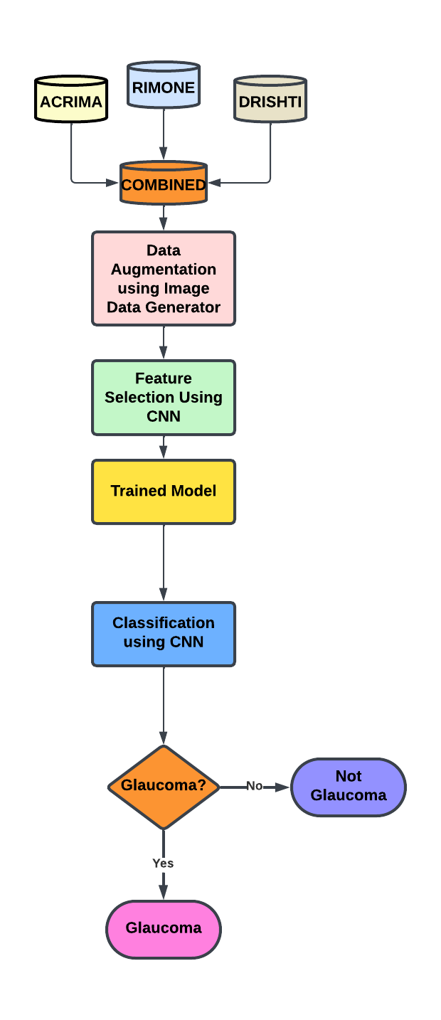
Fig.1: Methodology of Glaucoma Detection Using CNN
Many pretrained framework such as AlexNet, ResNet, VGGNet, etc. are used. The maps of saliency are created using these models on the considered data then these are employed for further steps of the process. Majority of the proposed models used ground truths and modified ground truths for the identification of glaucoma. Some researchers have used UNet for Image Segmentation, which slows down the middle layers of the system. Some of the existing methods used imbalanced data where, imbalance data caused disturbance in the output or detection. So balancing should be applied. Very few researchers used many parameters, it'll definitely effect model’s performance. In this we propose a model Fig.1 consisting of a combined dataset of ACRIMA, DRISTI and RIMONE. The proposed methodology uses an image data generator for data augmentation.
The original images have increased due to augmentation and a large dataset is prepared. The dataset is split into 80:10:10 for training data, testing and validation data. Later the augmented pictures have been sent for feature selection using CNN. The images are divided using binary classification as there are two outcomes. The model can predict the glaucomatous eye accurately.
In the Fig.1[4] the first step is dataset collection second step is data pre-processing, third step is feature extraction, fourth step is feature selection, fifth step is algorithm that includes use of CNN and last step is evaluation matrices which are used to calculate results based on the above specified evaluation matrices. The Fig.2[5] shows the neural networks of CNN.

Fig.2: Neural Networks

IV. PERFORMANCE EVALUATION METRICS
For Evaluation of the prototype, we are using metrics like accuracy, F1score, recall, precision. A machine will always produce an outcome and we have no idea which is correct one or not unless someone hints that out in our model. For calculating these metrics, we can use the confusion matrix which consist of four characteristics.
A. Accuracy
The model's accuracy is a measure of its performance across all classes. Accuracy is simply the percentage of correctly classified items it comes to multiclass classification.
B. Recall
The percentage of positive observations that were correctly classified is used to compute recall as positive in comparison to all Positive samples.
C. Precision
The proportion of correctly classified Positive cases to all Positive samples is used to determine accuracy (either incorrectly or correctly). Precision describes how precisely the model labels a random pick as positive.
D. Sensitivity
Sensitivity is used to evaluate model performance because it allows us to see how many positive instances the prototype was able to correctly identify. In a prototype few false negatives will occur from a high sensitivity detector, which implies that some positive occurrences are being missed.
E. Specificity
When sensitivity is used to evaluate model performance, it is often compared to specificity. Specificity measures the proportion of accurately recognized true negatives by the model
F. F1-score
The precision and recall harmonic mean is the F1 score. It functions as a statistical instrument for performance evaluation. An F-score can range from zero to 1.0, which represents flawless recall and accuracy, and from zero to zero when neither recall nor precision are present

Additionally, users benefit from Gigabit Ethernet for reliable wired networking.

Additionally, users benefit from Gigabit Ethernet for reliable wired networking.

Additionally, users benefit from Gigabit Ethernet for reliable wired networking.

Additionally, users benefit from Gigabit Ethernet for reliable wired networking.

VI. CONCLUSION AND FUTURE WORK
Permanent blindness is caused by the complication of glaucoma, which is connected to optic nerve damage. Using glaucoma detection technology will expand thanks to this method of medical image processing technology. The computer-generated outcomes of this work will help to raise the bar for clinical judgment when it comes to glaucoma identification.
Because there are more normal fundus photos in the dataset, this algorithm can detect the glaucomatous images correctly. The proposed prototype uses an image data generator for data augmentation. The original images have increased due to augmentation and a large-scale dataset is prepared. Later the augmented images have been sent for feature selection using CNN. The images are classified using binary classification as it has two outcomes.
The proposed system attained a 98.47% accuracy rate, which is noteworthy in this field. In our upcoming research, we intend to implement convolutional neural networks within the recognition of numerous eye illnesses, including cataracts, retinal detachment, and diabetic retinopathy

VII. REFERENCES
- Kim, Ko Eun, et al. "Development and validation of a deep learning system for diagnosing glaucoma using optical coherencetomography."Journalofclinicalmedicine9.7(2020):2167, Doi: https://doi.org/10.3390/jcm9072167.
- Li, Liu, et al. "A large-scale database and a CNN model for attention-based glaucoma detection." IEEE transactions on medical imaging 39.2 (2019): 413-424
DOI: 10.1109/TMI.2019.2927226
- Dheeraj Kumar Agrawal, , Bhupendra Singh Kirar, and Ram Bilas Pachori. "Automated glaucoma detection using quasi‐bivariate variational mode decomposition from fundus images." IET Image Processing 13.13 (2019): 2401-2408.
- M., S., Issac, A., & Dutta, M. K. (2018). Using novel blood vessel tracking and bend point detection, an automated and robust image processing algorithm for glaucoma diagnosis from fundus images. International Journal of Medical Informatics,110,52–70. Doi :10.1016/j.ijmedinf.2017.11.015
- M. Tabassum et al., "CDED-Net: Joint Segmentation of Optic Disc and Optic Cup for Glaucoma Screening," in IEEE Access, vol. 8,pp.102733-102747,2020,
Doi: 10.1109/ACCESS.2020.2998635.
- K. A. Thakoor, S. C. Koorathota, D. C. Hood and P.Sajda, "Robust and Interpretable Convolutional Neural Networks to Detect Glaucoma in Optical Coherence tomography Images," in IEEE Transactions on Biomedical Engineering, vol.68,no.8,pp.2456-2466,Aug.2021,Doi: 10.1109/TBME.2020.3043215.
- Abdel-Hamid, L. (2019). Glaucoma Detection from Retinal Images Using Statistical and Textural Wavelet Features. Journal of Digital Imaging. Doi:10.1007/s10278-019-001890.
- Raghavendra, U Gudigar, A., Bhandary, S. V., Rao, T. N., Ciaccio, E. J., & Acharya, U.R. (2019). A Two Layer Sparse Autoencoder f or Glaucoma Identification with Fundus Images. Journal of Medical Systems, 43(9). Doi: 10.1007/s10916-019-1427-x.
- Patil, N., Patil, P. N., & Rao, P. V. (2021). Convolution neural network and deep belief network (DBN) based automatic detection and diagnosis of Glaucoma. Multimedia Tools
- A Serener and S. Serte, "Transfer Learning for Early and Advanced Glaucoma Detection with Convolutional Neural Networks," 2019 Medical Technologies Congress (TIPTEKNO),2019, pp.1-4,
Doi: 10.1109/TIPTEKNO.2019.8894965.
- D. Parashar and D. K. Agrawal, "Automatic Classification of Glaucoma Stages Using Two-Dimensional Tensor Empirical Wavelet Transform," in IEEE Signal Processing Letters, vol.28, pp. 66-70, 2021, Doi: 10.1109/LSP.2020.3045638.
- J. Civit-Masot, M. J. Domínguez-Morales, S. Vicente-Díaz and A. Civit, "Dual MachineLearning System to Aid Glaucoma Diagnosis Using Disc and Cup Feature Extraction,"in IEEE Access, vol.8, pp.127519-127529,2020, Doi: 10.1109/ACCESS.2020.3008539.

V. RESULTS AND DISCUSSIONS
There are several different performance metrics that can be used to evaluate a model's performance. Performance is evaluated using the Specificity, Sensitivity, Accuracy, Recall, Precision, and F1 score. The confusion matrix provides a detailed explanation of values such as False Negatives, False Positives, True Positives, and True Negatives.
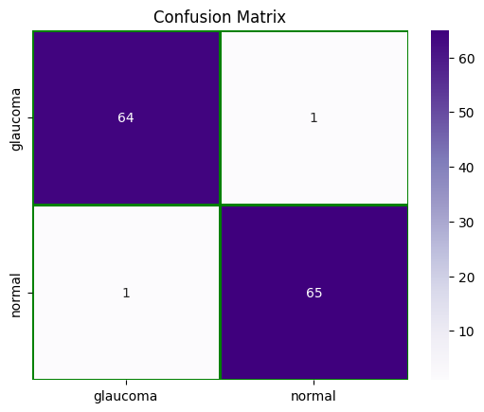

Fig.3:Confusion Matrix

We have compared different methods with the proposed methodology in terms of accuracy and are listed in below table TABLE I.
TABLE I
Comparison Results of Various Methods

Model | Accuracy
Proposed model | 98.47
ResNet-50 [4] | 94.5
EC-Net [4] | 97.2
Efficient-net CNNs model [9] | 88
CNN model [3] | 94
Inception V3 [14] | 90.4
ODG-Net [1] | 95.75
KNN [10] | 95.91
Google Net [8] | 83
DENet [15] | 91.83

The classification report here instigates the fact that this model which achieved an accuracy of 98.47% with an integrated dataset is to be noted and this is the first ever model to achieve this. All the existing studies have achieved the results in TABLE I by working on small datasets whereas the proposed model has a large dataset.
The CNN here can process even on low quality images. The dataset created is a balanced dataset with proportionate number and normal images of glaucoma.

Fig 1: Methodology Of Glaucoma

