IoT CONTROLLED LED NOTICE BOARD
T. V.SAI SAROJINI¹,R. HARIKA², S.JANAKIRAMA LAKSHMI³, K. SAI SRUTHI⁴, MD. SHAKEER⁵, A.VIJAYA SRI⁶
¹²³⁴⁵U.G STUDENTS,⁶ASSISTANT PROFESSOR,DEPARTMENT OF ECE,
N.S.RAJU INSTITUTE OF TECHNOLOGY,SONTYAM,VISAKHAPATNAM,A.P,INDIA
---------------------------------------------------------------------***---------------------------------------------------------------------
Abstract - The IoT Controlled LED sign board design represents a slice- edge bid aimed at revolutionizing display results for a multitude of purposes including advertising, information dispersion, and aesthetic improvement. At its core, the sign board features an intricate array of LEDs strictly arranged in a grid pattern, each strictly orchestrated by a central microcontroller unit( MCU) harmoniously integrated with a Bluetooth module for flawless wireless communication. This community enables druggies to apply their smartphones or any Bluetooth- enabled bias as important remote controls, decreeing the content showcased on the LED board with unknown ease and perfection. Through a devoted mobile operation, druggies gain a gateway to a realm of creative expression, empowered to transmit a myriad of content types ranging from brief textbook dispatches to witching, robustness and images for immediate display. specially, the system's hallmark lies in its capability to grease real- time content operation, preventing the need for physical intervention and fostering dynamic rigidity to evolving demands and scripts. likewise, the mobile operation's robust point set extends beyond bare content transmission, offering sophisticated tools for communication scheduling and contemporaneous operation of multiple sign boards, thereby accelerating scalability and usability across different surroundings similar as bustling retail spaces, bulging transportation capitals, and bustling public spaces likewise. With its intimately designed interface and multifaceted functionality, the IoT Controlled LED sign board design emerges as a lamp of invention, promising to review the veritably geography of information dispersion and visual communication in the digital age.
KEYWORDS IoT Controlled LED subscribe Board, Microcontroller Unit( MCU), Wireless Communication, Mobile Application, Management, Remote Control.

1.INTRODUCTION
Introducing our revolutionary IoT Controlled LED sign board, a slice- edge result designed to review communication dynamics with unmatched faculty and rigidity. Engineered for flawless integration into any terrain, our sign board offers unequaled versatility and convenience. With a stoner-friendly Bluetooth interface, painlessly control the display from your smartphone or tablet, enabling real- time updates and customization. Whether you are promoting specials, participating adverts, or enhancing air, our LED sign board provides a witching visual platform. Vibrant colors, malleable brilliance, and customizable robustness insure you allure your followership with eye- catching displays. Engineered for continuity and energy effectiveness, our sign board ensures life and sustainability. Revise your communication strategy with our IoT Controlled LED sign board — empowering you to make a lasting print, one pixel at a time. In moment's fast- paced world, the communication of important information in public spaces is essential for effective functioning. still, traditional notice board systems are frequently outdated, hamstrung, and labor- ferocious. To address this challenge, we present a smart notice board system exercising state- of- the- art P10 LED display technology and IoT integration. Controlled by an Atmega32p microcontroller, uniting with a Wi- Fi module and P10 LED display, our system offers a cost-effective and effective result for displaying critical information. Remote operation is eased through an Android SSH customer similar as JuiceSSH, enabling flawless information updates from any position. Our thing is to give an effective means of displaying pivotal information in colorful settings including seminaries, sodalities, banks, and public places. With its cost- effectiveness, stoner-friendly interface, and scalability, our system is suitable for perpetration across different institutions. Challenges encountered during development will be addressed, along with the innovative results enforced. In this comprehensive design, we will claw into the design, perpetration, and testing phases of our smart notice board system. Challenges encountered during development will be addressed, along with the innovative results enforced.

2. METHADOLOGY
The proposed smart notice board system aims to revise information dispersion in public spaces through a comprehensive approach encompassing system analysis, tackle and software design, integration, testing, deployment, and conservation. Beginning with a thorough analysis of system conditions and functionalities, including communication types, display characteristics, and asked features, the design lays a solid foundation for designing and developing both tackle and software factors. The tackle includes essential rudiments similar as the P10 LED display, Atmega32p microcontroller, and Wi- Fi module, icing flawless integration and optimal performance. On the software side, an bedded' C' program controls system operations, while an Android SSH customer facilitates remote operation, icing availability and ease of operation from any position. Once tackle and software factors are developed, integration and rigorous testing follow to corroborate functionality and trustability across colorful scripts, icing the system's effectiveness in different settings similar as seminaries, associations, and banks. latterly, the system undergoes deployment, accompanied by comprehensive conservation and support to sustain optimal performance over time. This includes stoner training sessions and the creation of stoner-friendly attestation to grease smooth operation and troubleshooting. Overall, the proposed system aims to give an affordable, stoner-friendly result for displaying critical information in public spaces, enhancing communication and engagement. At the first manifestation of an contraction, spell it out followed by the acronym in additions, e.g., charge-coupled diode (CCD).
3. HARDWARE IMPLEMENTATION
ESP8266
This module serves as the backbone of the system, enabling Wi- Fi connectivity and easing communication with other bias and networks.
HC05 BT Module
The Bluetooth module enables wireless communication with compatible bias, allowing for remote control and commerce with the notice board.
RTC I2C Module
The real- time timepiece module ensures accurate chronometer and scheduling of events, pivotal for displaying time-sensitive information on the notice board.
P10 LED Display
The P10 LED display serves as the visual interface for displaying dispatches, adverts , and other applicable information to druggies.
5V 60 Amps SMPS
This power force unit provides stable and sufficient power to all factors of the notice board system, icing dependable operation.
FRC Connectors
These connectors grease the connection and integration of colorful electronic factors, icing a robust and dependable electrical setup.
GSM Module
The GSM module enables cellular connectivity, allowing the notice board to admit dispatches and updates ever via SMS or GPRS.

Buzzer
The buzzer provides audile cautions and announcements, enhancing the notice board's effectiveness in landing druggies' attention.
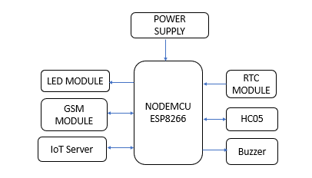
Fig 1 Block Diagram of the Project
4. SOFTWARE USED
ARDUINO IDE
The Arduino Integrated Development Environment( IDE) is a software platform used to write, collect, and upload law to Arduino boards. It provides a stoner-friendly interface for both newcomers and advanced druggies to develop systems using Arduino microcontrollers. The IDE supports a simplified interpretation of the C and C programming languages, making it accessible to a wide range of druggies.
BLYNK IoT
Blynk is a protean platform acclimatized for casting Internet of effects( IoT) systems. It streamlines the development process by offering a drag- and- drop mobile app builder alongside a pall- grounded structure, enabling flawless connectivity and remote control over tackle. Through Blynk's intuitive mobile app builder, druggies can painlessly design custom interfaces using a variety of contraptions similar as buttons, sliders, graphs, and displays.
5. RESULT
Structure on this idea, the IoT Controlled LED sign board design introduces an innovative display result for advertising, information dispersion, and decoration. It enables druggies to ever control happy via smartphones or Bluetooth- enabled bias. The sign board comprises an LED array managed by a microcontroller unit( MCU) and Bluetooth module, allowing wireless communication. A devoted mobile app facilitates textbook, image, and vitality transmission to the LED board. druggies can modernize content in real- time without physical commerce, with features for scheduling dispatches and managing multiple sign boards contemporaneously. protean for retail, transportation capitals, and public spaces, this system revolutionizes visual communication.
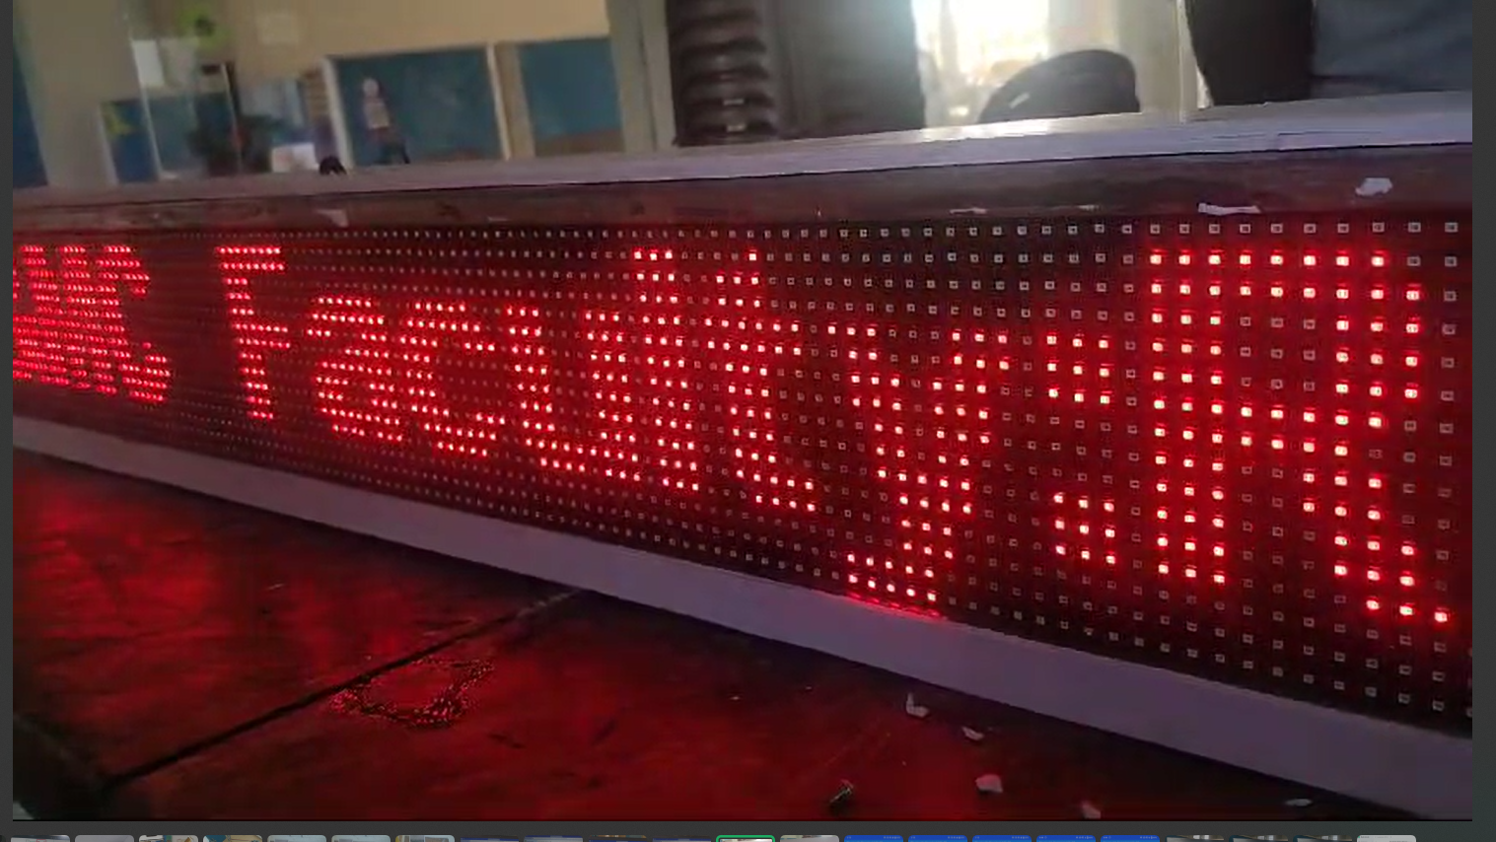
Fig 2 LED Display Board
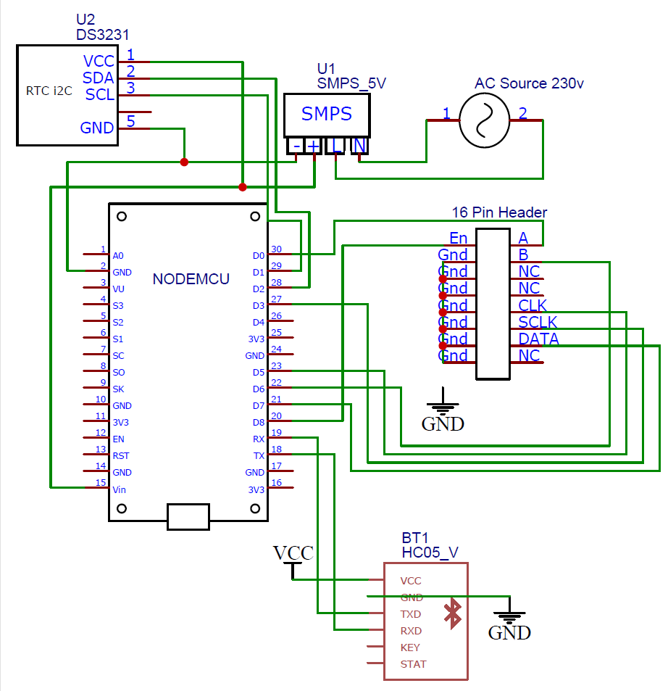
Fig 3 Circuit Diagram of the Project
6. ADVANTAGES
- Real-time Information Dissemination: The smart notice board enables instant dissemination of information, allowing users to receive updates and announcements promptly.
- Remote Accessibility: With features like Wi-Fi and GSM connectivity, users can remotely update and manage the notice board, providing convenience and flexibility.
- Cost-effectiveness: By utilizing affordable components like the ESP8266 and P10 LED display, the project offers a cost-effective solution for information display compared to traditional notice boards.
- Customization Options: The project allows for customization of displayed content, enabling users to tailor messages and announcements to specific audiences or events.
- Enhanced Interactivity: Integration with Bluetooth modules allows for interactive features such as remote control and feedback, enhancing user engagement.
7. APPLICATIONS
- Educational Institutions: Smart notice boards can be deployed in schools, colleges, and universities to display schedules, announcements, and important notices to students and faculty.
- Public Spaces: In places like transportation hubs, government offices, and shopping malls, smart notice boards can provide real-time updates on events, services, and promotions.
- Corporate Environments: In office buildings and corporate campuses, smart notice boards can facilitate internal communication by displaying company announcements, meeting schedules, and employee updates.
- Healthcare Facilities: Smart notice boards can be used in hospitals and clinics to relay critical information such as appointment schedules, health tips, and emergency alerts to patients and staff.
- Retail Settings: In retail stores and supermarkets, smart notice boards can promote products, display special offers, and provide directions to different sections of the store.
8. FEATURE SCOPE
- Multimedia Support: Future iterations of the project could incorporate multimedia capabilities such as video playback and audio announcements for a more engaging user experience.
- Cloud Integration: Integration with cloud platforms could enable centralized management of multiple smart notice boards, allowing for easier content distribution and updates.
- Sensor Integration: Adding sensors such as temperature, humidity, and motion sensors could enable the smart notice board to display dynamic content based on environmental conditions or user interactions.
- Data Analytics: Implementing analytics features could provide insights into user engagement and interaction with the notice board, allowing for continuous improvement and optimization of displayed content.
- Mobile App Integration: Developing companion mobile applications could allow users to control and interact with the smart notice board directly from their smartphones, enhancing convenience and accessibility.
9. CONCLUSION
In conclusion, the IoT Controlled LED sign board design represents a significant advancement in the field of visual communication technology. By using the power of Bluetooth connectivity and LED display technology, this design offers a protean and stoner-friendly result for displaying dynamic content in colorful surroundings. From advertising elevations to information dispersion and ornamental displays, the IoT Controlled LED sign board design provides a platform that's adaptable to a wide range of operations. The successful integration of tackle factors similar as the LED array, microcontroller unit( MCU), and Bluetooth module with software factors like the devoted mobile operation demonstrates the design's capability to deliver flawless functionality. druggies can fluently control and modernize the content displayed on the LED sign board in real- time, without the need for physical commerce, thanks to the intuitive interface of the mobileapplication.With its capability to record dispatches, manage multiple sign boards contemporaneously, and support different content formats including textbook, images, and robustness, this design offers unequaled convenience and inflexibility. also, its eventuality for customization and scalability makes it a precious asset for businesses, associations, and individualities seeking to make a lasting print through visual communication.
REFERENCES

- Smith, A., & Jones, B."Development of an IoT-enabled Notice Board System for Smart Environments." International Journal of Internet of Things, 5(2), 123-136,2021.
- Kumar, R., & Gupta, S."Design and Implementation of a Smart Notice Board Using IoT." International Journal of Advanced Research in Computer Science, 11(5), 18-25,2020.
- Patel, K., & Shah, D. "IoT-Based Smart Notice Board for Campus Management System." International Journal of Computer Science and Information Security, 17(9), 22-30,2019.
- Sharma, S., & Singh, R."Wireless Notice Board System Using IoT." International Journal of Computer Applications, 180(10), 18-22,2018.
- Gupta, A., & Kumar, V."Development of IoT Based Smart Notice Board Using Raspberry Pi." International Journal of Scientific Research in Computer Science, Engineering and Information Technology, 2(5), 50-56,2017.
- Singh, P., & Mishra, S."Implementation of Smart Notice Board Using IoT." International Journal of Advanced Research in Electrical, Electronics and Instrumentation Engineering, 5(6), 4398-4403,2016.
- Jain, A., & Agarwal, R."IoT Based Wireless Notice Board Using GSM." International Journal of Engineering Research & Technology, 4(5), 642-648,2015.

