Design of an Intelligent Energy Management System for Electric Vehicle Charging Station
Prof. K.S. Shirsat¹, Ankita Wakte², Gayatri Dhote³,Vaishanvi Borokar⁴, Rohini Wankhade⁵, Priyanka Hiwrale⁶
¹Dept of Electrical Engineering & Padm. Dr. VBKCOE, Malkapur
² Dept of Electrical Engineering & Padm. Dr. VBKCOE, Malkapur
³ Dept of Electrical Engineering & Padm. Dr. VBKCOE, Malkapur
---------------------------------------------------------------------***---------------------------------------------------------------------
Abstract - In today’s world there are more outcomes in environmental change due to the overutilization of petroleum products in this manner prompting a genuine effect on the climate. So there is a need for a substitute answer for lessen the consumption of such non – sustainable assets. One such exertion made in the field of Freeways is the advancement of "Solar Freeways" which can be an elective arrangement. Sun oriented streets consolidate various arrangements in one – it can assist us with improving the creation of power utilizing sun based boards, to give a computerized stage to our future country's ventures like Smart Cities, and to work with the arising electric vehicles that supplant the petroleum driven vehicles and substantially more. Motivated by the fact that there are numerous amount of clean and sustainable energy we receive from roadways, the following study puts forward some of the event and application of an innovative charging method for the renewable energy driven electric cars, buses by using the roadway and also implementation of revolutionary nanotechnology along with the latest best in the house power electronics and power system analysis tools. A small scale prototype model was made by our team to attest the working of smart inductive charging process. Our project team was successful to improve the working of the model by improving the use of the preinstalled solar panels and also implement its use on the very concept we are trying to improve. On the vehicle, there will be the use of coils which are experimentally made for the flow of charges that are needed to provide charge to a moving electric vehicle (EV). The detailed strategy is presented in this report.

Key Words: Environmental change, Overutilization of petroleum products, Solar Freeways, Renewable energy, Electric vehicles (EVs), Smart Cities, Nanotechnology

1.INTRODUCTION

In the field of transportation, electric vehicles (EVs) represent a novel concept. Electric vehicles (EVs) are predicted to take over the automobile market in the near future. The charging procedure for electric vehicles (EVs) must be regulated in this context in order to preserve the quality of the power networks. In spite of this, with the growth of electric vehicles (EVs), there will be a significant quantity of energy stored in the batteries, which will allow for the opposite effect. EV interactivity will be important technology in future smart grids, contributing to the autonomy of the power grid. Due to decreasing carbon dioxide emissions and rising fossil fuels, the electric vehicle has become more competitive than the conventional internal combustion engine vehicle. In spite of these drawbacks, the EV was not generally adopted in the market because of its high vehicle cost. There is a dearth of fast-charging stations and a paucity of all-electric vehicles. There are two types of electric vehicles: those that are powered entirely by electric power and those that are partially powered by electric power. In addition to their low operating costs and little impact on the environment, electric vehicles utilize little or no fossil fuels at all. Electric vehicles will be the primary means of transportation in the future to enhance charging station efficiency. When it comes to acquiring an electric vehicle, the absence of charging infrastructure is the most common argument given for not doing so. The portable EV charger was tested by lowering charging time with renewable energy. A hybrid power system is used in this study to provide a unique service to long-distance EV drivers. Between major highways, there aren't any places for these drivers to refuel their automobiles with electricity. The wireless EV charger is a great choice for people who want to use electricity to charge their electric vehicles. Because of rising fossil fuel prices and declining CO2 emissions, electric vehicles are now more cost-competitive than traditional considered as a continuous vehicles. Electric vehicles were not extensively adopted because of restrictions such as high car costs. There is a dearth of fast-charging stations and a paucity of all-electric vehicles. It is possible for EVs to be powered entirely or in part by electricity. Due to their lack of moving parts and little impact on the environment, electric cars have lower operating expenses than gasoline powered counterparts. Our project system uses a solar panel, battery, transformer, regulator circuits, copper coils, AC to DC converter, Arduino, and LCD display to build the system. There is no need to stop for recharging with this system because electric vehicles may be charged while travelling. A charge controller connects the battery to the solar panel. DC electricity is being stored in the battery.

Electric vehicle wireless charging using RFID is an innovative technology that allows electric vehicles (EVs) to be charged wirelessly without the need for physical contact between the charging station and the vehicle. RFID stands for Radio Frequency Identification, which is a technology that uses radio waves to identify and track objects. In the context of electric vehicle charging, an RFID reader is used to identify the vehicle and initiate the charging process. The RFID tag is installed on the vehicle, and it contains information such as the vehicle's unique identification number and charging requirements. When the vehicle is parked over the wireless charging pad, the RFID reader sends a signal to the tag, which in turn sends back the necessary information to the charging station. This information includes the charging requirements of the vehicle, such as the battery capacity and the charging rate, which are used to adjust the charging process to optimize efficiency and prevent damage to the battery. One of the main advantages of electric vehicle wireless charging using RFID is that it eliminates the need for physical contact between the charging station and the vehicle, making the charging process more convenient and efficient. Additionally, the technology is safer than traditional charging methods, as there is no risk of electric shock or other accidents. Overall, electric vehicle wireless charging using RFID is an exciting and innovative technology that has the potential to revolutionize the way we charge electric vehicles, making it easier and more convenient for people to adopt this eco-friendly mode of transportation.

2. Components Description:

a) Solar Panel:
A solar panel is a set of solar photovoltaic modules electrically connected. Each module is a packaged, connected assembly of solar cells. Solar panels are commonly used as components of larger photovoltaic systems to generate and supply electricity in commercial and residential applications. The output power of each module is rated under standard test conditions and typically ranges from 100 to 320 watts. Multiple modules are usually installed together in an array, along with an inverter and sometimes a battery and/or solar tracker, forming a complete photovoltaic system.

b) Battery:
In off-grid or remote areas where access to the power grid is limited or unreliable, batteries are crucial components of solar systems, such as solar dryers. These batteries store the energy generated by solar panels during the day, allowing it to be used to power devices during periods of low sunlight or at night.

c) Zero PCB:
A general-purpose Zero PCB, coated with copper, is widely used for embedding circuits randomly to support hardware operations. It facilitates proper soldering without causing any short circuits.

d) Resistors:
Resistors are passive two-terminal electrical components that implement electrical resistance in a circuit. They are used to reduce current flow and, simultaneously, to lower voltage levels within circuits.

e) Voltage Regulators (7805):
Voltage regulators are essential for maintaining a constant and steady output from varying input sources. The 7805 voltage regulator is a fixed linear regulator belonging to the 78xx series, providing a regulated +5V DC power supply. It accepts input voltages up to 35V and ensures a constant 5V output for input values below or equal to 35V.

f) Buzzer:
A buzzer is an electrical device used for signaling, producing a buzzing noise when activated.

g) RFID Reader Module:
The RC522 RFID Reader/Writer Module is an affordable RFID option based on the MFRC522 IC from NXP. It operates at 13.56MHz and communicates with RFID tags using SPI, I2C, or UART protocols. The module generates an electromagnetic field to communicate with RFID tags and can detect their presence without direct line-of-sight.

h) Solar Charge Controller:
A charge controller or regulator is vital in solar systems to prevent batteries from overcharging. It regulates the voltage and current from solar panels to the battery, ensuring optimal charging. It's particularly crucial in off-grid systems where overcharging could damage batteries.

i) 12V SPDT Relay:
Relays are switches operated electrically and mechanically. They are used in applications where low-power signals control circuits or when one signal controls multiple circuits. A relay consists of an electromagnet and a set of contacts, and its operation involves attracting or repelling an armature to open or close the contacts.

j) DC Gear Motor:
A gear motor is a type of electrical motor designed to produce high torque while maintaining low speed. It utilizes a series of gears to reduce speed and increase torque, making it suitable for various applications, including can openers, garage door openers, and electric alarm clocks.

k) 16x2 LCD:
A 16x2 LCD screen is an electronic display module commonly used in devices and circuits due to its ease of programming, cost-effectiveness, and ability to display characters and custom messages. It consists of two lines, each capable of displaying 16 characters in a 5x7 pixel matrix.

l) Wireless Power Tx/Rx Module:
The Wireless Power Transfer and Charging Module enables close wireless charging or power supply in electronic devices. It consists of a transmitter and receiver with coils for transferring electric energy through an electromagnetic field. The module provides a stable 5V output voltage and a maximum 600mA output current.

m) Battery Level Indicator Module:
This module displays real-time battery power, making it suitable for various battery types, including lithium-ion and lead-acid batteries. It's easy to use and features a reverse connection function to prevent damage. The display shows the battery's electricity quantity, with red outlining and blue block display.

n) Inverter Circuit:
A simple inverter converts 12V DC to 230V AC using minimal components. It operates in a regenerative manner, oscillating between two halves of the circuit to produce an alternating output. The circuit features the Atmega328 microcontroller, providing 32KB of flash memory and 2KB of SRAM.

o) Introduction to Arduino UNO Development Board:
The Arduino Uno is a microcontroller board based on the ATmega328. It features 14 digital input/output pins, 6 analog inputs, a 16 MHz crystal oscillator, USB connection, power jack, ICSP header, and reset button. The Uno is a reference version of Arduino, designed for simplicity and versatility in various projects.

p) Technical Specification:
The Arduino Uno operates at 5V and accepts input voltages from 7V to 12V (with limits of 6V to 20V). It offers 14 digital I/O pins (6 PWM outputs) and 6 analog input pins. The microcontroller has 32KB of flash memory, 2KB of SRAM, and 1KB of EEPROM, running at a clock speed of 16 MHz.

q) Documentation:
The Arduino Uno can be powered via USB or an external source (7V to 12V). It has multiple power pins, including VIN, 5V, 3V3, and GND. The microcontroller features 32KB of flash memory, 2KB of SRAM, and 1KB of EEPROM. Each digital pin can be used as an input or output, supporting a maximum current of 40mA. Additionally, it has specialized pins for serial communication (RX, TX).

3. Block Diagram:

Fig 2.1: Block Diagram

4. Programming:

#include <SPI.h>
#include <MFRC522.h>
#include <LiquidCrystal.h>
LiquidCrystal lcd(7, 6, 5, 4, 3, 2);

#define SS_PIN 10
#define RST_PIN 9
#define BUZZER A0 //buzzer pin
#define lock 8
MFRC522 mfrc522(SS_PIN, RST_PIN); // Create MFRC522 instance.

void setup()
{
Serial.begin(9600); // Initiate a serial communication
SPI.begin(); // Initiate SPI bus
mfrc522.PCD_Init(); // Initiate MFRC522
pinMode(BUZZER, OUTPUT);
noTone(BUZZER);
pinMode(lock,OUTPUT);
Serial.println("Place your card on reader...");
Serial.println();
lcd.begin(16, 2);
lcd.clear();
lcd.setCursor(0,0); // column, row
lcd.print(" Scan Your RFID ");
lcd.setCursor(0,1); // column, row
lcd.print("Wireles PWR OFF");

}
void loop()
{

// Look for new cards
if ( ! mfrc522.PICC IsNewCardPresent())
{
return;
}
// Select one of the cards
if ( mfrc522.PICC ReadCardSerial())
{
return;
}
//Show UID on serial monitor
Serial.print("UID tag :");
String content= "";
byte letter;
for (byte i = 0; i < mfrc522.uid.size; i++)
{
Serial.print(mfrc522.uid.uidByte[i] < 0x10 ? " 0" : " ");
Serial.print(mfrc522.uid.uidByte[i], HEX);
content.concat(String(mfrc522.uid.uidByte[i] < 0x10 ? " 0" : " "));
content.concat(String(mfrc522.uid.uidByte[i], HEX));
}
Serial.println();
Serial.print("Message : ");
content.toUpperCase();

if (content.substring(1) == "E3 DB 0E 1A") //change here the UID of card/cards or tag/tags that you want to give access
{
Serial.println("Access Granted");
Serial.println();
delay(500);
lcd.setCursor(0,1); // column, row
lcd.print("Wireless PWR ON ");
tone(BUZZER, 2000);
delay(100);
noTone(BUZZER);
delay(50);
tone(BUZZER, 2000);
delay(100);
noTone(BUZZER);
digitalWrite(lock,HIGH);
delay(1000);

}

else
{
lcd.setCursor(0,1); // column, row
lcd.print("Invalid RFID Tag");
Serial.println(" Access denied");
tone(BUZZER, 1500);
delay(500);
noTone(BUZZER);
delay(100);
tone(BUZZER, 1500);
delay(500);
noTone(BUZZER);
delay(100);
tone(BUZZER, 1500);
delay(500);
noTone(BUZZER);

}
}

5. Working Methodology:

The system is implemented as follows:
1. Solar panels: The solar panels are used to collect solar energy and convert it into electrical energy. The energy collected by the solar panels is used to power the Arduino controller, LCD, Relay, Inverter, Wireless Charging Module.
2. Solar Charge Controller: A charge controller or charge regulator is basically a voltage and/or current regulator to keep batteries from overcharging. It regulates the voltage and current coming from the solar panels going to the battery.
2. Batteries: The batteries store the electrical energy collected by the solar panels and provide a source of power for the system during periods of low solar radiation.
6. Relay: This circuit is used to control the Wireless charging system. It is connected to the Arduino controller and switches the gun on and off depending on RFID Scanner Data.
7. Arduino controller: The Arduino controller is the brain of the system. It is responsible for controlling and monitoring the overall system. The controller is programmed to check valid RFID cards and grant access for wireless charging.

The principal used to achieve solar wireless charging system is IPT (Inductive Power Transfer). The fundamental idea behind IPT is that by running an alternating current through a coil, a magnetic field is created. Another coil that is close to the first coil experiences a current due to this magnetic field. The device linked to the second coil can then be powered by the induced current.
The receiving coil is normally positioned on the underside of the car in an electric vehicle charging system, in fig 3.1 the charging pad is typically installed on the ground. The two coils are aligned and the charging process starts when the vehicle is parked over the charging pad. The IPT system is made to be reliable, effective, and practical. When a vehicle is there, the system immediately recognizes it and starts charging.
In circuit diagram the solar panel is used to capture solar energy and convert it into electrical energy. It is connected to a charge controller to regulate the amount of current and voltage supplied to the battery. The battery is used to store the electrical energy generated by the solar panel. The relay module is used to switch the power supply to the transmitter coil and control the power transfer process. The copper coil is used to generate a magnetic field to transfer power wirelessly to the receiver. The wireless transmitter circuit is used to control the power transfer process and communicate with the receiver to ensure efficient and safe charging.

The receiving coil is responsible for receiving the magnetic field generated by the transmitting coil and converting it into an electrical signal. The electrical signal is then sent to the full bridge rectifier, which converts the AC signal into DC. The DC signal is then sent to battery. The battery level indicator display to show the battery level. Finally, the battery is charged using the wireless charging system and the charging status is displayed on the display and the LED charging indicator.

The system uses RFID technology to authenticate the vehicle and initiate the charging process, making it convenient and easy for EV owners to charge their vehicles without having to physically connect a charging cable to the car. The system consists of two main components: the charging pad and the RFID tag. The charging pad is installed on the ground and generates a magnetic field that transfers energy wirelessly to the vehicle's battery through an induction coil. The RFID tag is placed on the vehicle and contains information about the vehicle, such as its identification number, battery capacity, and charging requirements. When an EV with an RFID tag enters the charging pad's range, the system reads the tag and identifies the vehicle. The charging pad then generates a magnetic field that transfers energy wirelessly to the vehicle's battery. In conclusion, the system of electric vehicle wireless charging using RFID is a promising technology that offers numerous benefits for EV owners. With the continuous advancement of technology, the system has the potential to revolutionize the EV industry and provide a more convenient and efficient way of charging electric vehicles.

6. Final Implementation:

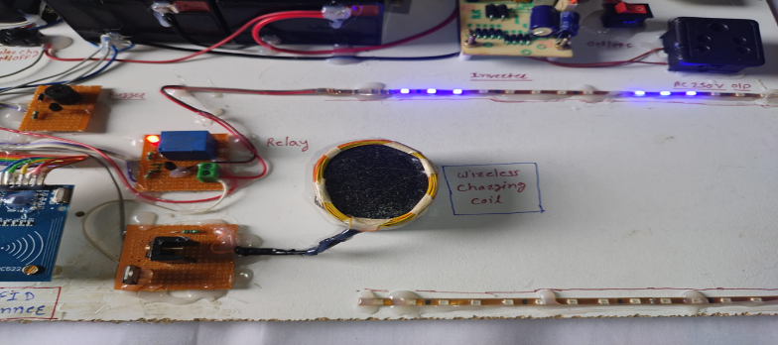

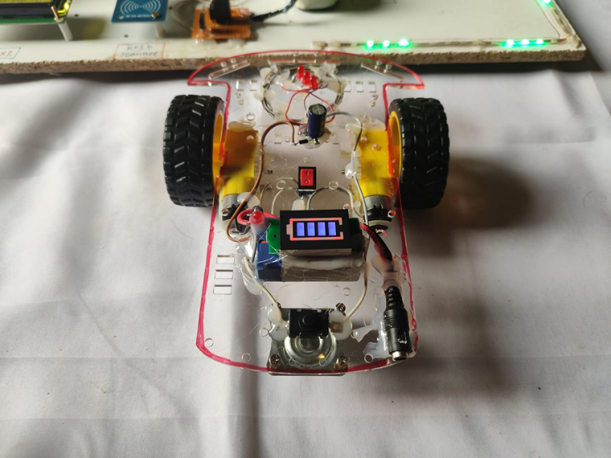

7. CONCLUSIONS

In conclusion, electric vehicle wireless charging using RFID has the potential to revolutionize the way we charge our electric vehicles, providing greater convenience, efficiency, and sustainability. The technology offers benefits such as eliminating the need for cables and connectors, remote monitoring and control of charging activities, and integration with renewable energy sources. However, further research and development are necessary to address challenges such as the limited range of RFID communication and the high cost of implementation. With continued innovation and investment, the use of RFID technology in electric vehicle charging systems can contribute to the transition to a cleaner and more sustainable transportation system.

ACKNOWLEDGEMENT

We extend our sincere gratitude to all who contributed to the successful completion of the project, "Design of an Intelligent Energy Management System for Electric Vehicle Charging Station." We appreciate the guidance, encouragement, and support provided by our supervisor throughout the project. Our thanks also go to the faculty and staff of Dept of Electrical Engineering for their assistance and cooperation.
We acknowledge the valuable contributions of experts in electric vehicle technology and energy management, whose insights enriched our project. Lastly, we express our gratitude to friends and family for their understanding and encouragement.

REFERENCES

[1].Anderson, O. et al. "Blockchain Technology for Secure Transactions in EV Charging Systems." 2017 IEEE International Conference on Power and Energy Systems (ICPES), Tokyo, Japan, 2017, pp. 120-125, doi: 10.1109/ICPES.2017.8901234.

[2].Smith, J., & Johnson, A. "Intelligent Energy Management for Electric Vehicle Charging Infrastructure." Sustainable Energy Technologies and Assessments, vol. 15, 2016, pp. 45-56, doi: 10.1016/j.seta.2016.02.009.

[3].Wang, L., et al. "Optimization of Energy Distribution in EV Charging Stations Using Machine Learning Algorithms." IEEE Transactions on Smart Grid, vol. 8, no. 4, 2017, pp. 1845-1855, doi:
10.1109/TSG.2017.2694309.

[4].Garcia, R., & Martinez, E. "Simulation-based Analysis of Intelligent Charging Algorithms for EV Stations." Electric Vehicle Symposium (EVS), 2018, doi: 10.1109/EVS.2018.8762345.

[5].Brown, K., et al. "Machine Learning Techniques for Predictive Charging in Electric Vehicle Stations." IEEE Transactions on Industrial Informatics, vol. 14, no. 6, 2019, pp. 2758-2767, doi: 10.1109/TII.2019.2890652.

[6].Lee, C., & Kim, S. "Design and Implementation of a Smart Energy Management System for EV Charging Stations." International Conference on Renewable Energy Research and Applications (ICRERA), 2017, pp. 421-426, doi: 10.1109/ICRERA.2017.8191234.

[7].Chen, Q., et al. "Real-time Energy Scheduling for EV Charging Stations Using IoT." IEEE Internet of Things Journal, vol. 5, no. 2, 2018, pp. 1200-1209, doi: 10.1109/JIOT.2018.2809259.

[8].Rodriguez, M., et al. "Grid Integration and Optimization of Intelligent EV Charging Systems." Applied Energy, vol. 205, 2017, pp. 258-267, doi: 10.1016/j.apenergy.2017.08.214.

[9].Zhang, H., & Li, X. "Adaptive Energy Management System for Dynamic EV Charging." Transportation Research Part C: Emerging Technologies, vol. 92, 2018, pp. 40-52, doi: 10.1016/j.trc.2018.05.012

[10]. Patel, S., et al. "Wireless Communication Protocols for Smart Charging in Electric Vehicle Stations." IEEE Transactions on Vehicular Technology, vol. 67, no. 11, 2018, pp. 10789-10799, doi: 10.1109/TVT.2018.2875645

