DESIGN & FABRICATION OF RETRACTABLE SEATING AND DRIVING MECHANISM ARRANGEMENT FOR TELESCOPING 3 WHEEL GO-KART
G. NARASIMHULU^{*1}, D. SHASHANK GOUD^{*2}, S. MANJUNATH*³ , K. AKHIL*⁴ ,B. VIJAY^{*5},
N. RAJENDER^{*6}
*1 Assistant Professor, Department of Mechanical Engineering, J.B. Institute of Engineering and
Technology, Hyderabad, Telangana
*2, * 3 ,* 4 ,* 5*,6 B Tech Student, Department of Mechanical Engineering, J.B. Institute of Engineering and
Technology, Hyderabad, Telangana

ABSTRACT

Most of the recreation parks are using 4-wheel petrol (or) diesel powered go-carts which are expensive, heavy in weight and pollutes the environment. As the fossil fuels are depreciating and cost of the fuels is also increasing rapidly in global markets, it is very much essential to develop new go-kart designs with less weight, runs on electric energy (battery) so that it is not dependent on costly imported fuels like petrol / diesel and also consumes less energy.
3 Wheel electric (battery powered) Go Kart is one of the less weight designs that consumes less energy and adds no pollution to the environment. As a part of our project dissertation, we are planning to fabricate chassis for telescopic 3-wheel go-kart.
Telescopic 3-wheel go-kart has fallowing advantages when compared to 4-wheel 2-seater go- karts;
- Less in mass hence gives good energy economy
- No pollution
- Easy to transport as it occupies less space

Project Involves;
  - Study of various types of chassis, materials used for chassis, structural elements like pipes, plates and flats, fabrication operations like welding, cutting, drilling, etc.
- INTRODUCTION
A go-kart, also written as go-cart (often referred to as simply a kart), is a type of open-wheel car. Go-karts come in all shapes and forms, from motor less models to high-powered racing machines. Some, such as Super-karts, are able to beat racing cars or motorcycles on long circuits.
Gravity racers, usually referred to as Soap Box Derby carts, are the simplest type of go-karts. They are propelled by gravity.
Many recreational karts can be powered by four-stroke engines, while racing karts use a two- stroke or, rarely, higher powered four-stroke engines. Most of them are single seater but some recreational models can accommodate a passenger. In some countries, go-karts can be licensed for use on public roads often referred to as street tracks. Typically, there are some restrictions; in the European Union, a go-kart modified for use on the road must be outfitted with headlights (high/low beam), tail lights, a horn, indicators, and an engine not exceeding 20 hp (15 kW).
Besides traditional kart racing, many commercial enterprises offer karts for rent, often called "recreational" or "concession" karts. The tracks can be indoor or outdoor. Karts are rented by sessions (usually from 10 to 30 minutes). They use sturdy chassis complete with dedicated bodywork, providing driver safety. Most of these enterprises use an "Arrive and Drive" format which provides customers with all the safety gear (helmets, gloves and driver outfits) necessary, and allow them to show up anytime to race at a reasonable price, without the problem of having to own their own equipment and gear.
Outdoor tracks can offer low-speed karts strictly for amusement (dedicated chassis equipped with low powered four-stroke engines or electric motors), or faster, more powerful karts, similar to a racing kart, powered by four-stroke engines up to 15 hp (11 kW) and, more rarely, by 2- stroke engines, but designed to be more robust for rental use. Typically, outdoor tracks are also be used for traditional kart races.
Indoor kart tracks can be found in many large cities in different parts of the world. These tracks are often located in refurbished factories or warehouses, and are typically shorter than traditional outdoor tracks. Indoor karts are usually powered by a four-stroke gasoline engine producing anywhere from 5 to 13 hp (4 to 10 kW), or sometimes by an electric motor. Many tracks offer competitive races and leagues. At the top level, an Indoor Karting World Championship (IKWC) exists. Nowadays most of the racers are using 4-wheel petrol (or) diesel powered go-carts which are expensive, heavy
in weight and pollutes the environment. As the fossil fuels are depreciating and cost of the fuels is also increasing rapidly in global markets, it is very much essential to develop new go-karts with less weight, runs on electric energy / battery so that it is not dependent on costly imported fuels like petrol / diesel and consumes less energy
3 Wheel electric (battery powered) go-kart is one of the less weight designs that consumes less energy and adds no pollution to the environment. Through this project we have made an effort to make less weight 3 wheel go kart chassis which can take 200Kgs Load (50kg Chassi+150Kg Men) and also support parts like motor, batteries, steering, controller etc., this chassis also accommodates retractable seat for passenger making it a 2-seater go-kart.
LITERATURE SURVEY
The go-kart is a vehicle that is small, quick, light, and simple to drive. Since the go-kart is designed for flat-track racing, it has a very poor ground clearance relative to most cars, but it does not have suspension. Because of its ease, low cost, and safer way of racing, go-karting is a perfect outlet for those involved in racing. It is possible to have an indoor or outdoor track. The go-kart tracks are much smoother than the F1 tracks.
A chassis is the basic framework of your vehicle. Sometimes the chassis is only the frame, while other times it includes the wheels, transmission, and sometimes even the front seats. A chassis is one of the most important components of a vehicle, without which the car would have no structure.
Coupe French car manufacturer “Poniard” used body panels entirely made of aluminum to dress the “Dana”. In the past few years manufacturer is increasingly using the expensive aluminum for their vehicle bodies. 72 years after the introduction of Dodge’s all-steel body, the Car Manufacturer Audio (in cooperation with the Aluminum Company of America (Alcoa)) was finally able to develop an equivalent in Aluminum. The Audio Aluminum Space Frame, used in the AAA, is the first car to be fitted with a chassis and Fig. 2: Audio Space Frame body made from 100% aluminum. The main reason to use aluminum or fiberglass Instead of steel is to save weight.
II .METHODOLOGY
We have taken a Mild Steel (MS) Square pipe of side 20mm and thickness 2mm and we have marked the pipe at distance 720mm from its edge and using measuring and marking tools and we have performed cutting operation using angle grinder machine with respect to the markings and we have performed grinding operation after cutting operation using angle grinder machine to get better surface finish with respect to the markings and we have obtained 2 pipes of length 720mm, side 20mm and thickness 2mm by following above mentioned process. We have taken a Mild Steel (MS) Square pipe of side 25mm and thickness 2mm and we have marked the pipe at distance 750mm from its edge using measuring and marking tools and we have performed cutting operation using angle grinder machine with respect to the markings and we have performed grinding operation after cutting operation using angle grinder machine to get better surface finish and we have obtained 2 pipes of length 750mm, side 20mm and thickness 2mm by following above mentioned process. As our retractable seat pipes are ready for cutting and we have performed cutting operation using angle grinder machine with respect to the markings as we have measured and we have again obtained two piece of length 360mm, width 25mm, and thickness 2mm by following above mentioned process. And again we have taken a Mild Steel (MS) square pipe of width 25mm and thickness 2mm and we have marked the pipe at distance 240mm from its edge using measuring and marking tools as the length taken we have performed cutting operation using angle grinder machine with respect to the markings we have taken. again we have obtained 2 pipes of length 240mm, width 25mm and thickness 2mm by following the mentioned process. Now for the seat we have taken a wooden piece of width 260mm and breadth 240mm for the driver seat and we have marked the wooden piece at distance 260x240 from its edge using measuring and marking tools for the driver seat now we have performed the cutting operation using angle grinder machine with respect to the markings we have done. Now we have obtained a one piece length 260mm, width 240mm and by following the above mentioned process. Now we have taken a wooden piece of width 360mm, length 240mm for the retractable seat or passenger seat. We have marked the wood at distance 360x240 from its edge using measuring and marking tools for the passenger seat and now we have performed the cutting operation using angle grinder machine with respect to the markings we have taken and we have obtained a one piece of length 360mm, width 240mm by following above mentioned process. Now we have taken a mild steel flat of length 340mm and thickness 4mm and we have marked the flat plate at a distance of 340mm from its edge using measuring and marking tools. We have performed cutting operation using angle grinder machine with respective to the markings. Now we have taken a Mild Steel (MS) pipe rod diameter 25mm and length 750mm and thickness 2mm for the drive mechanism and we have marked the pipe at a distance of 750mm from its edge using measuring and marking tools we have performed cutting operation using angle grinder with respective markings and after cutting we have obtained one piece of round pipe of diameter 25mm and 750mm length, thickness 2mm. now we have taken mild steel round pipe of diameter 20mm and length 400mm and thickness 2mm and we have marked the round pipe at a distance of 400mm from its edge using marking and measuring tool and now we have performed cutting operation using angle grinder machine with respect as markings done we have obtained one piece of diameter 20mm and length 400mm and thickness 2mm. Now we have marked round pipe at a distance 400mm from its edge using measuring tools. And now we have attached the drive mechanism to the chassis and we used bell crank mechanism for the drive mechanism.

III.MODELING AND ANALYSIS
MODELING
By using Catia V5 Software we have designed the following parts,
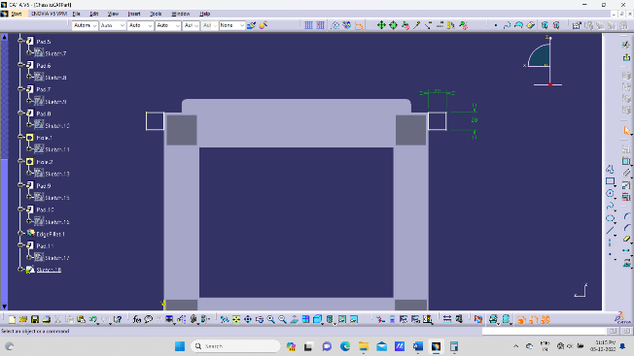
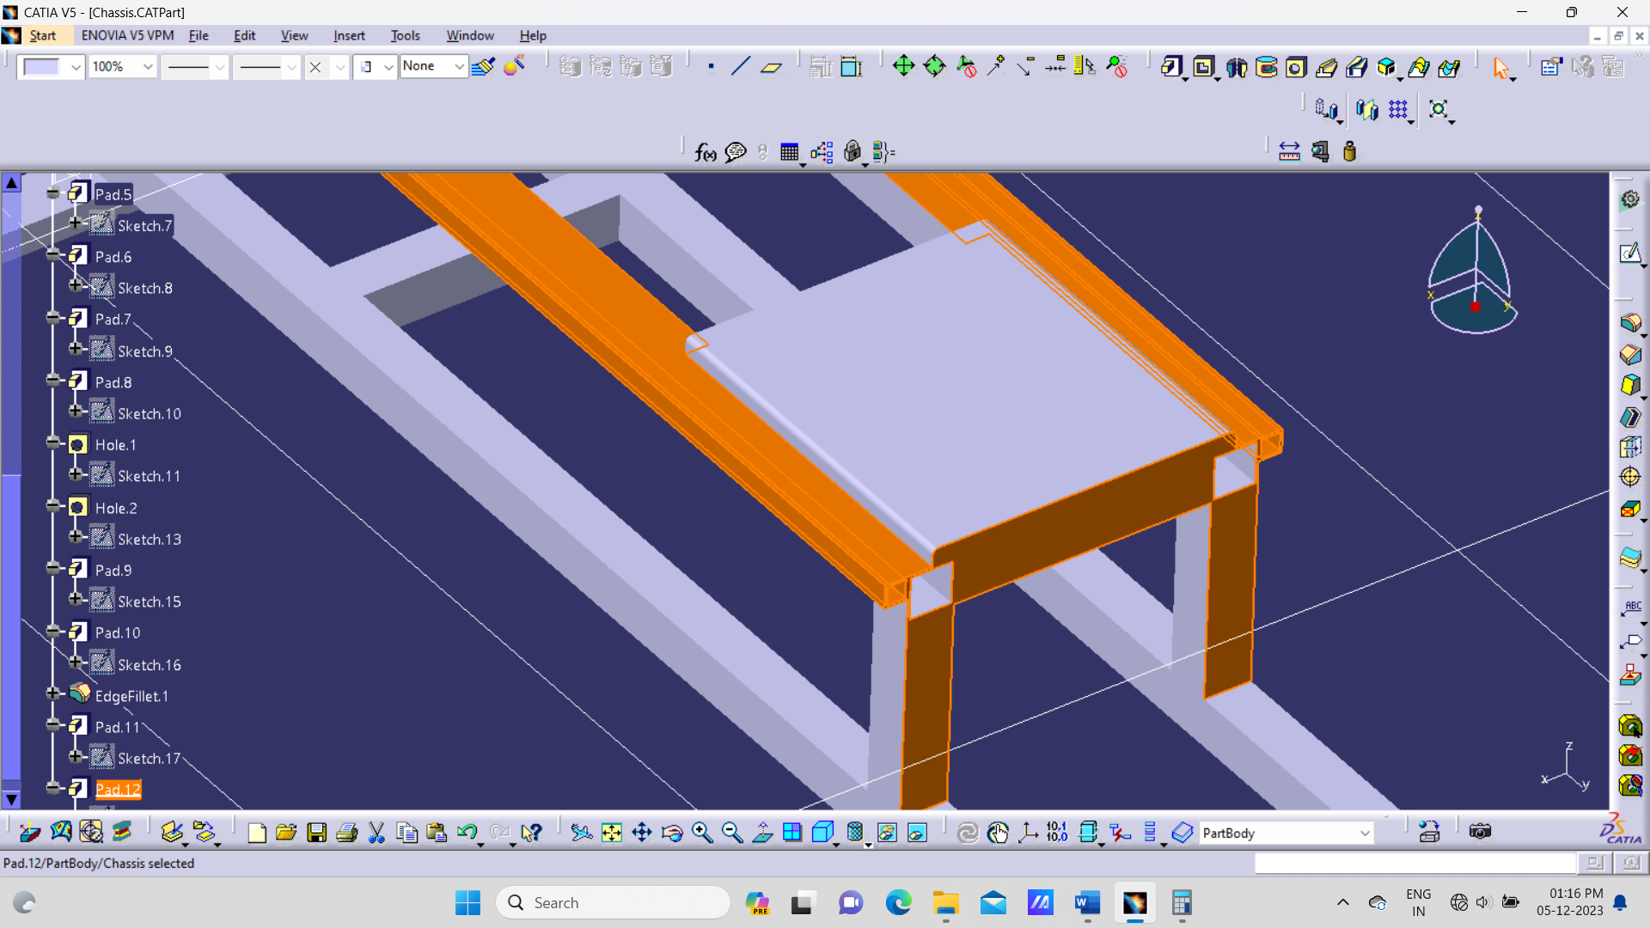
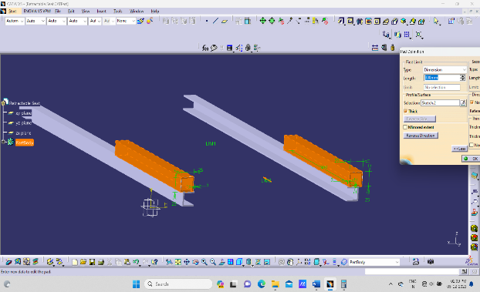
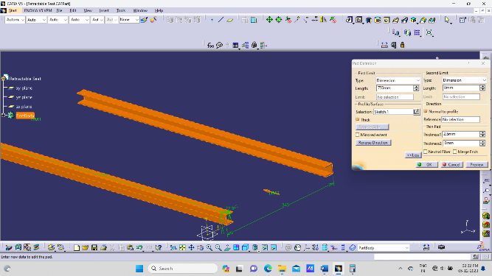

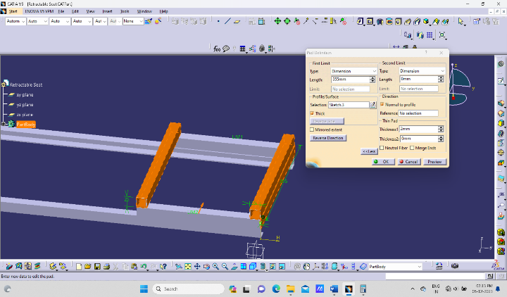
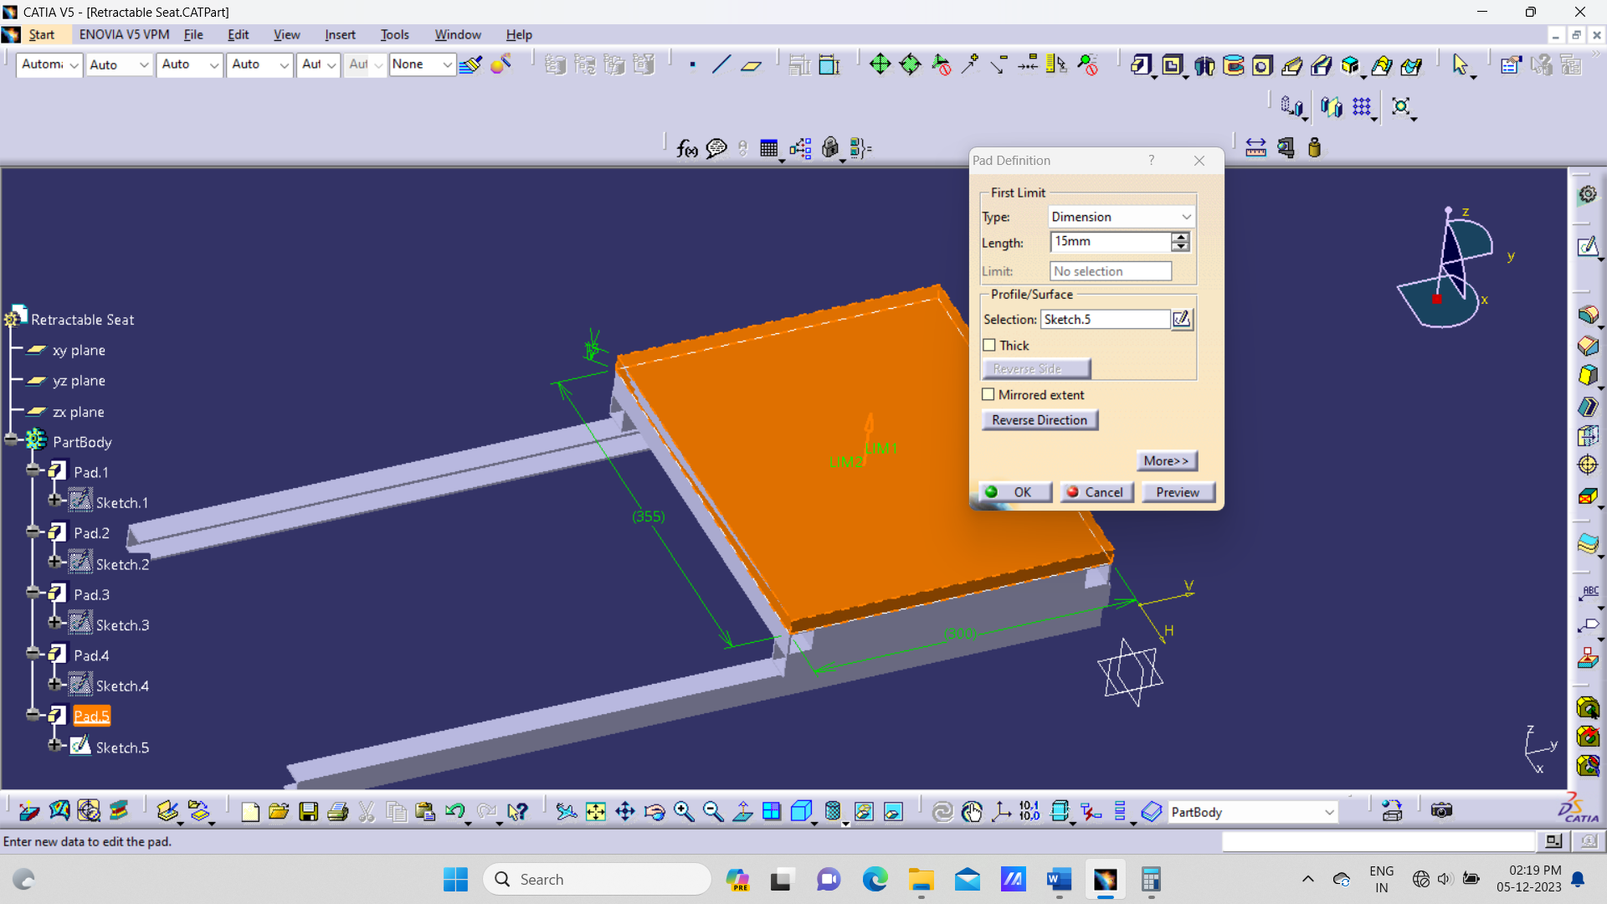
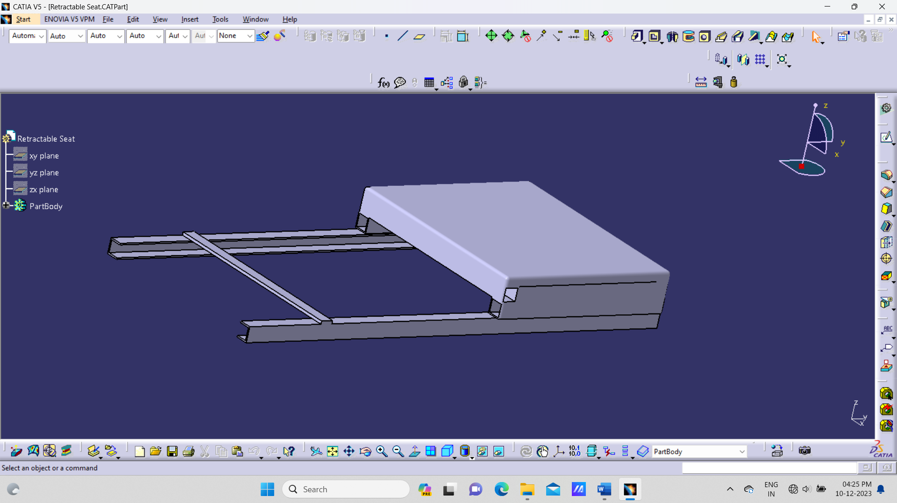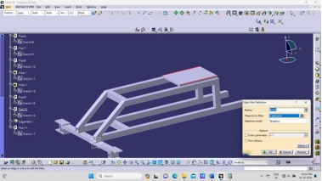

ANALYSIS

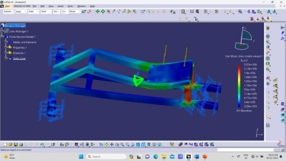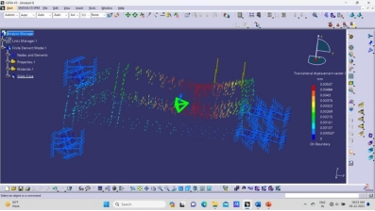

IV. FABRICATION
We have assembled all the components together and the final image of the project is as shown in the figure.
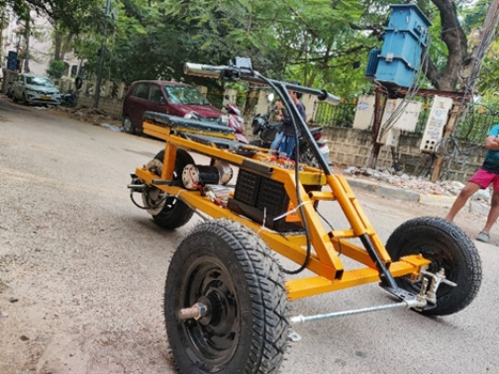
Fig- Final Output
- RESULTS AND DISCUSSION

3 Wheel electric (battery powered) Go Kart is one of the less weight designs that consumes less energy and adds no pollution to the environment. As a part of our project dissertation, we fabricated chassis for telescopic 3-wheel go-kart which contains less in mass hence gives good energy economy and No pollution, easy to transport as it occupies less space when compared to 4-wheel 2-seater go- karts.
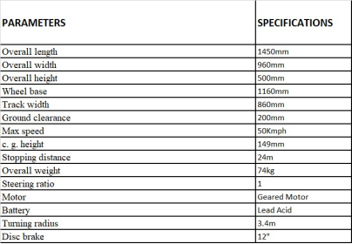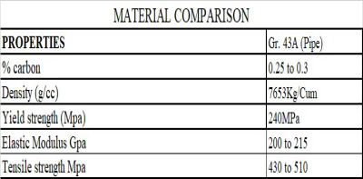
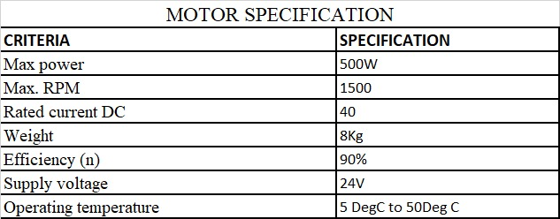
Table: - Go-Kart specifications

- CONCLUSION
We are using 40mm x 40mm, 25mm x 50mm and 25mm x 25mm Mild steel pipes to fabricate chassis of go-kart. The mild steel material sizes and thickness of 2mm is sufficient to bear the load of 150Kgs as per the analysis conducted. The chassis is so designed, it is able to accommodate motor, 3 wheels, batteries, driver and retractable seat, controller etc.
ACKNOWLEDGEMENTS
This work is not an individual contribution till its completion. We take this opportunity to thank all for bringing it close to the conclusion. First of all, we would like to thank our guide Mr. G. Narasimhulu conclusion considering our work and providing great guidance by timely suggestions and discussion at every stage of this work. Thanks to,
Dr. Anoop Kumar Shukla, Head of the Department of Mechanical Engineering for providing all facilities without which this seminar work would not have been possible. We sincerely thank Mr. G. NARASIMHULU for his guidance. I would like to express my gratitude towards my parents & other faculty members of J.B. Institute of Engineering & Technology for their kind cooperation and encouragement which helped me in the competition of this project My thanks and appreciation also go to my co-peers in assisting with different aspects of the project and people who willingly helped me out to the best of abilities.
- REFERENCES
- Company, Houghton Mifflin Harcourt Publishing. "The American Heritage Dictionary entry: chassis"
- Sturmey, Henry (2 April 1908). "The Use of Unsuitable Vehicles". Commercial Motor. 7 (160): 146–147. Retrieved 10 September 2010.
- Pfeffer, Prof Dr Peter E. (2017). 8th International Munich Chassis Symposium 2017: chassis.tech plus. Springer. p. 176. ISBN 9783658184599.
- Jump up to:ª ^{b} "Tatra takes you further". Retrieved 1 July 2015.
- "Tatra AS". Archived from the original on 28 March 2010. Retrieved 22 August 2013.
- "Triumph Herald 2000 chassis". Triumph Herald 2000 and Viking Fibreline Caravan.

