Modified SEPIC converter fed motor drive using ANN controller
Jaipriya P¹, Geetha V²
¹Jaipriya P PG scholar, power electronics and drives ,Government college of Engineering, Salem.
²Geetha V Professor & HOD EEE, Government college of Engineering, Salem.
³Third Author Department & College

---------------------------------------------------------------------***---------------------------------------------------------------------
Abstract - Modern day-to-day devices also use an AC source as an input while working with DC voltage. An AC-DC converter is used to get an effective and versatile DC output. Without sacrificing conversion efficiency, however, traditional converters are not suitable for high voltage output. Within this paper a new topology called the Cascaded Boost-SEPIC (CBS) converter is suggested. The converter is validated on the basis of conversion efficiency, minimum THD and maximum power factor. The results obtained evinces the improvement achieved in the power quality.
Key Words: AC-DC Converter; ANN (Artificial Neural Network controller); Separately excited DC motor

1.INTRODUCTION

Electronic devices are used in grid-connected systems, communication systems, and power supply systems etc. which play an indispensable role in our daily lives. Devices operate in variable voltage levels. A converter that facilitates the capability of different level of operating voltage is essential for versatile use. But not all converters are able to make conversion properly without compromising performance. It is almost always the case that a tradeoff has to be made between necessity and performance. High voltage gain will cause for a deterioration of signal shape (high THD).
The overall efficiency goes down slightly as the duty cycle rises in conventional converter. ^{[1][8]} Again increasing duty cycle causes conduction losses and serious reverse-recovery problem in diodes. ^{[9][10]} Also Boost converter can operate with lower voltage level of MOSFET. Boost converter also gives output with lower distortion which makes the circuit manage the THD level as low as possible.
In this paper a new topology is introduced – Cascaded Boost SEPIC (CBS), which is used to avail different voltage level in accordance the duty cycle. Higher voltage conversion can be achieved using cascaded Boost-SEPIC converter.

1. Block diagram
The following block diagram that consist of AC supply that is rectified by the full wave rectifier and converted into DC supply and then the switch is controlled by the ANN controller and given to the motor load.
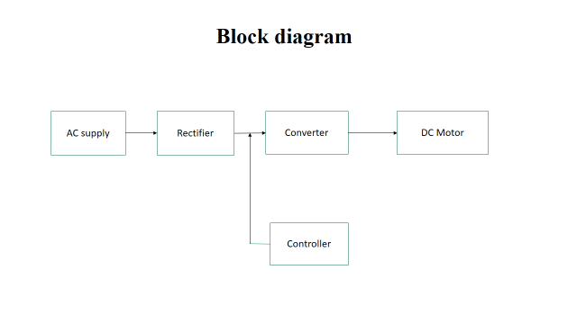

Circuit diagram
In this Fig 3.1.1 it shows that the circuit diagram of the SEPIC converter with given input AC supply to the circuit and the diode it converts into DC supply by using the full bridge rectifier and then the switch is being controlled by using ANN (Artificial Neural Network) and then output will given to the load.

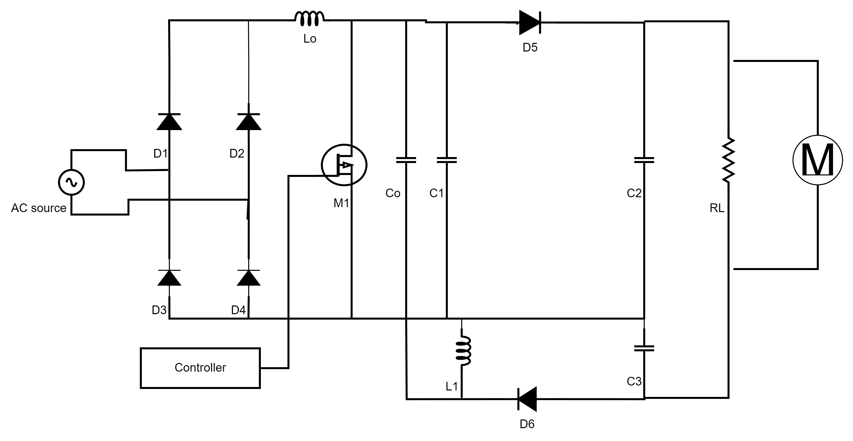

Modes of operation
Mode 1:
In mode 1 operation Fig 3.2.1 shows that the current flows from the higher potential to the lower potential. At mode 1 when the switch is ON , the diode D₅ will not conduct and the current flows from the supply through diode D₆ and C₂ supplies energy to load.
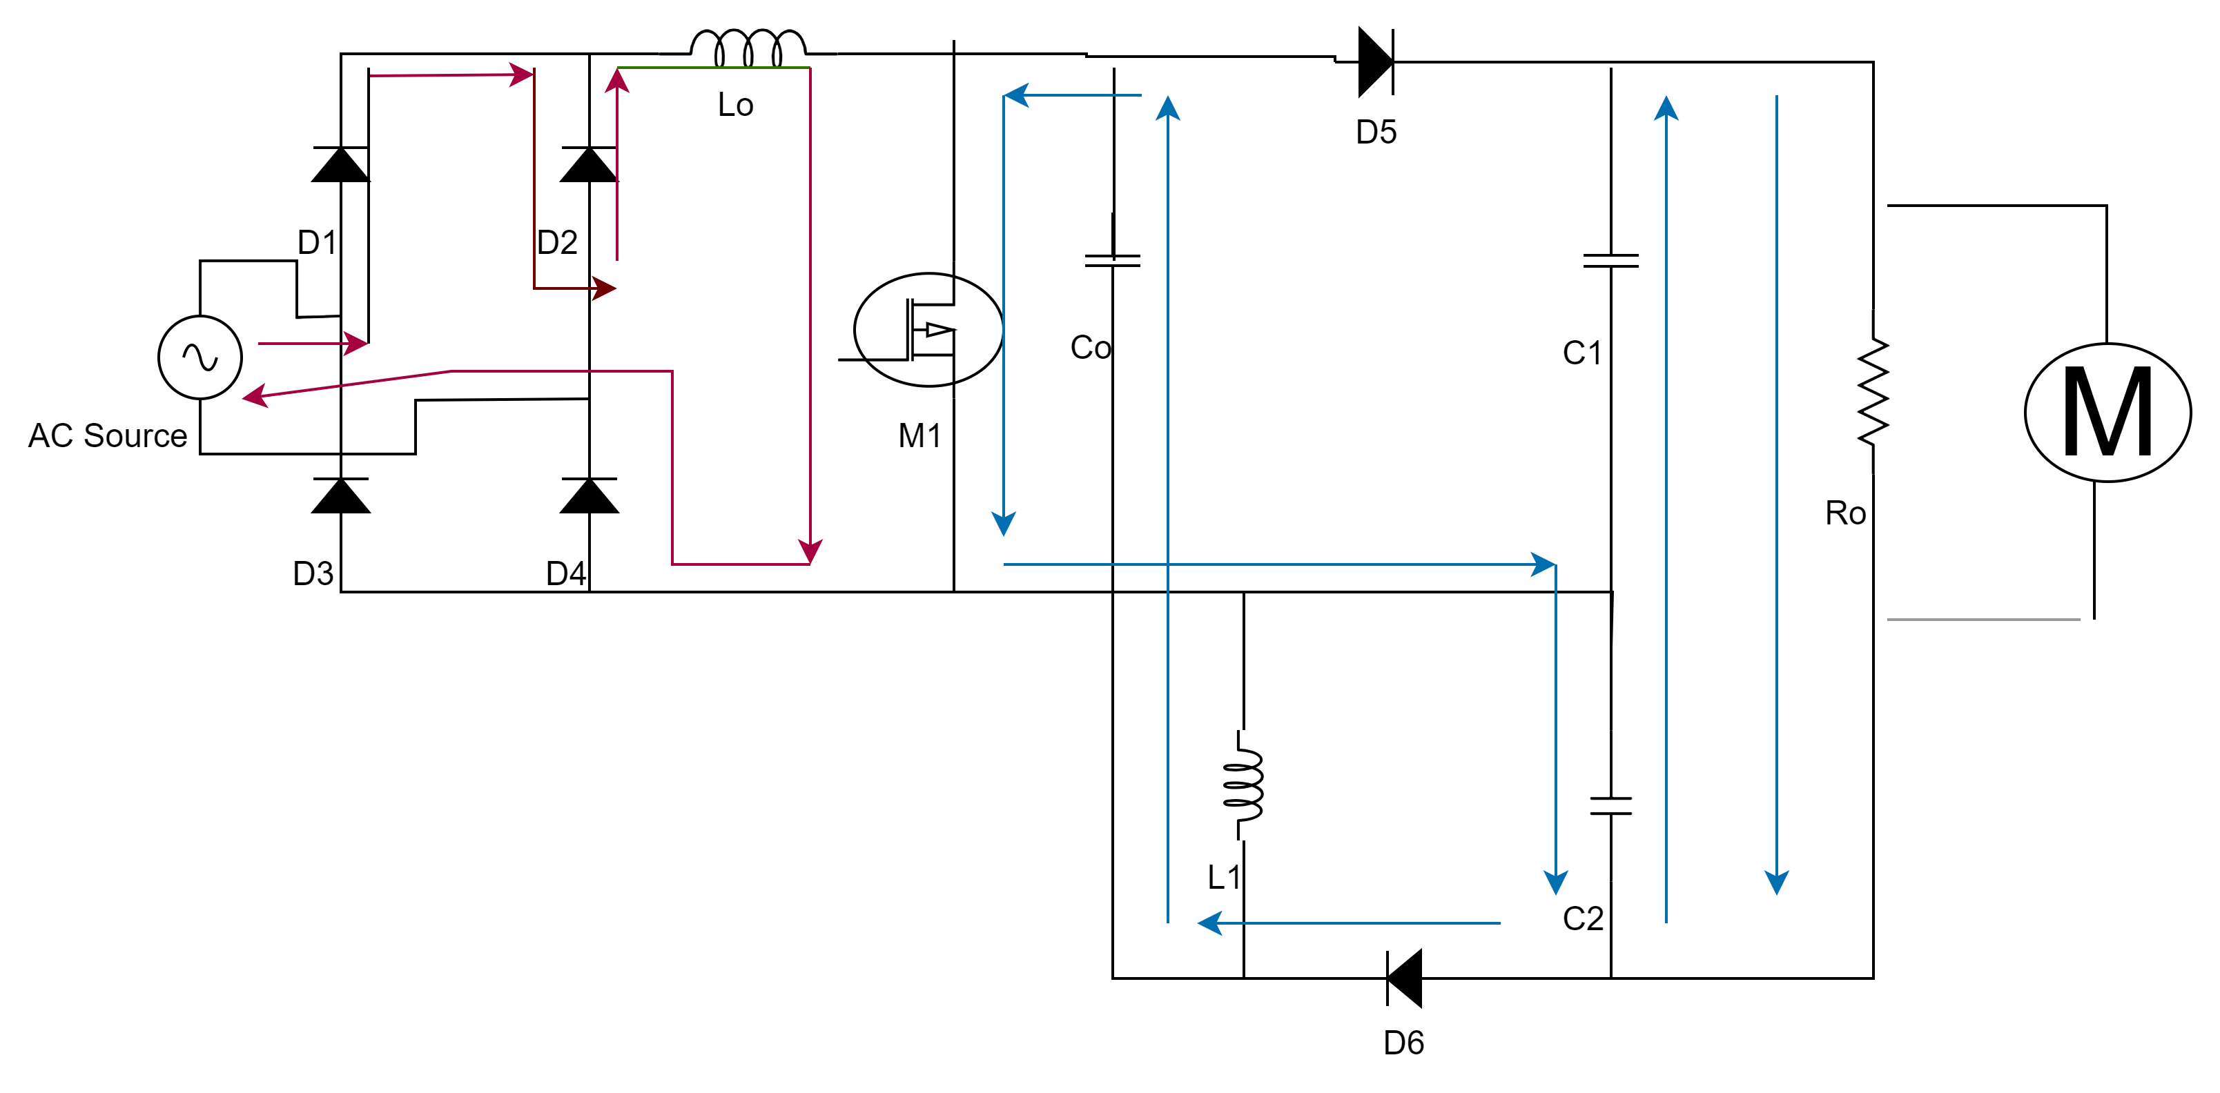

Mode 2:
In mode 1 operation Fig 3.2.2 shows that the current flows from the higher potential to the lower potential. At mode 2 when the switch is OFF, the diode D₆ will not conduct and the current flows from the supply through diode D₅ and C₃ supplies energy to load.
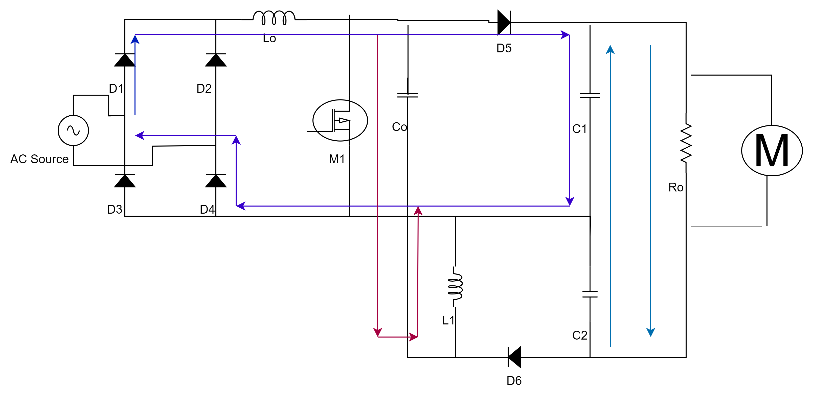

Mode 3:
In mode 3 operation Fig 3.2.3 shows that the current flows from the lower potential to the higher potential. At mode 3 when the switch is ON , the diode D₅ will not conduct and the current flows from the supply through diode D₆ and C₂ supplies energy to load.

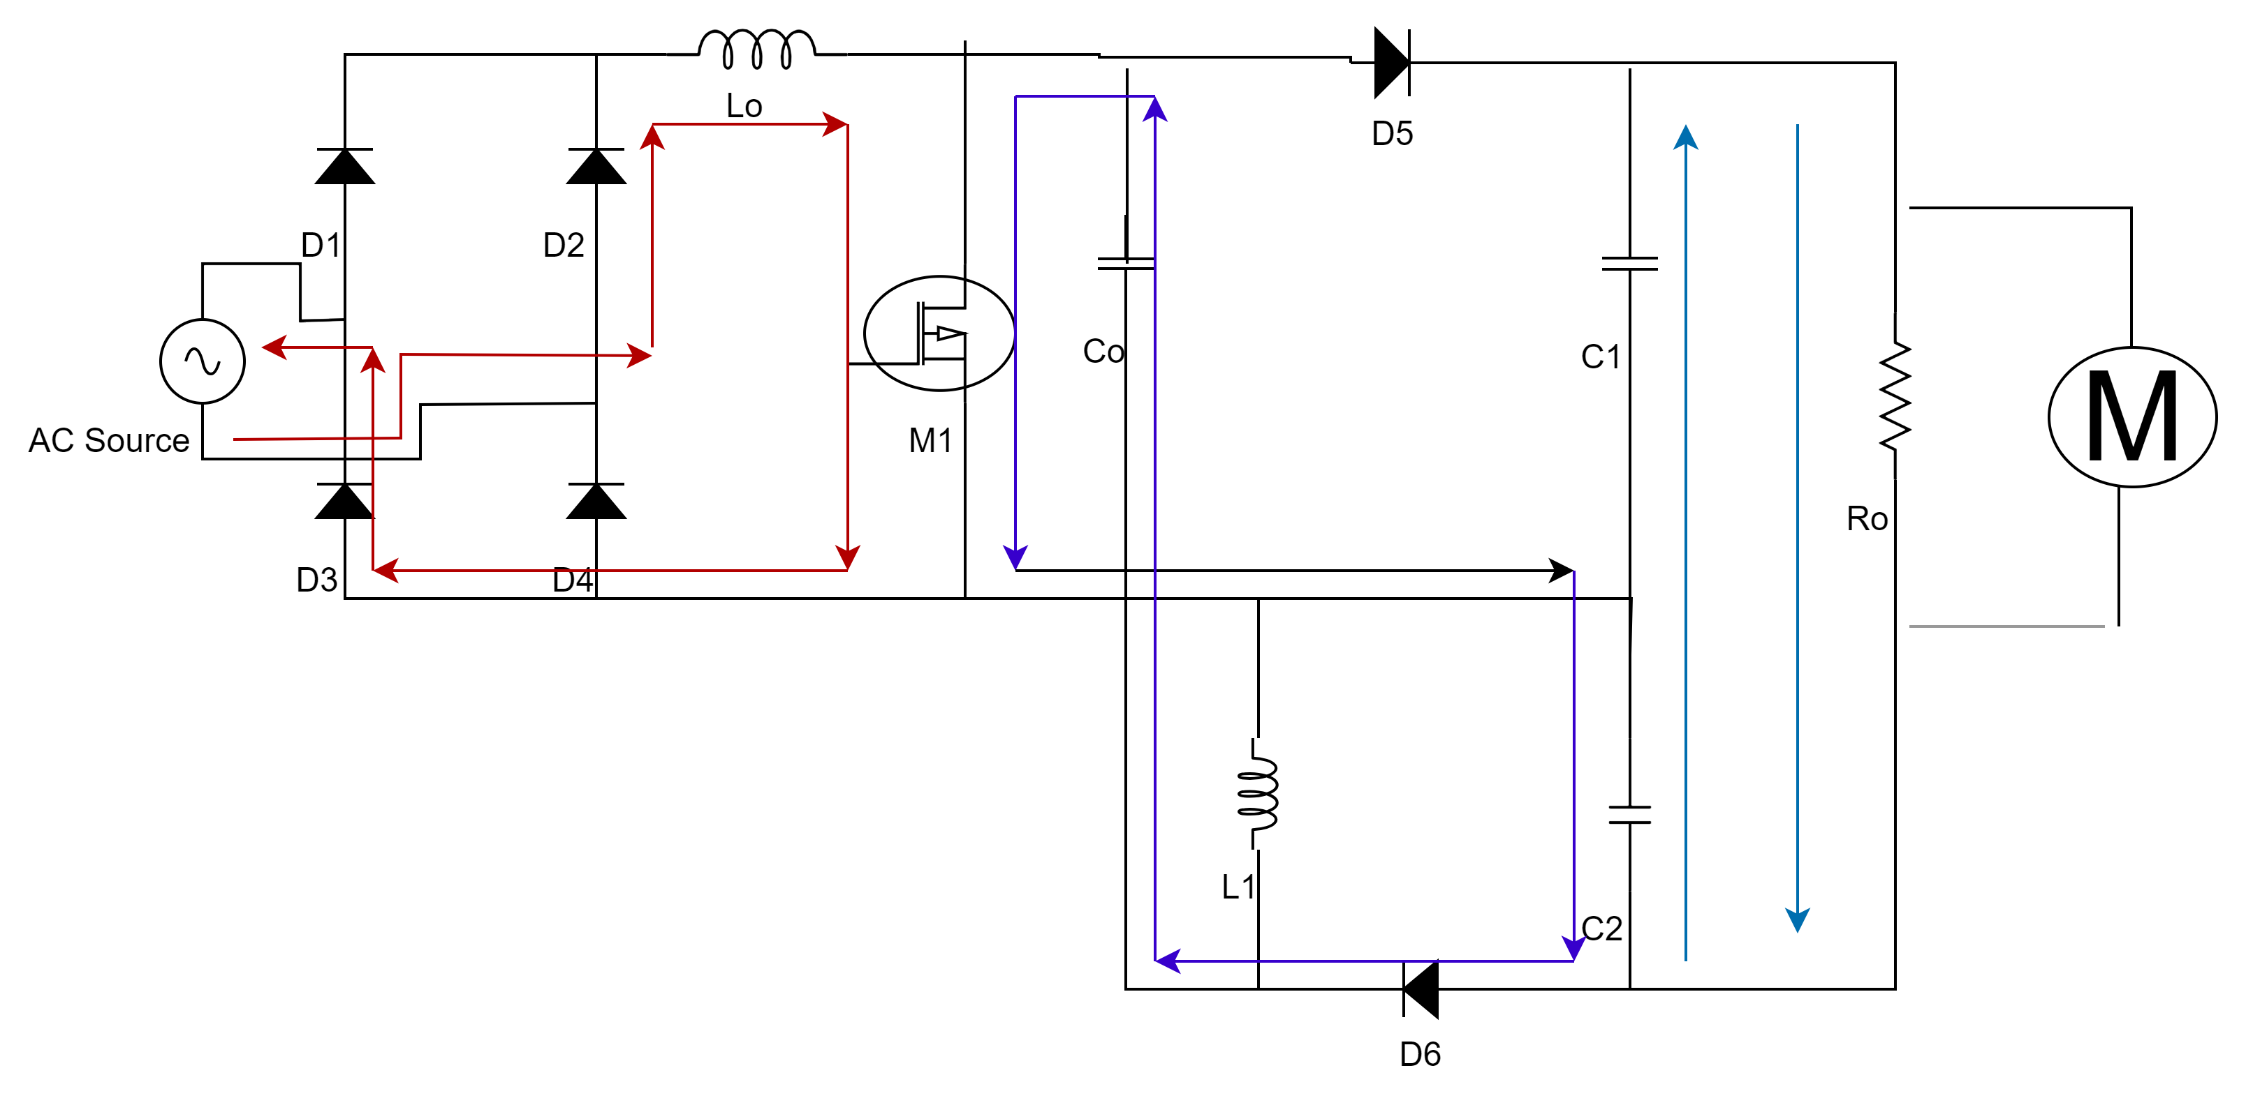

Mode 4:
In mode 4 operation Fig 3.2.4 shows that the current flows from the lower potential to the higher potential. At mode 3 when the switch is OFF, the diode D₆ will not conduct and the current flows from the supply through diode D₅ and C₃ supplies energy to load.
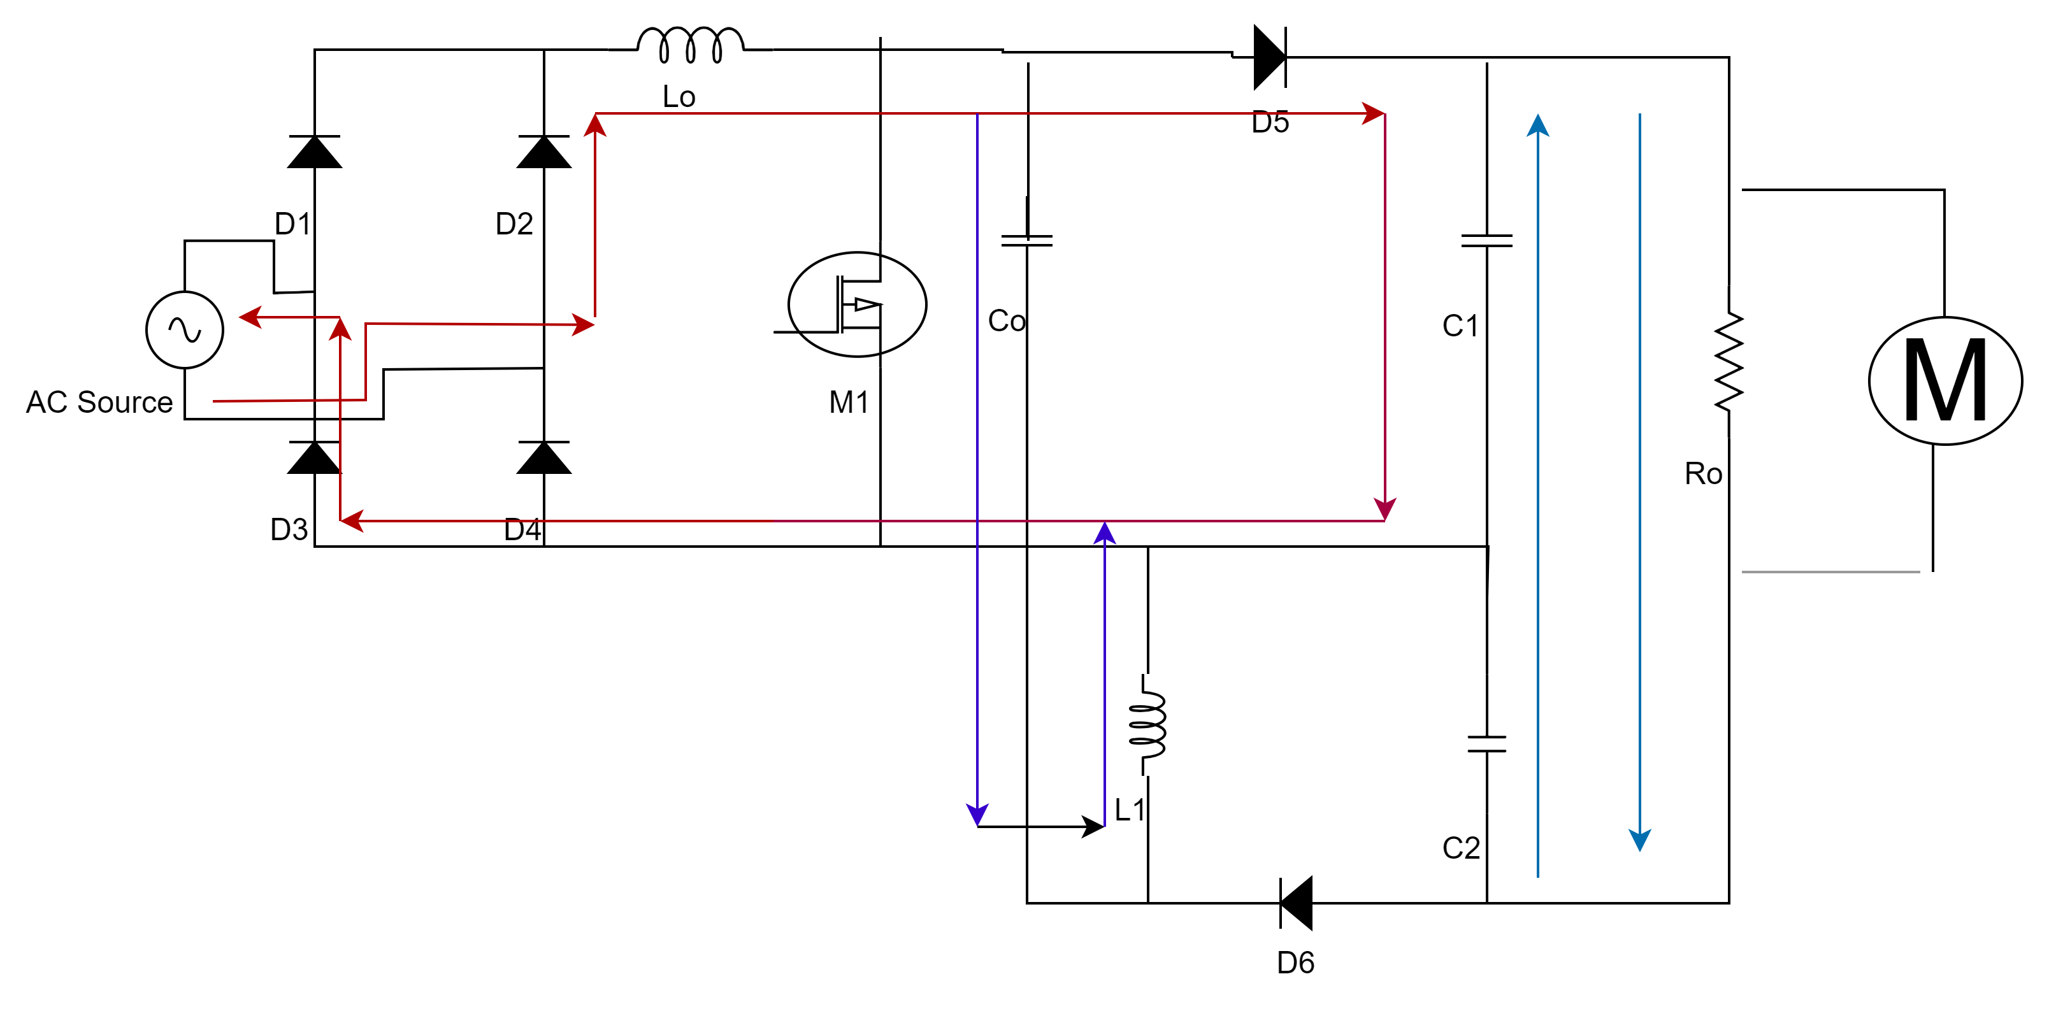

Table of modes of operation:
Modes | Switch | Conduction of diode | Energy flow
Mode 1(Higher potentialto lower ) | ON | D₆ | C₂
Mode 2Low to high potential | OFF | D₅ | C₃
Mode 3(Higher potential to lower potential) | ON | D₆ | C₂
Mode 4(Low to high potential) | OFF | D₅ | C₃

Modelling of the Converter
The voltage gain of the converter is calculated by the given formula.
$$v_{0}=v_{01}+v_{02---------------------1 }$$
$$v_{0}=\frac{1}{\left(1-D\right)}v_{i}+\frac{D}{\left(1-D\right)}v_{i --------- 2 }$$
${ v}_{0}$=${ Gv}_{i}$
G = $\frac{\left(1+D\right)}{\left(1-D\right)}$ -------------------------------3
Design of the converter
Selection of Inductor
ߡI_{L} = I_{N} × 40% = I_{out} ×$\frac{\text{v}\text{out}}{\text{v}in⁡}$ × 40%
Where ߡI_{L} = Ripple current of inductors
I_{N} =Input current
I_{out =} Output current
L_{o =} L₁ = L $\frac{v_{in(min)}}{\text{ߡ}\text{I}\text{L}\text{×f}sw}$
Selection of Capacitor
I_{out(RMS) =} I_{out} × $\sqrt{\frac{\text{v}\text{out+}\text{v}\text{D }}{\text{V}in min⁡}}$
I_{out =} Output current
$\text{C}\text{out}$ ≥ I_{out} × $\frac{\text{I}\text{ou}t\text{×} D}{\text{V}\text{ripple}\text{×}0.5}$
$\text{C}\text{out}$ is the output capacitance
Selection of Diode
V RD1 = V IN (max) +V OUT (max)
Minimum peak reverse voltage the diode must withstand is =V_{RD1}

Simulation Diagram
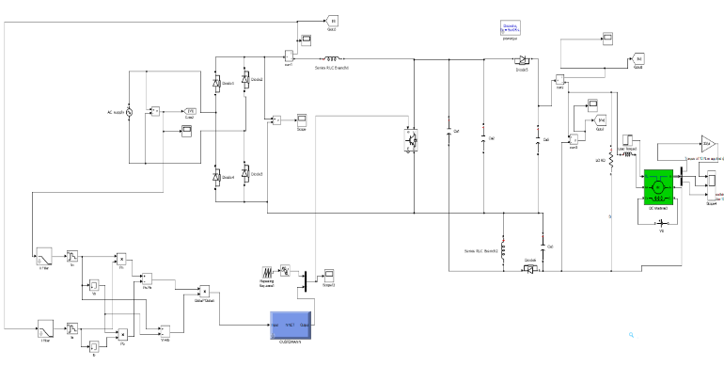
Fig 1.1 Simulation diagram
Simulation Results
Input Voltage waveform
Fig 1,2 Shows the input voltage waveform that is obtained in the MATLAB/SIMULINK.

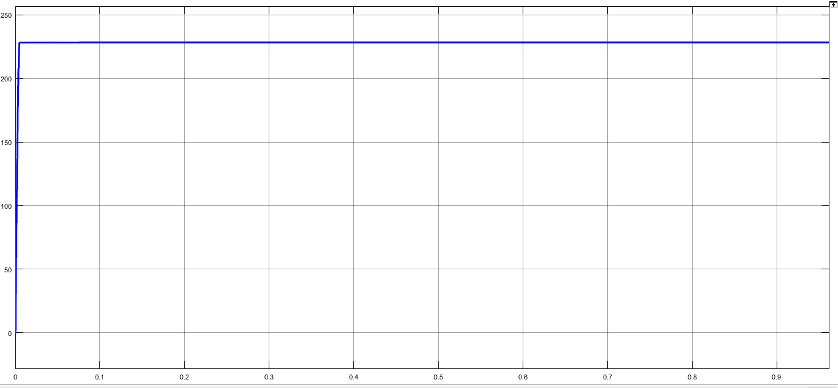
Fig 1.2 Input voltage waveform

Input Current Waveform
Fig 1.3 Shows the simulated waveform of input current in MATLAB/ SIMULINK.

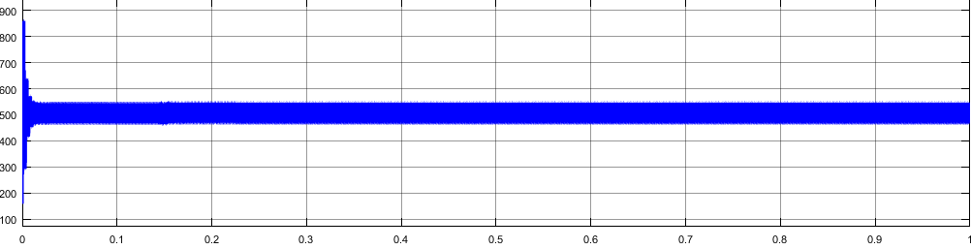
Fig 1.3 Input current waveform.

Input voltage after rectification
Fig 1.4 Shows the simulated waveform of the input voltage after rectification in MATLAB/SIMULINK.

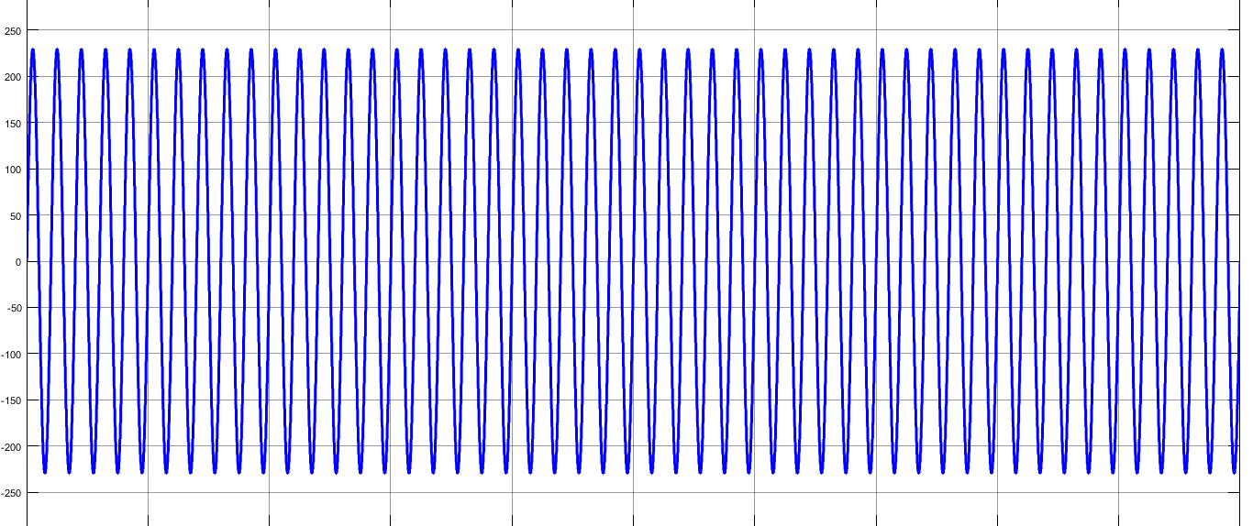
Fig 1.4 Input voltage rectification
Output current waveform
Fig 1.5 Shows the waveform of the output current that is simulated in MATLAB/ SIMULINK.

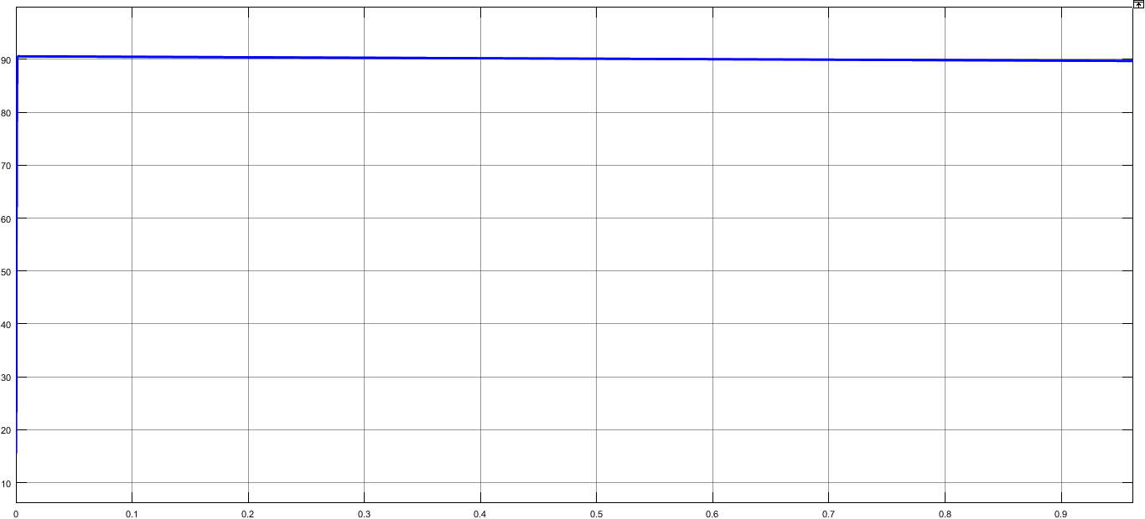
Fig 1.5 Output current waveform
Output voltage Waveform
Fig 1.5 Shows the waveform of the output current that is simulated in MATLAB/ SIMULINK.
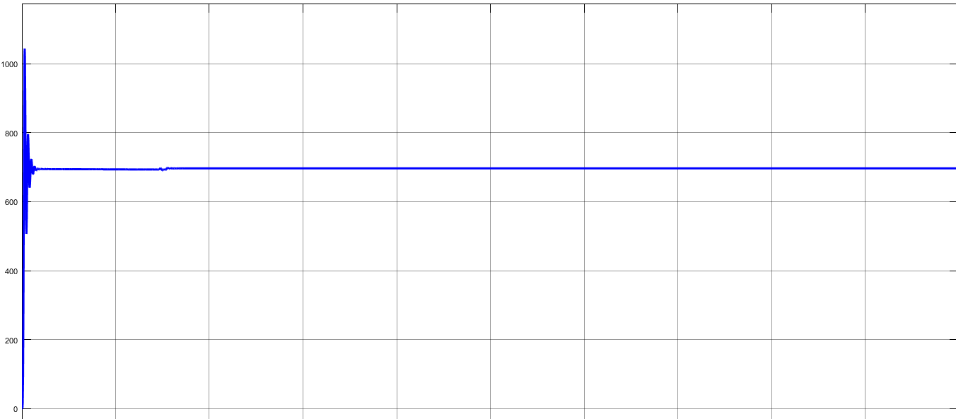
Fig 1.6 output voltage waveform

Simulated Parameters
Table 1.1 Shows the simulated parameters
Parameters | Values
Input voltage | 230V
$$L_{0 },L_{1}$$ | 3.36µH
$$C_{0}{ ,C}_{1}$$ | 4.7µF
$$C_{2}{ ,C}_{3}$$ | 100µF

3. CONCLUSIONS

The proposed MBS converter designed by cascading Boost and SEPIC converter to obtain the advantages of both the converters. The maximum efficiency the circuit can produce without any controller is 97.8%. However the THD was quite high which is brought down to 9.94% by using the PI controller. The power factor is also improved with the addition of the PI controller. The proposed MBS converter can be effectively used for high voltage DC application like DC micro grid, heater etc.

REFERENCES

[1 ]Wilmar Martinez, Camilo A. Cortes, Jun Imaoka, Kazuhiro Umetani, Masayoshi Yamamoto, "Current ripple modeling of an interleaved high step-up converter with coupled inductor", Future Energy Electronics Conference and ECCE Asia (IFEEC 2017 - ECCE Asia) 2017 IEEE 3rd International, pp. 1084-1089, 2017.
[2] Y. Liang, "A New Type of Statcom Based on Cascading Voltage Source Inverters with Phase-shitted Unipolar SPWM", IAS'98
[3] D.-H. Lee, F. C. Lee, "New Cascade Switch Multilevel PWM Converters", APEC'99, pp. 329-324.
[4] L. Huber, M. M. Jovanovic, "A design approach for server power supplies for networking applications", Proc. 15th Annu. IEEE Appl. Power Electron. Conf. Exp., pp. 1163-1169, 2000.
[5] L. Muller, J. W. Kimball, "High gain DC-DC converter based on the cockcroft-walton multiplier", IEEE Transactions on Power Electronics, vol. 31, no. 9, September 2016.
[6] J. P. de Souza, DE Oliveira, R. Gules, E. F. R. Romaneli, A. A. Badin, "A high static gain CUK DC-DC converter", IEEE 13th Brazilian Power Electronics

Conference and 1st Southern Power Electronics Conference, 2015.
[7] A. A. A. Freitas, F. L. Tofoli, E. M. Sa, S. Daher, F. L. M. Antunes, "High-voltage gain DC-DC boost converter with coupled inductors for photovoltaic systems", IET Power Electronics, vol. 8, no. 10, April 2015.
[8] R. W. Erickson, D. Maksimovic, Fundamentals of Power Electronics, Kluwer Academic Publishers, 2001. [9] . Q. Zhao, F. Tao, F. C. Lee, P. Xu, J. Wei, "A simple and effective to alleviate the rectifier reverse-recovery problem in continuous-current-mode boost converter", IEEE Trans. Power Electron, vol. 16, no. 5, pp. 649-658, Sep. 2001.
[10] C. T. Pan, C. M. Lai, M. C. Cheng, L. T. Hsu, "A low switch voltage stress interleaved boost converter for power factor correction", IEEE Int. Conf. Power Electronics and Drive Systems, pp. 49-54, 2009.

