REMOVAL OF LEAD FROM WATER BY USING ADSORPTION
A.M.Yuvajeyshree¹, R.Saraswathi²
Department of Civil Engineering & Coimbatore Institute of Technology
Department of Civil Engineering & Coimbatore Institute of Technology

Contact Information
A.M.Yuvajeyshree
2nd- M.E. - Environmental Engineering and Management
Department of Civil Engineering
Coimbatore Institute of Technology
No.68, Bazzar Street,
Ammoor,
Ranipet- DT- 632501
6379925662, 9940822292
yuvajeyshree@gmail.com

Abstract:
Adsorption is an effective method in treating heavy metals of wastewater. The presence of high dissolved lead (Pb) concentration in water and can cause health problems for long-term exposure to these heavy metals. This study investigates eggshell, pomegranate peel and orange peel as an alternative adsorbent. The effects of contact time, initial metal concentration and adsorbent dosage were studied in batch experiments. Overall, the findings suggest that eggshell, pomegranate peel, and orange peel are promising low-cost and eco-friendly adsorbents for the removal of lead from contaminated water sources. The removal percentage of lead observed was 99.05% from eggshell, 99.01% from pomegranate peel and 99% from orange peel. The result shows that more than 90% removal of Pb occurred at optimum contact hours of 40 minutes for eggshell, 70 minutes for pomegranate peel and 80 minutes for orange peel and optimum initial concentration was 4 ppm for eggshell, 4 ppm for pomegranate peel and 6 ppm for orange peel Pb removal. Design using response surface methodology was carried out in this work. The RSM modelling was found to be successful in predicting the removal efficiency with R² greater than 0.90.
Key words: Adsorption, Eggshell, Pomegranate peel, Orange peel and Heavy metal removal.
1. Introduction:
Lead contamination in water sources poses a significant threat to public health and environmental well-being. Lead, a toxic heavy metal, can infiltrate water supplies through various pathways, including corroded plumbing systems, industrial runoff, and environmental pollution. Exposure to lead-contaminated water can result in severe health consequences, particularly for vulnerable populations such as children and pregnant women. The urgent need to mitigate lead contamination has prompted the exploration of innovative and sustainable solutions, among which adsorption using natural materials has emerged as a promising method.
This study focuses on the removal of lead from water using adsorption techniques with three natural adsorbents: eggshell, pomegranate peel, and orange peel. These materials have gained attention due to their abundance, low cost, and environmentally friendly properties. By harnessing the adsorption capabilities of these natural substances, this research aims to contribute to the development of effective and accessible methods for lead remediation in water treatment processes.
The effectiveness of eggshell, pomegranate peel, and orange peel as adsorbents for lead removal will be investigated through batch experiments. Parameters such as contact time, initial lead concentration, and adsorbent dosage will be analyzed to optimize the removal efficiency of each adsorbent. Furthermore, the adsorption mechanisms and surface characteristics of the materials will be explored to gain insights into their performance in lead removal.
This study holds significance not only for its potential to provide a sustainable solution for lead remediation but also for its contribution to the utilization of natural resources in environmental protection efforts. By investigating the adsorption capabilities of eggshell, pomegranate peel, and orange peel, this research aims to offer insights into the development of cost-effective and environmentally friendly methods for addressing lead contamination in water sources. Ultimately, the findings of this study may contribute to the advancement of water treatment technologies and the protection of public health from the hazards of lead exposure.
The study utilized Response Surface Methodology (RSM) to determine the optimal combination of various factors influencing the removal of Pb from wastewater. RSM proved advantageous by reducing the number of experiments required, lowering costs, mitigating experimental challenges, and minimizing time compared to other statistical methods.
In this investigation, Box Behnken Design (BBD) was employed to model and predict the removal of Pb. The factors under consideration included the concentration of Pb ions, contact time, temperature, and time. RSM was selected as a robust statistical and scientific approach to assess the effectiveness of the experimental method. By employing different parameters simultaneously within the RSM framework, the study aimed to streamline the experimental process and reduce the number of trials through Design of Experiment (DOE).
In the present study, the Eggshell, pomegranate peel and orange peel was used to prepare adsorbent to remove heavy metal particularly Pb ion from synthetic water.
2. Materials and methods:
2.1.1. Eggshell:
Eggshells obtained from kitchen waste serve as the primary adsorbent in this study. To prepare the eggshells, they undergo thorough cleaning using boiled de-ionized water to eliminate any dirt particles. Following the removal of the eggshell membrane, the shells are crushed into irregularly sized pieces, as uniformity in size is not a parameter under investigation. Subsequently, the crushed eggshells are air-dried in a hot air oven set at 105°C. After 24 hours, the drying process is repeated, with the eggshells washed again until no discoloration is observed, followed by another 24-hour drying period in the hot air oven. Once completely dried, the eggshells are stored in an airtight container for future use in the adsorption experiments.
2.1.2. Pomegranate peel:
The pomegranate peels, gathered for this study, underwent initial preparation by being cut into small pieces and washed with distilled water to eliminate any inherent dust and dirt particles. Following this, the washed peels were immersed in double-distilled water overnight, after which the soaked sample was filtered. This overnight soaking and filtration process was repeated multiple times until all coloration and soluble materials were effectively removed from the pomegranate peels.
Subsequently, the decoloured peels were subjected to oven-drying at a temperature of 105°C for duration of 3 hours. Once dried, the peels were crushed to achieve the desired particle size of 120 micrometers and subsequently stored in an air-tight container for future utilization in the experimental procedures.
2.1.3. Orange peel:
Orange peels were gathered from fruit shop and were rinsed with distilled water, after which they were air dried and later oven dried at 80 °C for 12 h. It can be stored in a container which is air tight for further analysis.

2.2. Preparation of Aqueous solutions for lead (Pb):

A stock solution of lead was prepared (1000 mg L⁻¹) by dissolving required amount of Pb (NO₃)₂ in distilled water. The stock solution was diluted water to obtain desired concentration ranging from 20 to 60 mg L⁻¹.

2.3. Batch adsorption experiment:

The experiments were conducted using a thermal shaker to maintain controlled temperature conditions for duration of 1 hour, with agitation at 120 rpm. 250 mL Erlenmeyer flasks were utilized, each containing 100 mL of solutions with varying concentrations of lead ions (Pb) at different temperatures. Jar tests were performed to investigate the impact of various operational parameters on the adsorption rate. Different weighted amounts of each sample (e.g., eggshell, pomegranate peel, or orange peel) were added to 100 mL solutions with varying initial concentrations of Pb ions. The batch process was chosen to ensure consistency, eliminating the need for volume correction during the experiment. Samples were withdrawn from the flasks at regular intervals, and the residual concentration of Pb ions in the solution was determined using Atomic Absorption Spectroscopy (AAS). Prior to analysis, the adsorbent material was separated from the solution by filtration using Whatmen filter paper to ensure it was free from any carbon residues. This methodology allowed for accurate assessment of the adsorption capacity and efficiency of the adsorbent materials for removing Pb ions from solution.

2.4. Batch Experiment Studies:

Literature suggests that removal of Pb from wastewater over activated carbon using adsorption depends very much on the factors such as pH, contact time, initial concentration and adsorbent dosage. Therefore, the influences of these parameters were investigated by varying any one of the process parameters and holding the other parameters constant.

2.4.1. Effect of pH:

The stability of Pb is dependent on the pH of the system. Lead in aqueous solution can be present in different ionic forms, which are closely related to the pH of the solution. The effect of solution pH on Pb adsorption was studied using Eggshell, Pomegranate peel and Orange peel as adsorbent. The experimental results showed that the adsorption was favourable at acidic condition and decreased with increasing pH. The percentage of Pb adsorbed by Eggshell decreased from 97.75% to 92.40% when the pH was increased from 5 to 10. The maximum percent removal of Pb was obtained at pH 5, and therefore pH 5 was selected for the rest of the experiments. The percentage of Pb adsorbed by pomegranate peel decreased from 98.85% to 98.65% when the pH was increased from 4 to 10. The maximum percent removal of Pb was obtained at pH 4, and therefore pH 4 was selected for the rest of experiments. The percentage of Pb adsorbed by orange peel decreased from 97.65% to 96.70% when the pH was increased from 5 to 10. The maximum percent removal of Pb was obtained at pH 5, and therefore pH 5 was selected for the rest of experiments.

2.4.2. Effect of time of contact:

The effect the contact time on the percentage of removal of Pb by the eggshell, pomegranate peel and orange peel. The Time effect was studied by shaking the Pb solution with adsorbent for a specified time interval. Various time Intervals were chosen for determining the removal of the Pb by the eggshell.10, 20, 30, 40, 50,60,70,80 and 90 minutes with the time interval of 10 minutes were taken up for the studies. After that 40, 70 and 80 minutes were taken for the removal of Pb by the eggshell, pomegranate peel and orange peel.
2.4.3. Effect of Adsorbent dosage:
Adsorbent dosage is an important parameter because this determines the capacity of an adsorbent for a given initial concentration, separation cost and consequently the overall water treatment cost. The percentage of Pb adsorbed by Eggshell from 98.80% when the dosage 0.2 g L⁻¹. The percentage of Pb adsorbed by pomegranate peel from 98.65% when the dosage 0.7 g L⁻¹. The percentage of Pb adsorbed by orange peel from 99.3% when the dosage 0.3 g L⁻¹.
2.4.4. Effect of initial concentration:
Experimental results showed that the adsorption capacity increased with increasing initial Pb concentration because fraction of surface coverage increased subsequently. The increase in initial concentration of lead results in the increased uptake capacity and decreased percent removal since at high initial concentrations, number of moles of lead available to surface area is high, number of collisions between lead molecules and adsorbent get increased, and a driving force to overcome all mass transfer resistances between the aqueous and solid phases is developed. When the initial concentration of Pb was 4ppm, the adsorption process utilizing pomegranate peel achieved a remarkable removal percentage of 95.5%. When the initial concentration of Pb was 4ppm, the adsorption process utilizing eggshell achieved a remarkable removal percentage of 99.05%. When the initial concentration of Pb was 6ppm, the adsorption process utilizing orange peel achieved a remarkable removal percentage of 99.35%.
2.5. Experiment Parameter:
The effect of pH on the percentage removal was investigated over the range of 2-12. The pH was adjusted by addition of 0.1 M HCI or NaOH. The effect adsorbent dosage (1-10 g/L), initial Pb ions concentration (10-100 mg/L) and temperature (10-50 °C) on the adsorption potential of Pb ions were studied. The Pb concentration retained in the adsorbent phase was calculated according to:
q_{e} = $\frac{(C0 – Ce)V}{W}$
Where Co and C, are the initial and equilibrium concentrations (mg/L) of lead solution respectively; V is the volume (L): and W is the weight (g) of the adsorbent. Two replicates per sample were done and the average results are presented

By knowing the lead concentration at initial concentrations and equilibrium concentrations, the efficiency of adsorption of lead can be calculated by using the following equation for efficiency of adsorption lead:
Adsorption (%) = $\frac{(C0 – Ce)}{W}$ × 100
2.6. Analytical Method:
Atomic-absorption spectrophotometer utilizes the phenomenon that atoms absorb radiation of particular wavelength. By atomic- absorption spectrophotometer, the metals in water sample can be analyzed. It consists of four basic structural elements; a light source (hollow cathode lamp), an atomizer section for atomizing the sample (burner for flame, graphite furnace for electro thermal atomization), a monochrometer for selecting the analysis wavelength of the target element, and a detector for converting the light into an electrical signal. It detects concentration of Pb in ppm level in the solution and volume of sample required is only 1 ml for one analysis.
3. Results and discussion:
3.1. Development of regression model equation
CCD was used to develop correlation between the adsorption of lead from aqueous solution variables to the adsorption of lead in eggshell, pomegranate peel and orange peel. The complete experimental range and levels of independent variables are given in Table 2. Runs 25-30 at the centre point were used to determine the experimental error. According to the sequential model sum of squares, the models were selected based on

Table 1
Relationship between coded and actual value of the variables
Code | Actual level of variable
-α | X_{min}
-1 | [(X_{max} + X_{min}/2]- [(X_{max} - X_{min}/2β]
0 | (X_{max} + X_{min}/2
+1 | [(X_{max} + X_{min}/2]+ [(X_{max} - X_{min}/2β]
+α | X_{max}
Where X_{max} and X_{min} are maximum and minimum values of X, respectively; β is 2^{n/4}.
Table 2
Experimental range and levels of independent variables
Variables | Symbol | -α | -1 | 0 | +1 | +α
Contact time(min) | X₁ | 10 | 20 | 30 | 40 | 50
pH | X₂ | 2 | 4 | 6 | 8 | 10
Initial concentration(mg L⁻¹) | X₃ | 10 | 20 | 30 | 40 | 50
Adsorbent dose(g L⁻¹) | X₄ | 1 | 2 | 3 | 4 | 5

3.2.1. LEAD – EGGSHELL:
Statistical analysis for lead – eggshell:
ANOVA technique was applied to the regression model and the significance of each term. It is determined by the corresponding F value, p value and sum of square (SS). Larger the F value, the more significant is the corresponding term. However, small p value indicates the rejection of null hypothesis and the variable is said to be significant.

ANOVA Table
Response 1: Removal efficiency of percentage
Source | Sum of Squares | df | Mean Square | F-value | p-value
Model | 691.96 | 14 | 49.43 | 2.60 | 0.0381 | significant
A-pH | 0.5551 | 1 | 0.5551 | 0.0292 | 0.8665
B-Time | 2.50 | 1 | 2.50 | 0.1318 | 0.7216
C-Dosage | 129.50 | 1 | 129.50 | 6.82 | 0.0196
D-Concentration | 16.42 | 1 | 16.42 | 0.8649 | 0.3671
AB | 43.40 | 1 | 43.40 | 2.29 | 0.1513
AC | 10.32 | 1 | 10.32 | 0.5437 | 0.4723
AD | 2.36 | 1 | 2.36 | 0.1245 | 0.7291
BC | 29.84 | 1 | 29.84 | 1.57 | 0.2291
BD | 7.77 | 1 | 7.77 | 0.4093 | 0.5320
CD | 21.05 | 1 | 21.05 | 1.11 | 0.3090
A² | 6.03 | 1 | 6.03 | 0.3176 | 0.5814
B² | 67.51 | 1 | 67.51 | 3.56 | 0.0788
C² | 290.81 | 1 | 290.81 | 15.32 | 0.0014
D² | 4.53 | 1 | 4.53 | 0.2386 | 0.6323
Residual | 284.74 | 15 | 18.98
Lack of Fit | 208.32 | 10 | 20.83 | 1.36 | 0.3853 | not significant
Pure Error | 76.42 | 5 | 15.28
Cor Total | 976.70 | 29

Fit Statistics
Std. Dev. | 4.36 |  | R² | 0.8485
Mean | 92.54 |  | Adjusted R² | 0.4364
C.V. % | 4.71 |  | Predicted R² | 0.3412
 |  |  | Adeq Precision | 7.9822
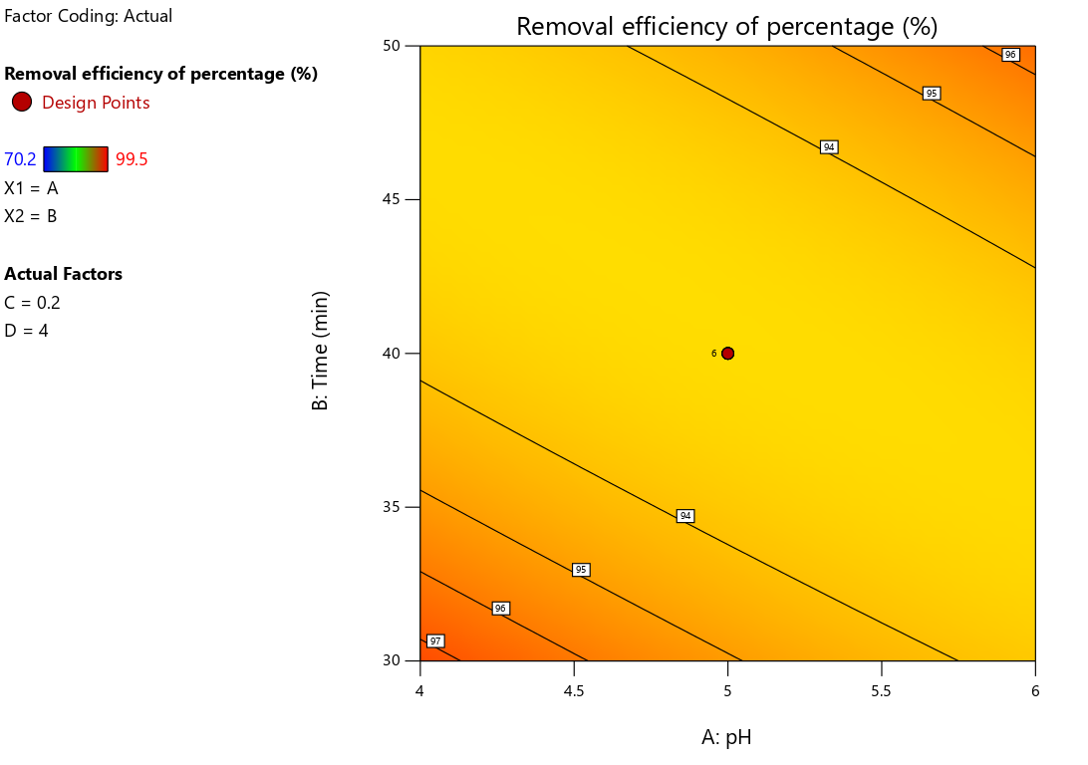
Figure 1: Contour Plot of Contact time, pH and Removal efficiency
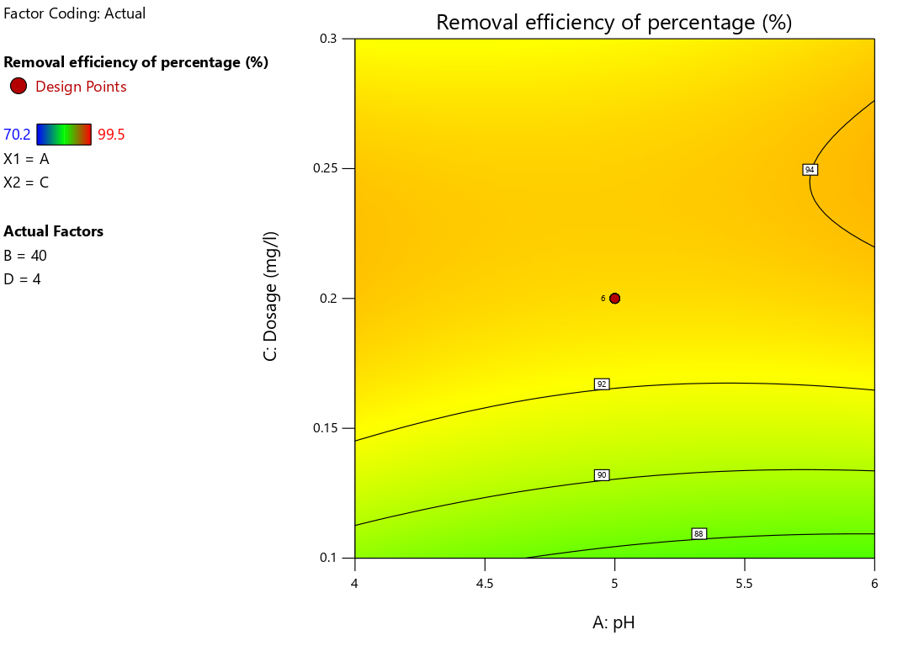
Figure 2: Contour Plot of pH, Adsorbent dosage and Removal efficiency

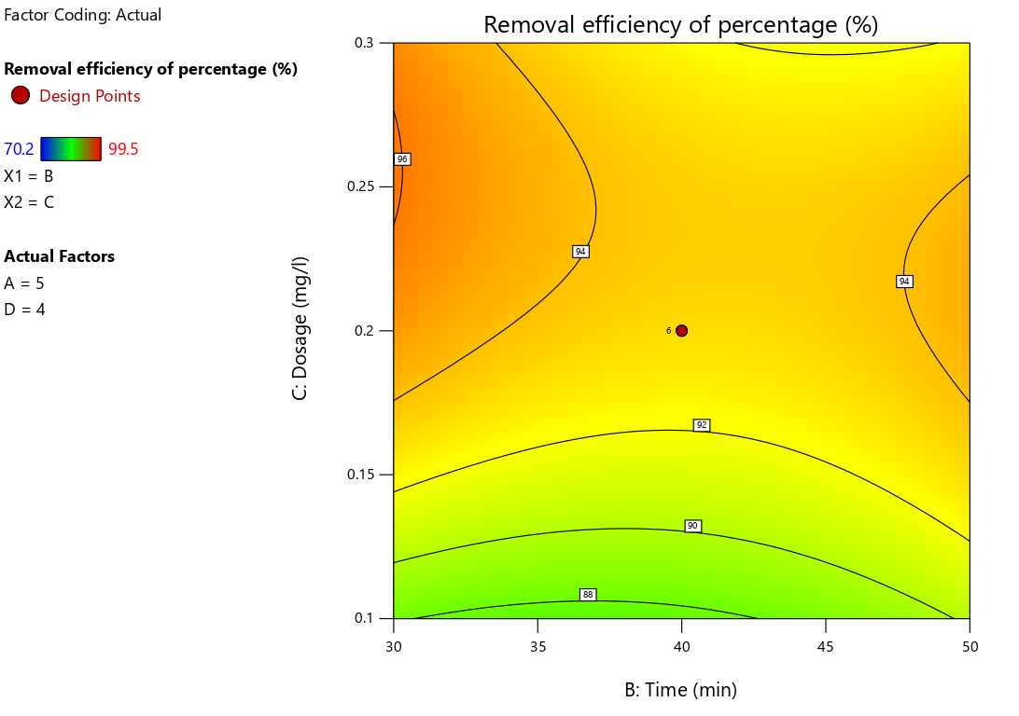 Figure 3: Contour Plot of Contact time, Adsorbent Dosage and Removal efficiency
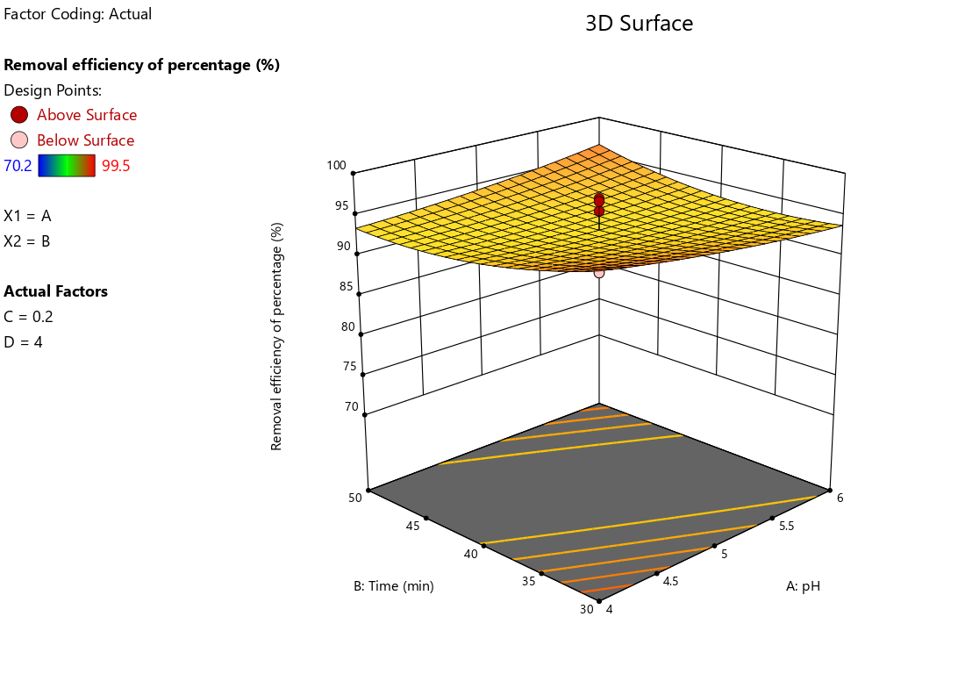
Figure 4: Plot of pH, Contact time and Removal efficiency

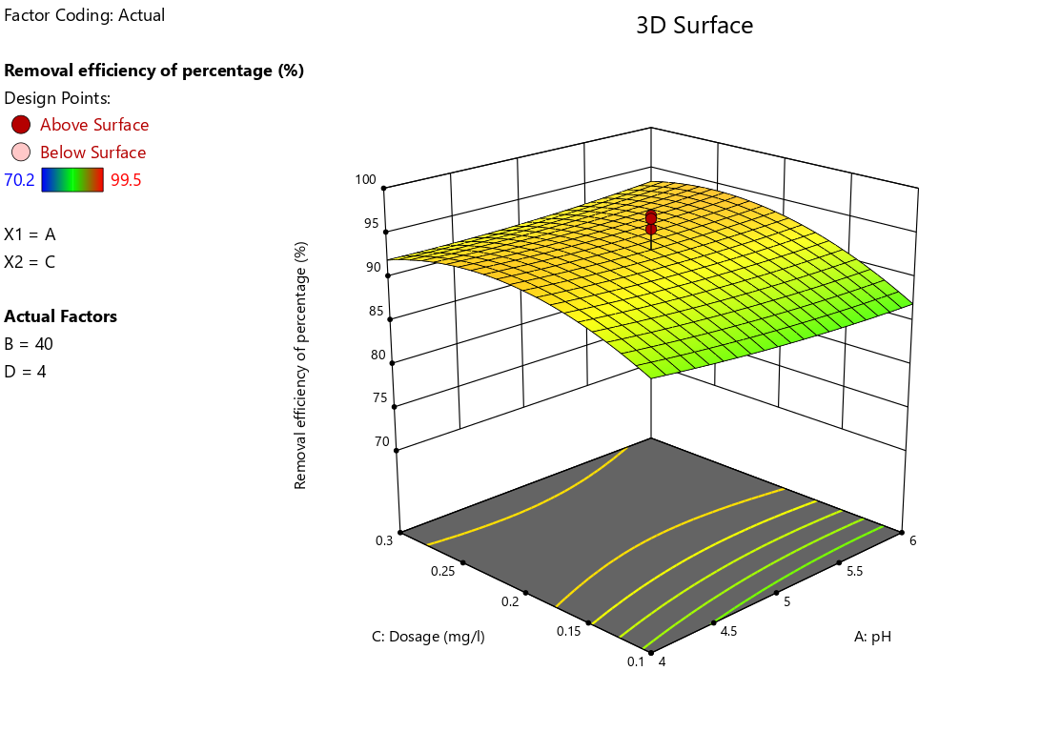
Figure 5: Plot of pH, Dosage and Removal efficiency

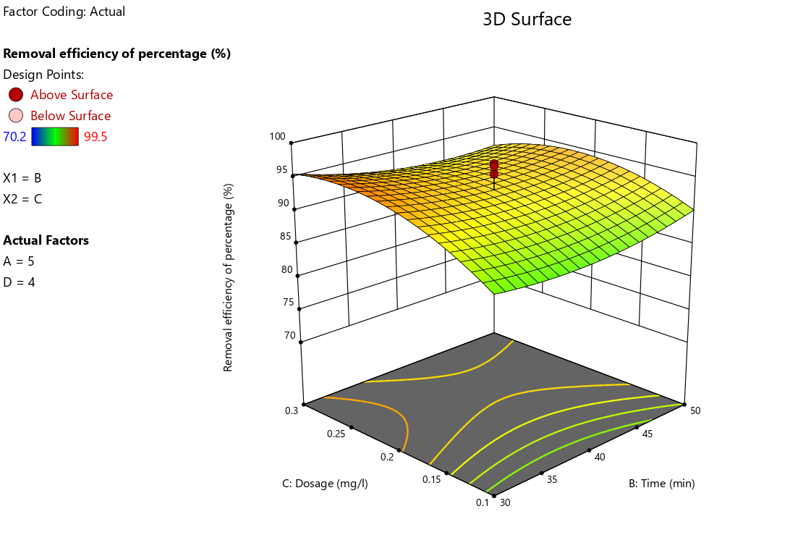

Figure 6: Plot of Time, Dosage and Removal efficiency

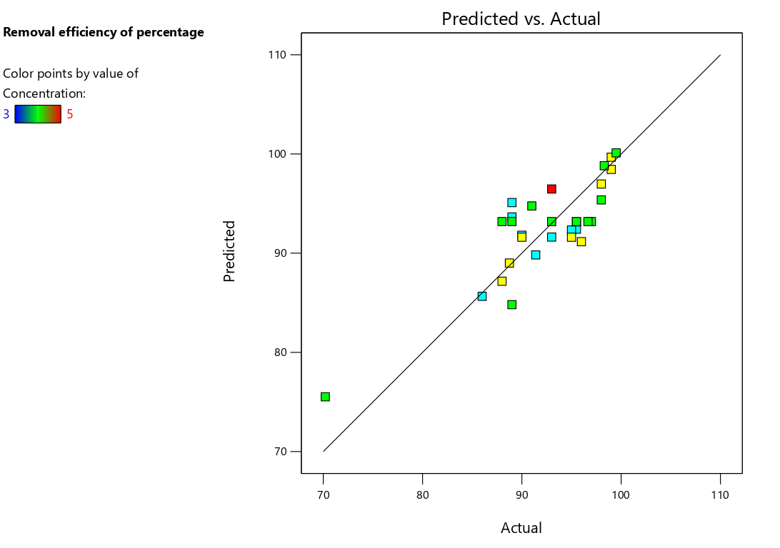
Figure 7: Predicted vs. Actual
3.2.2. LEAD – POMEGRANATE PEEL:

Statistical analysis for lead – Pomegranate peel:
ANOVA technique was applied to the regression model and the significance of each term. It is determined by the corresponding F value, p value and sum of square (SS). Larger the F value, the more significant is the corresponding term. However, small p value indicates the rejection of null hypothesis and the variable is said to be significant.

ANOVA Table:

ANOVA for Quadratic model
Response 1: Removal efficiency of percentage
Source | Sum of Squares | df | Mean Square | F-value | p-value
Model | 675.88 | 14 | 48.28 | 3.23 | 0.0156 | significant
A-pH | 312.77 | 1 | 312.77 | 20.91 | 0.0004
B-Contact time | 12.56 | 1 | 12.56 | 0.8394 | 0.3741
C-Dosage | 16.30 | 1 | 16.30 | 1.09 | 0.3131
D-Concentration | 6.47 | 1 | 6.47 | 0.4324 | 0.5208
AB | 0.6889 | 1 | 0.6889 | 0.0460 | 0.8330
AC | 43.76 | 1 | 43.76 | 2.93 | 0.1078
AD | 4.22 | 1 | 4.22 | 0.2823 | 0.6030
BC | 57.99 | 1 | 57.99 | 3.88 | 0.0677
BD | 25.55 | 1 | 25.55 | 1.71 | 0.2109
CD | 4.67 | 1 | 4.67 | 0.3119 | 0.5848
A² | 51.79 | 1 | 51.79 | 3.46 | 0.0825
B² | 154.61 | 1 | 154.61 | 10.33 | 0.0058
C² | 15.39 | 1 | 15.39 | 1.03 | 0.3265
D² | 0.4229 | 1 | 0.4229 | 0.0283 | 0.8687
Residual | 224.40 | 15 | 14.96
Lack of Fit | 205.63 | 10 | 20.56 | 5.48 | 0.0372 | significant
Pure Error | 18.77 | 5 | 3.75
Cor Total | 900.28 | 29

Fit Statistics
Std. Dev. | 3.87 |  | R² | 0.8507
Mean | 91.19 |  | Adjusted R² | 0.5181
C.V. % | 4.24 |  | Predicted R² | 0.3456
 |  |  | Adeq Precision | 6.0123
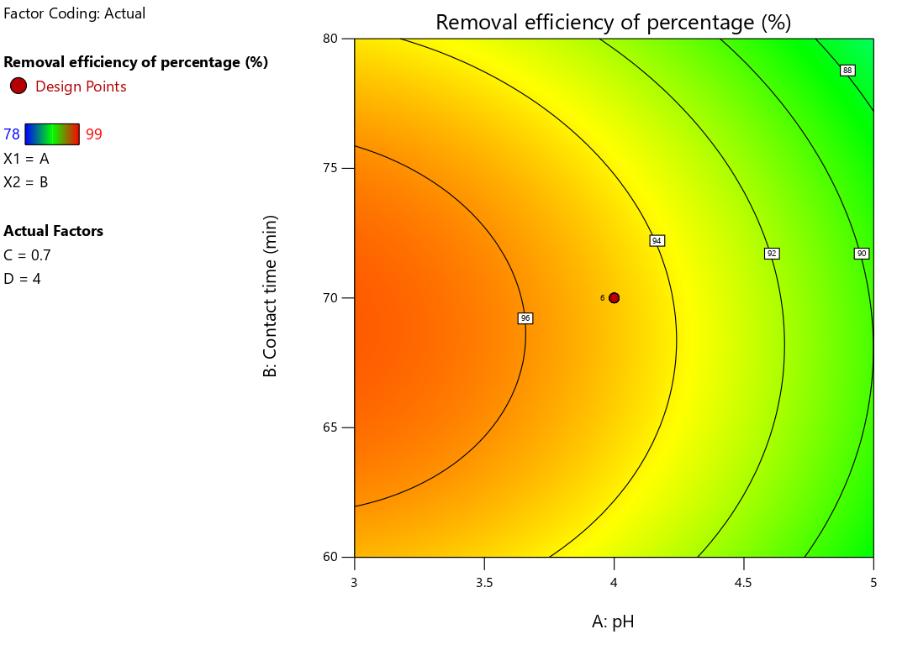 Figure 1: Contour Plot of Contact time, pH and Removal efficiency
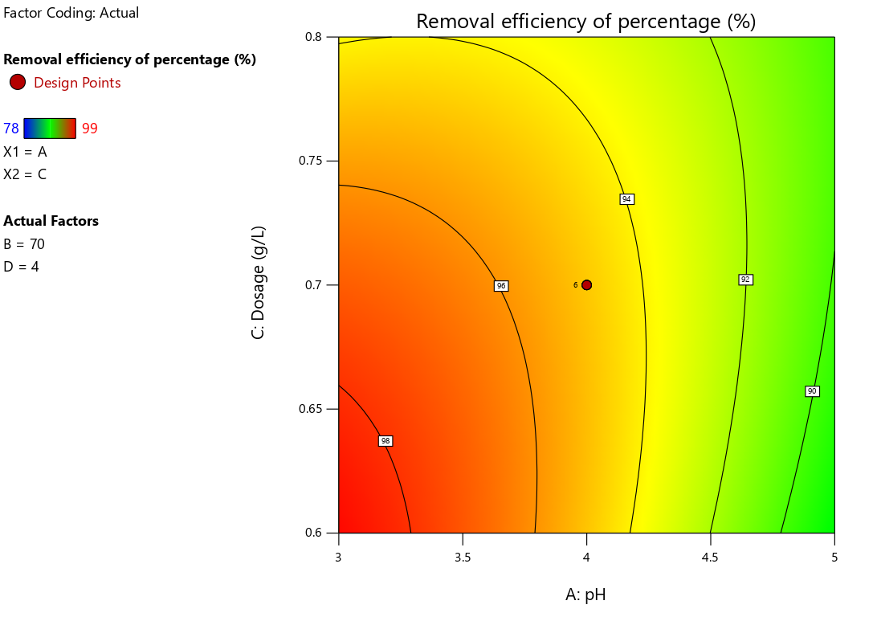
Figure 2: Contour Plot of pH, Adsorbent dosage and Removal efficiency

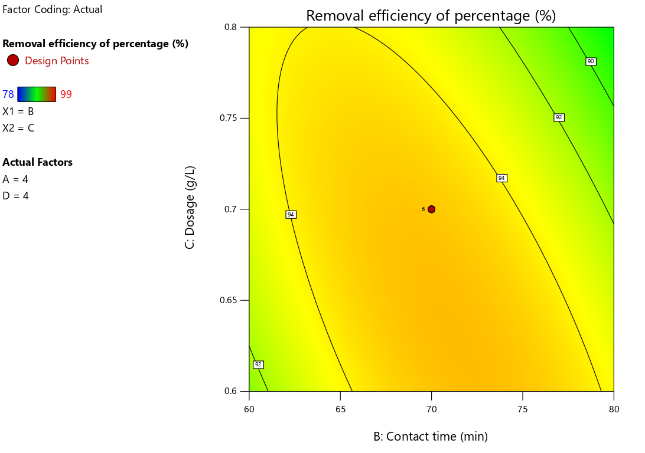
Figure 3: Contour Plot of Contact time, Adsorbent Dosage and Removal efficiency
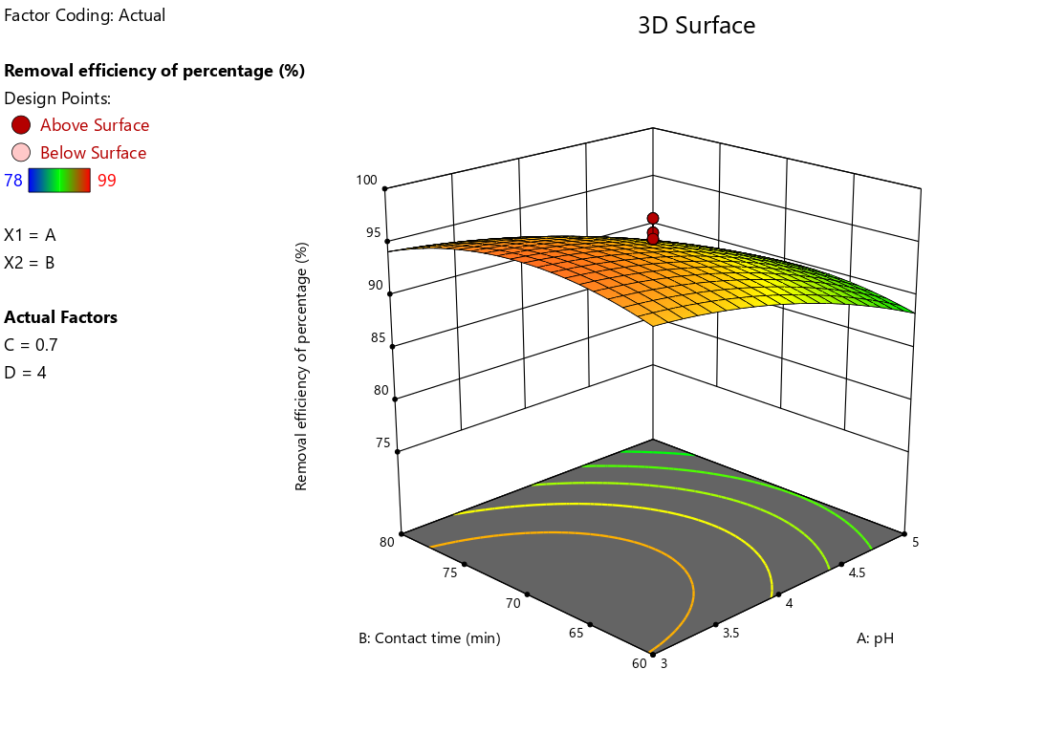
Figure 4: Plot of pH, Contact time and Removal efficiency
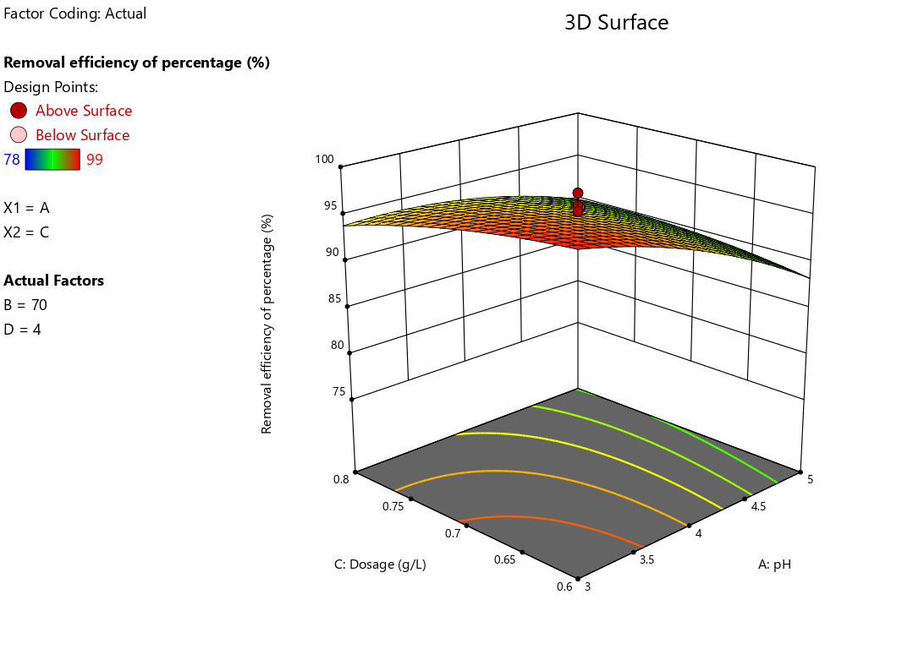 Figure 5: Plot of pH, Adsorbent dosage and Removal efficiency
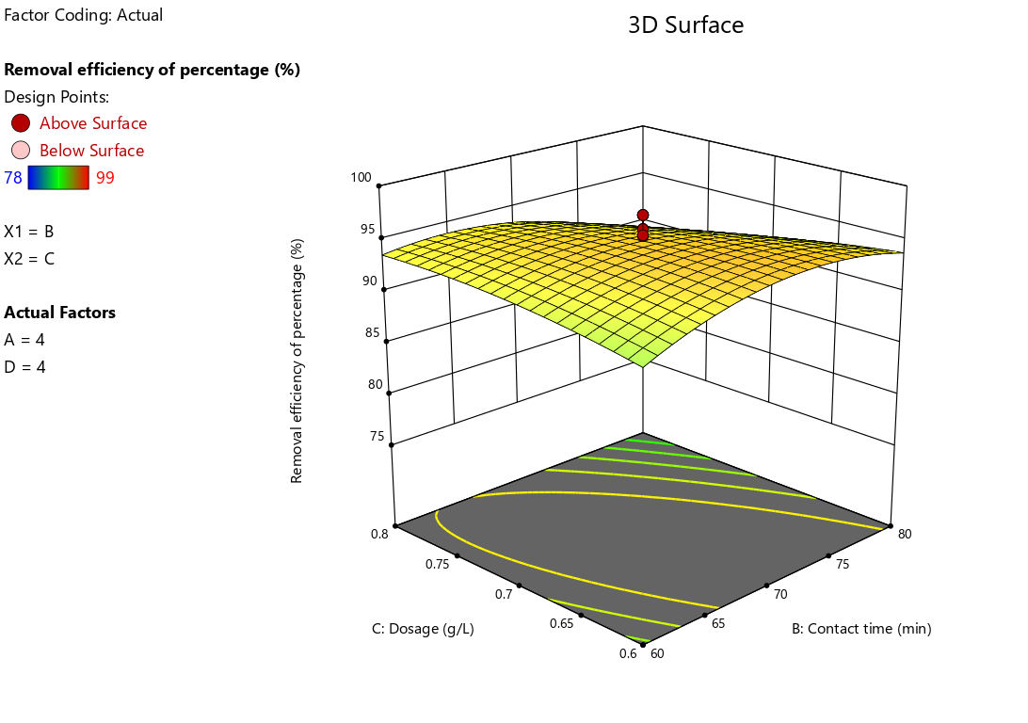 Figure 6: Plot of Time, Dosage and Removal efficiency

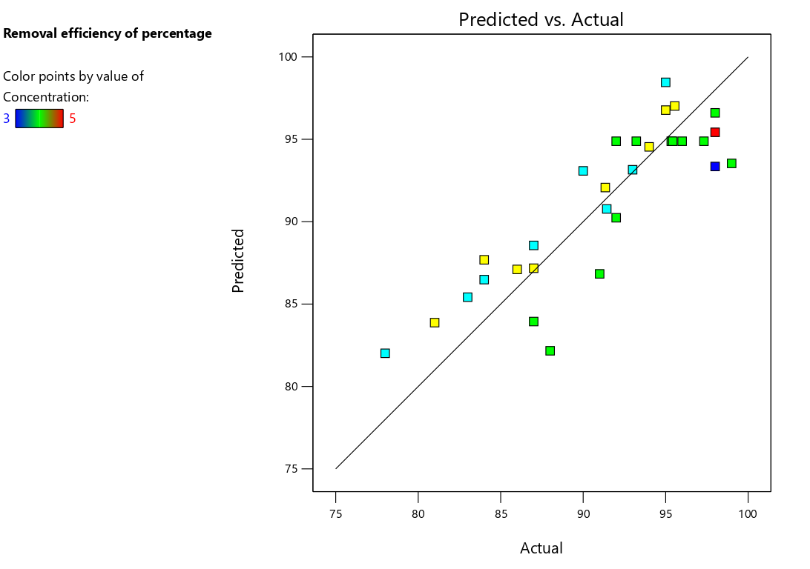
Figure 7: Predicted vs. Actual
3.2.3 LEAD – ORANGE PEEL:
Statistical analysis for lead – Pomegranate peel:
ANOVA technique was applied to the regression model and the significance of each term. It is determined by the corresponding F value, p value and sum of square (SS). Larger the F value, the more significant is the corresponding term. However, small p value indicates the rejection of null hypothesis and the variable is said to be significant.

ANOVA Table:

ANOVA for Quadratic model
Response 1: Removal efficiency of percentage
Source | Sum of Squares | df | Mean Square | F-value | p-value
Model | 596.93 | 14 | 42.64 | 2.56 | 0.0407 | significant
A-pH | 25.94 | 1 | 25.94 | 1.56 | 0.2313
B-Time | 12.72 | 1 | 12.72 | 0.7633 | 0.3961
C-Dosage | 57.94 | 1 | 57.94 | 3.48 | 0.0819
D-Concentration | 9.72 | 1 | 9.72 | 0.5831 | 0.4569
AB | 7.20 | 1 | 7.20 | 0.4319 | 0.5210
AC | 262.52 | 1 | 262.52 | 15.76 | 0.0012
AD | 4.46 | 1 | 4.46 | 0.2678 | 0.6123
BC | 9.44 | 1 | 9.44 | 0.5666 | 0.4633
BD | 22.44 | 1 | 22.44 | 1.35 | 0.2639
CD | 13.86 | 1 | 13.86 | 0.8317 | 0.3762
A² | 14.88 | 1 | 14.88 | 0.8931 | 0.3596
B² | 7.23 | 1 | 7.23 | 0.4340 | 0.5200
C² | 135.29 | 1 | 135.29 | 8.12 | 0.0122
D² | 0.0050 | 1 | 0.0050 | 0.0003 | 0.9865
Residual | 249.92 | 15 | 16.66
Lack of Fit | 178.05 | 10 | 17.80 | 1.24 | 0.4301 | not significant
Pure Error | 71.87 | 5 | 14.37
Cor Total | 846.85 | 29

Fit Statistics
Std. Dev. | 4.08 |  | R² | 0.8049
Mean | 93.35 |  | Adjusted R² | 0.4294
C.V. % | 4.37 |  | Predicted R² | 0.3332
 |  |  | Adeq Precision | 6.8159
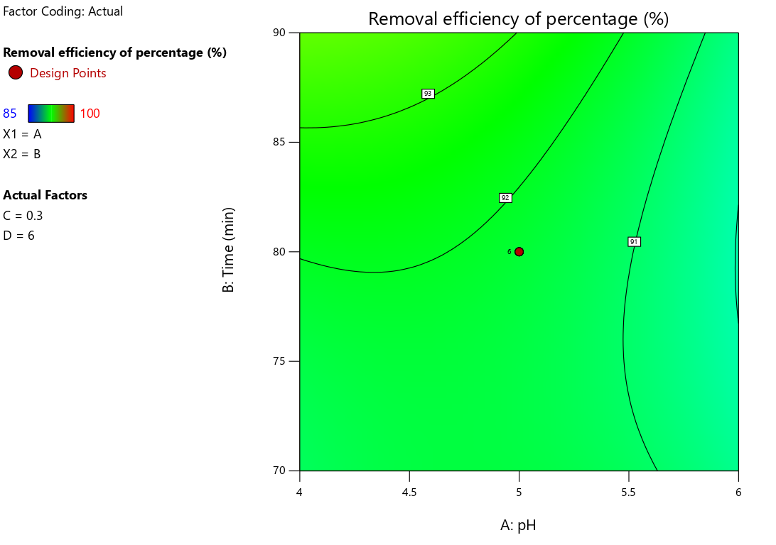
Figure 1: Contour Plot of Contact time, pH and Removal efficiency
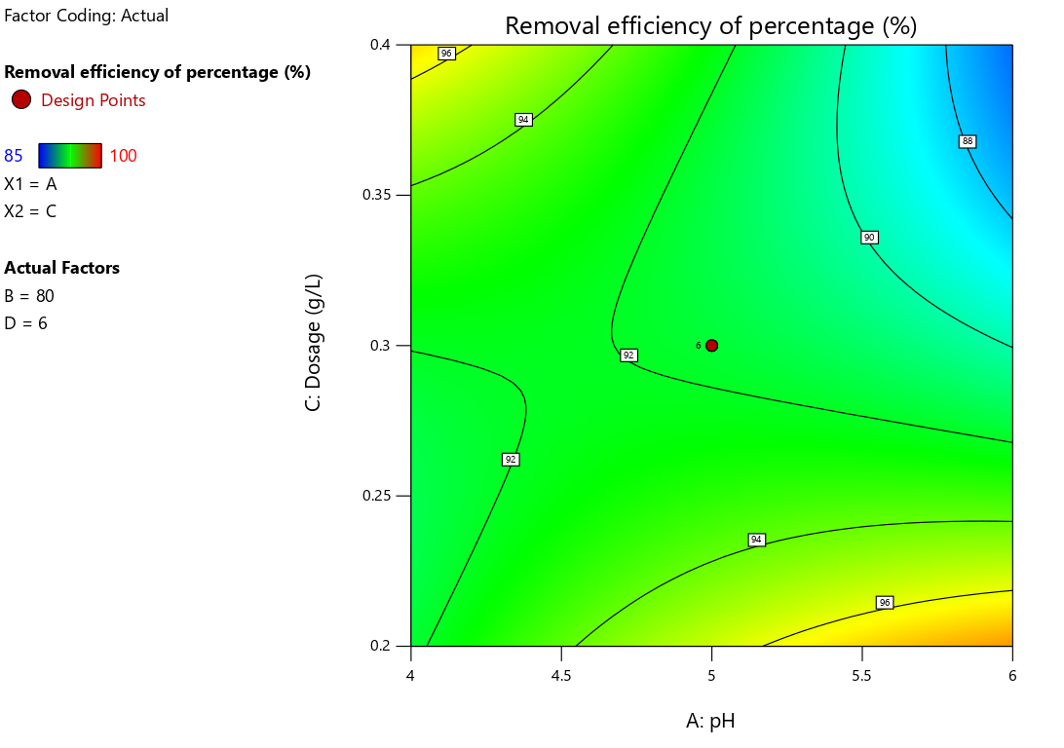
Figure 2: Contour Plot of pH, Adsorbent dosage and Removal efficiency

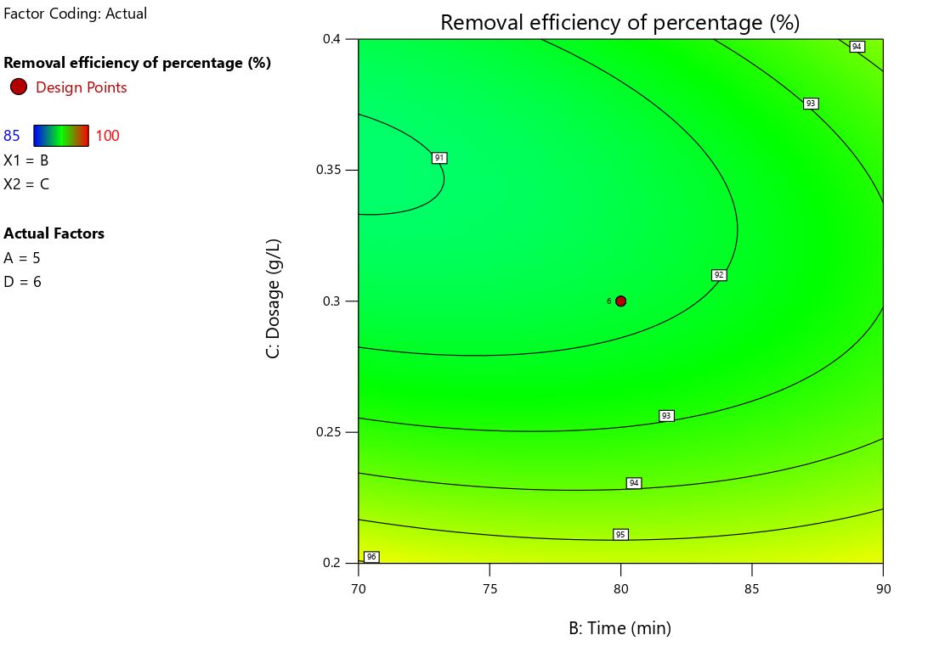
Figure 3: Contour Plot of Contact time, Adsorbent Dosage and Removal efficiency
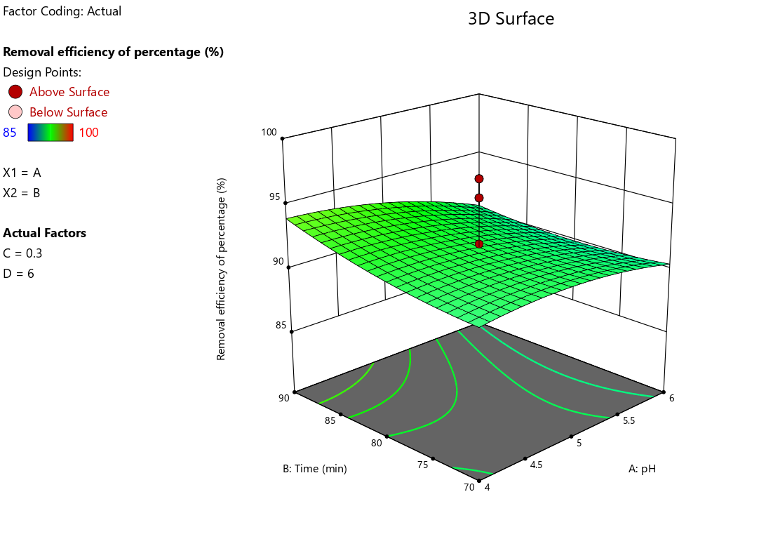
Figure 4: Plot of pH, Contact time and Removal efficiency

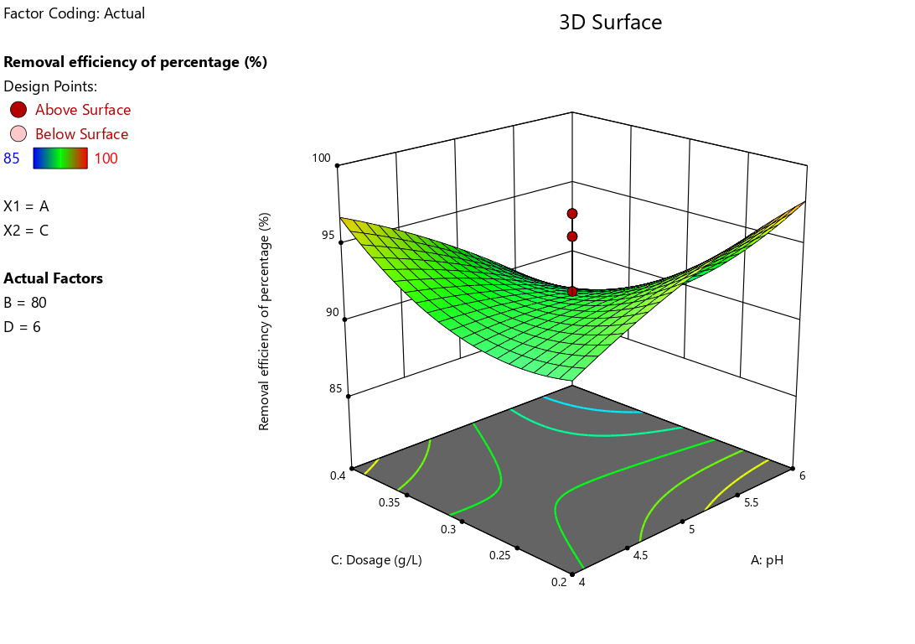
Figure 5: Plot of pH, Adsorbent dosage and Removal efficiency
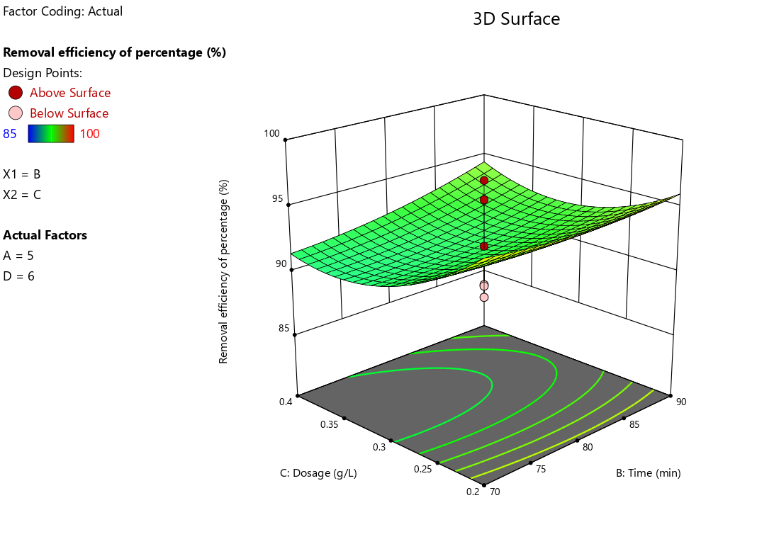
Figure 6: Plot of Time, Dosage and Removal efficiency

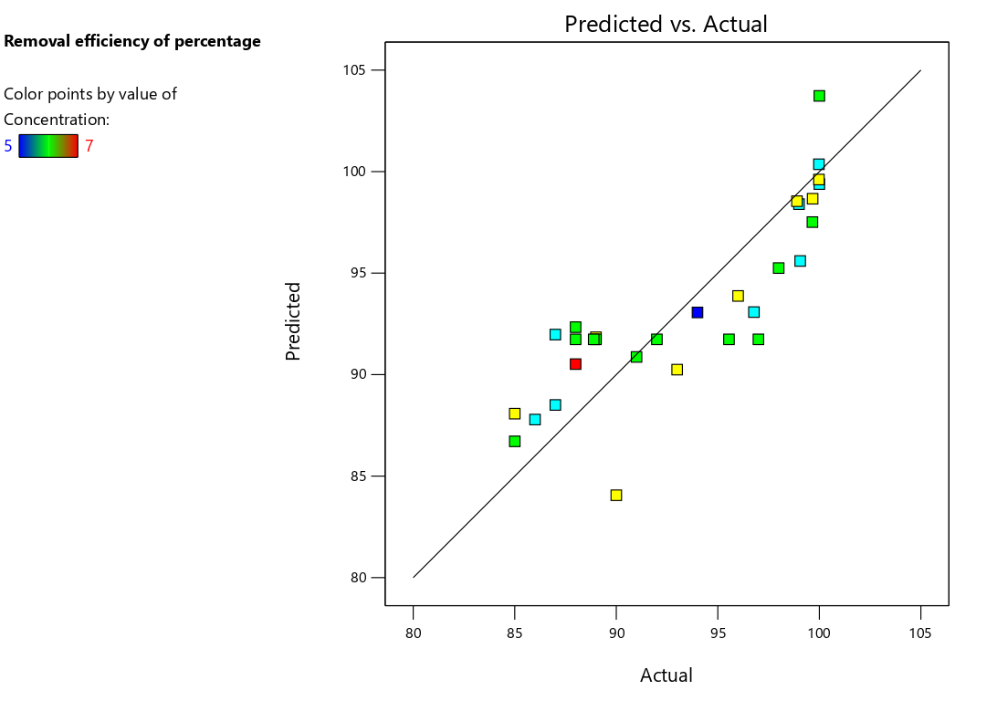
Figure 7: Predicted vs. Actual
4. Conclusion:
The aim of this study is to assess and optimize the lead adsorption capacity of eggshell, pomegranate peel, and orange peel. Response Surface Methodology (RSM) utilizing a Central Composite Design (CCD) with four variables—contact time, pH, initial concentration of lead, and adsorbent dose—was employed to analyze their effects on lead adsorption. Design Expert Software facilitated regression analysis, statistical significance determination, and response surface modelling for predicting responses across experimental regions. Models were developed to establish correlations between adsorption variables and responses.
Analysis of the response surfaces revealed that adsorbent dose had the most significant impact on lead adsorption. Process optimization was conducted, and experimental values closely matched those predicted by the models. Optimal conditions for lead adsorption were determined for each adsorbent: 0.2 g/L adsorbent dose, 40 minutes contact time, 4ppm initial lead concentration, and pH 5 for eggshell, resulting in 99.05% adsorption; 0.7 g/L adsorbent dose, 70 minutes contact time, 4ppm initial lead concentration, and pH 4 for pomegranate peel, yielding 99.01% adsorption; and 0.3 g/L adsorbent dose, 80 minutes contact time, 6ppm initial lead concentration, and pH 5 for orange peel, achieving 99% adsorption.
Moreover, the study highlighted that due to varying initial feed concentrations of lead, optimal adsorption was attained at different process parameters.

REFERENCE
1. A. Hashem, Chukwunonso O. Aniagor, M. Fikry, Ghada M.Taha, Sayed M. Badawy (2023) Characterization and adsorption of raw pomegranate peel powder for lead (II) ions removal. Journal of Material Cycles and Waste Management 25:2087–2100.
2. Abdel-Ghani NT, Hefny M, El-Chaghaby GA (2007) Removal of lead from aqueous solution using low-cost abundantly available adsorbents. Int J Environ Sci Tech 4(1):67–73.
3. Abdel-Ghani NT, El-Nashar RM, El-Chaghaby GA (2008) Removal of Cr (III) and Pb (II) from solution by adsorption onto casuarina glauca tree leaves. Ejeafche 7(7):3126–3133.
4. Heavy metal ions (lead, cobalt, and nickel) bio sorption from aqueous solution onto activated carbon prepared from Citrus limetta leaves. Carbon Lett 30:683–698.
5. Ahluwalia SS, Goyal D (2005) Removal of heavy metals by waste tea leaves from aqueous solution. Eng Life Sci 5(2):158–162.
6. Ahmad A, Rafatullah M, Sulaiman O, Ibrahim MH (2009) Removal of Cu(II) and Pb(II) ions from aqueous solutions by adsorption on sawdust of meranti wood. Desalination 247(1–3):636–646.
7. Akinbiyi A (2000) Removal of lead from aqueous solutions by adsorption using peat moss. A Thesis, University of Regina, Saskatchewan, Canada.
8. Anwar J, Umer S, Waheed-uz-Zaman, Salman M, Dar A, Anwar S (2010) Removal of Pb(II) and Cd(II) from water by adsorption on peels of banana. Bioresour Technol 101(6):1752–1755.
9. Astuti W, Chafidz A, Al-Fatesh, AS, Fakeeha AH (2020) Removal of lead (Pb(II)) and zinc (Zn(II)) from aqueous solution using coal fly ash (CFA) as a dual-sites adsorbent. Chin J Chem Eng .
10. Benhima H, Chiban M, Sinan F, Seta P, Persin M (2008) Removal of lead and cadmium ions from aqueous solution by adsorption onto micro-particles of dry plants. Colloids Surfaces B Bio interfaces 61(1):10–16.
11. Bhattacharyya KG, Sharma A (2004) Adsorption of Pb (II) aqueous solution by Azadirachta indica (Neem) leaf powder. J Hazard Mater 113(1–3):97–109.
12. Boudrahem F, Soualah A, Aissani-Benissad F (2011) Pb (II) and Cd (II) removal from aqueous solutions using activated carbon developed from coffee residue activated with phosphoric acid and zinc chloride. J Chem Eng Data 56(5):1946–1955.
13. Bulut Y, Baysal Z (2006) Removal of Pb(II) from wastewater using wheat bran. J Environ Manage 78(2):107–113.
14. Chakravarty S, Mohanty A, Sudha TN, Upadhyay AK, Konar J, Sircar JK, Madhukar A, Gupta KK (2010) Removal of Pb (II) ions from aqueous solution by adsorption using bael leaves (Aegle marmelos). J Hazard Mater 173(1–3):502–509.
15. Doyurum S, Celik A (2006) Pb (II) and Cd (II) removal from aqueous solutions by olive cake. J Hazard Mater 138(1):22–28.
16. El-Ashtoukhy ESZ, Amina NK, Abdelwahab O (2008) Removal of lead(II) and copper(II) from aqueous solution using pomegranate peel as a new adsorbent. Desalination 223:162–173.
17. Elkhaleefa A, Ali IH, Brima EI, Shigidi I, Elhag AB, Karama B (2021) Evaluation of the adsorption efficiency on the removal of lead (II) ions from aqueous solutions using Azadirachta indica leaves as an adsorbent. Processes 9(3):559.
18. Erenturk S, Malkoc E (2007) Removal of Pb (II) by adsorption onto Viscum album L.: effect of temperature and equilibrium isotherm analyses. Appl Surf Sci 253:4727–4733.
19. Fang J, Gao B, Mosa A, Zhan L (2017) Chemical activation of hickory and peanut hull hydrochars for removal of lead and methylene blue from aqueous solutions. Chem Speciat Bioavailab 29:197–204.
20. Feng Q, Lin Q, Gong F, Sugita S, Shoya M (2004) Adsorption of lead and mercury by rice husk ash. J Colloid Interface Sci 278:1–8.
21. Ghaffar A (2008) Removal of lead(II) ions from aqueous solution under different physicochemical conditions using various sorbents. Arab J Sci Eng 33(1):55–61.
22. Ghorbani A, Nazarfakhari M, Pourasad Y, Abbasi SM (2013) Removal of Pb ion from water samples using red mud (bauxite ore processing waste). E3S Web Conf 1:41019.
23. Goel J, Kadirvelu K, Rajagopal C, Garg VK (2005) Removal of lead (II) by adsorption using treated granular activated carbon: batch and column studies. J Hazard Mater 125(1–3):211–220.
24. Gupta VK, Ali I (2004) Removal of Pb(II) and chromium from wastewater using bagasse fly ash: a sugar industry waste. J Colloid Interface Sci 271:321–328.
25. Ho YS (2005) Effect of pH on lead removal from water using tree fern as the sorbent. Bioresour Technol 96:1292–1296.
26. Imamoglu M, Tekir O (2008) Removal of copper (II) and Pb (II) ions from aqueous solutions by adsorption on activated carbon from a new precursor hazelnut husks. Desalination 228(1–3):108–113.
27. Issabayeva G, Aroua MK, Sulaiman NM (2006) Removal of lead from aqueous solutions on palm shell activated carbon. Bioresour Technol 97:2350–2355.
28. Iyagba ET, Opete OSE (2009) Removal of chromium and Pb (II) from drill cuttings using activated palm kernel shell and husk. J Environ Sci Technol 3(7):171–179.
29. Kannan N, Veemaraj TE (2009) Removal of lead (II) ions by adsorption onto bamboo dust and commercial activated carbons: a comparative study. J Chem 6(2):247–256.
30. Liu S, Duan Z, He C, Xu X, Li T, Li Y, Li X, Wang Y, Xu L (2018) Rapid removal of Pb²⁺ from aqueous solution by phosphate-modified baker’s yeast. RSC Adv 8:8026–8038.

