LIQUID TEMPERATURE MEASUREMENT USING ARDUINO
Viresh M.Patil¹ , Chaitanya B.Jadhav² , Shrishailya V.Swami³ , Supriya U.Kamble⁴

^{1,2,3} Students,E&TC Dept, VAPM Almala, Latur, Maharashtra, India.
⁴Guide,,E&TC Dept, VAPM Almala, Latur, Maharashtra, India.

ABSTRACT
Temperature measurement in liquid environments is crucial for a wide range of applications spanning industries like pharmaceuticals, food processing, and chemical engineering. This project aims to design and implement a reliable and cost-effective system for liquid temperature measurement utilizing Arduino microcontroller, a 16x2 LCD display with I2C interface, a DS18B20 temperature sensor, and a 12-0-12 transformer with a 5V rectifier circuit.The project starts with an exploration of the underlying principles behind temperature sensing and display technologies. The DS18B20 temperature sensor, known for its high accuracy and digital output, is chosen for its suitability in liquid environments. The 16x2 LCD display with I2C interface is selected for its simplicity and ease of integration with Arduino, offering a clear and readable output for temperature readings. In conclusion, this project presents a comprehensive solution for liquid temperature measurement, leveraging the capabilities of Arduino, DS18B20 sensor, and 16x2 LCD display. The system's versatility and affordability make it suitable for deployment in a wide range of industrial and research settings, facilitating efficient temperature monitoring and control in liquid environments.

INTRODUCTION
Temperature measurement is a fundamental aspect of various industrial processes, particularly in applications involving liquids. Monitoring and controlling liquid temperature are critical in industries such as pharmaceuticals, food processing, chemical engineering, and environmental monitoring. Accurate temperature measurement ensures product quality, process efficiency, and regulatory compliance. Traditional temperature measurement methods often involve manual monitoring or expensive specialized equipment, which may not be suitable for continuous or remote monitoring.

METHODOLOGY
This chapter outlines the methodology employed in the design, development, and implementation of the liquid temperature measurement system using Arduino, a 16x2 LCD display with I2C interface, a DS18B20 temperature sensor, and a 12-0-12 transformer with a 5V rectifier circuit. The methodology encompasses several key steps, including circuit design, hardware assembly, software development, testing, and evaluation.

Hardware setup:

The first step is to assemble the hardware components required for the project. This includes the Arduino Nano module, LCD panel,,Temperature sensor, battery. The Arduino Nano module is connected.

HARDWARE COMPONENTS
  - Arduino Nano Micro-controller:
Arduino is an open-source prototyping platform based on easy-to-use hardware and software. Arduino boards are able to read inputs - light on a sensor, a finger on a button, or a Twitter message - and turn it into an output - activating a motor, turning on an LED, publishing something online. We can tell your board what to do by sending a set of instructions to the microcontroller on the board. To do so we use the Arduino programming language (based on wiring), and the Arduino Software(IDE), based on Processing.

The Arduino Uno can be powered via the USB connection or with an external power supply. The power source is selected automatically. External (non-USB) power can come either from an AC-to-DC adapter (wall-wart) or battery. The adapter can be connected by plugging a 2.1mm center-positive plug into the board's power jack. Leads from a battery can be inserted in the Gnd and Vin pin headers of the POWER connector.

The board can operate on an external supply of 6 to 20 volts. If supplied with less than 7V, however, the 5V pin may supply less than five volts and the board may be unstable. If using more than 12V, the voltage regulator may overheat and damage the board. The recommended range is 7 to 12 volts.

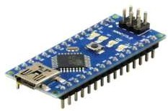

LCD PANEL

A liquid-crystal display (LCD) is a flat-panel display or other electronic visual display that uses the light-modulating properties of liquid crystals. Liquid crystals do not emit light directly. LCDs are available to display arbitrary images (as in a general-purpose computer display) or fixed images with low information content, which can be displayed or hidden, such as preset words, digits, and 7-segment displays as in a digital clock. They use the same basic technology, except that arbitrary images are made up of a large number of small pixels, while other displays have larger elements.

This is a basic 16 character by 2 line display.16×2 LCD module is a very common type of LCD module that is used in 8051 based embedded projects. It consists of 16 rows and 2 columns of 5×7 or 5×8 LCD dot matrices. The module were are talking about here is type number JHD162A which is a very popular one .

It is available in a 16 pin package with back light, contrast adjustment function and each dot matrix has 5×8 dot resolution. The pin numbers, their name and corresponding functions are shown in the table below.

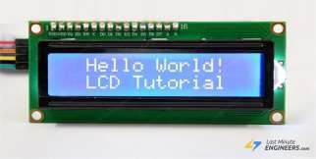

DS18B20 Temperature sensor
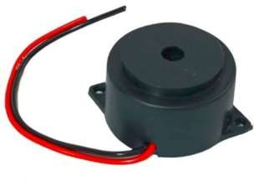
The DS18B20 is a digital temperature sensor manufactured by Maxim Integrated. It is widely used in various applications for its high accuracy, simplicity, and versatility. Here's an explanation of its key features and how it works:
Digital Output: The DS18B20 sensor provides temperature readings in digital format, making it easy to interface with microcontrollers, such as Arduino. This digital output eliminates the need for analog-to-digital conversion and simplifies the integration process.
One-Wire Interface: One notable feature of the DS18B20 is its one-wire interface. This means that multiple DS18B20 sensors can be connected to a single microcontroller pin using a single data line. Each DS18B20 sensor has a unique 64-bit ROM code, allowing multiple sensors to be individually addressed on the same bus.
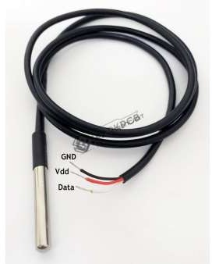

BUZZER

To measure liquid temperature using Arduino, you can employ a temperature sensor such as the DS18B20, LM35, or DHT11/DHT22. You can connect the sensor to the Arduino and read the temperature values. To incorporate a buzzer for indicating certain temperature thresholds, you'd set up conditional statements in your Arduino code. For example, if the temperature exceeds a certain threshold, the buzzer would emit a sound. Conversely, if the temperature falls below another threshold, a different sound could be emitted. This setup allows for both temperature measurement and alerting based on predefinedconditions.

RESULT
- 1. Maxim Integrated. (2015). DS18B20 Programmable Resolution 1-Wire Digital Thermometer Datasheet. Retrieved from
https://datasheets.maximintegrated.com/en/ds/DS18B20.pd f
- 2. Arduino. (n.d.). Arduino - Home. Retrieved from https://www.arduino.cc/
- 3. Arduino. (n.d.). LiquidCrystal Library for Arduino. Retrieved from
https://www.arduino.cc/en/Reference/LiquidCrystal
- 4. Maxim Integrated. (n.d.). OneWire Library for Arduino.
Retrieved from | https://github.com/PaulStoffregen/OneWire

The liquid temperature measurement syste incorporating Arduino, a 16x2 LCD display with I interface, a DS18B20 temperature sensor, and a 12-0- transformer with a 5V rectifier circuit, was successfu designed, implemented, and tested. The syst demonstrated accurate and reliable temperat measurement capabilities, with real-time display temperature readings on the LCD screen.During testi the system exhibited consistent performance across a ran of liquid temperatures, validating its accuracy and stabil The integration of the DS18B20 sensor with Ardui facilitated seamless data acquisition and processing, wh the LCD display provided clear and readable temperat outputs. The power supply circuitry ensured stable operation of the system, contributing to its overall reliability.
m,
2C
12
lly
em
ure
of
ng,
ge
ity. no
ile
ure
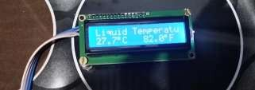
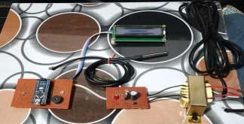

CONCLUSION

The liquid temperature measurement system presented in this project offers several advantages, including:
Accurate and real-time temperature measurement in liquid environments.Easy integration and interfacing with Arduino microcontroller.Clear and readable display of temperature readings on the LCD screen.Robust power supply circuitry for reliable operation.Versatility and adaptability for various industrial and research applications.Additionally,

the project identified some limitations and challenges, including:Limited temperature range of the DS18B20 sensor (-55°C to +125°C), which may not be suitable for extreme temperature environments.Dependency on Arduino microcontroller for data processing and display control, which may introduce complexity and potential points of failure.The need for careful calibration and testing to ensure accurate temperature readings and system performance.

REFERRzENCES

