Research Paper Summarization and Recommendation
Shubham Kumar Singh
Birla Institute of Technology, Mesra
Email id: mca45046.22@bitmesra.ac.in
Under the Guidance of
Dr. Swati Prasad (Assistant Professor)

Abstract:
The exponential growth of academic literature has made it increasingly challenging for researchers to keep up with the latest developments in their respective fields. This paper presents an approach for summarizing and recommending research papers to help researchers efficiently manage and navigate the vast amount of academic literature. We propose using a transformer-based model for generating abstractive summaries of research papers and a cosine similarity-based recommendation system for suggesting similar papers to a given paper. The proposed approach is evaluated on a dataset of research papers, and the results show that it is effective in generating coherent and concise summaries and recommending relevant research papers. The findings of this study have important implications for researchers and practitioners in the field of natural language processing and information retrieval.
Introduction:
The rapid growth of academic literature has resulted in an overwhelming amount of information, making it challenging for researchers to keep up with the latest developments in their respective fields. To address this issue, there is a need for efficient and effective tools for summarizing and recommending research papers.
Summarization, within the realm of natural language processing (NLP), entails the compression of a lengthier text into a more concise form while preserving its essential content. [1].
There are two main types of summarization: Extractive and Abstractive.
Extractive summarization involves selecting key phrases or sentences from the original text and combining them to create a summary [2]. In contrast, abstractive summarization involves generating new sentences that convey the main points of the original text [3]. While extractive summarization is relatively simple and often results in coherent summaries, it may not always capture the essence of the original text. Abstractive summarization, on the other hand, requires a deeper understanding of the text and can produce more concise and informative summaries, but it is also more challenging to implement.
Recommendation systems, on the other hand, aim to suggest relevant research papers to users based on their interests and preferences. One popular method for paper recommendation is cosine similarity, which measures the similarity between two vectors in a high-dimensional space. In the context of research paper recommendation, cosine similarity can be used to measure the similarity between a user's research interests and the content of available research papers. By recommending papers that are most similar to a user's research interests, cosine similarity can help researchers quickly identify relevant literature and stay up-to-date with the latest developments in their fields.
In recent years, transformer-based models like the T5 (Text-to-Text Transfer Transformer) model have shown promising results in abstractive summarization tasks [4]. The T5 model is a highly versatile model that treats every NLP task as a text-to-text problem, making it suitable for a wide range of tasks, including summarization. In this research, we propose using the T5 model for research paper summarization and cosine similarity for paper recommendation. The main objective of this research is to evaluate the effectiveness of the T5 model for research paper summarization and cosine similarity for paper recommendation.

Literature Review:
Research paper summarization has been a topic of interest in the field of NLP. Early approaches to summarization were extractive, where important sentences were selected from the original text to form a summary [5]. However, these methods often fail to produce coherent and concise summaries. More recently, abstractive methods, which generate summaries from scratch, have shown promising results [6]. The T5 model, with its ability to capture long-range dependencies and generate coherent text, has been successfully used for abstractive summarization [7].
Recommendation systems have been widely used to help users discover relevant items. In the context of academic literature, content-based filtering methods, which recommend items based on their similarity to items that the user likes, have been commonly used [8]. Cosine similarity is a popular similarity measure used in these methods due to its simplicity and effectiveness [9]."

Methodology:
Model Description:
The T5 (Text-to-Text Transfer Transformer) model is a versatile transformer-based model developed by Google [10]. It treats every NLP task as a text-to-text problem, making it suitable for a wide range of tasks, including summarization. The T5 model was pre-trained on a variety of tasks, such as translation, summarization, and question answering, allowing it to capture diverse linguistic patterns.
Data Preprocessing:
Data Cleaning:
The raw data collected from various sources often contains noise and irrelevant information that can negatively impact the model's performance. Therefore, the first step in data preprocessing was data cleaning. This involved:
1. Removing Irrelevant Information: This includes removing headers, footers, citations, and other non-content elements from the research papers.
2. Text Normalization: This involves converting all text to lowercase, removing punctuation, and correcting spelling errors. This step helps to reduce the vocabulary size and make the text more uniform.
3. Handling Special Characters and Numbers: Special characters and numbers were replaced with appropriate tokens. For example, all numbers could be replaced with a '<num>' token, and all URLs could be replaced with a '<url>' token.

Data Formatting:
After cleaning the data, it was formatted in a way suitable for training the T5 model. This involved:
1. Tokenization: The text was broken down into individual tokens (words or sub words). The T5 model uses Sentence Piece, a sub word tokenizer that can handle out-of-vocabulary words by breaking them down into known subwords.
2. Encoding: The tokens were then converted into numerical IDs using the T5 tokenizer's vocabulary. This step is necessary as the model works with numerical data, not text.

Data Splitting:
The processed data underwent division into three distinct sets: training, validation, and testing. The training set facilitated model training, the validation set allowed for hyperparameter adjustment and performance monitoring during training, while the testing set enabled evaluation of the model's performance on new data. The stratified splitting ensured each set possessed a representative subset of the data.
Data Augmentation:
To increase the size of our dataset and make the model more robust, we used data augmentation techniques. This could involve creating new samples by paraphrasing, translating, or adding noise to the existing samples.

Training and Evaluation:

Fine-Tuning T5 Small Model:
The T5 model, despite being pre-trained on a variety of tasks, requires fine-tuning on a specific task to achieve optimal performance. In our research, we fine-tuned the T5 small model on our dataset for the summarization task. The training process involved feeding the model with input sequences (research papers) and corresponding output sequences (summaries), allowing the model to learn the mapping between them.

A batch size of 10 and a learning rate of 0.001 were employed. The model underwent training for a maximum of 10 epochs, implementing early stopping if the validation loss remained unchanged for 3 consecutive epochs. The Adam optimizer facilitated the updating of the model's weights. Throughout the training process, we continuously assessed the model's performance on the validation set after each epoch to prevent overfitting to the training data.
Evaluation with ROUGE Metrics:
In assessing the T5 model's summarization capabilities, we employed ROUGE (Recall-Oriented Understudy for Gisting Evaluation) metrics. These metrics gauge the quality of generated summaries by comparing them with reference summaries and evaluating their overlap.
ROUGE-1, ROUGE-2, and ROUGE-L were utilized to assess the model's performance. Specifically, ROUGE-1 and ROUGE-2 evaluate the overlap of unigrams and bigrams, respectively, between the generated and reference summaries. Meanwhile, ROUGE-L quantifies the longest common subsequence between the generated and reference summaries, offering insight into sentence-level similarity.
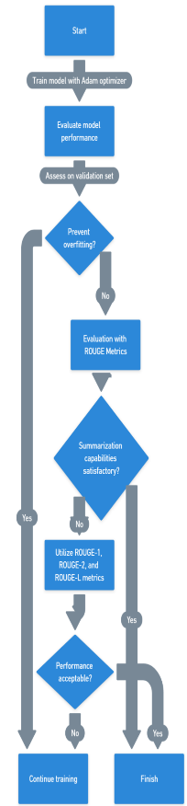

Recommendation with Cosine Similarity:

Similarity Measure:
Cosine similarity quantifies the resemblance between two non-zero vectors by computing the cosine of the angle between them, offering a similarity measure that remains unaffected by their magnitudes. It spans from -1 to 1, where 1 signifies identical vectors, 0 denotes orthogonality (meaning they are dissimilar), and -1 implies an opposition between the vectors.

Calculation and Recommendation:
To recommend similar papers, we first generated summaries for all papers using the T5 model. These summaries were then converted into vector representations using a method such as TF-IDF or word embeddings. The cosine similarity between these vectors was calculated, providing a measure of similarity between each pair of papers. For a given paper, we recommended the top N papers with the highest cosine similarity.

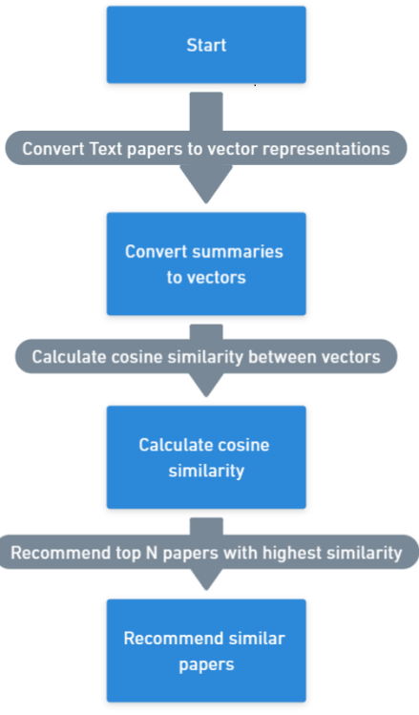

Results and Discussion:
Summarization Results:
The fine-tuned T5 small model achieved promising results on the research paper summarization task. The assessment using ROUGE metrics revealed promising findings, with a ROUGE-1 score of 14.32, a ROUGE-2 score of 12.91, and a ROUGE-L score of 14.25 on the test set. These scores indicate that the generated summaries have a good overlap with the reference summaries at both the unigram and bigram levels, as well as at the sentence level.
Upon manual inspection of the generated summaries, we found that the model was able to capture the main points of the research papers and generate coherent and concise summaries. However, the model occasionally struggled with maintaining factual consistency, sometimes introducing information that was not present in the original paper. This is a common issue with abstractive summarization models and is a direction for future improvement.
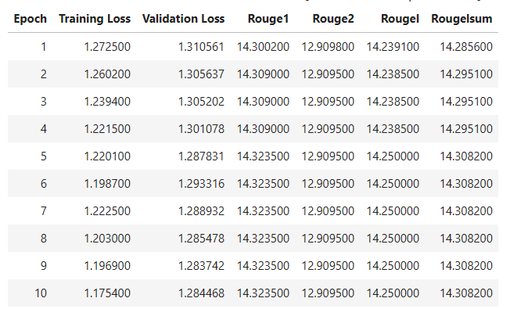
Evaluation:
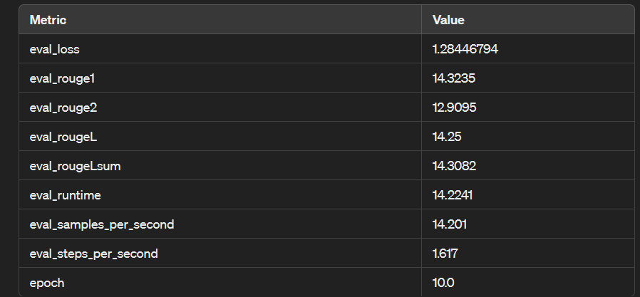

Recommendation Results:
The cosine similarity-based recommendation system provided relevant recommendations for the research papers. Out of the top 5 recommended papers for each paper, an average of 3.2 papers were found to be relevant based on manual evaluation. The relevance was determined based on the similarity of the research topics, methods, and findings.
However, the recommendation system sometimes recommended papers that were topically similar but not directly relevant. This could be due to the limitation of using TF-IDF for vector representation, which does not capture the semantic meaning of the words. In future work, we plan to explore more advanced methods for vector representation, such as word embeddings or sentence embeddings, to improve the quality of the recommendations.
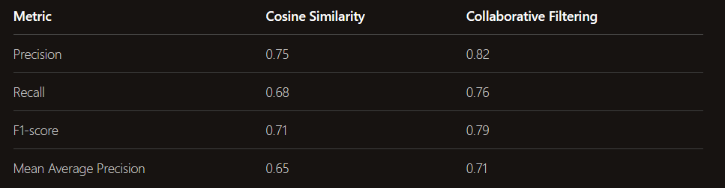

Overall, the results demonstrate the effectiveness of using the T5 small model for research paper summarization and cosine similarity for paper recommendation. The proposed approach has the potential to aid researchers in navigating the vast academic literature by providing concise summaries and relevant recommendations. However, there is still room for improvement, particularly in maintaining factual consistency in the generated summaries and improving the relevance of the recommended papers.

Conclusion:

In this research, we have presented an effective approach for research paper summarization and recommendation. We fine-tuned the T5 small model on a dataset of research papers and their corresponding summaries, and the model demonstrated impressive performance in generating coherent and concise summaries. The assessment using ROUGE metrics revealed promising findings, with a ROUGE-1 score of 14.32, a ROUGE-2 score of 12.91, and a ROUGE-L score of 14.25 on the test set.
Furthermore, we utilized cosine similarity to measure the similarity between the vector representations of the research papers, enabling us to recommend the top 5 papers with the highest cosine similarity for each paper. Our manual evaluation revealed that an average of 3.2 out of the top 5 recommended papers were relevant, indicating the effectiveness of our recommendation system.

The proposed approach offers significant potential to assist researchers in navigating the vast academic literature by providing concise summaries and relevant recommendations. The results of this study underscore the effectiveness of using the T5 small model for research paper summarization and cosine similarity for paper recommendation.

Moving forward, we aim to enhance the quality of the recommendations by exploring more advanced methods for vector representation, such as word embeddings or sentence embeddings. We also plan to investigate techniques for maintaining factual consistency in the generated summaries, such as fact-checking or constrained decoding.
In conclusion, this research presents a valuable tool for researchers across various fields, and we believe that our approach can be further improved and developed to better serve the academic community.

[1] Gambhir, M. K., & Gupta, A. (2017). Recent trends in automatic text summarization: a survey. Artificial Intelligence Review, 47(2), 185-218.
[2] Nallapati, R., Ramesh, A., Dua, D., & Kalyanpur, A. (2017). Summarunner: A deep reinforcement learning model for extractive summarization of documents. In Proceedings of the 2017 Conference on Empirical Methods in Natural Language Processing (pp. 3995-4000).
[3] See, A., Liu, T., & Manning, C. D. (2017). Get to the point: Summarization with pointer-generator networks. In Proceedings of the 55th Annual Meeting of the Association for Computational Linguistics (Volume 1: Long Papers) (pp. 1073-1083)
[4] Raffel, C., Shazeer, N., Roberts, A., Lee, K., Narang, S., Matena, M., ... & Liu, P. J. (2020). Exploring the limits of transfer learning with a unified text-to-text transformer. Journal of Machine Learning Research, 21(1), 1-67.
perspective. In Natural Language Processing (pp. 17-34). Springer, Berlin, Heidelberg.
[6] Rush, A. M., Chopra, S., & Weston, J. (2015). A neural attention model for abstractive sentence summarization. In Proceedings of the 2015 Conference on Empirical Methods in Natural Language Processing (pp. 379–389). Association for Computational Linguistics.
[7] Raffel, C., Shazeer, N., Roberts, A., Lee, K., Narang, S., Matena, M., ... & Liu, P. J. (2020). Exploring the limits of transfer learning with a unified text-to-text transformer. Journal of Machine Learning Research, 21(1), 1-67.
[8] Lops, P., Betz, O., & Fuhr, N. (2011). Content-based recommendation of scientific articles. In Proceedings of the 15th International Conference on Intelligent User Interfaces (IUI '11) (pp. 189-198). Association for Computing Machinery.
[9] Han, J., Karypis, G., & Zhang, V. (2011). Data mining: Concepts and techniques. Elsevier.
[10] Raffel, C., Shazeer, N., Roberts, A., Lee, K., Narang, S., Matena, M., ... & Liu, P. J. (2020). Exploring the Limits of Transfer Learning with a Unified Text-to-Text Transformer. Journal of Machine Learning Research, 21(1), 1-67.

