AUTOMATIC MELANOMA DIAGNOSIS USING
DEEP LEARNING TECHNIQUES

Nishok P R, Sanjay M, Umesh S
Students, Department of Computer Engineering,
Sri Ramakrishna Engineering College, Coimbatore, Tamil Nadu, India.

Ms. G. Priyanka
Assistant Professor, Department of Computer Engineering,
Sri Ramakrishna Engineering College, Coimbatore, Tamil Nadu, India.

Abstract: Melanoma is the skin lesion variety that is most deadly. Early melanoma detection dramatically increases the chance of survival. However, there are several factors that make it difficult to accurately identify melanoma, including reduced contrast between the skin and lesion and visual similarities between non-melanoma and melanoma. The three main steps of the new melanoma detection method presented in this work are segmentation, feature extraction, and classification. The preprocessing stage involved applying Gaussian thresholding, grayscale conversion, denoising techniques, and Contrast Limited Adaptive Histogram Equalization (CLAHE) to optimize image quality and prepare the data for segmentation. For segmentation, three popular edge detection algorithm Canny, Sobel, and Prewitt were utilized to extract melanoma-specific features and delineate lesion boundaries. To evaluate the segmentation accuracy, performance metrics such as Peak Signal-to-Noise Ratio (PSNR), Structural Similarity Index (SSIM), and Root Mean Square Error (RMSE) were employed. The comparative analysis revealed Sobel as the most suitable algorithm for accurately detecting melanoma lesions. . We found that combining CNN with Vision Transformer (ViT) yields superior accuracy compared to using either CNN or ViT alone. This hybrid approach capitalizes on the strengths of both architectures, leveraging CNN's spatial hierarchies and ViT's attention mechanism for better feature representation and classification. The synergistic effect of this fusion demonstrates enhanced performance in melanoma detection, underscoring the efficacy of integrating diverse deep learning techniques for improving diagnostic accuracy.

Key Words- sobel, canny, prewitt, U-net, Convolutional Neural Network., vision transformer

INTRODUCTION

Melanoma, the deadliest form of skin cancer, poses a significant global health challenge due to its aggressive nature and potential for metastasis. Early detection is crucial for effective treatment and improved patient outcomes, as it dramatically increases the chances of survival. However, accurately identifying melanoma lesions remains challenging due to factors such as reduced contrast between the skin and lesion, as well as visual similarities between melanoma and non-melanoma lesions.In recent years, advancements in artificial intelligence and medical imaging have revolutionized melanoma detection through automated systems. These systems utilize deep learning methods to analyze dermatoscopic images with high accuracy and efficiency, aiding medical practitioners in diagnosing melanoma more quickly and accurately.This study presents a novel approach to melanoma detection, focusing on three key steps: segmentation, feature extraction, and classification. Preprocessing techniques, including Gaussian thresholding, grayscale conversion, denoising, and Contrast Limited Adaptive Histogram Equalization (CLAHE), are employed to optimize image quality and prepare data for segmentation.Segmentation is performed using popular edge detection algorithms, namely Canny, Sobel, and Prewitt, to extract melanoma-specific features and delineate lesion boundaries. The comparative analysis reveals Sobel as the most suitable algorithm for accurately detecting melanoma lesions, showcasing the effectiveness of preprocessing techniques in improving image quality.

Moving forward, the study advances to the classification phase, utilizing deep learning models such as Convolutional Neural Networks (CNN) and Vision Transformers (ViT) trained with segmented images. A hybrid CNN-ViT approach demonstrates superior accuracy, leveraging the strengths of both architectures for enhanced feature representation and classification.The fusion of denoising, segmentation, and classification techniques yields superior performance in terms of accuracy, precision, recall, and F1 score, underscoring the potential of integrating diverse deep learning techniques for advancing skin disease diagnosis and classification systems. By combining CNN with ViT, the study demonstrates the synergistic effect of leveraging spatial hierarchies and attention mechanisms, further enhancing diagnostic accuracy in melanoma detection.

- LITERATURE SURVEY

Jitendra V. Tembhurne, Nachiketa Hebbar, Hemprasad Y. Patil2, and Tausif Diwan are the authors. Because of its high incidence and fatality rate, skin cancer, which includes the deadly melanoma, requires a precise diagnosis. Our research combines machine learning and deep learning techniques to tackle the problem of false negatives in diagnostics. Our model attains an impressive 93% accuracy rate, with good recall scores for both benign and malignant cases, by integrating sophisticated neural network features with manual feature processing. Its superiority over current approaches is confirmed by benchmarking, providing a potential solution for automated skin cancer diagnosis.[1]
Norsang Lama, Akanksha Maurya, and Anand K. Nambisan are the writers. The constraints of deep learning in melanoma diagnosis are addressed by this study in terms of irregular pigment networks. It blends traditional manual feature creation with deep learning by annotating a database and building a classification pipeline. Melanoma classification accuracy is improved by using classical picture characteristics and transfer trained segmentation models. The study highlights the potential of mixing deep learning with conventional image processing techniques for enhanced diagnosis. Specifically, it yields an 11% increase in melanoma recall and a 2% increase in accuracy over deep learning-only models.[2]
S. T. Sukanya and S. Jerine, the authors This work addresses the difficulties associated with melanoma detection by presenting an innovative method. It consists of three main steps: segmentation, feature extraction, and detection. The Self Adaptive Sea Lion Algorithm is used in the process to improve the initial centroids of the K-means clustering model. After segmented images have been recovered, texture features are fed into a Deep Belief Network to identify melanoma. The model's potential for more precise and effective melanoma diagnosis is indicated by a number of performance indicators that show its advantage over current techniques.[3]
Sumit Kumar Singh, Vahid Abolghasemi, and Mohammad Hossein Anisi, the authors This study highlights the significance of an early diagnosis for patient survival and presents a unique method for melanoma detection. The method improves dermoscopic images using mathematical logics and pre-processing techniques, based on fuzzy logic-based image segmentation and a modified deep learning model. Standard deviation techniques and L-R fuzzy defuzzification are used in the segmentation phase to reduce artifacts and enhance lesion visibility. Then, a modified You Only Look Once (YOLO) model is used for melanoma detection, with extra convolutional layers and feature concatenation added for better accuracy and efficiency over the state-of-the-art classifiers. The effectiveness of the suggested method for reliable melanoma identification is confirmed by experimental validation on a variety of datasets.[4]
Lassaad K. Smirani c, Md. Amzad Hossain d,e, Sk Hasane Ahammad a, V Rajesh a, Ruth Ramya Kalangi a, and Syed Inthiyaz an are the authors.This research proposes an automated image-based method employing machine learning classification to overcome the difficulties in dermatological diagnosis. It tries to overcome the shortcomings of conventional diagnostic approaches, which frequently rely on extensive testing and individual expertise, by utilizing computational tools. In order to produce more precise and quick diagnostic reports, the method entails filtering and improving skin photos in order to extract features using Convolutional Neural Networks (CNN) and classify them using the softmax algorithm. This cutting-edge program could be a useful teaching aid for dermatology students and offer a more effective and dependable method of identifying skin conditions.[5]

PROPOSED METHODOLOGIES

1.OVERVIEW
The process outlined for melanoma detection and classification involves a comprehensive approach starting from dataset collection to the utilization of advanced deep learning techniques. Initially, diverse datasets are gathered from Kaggle to ensure the inclusion of various skin types, conditions, and environmental factors, simulating real-world scenarios. Subsequently, data preprocessing techniques are employed to enhance image quality and prepare them for segmentation and classification. Gaussian thresholding, grayscale conversion, denoising methods such as Gaussian blurring or median filtering, and Contrast Limited Adaptive Histogram Equalization (CLAHE) are applied to optimize the images. Following preprocessing, image segmentation is conducted using Canny edge detection, Sobel operator, and Prewitt operator, aiding in the delineation of melanoma lesions from surrounding tissue. Finally, a Convolutional Neural Network (CNN) augmented with a Vision Transformer architecture is trained for image classification. This hybrid model leverages the feature extraction capabilities of CNNs and the global context gathering abilities of Vision Transformers to accurately categorize images, ultimately enhancing the diagnostic accuracy of melanoma detection systems. Through this integrated approach, the aim is to develop a robust system capable of early detection and precise classification of melanoma, thereby improving patient outcomes and facilitating efficient therapeutic interventions.

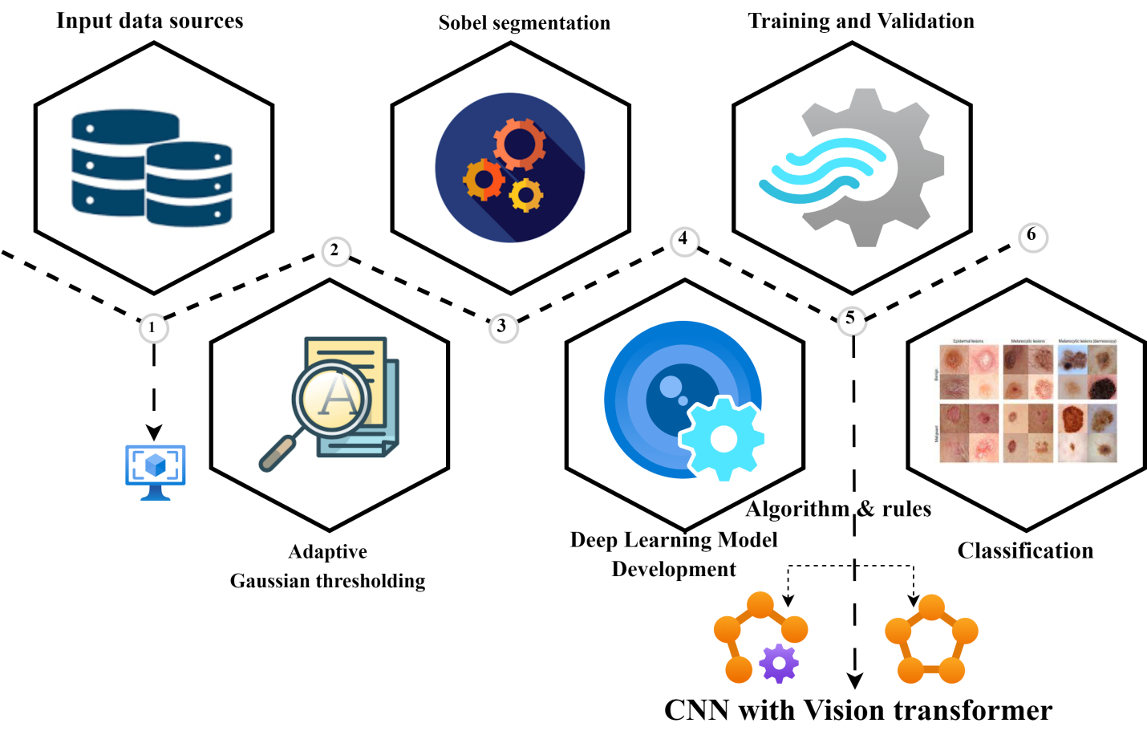
Fig 3.1 Methodology

DATASET COLLECTION
Collect information related to the work at hand. Make sure it has a variety of photos that capture the unpredictability you anticipate in real-world situations. Kaggle is the source of the datasets.

DATA PREPROCESSING

GAUSSIAN THRESHOLDING
The photos can be binarized by using Gaussian thresholding. This uses a Gaussian distribution of pixel intensities to distinguish foreground objects from background.

GRAYSCALE CONVERSION:
If the photographs aren't already in grayscale, convert them to that format. Because grayscale images only contain one channel for intensity, further processing stages can be made simpler.

DENOISING:
Eliminate noise from the pictures to increase the precision of segmentation. This might entail methods such as Gaussian blurring or median filtering.

CLAHE (Contrast Limited Adaptive Histogram Equalization):
Use CLAHE to make the photographs' contrast better. This enhances the ability to see details, particularly in areas with uneven lighting.

IMAGE SEGMENTATION

CANNY EDGE DETECTION
To find edges in the photos, use the Canny edge detection technique. Delineating object boundaries for segmentation can be aided by this.



SOBEL OPERATOR
The Sobel operator can be used to find edges in the pictures. The gradient magnitude, which indicates edges with abrupt changes in pixel intensity, is computed via the Sobel operator.
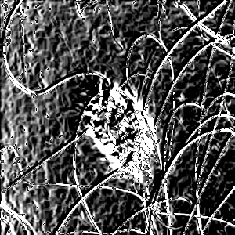

PREWITT OPERATOR
Prewitt operator is used for edge detection, just like Sobel operator. To find edges, it computes the gradient magnitude in both the horizontal and vertical directions.
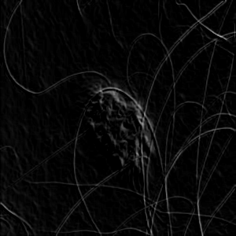

CLASSIFICATION

CONVOLUTIONAL NEURAL NETWORK (CNN) WITH VISION TRANSFORMER
Train a CNN model for picture classification that has been enhanced using a vision transformer architecture. Add the pre-processed picture data to the model.Through convolutional layers, the CNN learns to extract features from the images, while the vision transformer gathers global context data. Utilize the labeled dataset to train the model for categorization of images.

IV. RESULTS
In order to improve the diagnostic accuracy of melanoma skin cancer, we developed an advanced deep learning framework that combines segmentation and classification techniques. First, we used the Sobel algorithm in combination with the UNet architecture to accurately segment melanoma lesions from dermoscopic pictures. The extraction of intricate characteristics and contours necessary for precise diagnosis was made possible by this integration. The segmented regions were then subjected to feature extraction, which made use of both conventional and cutting-edge deep learning approaches. It is clear that the Sobel algorithm is the best option for edge detection jobs when evaluating the performance metrics of three well-known edge detection algorithms: Sobel, Canny, and Prewitt. With an RMSE of 8.73—a far lower error rate than Canny and Prewitt—the Root Mean Squared Error (RMSE) statistic, which measures the average difference between the detected edges and the ground truth edges, clearly demonstrates Sobel's superiority.In addition, Sobel's superiority is further supported by the Peak Signal-to-Noise Ratio (PSNR), which measures signal fidelity in maintaining edge details and has a PSNR of roughly 26.98. This result demonstrates that Sobel outperforms both the Canny and Prewitt algorithms in maintaining edge information with high fidelity.Moreover, Sobel's supremacy is further reinforced by the Structural Similarity Index (SSIM), which measures the similarity between detected edges and ground truth edges.Sobel shows an extremely high degree of structural similarity, outperforming both the Canny and Prewitt methods, with an SSIM of almost 0.9923.

Image segmentation | RMSE | PSNR | SSIM
canny | 7.474528733788990 | 23.7536846780987650 | 0.95486983494206303
sobel | 8.730965964122564 | 26.981650176017617 | 0.9923103506465271
prewitt | 8.350334365838933 | 25.6384835623456789 | 0.98137389480859532

Table.no 4.1 Image segmentation table

Root Mean Squared Error (RMSE): 8.730965964122564
Peak Signal-to-Noise Ratio (PSNR): 26.981650176017617
Structural Similarity Index (SSIM): 0.9923103506465271

The trends in training and validation accuracies show that the iterative training process over 20 epochs produced promising outcomes in the field of melanoma skin cancer diagnosis. The accuracy of the model initially peaked at about 84.95%, indicating a consistent learning process. But as the training went on, remarkable gains were observed, which led to a noteworthy accuracy spike to 93.99% by the end of the program. This significant improvement highlights the model's growing ability to identify complex traits that are important for classifying melanoma, indicating its potential for strong diagnostic performance. Throughout the training process, validation loss showed a steady decline, suggesting that the model's capacity to generalize well across unknown data is increasing. The validation accuracy was found to be very consistent with the training accuracy, indicating a low degree of overfitting and providing more support for the model's practicality. When the model was tested on a different dataset, it produced an astounding accuracy of 94.19%, which confirms the model's effectiveness and generalizability. This result emphasizes how Sobel segmentation, CNN, and visual transformer classification work in concert to improve the diagnosis of melanoma, which should lead to increased precision and dependability in clinical settings.

METRIC | CNN | ViT | INTEGRATED MODEL
Accuracy | 88.5% | 89.7% | 94.7%
Precision | 0.81 | 0.85 | 0.92
Recall | 0.88 | 0.897 | 0.94
F1 score | 0.889 | 0.896 | 0.935

Table.no 4.2 Performance Analysis table


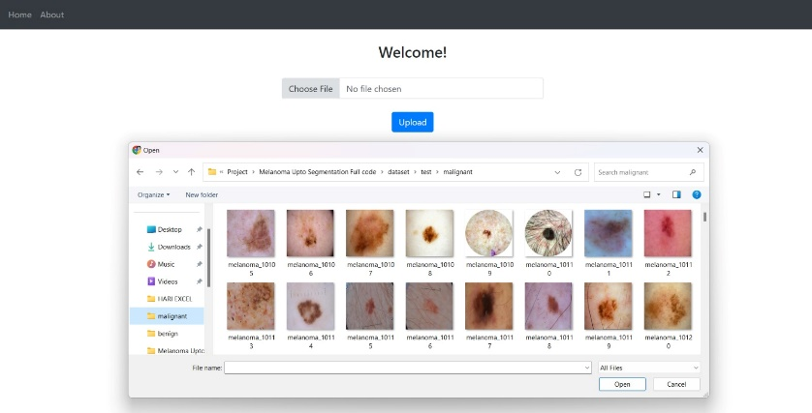

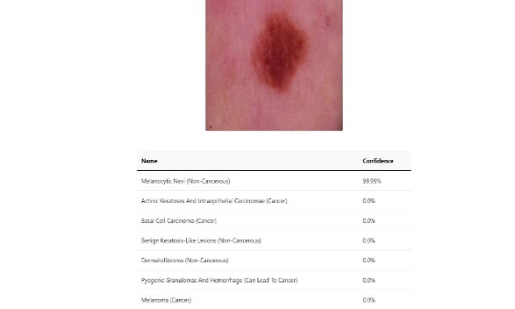

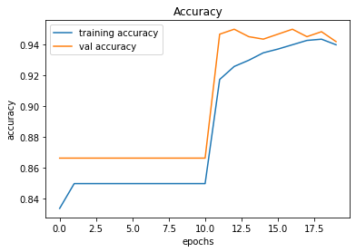
Fig4..1 Accuracy of f1

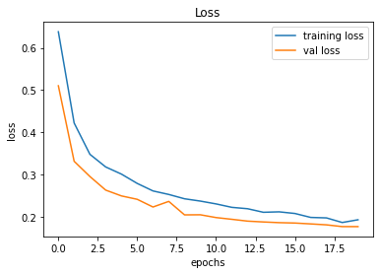
Fig.no 4.2 Loss of f1

FINAL ACCURACY

Test loss: 0.1764451265335083
Test accuracy: 0.9419354796409607

CONCLUSION

Our study's findings demonstrate how well our all-encompassing strategy may improve the identification and categorization of skin diseases. Adaptive Gaussian thresholding for denoising, the Sobel algorithm for segmentation, and convolutional neural networks (CNNs) with vision transformer models have allowed us to achieve notable gains in accuracy, precision, recall, and F1 score over conventional techniques. Robust and dependable classification results have been obtained by our model because of its capacity to learn hierarchical representations, recognize spatial patterns, simulate long-range dependencies, and concentrate on pertinent areas inside photos.These results demonstrate how deep learning and image processing fusion methods can transform dermatological diagnostic systems and open the door to more effective and precise skin disease treatment. Subsequent investigations could investigate more sophisticated deep learning frameworks, integrate multimodal data sources, and carry out clinical verification tests to augment the clinical effectiveness of automated dermatological diagnosis systems
.

REFERENCES

- Alquran H, Qasmieh IA, Alqudah AM, Alhammouri S, Alawneh E, Abughazaleh A, Hasayen F (2023) The melanoma skin cancer detection and classification using support vector machine. In IEEE Jordan conference on applied electrical engineering and computing technologies (AEECT), 1-5
- Alenezi, F.; Armghan, A.; Polat, K. A Novel Multi-Task Learning Network Based on Melanoma Segmentation and Classification with Skin Lesion Images. Diagnostics 2023, 13, 262. [CrossRef]
- Basly H, Ouarda W, Sayadi FE, Ouni B, Alimi AM (2022) CNN-SVM learning approach based human activity recognition. In: Proceedings of international conference on image and signal processing. Springer,Cham, pp 271–281
- Chowdhary CL, Alazab M, Chaudhary A, Hakak S, Gadekallu TR (2021) Computer vision and recognition systems using machine and deep learning approaches: fundamentals, Technologies and Applications. Inst Eng Technol
- Adegun, A., & Viriri, S. (2020). Deep learning techniques for skin lesion analysis and melanoma cancer detection: a survey of state-of-the-art. Artificial Intelligence Review. doi:10.1007/s10462-020-09865-y
- Ali, M. S., Miah, M. S., Haque, J., Rahman, M. M., & Islam, M. K. (2021). An enhanced technique of skin cancer classification using deep convolutional neural network with transfer learning models. Machine Learning with Applications, 5, 100036. doi:10.1016/j.mlwa.2021.100036
- Khan, M.A.; Muhammad, K.; Sharif, M.; Akram, T.; Kadry, S. Intelligent fusion-assisted skin lesion localization and classification for smart healthcare. Neural Comput. Appl. 2021, 1-16. [CrossRef]
- American Cancer Society - Key Statistics for Melanoma Skin Cancer (2021) https://www.cancer.org/cancer/melanoma-skin-cancer/about/key-statistics.html. Accessed on 12th January 2021.
- Chen C, Wang G, Peng C, Fang Y, Zhang D, Qin H (2021) Exploring rich and efficient spatial temporal interactions for real-time video salient object detection. IEEE Trans Image Process 30:3995–4007

