Automatic Load Sharing of Transformer With Cut Off System

Gaurav D Barhate, Ritesh N Chaudhari, Rohit T Thakre, Arun S Yeole, Ritesh D Nemade

Student, Department of Electrical Engineering

Prof. J. R. Hanumant

Professor, Department of Electrical Engineering

Padm. Dr.V. B. Kolte College of Engineering, Malkapur

Dist. Buldhana, 443101

ABSTRACT:

The objective of this project is to safeguard transformers from overload conditions by implementing load sharing. Overloading can lead to decreased efficiency and overheating of transformer windings, potentially causing damage. To mitigate this risk, a parallel connection with another transformer controlled by a microcontroller is proposed. The microcontroller monitors the load on the primary transformer, comparing it to a predetermined reference value. If the load exceeds this value, the secondary transformer assists in sharing the extra load. This arrangement ensures both transformers operate efficiently, preventing damage. The project comprises three main modules: a sensing unit to monitor load currents, a control unit, and a microcontroller unit responsible for signal processing and relay control. Additionally, a GSM modem is integrated to notify the control station of switching events. The project offers several benefits, including transformer protection, uninterrupted power supply, and short circuit protection. In low-voltage power systems serving high-load currents, employing paralleled lower-current modules is often preferred over a single large converter. This approach offers advantages such as easier design and manufacturing of standard modular converters, which can be combined as needed to meet specific load requirements, as well as increased reliability through redundancy.

Keywords: Transformer, Micro-Controller, Heat Sink, Relay, Rectifier.

INTRODUCTION

Transformers are vital in electric power transmission, yet face issues like overload and overheating, requiring costly repairs. Our goal is to safeguard transformers during peak hours by sharing the load and reducing strain. This involves parallel operation of transformers with temperature sensors for automatic load distribution. Rising residential electricity demand in China necessitates innovative solutions to manage peak loads without overburdening the system. Load management, or demand side management (DSM), is crucial for balancing supply and demand. Implementing alternative tariffs discourages excessive usage, benefiting suppliers by reducing peak load demand and costs. Additionally, load management promotes environmental safety and efficiency improvements. Advanced technologies are pivotal in designing intelligent load management systems to optimize efficiency and ease customer burdens.
The aim of this project is to develop an automatic transformer distribution and load sharing system. It will also have sensor to sense the temperature of transformer and share the load. Parallel operation is used to reduce the extra load; the transformer is protected.

PROPOSED SYSTEM

Our project, “Automatic load sharing of transformer” is divided in three parts i.e., Monitoring, Controlling and Displaying.

2.1 Monitoring

For monitoring system, we have used Arduino and current sensor through which monitoring of the load that the transformer is handling is done. The Arduino will calculate the load using current calculated by current sensor and display it on LCD display.

2.2 Controlling

In controlling system Arduino control the status (i.e., ON/OFF) of the transformer by relays. If load on the main transformer increases by its rated capacity, then Arduino senses it by current sensor and connects the second transformer to it in parallel. Further if the load increases by the rated capacity of both the transformer the Arduino sends the signal to the relays and switch OFF’s both the transformer till the load is not balanced.

BLOCK DIAGRAM

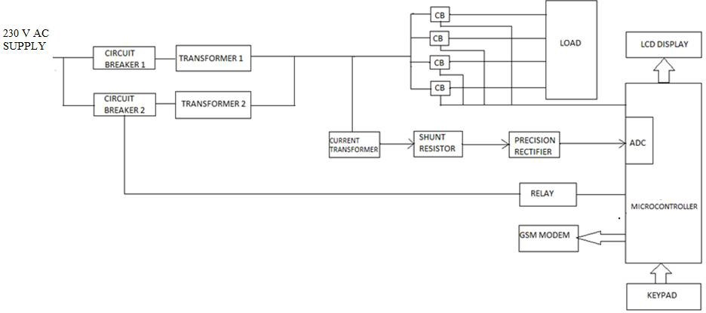

METHODOLOGY

- Transformer
A transformer is an electrical apparatus facilitating the transfer of electrical energy across multiple circuits via electromagnetic induction. It efficiently converts AC voltage from one level to another with minimal power loss. Operating on the principles of electromagnetic induction, transformers ensure mutual induction. In this study, a one-to-one transformer is employed, allowing direct connection to measuring devices through rectification. Successful parallel operation of transformers relies on fulfilling various conditions.

- Power Supply
The power supply is an electrical apparatus responsible for delivering electrical power to an electrical load. Its primary role involves converting electrical current from a source into the appropriate voltage, current, and frequency required by the load. This involves the conversion of mains AC to low-voltage regulated DC power and facilitating wireless energy transfer to power loads via wired connections.

- Voltage Regulator
Voltage regulators generate a stable DC output voltage from fluctuating DC input (which may contain a small amount of AC). This stable output is achieved by connecting the voltage regulator to the output of the filtered DC. Additionally, they can be utilized within circuits to step down high DC voltage to lower levels (e.g., employing a 7805 regulator to obtain 5V from a 12V source). There are two main categories of voltage regulators:
- Fixed voltage regulators (such as 78xx and 79xx).
- Variable voltage regulators (like LM317).
PROJECT IMPLEMENTATION

4.1 Hardware Implementation

Arduino Uno is an 8-bit ATmega328P microcontroller-based microcontroller board. It includes extra components to assist the ATmega328P microcontroller, such as a crystal oscillator, serial communication, voltage regulator, and so on. There are 14 digital input/output pins, 6 analogue input pins, a USB connection and Power barrel connector, an ICSP header, and a

reset button on the Arduino Uno. Arduino is capable of communicating with a computer, another Arduino board, or other microcontrollers. The ATmega328P microcontroller supports UART TTL (5V) serial communication, which is accessed by digital pins 0 (Rx) and 1 (Tx) (Tx). An ATmega16U2 on the board transmits serial data over USB, appearing to apps on the computer as a virtual com port. The ATmega16U2 firmware uses normal USB COM drivers and does not require an extra driver. A.inf file is necessary on Windows, however. You may transmit and receive simple textual data to and from the Arduino device using the serial monitor included in the Arduino software. When data is transferred through USB to seria chip and USB connection to the PC, two RX and TX LED on the Arduino board will flash (not for serial communication on pins 0 and 1). To communicate serially on any of the Uno digital pins, you'll need a Software Serial library. I2C (TWI) and SPI communication are also available on the ATmega328p. The Arduino software comes with a Wire library that makes using the I2C bus a breeze.

4.2 Software Requirement

It underpins both C and C++ programming dialects. Arduino supplies the product library, which gives some normal information and yield system. This is an open-source board which permits simple coding and transfer. Software Implementation Coding or Programming, Program utilized in the project, developed in C language with the Arduino linguistic structure in the Arduino IDE. The programming is likewise utilized for stacking the program code in to Arduino board. In this task, the Arduino IDE was utilized to program, create, debug, and transfer the coding into the microcontroller.

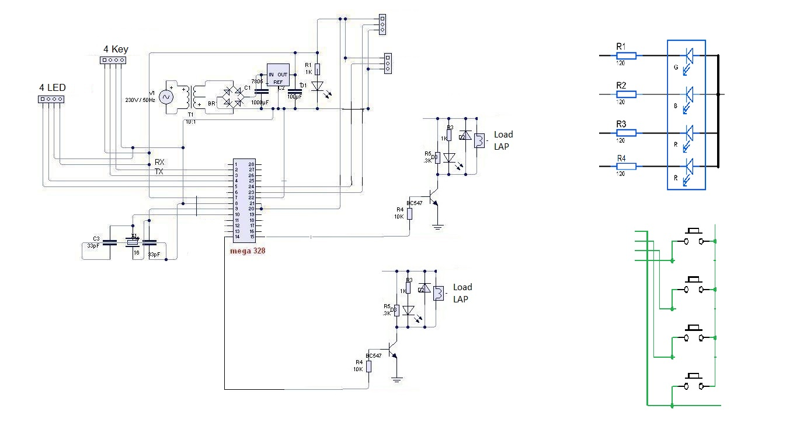

CIRCUIT DIAGRAM

- Transformer load sharing is automated using Arduino. The use of two identical transformers connected in parallel using a changeover relay.

- Transformer 1 is the primary transformer, also known as the master transformer, while Transformer 2 is the auxiliary transformer, also known as the slave transformer.
- A circuit breaker and a relay are connected in parallel by a standby transformer. The load current is continually measured by the current sensor and fed to the comparator. The primary transformer is switched on and the reserve transformer is switched off in normal operation.

- There are different conditions would apply while connecting the load which are discussed below.Under Normal

Condition

In the proposed system only one transformer is operating to feed the loads. A standby transformer is connected in parallel a circuit breaker and relay. The current sensor continuously measures the load current and feeds it to the comparator. Under normal condition the main transformer is in ON condition and the reserve transformer is in OFF condition. The user enters the reference value or maximum load limit, and the priority level of the load is also determined by the user or the responsible authority. During the normal the single transformer can able to feed the entire load.

5.1 Under Abnormal Condition

As the load requirement increases, during peak, a single transformer will not be able to feed the entire load. When the load demand exceeds the reference value, the Arduino will send a control signal to the relay coil to energise it. Because the transformers have the same ratings, the standby transformer will be connected in parallel and will share the load equally. Thus, all the loads are feed efficiently providing uninterrupted power supply. If load limits exceed the main transformer is in ON condition and the reserve transformer is in ON condition.

5.2 Shutdown Condition

When the load increases further to a value which is greater that the capacity of the two transforms, priority-based load shading will be implemented. The loads which have the lowest priority will be shut down by opening the respective circuit breakers. If the load limit exceeds the both the transformer. The main transformer and the reserve transformer will be in OFF condition.

RESULTS
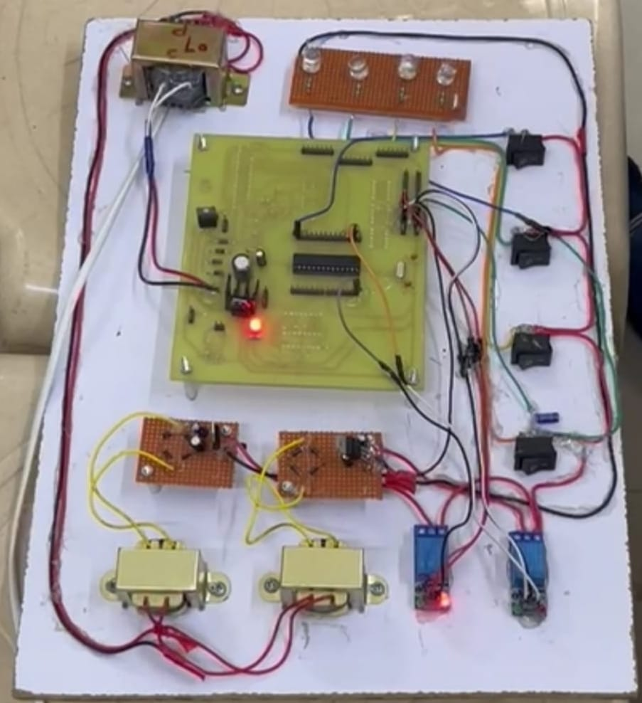

  - FUTURE SCOPE

- The load sharing by transformers occurs automatically.
- No manual errors occur in the process.
- This prevents damage to the main transformer from issues like overload and overheating.
- Uninterrupted power supply is ensured to consumers.
- Improved outcomes are observed.
- Power can be transferred over long distances at a lower cost.
- It enhances system efficiency, flexibility, and reliability. However, it also increases the risk of transformer short circuits.

    - CONCLUSION

In our implemented hardware system, we safeguard our power transformer during periods of peak loads by redistributing the workload to other slave transformers. Monitoring of transformer conditions and load distribution is conducted from a centralized control room. However, a notable drawback emerges when an overloaded transformer transfers its load; once unloaded, it cannot retrieve it, highlighting a research flaw that merits further exploration. Our numerical findings demonstrate the efficacy of our load sharing method in detecting abnormal states, revealing vulnerabilities within load sharing systems. This underscores the critical need for robust load management and monitoring facilitated by modern communication devices. Furthermore, it is imperative to explore the characteristics of load management and develop contemporary methodologies to enhance efficiency.

REFERENCES

- Hassan Abniki, H. Afsharirad, A. Mohseni, F. Khoshkhati, Has-san Monsef, Pourya Sahmsi

‘Effective On-line Parameters for Transformer Monitoring and Protection’, on Northern American

Power Symposium (NAPS), pp 1-5, September 2010.Sayali R. Tirpude, Dr. Harikumar Naidu, Pratik Ghutke Dept. of Electrical Engg, TGPCE, Nagpur, India HOD, Dept. of Electrical Engg, TGPCE, Nagpur, India Assistant Professor, Dept. of Electrical Engg, TGPCE, Nagpur, India.

- Rekha.T,BinduPrakash, Asna. S, Dinesh.S and Nandana.S.Prasad, “An Intelligent Method for Load Sharing of Transformers With Temperature Monitoring and Automatic Correction of Power

Factor”, International Journal Of Engineering Sciences & Research Technology, Volume 4, Issue3, pp. 416-421, 2015.

- Ashish R. Ambalkar, Nitesh M. Bhoyar, Vivek V. Badarkhe and Vivek B. Bathe, “Automatic Load Sharing of Transformers”, International Journal for Scientific Research & Development, Volume 2,
Issue 12, pp. 739- 741,2015.

- D.M.M. Ahmad, 2010. Evaluation of the Localised Loss Transformer Core Lamination. Journal of Applied Sciences, 10: 2917-2922.

- Transformer over Pre-trained Transformer for Neural Text Segmentation with Enhanced Topic Coherence Kelvin Lo, Yuan Jin1 Weicong Tan, Ming Liu, Lan Du1 Findings of the Association for Computational Linguistics: EMNLP 2021, pages 3334–3340 November 7–11, 2021. ©2021 Association for Computational Linguistics.
5

