PLANTS LEAF DISEASES DETECTION USING DEEP LEARNING
Bikkili Alekya Himabindu¹,Pathan Aaisha², Shaik Athiya³, Shaik Yasmin⁴
¹Assistant Professor, Electronics and Communiaction Engineering &Santhiram engineering College
²Student, Electronics and Communiaction Engineering &Santhiram engineering College
³Student, Electronics and Communiaction Engineering &Santhiram engineering College
⁴Student, Electronics and Communiaction Engineering &Santhiram engineering College
---------------------------------------------------------------------***---------------------------------------------------------------------

Abstract: Agriculture field has a high impact on our life. Agriculture is the most important sector of our Economy. Proper management leads to a profit in agricultural products. Farmers do not expertise in leaf disease so they produce less production. Plant leaf diseases detection is the important because profit and loss are depends on production. CNN is the solution for leaf disease detection and classification. Main aim of this research is to detect the apple, grape, corn, potato and tomato plants leaf diseases. Plant leaf diseases are monitoring of large fields of crops disease detection, and thus automatically detected the some feature of diseases as per that provide medical treatment. Proposed Deep CNN model has been compared with popular transfer learning approach such as VGG16. Plant leaf disease detection has wide range of applications available in various fields such as Biological Research and in Agriculture Institute. Plant leaf disease detection is the one of the required research topic as it may prove benefits in monitoring large fields of crops, and thus automatically detect the symptoms of diseases as soon as they appear on plant leaves.

Key Words: Diseases, CNN, Deep Learning
- INTRODUCTION
Plants are pivotal not as it were for people, but moreover for creatures who depend on them for nourishment, oxygen, and other necessities. The government and specialists are taking noteworthy activities to upgrade nourishment generation, and they are working effectively in the genuine world. When a plant gets to be tormented with a illness, all living living beings in the environment are influenced in a few way.
Apple, grape, corn, potato, and tomato plant leaves which are categorized total 24types That contains twenty-four types of leaf diseases and twenty-four thousand leaves images are labels apple label namely: Apple scab, Black rot, apple rust, and healthy. Grape label namely: Black rot, Esca, healthy, and Leaf blight. Corn label namely: Corn Cercospora spot Gray spot, Corn rust, Corn healthy, Corn Northern Blight. Potato label namely: Early blight, healthy, and Late blight. Tomato label namely: bacterial spot, early blight, healthy, late blight, leaf mold, septoria leaf spot, spider mite, target sport, mosaic virus.
The dataset consist of 31,119 images of apple, grape, potato and tomato, all Images are resized into 256 x 256, that images divided into two parts training and testing dataset.
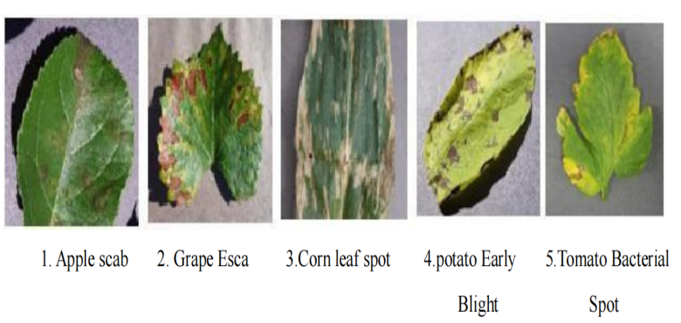
Fig- 1. Various Plant diseases
In figure above we can see vegetable and fruit leaves like potato, tomato, corn, apple, grape with diseased part this disease can be easily detected using deep learning techniques.
This disease detected using convolutional neural network (CNN), and also this model is compared with VGG16. Images are resized into 224 x 224.

- PROPOSED SYSTEM
The recognition and classification procedures are depicted in Fig.

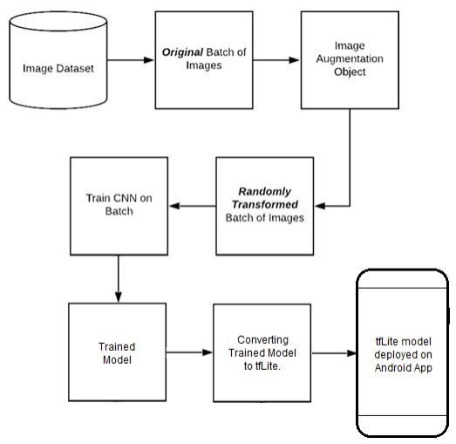
Fig- 2. Block Diagram Of Proposed System
(1) The first step is to collect data. We are using the Plant Village Dataset, which is widely available.
(2) This dataset was released by crowdAI.
(3) Pre-processing and Augmentation of the collected dataset is done using pre- processing and Image-data generator API by Keras.
(4) Building CNN(Convolutional Neural Network) Model for classification of various plant diseases.
(5) Developed model will be deployed on the Android Application TensorFlow lite.
2.1 CONVOLUTIONAL NEURAL NETWORK ARCHITECTURE(CNN)
In the field of image classification, deep learning has made significant advancements, and one popular technique used is Convolutional Neural Networks (CNNs). To further improve
the performance of CNNs, various architectural modification can be applied. These modification include introducing dropout layers between layers, altering the number of layers and filters in the convolutional models, adjusting the stride window size, filter size, and utilizing max pooling.
Apple, grape, potato, and tomato plant clears out which are categorized add up to 24 sorts of names apple name specifically: Apple scab, Dark decay, Apple rust, and sound. Corn name specifically: Corn Cercospora Gray spot, Corn rust, Corn sound, Corn Curse. Grape name specifically: Dark spoil, Esca, solid, and Leaf scourge. Potato name to be specific: Early curse,
solid, and Late curse. Tomato name specifically: bacterial spot, early curse, solid, late curse, leaf form, septoria leaf spot, insect bug, target wear, mosaic infection, and yellow leaf twist virus.
The dataset comprise of 31,119 pictures of apple, corn, grape, potato and tomato, out of 31,119 pictures 24000 pictures are utilized. all Pictures are resized into 256 x 256,that pictures partitioned into two parts preparing and testing dataset, the entire run of the prepare test part utilizing 80-20 (80% of the entirety dataset utilized for the preparing and 20% for the testing). At that point prepare CNN model.

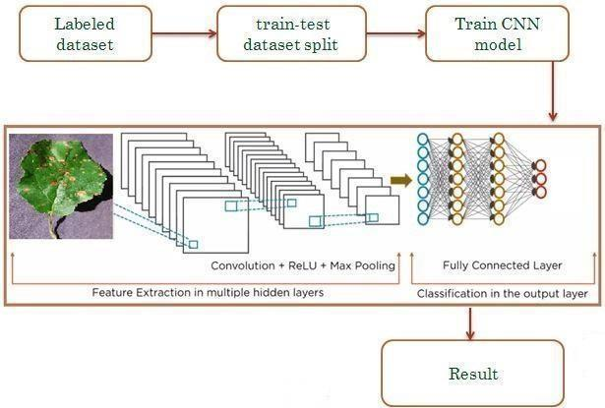
Fig-3: Proposed Workflow
Convolutional neural systems (CNN) can be utilized for the computational show creation that works on the unstructured picture inputs and changes over to yield names of comparing classification. They have a place to the category of multilayer neural systems which can be prepared to learn the required highlights for classification purposes.
Less pre-processing is required in comparison to conventional approaches and programmed highlight extraction is performed for superior execution. For the reason of leaf illness discovery, the best comes about seem be seen with the utilize of a variety of the LeNet architecture.
LeNet comprises of convolutional, actuation, max-pooling and completely associated layer moreover LeNet is straightforward CNN demonstrate. This engineering utilized for the classification of the leaf maladies in LeNet show. It comprises of an extra square of convolution, enactment and pooling layers in comparison to the unique LeNet design. The show utilized in this paper been appeared in Fig. 3 .Each piece comprises of a convolution, enactment and a max pooling layer. Three such squares taken after by completely associated layers and soft-max actuation are utilized in this engineering. Convolution and pooling layers are utilized for highlight extraction though the completely associated layers are utilized for classification. Actuation layers are utilized for presenting non-linearity into the network.
Convolution layer applies convolution operation for extraction of highlights. With the increment in profundity, the complexity of the extricated highlights increments. The estimate of the channel is settled to 5 × 5 while number of channels is expanded continuously as we move from one square to another. The number of channels is 20 in the to begin with convolution piece whereas it is expanded to 50 in the moment and 80 in the third. This increment in the number of channels is essential to compensate for the diminishment in the estimate of the include maps caused by the utilize of pooling layers in each of the squares. After the application of the convolution operation include maps are zero cushioned, in arrange to protect the measure of the picture. The max pooling layer is utilized for diminishment in estimate of the include maps, speeding up the preparing handle, and making the demonstrate less variation to minor changes in input. The bit
estimate for max pooling is 2×2. Re- LU enactment layer is utilized in each of the pieces for the presentation of non-linearity. Moreover, Dropout regularization procedure has been utilized with a keep likelihood of 0.5 to maintain a strategic distance from overfitting the prepare set. Dropout regularization haphazardly drops neurons in the arrange amid cycle of preparing in arrange to diminish the fluctuation of the show and streamline the arrange which helps in anticipation of
over fitting. At long last, the classification square comprises of two sets completely associated neural arrange layers each with 500 and 10 neurons individually. The moment thick layer is taken after by a delicate max enactment work to compute the likelihood scores for the ten classes.
- DATASET, IMPLEMENTATION
The dataset used in this paper consists of photographic images. We gathered a substantial number of tomato photographs from Kaggle. While collecting data, we focus on the correct image sizes, resolutions, and quality of both normal and infected images. The dataset contains 6926 PlantVillage images. Using Python TensorFlow Keras, the dataset has been processed. The dataset includes three image types, including Bacterial spot, Tomato yellow leaf curl virus, and Healthy. In the dataset, 1590 images are categorized as healthy, 2127 as bacterial spots, and 3209 as yellow leaf curl virus.
Adam is utilized as the optimizer in this study. Adam is an effective optimization algorithm that allows for dynamic adjustment of the learning rate during the training process. The categorical cross-entropy loss function is employed to train the model, which is suitable for multi-class classification tasks.
CCE(y,t) = −X(ti log(yi) + (1 − ti)log(1 − yi))

The dataset is first used to validate the model and then to test it. The model is trained using the Ąt function, which iteratively measures the systems performance over a specific number of epochs. Once the training process is completed, the model is configured for the testing procedure. This ensures that the trained CNN model is fully optimized and ready to demonstrate its potential.
- EXPERIMENTAL RESULT AND ANALYSIS
4.1 Experimental Result
We used 80% of the data to train the model and 10% of the data to test the model. In addition, the data set aside for training was split again, this time by 10% for validation. The total number of epoch count is 50. The Python Keras library were used to implement the model. The experiment was run utilizing the Google-provided graphics processing unit (GPU) Colab.
5.2 Performance Evaluation Metric
We analyze the performance of the proposed CNN model in terms of accuracy and loss. The accuracy is calculated from the confusion matrix. We require the followings to compute
accuracy.
● TP (True Positive) indicates a correct prediction of Tomato Leaf diseases.
● FP (False Positive) indicates healthy cases of tomato leaf.
● TN (True Negative) is the correctly classiĄed Tomato Leaf disease.
● FN (False Negative) is the disease cases that are misclassiĄed as normal or leaf
disease.
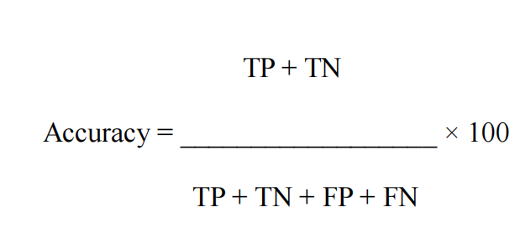
Table 1 shows the training, testing accuracy and loss of the CNN model at different epochs.
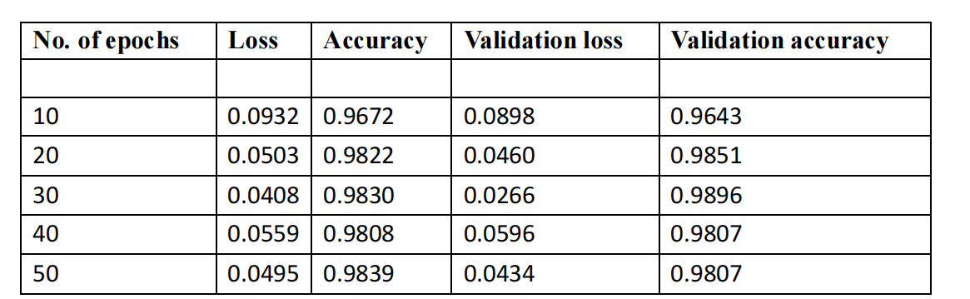
Loss, accuracy, validation loss and validation accuracy for each instance of the system is summarized in Table. The proposed CNN network achieved for the Ąrst 10 epoch 0.0932 loss, 96.72% accuracy, 0.0898 validation loss, 0.9643 validation accuracy and for the 50 epoch we got 0.0495 loss, accuracy 98.39% accuracy, 0.0434 validation and 0.9807 validation accuracy
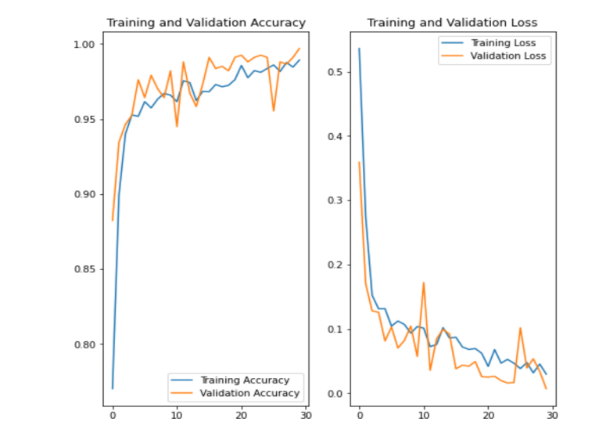

Fig-4. Evaluation metrics of the proposed system (a) Graph for Accuracy (b) Graph for Loss.
For CORN Leaf
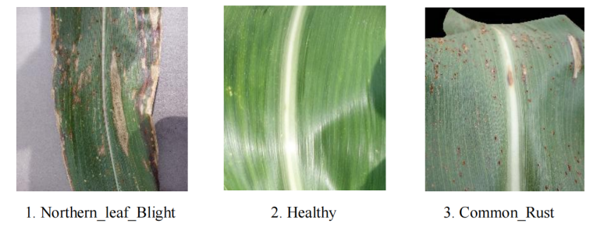
For Potato Leaf
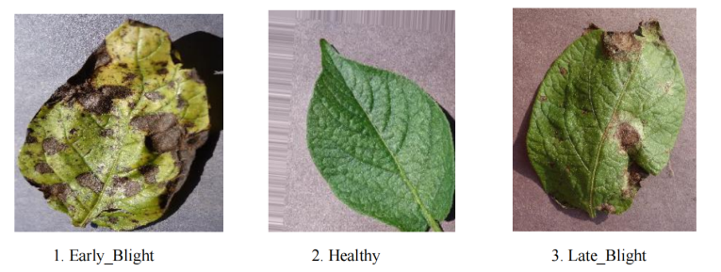
For Tomoto Leaf
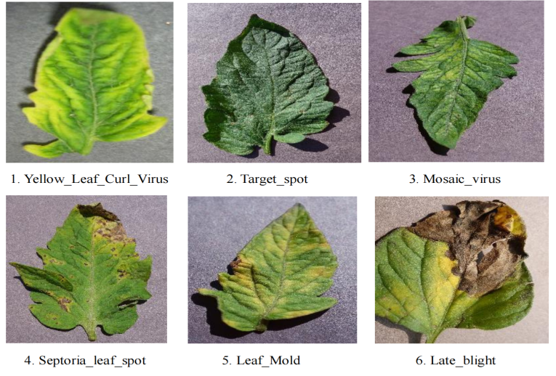
CONCLUSION
This study focuses on the classification of tomato leaf images, where a deep Convolutional Neural Network (CNN) system was developed to detect diseases in tomato leaves. The CNN architecture was employed to identify patterns and features, successfully distinguishing healthy leaves. The proposed architecture achieved impressive results, including a loss of 0.0495, an accuracy of 98.39%, a validation loss of 0.0434, and a validation accuracy of 0.9807. However, one major constraint is the lack of specialized equipment and instruments. Therefore, future work aims to conduct tests using relevant tools and establish collaborations with radiologists to further enhance the applicability of our model. Overall, this research presents a robust CNN-based system for the classification of tomato leaf diseases, showcasing its superior performance compared to some existing approaches.
REFERENCES
- http://www.apeda.gov.in/apedawebsite/index.html: Agricultural and processed food products export development authority (2017).
- Nalawade R, Nagap A, Jindam L, Ugale M (2020) Agriculture field monitoring and plant leaf disease detection, pp 226–231.
- Bhagat M, Kumar D, Mahmood R, Pati B, Kumar M (2020) Bell pepper leaf disease classification using CNN. Expert systems with applications, pp 1–5.
- Sardo˘gan M, Tuncer A, Ozen Y (2018) Plant leaf disease detection and classification based on CNN with lvq algorithm. In: 2018 3rd International conference on computer science and engineering (UBMK), pp 382–385.
- Nandhini S, Suganya R, Nandhana K, Varsha S, Deivalakshmi S, Thangavel SK (2021) Automatic detection of leaf disease using CNN algorithm, pp 237–244.
- Trivedi J, Shamnani Y, Gajjar R (2020) Plant leaf disease detection using machine learning, pp 267–276.
- Dalal T, Singh M (2021) Review paper on leaf diseases detection and classification using various CNN techniques, pp 153–162
- Ajra H, Nahar MK, Sarkar L, Islam MS (2020) Disease detection of plant leaf using image processing and CNN with preventive measures, pp 1–6.
- Lu J, Hu J, Zhao G, Mei F, Zhang C (2017) An in-field automatic wheat disease diagnosis system 142:369–379.
- Kamilaris A, Prenafeta-Bold FX (2018) Deep learning in agriculture: a survey 147:70–90.
- Bhattacharya S, Mukherjee A, Phadikar S (2020) A deep learning approach for the classification of rice leaf diseases, pp 61–69.
- Gajjar R, Gajjar N, Thakor VJ, Patel NP, Ruparelia S (2021) Real-time detection and identification of plant leaf diseases using convolutional neural networks on an embedded platform 147:1432–2315.
- Ferentinos K (2018) Deep learning models for plant disease detection and diagnosis 145:311–318.
- Barbedo J (2019) Plant disease identification from individual lesions and spots using deep learning 180:96–107.
- Singh V, Misra A (2017) Detection of plant leaf diseases using image segmentation and soft computing techniques 4:41–49.
- Durmu¸s H, Gunes E, Kirci M (2017) Disease detection on the leaves of the tomato plants by using deep learning, pp 1–5.
- Kibriya H, Rafique R, Ahmad W, Adnan S (2021) Tomato leaf disease detection using convolution neural network, pp 346–351.
- Bin L, Zhang Y, He D, Li Y (2017) Identification of apple leaf diseases based on deep convolutional neural networks 10:11–24.
- Naik D, Shaikh R, Shetti S, Kanakaraddi S, Jahagirdar S, Hubli B (2015) Detection and quantification of disease in cabbage using clustering and RGB colour features 14:2–20.
- Lee SH, Chan CS, Mayo SJ, Remagnino P (2017) How deep learning extracts and learns leaf features for plant classification 71:1–13.
- http://www.kaggle.com/vipoooool: New plant diseases data-set Srivastava P, Mishra K, Awasthi VVKS, Pal PK (2021) Plant disease detection using convolutional neural network 691–698.

