DEVELOPMENT OF AUTOMATIC INDICATOR AND WOMEN SAFETY DEVICE ON BIKE
SHAIK ASHRAF^{*1}, Y.PREM KUMAR^{*2}, K.ASHISH*³ , K.ANIL KUMAR*⁴ ,G.VINIL KUMAR^{*5.}
*1 Assistant Professor, Department of Mechanical Engineering, J.B. Institute of Engineering and
Technology, Hyderabad, Telangana
*2, * 3 ,* 4 ,* 5 B Tech Student, Department of Mechanical Engineering, J.B. Institute of Engineering and
Technology, Hyderabad, Telangana

ABSTRACT
Bikes are most preferred vehicles due to low initial cost and maintenance. the commercial utilization of bikes with the introduction of Uber, Rapido, Ola etc is increased. Indicators- whether attached at the front, side or rear of the vehicle – provide information for other road users through their signals and are thus responsible for safety on the roads to a substantial extent. Negligence in using the indicators often leads to accidents. Which can be avoided by incorporating automatic indicators and safety cut-off switch for safety on commercial bikes.
This project involves developing of automatic indicators and safety device for bikes. The automatic indicator after completing a turn switches off automatically in case the rider forgets to switch off, which results in decrease in accidents. Safety Cut – off switch can be used to alert or cut-off the power to EV motor or Engine when co-rider senses some risk from driver. Study of various types of indicators and functionalities, sensors, switches and mountings for automobiles is carried out extensively.
The integration of automatic indicators and safety devices on bikes represents a significant step forward in enhancing both the functionality and security of two-wheeled transportation. By automating indicators, riders can focus more on the road ahead, reducing the risk of accidents caused by distracted riding.
Keywords: Indicators, Controller, Battery, Sensing Element, Emergency Safety Cut Off Switch.

- INTRODUCTION
In today’s world most of the road accidents which are leading to losing life are due to indicators or turning lights while taking a turn. Drivers who do not use their turn signals correctly are a danger to other drivers, whether they realize it or not. The Society of Automotive Engineers (SAE) reports that two million accidents occur every year due to drivers who fail to signal. A separate survey showed that 71 percent of drivers between the ages of 18 and 24 said that they did not use their blinkers consistently. We also observed drivers forget to turn off the indicator lights which make the driver behind them confused and thus can lead to road accidents that break into heavy disaster. There is also a possibility that the emergency service at this point may get delayed due to some unnatural reasons which leads to high risk of losing life and heavy physical damage to the person driving and the person driving behind them. In order to avoid the road accidents or reduce the rate of road accidents we analysed the situation and trying to implement automatic indicator off system in motorcycles i.e. two wheelers that turns off the indicators after taking a turn, so to control the rate of accidents on roads.
It is also very unfortunate that now a days there is increase in the misusing safety and trying to abuse them by commercial taxi drivers. The drivers try to misuse this freedom and try to assault or abuse while travelling in their taxis which also results in increase in the death rate of and resulting bad esteem of the and their family and friends in the society, due to this thing the feel insecure and attempt to injure themselves or attempt to suicide. We as a group observed this problem and the worse behaviour of the taxi drivers and came forward to undertake this case and develop a safety device in motorcycles i.e. two wheeler which work as commercial taxis that allows to stop the vehicle when they feel dangered or insecure while travelling in these taxis As most of the people prefer two wheeler taxis as due to their mobility and easy transportation across different places and the cost these two wheeler are comparatively less than other forms of transport.
In order to avoid this, a safety cut-off switch is provided at the pillion seat and the pillion ( travelling on the two-wheeler taxis are encouraged to use to safety cut-off switch when the driver tries to misbehave with them.
The safety Cut-off switch is connected directly to the ignition and when the pulls the cut-off the vehicle stops and gets a chance to defend themselves, attack drivers or escape from the situation. The safety Cut-off switch is provided in such a way that the driver consumes a lot of time to restart their vehicle or the vehicle breaks down and requires a new part in Safety Cut-off switch to turn on the vehicle that allow the to tackle up the situation

II.LITERATURE SURVEY

As far as the traffic discipline is concerned, we see many people on the roads who somehow forget to turn off the indicator after the turn which sometimes leads to minor brouhaha on the road and seldom an accident.
Motorcyclists are constantly exposed to more danger than operators of other vehicles. On a bike we are more exposed and don’t have the safety net provided by doors, a roof, reinforced steel beams, and roll cages. A major factor in motorcycle safety is
visibility — a bike is smaller and harder to see, and even the horn can’t compare to the ones found on cars. As a result, it is even more important for riders to signal their intent on the road, especially with the use of turn signals. But sometimes because we don’t have proper traffic rules and people don’t follow the existing few rules, they ended up triggering the off sensor even before the turn.
Unlike cars, motorcycles do not always come with self-cancelling signals, especially when it comes to older models. The danger is compounded when even veteran motorcyclists occasionally forget to switch off their signals or are not aware they are even on. It does happen. For bikes that do come with self-cancelling signals, they are usually set to switch off after a certain distance or time has passed, which may not always be ideal. The Smart Turn System from Slovenia-based company ABCS System designed to mitigate these risks.
The Smart Turn System uses motion sensor technology to determine when a rider has changed a lane, exited a freeway, or simply taken a turn. The new Smart Turn System uses an advanced algorithm that analyses collected data on direction, inclination, acceleration and vibration of the vehicle in order to reliably switch the turn-signals off after the completion of a manoeuvre. A patented system collects movement data (300 elements per second), including acceleration, inclination, heading, and vibration. It then uses an algorithm to determine what the rider is doing and, at the completion of the manoeuvre, switches off the motorcycle’s turn signal. It is integrated into the bike’s electronics to use its stock lights.

III .METHODOLOGY
INDICATORS
Automobile turn indicators currently in use have limitations in communicating the actual intended manoeuvre a vehicle is likely to perform. For example, a vehicle intending to perform a U-Turn manoeuvre uses the same indicator as that used for either a right or a left turn depending on whether a LHT (Left Hand Traffic) or a RHT (Right Hand Traffic) regime is in operation in the region in which it is moving. The same indicator is also used for indicating changing of lanes or permitting a passing (overtaking) manoeuvre to a following vehicle on request. Some thoughts are presented in this article to overcome these and other limitations by using coloured LEDs to display the intended manoeuvre.
Set of turn (left/right) indicator lights (flashers) are provided in the front, sides and rear end of all motorized vehicles as appropriate considering the vehicle class and type. In some models these are also provided on the external rear view mirrors. The turn indicator lights on a vehicle guide the pedestrians and other vehicles (both, motorized and non-motorized) moving in the vicinity to make appropriate manoeuvres (proceed, slow down or stop). The flashers are yellow or amber in colour in general. In some countries, however, the front flashers could be white in color. The flashers located on the right-hand side of the vehicle communicate to other road users the maneuvers, such as, changing lanes rightwards or turning right or turning-U to right, which the flashing vehicle intends to perform. Likewise, the left flashers indicate to the corresponding manoeuvres in the opposite direction.
The flashers are controlled by a lever or a stalk. The clock wise movement of the lever turns on right flashers and anti-clock wise movement turns left flashers. The movement of the lever, in general, corresponds to the movement of the steering and the resultant turn. The other lights external to the vehicle which guide the other road users are the red coloured tail lamp and break light and fog lights and others. The whole set of external lights and indicators could be termed VMIS (Vehicle Manoeuvre Information System) with a subsystem termed VTIS (Vehicle Turn Indicator System) comprising of the turn indicators or flashers. VMIS is in use for many years and served fairly well thus far. However, it has limitations.

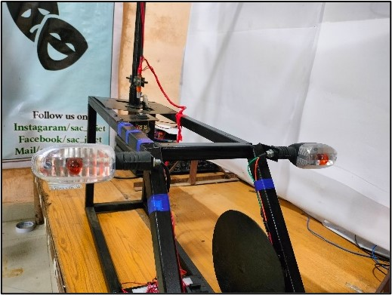

Fig- Indicators
SAETY CUT OFF SWITCH:
Emergency Safety Cut off switch is a switch provided at the backside near to pillion. This switch ensures the safety of the while on commercial two-wheeler taxis. The switch is provided in such a way that it is directly given to the engine and whenever the travelling behind feels unsafe or insecure, they can use the switch which stops the vehicle there itself and allows them to defend or escape from the situation. The switch is given in such a way that it does not allow the vehicle until the driver gets down the vehicle and sets the switch back which gives the ample amount of time to react accordingly in that situation.
CONTROLLER
The electric vehicle controller is the electronics package that operates between the batteries and the motor to control the electric vehicle ‘s speed and acceleration much like a carburettor does in a gasoline-powered vehicle. The controller transforms the battery’s direct current into alternating current (for AC motors only) and regulates the energy flow from the battery. Unlike the carburettor, the controller will also reverse the motor rotation (so the vehicle can go in reverse), and convert the motor to a generator (so that the kinetic energy of motion can be used to recharge the battery when the brake is applied). In the early electric vehicles with DC motors, a simple variable-resistor-type controller controlled the acceleration and speed of the vehicle. With this type of controller, full current and power was drawn from the battery all of the time. At slow speeds, when full power was not needed, a high resistance was used to reduce the current to the motor. With this type of system, a large percentage of the energy from the battery was wasted as an energy loss in the resistor. The only time that all of the available power was used was at high speeds. Modern controllers adjust speed and acceleration by an electronic process called pulse width modulation
. 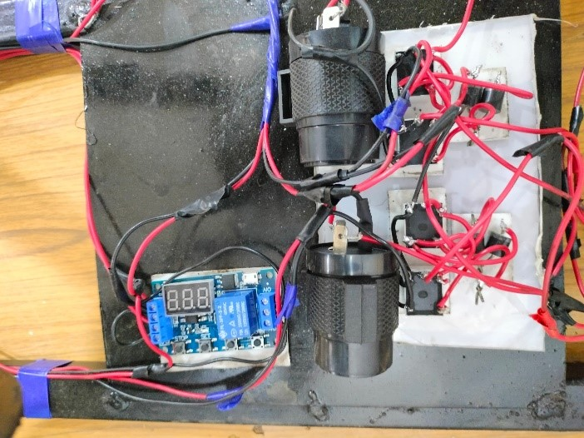
Fig- Controller
Switching devices such as silicone-controlled rectifiers rapidly interrupt (turn on and turn off) the electricity flow to the motor. High power (high speed and/or acceleration) is achieved when the intervals (when the current is turned off) are short. Low power (low speed and/or acceleration) occurs when the intervals are longer. The controllers on most vehicles also have a system for regenerative braking. Regenerative braking is a process by which the motor is used as a generator to recharge the batteries when the vehicle is slowing down. During regenerative braking, some of the kinetic energy normally absorbed by the brakes and turned into heat is converted to electricity by the motor/controller and is used to re-charge the batteries. Regenerative braking not only increases the range of an electric vehicle by 5 - 10%, it also decreases brake wear and reduces maintenance cost.
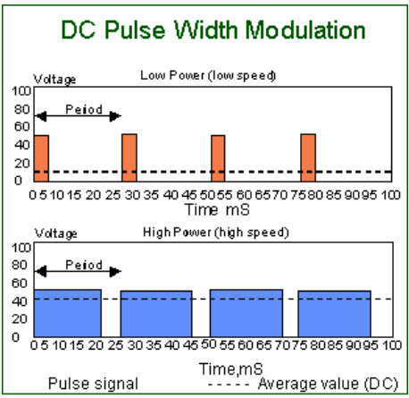
Fig- DC Pulse with Modulation

BATTERY
The battery is the main source of electrical energy in our vehicles. It stores chemicals, not electricity. Two different types of lead in an acid mixture react to produce an electrical force. This electrochemical reaction changes chemical energy to electrical energy.
The main functions of battery are:
- Engine Off: Electricity from the battery is used to operate lighting, accessories, or other electrical systems when the engine is not running.
- Engine Starting: Current from the battery is used to operate the starter motor in electric start vehicles and to provide sufficient current for the ignition system during engine cranking.
- Engine Running: Electricity from the battery may be needed to supplement the charging system when the vehicle’s electrical load requirements exceed the charging system’s ability to produce electricity. Both the battery and the alternator supply electricity when demand is high. Generally, this circumstance doesn’t crop up in two wheelers as we have very less electrical stuff.
SENSING ELEMENT
Position sensors are devices that can detect the movement of an object or determine its relative position measured from an established reference point. These types of sensors can also be used to detect the presence of an object or its absence.
There are several sensor types that serve similar purposes to position sensors and which are worthy of mentioning. Motion sensors detect the movement of an object and can be used to trigger action (such as illuminating a floodlight or activating a security camera). Proximity sensors as well can detect that an object has come within range of the sensor. Both sensors, therefore, might be considered as a specialized form of position sensors. More about these sensors may be found in our related guides about proximity sensors and about motion light sensors. One distinction with position sensors is that they are for the most part concerned with not only the detection of an object but also with the recording of its position and therefore involve the use of a feedback signal that contains positional information.

IV. MODELING AND ANALYSIS
MODELING
By using Catia V5 Software we have designed the following parts,
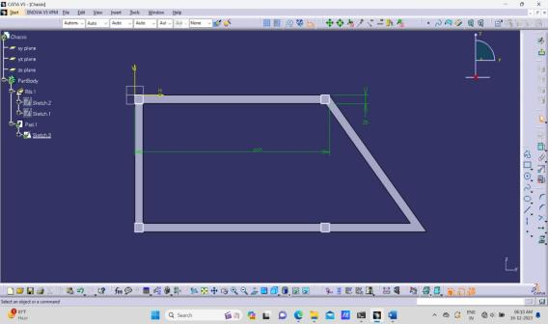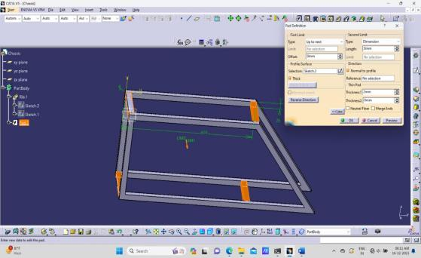

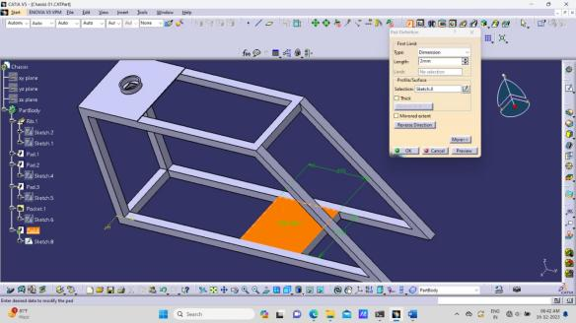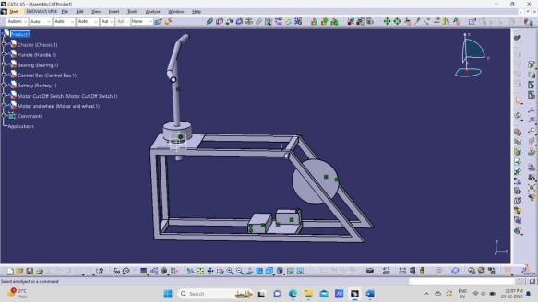

ANALYSIS

Design analysis uses the finite element analysis (FEA) method to simulate the physical behavior of a product
design. The FEA process involves breaking down all systems into individual components or "elements".

Upon application of 10kg (98.1N) load on structure it is observed that the maximum stress exerted is 3.07 x 106
N-m2 which is much lesser than 210MPa (Yield Stress of Mild Steel) is shown below

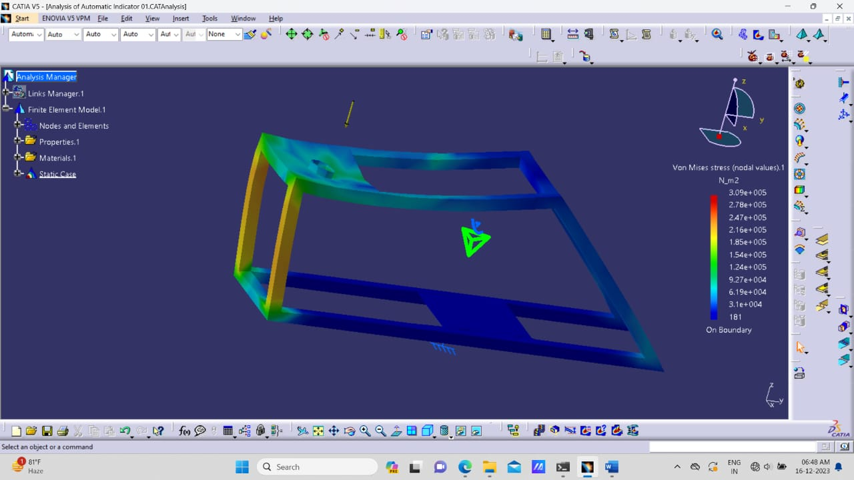

Hence the selected material mild steel and thickness are sufficient to take the load.
Max transitional displacement is 0.00057mm which is too low.

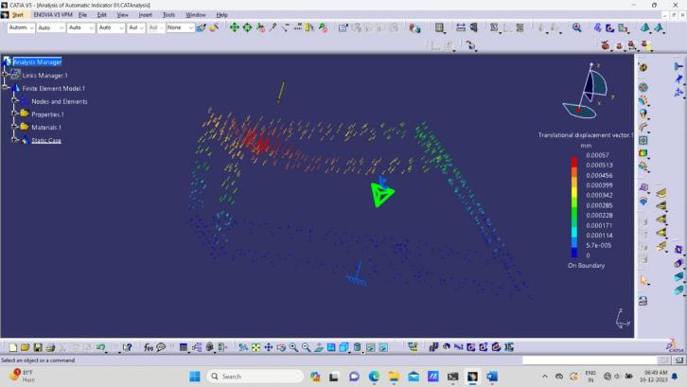

V. FABRICATION

Major materials used in this Fabrication are MS Square and circular rods, Battery, Nuts and Bolts.
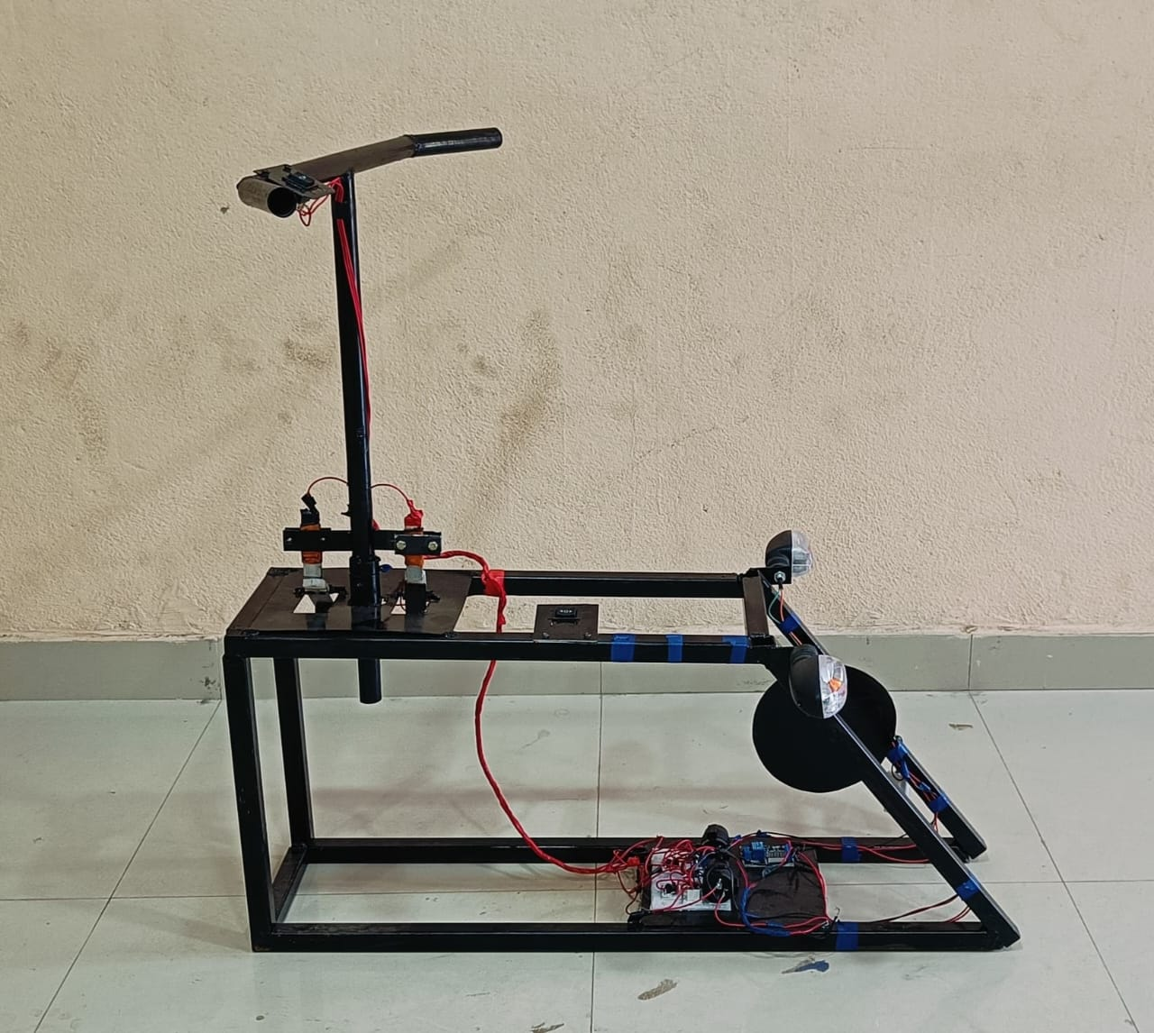
Fig- Final Output

VI. RESULTS AND DISCUSSION

Automatic indicators and safety devices on bikes are successfully incorporated. The automatic indicator after completing a turn switches off automatically in case the rider forgets to switch off. Safety cut off switch provided at the backside near to pillion which is directly connected to ignition switched off the engine in case of potential threat to pillion rider.
Switching device silicone-controlled rectifiers rapidly interrupt (turn on and turn off) the electricity flow to the motor. These advancements not only contribute to the overall safety of riders but also promote inclusivity and accessibility within the biking community. ultimately fostering a safer and more enjoyable riding experience for all.

VII .CONCLUSION
The automatic indicators and safety device on bikes are super handy and easy to control. They turn off by themselves after a turn, so you don't have to remember to switch them off. Helps avoid confusion on the road, making riding safer for everyone, it's one less thing to worry about when you're enjoying your ride. The automatic indicators to avoid accidents that may happen due to negligence in switching indicators and safety cut-off switch for safety of travelling on others / commercial bikes.
User-Friendly design and operation of safety switches that are intuitive and easy to use, even in high-stress situations. Simple activation mechanisms, such as push buttons or toggles, ensure that riders can activate the device quickly and without confusion.

ACKNOWLEDGEMENTS

This work is not an individual contribution till its completion. We take this opportunity to thank all for bringing it close to the conclusion. First of all, we would like to thank our guide Mr. Shaik Ashraf conclusion considering our work and providing great guidance by timely suggestions and discussion at every stage of this work. Thanks to, Dr. Anoop Kumar Shukla, Head of the Department of Mechanical Engineering for providing all facilities without which this seminar work would not have been possible. We sincerely thank Mr. Shaik Ashraf for his guidance. I would like to express my gratitude towards my parents & other faculty members of J.B. Institute of Engineering & Technology for their kind cooperation and encouragement which helped me in the competition of this project My thanks and appreciation also go to my co-peers in assisting with different aspects of the project and people who willingly helped me out to the best of abilities.

VIII. REFERENCES
- [1] Vehicle navigation system turn indicator by James Walker (2005), US Patent US20050187710A
- [2] Automotive Lane change aid by Kenneth Schofield (2005), United States Patent USOO6882287B2
- [3] A turn-signal device with auto cancellation feature (2005), French Patent WO2005009822A2
- [4] Jae Kyu Suhr and Ho Gi Jung, “Sensor Fusion-Based Vacant Parking Slot Detection and Tracking. IEEE transactions on intelligent transportation systems, vol. 15, no. 1, pp. 21-36, February 2014.
- [5] Jae Kyu Suhrand Ho Gi Jung, “Fully-automatic Recognition of Various Parking Slot Markings in Around View Monitor (AVM) Image Sequences,” 2012 15thInternational IEEE Conference on Intelligent Transportation Systems Anchorage, Alaska, USA, pp. 1294-1299, September 16-19, 2012

