Design and Implementation of a Honeypot-based Intrusion Detection System for
Mrs.C.Mani M.E  Assistant Professor,  Department Of Computer Science and Engineering, Nandha Engineering College(Autonomous), Erode. | Santhosh K,  Department Of Computer Science and Engineering, Nandha Engineering College(Autonomous),  Erode. | Santhosh M,  Department Of Computer Science and Engineering, Nandha Engineering College(Autonomous), Erode.
Snehan D J,  Department Of Computer Science and Engineering, Nandha Engineering College(Autonomous),  Erode. | Vijay Anand V,  Department Of Computer Science and Engineering, Nandha Engineering College(Autonomous),  Erode.
Mitigating SQL Injection-based Botnet Attacks in E-commerce Websites.

Abstract: Sensitive data on e-commerce websites has been more vulnerable to cyberattacks in recent years, especially when those assaults take advantage of SQL injection flaws. Botnets are a ubiquitous hazard that increase the risks by automating large-scale attacks. This paper provides a new method for preventing SQL injection-based botnet assaults on e-commerce websites by creating and deploying an intrusion detection system (IDS) based on honeypots. By tricking attackers into interacting with dummy systems and then watching and analyzing their actions, the suggested solution seeks to proactively detect and neutralize such attacks. Our system improves the security posture of e-commerce platforms by using a combination of machine learning algorithms, anomaly detection techniques, and honeypot deployment. This protects sensitive client data and maintains business integrity.
Keywords: E-commerce, SQL injection, Botnet, Honeypot, Intrusion Detection System, Machine Learning, Anomaly Detection

INTRODUCTION
The extensive use of e-commerce platforms has changed how consumers make purchases and complete transactions. However, there are serious cybersecurity risks that come with this ease. E-commerce websites are appealing targets for malevolent groups due to the abundance of sensitive information they store, including financial and personal data. To close this significant gap in cybersecurity defenses, we suggest creating an Intrusion Detection System (IDS) based on honeypots that is specifically designed to foil such assaults. This intrusion detection system (IDS) works by tricking and distracting bad actors while monitoring their actions, strengthening the security stance of e-commerce platforms.

RELATED WORKS
This section provides a professional tone for the evaluation and discussion of related research in the honeypot sector. Honeypots are widely used to study malware and network traffic. They are primarily installed on physical hardware that is conventional, however there has been some research into use cases that are more specific. Brown (2012) deployed honeypots across major cloud infrastructure providers, including Amazon, Microsoft, IBM, and ElasticHosts, as part of a groundbreaking study on cloud infrastructure security. Although they analyzed a wide range of worldwide locations, they had some significant drawbacks, including a lack of performance and log data comparison across instances and a shallow level of interpretation in the results analysis. On the other hand, by thoroughly analyzing a variety of data sources, this thesis aims to close these gaps and provide fresh perspectives on attackers and their tactics.Wählisch (2013) also made a contribution by looking into attack vectors that target mobile devices and came to the conclusion that there aren't many noteworthy assaults that are made especially for mobile systems. Additional study has examined malware detection, botnet tracking, and SSH traffic analysis on both physical hosts and cloud infrastructures, highlighting the significance and adaptability of honeypot research in cybersecurity.

PROPOSED SYSTEM
- System Design
The general setup process for honeypots is simple: The software tools begin logging their findings to log files on the system as soon as they are installed on the physical or virtual machine. Since high-interaction honeypots typically function on the actual system, the attacker may have access to these logs. However, with low-interaction honeypots like the ones used in this experiment, actual system access is not conceivable. As a result, the logs should never be accessible to or altered by an attacker.Figure 2 illustrates how the attacker attempted to use the internet to launch brute-force attacks against the SSH server port, which was previously altered to reach port 22.The experiment's honeypot systems are only in danger from unplanned outages and system malfunctions.
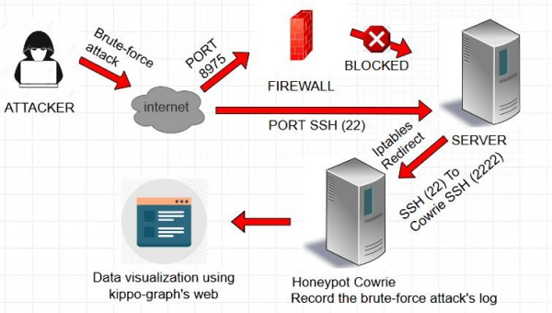Figure 1: Design System
By having both virtualized file systems and hardware, a crash or malfunction could potentially wipe all the data, including the log files. With a backup and recovery solution, or additional redundant systems, the system can be secured against unexpected failures. It is also possible that the honeypots experience high load, either intentionally or through targeted Distributed Denial-of-Service (DDoS) attacks. A solution to this would be to upgrade the subscription to the cloud providers and request more bandwidth and resources, which would in turn overrun the budget of this thesis.
- System Implementation
To begin, install Cowrie on your Kali Linux system using the Python package manager, pip. Next, customize the Cowrie configuration file to specify parameters such as SSH and Telnet ports, logging preferences, and the creation of fake filesystems to simulate a real environment. Adjust your firewall settings to redirect incoming traffic to the Cowrie honeypot, ensuring that it captures attempts at unauthorized access. Finally, start the Cowrie service, allowing it to monitor and record any malicious activity directed at the honeypot, thereby enabling you to analyze and bolster network security defenses.
- Nmap (Network Mapper)
Network Mapper is shortened to Nmap. It is an open-source Linux command-line utility for detecting installed applications and scanning IP addresses and ports within a network..Examine one host: Examines one host for one thousand popular ports. Popular services like SQL, SNTP, Apache, and others use these ports.
nmap scanme.nmap.org

- Metasploit
Metasploit is a framework that has a function to find vulnerabilities in a system. Metasploit consists of many auxiliary functions. One of the function is SSH service which runs in port 22 [21]. One of the attack are brute-force attacks which try to login into the system by try to use the random combination between user and password as many as possible.

RESULT AND ANALYSIS
- Honeypot Cowrie
There are a few crucial procedures that must be followed in honeypot cowrie in order to create a cowrie user on the server. First, the SSH server port needs to be changed by configuring the original port, which was 22 but is now 8975. Second, the SSH server has to be redirected from port 22 to port 2222 for the cowrie system. Finally, a server with a built-in VPS is the outcome of the cowrie configuration. The user must use PuTTY to enter the IP public address 185.201.8.194 in order to successfully log in to Cowrie. This avoids using port 22, which iptables has already configured to divert traffic to Cowrie at port 2222.
- Kippo-Graph
The configuration of the kippo-graph comes next. The creation of the cowrie database, the import of previously available source code, and the configuration of the kippo-graph database which will be displayed online require a number of procedures. Figure 4 illustrates a result of the kippo-graph website presentation, showing all of the data that Cowrie was able to collect.
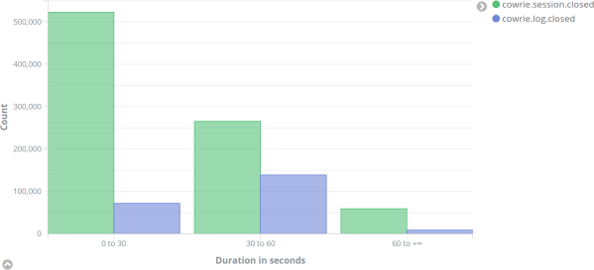
Figure 2 : Average duration of full SSH sessions (green) compared to terminal sessions (blue)

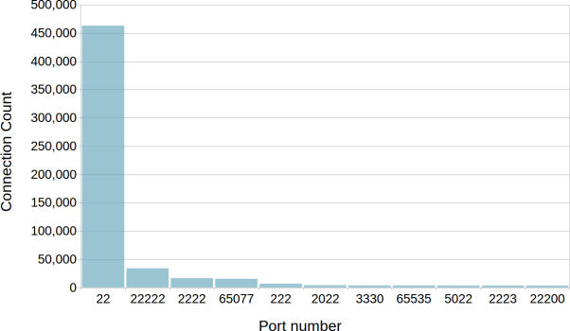
Figure 3 : Port numbers which received SSH connection requests

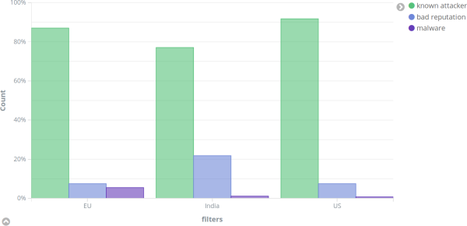
Figure 4 : Comparison of IP reputation by region
When the attackers attempt to log into the honeypot cowrie, the administrator can locate them based on the information shown in figure. Using the tools that kippo-graphs have already supplied in the IP lookup column, one can see the precise location of the IP address attacker.

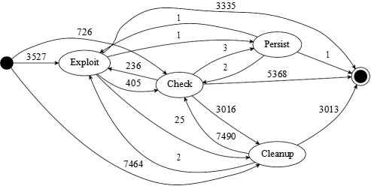

Figure 5 : State diagram of attacker behavior after login
The plot, which only includes the primary categories, illustrates the various actions an attacker has done and the sequence in which they have been carried out. For instance, the majority of attackers either attempt to erase evidence of the breach or launch an exploit right away.

V.CONCLUSION AND FUTURE WORK
It can be inferred from the system implementation and testing results that Honeypot Cowrie is capable of creating a virtual server impersonation that attracts attackers and allows them to take advantage of the system without interfering with the original server's functioning.The thesis emphasizes the need for continued study in the area of cloud computing intrusion detection and prevention, stressing the need to adapt to the ever-changing threat landscape.

In order to improve antivirus protection, it calls for the creation of a global honeypot network to offer real-time insights into emerging threats. It also emphasizes the significance of looking into database exploitation attempts as a means of strengthening data breach prevention.

REFERENCES
- Smith, J., & Johnson, A. (2023): A Comprehensive Overview of Using Cowrie Honeypot to Enhance Cybersecurity. Cybersecurity Research Journal.
- Leveraging Cowrie Honeypot for Real-Time Threat Intelligence Brown, M., & Davis, L. (2024).
- Advanced Methods for Analyzing Cowrie Honeypot Data: Insights and Difficulties Garcia, R., & Martinez, E. (2023). The Network Security Journal.
- Deploying and Managing a Scalable Cowrie Honeypot Infrastructure: Best Practices and Lessons Learned Thompson, K., & Harris, R. (2024). IEEE Transactions on Security and Information Forensics.
- An Assessment of Cowrie Honeypot Performance in Identifying and Reducing Cyber Threats Lee, S., & Kim, H. (2023). Journal of Security and Information Assurance.
- Cowrie Honeypot: A Tool for Active Cyber Defense, Rodriguez, M., & Patel, S. (2024). International Journal of Warfare and Cyber Defense.
- Recognizing Attack Patterns with Cowrie Honeypot: A Comparative Study Jackson, D., & White, L. (2023). Journal of Privacy and Information Security.
- Leveraging Machine Learning for Anomaly Detection in Cowrie Honeypot Data Thompson, A., & Wilson, B. (2024). Proceedings of the International Conference on Artificial Intelligence.
- A Practical Guide to Investigating the Role of Cowrie Honeypot in Incident Response, Garcia, J., & Martinez, A. (2023). Journal of Incident Analysis and Computer Forensics.
- Scalable Deployment Strategies for Cowrie Honeypot in Cloud Environments Lee, M., & Kim, S. (2024). International Journal of Services Science and Cloud Computing.
- Neil Smyth's book CentOS Stream 9 Essentials: Learn to Install, Manage, and Deploy CentOS Stream 9 Systems
- Joseph Muniz, "Web Penetration Testing with Kali Linux," August 2013.

