Protection of mixed overhead and underground cable lines

Vinayak Pawar 1, Prof. Jaysing A. Gurav (Kshirsagar) 2
1Student, M.E Electrical Engineering (Power System), Zeal College of Engineering, Pune, Maharashtra, India.
2Professor, M.E Electrical Engineering (Power System), Zeal College of Engineering, Pune, Maharashtra, India.
---------------------------------------------------------------------***---------------------------------------------------------------------
Abstract - This paper describes the protection challenges of overhead line along with underground cable to use auto recloser for Transient faults in Power system to minimize the breakdown time & maintain reliability of power system for mixed transmission line

Key Words: Auto reclosing, differential protection cable protection

INTRODUCTION
. In Overhead transmission lines different types of protections are used to protect the transmission line against various types of faults as these transmission lines are connected in various grids & generation stations are with various different types of generators. Abnormal conditions are created by faults due to which insulation level of conductor gets reduced due which excessive heating & abnormal conditions created. Failure of single line creates multiple cascading trappings of transmission line as well as numbers of generators.

The faults in the power system may occur because of the number of earthquake, crashing of aeroplane, mechanical supporting structure, falling off a tree, due to natural disturbances like high speed wind pressure, lightning strokes etc.

The most common type of faults in power system are due to flashover of insulators on overhead transmission lines, due to lightning strokes . The number of faults per year is proportional to the length of conductor and is approximately inversely proportional to the system voltage level .

The types of faults in power system are mainly classified into
- Open circuit faults.
2 ) Short circuit faults
Open circuit faults :-The open circuit fault in system mainly occurs because of the opening of conductors it may be one conductor or two conductors. If the open circuit fault takes place in series with the transmission line, and because of this, it is also called the series fault. Such types of faults affect the reliability of the power system. The open circuit fault is categorized as
- Open Conductor Fault
- Two conductors Open Fault
- Three conductors Open Fault.
The open circuit fault is shown in the figure below
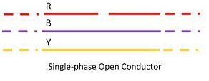
Short Circuit Faults:-
In short circuit fault, when the conductors of the different phases come into contact with each other due to which short circuit takes place. Due to which excessing current flows through the system as well as in equipment it may lead to causing damages the equipment as well as disturb the entire power system. Also, it creates cascading effect to trip the entire system as well grid system some time it may lead to failure of generating system the fault current travels in KA.
The short-circuit fault mainly divided into the symmetrical and unsymmetrical fault

Symmetrical faults:-
This type of faults which involve all the three phases comes into contact which is known as the symmetrical fault. When such types of fault occurs all three phases are in balanced condition even after the fault took place. The symmetrical faults mainly occur due terminal of the generators short circuited. Such type of may arise on account of the resistance of the arc between the conductors or due to the lower footing resistance. Further the symmetrical fault are classified into line-to-line-to-line fault and three-phase line-to-ground-fault
Line – Line – Line Fault – This types of faults are in balanced conditions that is the system remains symmetrical even after the fault took place . The Line to line to Line occurs very rarely in power system due to which very high excessive current flows through the system this is most severe type of fault which involves the large amount of current flows through system. So rating of circuit breaker is capable to sustain such type of fault
Three-phase line to the ground fault (L – L – L – G ) – The three-phase line to ground fault includes all the three phase of the system. The L – L – L – G fault occurs between the three phases and the ground of the system. The probability of occurrence of such type of fault is nearly 2 to 3 percent.

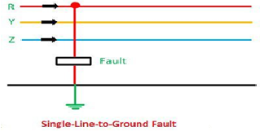

Unsymmetrical Fault
Due to unsymmetrical faults the current in each phase is different i.e. each current having different magnitude and phases in the three phases of the power system are known as the unsymmetrical fault. It is also defined as the fault which involves the one or two phase with ground or Line to Line or line to line to ground fault or two phases with ground fault. The unsymmetrical makes the system is unbalanced conditions. It is mainly classified into three types. They are
- Single Line-to-ground (L – G) Fault
- Line-to-Line Fault (L – L)
- Double Line-to-ground (L – L – G) Fault
The unsymmetrical fault is the most common types of faults occur in the power system.
1. Single Line-to-Line Ground – About 70-80% faults are occurred by single line to ground faults, due to which one conductor are fall down to ground or touches to neutral wire.
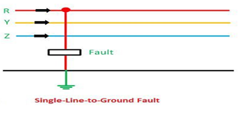
2. Line – to – Line Fault – This type of faults take place due to heavy wind pressure in this type of faults two conductors are directly short circuited. The heavy wind swinging the line conductors due to which may two conductors are touches with each other and hence cause short-circuit. The percentage of such type of faults is approximately 15 – 20%.

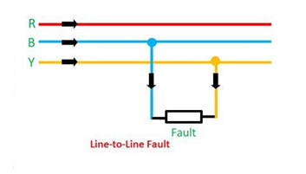
3. Double Line – to – line Ground Fault – This type of faults took place near about 10% in which In the two lines gets connected or in contact with each other along with the ground terminal.

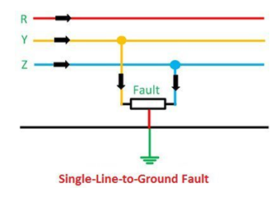

The symmetrical and unsymmetrical fault mainly occurs in the terminal of the generator, and the open circuit and short circuit fault occur on the transmission line.

Protection of Transmission line
Differential Protection.
Phase Comparison.
Over Current Protection.
Earth fault overcurrent protection (Use for protect from large residual current)
Distance Protection.

Differential Protection:-
Line differential protection is one of the most popular forms of transmission line protection. This type of protection is based on Kirchoff's current law, in which the current is flowing into a line must be equal to the current flowing out of the line

Phase Differential:-
It is a comparison of the phase of two waveforms, usually of the same nominal frequency. In time and frequency, the purpose of a phase comparison is generally to determine the
frequency offset (difference between signal cycles) with respect to a reference.

Over Current Protection: -
Over Current Relays are used for protection of transmission line only up to 50 kV that is only for low voltages basically it is a variable distance and variable operating time due to changes in fault impedance and
operating voltage.

Earth fault overcurrent protection: -
It will operate in case of fault involving earth occurs only it is due to residual circuit or across the zero phase sequence filter.

Distance Protection:-
Distance Protection is a Non-unit System of Protection, which measures the Impedance between the Relay Location and the point where the fault is incident and compares it with the Set Value. If the measured Impedance is less than the Set Value , the Relay operates and Isolates the Faulty Section

Application of Auto Reclosure:-
The term auto-reclosing in transmission lines refers to the automatic reclosing of breaker contacts after momentary isolation of the system from the fault.

Auto-reclosing is connected to circuit breakers to enhance the stability margins. It will help us to improve the system's reliability. In the transmission system auto reclosure will automatic reclosing circuit breakers, there is no need for an operator to reclose the circuit breaker contacts manually for temporary and semi-permanent faults.

The extra high voltage transmission lines transfer huge amount of electric power in each phase . Hence, it is always desirable that the power flow should be continuation through the lines should not be interrupted for a long time. In transmission line faults are temporary in nature or permanent fault. Temporary faults get automatically cleared, and these do not require any attempt for fault rectification. It is normal practice by the operators that after each initial faulty tripping of the line, they close the line. If
the fault is transient, the line holds after the second attempt of closing the circuit breaker, but if the fault persists, the protection system again trips the line and then it is declared as permanent
fault.
In extra high voltage transmission lines carry huge power is flowing if any delay occurs due to manual operation for closing the circuit , there will be a big loss of system in the view of cost
and stability. By introducing the auto reclosing scheme in the extra high voltage transmission
systems, we can avoid the unwanted delay due to human operation. Further categorize the faults in
electrical transmission system are in three ways,
1. Transient Fault
2. Semi Permanent Fault
3. Permanent Fault
The transient faults are those which automatically removed momentarily. Semi-permanent
faults are also transient in nature but there take few moments to remove. Semi-permanent faults
may get occurred due to the falling of things on the live conductors. Semi-permanent faults get
removed after the cause of faults is burnt away. During both of the above-mentioned faults, line
is tripped but the line can be restored if the circuit breakers associated with the line are closed.

Protection of Mixed Transmission Line
Auto-recloser or auto-reclosing scheme exactly does this. In an overhead transmission system, 80% of the faults are transient, and 12% of faults are semi-permanent. In auto-reclosing scheme if the fault is not cleared at first attempt, there will be double or triple shorts of reclosing until
the fault is cleared. It the fault still persists, this scheme permanently opens the circuit breaker.

A prescribed time delay may be imposed on the auto-reclosing system to permit the semipermanent fault to remove from the circuit.
Auto-recloser or auto-reclosing scheme exactly does this. In an overhead transmission system, 80% of the faults are transient, and 12% of faults are semi-permanent. In auto-reclosing scheme if the fault is not cleared at first attempt, there will be double or triple shorts of reclosing until
the fault is cleared. It the fault still persists, this scheme permanently opens the circuit breaker.

Application of Mixed Transmission Line:-
Generally, when a fault occurs on a transmission line, auto reclosing is performed for the purpose of improving the continuity of service by clearing the fault and restoring the power system.

But recently, the operation of a mixed transmission system has increased. Therefore, a proper protection scheme for a mixed transmission system is required in order to maintain reliability of power system . However, due to underground cable sections & mixed transmission line the auto reclosing scheme should be applied very carefully. Because when a fault occurs in the underground cable section are mostly a permanent fault in such situation If auto reclosing is performed on a permanent fault condition, it may cause excessive overcurrent and switching surge are generated due to which can generate a serious impact on the whole transmission system and even cause an explosion. Due to this, many utilities worldwide do not allow auto reclosing or only apply it very restrictively on a mixed transmission system based on their practice. However, there is no clear guidance or standard related to auto reclosing on a mixed transmission system
In the event of a fault on high-voltage transmission lines, auto-reclosing is one of the main protection functions. The most of the faults on overhead lines are temporary, so auto reclosing normally will clear the fault and restore the availability of the system. However, faults on underground cables are mainly permanent and an auto-reclosing sequence could potentially worsen the damage and collapse the system .

Therefore, the protection scheme challenge is more demanding with high-voltage mixed lines because they include underground cable sections. It is important to be able to determine if the fault occurred in the underground cable section to block the reclosing function.

The most reliable way to achieve this is by implementing a differential protection scheme on the cable section, but this can be costly and oftentimes is not practically feasible.

Non Possibility of Test Charge due to cable
Delay In Restoration
Disturbed Power Flow
Undesired loading of other Lines
Panic Condition for Line Staff.

Probable Hurdles with Conventional CT’s & Solution
Installation at LILO Tower is Difficult (Structural stability)
May Change tower design
Differential Protection with Pilot Wire is not advisable
More Outage requirement
Accuracy of Operation can not be ensured
Optical Current Transformer is one of the feasible option
Lighter Installation
No need to Modify any Tower Structure/ Part
Accuracy Can be ensured
Less Installation Activity result in Reduced Outage Time

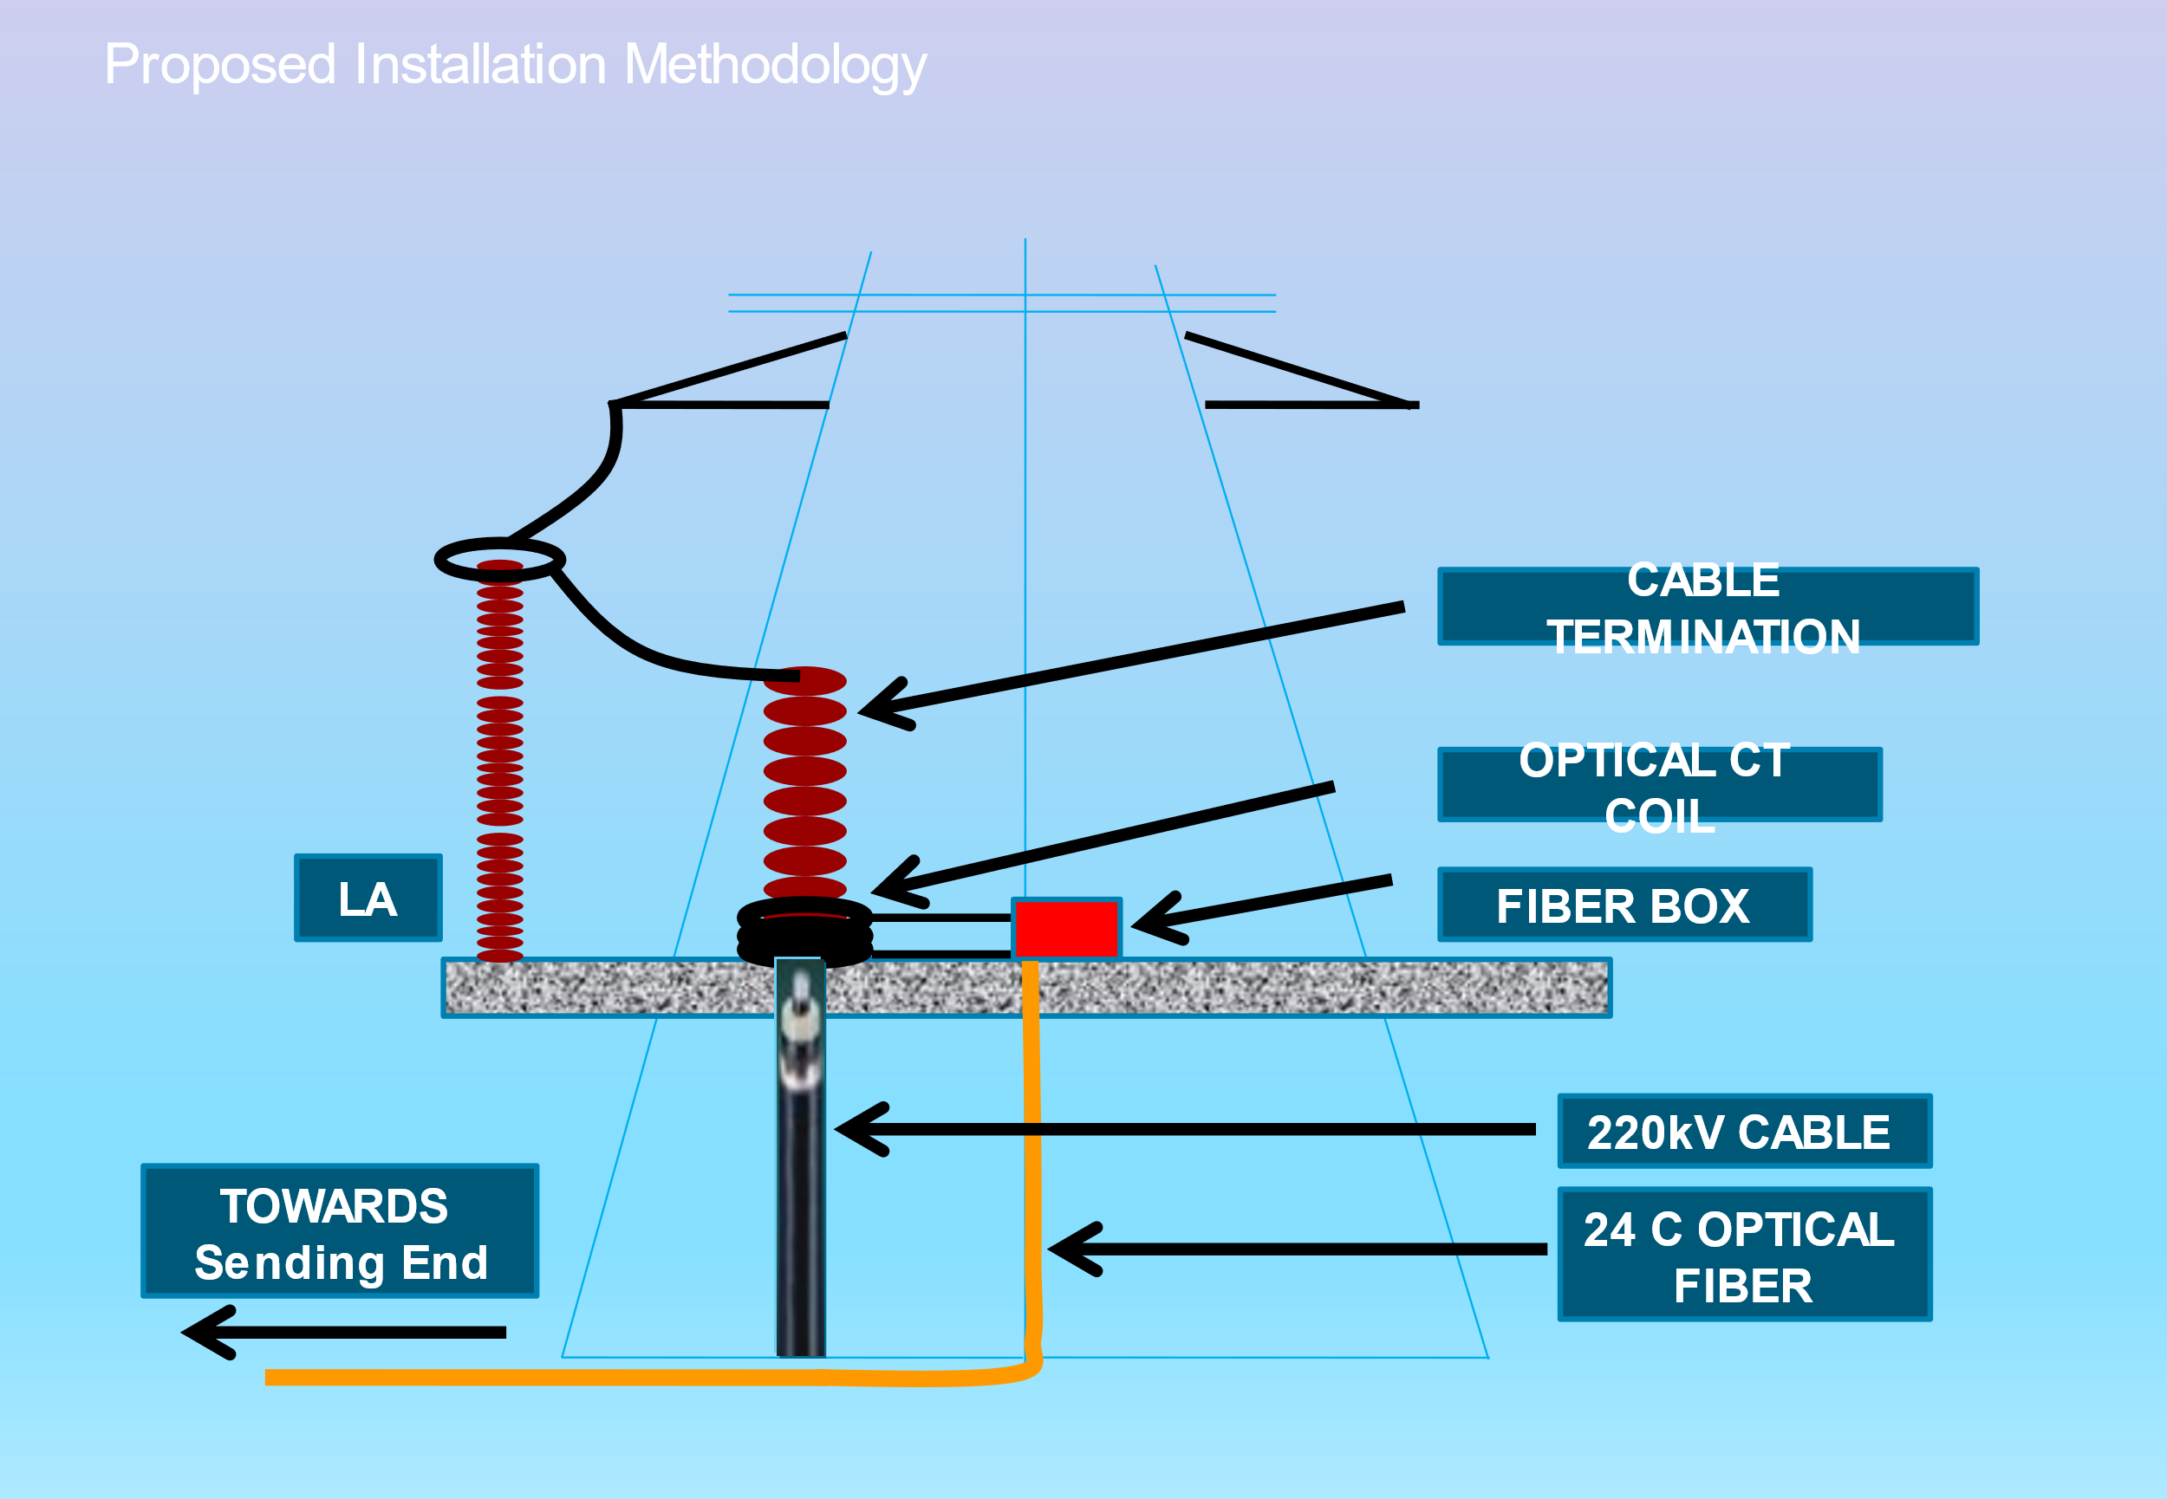

Benefits

Fault Discrimination
Once established, Can be used for Line A/R
Provides confidence for Line Test Charge
Fast Restoration of Line
Improved Reliability
Simpler Installation

In case of mixed transmission line Optical current transformer is to be connected at cable side in case of fault occurs CT secondary will sense the current through secondary side it will match the sending end current if the difference is marginal or near by zero it will assume that there is no fault in cable section and it will give command to auto recloser to switch on the line if faults are temporary in nature line will get restored but if faults on transmission line is permeant in nature it will automatically tripped the line

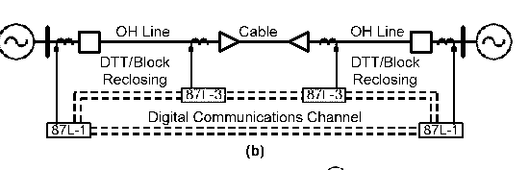

Conclusion
Current differential protection schemes with sequence current differential elements provide the best protection selectivity and sensitivity for cable and mixed conductor technology circuits.
Take special care when calculating ground distance element settings, including proper selection of the zero-sequence current compensation factor, because the zero-sequence impedance of the cable is not a linear function of the fault distance and is affected by cable bonding and grounding methods.
Apply modern relays that offer integrated line current differential protection, full distance schemes, negative- sequence directional elements, pilot scheme logic, and relay- to-relay communications. Functional integration in digital relays offers the most in cable protection.
Use relay-to-relay communications to create new protection schemes and to combine traditional schemes to reduce costs, increase reliability, and enhance performance of cable protection systems.

References
- V. Leitloff, X. Bourgeat, and G. Duboc, “Setting Constraints for Distance Protection on Underground Lines,” proceedings of the Seventh International Conference on Developments in Power System Protection, Amsterdam, Netherlands, April 2001.
- D. Tziouvaras, “Protection of High-Voltage AC Cables,” proceedings of the 32nd Annual Western Protective Relay Conference, Spokane, WA, October 2005.

