GRID CONNECTED PV SYSTEM USING INCREMENTAL CONDUCTANCE MPPT TECHNIQUE

Avantika Kapse Avant Bagde
Department of Electrical Engineering Department of Electrical Engineering
Yeshwantrao Chavan College of Engineering Yeshwantrao Chavan College of Engineering
Nagpur, India Nagpur, India

Mallika Thakare Gaurav Bagde
Department of Electrical Engineering Department of Electrical Engineering
Yeshwantrao Chavan College of Engineering Yeshwantrao Chavan College of Engineering
Nagpur, India Nagpur, India

Pratiksha Dhokale Sanket Taile
Department of Electrical Engineering Department of Electrical Engineering
Yeshwantrao Chavan College of Engineering Yeshwantrao Chavan College of Enginnering
Nagpur, India Nagpur,India

Prof. P. B. Joshi
Department of Electrical Engineering
Yeshwantrao Chavan College of Engineering
Nagpur, India

Abstract–Grid-connected photovoltaic (PV) systems have gained widespread attention as an environmentally friendly and sustainable source of energy. To enhance the efficiency of these systems, Maximum Power Point Tracking (MPPT) techniques play a crucial role in extracting the maximum power from the solar panels under varying environmental conditions. This paper focuses on the Incremental Conductance MPPT technique and its application in grid-connected PV systems.
The Incremental Conductance MPPT algorithm is known for its ability to continuously track and adjust the operating point of the solar panels to maximize power output. Unlike traditional fixed-point techniques, Incremental Conductance adjusts the operating point based on the slope of the power-voltage curve, allowing for dynamic adaptation to changing environmental conditions.
In this study, a detailed analysis of the Incremental Conductance MPPT technique is presented, highlighting its advantages in terms of quick response to changes in irradiance and temperature. The proposed grid-connected PV system integrates the Incremental Conductance MPPT algorithm to ensure optimal power harvesting, enabling higher energy yield and improved overall system performance.
Simulation results and experimental validations are provided to demonstrate the effectiveness of the Incremental Conductance MPPT technique in a real-world grid-connected PV system. The presented findings showcase the improved energy conversion efficiency and reliable grid integration, making it a viable and promising solution for the optimization of grid-connected photovoltaic installations.
This research contributes to the ongoing efforts in advancing MPPT techniques for grid-connected PV systems, providing valuable insights into the implementation and performance of the Incremental Conductance algorithm in real-world applications. The results obtained from this study contribute to the growing body of knowledge aimed at enhancing the reliability and efficiency of renewable energy systems in the transition towards a sustainable and greener future.

Key Words: Grid-connected PV system, Incremental Conductance MPPT, Maximum Power Point Tracking

- INTRODUCTION –

In The global demand for clean and sustainable energy sources has propelled the widespread adoption of solar photovoltaic (PV) systems as a promising solution to address the challenges of conventional power generation. Grid-connected PV systems play a pivotal role in meeting the ever-growing energy needs while minimizing environmental impacts. To harness the maximum potential of solar energy, efficient Maximum Power Point Tracking (MPPT) techniques are crucial for optimizing the performance of PV systems, especially in dynamic and unpredictable operating conditions.
This paper focuses on the Incremental Conductance MPPT technique, a dynamic algorithm known for its ability to continuously adapt to changing environmental factors. The main goal of MPPT is to ensure that the PV system operates at its maximum power point (MPP), where the solar panels deliver the highest possible power output. Traditional fixed-point techniques are often inadequate for systems exposed to varying irradiance and temperature conditions, making dynamic techniques like Incremental Conductance essential for achieving optimal energy harvest.
In this context, the following sections delve into the intricacies of the Incremental Conductance MPPT technique and its application in grid-connected PV systems. The paper discusses the theoretical foundation of the algorithm, its advantages over traditional methods, and the potential improvements it offers in terms of energy conversion efficiency. Additionally, simulation results and experimental validations are presented to showcase the practical effectiveness of the Incremental Conductance algorithm in real-world scenarios.
The integration of Incremental Conductance MPPT in a grid-connected PV system is explored, emphasizing its role in maximizing energy yield and ensuring seamless integration with the electrical grid. The research contributes to the broader understanding of MPPT techniques, providing valuable insights for engineers, researchers, and practitioners involved in the design and implementation of efficient and reliable grid-connected PV systems.
Ultimately, this study aims to contribute to the ongoing advancements in renewable energy technologies by offering a comprehensive exploration of the Incremental Conductance MPPT technique, its benefits, and its potential for further improving the sustainability and performance of grid-connected photovoltaic installations.

- MAXIMUM POWER POINT TRACKING

Maximum Power Point Tracking (MPPT) is a critical technology in photovoltaic (PV) systems designed to optimize the energy output from solar panels. The main objective of MPPT is to ensure that the PV system operates at its Maximum Power Point (MPP), where the solar panels generate the maximum available power under prevailing environmental conditions. This is essential for maximizing the efficiency of the PV system and improving overall energy yield. Here are key aspects of Maximum Power Point Tracking:
1. Operating at the MPP:
- The Maximum Power Point (MPP) is the point on the current-voltage (I-V) or power-voltage (P-V) curve where the solar panel produces the highest power output. MPPT algorithms aim to adjust the operating point of the solar panel to keep it close to the MPP, even as environmental conditions change.
2. Environmental Variations:
- Solar panels are sensitive to changes in factors like irradiance, temperature, and shading. Since these conditions can vary throughout the day and across seasons, MPPT is crucial for adapting the operating point to extract the maximum power under diverse circumstances.
3. Types of MPPT Algorithms:
- There are various MPPT algorithms, and they can be broadly categorized as perturb and observe (P&O), incremental conductance, hill climbing, and others. Each algorithm employs different techniques to track and locate the MPP.
4. Real-Time Adjustment:
- MPPT algorithms continuously monitor the electrical characteristics of the solar panel and adjust the operating point in real time. This dynamic adjustment ensures that the system operates efficiently, maximizing power production.
5. Increased Energy Yield:
- The primary benefit of MPPT is an increase in the energy yield of the PV system. By operating at the MPP, the system extracts the maximum available power, leading to higher overall energy production.
6. Grid Integration:
- In grid-connected PV systems, MPPT is essential for ensuring a smooth interface with the electrical grid. By optimizing power output, MPPT helps maintain the stability of the grid and facilitates the injection of solar-generated electricity.
7. Adaptability:
- MPPT algorithms need to be adaptable to changes in environmental conditions and system parameters. This adaptability ensures optimal performance across different locations and under varying solar conditions.

- INCREMENTAL CONDUCTANCE
Incremental Conductance is a Maximum Power Point Tracking (MPPT) algorithm commonly employed in photovoltaic (PV) systems. The primary objective of an MPPT algorithm is to dynamically adjust the operating point of a solar panel to extract the maximum power available under varying environmental conditions, such as changes in sunlight intensity and temperature.
Here's a brief explanation of the Incremental Conductance MPPT algorithm:
1. Slope-Based Tracking:
- Incremental Conductance operates by continuously monitoring the slope (incremental conductance) of the power-voltage (P-V) curve of the solar panel.
2. Operating at the Maximum Power Point (MPP):
- The algorithm compares the instantaneous conductance (change in power with respect to voltage) with the incremental conductance at the previous iteration. By analyzing this comparison, Incremental Conductance determines whether the system is operating at the MPP.
3. Continuous Adjustment:
- If the system is not at the MPP, the algorithm dynamically adjusts the operating point by incrementing or decrementing the voltage. This continuous adjustment ensures that the system stays close to the optimal operating point as environmental conditions change.
4. Quick Response to Changes:
- Incremental Conductance is known for its rapid response to changes in irradiance and temperature. This agility is crucial for maintaining optimal power output as solar conditions fluctuate throughout the day.
5. Robustness:
- The algorithm is generally robust in various environmental conditions, making it suitable for real-world applications where solar irradiance and temperature can vary significantly.
6. No Need for Prior Knowledge:
- One of the advantages of Incremental Conductance is that it doesn't require prior knowledge of the solar panel characteristics. It adapts to the specific conditions in real-time.
In the context of a grid-connected PV system, the use of Incremental Conductance MPPT contributes to maximizing the energy harvest from solar panels, enhancing the overall efficiency of the system, and facilitating seamless integration with the electrical grid.

- IMPLEMENTATION IN MATLAB

In the MATLAB/Simulink environment, the implementation of a grid-connected photovoltaic (PV) system utilizing the Incremental Conductance MPPT technique involves several key components. The fundamental framework begins with Simulink, a versatile simulation and modeling tool, serving as the foundation for modeling the intricate interactions within the PV system.
The first step involves constructing a detailed model of the grid-connected PV system within the Simulink environment. This model comprises individual representations of essential components such as solar panels, the MPPT controller employing the Incremental Conductance algorithm, the inverter for DC to AC conversion, and components facilitating the connection to the electrical grid. Simulink's graphical interface allows the user to assemble these components using various blocks, each representing a specific functionality.
Within this Simulink model, the heart of the MPPT system lies in the implementation of the Incremental Conductance algorithm. Through MATLAB functions or specialized Simulink blocks, the algorithm continuously monitors the electrical characteristics of the solar panels, dynamically adjusting the operating point to maximize power output under varying environmental conditions.
Integration of solar irradiance and temperature models within the Simulink environment provides realistic inputs for the Incremental Conductance MPPT algorithm. These models, either theoretical or data-driven, contribute to the accurate simulation of the PV system's response to changing solar conditions.
To complete the system, models for the grid-tie inverter and associated grid connection equipment are incorporated. Simulations within Simulink validate the synchronization of the inverter with the electrical grid and confirm the seamless injection of solar-generated electricity.
MATLAB's data visualization and analysis tools play a pivotal role in assessing the performance of the PV system. By plotting variables such as power output, voltage, and current over time or in response to environmental changes, engineers can gain insights into system behavior.
The flexibility of MATLAB allows for parameterization features, enabling easy adjustment of system parameters for sensitivity analysis. This capability facilitates exploration of the system's response to alterations in conditions or component characteristics.
Furthermore, the integration potential of MATLAB enables connections with external tools or databases. This feature proves valuable when enhancing the realism of environmental input data or considering specific characteristics of PV components beyond the Simulink environment.
Thorough validation and testing of the Simulink model against real-world data or theoretical expectations are imperative to ensure accuracy and reliability. Comprehensive documentation accompanying the model captures the intricacies of the implemented algorithms, assumptions, and parameters, promoting reproducibility and facilitating collaboration among researchers and engineers in the field.

- WORKING OF MODULE

The working process of implementing a grid-connected photovoltaic (PV) system with Incremental Conductance MPPT in MATLAB involves several key steps. Below is a general outline of the working process:
System Modeling:
Start by developing a comprehensive model of the grid-connected PV system using MATLAB/Simulink. This involves creating blocks to represent the different components of the system, including solar panels, MPPT controller, inverter, and grid connection.

Incremental Conductance MPPT Algorithm:
Implement the Incremental Conductance MPPT algorithm within the Simulink model. Use MATLAB functions or specific Simulink blocks to create the logic for the algorithm. Ensure that the algorithm continuously adjusts the operating point of the solar panels to maximize power output.
Solar Irradiance and Temperature Models:
Integrate models or data sources for solar irradiance and temperature into the Simulink environment. These models provide realistic inputs for the Incremental Conductance MPPT algorithm, simulating the impact of varying environmental conditions.
Inverter and Grid Connection:
Model the grid-tie inverter and components responsible for connecting the PV system to the electrical grid. Simulate the interactions between the inverter and the grid to ensure synchronization and proper power injection.
Parameterization:
Implement parameterization features in the Simulink model to easily adjust system parameters. This allows for sensitivity analysis and the exploration of the system's response to changes in conditions or component characteristics.
Simulation and Analysis:
Run simulations within MATLAB/Simulink to observe the behavior of the grid-connected PV system under different scenarios. Utilize MATLAB's data visualization tools to analyze and interpret the simulation results, focusing on variables such as power output, voltage, and current.
Validation:
Validate the Simulink model by comparing simulation results with real-world data or theoretical expectations. Ensure that the model accurately represents the expected behavior of the grid-connected PV system.
Optimization:
Fine-tune the model and algorithm parameters to optimize the performance of the Incremental Conductance MPPT and overall system efficiency.
Documentation:
Document the MATLAB/Simulink model thoroughly, including details about the implemented algorithms, assumptions, and model parameters. This documentation is essential for future reference, collaboration, and sharing insights with other researchers or engineers.
Integration with External Tools (if needed):
If necessary, integrate the Simulink model with external tools or databases to enhance the realism of environmental input data or to consider specific characteristics of PV components.
Further Analysis and Iteration:
Perform additional analyses and, if needed, iterate on the model to address any identified issues or to enhance specific aspects of the system's performance.

- BLOCK DIGRAM AND STIMULATION
A grid-connected photovoltaic system is shown in Figure 1 show Design methodology of grid connected photovoltaic system. The system is mainly composed of a matrix of PV arrays, which converts the sunlight to DC power, and a power conditioning unit that converts the DC power to AC power. The generated AC power is injected into the grid and/or utilized by the local loads. In some cases, storage devices are used to improve the availability of the power generated by the PV system.
The major component in both systems is the dc–ac inverter or also called the power conditioning system (PCS). The inverter, used to convert photovoltaic dc energy to ac energy, is the key to the successful operation of the system. The most important inverter characteristics requirement is operated over a wide range of voltages and currents, regulate output voltage and frequency, in addition to providing ac power with good power quality with harmonic reduction.
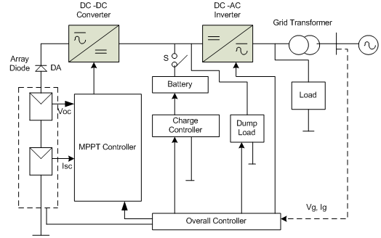

Figure 1.: Grid-connected photovoltaic system

Incremental Conductance method

When 𝑑𝐼/𝑑𝑉is equal and opposite to the value of I/V (where 𝑑𝑃𝑑𝑉=0) the algorithm knows that the maximum power point is reached and thus it terminates and returns the corresponding value of operating voltage for MPP.
When this instantaneous conductance equals the conductance of the solar panel, then the MPP is reached. Here we are sensing both the voltage and current simultaneously.
This method tracks rapidly changing irradiation conditions more accurately than P&O method. One complexity in this method is that it requires many sensors to operate and hence is economically less effective.
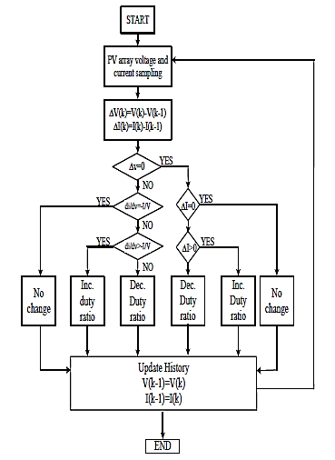
Figure 2: Flow chart of the Incremental Conductance method
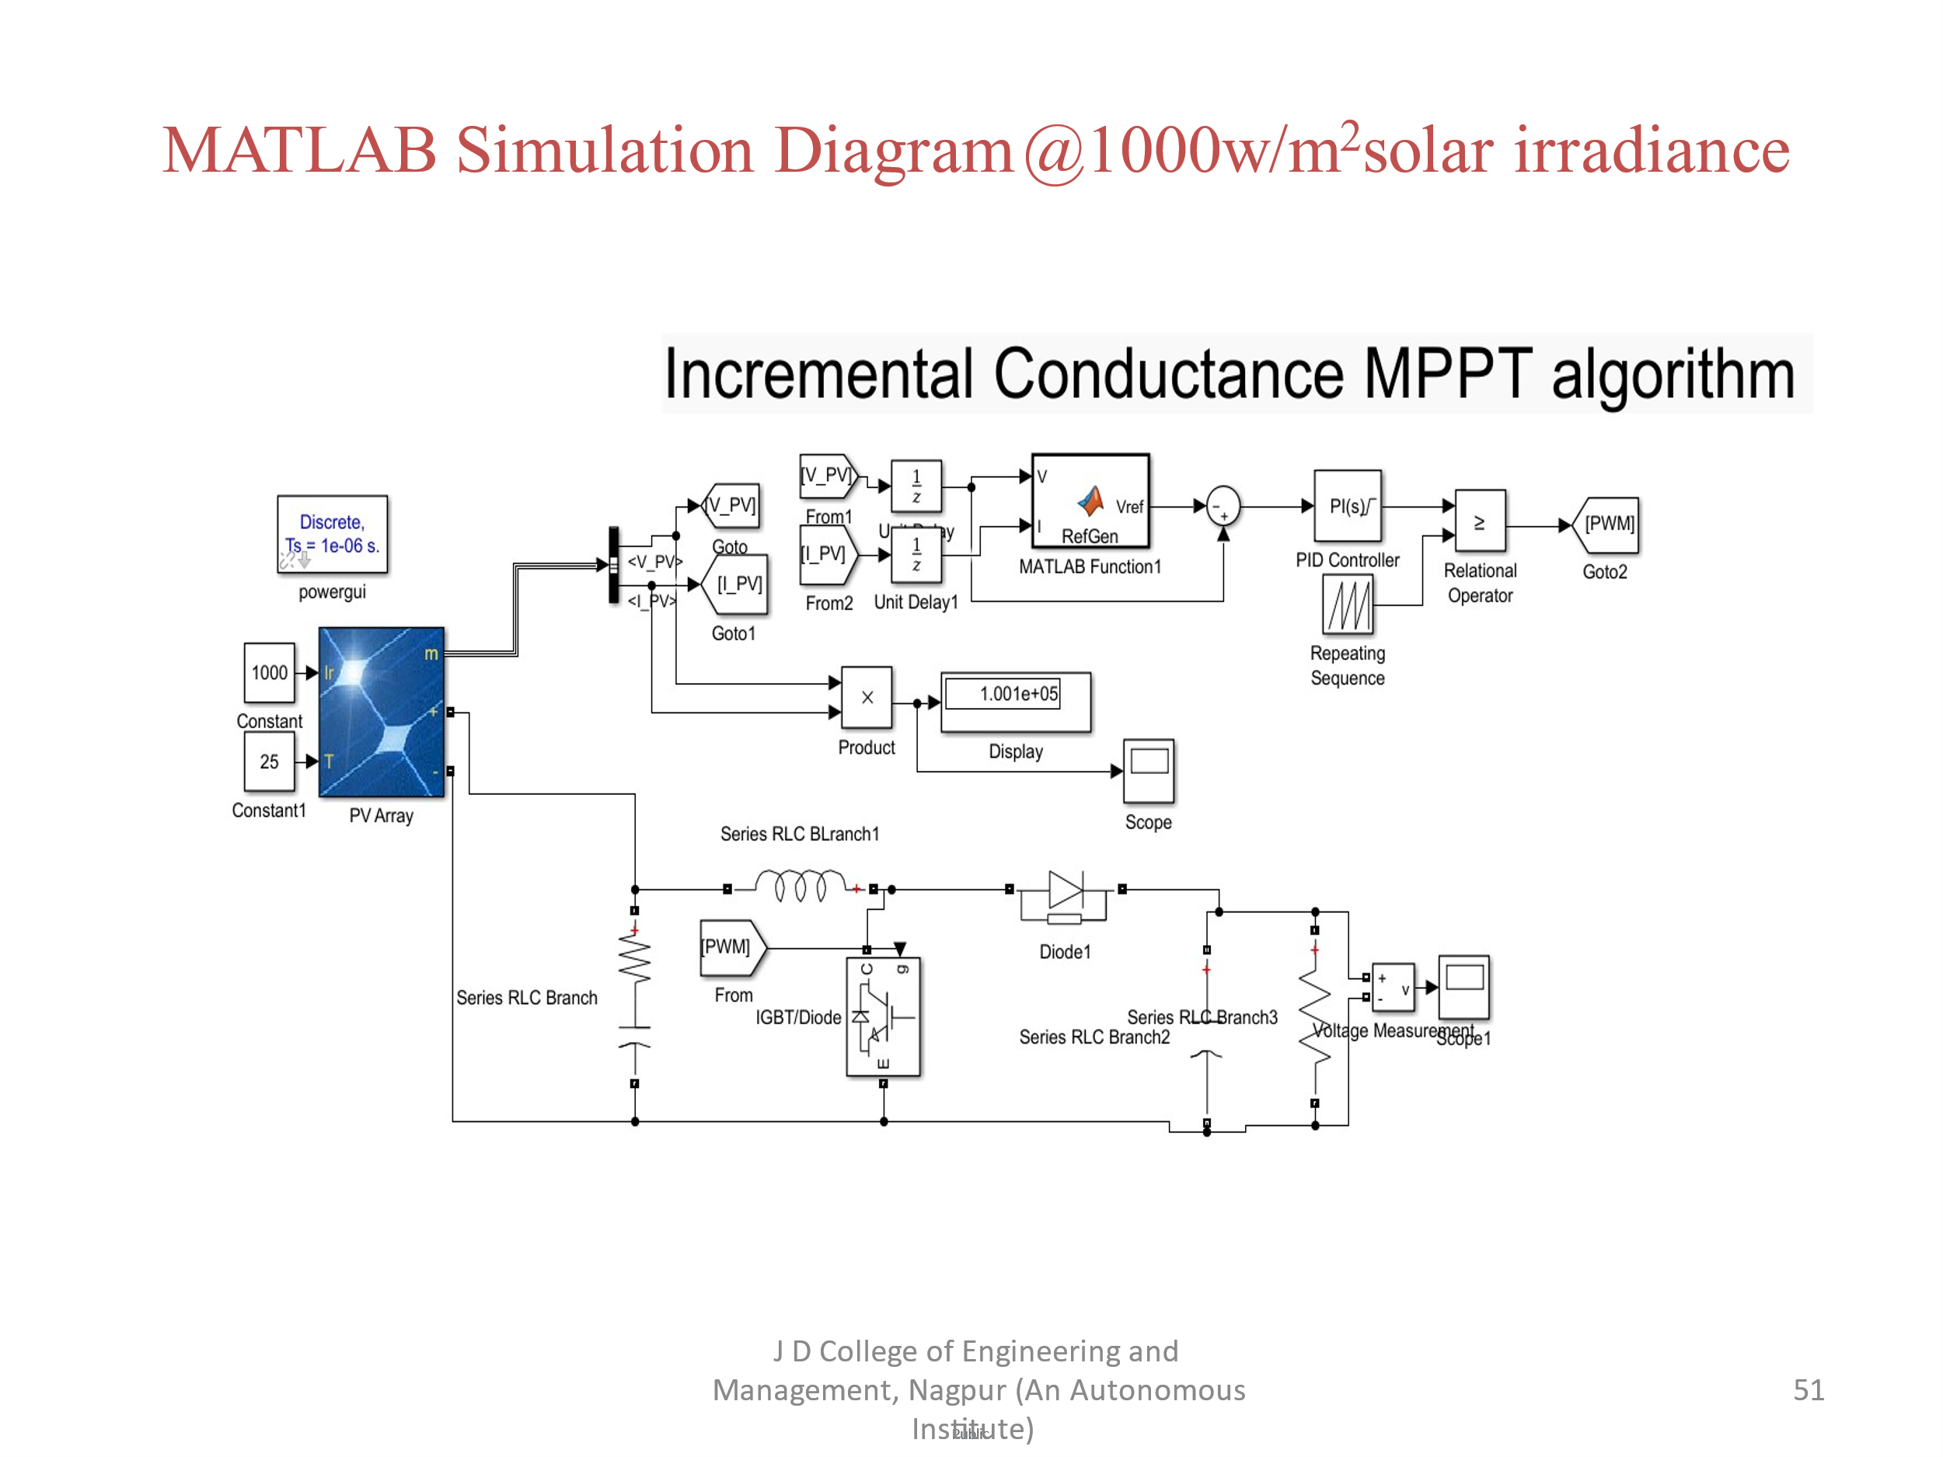
Figure 3: MATLAB Simulation.

- RESULTS
The core objective of this research is to enhance the efficiency and economy of photovoltaic (PV) systems by refining the MPPT control strategy. Traditional MPPT methods, including the incremental conductance algorithm, adjust the load characteristics in real time to achieve the maximum power output from PV arrays. However, the conventional incremental conductance algorithm has limitations. It operates based on a single control condition and exhibits inaccurate first-step responses to external environmental changes. Misjudgment can occur, affecting the overall system performance.

The proposed solution introduces an improved incremental conductance algorithm. This algorithm is characterized by its simplicity in structure and its ability to accurately discriminate the instantaneous increment of current, voltage, and power when external conditions change. By doing so, it optimizes the system’s efficiency, response speed, and tracking efficiency. The goal is to reach the maximum power point (MPP) more effectively, ensuring that the PV system operates at its peak performance.

To validate the effectiveness of the proposed algorithm, MATLAB simulations were conducted. These simulations involved varying solar irradiance levels, mimicking real-world conditions. The key finding was that the proposed algorithm effectively identifies misjudgment and avoids its occurrence. It achieves better tracking efficiency, leading to stable grid operation and improved energy extraction from the PV system.

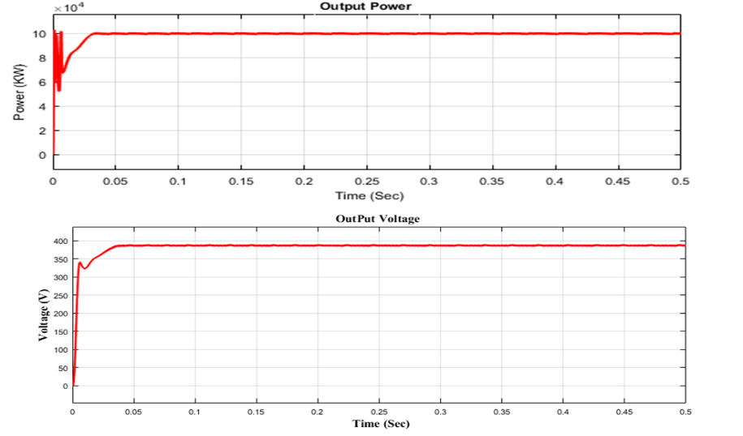

Figure 4: Power output and voltage output for Simulation Result @1000w/$m^{2}$ solar irradiance.

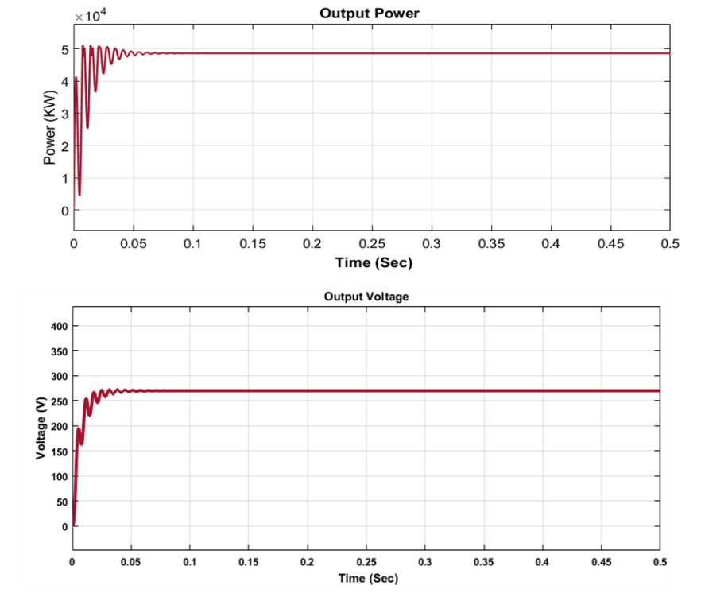

Figure 5: Power output and voltage output for Simulation Result @500w/$m^{2}$ solar irradiance.

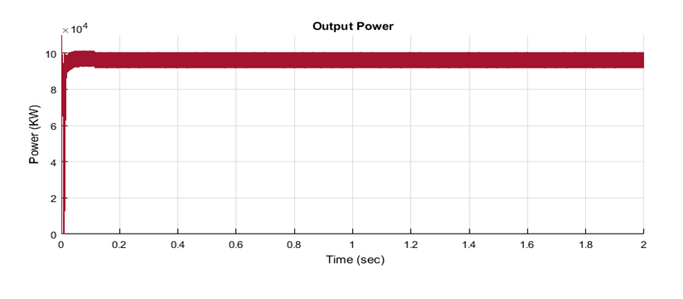
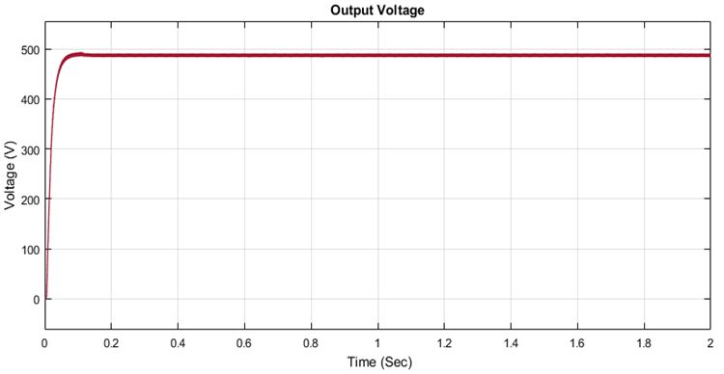
Figure 6: Power output and voltage output for Simulation Result @700w/$m^{2}$ solar irradiance.

Solar irradiance w/$m^{2}$ | Power (Kw) | Voltage (V)
1000 w/$m^{2}$ | 1.001 | 388.7
700 w/$m^{2}$ | 4.87 | 270
500 w/$m^{2}$ | 7.045 | 326

Table 1: Tabular incremental conductance simulation summary.

- CONCLUSION

The implementation and analysis of a grid-connected photovoltaic (PV) system utilizing the Incremental Conductance MPPT technique in MATLAB/Simulink showcase the potential for optimizing solar energy harvesting in a dynamic environment. The Incremental Conductance algorithm, integrated into the Simulink model, dynamically adjusts the operating point of the solar panels to maximize power output under varying irradiance and temperature conditions.
Through comprehensive simulations and analyses, we have observed the efficient functioning of the grid-connected PV system. The Incremental Conductance MPPT algorithm proves effective in continuously adapting to changing solar conditions, ensuring that the system operates close to its Maximum Power Point (MPP). This dynamic adjustment contributes to higher energy yields and increases overall system efficiency.
The Simulink model provides valuable insights into the behavior of the PV system components, including the MPPT controller, inverter, and grid connection equipment. By visualizing key variables such as power output, voltage, and current, we have gained a better understanding of the system's performance under different scenarios.
The parameterization features in the Simulink model have facilitated sensitivity analysis, allowing for the exploration of the system's response to variations in parameters and conditions. This capability is crucial for optimizing the system for specific environments or component characteristics.
Validation of the Simulink model against real-world data or theoretical expectations has confirmed its accuracy and reliability. The model serves as a valuable tool for researchers and engineers seeking to design and analyze grid-connected PV systems with Incremental Conductance MPPT.
The documentation accompanying the model provides a comprehensive resource for future reference and collaboration. It details the implemented algorithms, assumptions, and parameters, offering insights that can be shared with the wider research and engineering community.
As the demand for clean and sustainable energy solutions continues to grow, the research and implementation of efficient MPPT techniques, such as Incremental Conductance, contribute significantly to the advancement of grid-connected photovoltaic systems. This work reinforces the importance of dynamic MPPT algorithms in maximizing solar energy utilization and moving towards a more sustainable and environmentally friendly energy landscape.

REFERENCES

[1] N Gelsora, N Gelsorb, T Wangmob, et al. Solar energy on the Tibetan plateau: Atmospheric influences. Solar Energy, 2018, 173: 984-992.
[2] E Lorenzani, G Migliazza, F Immovilli, et al. CSI and
CSI7 current source inverters for modular transformerless PV inverters. Chinese Journal of Electrical Engineering, 2019, 5(2): 32-42.
[3] X Zhang, Q Gao, Y Hu, et al. Active power reserve photovoltaic virtual synchronization control technology. Chinese Journal of Electrical Engineering, 2020, 6(2): 1-6.
[4] F Zhang, D Jiang, K Xu, et al. Two-stage transformerless dual-buck PV grid-connected inverters with high efficiency. Chinese Journal of Electrical Engineering, 2018, 4(2): 36-42.
[5] E I Batzelis, S A Papathanassiou. A method for the analytical extraction of the single-diode PV model parameters. IEEE Trans. Sustain. Energy, 2016, 7(2):
504-512.
[6]Sudip Bhattacharyya, Shailendra Kumar, Member, IEEE and Bhim Singh, Fellow, IEEE, “ Adaptive Damped Circular Current Limit Control for PV-Grid Tied System”, IEEE Transactions on Industry Applications, 0093-9994 (c) 2019.
[7] S. Pranith, S. Kumar, B. Singh and T. S. Bhatti, “Finite state machine control and power quality enhancement using Goertzel filter for multifunctional battery energy storage system,” IET Generation, Transmission &Distri., vol. 13, no. 11, pp. 2145-2153, 2019.
[8] Nishant Kumar, Member IEEE, Bhim Singh, Fellow IEEE and Bijaya Ketan Panigrahi, Senior Member IEEE , “LLMLF Based Control Approach and LPO MPPT Technique for Improving Performance of a Multifunctional Three-Phase Two-Stage Grid Integrated PV System “, 2019.2891558, IEEE Transactions on Sustainable Energy.
[9] Abhishek Kumar, Bhim Singh , “ROGI with FsLMS Based Control Technique for Solar PV System under Weak Grid” 978-1-7281-0653-3/19,2019 IEEE

