TABLE OF CONTENT

Abstracts ……………………………………………………………………………………………………………………………………………2
Introduction…………………………………………………………………………………………………………………………………………2
Importance of Recycling paper Benefits……………………………………………………………………………………………….2
Paper and Cardboard Production…………………………………………………………………………………………………………3
Paper Recycling ……………………………………………………………………………………………………………………….………….4
Conclusion …………………………………………………………………………………………………………………………………………..5
References…………………………………………………………………………………………………………………………………………….6

Abstract:
Since the day it was discovered until today, paper has been a piece of human existence, and it is acquiring considerably greater prevalence as the years pass by. Likely, the day-to-day schedule begins with the utilization of paper and, furthermore, ends with the utilization of paper. What's more concerning is that an enormous amount of wastepaper is created. At times, it causes severe natural degradation. A survey estimates that to produce 1 ton of paper, 17 trees are required. Additionally, we have seen that any enormous establishment, particularly instructive foundations like schools, and colleges, produces a huge amount of wastepaper, which could be recycled through environmental technology. Thus, REcosystem, a wastepaper collection and reusable product selling website, comes to the picture here, where waste papers are collected and recycled into usable products such as pencils,
scrapbooks, notebooks, etc.
Keywords -Recycling paper, wastepaper, Environmental technology.

Introduction:
Strategies for waste management are used to stop the rapid depletion of natural resources, keep them safe for the environment and public health, and turn trash into valuable knowledge and resources. These methods serve as the foundation for the "sustainable development" paradigm, which is widely acknowledged as a crucial political goal worldwide. Because raw paper is either hard to come by or in short supply, reusing paper has become a common practice in the paper and paper board sectors. Reusing paper saves a ton of other expenses in addition to an ever-growing quantity of regular assets. Newsprint paper, writing and printing paper, and item bundling are important uses for repurposed paper. In a country like India, more than 35 percent of the raw materials used to make paper are recycled.

Importance of Recycling Paper Benefits:

The following picture shows the environmental benefits of using recycled copy paper rather than virgin copy paper:

Pic 1.1 -Virgin fiber
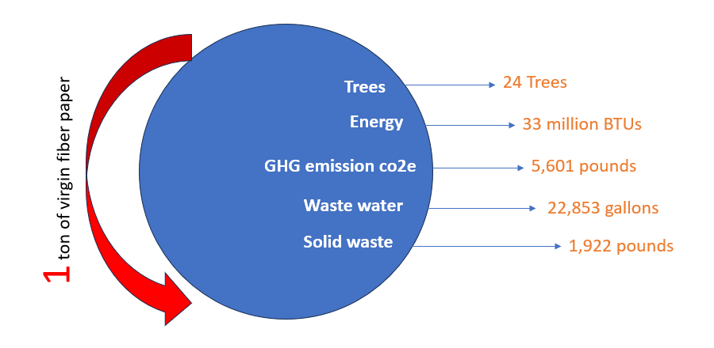
Pic 1.2 -Recycled copy paper
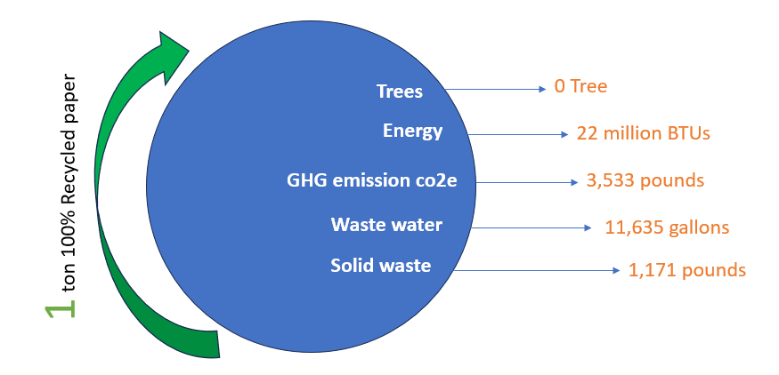

Paper and Cardboard production:
Paper and packaging materials contribution was also increasing in every year. We can easily recycle in these type materials. Tissue was the only segment of the global paper- and board-making industry to enjoy an increase in production, with every region of the world contributing to year-on-year growth of 4.3% to 40.5 million tonnes. The increased tissue production was a particularly pronounced 8% in Asia to 15.21 million tonnes. Of the other paper- and board-making segments, newsprint followed the trend of the recent past in suffering the sharpest drop in production during 2019. Almost 2 million tonnes were wiped off global production as the total slid more than 10% lower year on year to 17.3 million tonnes; Asia and Latin America recorded the steepest falls of, respectively, 14% to 5.91 million tonnes and 22% to 2,94,000 tonnes. Printing & writing fared little better: production worldwide was approaching 5% lower than in 2018 at 91.55 million tonnes, largely as a result of declines of 8.4% in Europe to 26.15 million tonnes and of 14% in USA/ Canada to 13 million tonnes. Meanwhile, largest producer Asia witnessed only a negligible dip in its printing & writing output to 47.4 million tonnes.

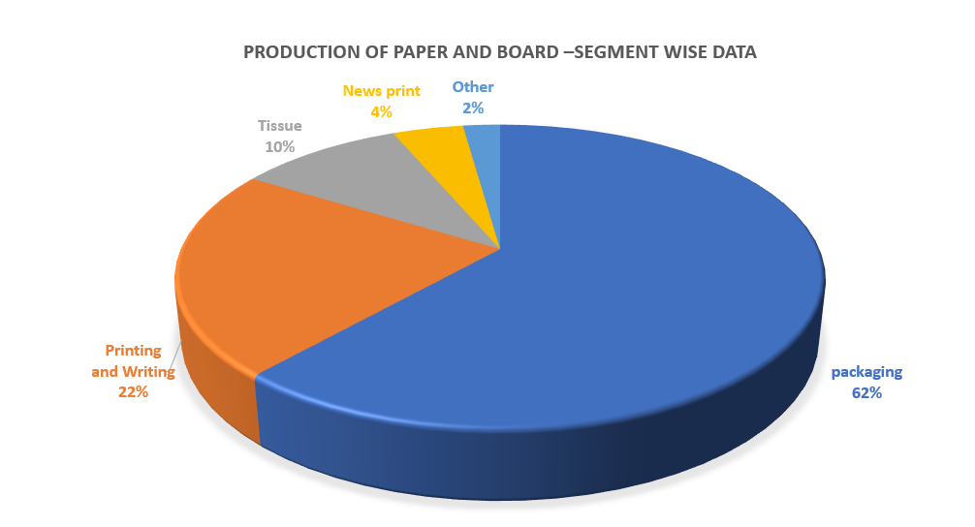

PAPER RECYCLING:
Since 2000, the European paper value chain has been committed to the two-fold aim of improving recycling and increasing efforts to remove obstacles hampering paper recycling in Europe. In 2021, the signatories of the European Declaration on Paper Recycling declared their commitment to reach a 76% paper recycling rate by 2030. The new European Declaration on Paper Recycling 2021-2030 was published on 29 June 2022. Both consumption of new paper and board and collection of Paper for Recycling (PfR) decreased (-1.8% and -5.0% respectively). As a result, the recycling rate decreased in 2022 compared to 2021. In 2022, 70.5% of all paper and board consumed in Europe was recycled. The impact of the war in Ukraine and the energy crisis, as with many sectors, impacted the Paper for Recycling market. The high electricity and gas prices have had a disproportionate impact on the operation of paper mills consuming PfR. Mills consuming PfR are more dependent on gas supply for their energy consumption when compared to mills using virgin fibres as feedstock and thus energy crisis impacted more PfR utilization, resulting in a small decrease in the utilisation of PfR despite the significant investments made in new recycling capacities in Europe during the previous year At regional level, the number of countries with a recycling rate below 60% was 7 in 2022, down from 9 in 2021. In 2022, the number of countries exceeding recycling rates of 70% was 14, down from 16 in 2021. Consumption of all grades of paper and board decreased in 2022, except sanitary papers (+3.5%) and cartonboard (+6.5%). At international level, Europe continues to be the world champion in paper recycling, followed by North America. The paper recycling rates of other world regions are improving, but from lower levels. In Europe, paper fibres were used 3.5 times on average in 2022, while the world average was 2.5 times. The EU has increased its targets for the recycling of municipal and packaging waste; it is clear that the well-functioning paper recycling chain is a key driver for meeting these targets. Paper recycling is a “Made in Europe” industry. As collection, sorting and recycling take place in Europe, paper recycling prolongs value creation and job opportunities in Europe from a renewable and predominantly European resource: wood. Making recycling easy and simple, year after year, requires a huge effort by the paper value chain. We explain these efforts in our annual monitoring reports and are proud of the progress. For the commitment period of 2021-2030 the recycling rate calculations are independently verified by Deloitte.

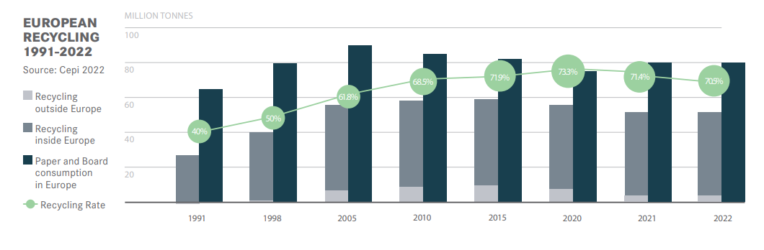

Conclusion:
As was the case in our first revamped annual statistical report published last year, data in this second edition illustrate the importance of recovered fiber in the production of paper and board around the world, particularly in the growing packaging segment. Indeed, its significance in the global production mix intensified in 2019. Nevertheless, there is scope for significant increases in the use of recovered fibers, including in the printing & writing segment and in some emerging regions of the world, especially when taking into account strong population and middle-class growth projections for many developing countries. (Worldwide, the middle class increased from 1.8 billion people in 2009 to around 3.5 billion in 2017, and is projected to reach 5.3 billion by 2030.) Growth in recovered fibre consumption would bring a huge environmental benefit as accepted scientific research suggests that recycling one ton of paper saves more than 4000 kWh of energy as well as vast quantities of water. The paper recycling industry enshrines the principles of a Circular Economy given that we are clearly heading in the direction of a world in which recycling content will become an ever-increasing component of the final paper and board product mix.so finally we considered paper recycling rate is year to year increasing but previous analytical data all are above the 60 % so we should take recycle rate for paper and cardboards values are 70%.here we can ensure based on analytical data the recycle values are not less than 70% because 2030 paper recycle content will come 76%.so paper recycle rate is 70% it will be varying but approximately we will take 70%.

References:
[1] National Environmental Engineering Research Institute Survey, India, 2016
http://www.ijirst.org/articles/IJIRSTV2I11227.pdf
[2] National Recycling Strategy Document and Action Plan, 2014-2020, Ireland
http://www.epa.ie/pubs/reports/waste/haz/NHWM_Plan.pdf
[3] Paper Recycling Market: Global Industry Analysis 2013 - 2017 and Opportunity Assessment.
2018 - 2028
https://www.futuremarketinsights.com/reports/paper-recycling-market
[4] The United Nations Conference on Sustainable Development, Rio+20
https://sustainabledevelopment.un.org/content/documents/733FutureWeWant.pdf
[5] A Discussion paper on collection and recycling of waste paper in India under Ministry of Environment and
Forests, DIPP, 2011, Govt. Of India,
https://dipp.gov.in/sites/default/files/DiscussionPaper_Recycling_WastePaper_21October2011%20%208.pdf
[6] Sharma, V.K. Wastepaper in Mumbai (India) an approach for abridged life cycle assessment, LCA Case
Studies, January, 2000.
https://link.springer.com/article/10.1007/BF02978552#citeas
[7] Sustainability outlook, Opportunity for Increasing Waste Paper Reuse in India
http://www.sustainabilityoutlook.in/content/opportunity-increasing-waste-paper-reuse-india
[8] Paperwork - Comparing Recycled to Virgin Paper, April, 2012
https://environmentalpaper.org/wp-content/uploads/2017/08/Paperwork.pdf
[10] Why India is a world leader in waste paper, Navin Singh Khadka,
Environment correspondent, BBC World Service
https://www.bbc.com/news/world-asia-india-46641059
[11] Waste Paper Recycling Market to 2027 - Global Analysis and Forecasts by Type (Corrugated Cardboard,
Newspapers, Magazines, White Office Paper, and Mixed Paper); Application (Wrapping Paper, Printing and
Writing Paper, and Others), and Geography
https://www.theinsightpartners.com/reports/waste-paper-recycling-market
[12] India Paper & Paper Products Market By Application (Writing & Printing Paper, Paperboard &
Packaging, Newsprint and Specialty Paper), By Raw Material (Waste & Recycled Paper, Wood and Agro
Residue), Competition, Forecast & Opportunities, 2024, TechSci Research
https://www.researchandmarkets.com/reports/4769674/india-paper-and-paper-products-market-by

……………………...Save Nature and Create New Future…………………………………

