Electricity theft detection and Prevention using Arduino and iot
Sushant More ¹, Samarth Patil², Pushkraj Chavan³, Shrishil Suryawanshi⁴, Pravin Lohar⁵, Ruturaj Kapurkar⁶,
^{1,} Lecturer, Electrical Engineering Department, Rajarambapu Institute of Technology, Rajaramnagar
^{2, 3, 4, 5, 6,} Students, Electrical Engineering Department, Rajarambapu Institute of Technology, Rajaramnagar

Abstract
One of the biggest issues facing the Maharashtra State Electricity Board (MSEB) and power providers is electricity theft. As a result, consumers must pay higher electricity bills and power providers are unable to make a profit from the selling of electricity. This study addresses the use of Internet of Things (IoT) technologies to construct a low-cost system for detecting and preventing electricity theft. gives to. The Arduino microcontroller board serves as a dual-purpose component. The GSM module uses WiFi to notify the user and Mahavitaran about system activity. With a portable laptop computer, this system can be operated..

Introduction
The most prevalent issue in our nation is power theft. India has a relatively large population, and daily incidents of electricity theft are also rising. The nation struggles with industrial supply power theft as well as domestic power theft each year, which causes suppliers to lose distribution power. The nation constantly has electrical issues as a result of electricity theft.decrease in both rural and urban regions. An approximate of $16.2 billion is believed to have been lost by India's power sector.only as a result of theft each year. This project assists in mitigating and averting the present issues. all of the country. Numerous academics have studied the detection of electricity theft [1, 2].Some academics have suggested using prepaid electricity billing meters to track household electricity usage.Instruments [3, 4]. For clients with dispersed single-phase meters, a microcontroller-based invoicing system has been suggested [5]. There are several ways that electricity can be taken.It is challenging to determine how the theft occurred. Our idea is to use electricity theft detection.

PROPOSED METHODOLY

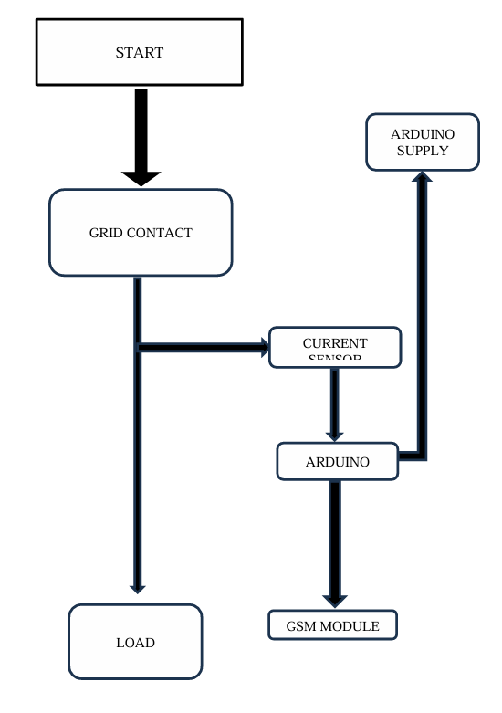
Fig. 3.1 Flow chart of Electricity Theft detection
The proposed methodology can be understand using above flowchart

CIRCUIT DIAGRAM

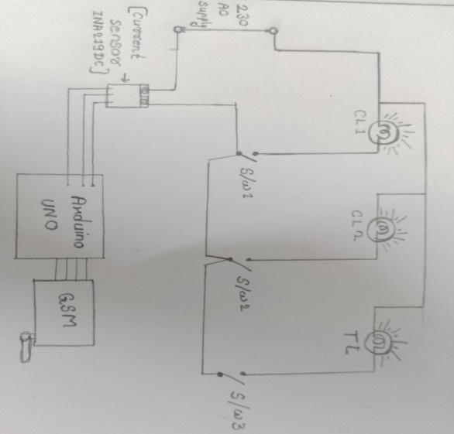
Fig. 3. Circuit diagram
The detailed information about the block diagram and actual connections are showed in circuit diagram. The working of circuit can be understood by both proposed methodology and block diagram. The specification of components.

RESULT

RESULT

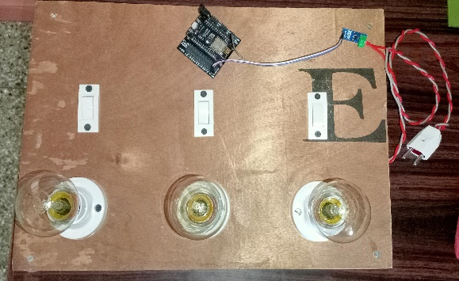
Fig. 4. Photographs of Prototype

CONCLUSION AND FUTURE SCOPE
CONCLUSION
The ability hardware and software integration has gone into the design and development of a wireless electricity theft detection and monitoring system. This technology offers an efficient and user-friendly method of detecting electrical theft without the need for a human interface. Using IoT facilitates the achievement of the several benefits of communications over wireless networks. Power theft really involves evading the energy meter, but in our project, we've also indicated the theft by raising the demand, and this is an economical way to do it.

FUTURE SCOPE
•The future scope of our project is particularly in Mahavitarn (MSEB).

CONCLUSION AND FUTURE SCOPE

RESEARCH PAPER
1) S. V. Anushree and T. Shanthi, “IoT Based Smart Energy Meter Monitoring and Theft Detection Using ATMEGA”, International Journal of Innovative Research in Computer and Communication Engineering, Vol. 4(11), Pp.19801-19805. (2016).
2) S. Sridhar, H. Bharath, V. Vishvesh, K. V. Gowtham and H. Girish, “IoT based-Transformer power theft detection and protection”, International Journal of Engineering Research, Vol. 5 (4), pp: 992-1128, (2016).
3) L. K. Lekha, G. Jegan and M. D. Ranganathan, “IoT Based Household Appliances Control And Tampering Detection Of Electricity Energy Meter”, ARPN Journal of Engineering and Applied Sciences, Vol. 11(11), pp7376-7379, (2016).
4) P. D. Talwar and S. B. Kulkarni, “IoT Based Energy Meter Reading”, International Journal of Recent Trends in Engineering and Research, Vol.2(6), (2016).
WEBSITES
6)https://www.google.com/url?sa=t&source=web&rct=j&opi=89978449&url=https://www.irjmets.com/uploadedfiles/paper/issue_12_december_2022/32683/final/fin_irjmets1672589915.pdf&ved=2ahUKEwjTvKq_qb2FAxUcjq8BHYJlB6oQFnoECDUQAQ&usg=AOvVaw1aDDSL9nv4aVvEZ1gjC521
7)https://www.google.com/url?sa=t&source=web&rct=j&opi=89978449&url=https://www.pantechsolutions.net/power-theft-detection-and-billing-using-arduino&ved=2ahUKEwjTvKq_qb2FAxUcjq8BHYJlB6oQFnoECDsQAQ&usg=AOvVaw0Bc8tLMdciB5cY2BMWGUIe

