PATIENT MONITORING HUMANOID ROBOT FOR PANDEMIC SITUATIONS
Mr. Pawan P1, Amrutha D2, Ganavi S S3, Shilpa Nayaka4, Shreya B S5

1Assistant Professor, Department of Electrical and Electronics Engineering, PES Institute of Technology, Shivamogga

2345UG students, Department of Electrical and Electronics Engineering, PESITM, Shivamogga

Email: pawanp@pestrust.edu.in, amruthax23@gmail.com , ganavisuresh702@gmail.com

Abstract— Patient monitoring Humanoid Robot for Pandemic Situations.
Abstract: Humanoid robots are a rapidly evolving field of research and development that aims to create robots with human- l ike characteristics and capabilities. These robots possess a wide range of applications, from assisting humans in various tasks to exploring environments that are hazardous or inaccessible to humans. The development of humanoid robot involves the integration of advanced technologies, including robotics, artificial intelligence, computer vision, and natural language processing.
This abstract explores the key aspects of humanoid robots, including their design, locomotion, perception, cognition, and interaction capabilities. It discusses the challenges involved in creating humanoid robots that can navigate complex environments, recognize and manipulate objects, understand and respond to human speech and gestures, and exhibit social behaviours. The abstract also highlights the potential benefits and ethical considerations associated with humanoid robots, such as their role in healthcare, education, e n t e r t a i n m e n t , a n d d i s a s t e r r e s p o n s e .
Furthermore, the abstract addresses ongoing research efforts and technological advancements in the field of humanoid robotics, including the development of more dexterous and agile robot improvements in human- robot interaction, and the integration of machine learning and deep learning techniques. It emphasizes the importance of interdisciplinary collaboration and the need for robust hardware and software solutions to overcome the challenges faced in creating humanoid
robots.

Keywords—ATmega8 microcontroller, DHT Sensors, Heart Beat Sensor,LCD.

- INTRODUCTION

Humanoid robot is the robot which is similar to human being in anthropometric structure. It has different body parts like two legs, two hands, head and trunk. Due to this anthropometric similarity, these robots can do everyday task but only being a humanoid robot doesn't allow that it can perform the entire task that a human being can do. Applications of humanoid robot are common in the field of healthcare and education but we are trying to use a humanoid in different field which can be hazardous for mankind but

require human skill to perform that task like in mining where hazardous gas may be present, bomb disposal squad, spraying disinfectant as well as in field like cleaning jobs, distribution of required things.
Today’s robots are not being designed to take jobs from human being. Instead, they are being developed with a focus on taking over typical works that humans should not be doing.
A humanoid robot not only resembles human beings’ physical attributes but also may communicates with humans, as well as it can take orders from its users and perform various tasks. A humanoid robot has different part as apart from mechanical structure it utilizes sensors, actuators, cameras and speakers and they are programmed for a particular action or having flexibility programmed for its user’s requirement. The researchers are doing practices for getting a humanoid robot since 1970 however in the era of 1990 they got success after Honda motor co., ltd. Developed “Honda P3” a humanoid robot that can staidly walk. In Japan also Ministry of economy, trade and industry (METI) in 1998 launched a five-year national project called “Humanoid Robot Project” (HRP). Since the use of robotics in various industries like constructions, healthcare, manufacturing, Military, and education is well established but humanoid robot is still in its development phase as researchers are doing work for manufacturing an enhanced, more dynamic stable humanoid. The humanoid robot scan help in various physical activities however its effectiveness is still a concern.
As we know the world is facing many pandemic diseases where humanoid robot assistant can be fruitful in different applications like spreading of sanitizers, distribution of food materials as well as food packets, thermal scanning etc. but this can be technically challenging and fascinating. This paper highlights the development of a system based on Artificial Intelligence for Medical Science, where humanoids can navigate through desired destinations, diagnose an individual for various Pandemics through various parameters and make a survey of a locality for the same.

LITERATURE SURVEY

The problem statement for patient monitoring humanoid robots revolves around the need for continuous and personalized healthcare monitoring in various settings such as hospitals, nursing homes, and private residences. Current healthcare systems face challenges in providing round-the- clock monitoring and timely interventions for patients with chronic conditions, elderly individuals, and those in need of post-operative care. Traditional monitoring methods are often labor-intensive, prone to human error, and limited in their ability to provide real-time feedback.
[1] IEEE Sensor Journal “ IoT Based Humaoid Software for Identification and Diagnosis of Covid-19 Suspects” this paper show a brief understanding about Humanoid robots and Covid 19 Identification and Diagnosis. [2] International conference on Engineering Technologies and Applied sciences “ Design and Development of assistive robotic system” this helps us to understand the Design and Improve the performance of Assistive Robots and the

performance and working principle of Assistive robotic system. [3] IEEE Journal Paper, Published on December 2020 worked upon the perceptual components and task oriented components. Understanding of overall design of Autonomous system and a survey on the robots in hospitals.

METHODOLOGY

The primary goal of this project is to offer medical services to poor in remote areas in the state in an effective manner. The main objective is to reduce the human effort in treating the patients. People in villages and remote areas do not stand a chance to get treated by a medical expert who lives in cities. A recorded voice and a display instructs the patient to be sit near to the Pi-Doctor and instructs to tell the type of disease in a coded form(e.g. Fever- 01, BP-02 etc.) . The various s e n s o r o u t p u t s a r e c o n n e c t e d t o t h e Microcontroller. If the output of the sensor is analog and with the help of ADC in Raspberry Pi converts the signal to digital form. The sensed digital data is compared with the standard value , if does not matches then the patients are made aware of the disease using the monitor display connected to the PC. The Robotic arm gives the necessary medicines for the disease of the patient and also treats the patient in a hospitality manner. The Robotic Arm rotates in right and left and in 360’ direction and picks the medicine as accordingly to the disease and give it to the patient.
The block diagram of the proposed method is shown in the figure

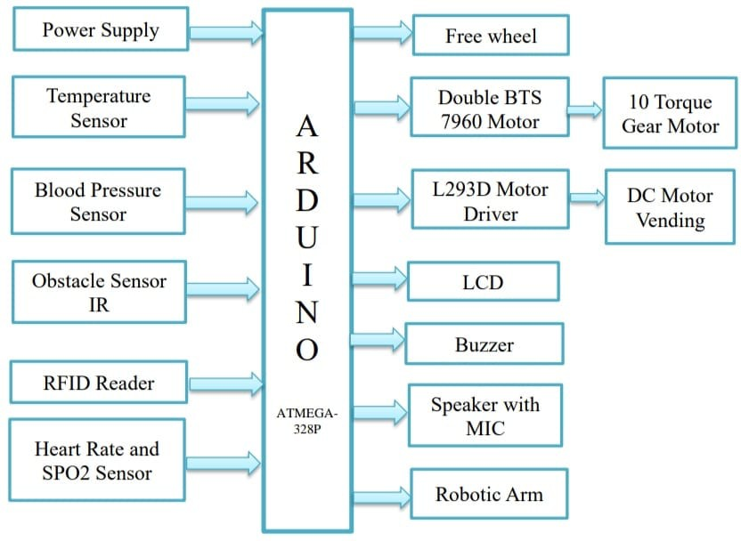

Figure 1: Block diagram of Patient monitoring Humanoid Robot For Pandemic Situations.

COMPONENT DESCRIPTION
Arduino Uno :Arduino Uno is a microcontroller board based on the ATmega328P (datasheet). It has 14 digital input/output pins (of which 6 can be used as PWM outputs), 6 analog inputs, a 16 MHz ceramic resonator (CSTCE16M0V53-R0), a USB connection, a power jack, an ICSP header and a reset button. It contains everything needed to support the microcontroller; simply connect it to a computer with a USB cable or power it with a AC-to-DC adapter or battery to get started.
Power supply unit: It requires 3.3 V for MICRO CONTROLLER module and for other sensors like Spo2, LM35, Accelerometer and pulse rate etc requires 5V. So to do this we will have to build variable power supply unit using voltage

divider circuit and regulator ICs like regulator IC 7805 and amplifier 317.

DHT Sensor: DHT11 Temperature & Humidity Sensor features a temperature & humidity sensor complex with a calibrated digital signal output. By using the exclusive digital-signal-acquisition technique and temperature & humidity sensing technology, it ensures high reliability and excellent long-term stability. This sensor includes a resistive- type humidity measurement component and an NTC temperature measurement component, and connects to a high- performance 8-bit microcontroller, offering excellent quality, fast response, anti-interference ability and cost- effectiveness. The DHT11 is a commonly used Temperature and humidity sensor that comes with a dedicated NTC to measure temperature and an 8-bit microcontroller to output the values of temperature and humidity as serial data.
Heart beat sensor: Heart beat sensors are designed to give digital output heart beat when a finger is placed on it. When the heart beat detector starts working, the light emitting detector (LED) blinks simultaneously for every heartbeat.These devices use electrical detection to track your heart rate. They detect electrical activity through a band that wraps around your chest. For most of these devices to work as designed, the band must be wet, or you need to use a conductive gel where the sensors touch your skin.
Obstacle sensor IR: The Infrared Obstacle Avoidance Sensor has a pair of infrared
transmitting and receiving sensors. The infrared LED emits Infrared signals at certain frequency and when an obstacle appears on the line of infrared light, it is reflected back by the obstacle which is sensed by the receiver.Sensors for obstacle detection are devices that can detect the presence of obstacles in the path of a vehicle or a robot. These sensors are commonly used in various applications such as autonomous vehicles, drones, and robotic systems.
RFID Reader: RFID refers to a wireless system comprised of two components: tags and readers. The reader is a device that has one or more antennas that emit radio waves and receive signals back from the RFID tag. Radio Frequency Identification (RFID) is a technology that uses radio waves to passively identify a tagged object. It is used in several commercial and industrial applications, from tracking items along a supply chain to keeping track of items checked out of a library.
L293D Motor Driver :
L293D IC is a typical Motor Driver IC which allows the DC motor to drive on any direction. This IC consists of 16-pins which are used to control a set of two DC motors instantaneously in any direction. It means, by using a L293D IC we can control two DC motors. As well, this IC can drive small and quiet big motors.The L293 and L293D devices are quadruple high-current half-H drivers. The L293 is designed to provide bidirectional drive currents of up to 1 A at voltages from 4.5 V to 36 V. The L293D is designed to provide bidirectional drive currents of up to 600-mA at voltages from 4.5 V to 36 V.

Liquid Crystal Display: LCD (liquid crystal display) is the technology used for displays in notebook and other smaller computers. Like light- emitting diode and gas-plasma technologies, LCDs allow displays to be much thinner than cathode ray tube technology. LCDs consume much less power than LED and gas-display displays because they work on the principle of blocking light rather than emitting it.

ADVANTAGES
- Continuous Monitoring: They can provide 24/7 monitoring of patients' vital signs and other
health parameters, ensuring timely detection of any abnormalities or emergencies.
- Efficiency: These robots can automate routine tasks such as taking vitals, administering medication reminders, and assisting with mobility, thereby reducing the workload on healthcare staff and allowing them to focus on more critical aspects of patient care.
- Consistency: Robots can perform tasks consistently without fatigue or distraction, ensuring accuracy and reliability in patient monitoring and care.
- Remote Monitoring: They can be equipped with telepresence capabilities, allowing healthcare providers to remotely monitor and interact with patients, especially in situations where physical presence is challenging or risky.
- Personalized Care: Advanced humanoid robots can be programmed to adapt to individual patient needs and preferences, providing personalized care and support.
- Enhanced Communication: These robots can serve as companions for patients, offering social interaction, entertainment, and emotional support, which can contribute to improved patient well- being and recovery.
- Cost-Effective: While initial investment costs may be significant, in the long run, patient monitoring humanoid robots can potentially reduce healthcare costs by improving efficiency, preventing complications, and reducing the length of hospital stays.
- RESULT

The output of the three sensors are displayed in the LCD as shown in the Figure 3. The information regarding the patient is sent to the end user using the Arduino UNO Application.

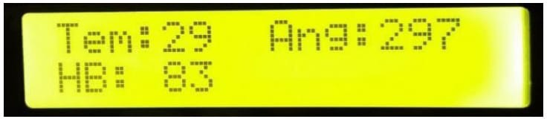

Figure 2. LCD Output

EXPECTED OUTCOME
This can be extended to remote areas also by our innovative technology Pi-DOCTOR and it creates a great impact on the society and the health industry will drastically depend on bio-medical electronics

like the proposed one which shall be implemented in every remote village across the state and country.
The lives of people is changing every day and expecting a technological innovation to help them solving their issues. This project is unique and will surely help the poor people who are not aware of the current medical hazards. As per the words of Neil Armstrong “That's one small step for a man, one giant leap for mankind”. This project will set in future as humanoid robots and assist the patient and treat the patients.

ACKNOWLEDGMENT

We would like to express our sincere gratitude towards our guide, Mr. Pawan P, Assistant professor for the help, guidance and encouragement. This work would have not possible without his valuable time, patience and motivation. We thank him for making our stint thoroughly pleasant and enriching. It was great learning and honour being his students. We deeply indebted to professor. They were always helpful and enthusiastic and this inspired us in our work.

REFERENCES

[1]. Swapnili Karmore, Rushikesh Bodhe, Fadi Al-Turjman, R Lakshmana Kumar, Sofia Pillai “IoT Based Humanoid Software for Identification
and Diagnosis of Covid-19 Suspects” IEEE Sensors Journal ,Vol 10, 2020
[2]. Syed Faiz Ahmed, Isho James Kiwarkis, Ala Bahjat Mohammed, Ahmed Hasan Mohammad, Ahmed Abdulsalam Mihi, Mohammed Shawkat Saeed ,Bland Dilshad Diwali, “Design and Development of Assistive Robotic System for Covid-19” Vol 5, 7, 2020
[3]. Yang Shen , Fei Long , Luis A Mateos, “ Robots under Covid-19 Pandemic: A Comprehensive survey ” , 2021

[4]. MD. MILON ISLAM 1 , FAKHRI KARRAY 1 ,
(Fellow, IEEE), REDA ALHAJJ 2 , (Senior Member, IEEE), AND JIA ZENG 3, “A Review on Deep Learning Techniques for the Diagnosis of Novel Coronavirus (COVID-19) ”
[5]. Kumar Abhishek, Vijay Kumar Dalla and Abhishek Shrivastava “ Humanoid robot applications in Covid-19: A comprehensive Study ” May 2021

