SURVEILLANCE CAR USING ESP32 CAM
Vyankatesh Y.Sharma¹ , Somesh S.Bhujbal² , Mahitosh S.Mande³ , Ranjeet R.Shinde⁴, Yogesh P. Patil⁵
^{1,2,3,4} Students,E&TC Dept, VAPM Almala, Latur, Maharashtra, India.
⁵Guide,,E&TC Dept, VAPM Almala, Latur, Maharashtra, India.

ABSTRACT
A surveillance car using ESP32-CAM is a system that utilizes the ESP32-CAM board and a car chassis to create a mobile surveillance device. The ESP32-CAM is allow-cost development board that integrates a small camera module and Wi-Fi connectivity. The car chassis allows the device to move around and capture video in different locations. The system can be controlled through a web interface hosted on the ESP32-CAM board. The web interface allows the user to control the car movement, view live video streams, and take snapshots of the video feed. Additionally, the system can be programmed to detect motion using computer vision algorithms, such as object detection and tracking, and send alerts to the user. The surveillance car using ESP32-CAM has potential applications in home security, monitoring of remote locations, and industrial surveillance. With its low cost and easy-to-use interface, it provides a convenient solution for anyone who needs to monitor their surroundings remotely

- INTRODUCTION
The development of surveillance car has been a growing area of interest due to its applications in various fields such as security, industrial monitoring, and home automation. The surveillance car using the ESP32-CAM is a project that focuses on developing a low-cost and efficient surveillance car for indoor and outdoor use.
Surveillance cars are becoming increasingly popular in modern times due to their ability to monitor and collect information from a remote location. The use of the ESP32 CAM module, which is an integrated camera module with Wi-Fi and Bluetooth connectivity, has made it possible to create surveillance cars that can be controlled remotely.

- METHODOLOGY
The ESP32-CAM is a low-cost microcontroller that integrates a camera module and Wi-Fi capabilities. In this project, we use the ESP32-CAM to control the movement of the car and capture video and images that can be viewed remotely. The car is equipped with a set of motors that enable it to move in different directions.
The methodology for developing a surveillance car using ESP32-CAM can be divided into several steps:

Hardware setup:

The first step is to assemble the hardware components required for the project. This includes the ESP32-CAM module, motor drivers, motors, wheels, chassis, battery, and infrared sensor. The ESP32-CAM module is connected.

HARDWARE COMPONENTS
  - ESP32cam
The ESP32-CAM shown in Fig.3.1.1 is a small-sized camera module that is based on the ESP 32 microcontroller and OV2640 sensor. It is capable of capturing images, streaming video, and performing various image processing tasks. The ESP32CAM module also features Wi-Fi and Bluetooth connectivity, making it ideal for 10T and surveillance applications.
Here are some key features of the ESP32- CAM:
- ESP32 microcontroller
- OV2640 2 MP camera sensor
- Wi-Fi and Bluetooth connectivity
- GPIO pins for interfacing with other devices
- Micro SD card slot for storage
- 5 V DC power supply

To use the ESP32-CAM module, you need to have some knowledge of programming, especially with theArduino IDE, as it is commonly used to program the
You will also need to have some basic electronics knowledge, such as how to connect wires and components to the GPIO pins of the module shown in Fig 3.5.1.

There are many projects that you can do with the ESP32CAM, such as building a smart security camera, a remote-controlled car with a camera, or even a face recognition system. With its small size and powerful features, the ESP32-CAM is a versatile and powerful tool for makers and hobbyists

  - MOTOR DRIVER
The L298N is a popular motor driver IC (integrated circuit)
that can control the direction
and speed of DC motors and stepper motors. It can handle up to 2 amps of continuous current per channel, and has a wide input voltage range of 5V to 35V.
The L298N has two H-bridge circuits, which are used to control the direction of the motor. Each H-bridge consists of four transistors that can be controlled independently. By switching these transistors on and off in the correct sequence, the motor can be driven in either direction.
To use the L298N, you need to connect it to your microcontroller or other control circuitry. There are several pins on the L298N shown in Fig 3.2.1 that you need to connect
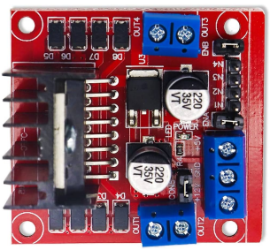

3.3 CAR CHASIS
A car chassis serves as the structural foundation of an automobile, providing support for various components such as the engine, suspension system, steering mechanism, and body panels. Typically constructed from steel, aluminum, or composite materials, the chassis is designed to withstand the forces and stresses encountered during vehicle operation, including acceleration, braking, and cornering. It forms the framework onto which all other components are mounted, ensuring structural integrity and rigidity while also dictating the overall size, weight, and handling characteristics of the vehicle. Modern car chassis designs often incorporate advanced engineering techniques such as computer-aided design (CAD) and finite element analysis (FEA) to optimize strength, weight, and safety performance
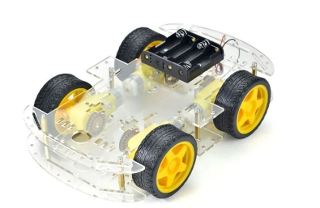

  - PAN TILT SERVO ASSEMBLY
Pan-tilt servo assemblies are mechanisms used to control the movement of a camera or sensor in two dimensions: horizontally (pan) and vertically (tilt). These assemblies typically consist of two servo motors mounted orthogonally to each other, with one controlling the horizontal movement (pan) and the other controlling the vertical movement (tilt). A typical pan-tilt assembly includes servo motors, gears, mounting brackets, and sometimes bearings or bushings to ensure smooth movement. These are the actuators responsible for moving the assembly. They are controlled by sending specific electrical signals to them, which dictate the position they should move to Gears are used to transfer the rotational motion of the servo motors to the pan and tilt axes. They can provide mechanical advantage and precise control over the movement
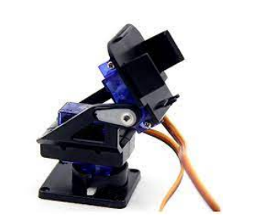

- RESULT
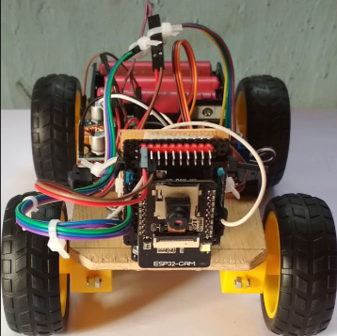
A surveillance car using an ESP32 Cam is powerful and versatile device that can be used in a variety of applications. Whether you want to monitor your home or office, keep an eye on your pets, or even use it in industrial settings, the ESP32 cam has the features and capabilities to get the job done.

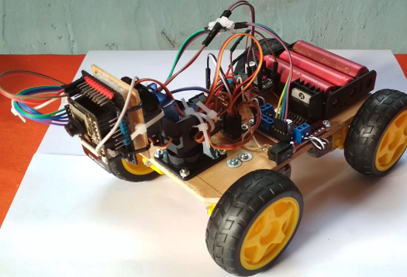

- CONCLUSION
In conclusion, the surveillance car using ESP32-CAM is a promising project that can be used for various applications, such as monitoring and surveillance of homes or offices. The ESP32-CAM module provides a compact and cost-effective solution for capturing images and streaming video. By integrating it with a car platform, it is possible to remotely control the car and view live video footage from the camera. With the increasing demand for remote monitoring and surveillance, this project has the potential to provide a practical and affordable solution for many different scenarios.

By leveraging the mobility of a vehicle, the system offers unprecedented flexibility in gathering real-time visual data across diverse environments, enhancing situational awareness and response capabilities for various stakeholders including law enforcement, emergency services, and private security firms.

6 REFERRENCES
  - “Design and Implementation of SPY Car”, IJARIIE-ISSN(0)-4396,Vol- 5
Issue-5 2019.
  - Liu, C., et al. "Design and implementation of a wireless surveillance car based on ESP32- CAM." IEEE Access, vol. 9, 2021,
pp. 14582-14591.
  - Kumar, S., et al. "Design and implementation of a low-cost surveillance car for indoor applications." International Journal of Computer Applications, vol. 180, no. 18, 2018, pp. 9-14.
  - Wang, Y., et al. "Design and implementation of a wireless car for environmental monitoring. “Sensors, vol. 21, no. 1, 2021, p. 36.
  - Namenda, N., et al. "Design and implementation of a low-cost surveillance car using Raspberry Pi." International Journal of Innovative Technology and Exploring Engineering, vol. 8, no.12, 2019, pp.
46-50.
  - Noh, J., et al. "Development of a surveillance car with obstacle avoidance capability." International Journal of Advanced Ceric Systems, vol. 15, no. 1, 2018, pp. 1-8.

