“IC Engine Operated Power Weeder Machine”

1)Mr. Saurabh Narkhede, 2)Prof. Pranav G. Firke, 3) Mr. Rohit Patil
4) Mr. Ram Punde, 5) Mr. Rahul Kawale, 6) Mr. Rohit Bhangale, 7) Mahadeo Wadhe
Department of Mechanical Engineering, Padm. Dr. V. B. Kolte College of Engineering, Malkapur

Abstract- India is well known as agriculture country. The population of our country largely increasing day by day. Thus the increase in population agriculture space area get divided into small parts. Now a days it becomes difficult to introduce advance technology equipment and machineries in shell part of agricultural land. In India most of the farmers are using the conventional farming method for doing their all the agriculture work. So that time and money both are west. It is observed that Indian farmers are show in adopting the new technology due to the cost because yet which are the new technology are developed are highly costly. In the IC Engine Operated Weeder Machine which is definitely useful for farmer to apply in small part of agricultural land. Of course it is economical to purchase and maintain it. In this machine we have use IC engine of sufficient capacity which develop the forces as we required. For running this machine which is operated with the help of bullocks. This machine is more efficient and less consuming than the other one. Agricultural area has been in the area of continuous research, and has made significant improvement in the recent period. Currently, standard cultivation removes weeds from the majority of the bed using sweeps, knives, coulters and blades. Typically a 4-inch wide band is left around the seed line. Weeds in the uncultivated band are typically removed by hand, and the density of weeds that occur there, determines how laborious and costly subsequent hand weeding will be. Mechanical weeding machine is a project used to remove unwanted plants/weeds, which grows around the crops. Technology will continue to develop and improve in the coming years. These technologies do not entirely replace the need for hand labor, but they can make subsequent hand weeding operations less costly and more efficient. So we are going to make a machine which removes these unwanted plants more efficiently and at a considerable less cost. We have made a machine which removes weed from in the line and around the plants. It uses rotary motor operated jaws which indeed removes weed. The design and other technical details are presented in the report.
Keywords:- 2 stroke IC engine, weeder blades, frame, gears, shaft, chain drive, wheels etc.

.I. INTRODUCTION
India is a agricultural country. More than 70% of its population is dependent on agriculture for their living, still many of the farmers use conventional methods to remove

weed. Thus there is a need to bring in new modern technologies to make farming easy and time saving. To achieve a high yielding vegetable production, good agricultural practices are required. One of the most important practices is to properly manage weeds. Weeds affect crop yield due to competition to acquire plant nutrients and resources Weeds have very fast growth rates compared to crops, and if not treated and managed, they may dominate the field. Some farmers adopt agronomic practices that improve crop competitiveness such as planting vigorous crop seeds at relatively shallow depths and planting right after a weed control operation. This method is used to prevent the weed seeds from germinating before the crop is planted and to ensure that crop plants emerge before the weed plants. This practice will not only ensure a maximized crop yield and reduce weed infestation, but also minimize any economic losses The above practice should be applied for controlling weeds if the canopy closes and does not allow much light onto the ground surface where weeds will germinate and grow. However, weed control is still required during the crop production cycle. Diesel engines are playing a vital role in Road and sea transport, Agriculture, mining and many other industries. Considering the available fuel resources and the present technological development, Diesel fuel is evidently indispensable. In general, the consumption of fuel is an index for finding out the economic strength of any country. In spite, we cannot ignore the harmful effects of the large mass of the burnt gases, which erodes the purity of our environment every day. An aqua silencer is used to control the noise and emission in IC engines. The reason why we go for aqua silencer is, in today life the air pollution causes physical ill effects to the human beings and also the environment. The main contribution of the air pollution is automobiles releasing the gases like carbon dioxide, unburned hydrocarbons etc. Most of the people in our country depends on farming for money. This business is a traditional for Indian people. India got a very good climate and soil condition which is useful for agriculture. India is sub-continent and a variety of indigenous or old implements are in use in different parts of country for last so many centuries. Before effort made to introduced foreign implement, it was necessary that a survey of indigenous agriculture implements use in India should be undertaken. we found that the concept are prices worthy but one common and vital lacuna. We observed in almost all previous work in that they lack any suitable technical design and are fabricated without going into designing details. So for overcoming all the above difficulties we have design a multi utility machine, in which we are use engine to drive it, instate of bullocks. This design is quite simple, effective, flexible to implement in agriculture field and can be developed to perform multiple activities. This equipment is highly efficient, because it is made of light weight material and components so it should easily drive whenever required. It is multipurpose equipment. A suitable design not only save material and labour cost but also reduces time and weight of some components, thereby reducing cost which is an essential feature to be considered for Indian farmer because such equipment or not use by farmer owing loss of plant but by those who are small farmers owning 5 to 10 acers of land. However the suggest design is done only for weeding purpose, due to paucity of time, but can be further developed for other operation like rotavator, sowing purposed and many other operation. It construction is quite complex because we use IC engine in it but other parts of this machine is simple and it easy to manufacture and fabricate.

II. LITERATURE REVIEW
Swapnil Kadu L.et.al[2] In this machine chain and sprocket are used for power transmission whereas in other machine gears are used for used, cost reduction. As machine is simple in construction, accurate manufacturing and standard components are used, so machine required less maintenance. As machine is developed by sheet metal formation hence weight of the machine is low. There are no casting parts. It is designed on the basis of optimum material consideration. The working capacity of this machine is 2.5 Acre per day. It requires 10 liters per day for the operation. Single operator can operate this machine easily.
Mr. Mahesh Gavali.et.al[3] Portable weeders are available in various ranges in Indian market. The power rating of these weeders is from 1.5 HP to 5 HP majority of them is petrol powered for cutters and manual movement in field. Weights of these are between 10.4 kg to 44 kg as they needed to be driven manually. The weed removal rate is obliviously low. They have low initial cost ranging between Rs. 15000/- to 40000 and operating cost largely depends on cost and consumption of petrol and manual labor required for operation.
Prem tiwari.et.al[5] Three models of light weight power tiller evaluated for seedbed preparation, intercultural operation and basin preparation in the orchards. The following operational problems were observed: The power tillers do not have separate transport wheels as rotavator itself served the purpose of transport-cum-rotary unit. This was the technical drawback in all the power tiller because the recommended ratio of peripheral speed of the rotary unit to the forward speed of power tiller, which should be 4-6 for efficient working, could not be maintained. The power tiller had jumping action due to high forward speed and low depth of tilling. Backward pulling of power tiller was required due to high forward speed. High workload on operator was observed due to back ward pulling and continuous effort applied to move the power tillers in straight line.
S. Sai Mohan.et.al[11] Weeding is an labour intensive agricultural operation and about 1/3rd of the cost of cultivation is accounted towards weed control operation alone. Any delay and negligence in weeding operation effects the crop yields up to 30-40%.Power weeder was evaluated for its performance in sugarcane crop. This test was conducted at different moisture contents of soil observed at 30, 45 and 60 DAS and different speeds of weeder. The density decreased from 0.84 to0.65 gcm-3with increased soil moisture content from 7±1 to 12±1 percent. The field efficiency of power weeder was high when operated at 4.153 km h-1 during initial crop growth and gradually decreases with increasing DAS. The weeding efficiency of power weeder was observed to be high at every stage of crop with varying speeds. When operated at lower speeds the plant damage will be minimum whereas operating at high speeds will result in maximum plant damage. The cost of weeding per hectare was observed as Rs. 3,878 ha-1 and Rs. 8,000 ha-1 for power weeding and traditional weeding, respectively. It can be started and operated by farmer or any unskilled labour with ease. Also working with power weeder in between the rows is easy with a very less maintenance cost.

III. CONSTRUCTION OF POWER WEEDER MACHINE
Assembly of machine consist the mounting of engine on the frame & chassis is mounted on wheel. Then the engine is assembled on chassis by using nut, bolt & somewhere by weld as required. Manufacturing of motor includes following procedure. Weeding tool is cut by grinding cutter & bending of the tool is done manually. This tool is attached with the frame by adjusting setting.
A single wheel is fitted below the chassis with the help of nut & bolt. Round pipe is used for the handles with required dimensions & switch is fitted on handle & directly connected to the engine by using wire. Switch & other connections are made for on/off the engine & Switch is mounted on handle of machine. For construction of the weeder machine there are various components are used which are as listed below:
A. Two Stroke Petrol Engine
In fabrication of power weeder, engine is the most important component. For this project we used a 2 stroke petrol engine. The figure of the engine is shown below:
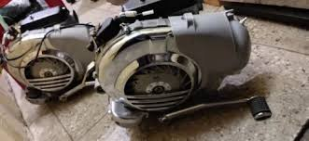
Fig.1: Two Stroke Petrol Engine
A two-stroke (or two-stroke cycle) engine is a type of internal combustion engine that completes a power cycle with two strokes (up and down movements) of the piston in one revolution of the crankshaft. A four-stroke engine requires four strokes of the piston to complete a power cycle in two crankshaft revolutions. In a two-stroke engine, the end of the combustion stroke and the beginning of the compression stroke happen simultaneously, with the intake and exhaust (or scavenging) functions occurring at the same time. Petrol engines takes in a mixture of air and petrol and compress to less than 1275kpa and use a spark plug to ignite the mixture when it is compressed by the piston head in each cylinder.
B. Weeder Tool
The figure of the weeder tool used in fabrication of the power weeder is shown below
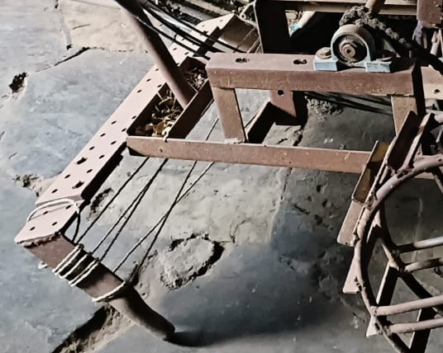
Fig. 2 Weeder Tool
The weeder tool which is used for the fabrication of the power weeder is made from mild steel having standard size length 203.2 mm of and width of 25.4 mm is assembled on chassis by using lock nut and bolts and somewhere by welding as per requirement. Lock nuts and bolts having size equal to 10 mm diameter of hexagonal head are used for assembling the blade on disc. The main purpose of using lock nuts is to avoid slippage during working of machine. It is used to remove weeds in and around tree, Garden lawn edges, vegetable beds etc. The extra-long handle helps you weed seamlessly. He action hand weeder tool can easily weed and cultivate along the rows and between the plants. It's just the best hoe or straw skirt you'll find.
C. Chassis Frame
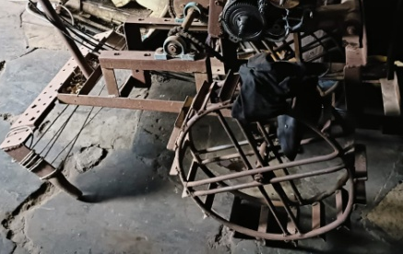
Fig. 3 Chassis Frame
Chassis is constructed from angles made up of mild steel which are cut as required length and are then welded together with the help of welding torch (Arc welding). Chassis act as a load carrying part and mounting for all the parts of machine including engine, wheels, transmission system, tools, etc. It keeps all the part assembled together.

D. Bearing Pedestal
A bearing pedestal, also known as a bearing housing, is a component that supports a bearing and provides the necessary structural support and protection. It is designed to hold the bearing securely in place and often includes features such as mounting holes, seals, and lubrication channels to ensure the proper functioning of the bearing.
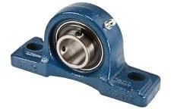
Fig. 4 Bearing Pedestal
Bearing pedestals are commonly used in various industrial applications, including machinery, equipment, and vehicles, where bearings are essential for supporting rotating or moving parts. Pedestal bearing also called plummer block or pillow block. It used to provide support for a rotating shaft with the help of compatible bearing & various accessories. Housing material for a pillow block is typically made of cast iron or cast steel.
F. Shaft
Shaft is made up of cast steel. It is used to support wheels and provide motion to them with the help of proper transmission system. One sprocket is attached to the shaft which receives motion from engine with the help of chain. Figure shows the view of shaft used in fabrication of weeder.
Fig. 5: Shaft used in fabrication of weeder
Chain is used to provide transmission of power as well as motion from engine shaft to the shaft carrying wheels. Chain is mounted on sprockets attached and properly aligned. Chain ensures smooth transmission without much loss. Chain used is of single strand type.
G. Chain Wheel Mechanism
A sprocket with a hole that matches the diameter of the shaft is chosen and slid onto the shaft. The sprocket is then rotated until the keyways in the sprocket and shaft line up. A rectangular piece of steel bar called a key is slid into the keyways to prevent the sprocket from spinning on the shaft. Chain and sprocket mechanisms perform the same task as a belt and pulley system, i.e. they transfer motion and force from one shaft to another. A belt can slip on a pulley but the teeth on the sprocket prevent the chain from slipping.
Fig. 6 Chain Wheel Mechanism
A chain and sprocket is used wherever a positive, non-slip drive is required, e.g. bicycles, motorcycles, forklift mechanisms, and the camshaft drives in car petrol engines. standard general purpose roller chains, widely used in industry
E. Handel & Wheel
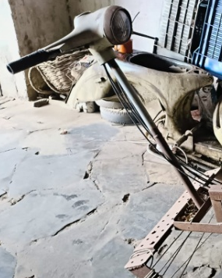
Fig. 7 Handel
Handle is used to guide the vehicle in desired direction. Also it is used to vary the speed of machine as desired as accelerator is provided on handle. Handle is designed according to human comfort in height and handling of machine. There is a single wheel attached to the machine. This front wheel is attached below the chassis.

IV. WORKING
In IC engine operated weeder machine, we used 2 stroke IC engine of 145cc and torque of 9.81 N/M at 5000 rpm. It has 2 wheel situated on driving shaft, driving shaft is drive by engine means of gear and chain arrangement. On both ends of the driving shaft the wheels are attach with the help of bearing. And the bearing is fixed to the frame. The weeding tool is attached at backside of frame. For proving force on the tool handle is welded on the tool. All the engine control are maintain from this handle. When the engine is started, the driven axle is rotated with the help of chain drive due to which wheels are also rotate. The torque ratio is obtained by gearing arrangement which is supplied manually. High torque ratio is obtained at low gear. As the wheel rotate machine start moving removing the unwanted grass from the farm. Engine speed is maintain by adjusting gear and acceleration. In this way weeding operation is perform.
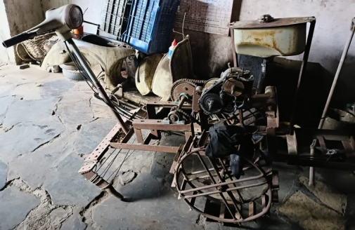
The working of power weeder machine is as Shortly explain in following steps given below:
- Initially we have to start the engine by starter button which is mounted on handle.
- As we used two stroke petrol engines it provides rotational energy to the shaft connected to it.
- It results in the rotation of chain and wheel connected to the chain get rotated.
- The weeder tool gets pushed in forward direction.
- Due to the motion of tool when it touches the soil the process of weeding gets started.
- Hence weeding is done with less effort and less cost.

V. ADVANTAGES & DISADVANTAGES
ADVANTAGES
- Helps to reduce manpower.
- Replace traditional method of weeding by using bulls.
- Remove unwanted grass as well as provide rotary cultivation for crops like soybean, maize and gram etc.
- Help to reduce process times.
- Provide low cost and compact design.
- Reduce use of harmful pesticide for weed control.
DISADVANTAGES
- Use of petrol engine requires fuels which is non- renewable.
- It can be only used for limited crops.

VI. CONCLUSION
In this paper we will try to reduce the human effort with the help of two stroke IC engine. The engine presented here serves the purpose of an economical lighter and flexible mechanism which could developed to perform multiple activities. The design presented is subject to entire needs of the small farmer. Hybrid vehicle reduce emission, increases efficiency and improve fuel economy also reduce pollution.
This machine performs weeding for the more acers of the land than the conventional one. Our machine is more efficient, economical, more effective and less time consuming than that conventional weeder machine. It is observed that the depth of tool totally depends on the molecular structure, condition of soil as well as moisture content into the soil. This work is about integrating of mechanical system to the agriculture fields for the agriculture operations. Many operations including ploughing, weed removal, ground softening etc can be performed. Different agriculture tools are often adopted by applying different mechanisms to the machine. Hence it’s a multi operational device that can be effectively used in fields. The fabrication of Low cost Weeder is done with locally available material. The overall performance of the weeder was satisfactory.
VII. REFERENCES
- Swapnil Kadu L, Ganesh Kadam B, Kishor Jadhav P, Vikas Gawade S, Abhijit Garje, Anil Gosavi, “Design, Development and Operation of 3.5HP Power Tiller,” International Journal of Recent Research in civil and mechanical Engineering, Vol. 2 Issue 1, pp: (149-154), Month: April 2015- September 2015.
- Mahesh Gavali, Satish Kulkarni, “Comparative analysis of portable weeder and power tillers in the indian market,” International Journal of Innovative Research in Science, Engineering and Technology, Vol. 3, Issue 4, pp: (11004-11013), April 2014.
- Krishi Vigyan Kendra, Sabour, Bhagalpur, Bihar, “Different Attachments of a Power Tiller: A Review,” International Journal ofScience, Environment, Vol. 7, No 3, pp: (1024-1035), 2018
- Zakariyan, A. M. El-Okene, U. S. Mohammed, N. Oji, I. Abubakar, J. K. Agunsoye and K. Ahmad, “Modification of Portable Power Tiller for Small Scale Weeding Operation,” Journal of Engineering Research and Reports, pp.54-56, 2021.
- T. P.Ojha, “Success and failures of Power Tiller in Indian Agricultural,” Central Insitute of Agricultural Engineering, pp.30- 33.

