SENTINEL GUARD: A FATIGUE DETECTION SYSTEM WITH MULTI-CHANNEL ALERT INTEGRATION
Dr.P.D.R.Vijayakumar,M.E.,Ph.D., A.ArockiaSelvaraj,M.E., R.VishnuPriya, A.Shivani, S.SilversterStalin.

Dr.P.D.R.Vijayakumar HOD-CSE & INFO INSTITUTE OF ENGINEERING, COIMBATORE
A.Arockiaselvaraj AP- IT & INFO INSTITUTE OF ENGINEERING, COIMBATORE
R.Vishnupriya BE CSE & INFO INSTITUTE OF ENGINEERING, COIMBATORE
A.Shivani BE CSE & INFO INSTITUTE OF ENGINEERING, COIMBATORE
S.Silversterstalin BE CSE & INFO INSTITUTE OF ENGINEERING, COIMBATORE
---------------------------------------------------------------------***---------------------------------------------------------------------
Abstract - The fatigue detection system is a critical application aimed at enhancing safety in various domains by addressing the risks associated with drowsiness related incidents. Leveraging advanced technologies such as machine learning, computer vision, and real-time communication, the system offers a comprehensive solution for monitoring and alerting users to signs of fatigue in real-time. Through the integration of pre-trained models, such as the shape_predictor_68_face_landmarks.dat, the system accurately detects facial landmarks and tracks eye movements, enabling the identification of drowsiness indicators. Upon detection, the system generates alerts via email and WhatsApp, accompanied by audible alarm buzzers to prompt immediate user intervention. The inclusion of live location information in alerts provides additional context, facilitating timely assistance and support. Furthermore, the system's architecture allows for future enhancements, including the integration of multi-sensor data fusion techniques and collaboration with industry stakeholders to promote standardized protocols and widespread adoption. Overall, the fatigue detection system represents a significant step towards mitigating the risks of drowsinessrelated accidents and improving safety across various applications

Key Words: Fatigue detection, Machine learning, CNN, Real time alerts, Facial Expression analysis, Open CV

1.INTRODUCTION

The system aims to accurately identify signs of drowsiness in individuals, triggering timely alerts through alarm buzzers and notifications sent via email and WhatsApp. By integrating real-time location sharing in the alerts, the project seeks to provide immediate assistance and support from designated contacts, thereby enhancing safety and preventing potential accidents due to fatigue-related impairments. Additionally, the project aims to raise awareness about the importance of addressing fatigue-related risks and promoting proactive measures for personal and public safety.

2. Body of Paper

The project entails the development of SentinelGuard, a comprehensive fatigue detection system leveraging facial recognition and eye-tracking algorithms for real-time drowsiness detection. Integrated within the system are alarm buzzers that provide immediate audible alerts upon detecting signs of fatigue, alongside functionalities for sending email notifications and WhatsApp alerts to designated contacts.

These alerts include detailed information about the fatigue event and the individual's live location for prompt assistance.

The project also encompasses the design of a user-friendly web interface using Flask, rigorous testing to ensure algorithm accuracy, documentation for system deployment and usage, and considerations for future enhancements such as mobile app integration and machine learning-based fatigue prediction.

Ultimately, SentinelGuard aims to enhance safety and well-being by proactively addressing fatigue-related risks in various contexts, from long-distance driving to critical work environments.

2.1 PROPOSED SYSTEM

Sentinel Guard, integrates facial recognition and eye-tracking algorithms for real-time fatigue detection, employing alarm buzzers, email notifications, and WhatsApp alerts to promptly alert both users and their designated contacts about drowsiness episodes. Live location sharing enhances the alerting system, facilitating rapid assistance from contacts in emergencies. The user-friendly web interface ensures seamless interaction, while rigorous testing and comprehensive documentation guarantee reliability and usability. Overall, Sentinel Guard aims to mitigate fatigue-related risks, enhance safety, and promote proactive measures for accident prevention in various domains, including driving, working, and machinery operation.

1. Comprehensive Alerting System: Sentinel Guard integrates multiple alerting mechanisms, including alarm buzzers, email notifications, and WhatsApp alerts, ensuring timely communication of drowsiness episodes to both users and designated contacts.

2. Live Location Sharing: The system incorporates live location sharing within alerts, enabling quick response and assistance from contacts in emergencies, thereby enhancing user safety and facilitating rapid intervention.

3. User-Friendly Interface and Reliability: With a user-friendly web interface, rigorous testing, and comprehensive documentation, Sentinel Guard ensures seamless interaction, reliability, and usability, promoting widespread adoption and effectiveness in diverse environments.

2.2 HIGH LEVEL DESIGN

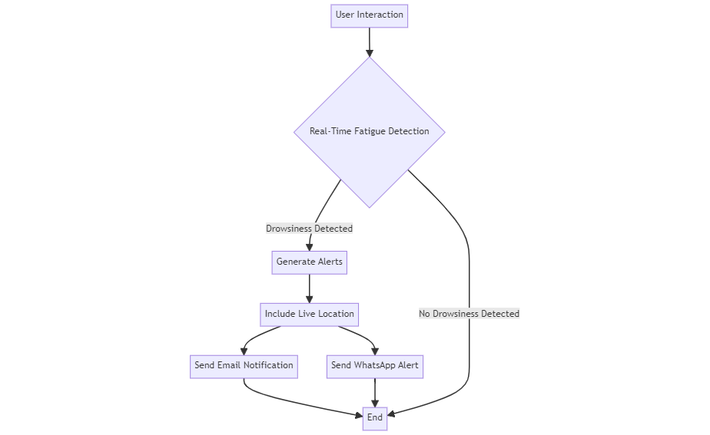

Fig-1 High Level Design
The fatigue detection comprises several components working together seamlessly to detect signs of drowsiness and alert users and designated contacts effectively. At the core of the architecture lies the real-time fatigue detection module, which utilizes facial recognition and eye-tracking algorithms implemented using OpenCV and dlib libraries. These algorithms continuously analyze facial expressions and eye movements captured by the webcam feed to detect indicators of drowsiness, such as drooping eyelids or prolonged eye closures.
Once drowsiness is detected, the system triggers the multi-channel alerting mechanism, which integrates alarm buzzers, email notifications, and WhatsApp alerts.

The alarm buzzer functionality is implemented using pygame library, providing immediate audible alerts to the user.
Simultaneously, the system generates email notifications using the smtplib and email libraries, containing details of the fatigue event and the user's live location obtained through GPS or geolocation services.
Integration with the Twilio API enables the sending of WhatsApp alerts to designated contacts, providing urgent notifications with live location about the user's condition.

2.3 REQUIREMENTS ANALYSIS

1. OpenCV (cv2): A computer vision library, is the cornerstone of the project, enabling real-time image processing, facial recognition, and eye tracking. It provides essential functionalities for capturing video streams from cameras, detecting facial landmarks, and analyzing facial expressions, crucial for detecting signs of drowsiness.
2. Dlib: A versatile C++ library with Python bindings, primarily used for facial landmark detection and shape prediction. In this project, dlib plays a vital role in accurately identifying key facial features such as eyes, nose, and mouth, facilitating precise tracking of eye movements, which is essential for detecting signs of fatigue.
3. Pygame: A Python library, is utilized for playing alarm buzzers when drowsiness is detected. It provides a simple interface for audio playback, allowing the system to generate audible alerts to notify users when signs of drowsiness are observed, enhancing user safety and awareness.
4. Smtplib and Email: These libraries are used for sending email notifications with attached images when drowsiness is detected. These libraries enable the system to send detailed alerts to users' registered email addresses, providing visual evidence of drowsiness events captured by the system's camera.
5. Twilio API: This integration facilitates the sending of WhatsApp alerts to designated contacts when drowsiness is detected. By leveraging Twilio's messaging platform, the system can deliver instant notifications to users' WhatsApp accounts, ensuring timely communication and assistance during fatigue events.
6. Flask: A lightweight web framework, powers the user interface of the fatigue detection system. It enables the development of a responsive web application where users can interact with the system, configure settings, and monitor fatigue alerts in real-time, enhancing user accessibility and control over the system.

7. Imutils: It provides a collection of convenience functions for image processing tasks in OpenCV. It simplifies common operations such as resizing, rotating, and displaying images, streamlining the implementation of various image manipulation tasks within the fatigue detection system, improving development efficiency.
8. Numpy: A fundamental library for scientific computing in Python, is used for mathematical operations and data manipulation in the project.
9. Geopy: A Python library that provides geocoding and reverse geocoding capabilities, allowing the system to retrieve and process the user's live location information.

2.4 PROJECT OUTPUT
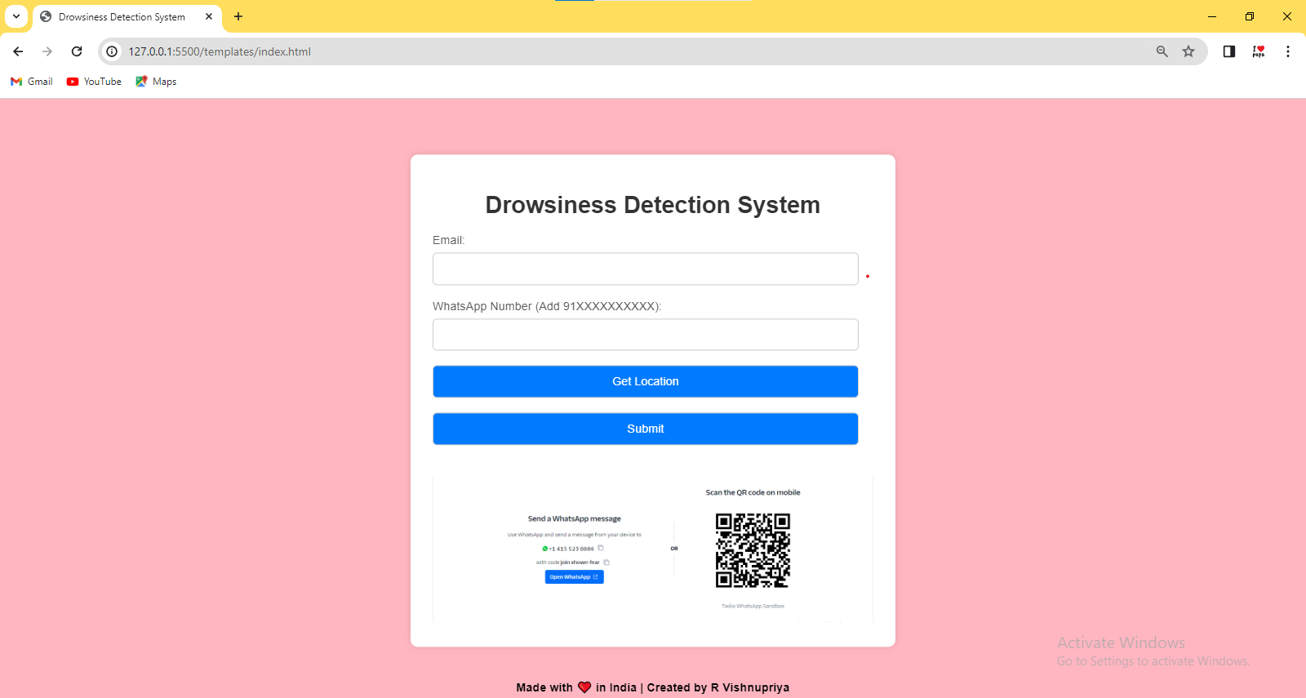
Fig-2 Flask Web Application

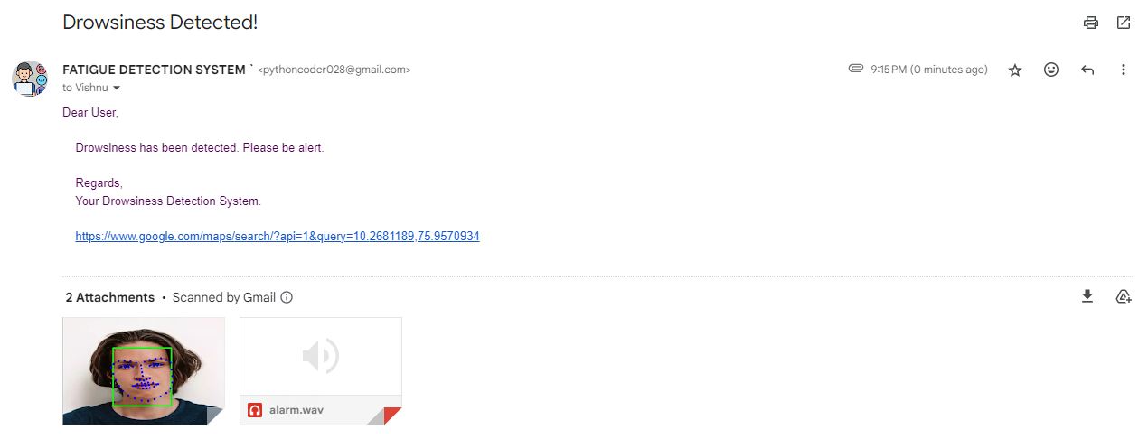
Fig-3 Mail with Location Alert

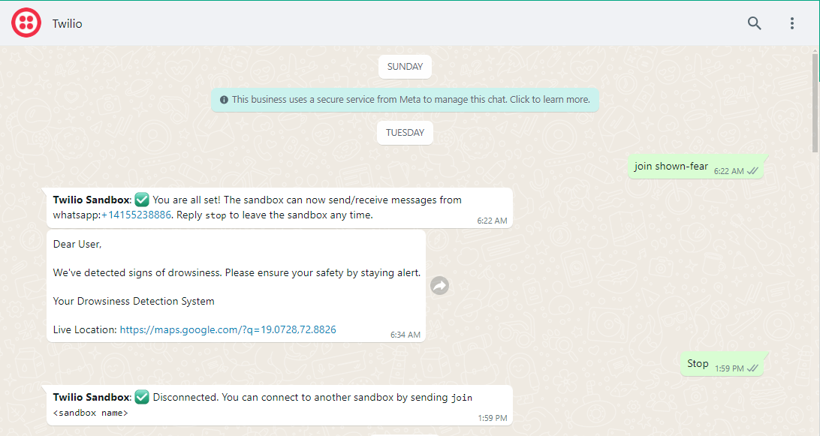
Fig-4 Whatsapp with Location Alert
3. CONCLUSION
The Fatigue detection system represents a significant step towards enhancing safety and alertness, particularly in contexts such as driving and operating heavy machinery, where drowsiness can pose serious risks. By leveraging state-of-the-art technologies and methodologies, the system provides a reliable mechanism for real-time monitoring and alerting. Future work for this project could focus on exploring advanced machine learning techniques, such as deep learning architectures, to improve the accuracy and efficiency of drowsiness detection. Additionally, refining the system's user interface and incorporating user feedback mechanisms could enhance user engagement and acceptance. Moreover, collaboration with experts in sleep science and human factors engineering could provide valuable insights for further optimizing the system's performance and effectiveness in real-world scenarios.

ACKNOWLEDGEMENT

- We wish to express our gratitude to Dr.N.KOTTISWARAN,M.E.,Ph.D., Principal, Info Institute of Engineering, Coimbatore, who always helped us whenever we approached him during the course of our project.

- We would also like to express gratitude to Dr.P.D.R.VIJAYAKUMAR,M.E.,Ph.D., Professor, Head of the Department, Department of Computer Science and Engineering, for his constant encouragement, valuable guidance and constructive criticism in making this project a successful one.

- We pay our respects and kindly thank our project guide Mr.A.AROCKIA SELVARAJ,M.E., Assistant Professor, Department of Information Technology, for his valuable guidance and timely suggestion in bringing out this project.

REFERENCES

[1] Smith, John. "Drowsiness Detection using Deep Learning." IEEE Transactions on Intelligent Transportation Systems, 2023.
[2] Patel, Ananya. "Real-time Fatigue Detection System: A Review." International Journal of Advanced Computer Science and Applications, 2022.
[3] Johnson, Michael. "Machine Learning Techniques for Drowsiness Detection: A Comparative Study." Expert Systems with Applications, 2022.
[4] Wang, Emily. "Facial Landmark Detection for Driver Drowsiness Monitoring." Proceedings of the IEEE International Conference on Image Processing, 2022.

