Simulation and Modeling of Distribution System Based on Short Circuit Analysis
Krishna L. Patil¹, Prof. Chinmay V. Deshpande², Dr. M.G. Unde³
1Student, M.E Electrical Engineering (Power System), Zeal College of Engineering, Pune, Maharashtra, India.
2Professor, M.E Electrical Engineering (Power System), Zeal College of Engineering, Pune, Maharashtra, India.
³Asst.Professor, M.E Electrical Engineering (Power System), Zeal College of Engineering, Pune, Maharashtra, India.

---------------------------------------------------------------------***---------------------------------------------------------------------
Abstract - In the View of sizing an electrical installation and the required equipment, as well as determining the means required for the protection of life and property, Problems that may occur at any point in the Power System.
There are two major problems that can occur in power system; these are open circuits fault and short circuits fault. Of the two, short circuit is the most dangerous because it can lead to very high fault currents and these currents can have very substantial effects such as electromechanical forces and thermal heating on equipment that may need replacement of equipment and may even cause fires and other similar ensuing effects in the power system
To prevent problems from short circuits, it is required to design electrical protection systems that will be able to detect abnormal fault currents that may occur and then take remedial action to isolate the faulty section of the system in as short a time as is consistent with the magnitude of the short circuit fault current level. This requires that the fault current be predicted for a fault in any particular location of the power system. This paper described the Simulation Model of Distribution System Based on the Short Circuit Analysis. This analysis is done by using ETAP Software (Electrical Transient Analyzer Program Software) and it is based on International Electrotechnical Commission (IEC) – 60909 Standards.
With the help of this Analysis, we will be able to do the Selection of Switchgear Equipment as Circuit Breaker, Fuses, Power Contactors, Over Load Relays and Appropriate Relay and do the Relay Setting if any as per project requirement

Key Words: Short-Circuit Analysis, ETAP, Short-Circuit Calculations, Equipment Protection

- INTRODUCTION

Short circuit calculation is one of the most important and unavoidable calculation in electrical design. All the electrical Equipments should be able to withstand fault current for specified time. Protecting Equipments should be able to clear any available fault current in the system safely. Also protecting Equipments shall clear the fault within the withstand time of the equipment to be protected.
Mostly, Short Circuit Calculation (SCC) is performed to find the maximum available fault current and minimum available fault current in the system. Maximum available fault current is used for selecting the short circuit withstand capacity of all electrical equipments. Maximum available fault current for Line to Ground (LG) fault is used for designing the Earthing system. Minimum available fault current is used for selecting the pickup setting of the instantaneous over current relay. Electronic Transient Analyzer Program (ETAP) software can be used for performing short circuit calculation. For large systems, short circuit calculation time can be reduced by using ETAP

- BASIC STATISTICS

Electrical installations almost always require protection against short-circuits wherever there is an electrical discontinuity. This most often corresponds to points where there is a change in conductor cross-section. The short-circuit current must be calculated at each level in the installation in view of determining the characteristics of the equipment required to withstand or break the fault current.
It is important to determine the various short-circuit currents and the resulting parameters for the different protection devices of a low-voltage installation
In order to correctly select and adjust the protection devices, the two values of the short-circuit current must be evaluated.
- The maximum short-circuits current, used to determine:
  - The breaking capacity of the circuit breakers
  - The making capacity of the circuit breakers
The electro-dynamic withstands capacity of the wiring system and switchgear. The maximum short-circuit current corresponds to a short-circuit in the immediate vicinity of the downstream terminals of the protection device. It must be calculated accurately and used with a safety margin.
- The minimum short-circuits current, essential when selecting the time-current curve for circuit breakers and fuses, in particular when:
  - Cables are long and/or the source impedance is relatively high (generators, UPSs)
  - Protection of life depends on circuit breaker or fuse operation, essentially the case for Transmission Networks and IT electrical systems

Types of short-circuits:

Various types of short-circuits can occur in electrical installations which are listed as below. [2]

- Symmetrical Faults
- Three-Phase Ungrounded Fault (LLL)
- Three-Phase Grounded Fault (LLL-G)

- Un-Symmetrical Faults
  - Phase to Phase Ungrounded Fault (LL)
  - Phase to Phase Grounded Fault (LL-G)
  - Phase to Ground Fault (L-G)

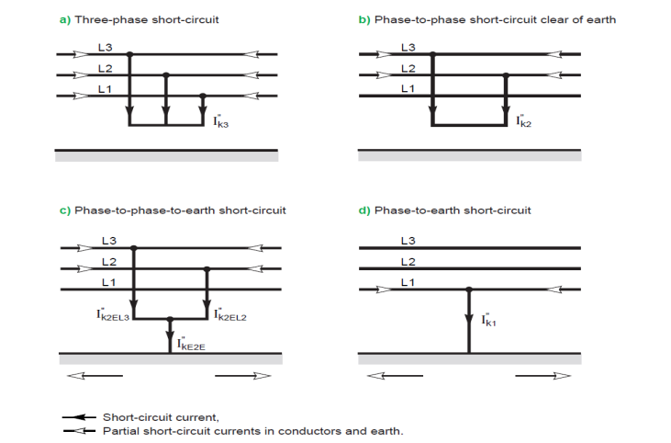

Fig-1: Different types of short-circuits and their currents. The direction of current is chosen arbitrarily as per IEC 60909.

Characteristics of Short-Circuits:

The primary characteristics are: [4]

- Duration (Self-Extinguishing, Transient and Steady-State)
- Origin
    - Mechanical (break in a conductor, accidental electrical contact between two conductors via a foreign conducting body such as a tool or an animal)
    - Internal or atmospheric over-voltages
    - Insulation breakdown due to heat, humidity or a corrosive environment
- Location: Inside or Outside a machine or an electrical switchboard
    - Phase-to-Earth (80% of faults)
    - Phase-to-Phase (15% of faults). This type of fault often degenerates into a three-phase fault
    - Three-phase (only 5% of initial faults)

Consequences of Short-Circuits:

The consequences are variable depending on the type and the duration of the fault, the point in the installation where the fault occurs and the short-circuit power. Consequences include: [4]
- At the fault location
  - Damage to insulation
  - Welding of conductors
  - Fire
  - Danger to life
- On the faulty circuit
  - Electro-dynamic forces resulting in - Deformation of the bus-bars - Disconnection of cables
  - Excessive temperature rise due to an increase in Losses
  - Damage to insulation
- On the other circuit of Networks
  - Voltage dips during the time required to clear the fault, ranging from a few milliseconds to a few hundred milliseconds
  - Shutdown of a part of the network
  - Dynamic instability or Loss of machine Synchronization
  - Disturbances in Control / Monitoring circuits

Short-Circuit Analysis using ETAP:

The ETAP Short-Circuit Analysis Program analyzes the effect of 3-phase, 1-phase, line-to-ground, line-to-line, and line-to-line-to-ground faults on electrical power systems. The program calculates the total short-circuit currents as well as the contributions of individual motors, generators, and utility ties in the system. Fault duties are in compliance with the latest editions of IEC Standards (IEC 60909). [3]
This part describes definitions and usage of different tools you will need to run short-circuit studies. In order to give you a better understanding of the standards applied to short-circuit studies and to interpret output results more easily, some theoretical background, and standard information are also included.
The IEC Short-Circuit Toolbar sections explain how you can launch a short-circuit calculation, open and view an output report, or select display options. The Short-Circuit Study Case Editor section explains how you can create a new Study Case, what parameters are required to specify a Study Case, and how to set them. The Display Options section explains what options are available for displaying some key system parameters and the output results on the one-line diagram, and how to set them.
The Required Data section describes what data are necessary to perform short-circuit calculations and where to enter them. If you perform short-circuit studies using IEC Standards, the IEC Calculation Methods section provides useful information on standard compliance, definitions on most commonly used IEC technical terms, general and detailed descriptions of calculation methods for all important results, including initial symmetrical short-circuit current, peak short-circuit current, symmetrical short-circuit breaking current, and steady-state short-circuit current. Finally, the Short-Circuit Study Output Report section illustrates and explains output reports and their format.

IEC CALCULATION METHODS:

ETAP provides two Short-Circuit Calculation Methods based on ANSI/IEEE and IEC Standards. You can select the calculation method from the Short-Circuit Study Case Editor. This section describes the IEC Standard Method of Calculation.

Standard Compliance
ETAP short-circuit calculation per IEC Standards fully complies with the latest IEC documentation as listed below:
Standard | Pub. Year | Title
IEC 60909-0 | 2016 | Short-Circuit Currents in three-phase a.c. systems - Part 0: Calculation of Currents
IEC 60909-1 | 2002 | Short-circuit currents in three-phase a.c. systems - Part 1: Factors for the calculation of short-circuit currents according to IEC-60909-0
IEC 60909-2 | 1992 | Electrical equipment - Data for short-circuit current calculations in accordance with IEC 60909 (1988)
IEC 60909-4 | 2000 | Short-circuit currents in three-phase a.c. systems Part 4: Examples for the calculation of short-circuit currents
IEC 60947-1 | 2004 | Low voltage switchgear and control gear, Part 1: General rules
IEC 60947-2 | 2003 | Low voltage switchgear and control gear, Part 2: Circuit breakers

These standards are for short-circuit calculation and equipment rating in AC systems with nominal voltages operating at 50 Hz or 60 Hz. They cover 3-phase, line-to-ground, line-to-line, and line-to-line-to-ground faults.

IEC 60909 and the associated standards classify short-circuit currents according to their magnitudes (maximum and minimum) and fault distances from the generator (far and near). Maximum short-circuit currents determine equipment ratings, while minimum currents dictate protective device settings. Near-to-generator and far-from-generator classifications determine whether or not to model the AC component decay in the calculation, respectively.

General Description of Calculation Methodology

In IEC short-circuit calculations; an equivalent voltage source at the fault location replaces all voltage sources. A voltage factor c is applied to adjust the value of the equivalent voltage source for minimum and maximum current calculations.
All machines are represented by their internal impedances. Transformer taps can be set at either the nominal position or at an operating position, and different schemes are available to correct transformer impedance and system voltages if off-nominal tap setting exists. System impedances are assumed to be balanced 3-phase, and the method of symmetrical components is used for unbalanced fault calculations.

Zero sequence capacitances of transmission lines, cables and shunt admittances can be considered for unbalanced fault calculations (LG and LLG) if the option in the study case is selected to include branch Y and static load. This means that the capacitances of static loads and branches are considered based on IEC 60909-0 2001. The basic model used to consider these shunt admittances is shown below:
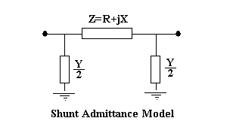
Fig: 2 Shunt Admittance Model
Calculations consider electrical distance from the fault location to synchronous generators. For a far-from-generator fault, calculations assume that the steady-state value of the short-circuit current is equal to the initial symmetrical short-circuit current and only the DC component decays to zero. However, for a near-to-generator fault, calculations count for decaying in both AC and DC components. The equivalent R/X ratios determine the rates of decay of both components, and different values are recommended for generators and motors near the fault.

Calculations also differ for meshed and unmeshed networks. The factor k, which is used to multiply the initial short-circuit current to get the peak short-circuit current ip, is defined differently for different system configurations and the methods selected to calculate the R/X ratios.

Calculation Methods

- Initial Symmetrical Short Circuit Current Calculation
Initial symmetrical short-circuit current (I”_{k}) is calculated using the following formula:
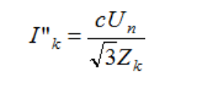
where Z_{k} is the equivalent impedance at the fault location.
- Peak Short Circuit Current Calculation
Peak short-circuit current (i_{p}) is calculated using the following formula:
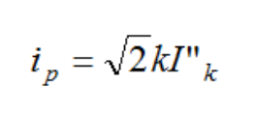
where k is a function of the system R/X ratio at the fault location
IEC Standards provide three methods for calculating the k factor:
- Method A - Uniform ratio R/X. The value of the k factor is determined from taking the smallest ratio of R/X of all the branches of the network. Only branches that contain a total of 80 percent of the current at the nominal voltage corresponding to the short-circuit location are included. Branches may be a series combination of several elements.
- Method B - R/X ratio at the short-circuit location. The value of the k factor is determined by multiplying the k factor by a safety factor of 1.15, which covers inaccuracies caused after obtaining the R/X ratio from a network reduction with complex impedances.
- Method C - Equivalent frequency. The value of the k factor is calculated using a frequency-altered R/X. R/X is calculated at a lower frequency and then multiplied by a frequency-dependent multiplying factor.

- Symmetrical Short Circuit Breaking Current Calculation
For a far-from-generator fault, the symmetrical short circuit breaking current (I_{b}) is equal to the initial symmetrical short circuit current.
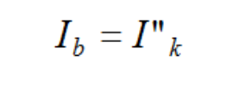
- DC Component of Short-Circuit Current Calculation
The DC component of the short-circuit current for the minimum delay time of a protective device is calculated based on initial symmetrical short-circuit current and system X/R ratio:
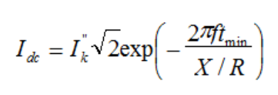
Where f is the system frequency, t_{min} is the minimum delay time of the protective device under concern, and X/R is the system value at the faulted bus.
ETAP plots the dc component of the fault current vs. time. The I_{dc} component is printed in the “Breaking and DC Fault Current (kA)” section of the short-circuit report for each fault location. The currents in this report are always based on the total bus fault current.
- Asymmetrical Short Circuit Breaking Current Calculation
The asymmetrical short-circuit breaking current for comparison with circuit breaker rating is calculated as the rms value of symmetrical and DC components of the short-circuit current.
ETAP plots the asymmetrical breaking current at every bus starting from 0.01 until 0.3 sec. This information can be used for selection of the circuit breaker breaking current depending on the t min value of the device. The I basym is printed in the “Breaking and DC Fault Current (kA)” section of the short-circuit report for each fault location. The currents in this report are always based on the total bus fault current.

- Steady-State Short circuit current Calculation
Steady-state short circuit current I_{k} is a combination of contributions from synchronous generators and power grid. I_{k} for each synchronous generator is calculated using the following formula:
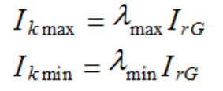
where λ is a function of a generator’s excitation voltage, ratio between its initial symmetrical short circuit current and rated current, other generator parameters, and I_{rG} is the generator’s rated current.
The steady-state short circuit current calculated is dependent on the option selected for short circuit current in the study case. If the Max and User-Defined c Factor is selected, the maximum steady-state current short circuit is reported. If the Min option is selected, the minimum steady-state short circuit current is reported.
This maximum steady-state short circuit current is used to determine minimum device ratings. The minimum steady-state short circuit value is used for relay coordination purposes in preventing the occurrence of nuisance trips and loading deviations.

Transient Short-Circuit Calculation

In additional to device duty calculations, ETAP also provides transient short-circuit calculation per IEC Standard 61363-1. The transient short-circuit calculation presents fault current waveforms as a function of time, considering a number of factors that affect short-circuit current variations at different time after the fault. These factors include synchronous machine sub-transient reactance, transient reactance, reactance, sub-transient time constant, transient time constant, and DC time constant. It also considers decay of short-circuit contributions from induction motors. This detailed modelling provides an accurate evaluation of the short-circuit current for sizing protective devices and coordinating relays for isolated systems such as ships and offshore platforms. The calculation can be conducted on both radial and looped system with one or multiple sources. [3]

Based on the equations given in IEC Standard 61363, the SC current includes 3 parts: sub-transient, transient, and steady state components. The sub-transient and transient components equal to a magnitude multiplied by an exponential term. The short-circuit current at any given time is the summation of the three components. In the Short-Circuit Summary Report, the magnitudes of the three components are printed under sub-transient, transient, and steady-state current columns.

The IEC 61363-1 performed by ETAP applies to both meshed and non-meshed systems since it is unrealistic to expect an electrical system to be completely non-meshed. The same approach is used to determine the contributions from meshed systems as is used for non-meshed systems since there is no other methodology provided in the guideline to handle the transient short-circuit currents for meshed systems.

As calculation results, ETAP provides short-circuit current as function of time up to 0.1 second at 0.001 second time increment. It also presents short-circuit current as function of cycles up to 1 cycle at 0.1 cycle increment. Along with the instantaneous current values, ETAP also furnish calculated AC component, DC component, as well as top envelope of the current waveform. In the summary page, it also provides the sub-transient, transient, and steady-state fault current for each bus.

In addition, ETAP provides options to increase the time of the transient waveform plots, plot all three phases, and also modify the angle at which the fault will initiate. Note that extending the time beyond the default and previous value of 100 ms falls outside of the scope of the IEC 61363 standard. The plots are assumed to be the natural decay of the time constants of the electrical system and machinery. Machine control units are not considered for this calculation. Please see the Standard page of the Study Case Editor for more details.

ETAP Software

Electrical Transient Analyser Program is an electrical network modelling and simulation software tool used by power systems engineers to create an "electrical digital twin" and analyse electrical power system dynamics, transients and protection.
ETAP is a powerful, user friendly and easy to use tool with trusted output data and calculations. [3]

- ETAP FEATURES

- ETAP Digital Twin Platform
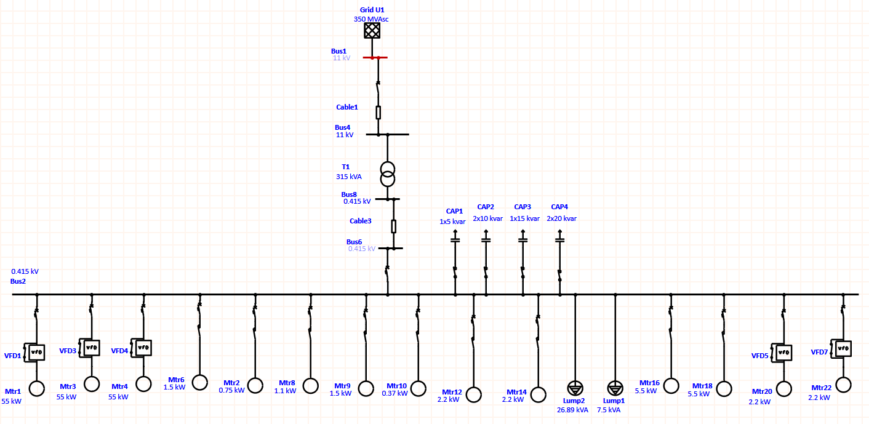
- Single foundation and database with seamless operation
- Real-Time predictive simulations for situational awareness and intelligence for operators and management
- Integrated applications for designers, planners, engineers, operators and maintenance personnel
- Intelligent Time Saving Capabilities
- Model and analyze projects with multi-dimensional database and Study Wizards
- Rule-based automation for one-line diagram creation and protective device evaluation
- Powerful study result-analyzers to compare multiple scenarios at a glance
- Scalable Solutions
- Verified and Validated Solutions

- SIMULATION MODEL

This One Line Diagram Indicating the Various Components of the Distribution System like Grid, HT Cable. Transformer, LT cable, Capacitor Banks and Various Outgoing feeders, out of which some of them are with VFD

Fig-2: One Line Diagram Indicating the Various Components of the Distribution System
Table -1: Parameters used for the model

 | Parameters | Nomenclature | Values
  Sr. No.
1 | Voltage | V | 415 Volts
2 | Power | P | As per SLD
3 | Frequency | F | 50 Hz

Table -2: List of Components used for the model

 | Components | Module Name |  | Specifications
  Sr. No.
1 | Bus-Bar | Main – Aluminium | 50 x 10 mm for Phase  50 x 05 mm for Neutral
2 | I/C Breaker - MCCB | LV432415X | 400A, 4P MP LSING BASED MCCB 36KA
3 | O/G MCCB for 55 KW Motor | LV510330 | 160A TP TM BASED MCCB 36 KA
4 | O/G MPCB for 1.1 KW Motor | GV2LE08 | 4.0A, MPCB, 50KA
5 | O/G MPCB for 1.5 KW Motor | GV2LE10 | 6.3A, MPCB, 50KA
6 | O/G MPCB for 2.2 KW Motor | GV2LE10 | 6.3A, MPCB, 50KA
7 | O/G MPCB for 0.75 KW Motor | GV2LE07 | 2.5A, MPCB, 50KA
8 | O/G MPCB for 0.37 KW Motor | GV2LE06 | 1.6A, MPCB, 50KA
9 | O/G MPCB for 5.5 KW Motor | 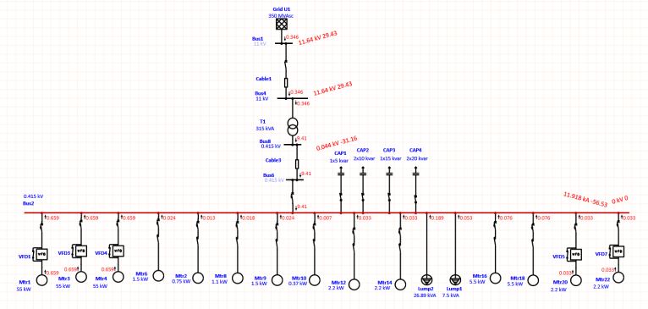  GV2LE20 | 18A, MPCB, 50KA

Bus-Bar – Alu. | 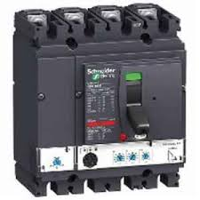MCCB
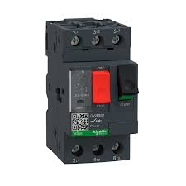MPCB | 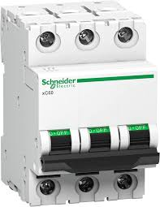MCB
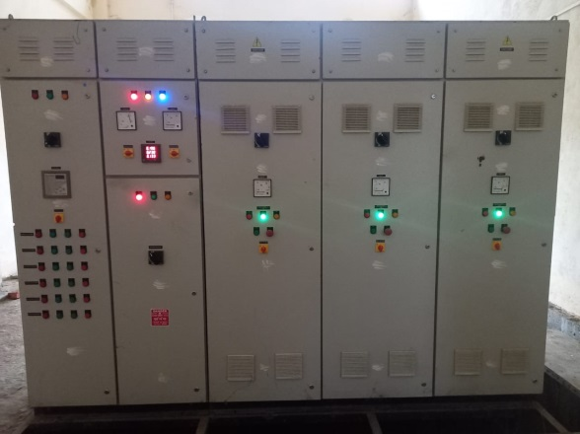 FRONT SIDE
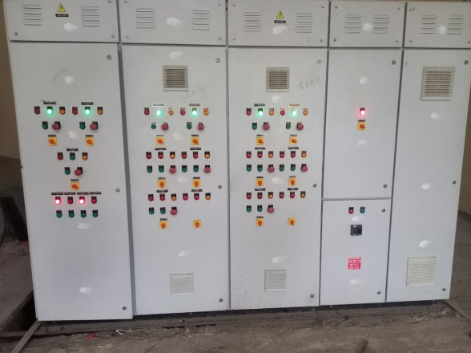 BACK SIDE

Fig-3: Overview of Model
- SIMULATION

For the Simulation of Model Based on the Short Circuit Analysis by using ETAP Software, we have perform the actual Short-Circuit Condition for Bus-1 & Bus-2 with different conditions in software and observed the results based on International Electrotechnical Commission (IEC) – 60909 Standards. Results for 3 phase fault at Bus-2 and Transient Short Circuit Fault Current at Bus 1 and Bus 2 Vs Time is indicated below for reference.

- RESULT AND ANALYSIS

Fig-4: This One Line Diagram Indicating the Contribution of fault Current when there is 3 Phase Fault at Bus2

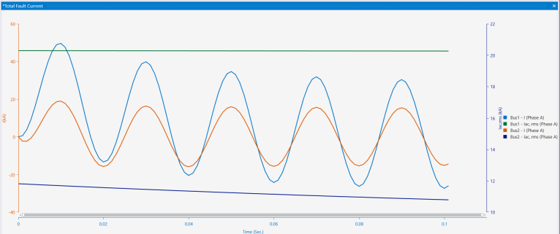

Fig-5: This Graph is Indicating Transient Short Circuit Fault Current at Bus 1 and Bus 2 Vs Time

- CONCLUSIONS

This Paper presents the Simulation and Modeling of the Distribution System based on Short Circuit Analysis and Calculation by using the ETAP Software which is most important and unavoidable calculation in electrical design for one the STP Project in Maharashtra.

With the help of this Analysis and Simulation, we have done the following Task,
  - To Calculate the Maximum Available Fault Current and Minimum Available Fault Current in the System.
  - Selection of Switchgear Equipment as Circuit Breaker, Fuses, Power Contactors, Over Load Relays along with Bus-bar sizes

REFERENCES

[1] Design of Electrical System Based On Short Circuit Study Using ETAP For IEC Projects

[2] IEC 60909-0: Short Circuit Current in Three Phase AC System

[3] ETAP – Software Training Manuals: ETAP Getting Started, Calculations of Short-Circuit Currents, Running Short-Circuit Analysis

[4] Cahier Technique Schneider Electric n° 158

