Smart Gas Leakage Detector System

Bharathi A Assistant Professor Of Information Technology
Nandha Engineering College Erode bharathi.a@nandhaengg.org
Sangeetha K M Information Technology
Nandha Engineering College Erode sangeethamoorthi888@gmail.c om
Thayanithi P J Information Technology
Nandha Engineering College Erode thayanithipanneerselvam@gma il.com
Nishok Balaji B Information Technology
Nandha Engineering College Erode nishokbalaji2003@gmail.com

Abstract— The Smart Gas Leakage Detector stands as a crucial innovation, dedicated to identifying and promptly notifying users of potential gas leaks within both residential and commercial settings. Its core functionality revolves around employing sophisticated sensor technology, capable of actively monitoring the concentration levels of various gases present in the immediate surroundings. Among the gases it effectively tracks are commonly used ones like natural gas (methane) and propane, providing comprehensive coverage for potential leakages. This proposed system for smart gas leakage detection significantly contributes to proactively identifying and monitoring leaked gases within an environment. Specifically designed for industries, the system integrates MQ gas sensors, leveraging their effectiveness in swiftly identifying the presence of hazardous gases. In the event of a gas leak, the system is programmed to trigger multiple alert mechanisms for user notification. The system employs a multi-layered approach to alerting users in case of a gas leak. This includes an OLED display to provide immediate visual cues, an alarm for audible alerts, and a BOT call to ensure instantaneous and direct communication. Furthermore, the system leverages email notifications, sending alerts to designated email addresses, ensuring that relevant parties are informed promptly and effectively. By harnessing these alerting mechanisms, the system aims to mitigate the potential risks associated with gas leaks. Its proactive detection capability plays a critical role in preventing major accidents that could result in severe consequences, including loss of life. Ultimately, the Smart Gas Leakage Detector offers a comprehensive and proactive solution to detect, alert, and potentially avert hazardous situations, thus safeguarding lives and mitigating the impact of gas leaks in both residential and industrial settings.

Keywords— sophisticated sensor technology, comprehensive coverage, identifying and monitoring leaked gases, trigger multiple alert mechanisms.
- INTRODUCTION
The introduction heralds the Smart Gas Leakage Detector as a pioneering breakthrough in the realm of gas safety and monitoring technology [1]. It marks a significant stride forward in proposing a solution aimed at promptly detecting gas leaks and notifying individuals to preempt potential hazards stemming from such occurrences. This innovative system centers on the concept of mitigating risks arising from gas
leakages by introducing a dedicated device. The primary objective revolves around designing a mechanism capable of swiftly identifying gas leaks and providing timely alerts to property owners or occupants [2]. The core emphasis lies in averting possible complications associated with these leaks. Crafted specifically for gas leak monitoring and alerting purposes, the system operates through an Arduino microcontroller [3]. It integrates crucial components such as a buzzer and an MQ gas sensor, positioning itself as a comprehensive solution for monitoring gas leakages. Through this amalgamation of technology, the system aims to proactively detect gas leaks and communicate alerts efficiently [4]. In summary, the Smart Gas Leakage Detector emerges as a vital innovation, setting its sights on enhancing safety measures by promptly detecting gas leaks and facilitating timely alerts through an Arduino-driven system, ultimately aiming to prevent potential risks and hazards caused by gas leakages.
IoT, short for the Internet of Things, embodies a network where interconnected devices communicate among themselves and with the cloud [5]. The technology fosters seamless communication between various devices, enabled by affordable computer chips and high-speed telecommunication. This technological evolution has led to an extensive network with billions of internet-connected devices [6]. Consequently, common place items like toothbrushes, vacuums, vehicles, and machinery are now equipped with sensors capable of gathering data and executing intelligent responses to user input [7]. This connectivity facilitates enhanced functionality and smarter operations for everyday objects, transforming them into responsive entities capable of collecting and processing data for improved user experiences and operational efficiency [8].
Gas is the most commonly used fuel in Nigerian homes and industry in which some required measures have to be strategized in other to protect against incidents and accidents such as suffocation and explosion associated with its usage [9]. LPG is a highly inflammable gas made up of a mixture of butane (C4H10) and propane (C3H8) through buthylene and prophylene and another hydrocarbon present in small quantity, due to the odorless of these chemical ethyl mercaptans is added as an odorant to give a powerful scent so that when leakage occurs it can be perceived, however in a situation of the minimum quantity of gas leakage, some people have a poor sensing ability to perceive and so, more reliable and effective device use in detecting gas (gas leakage detector) has to be installed in homes, industries, and vehicles of LPG usage to avoid explosion [10]. LPG leakage refers to several factors such as leakage in the pipe, hose not properly fixed, and hearing of whistling or hissing sound around the cylinder, valve not fitted properly [11].

2.1 ARDUINO
- COMPONENTS
2.4 WEMOS D1 R2 MICROCONTROLLER
The D1 R2 stands as a WiFi-enabled development board,

The Arduino UNO represents a versatile, cost-effective, and user-friendly programmable microcontroller board, widely adopted for diverse electronic applications. Its open-source nature and affordability make it an accessible platform for integrating into a broad spectrum of projects. This board boasts compatibility not only with other Arduino models but also with shields and Raspberry Pi boards, enhancing its versatility and integration capabilities within different ecosystems. With its robust capabilities, the Arduino UNO serves as a control hub for a multitude of devices, allowing interaction with various components such as relays, LEDs, servos, and motors. This facilitates the creation of intricate systems, enabling the board to function as a control interface, managing inputs and outputs efficiently. Its adaptability and ease of use make it an ideal choice for hobbyists, educators, and professionals alike, empowering them to explore, prototype, and innovate within the realm of electronics and programming. The Arduino UNO represents a versatile, cost-effective, and user-friendly programmable microcontroller board, widely adopted for diverse electronic applications. Its open-source nature and affordability make it an accessible platform for integrating into a broad spectrum of projects. This board boasts compatibility not only with other Arduino models but also with shields and Raspberry Pi boards, enhancing its versatility and integration capabilities within different ecosystems.
  - BREADBOARD
A breadboard is a prototyping tool used in electronics to create temporary circuits. Comprising a plastic board with holes for inserting components and metal clips to connect them, it requires no soldering. It enables rapid assembly and testing of circuit designs by allowing components to be easily inserted, rearranged, and removed. Popular among beginners and professionals alike, 3 breadboards facilitate experimentation, circuit validation, and rapid prototyping of electronic projects. They serve as a versatile platform for assembling and testing circuits without the need for permanent connections, offering a user-friendly environment for learning, designing, and iterating electronic designs.
  - MQ SENSORS
MQ gas sensors encompass a versatile range utilized for detecting numerous gases such as alcohol, smoke, methane, LPG, hydrogen, NH3, Benzene, Propane, and more. Comprising electrodes coated with a specific sensing material, these sensors operate by heating the material, thereby enhancing its reactivity and sensitivity. Each sensor within the MQ family is tailored to detect a specific gas type, leveraging the unique composition of its sensing material. Upon exposure to the target gas, the material's reactivity triggers changes in electrical conductivity, allowing the sensor to identify and quantify the gas concentration present in the environment.The electrode's specialized coating serves as the primary element enabling the sensor's selectivity and responsiveness to particular gases. By heating this coated electrode, MQ sensors amplify their sensitivity, facilitating the detection and monitoring of a diverse array of gases, contributing significantly to safety and environmental monitoring applications.
utilizing the ESP8266EX, designed in the familiar form factor of an Arduino UNO board. Offering compatibility with both the Arduino IDE and NodeMCU, it serves as a versatile platform for diverse programming environments. One of its prominent features includes an integrated switching power supply, granting the flexibility to power the board using a power supply of up to 12V. This onboard power supply mechanism enhances convenience by allowing various voltage sources to power the D1 R2, expanding its adaptability for different setups and applications. Overall, the D1 R2 represents a compact and capable development board, leveraging its WiFi capability and compatibility with popular programming environments to offer a flexible and accessible platform for IoT (Internet of Things) projects, connectivity-based applications.
- RELATED WORKS
In this section, discussion and analysis of the various research methodologies are done with the goal of finding the gas leakage detection system.
Schweighardt and Zatko (2007) considered a system for detecting gas leaking out of joint in a gas transport and/or storage system [12]. The system makes use of plurality of sensors located at positions e.g. stationary or fixed, as close as possible to potential leak site(s) to provide signals indicative of a leak to data acquisition unit which can then determine the dominant leak direction, where upon corrective action can be taken e.g. tightening the bolt(s) closest to a leak. Moreover, the system enables one to monitor or track changes in the leakage rate.
Komiyama et al.(2003) presented a gas leakage detection system detecting leakage of plurality of kinds of gases by analysing components of a sampled gas and means for determining that at least one kind of specific gases when is included in the sampled gas is equal to one or more than predetermined quantity as a result of analysis [13]. By analysing means, a gas leakage detection method of monitoring an operating state by eliminating a harmful substance included in a plurality of gases that leak and a semiconductor apparatus having a gas detection system that detects a leakage of plurality of kinds of gases.
Saidi et al. (2008) proposed a method of detecting concentration of predetermined gas, a gas sensor comprising a gas detector, a processor to determine a rate of change of the concentration over a time interval and a communication device to communicate to at least one of a second gas detector and a server [14].
Yoshida (2009) explores fuel battery system comprising of a fuel battery to which a gas is supplied to generate power, a pipe which communicates with fuel battery and a method of detecting a gas leakage in the fuel battery system. The major task was to improve performance [15].

In their paper Yokosawa et al. (2008) suggested leakage detection system configured by a number of gas sensors; leakage spot is promptly and accurately estimated [16]. An output voltage of each sensor is converted into concentration and a time differential output of concentration is obtained. A leakage spot is estimated to be on a straight line connecting between the sensors for which the time differential coefficient is large.
Farnsworth (2010) explored passive leak detection device including a pressure switch, a check valve and a balance valve [17]. When the balance valve is closed and fluid is flowing out of a fluid port, the pressure differential from the inlet chamber is operable to couple the electric output lead to the electric input lead thereby indicating a leak.
Grimberg (2010) proposed an imaging system and method for detecting a substance that has a detectable signature in a known spectral band [18]. The system comprises a thermal imaging sensor and optics and two interchangeable band-pass filters located between the optics and the detector. A first filter transmits electromagnetic radiation in a first spectral band that includes the known spectral band and blocks electromagnetic radiation for other spectral bands. A second filter transmits only electromagnetic radiation in a second spectral band in which the substance has no detectable signature. The system also includes a processor for processing the images to obtain reconstructed fused image involving using one or more forms of transforms aiming at obtaining similarity between one or more images acquired with the first filter and one or more images acquired with the second filter before reconstructing the fused image.
Chudnovsky (2000) suggested a method and apparatus for remote detection of gas leak and determination of the relative concentration of a gas using non dispersive infrared absorption of backscattered laser light with background compensation [19]. The method includes source of coherent infrared radiation, measuring output signals. The apparatus includes video camera to record a visual image of an object at a point where a maximum relative concentration was recorded and laser pointer to indicate a position of invisible infrared beam on target.
Nawa et al. (2004) presented a gas leakage detection system that includes a flow path, a dual mode valve disposed in the flow path, an ultrasonic measuring section including a pair of ultrasonic transducers, disposed in the flow path upstream from the dual mode valve, a flow rate calculation section for computing with flow rate based on the signal from the ultrasonic measuring section and a control section for controlling a dual mode valve [20]. The control section closes or opens the valve instantaneously, and the flow rate calculation computes a flow rate when the dual mode valve is
closed. Thus gas leakage can be detected substantially without stopping a gas flow when a user is using the gas.
- GAS LEAKAGE DETECTION SYSTEM
Gas leakage detection system incorporates a gas sensor for use to detect the presence of dangerous gas leak in your car or in service station, storage tank environment or at home. This unit can be easily incorporated into an alarm unit, to sound an alarm or give a visual indication on the gas concentration on the OLED screen. The sensor has excellent sensitivity combined with a quick response time. The sensor can also sense iso-butane, propane, Liquefied Natural Gas (LNG) and cigarette smoke. Furthermore, the microcontroller will send Email of the user indicating a gas leakage. The system will count some few seconds checking a gas leakage, if gas leakage persists it will shut down the power by the changeover switch interfaced through a magnetic relay. An analog to digital (A/D) converter read an analog voltage signal from the gas sensor and converts it into a digital equivalent number that can be read by a microcontroller. It has one input voltage and 8 bits as output. A/D converter is embedded in most microcontrollers only pin definitions have to set input as analog or digital. Smith (2006) explains microcontroller is essentially an inexpensive single chip computer. Single chip means the entire computer system lies within the confinement of sliver of silicon encapsulated inside the plastic housing of an integrated circuit. The microcontroller contains a Central Processing Unit (CPU), Random Access Memory (RAM), Read Only Memory (ROM), Input/Output (I/O) lines, serial and parallel ports, timers and sometimes other built-in peripherals such as Analog to Digital (A/D)converters and Digital to Analog (D/A) converters.
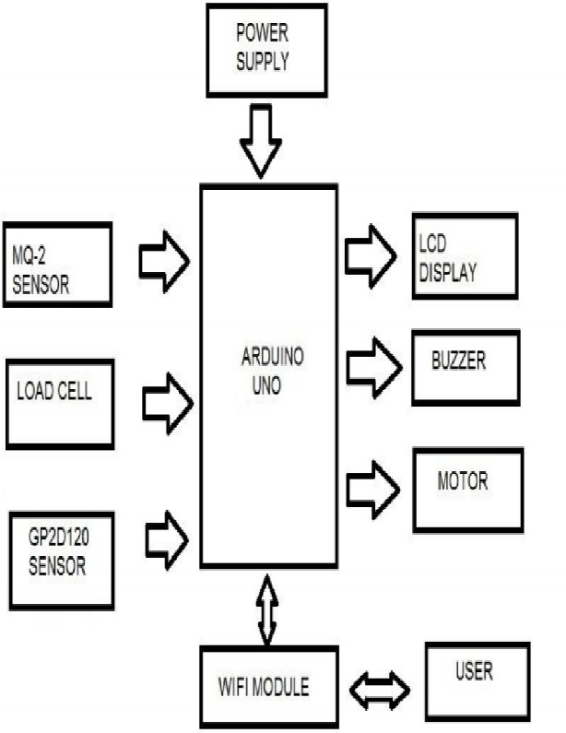

Fig.1 Normal Flow Diagram

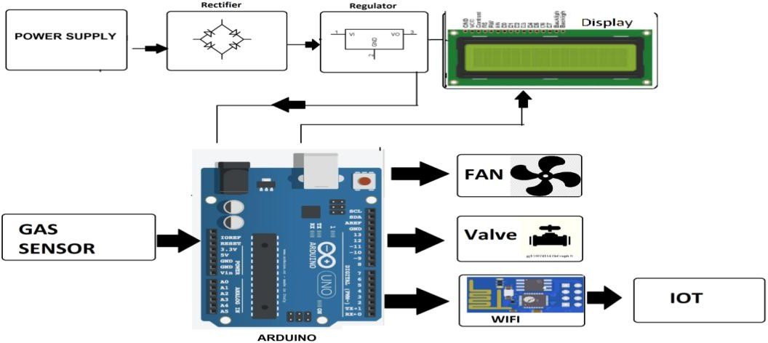

Fig.2 Block Diagram

Connection of GSM module and microcontroller
GLDS system is based on GSM network technology for transmission of Email from the microcontroller once the gas leak is detected, through the level changer MAX232 to a modem. In order to enable users to find out about on-the-spot gas leakage situation at home, we can utilize GSM module. Nokia 3310 GSM module 900/1800MHZ high integration frequency was chosen and interfaced with microcontroller’s Transmit (Tx) and Receive (Rx) ports. By microcontroller PIC16F877A serial communication interface standard asynchronous communication way, we change the interface into standard RS-232 through the interface chip MAX232, then connecting the module on RS-232 interface directly, and carry on the conveyance of data. It is programmed to send messages with Attention (AT) command language. The message to be sent can be “WARNING: DANGEROUS GAS LEAKAGE OCCUR”. Then the user upon

reception of the Email will take an appropriate action. Programmable Interface Controllers (PIC) was developed by Microchip Technology. It has many electronic circuits built into it, which can decode written instruction and convert them to electrical signal. The microcontroller will then step through these instructions and execute them one by one. The input components consist of push buttons and gas sensor. The control unit is the microcontroller PIC16F877A. The microcontroller monitors the inputs and as a result the program would turn output ON and OFF depending on the state of the sensor. The microcontroller stores the program in its memory, and executes the instructions under the control of clock circuit. The output devices are made up from Light Emitting Diodes (OLED), buzzers, magnetic relay, OLED, audible alarm and GSM interface for triggering Email in case gas leakage is detected.

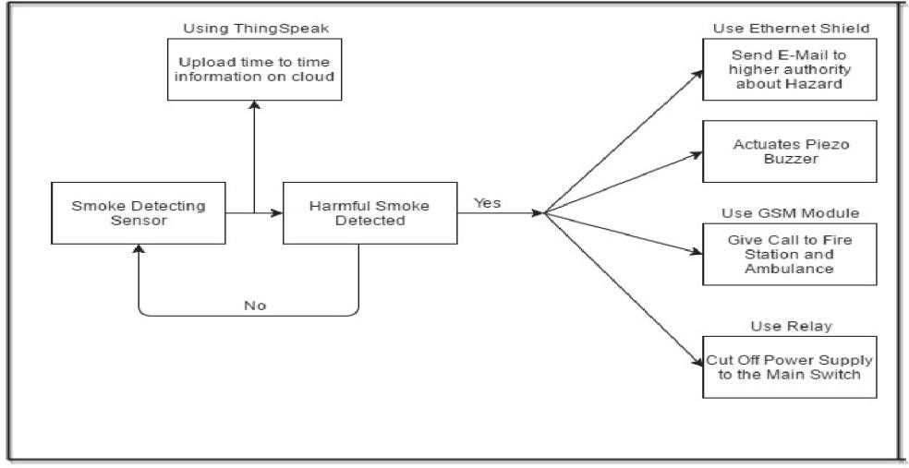
Fig.3 Work Flow Diagram

- RESULTS AND DISCUSSION
The Proteus Design Suite is a proprietary software tool suite used primarily for electronic design automation. The software is used mainly by electronic design engineers and technicians to create schematics and electronic prints for manufacturing printed circuit boards. This system is based on Arduino and MQ gas sensor. When the sensor detects gas in atmosphere, it will give a digital output of 1 and if gas is not detected the sensor will give a digital output of 0. Arduino will take the sensor output as the digital input. If sensor output is high, then the buzzer will start tuning and the OLED will show that “Gas detected: Yes”. If sensor output is low then the buzzer will not be tuning, OLED will show that “Gas detected: No”. The detector incorporates a MQ sensor (with gas detection range of 10–20,000 ppm) as the gas sensor, microcontroller as the control unit, OLED for displaying gas concentration, a buzzer as an alarm and a number of LEDs to indicate the gas leakage status. The microcontroller senses the presence of a gas when the voltages signal from the MQ sensor goes beyond a certain level and gives an audiovisual alarm.

If the system detects the level of gas in the air that exceeds the safety level it will activate the alarm which includes the buzzer to alert the users at home of the abnormal condition and to take any necessary action. The most tell-tale sign of a leak is the smell of gas in the home. The output result of this paper is that the leakage will be detected and stopped within 2 s after the leakage starts. This system can even detect the level of gas leakage. This is an efficient method for automatically detecting and controlling the gas leakage. Moreover, the fire accidents are also prevented by switching off the power supply. The idea for gas detection and control can be implemented at a large scale for various industries. This system can be installed in a kitchen, industries, at a hostel cafeteria, and any other areas.

Gas Sensor | Gases
MQ-2 | Methane, Butane
MQ-3 | Alcohol, Ethanol
MQ-6 | LPG
MQ-7 | Carbon Monoxide
MQ-135 | Air Quality (Ammonia, Benzene, Smoke)
Table.1 Gases according to the type of Sensors
Achieved analytical results:
    - The system displayed advertisement when no gas leakage was detected. No message was sent to the user, indicating home status is safe.
    - When gas leakage was detected, the system sounded the alarm, sent a warning Email, call to the user about gas leakage and displayed warning message to the OLED.
    - After some delay, when leakage persisted, the system shut down the electric power.

Gases | Chemical Formula | Sensor can detect the gas ranges from
Methane | CH₄ | 5000 – 20000 ppm
Butane | C4H10 | 300 – 5000 ppm
Alcohol | C₂H₆O | 25 – 500 ppm
Ethanol | C₂H₅OH | 25 – 500 ppm
LPG | C₃H₈ and C₄H₁₀ | 300 – 10000 ppm
Carbon Monoxide | CO | 20 – 2000 ppm
Ammonia | NH₃ | 10 – 300 ppm
Benzene | C₆H₆ | 10 – 1000 ppm
Smoke | CO₂ | 50 – 5000 ppm
Table.2 Concentration Level Of Sensing the gases

Applications
    - Chemical Industries.
    - Medical and Life-Science Industries.
    - Hospitals.
    - Houses.

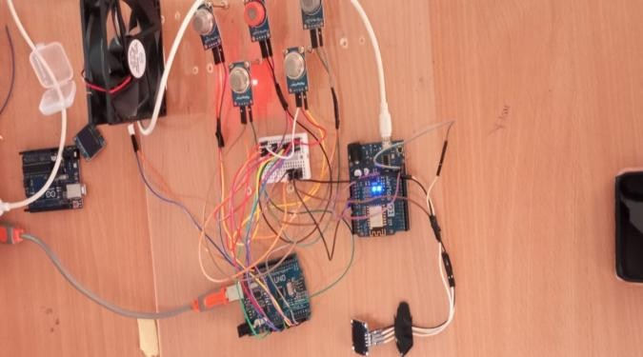
Fig.4 Prototype

- CONCLUSION
Our proposed smart gas leakage detection system utilizes MQ gas sensors to effectively detect and monitor gas leaks in the environment, particularly in industrial settings. In the event of a gas leakage, the system employs various alert mechanisms such as OLED display, alarm, BOT call, and EMAIL notifications to alert the user and corresponding email ID. By leveraging these detection methods, our system enables swift identification of gas leaks, providing immediate alerts to users through multiple channels. This proactive approach significantly reduces the risk of major accidents, potential fatalities, and associated losses. With timely notifications and alerts, individuals can take necessary precautions and actions, ultimately enhancing safety measures and mitigating the impact of gas-related incidents.
REFERENCE
- Bloem, Jaap, Menno Van Doorn, Sander Duivestein, David Excoffier, René Maas, and Erik Van Ommeren. "The fourth industrial revolution." Things Tighten 8, no. 1 (2014): 11-15.
- National Academies of Sciences, et al. "Emergency alert and warning systems: Current knowledge and future research directions." (2018).
- Shaharuddin, Sarah, et al. "The role of IoT sensor in smart building context for indoor fire hazard scenario: A systematic review of interdisciplinary articles." Internet of Things (2023): 100803.
- Sassi, Mohamed Saifeddine Hadj, and Lamia Chaari Fourati. "Comprehensive survey on air quality monitoring systems based on emerging computing and communication technologies." Computer Networks 209 (2022): 108904.
- Greengard, Samuel. The internet of things. MIT press, 2021.
- Vermesan, Ovidiu, and Peter Friess, eds. Internet of things: converging technologies for smart environments and integrated ecosystems. River publishers, 2013.
- Um, Jung-Sup, and Jung-Sup Um. "Introduction to the fourth industrial revolution." Drones as Cyber-Physical Systems: Concepts and Applications for the Fourth Industrial Revolution (2019): 1-20.
- Verhoef, Peter C., et al. "Consumer connectivity in a complex, technology-enabled, and mobile-oriented world with smart products." Journal of Interactive Marketing 40.1 (2017): 1-8.
- Ramya, V., and B. Palaniappan. "Embedded system for Hazardous Gas detection and Alerting." International Journal of Distributed and Parallel Systems (IJDPS) 3.3 (2012): 287-300.
- Mujawar, T. H., et al. "Development of wireless sensor network system for LPG gas leakage detection system." International Journal of Scientific & Engineering Research 6.4 (2015): 558-563.
- Asafe, Yekini N., et al. "Gas Leakage Detector and Monitoring System." International Journal of Engineering and Manufacturing 12.5 (2022): 56-65.
- Schweighardt, F. K. and Zatko D.A. (2007). Gas Sensor Array System and Method for Detecting Gas Leaks at a Connecting Joint. United States Patent Pub. No US 2007/0056354 A1.
- Komiyama, K., Watanabe, S. and Gotoda, K. (2003). Method and Apparatus for Leak detecting, and Apparatus for Semiconductor Manufacture. United States Patent Pub. No US 2003/0010918.
- Saidi, A., Chiricescu, Norris, J.M., and Schuette M. A. (2008). Method and System for Gas Leak Detection and Localization. United States Patent Pub. No US 2008/0168826 A1.
- Yoshida, N. (2009) Fuel Battery System, Method for Detecting Gas leakage in Such System and mobile Object. United States Patent Pub. No US 2009/0239105 A1.
- Yokosawa, K., Nakano, S. and Saitoh, K. (2008). Leakage Detection System. United States Patent Pub. No US 2008/0262757 A1.
- Farnsworth, J. M. (2010). Passive Leak Detection Devices and systems for Detecting Gas Leaks. United States Patent Pub. No US 2010/0089127 A1.
- Grimberg, E. (2010). System and Method for Gas Leakage Detection. United States Patent Pub. No US 2010/0284570 A1.
- Chudnovsky, B. H. (2000). Leak Detection System. United States Patent Pub. No. 6,157,033.
- Nawa, M., Iwanaga, S. and Nanba, M. (2004). Gas Leak Detection System. United States Patent Pub. No. 6,725,878 B1.

