“Stock Market Analysis and Prediction:Artificial Intelligence Leveraging Machine Learning and Financial Data Analytics”
Vikas Sharma¹ Karishma Tiwari¹ Shaheen¹ Dr Kirti Shukla²
¹ Master of Computer Application , School of Computer Science & Engineering
Galgotias University
²Associate Professor, Galgotias University.

Abstract
In this research project, dive into the exciting world of stock markets to understand how artificial intelligence (AI) and financial data can help us predict stock price movements, where the goal is to create smart models that can assist investors, traders, and financial experts in making informed decisions. Here, start by looking at a lot of historical data, like how stock prices have changed over time, how much trading happened, and even information from financial reports and news. After cleaning up the data to make sure it's accurate and complete. Next, use powerful computer programs that learn from this data to make predictions. These programs are like detectives, searching for patterns and clues in the data to tell what might happen next and make these programs even smarter by picking the most important pieces of information. We're not just looking at numbers either. We're also paying attention to the news and social media to see how people feel about the stock market. This helps us understand how emotions can affect stock prices. But we're not stopping there. If predictions are correct by looking at past data, and we use math to measure how good our predictions are. We also talk about the risks and things we need to be careful about when predicting stock prices. Ultimately, we want to improve people's ability to comprehend and make predictions about the stock market through our study. By using AI and financial data, we hope to help investors and experts make smarter choices in the ever-changing world of finance.

Keywords: Stock Market Trends, Machine Learning, AI, Financial Data, Predictions, Risk Management.

- Introduction
Stock exchanges are a type of finance market where shares can be bought and sold by individuals and groups in firms with public listings.The market for stocks in particular has always been a volatile and complicated area of the financial markets, affected by a complex interaction of political, economic, and social forces. Many businesses are available on the market with their stock lists, investors find their equities appealing because of these [1].These days, the stock market is one indicator of a nation's economic health. [2]. Stock prices are impacted by several variables, such as the financial condition of the business, economic conditions, news and events, investor sentiment, and more. Because of the exceptional revenues, as we all know, it has been in the news for a long time [3]. The stock market is seen to be one of the most lucrative financial channels as it is used to exchange large amounts of money every day. [4]. Many people make hefty stock market investments, yet Sometimes, they experience very significant losses because They are dependent on stockbrokers, who offer guidance to investors based on technological, time series, and basic Analysis and prediction are two fundamental processes in data science,statistics,and various fields of research and decision-making. One possibility is using machine learning (ML) and artificial intelligence (AI) to make stock market predictions [5]. Analysis refers to the process of examining and interpreting data or information to uncover patterns, trends, relationships, and insights. It involves breaking down complex data into more understandable components and drawing meaningful conclusions from it. Traditional ANN algorithms may also make inaccurate stock market predictions due to the problem's initial weight easily falling into the local optimal [6]. Data analysis often includes the following steps : Gathering, Clarifying, Investigating, and Transforming Data Statistical Analysis, Machine Learning and more. Prediction, on the other hand, is the process of using existing data or information to make informed estimates or forecasts about future events or outcomes. It involves using patterns and trends observed in historical data to make predictions about what might happen next. Key aspects of prediction include: Training Data, Model Building, Testing and Validation, Prediction, Accuracy Assessment.analysis involves understanding and deriving insights from existing data, while prediction involves using that understanding to make informed estimates about future outcomes. Both processes are crucial for informed decision-making and problem-solving in a wide range of fields. There are various algorithms and approaches used to forecast the price of stocks and trends via use of ML. Remember that because financial markets are complicated and sometimes unpredictable, precisely forecasting stock prices is a difficult endeavor. Identifying complex stock market patterns requires intricate techniques, with feature selection being pivotal for robust predictions, as features unveil crucial insights from intricate data [7]. This article discusses an approach that includes big data, machine learning, and Python. The stock market is more complicated than it originally appears. It is a complex dynamical system that is transformational and non-linear. Making a long-term investment is one of the crucial financial decisions. It is believed that machine learning could help investors make better selections. By utilizing the capabilities of machine learning, this research article looks into the area of stock market analysis. Artificial intelligence's subset of machine learning gives analysts and investors the tools they need to process, analyze, and model data at scale. We leverage ML approaches to provide a thorough grasp of how they may be used for stock market analysis, boosting risk assessment, portfolio management, and decision-making procedures Our research draws upon a comprehensive dataset encompassing historical stock prices, financial statements, market news, and macroeconomic variables, all retrieved and manipulated using Python and its library such as numpy, scipy for big data handling and other component is yfinance APIs. Throughout this paper, we will examine key aspects of machine learning in stock market analysis, including feature engineering, data preparation, model selection, and assessment metrics, all executed using Python.
- Literature Survey
Ever since the stock market was established, a large number of predictors have been actively attempting to forecast stock values using a variety Among algorithms for ML, on the stocks of various companies, including SVR, LR, SVM, Genetic Algorithms, Neural Networks, and a host of other topics [4] on stocks of different businesses. Later, researchers tried using nonlinear models for prediction and developed machine learning techniques like neural networks and support vector machines (SVM), and various other techniques which they successfully used to predict stock price time series [8,9,10,11,12]. A thorough review of the suggested methodologies, including calculation methods, ML algorithms, and significant features is also provided in [10,11,12] by the authors. Numerous articles exhibit variability according to various factors. Various authors employ a wide range of ML methods depending on various factors. A few writers contend that the Neural Networks produced greater results than previous strategies [4]. Like, in paper [13]. Four models: CNN, RNN, LSTM, and MLP.—were trained by Hiransha M. and GopalKrishnan E. A. It was found that CNN outperformed the other three networks.
1. ML Stock Price Forecasts using Python [14]
Research with a primary focus on stock market prediction prices employing an array of ML techniques and subsequently comparing and contrasting the results using LTSM. The study's major focus in the publications is on machine learning methods like moving averages and linear regression. The study focuses on teaching the computer to forecast the future using data points scattered across the past. The technology front was centered on machine learning libraries like SkLearn, Scipy, and Numpy. To visualize, analyze, and make predictions, Sci-kit was utilized. While Numpy was utilized to prepare the data for analysis.
2. SVM -Based Prediction of the Stock Market [15]
It mainly makes use of SVM to forecast the market for stocks. This method uses a type of learning where someone (a supervisor) helps guide the process. In these articles, the survey is done using R-Studio software. The information is collected using Quandl, a tool that has a way to get the stock prices of companies using a programming language called R. In these article sets, we don't actually make predictions. Instead, we show how effectively SVM & LR work match the information by employing examinations and training. As ways we checked how well the prototypes worked consist of using MSE, MAE, and RMSE.
3. Predicting the Stock Market Method using the AutoRegressive Integrated Moving Average Model [16]
It consider fundamentally employment autoRegressive Integrated Moving Average demonstrate to make inventory advertise expectations AutoRegressive Integrated Moving Average provide an elective strategy in light of progressing inventory showcase expectation precision the pieces included forecast among development in light of clever fifty list about the Indian inventory showcase the investigation includes month to month data with relation to the final inventory compilations of clever spanning the years 2014–2018 and including add up to based on 1222 notes and information deterioration what is the most calculateRegarding the examination later breaking down the data that was confirmed if the information remained still or not utilizing tThe Alternative Display Facility made dickey bigger more full experiment taking after the Alternative Display Facility an association and fractional correlation analysis A chart was drawn taken after by the discourse and carrying out AutoRegressive Integrated Moving Average demonstrate the analysis was completed by exhibiting How closely the AutoRegressive Integrated Moving Average Show's estimates matched the actual cost indicates how well the show uses its timely scheduling information.Predicting the movement of stock closing prices is a classic problem at the interface of computer science and finance. Actually, there are different ways to predict stock market prices using AI [17]. The stock market forecasting tools can be used to monitor, forecast, and control the market as well as to help with decision-making [18,19].
3. Research Methodology
Based on a historical record of ten years data collection, decision tree (DT), bagging, random forest (RF), adaptive boosting (Adaboost), gradient boosting, and extreme gradient boosting (XGBoost), as well as ANN, RNN, and LSTM, were used to accomplish this objective [20].Linear regression (LR), decision tree (DT), random forest (RF), and generalized LR are some of the models available [20].The various strategies connected for accomplishing share cost forecast are roughly divided into four groups:
- Conventional ML Techniques - This category comprises conventional techniques like logistic and linear analysis of regression.
- Neural Nets and Deep Learning: RNNs and LSTMs are frequently used in these approaches. They belong to a certain class of RNN.

- Time series analysis techniques - These techniques rely on projections and predictions of discrete-time data.
- Methods based on graphs - These approaches frequently compare the stock market to a system of linked nodes in which changes to one node would have an impact on the prices of other nodes.
Advantages and disadvantages of the many methods used to predict stock prices:-

Table:-1

S.No. | Class | Virtues | Deficiencies
1. | Conventional ML Techniques | Traditional ml calculations in specific svm delivery comes about with a comparatively more prominent exactness since they perform well with datasets with a tall degree of measurement. | These algorithms are quite sensitive to anomalies.
2. | Deep Learning and Neural Networks | The most common Profound Learning computations used for the task are RNNs and LSTMs. RNNs have an advantage in that they preserve the context of the data while preparing. Because they can connect the non-linear temporal arrangement information inside the delay state, LSTMs function rather effectively. | Requires a lot of training  time and memory capacity.
3. | Time series analysis techniques | Short-term stock price predictions using time-series forecasting methods like ARIMA are accurate for linear data. | When used to anticipate stock prices over the long term, the model might not produce reliable results.
4. | Graph-based approaches | Focuses on building linkages between the nodes based on correlation and causality, this is beneficial for revealing hitherto unforeseen insights and assisting with well-informed decision-making. | In terms of accuracy, traditional ML algorithms continue to beat graph-based methods.

We focused mostly on publications that employed a lot of data and produced good results for the primary criteria: great coverage, high accuracy.
4. Proposed Work

yfinance is a Python package that offers an easy-to-use interface for obtaining financial data from Yahoo Finance. It allows you to easily retrieve historical stock price data, real-time stock quotes, and other financial information for a wide range of publicly traded companies. yfinance is built on top of Yahoo Finance's public API.
Here are some common tasks you can perform using the yfinance library:
1. Retrieve Historical Stock Data: You can use yfinance to fetch historical stock price data for a specific stock or index over a specified date range.
2. Real-Time Stock Quotes: You can also get real-time stock quotes for a specific stock.
3. Accessing Financial Information: You can access various financial information about a company, such as market capitalization, dividend yield, and more.
4. Fetching Dividend and Split Data: yfinance also allows you to retrieve dividend and stock split data.
5. Getting Multiple Symbols: You can retrieve data for multiple stocks at once.
Keep in mind that Yahoo Finance's API may have usage limitations, and the availability of certain data may change over time. Ensure you check the documentation and terms of use for the most up-to-date information on how to use yfinance and access Yahoo Finance data. In this research paper predict the stock using machine learning and is shows a home page has some content in navbar and after that we choose visualization, prediction or about the web application it depends on the need in visualization interact with the graphical representation of stock market in an interesting way and using prediction see the predicted values of stock price of future.
Here understand the model with the pictures:-
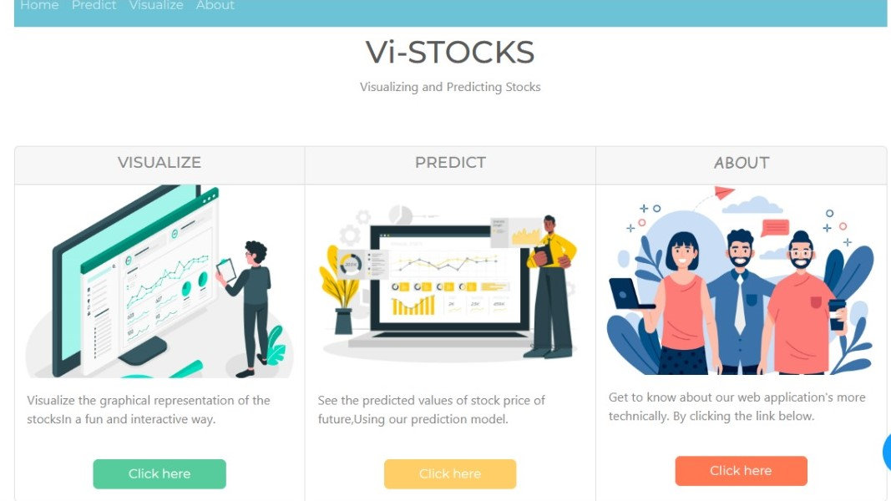

Above image is the Home page of stock market prediction using AIML.

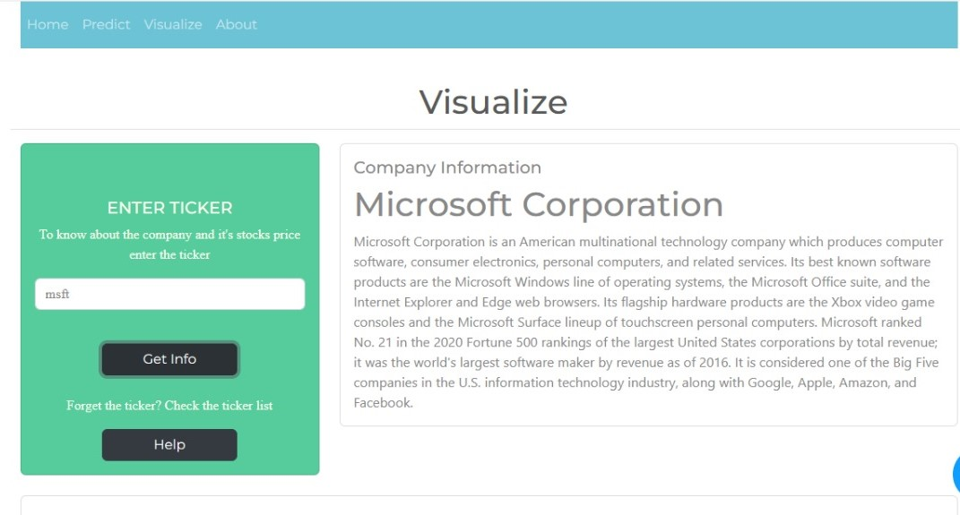
Above image shows the visualization part of the stock market prediction model for visualization select a ticker every organization has own ticker every ticker is unique, select that if you don't know ticker of any organization select the help to get the ticker of that organization, want to see the visualization part.
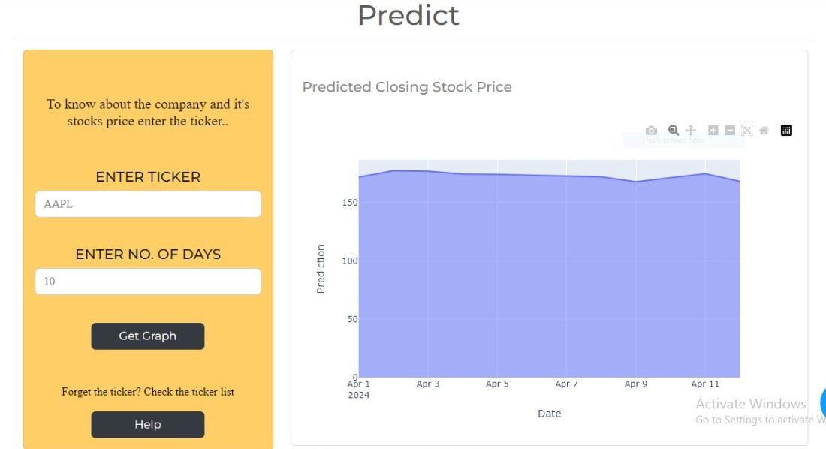
Now know about the company and its stock price enter the ticker and select the number of days it shows the date horizontally and predication vertically. It shows the prediction in chart format. In this we predict any company stock price.
To create a stock price prediction application using the yfinance API for fetching stock data, the Dash framework for building a web-based user interface, and Python for machine learning, you can follow these general steps:
1. Setup Environment: Make sure you have Python installed on your system. Install the required libraries: yfinance, dash, dash-bootstrap-components, pandas, scikit-learn, and any other libraries you may need for your machine learning models.
2. Data Collection: Use the yfinance library to fetch historical stock price data for the stock you want to predict. You can specify the date range and other parameters.
3. Data Preprocessing: Clean and preprocess the historical stock price data as needed. You may want to calculate additional features or signals that can be used as input features for your machine learning model.
4. Machine Learning Model: Build forecast for stock prices ML technique that employs libraries like scikit-learn. You can choose from various regression algorithms or time series forecasting models depending on your specific prediction task.
5. Web Application with Dash: Use Dash to create a web-based user interface for your stock price prediction application. You can design the layout and components of the application, including input fields for user interaction.
6. Integration: Construct an interface between your machine learning model and the Dash program. Define callback functions that take user input and make predictions using the trained model.
7. Deployment: Deploy your Dash application to a web server or cloud platform so that it can be accessed by users.
8. User Interaction: Users can interact with your web application by providing input (e.g.,
selecting a date), and the application will display the predicted stock price.
Dash is a Python web application structure that permits the development of interactive,dashboards and data visualizations on the web. It is built on top of Flask, Plotly, and other libraries and provides a high-level API for building web applications with Python. Dash allows developers to create interactive web applications with rich user interfaces using Python, without the need for extensive knowledge of web development languages like HTML, CSS, or JavaScript.
Key features of Dash include:
1. Component-Based Architecture: Dash applications are constructed using a component-based approach. Developers can define the layout and behavior of their application using Python functions and classes, making it easy to create interactive and dynamic interfaces.
2. Interactive Data Visualization: Dash integrates seamlessly with A well-liked Python package for making interactive data visualizations called Plotly. This allows developers to embed interactive charts, graphs, and plots directly into their Dash applications.
3. Cross-Platform Compatibility: Dash applications can be deployed on various platforms, including web servers, cloud services, and even as standalone desktop applications, making them highly versatile.
4. Custom Styling: While Dash simplifies web development, it also provides options for customizing the styling and appearance of applications using CSS.
5. Callback Functionality: Dash applications can include callback functions that respond to user interactions, enabling real-time updates and dynamic behavior based on user input.
6.Integration with Data Sources: Dash applications can be connected to various data sources, such as databases or external APIs, to provide real-time data updates and analysis.
5. Result & conclusion
1: Data Preparation :We'll need historical stock price data. We can obtain this data from various sources, such as Yahoo Finance or APIs like Alpha Vantage. For this example, let's assume we have a CSV file with historical stock prices.
2: Feature Selection :Select relevant features or predictors that can help in predicting stock prices. Common features include historical prices, trading volume, and technical indicators.
3: Split Data: Split the data models are evaluated by dividing them into sets for testing and training.
4: Model Selection and Training :Choose a ML prototype to forecast the inventory marketplace. Random forests, decision trees, and linear regression are typical options, or more complex models like neural networks.

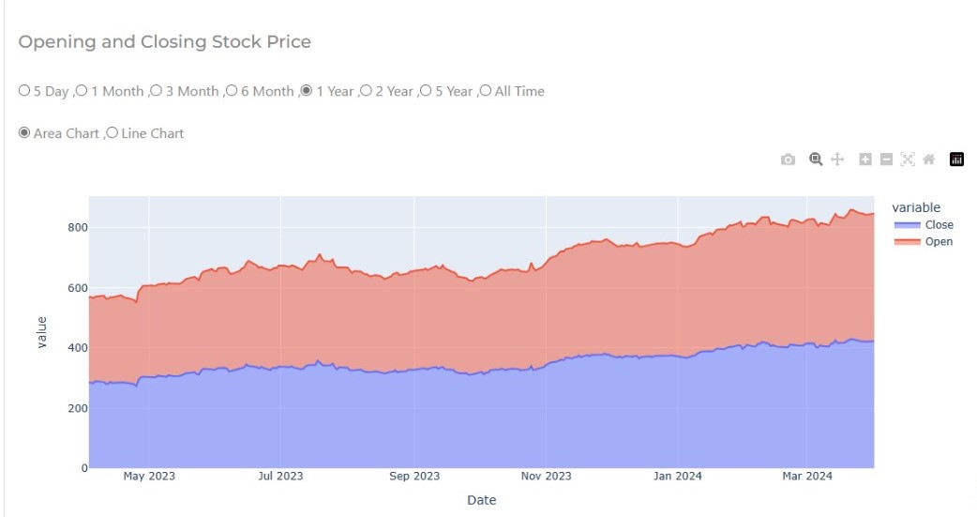
Here we see the result of an organization value vertically and date horizontally the result shows in the line chart.
These steps provide a basic framework for stock market prediction using Python and machine learning. However, keep in mind that predicting stock prices accurately is a challenging task due to the many factors that influence markets. Real-world applications often require more sophisticated models, feature engineering, and access to up-to-date data. Additionally, it's essential to consider the dangers and constraints of inventory marketplace forecasting when making investment decisions.
6. Reference
[1].Bhattacharjee. Indronil, and Pryonti Bhattac-
harja. "Stock Price Prediction: A Comparative Study between Traditional Statistical Approach and Machine Learning Approach." 2019 4th International Conference on Electrical Information and Communication Technology (EICT). IEEE, 2019.
[2]. S. Chakravarty, B. K. Paikaray, R. Mishra and S. Dash, "Hyperspectral Image Classification using Spectral Angle Mapper," 2021 IEEE International Women in Engineering (WIE) Conference on Electrical and Computer Engineering (WIECON-ECE), 2021, pp. 87-90, doi: 10.1109/WIECONECE54711.2021.9829585.
[3]. Hegazy, Osman, Omar S. Soliman, and Mustafa Abdul Salam. "A machine learning model for stock market prediction." arXiv preprint arXiv:1402.7351 (2014).
[4]. Yoo, Paul D., Maria H. Kim, and Tony Jan. "Machine learning techniques and use of event information for stock market prediction: A survey and evaluation." International conference on Computational Intelligence for Modelling, Control and Automation and International Conference on Intelligent Agents, Web Technologies and Internet Commerce (CIMCAIAWTIC'06). Vol. 2. IEEE, 2005.
[5]. Htun HH, Biehl M, Petkov N (2023) Survey of feature selection and extraction techniques for stock market prediction. Financ Innov 9(1):26
[6]. Sharma DK, Hota HS, Brown K, Handa R (2022) Integration of genetic algorithm with artificial neural network for stock market forecasting. Int J Syst Assur Eng Manag 13(Suppl 2):828–841.
[7]. Maqbool, J.; Aggarwal, P.; Kaur, R.; Mittal, A.; Ganaie, I.A. Stock Prediction by Integrating Sentiment Scores of Financial News and MLP-Regressor: A Machine Learning Approach. Procedia Comput. Sci. 2023, 218, 1067–1078. [Google Scholar] [CrossRef]
[8]. Jamous R, ALRahhal H, El-Darieby M (2021) A new ann-particle swarm optimization with center of gravity (ann-psocog) prediction model for the stock market under the effect of covid-19. Scientific Programming, 2021:1–17.
[9]. Thakkar A, Chaudhari K (2021) Fusion in stock market prediction: a decade survey on the necessity, recent developments, and potential future directions. Inf Fusion 65:95–107
[10]. Kumar D, Sarangi PK, Verma R (2022) A systematic review of stock market prediction using machine learning and statistical techniques. Mater Today: Proceed 49:3187–3191
[11]. Mintarya LN, Halim JN, Angie C, Achmad S, Kurniawan A (2023) Machine learning approaches in stock market prediction: a systematic literature review. Procedia Comput Sci 216:96–102
[12]. Krishnapriya CA, James A (2023) A survey on stock market prediction techniques. In: 2023 International Conference on Power, Instrumentation, Control and Computing (PICC) (pp 1-6). IEEE.
[13]. Hiransha, M., et al. "NSE stock market prediction using deep-learning models." Procedia computer science 132 (2018): 1351-1362.
[14]. Puneet Singh, Prem Kumar Yadav, Shashank Chaurasia ,Shubham Bhardwaj, “Stock Price Predictions With ML Using Python”, IJSREM ,2020.
[15]. Vaishnavi Gururaj , Shriya V R and Dr. Ashwini “Stock Market Prediction using Support Vector Machines”, IJEAR ,2019.
[16].“Support-Vector Networks” Corinna Cortes, Vladimir Vapnik.
[17]. Soni P, Tewari Y, Krishnan D (2022) Machine Learning approaches in stock price prediction: a
systematic review. In: Journal of Physics: Conference Series (Vol 2161, No. 1, p. 012065). IOP Publishing.
[18]. Qiu Y, Song Z, Chen Z (2022) Short-term stock trends prediction based on sentiment analysis and machine learning. Soft Comput 26(5):2209–2224.
[19]. Sahu AK, Gupta PK, Dohare AK, Singh AK, Mishra A, Rao A, Jha S (2023). Stock market prediction using machine learning. In: 2023 International Conference on Computational Intelligence, Communication Technology and Networking (CICT) (pp. 512-515).
[20]. Warda M. Shaban, Eman Ashraf & Ahmed Elsaid Slama, (2023) SMP-DL:a novel stock market prediction approach based on deep learning for effective trend forecasting.

