ASSESSMENT AND SUSTAINABLE PURIFICATION OF MICROPLASTICS FROM EFFLUENTS RECEIVED IN WASTE WATER TREATMENT PLANT
(Er. Vikramjit Singh)
Abstract- Microplastics are plastic particles smaller than 5.0 mm in size (Arthur et al. 2009). The lower bound (size) of the microplastics is not defined. There are two main ways microplastics are formed and enter a body of water: primary and secondary microplastics (Arthur et al. 2009). Plastic debris provides a sink and a source for chemical contaminants. On the other hand, hydrophobic contaminants present in the water may sorb to the plastic particles (Carpenter et al. 1972, Teuten et al. 2007, Andrady 2011). Thus, microplastics may provide a mechanism to transport concentrated contaminants to organisms (Browne et al. 2007). Wastewater treatment plants serve to collect and treat wastes that are known to include microplastic and other small anthropogenic litters. Here,we determined the microplastic loads and removal efficiencies of two wastewater treatment plants (WWTPs) with different treatment sizes, operations and service composition discharging to lassara drain over the course of a year. Overall, we found that MP concentrations (by weight per 5L) varied in influent and effluent at each WWTP. The largest wastewater treatment plant 52 MLD Capacity in the study has MP removal efficiency of average 95.29 %. The other one has smaller facilities 4.5 MLD capacity had average removal efficiency of 93.44 %.
Keywords – Microplastics, Sewerage treatment plant (STP) FTIR, SEM analysis, Removal Efficiency etc.
Introduction- The general term ‘microplastics’ is used to describe particles and fibres of a diverse range of polymers less than 5000 μm in size (with the minimum particle size subject to methodological limitations (Horton et al., 2017)). These can be intentionally manufactured within this size range (primary microplastics) or formed by the fragmentation or break-up of larger plastics or plastic-containing items, known as secondary microplastics (Hartmann et al., 2019). Microplastics have been identified as a contaminant of emerging concern (Lambert and Wagner, 2018) and their presence in the environment raises questions about the risk they pose to human and environmental health. Wastewater treatment works (WwTWs) have been identified as an important pathway for microplastic pollutants to enter the terrestrial environment (Sun et al.,2019; Karapanagioti and Kalavrouziotis, 2019). Microplastics are released to the environment either through the discharge of final effluent, from the release of untreated sewage via combined sewer overflows (Woodward et al., 2021), or through the recycling of sewage sludge (a by-product generated from the treatment of wastewater) to agricultural land. Due to the importance of STP's as a pathway for the release of microplastics to the terrestrial environment it is important to have a thorough understanding of the fate and behaviour of microplastics in wastewater and sludge, and to identify the potential environmental exposure and associated risks. Field observations have found higher counts of microplastics in water and sediment near or downstream of wastewater treatment plants (e.g. Browne et al., 2011; Estahbanati and Fahrenfeld, 2016). Recently, several studies have reported microplastic in treated effluent from WWTPs around the world, with some studies also calculating removal efficiency of microplastics through treatment processes. Recent reviews of the existing literature on microplastics in wastewater treatment plants are available (Ziajahromi et al., 2016; Prata, 2018). Within a single study of 12 WWTPs by Mason et al. (2016), microplastic concentrations in treated effluent were observed to vary among facilities by a factor of 50. While variation would be expected due to differences in the service areas and operations of wastewater treatment plants, comparing across studies is additionally complicated by variation in sample collection and processing methodologies. In this paper we have considered two nos Sewage treatment plant situated at Bathinda Punjab. Samples were collected at the inflow and outflow of a STP 52 MLD capacity located at Mansa Road, Bathinda and 4.5 MLD capacity situated at Goniana road bathinda have been considered. This study is preliminary; this study allowed us to preliminary investigate the performances of a full-scale STP, which is a technological solution commonly applied to the on-site treatment of wastewater. The objective of the present study is to characterize the loading of microplastic to and from two wastewater treatment plants directly and locally discharging to the lassara drain and to determine whether there is a difference in the treatment effectiveness between WWTPs or variability over time.
REVIEW OF LITERATURE
Microplastics emitted from wastewater treatment plants may present unique toxicological risks posed by their immediate bio-accessibility and their potential to have relatively high concentrations of sorbed pharmaceuticals and other chemicals found in wastewater compared to natural organic matter or dietary items found in the environment, depending on factors such as sorption capacity and desorption kinetics (Beckingham and Ghosh, 2017; Li et al., 2018; Seidensticker et al., 2017). A study published by yang et al., 2019 presented the results of a study by researchers in Beijing, China in which microplastics were removed from municipal sewage treatment plants. Anoxic, aerobic and anaerobic A2O treatments were used during the initial treatment process of the influents. This included an aerated grit chamber, primary and secondary sedimentation tanks, and an aerated grit chamber. Denitriication, ultrafiltration, ozonation and ultrasound are techniques used to remove microplastics from wastewater and complete the treatment process Polyethylene terephthalate and polyester rank first in abundance in the effluent, with 42.26% and 19.1%, respectively, according to FTIR analysis. During the study of Li et al. (2018), Membrane-based technology for the removal dynamic membranes were used to effectively remove microplastics from synthetic wastewaters, The study applied dynamic membranes for the effective removal of microplastics. Sinem hazal et. Al has studied the Turkish textile mill in which they draw Ten samples of inflows and outflows of the WWTP of a textile company (applying a physic-chemical process) have been analyzed.
RESEARCH GAP
While the methods and techniques are proven effective for the characterization of MPs in environmental samples, further work is still needed to establish reliable, more accessible, and easy-to-use methods for the MP analyses in WWTPs. Firstly, the removal of organic and inorganic matters in the wastewater and sludge samples still needs improvement. Even the combinations of biological hydrolysis, enzymatic treatment and two rounds of WPO could not successfully remove the inorganic and organic matters in some wastewater and sludge samples to a satisfactory extent. The identification of certain types of MPs using micro-FTIR and Raman spectroscopy can be hindered by fluorescence and plastic additives and fillers. Thirdly, the procedure of the isolation, characterization, and quantification of MPs in wastewater and sludge samples is still laborious and time consuming, and highly dependent of the skill and experience of the operators. Thus, there is a pressing need to standardize the procedure for sampling, chemical treatment, identification, and quantification of MPs in wastewater and sludge samples. The standards and regulations for the levels of MPs in the final wastewater effluents and biosolids discharged from WWTPs still need to be adequately standardized to effectively regulate and eliminate the environmental impact of MPs from WWTP discharges.
Study area – 52 MLD capacity waste water treatment plant located at mansa road bathinda (punjab) catering discharge of whole Bathinda town, discharge from industrial growth center, ITI Focal point etc. Total Influx of waste water is 46 MLD.
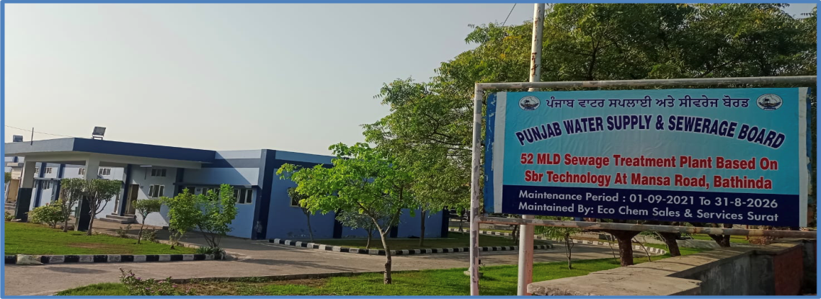
and 4.5 MLD capacity WWTP located at NH-54 bathinda catering discharge of outer wards of bathinda city. daily influx of water is about 3.2 MLD.It is catering discharge from Area situated across sirhind canal and from Malout Road. 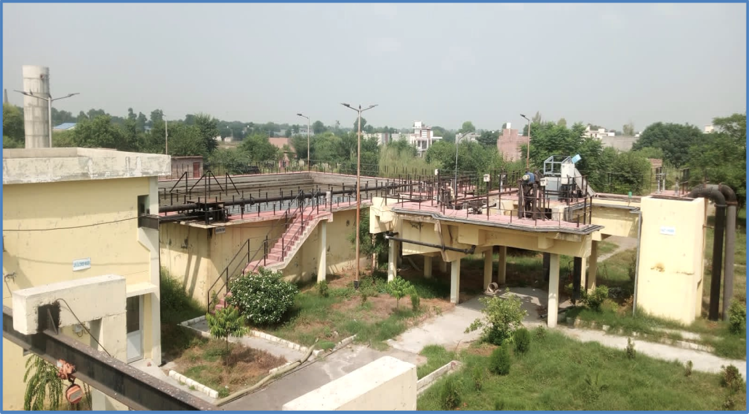
STP operates on SBR Technology and the smaller one is operates at activated sludge technology, The characteristics of the service areas for the two WWTPs as well as treatment steps are compared
Apparatus and Materials
Squirt bottle containing distilled water, 500-mL glass beaker, Analytical balance (precise to 0.1 mg), Metal spatula Drying oven (90ºC), Iron (Fe(II)) solution (0.05 M), 30% Hydrogen peroxide, Stir bar, Laboratory hot plate Watchglass, Sodium chloride (commercial table salt is sufficient), Standard Metal Forceps, Density separator, which is assembled using a glass funnel (122-mm in diameter) is fitted with a 50-mm segment of latex tubing on the bottom of the stem and a pinch clamp is attached to control liquid flow from the funnel, Retort stand, O-ring, Spring clamp (2-inch), Aluminum foil, Customized small sieves, each measuring 59 mm (diameter), 4-mL glass vials
Methodology
Methodology for analyzing wastewater treatment plant samples for microplastics was adapted from previously published methods (Nor and Obbard, 2014; Masura et al., 2015). Steps to isolate and enumerate microplastics from the wastewater matrices involved.
Sampling was conducted in November 2023 and march of 2024. The strategy to sample over the course of a year was chosen to observe potential seasonal trends. Samples at the influent and effluent ends of each WWTP’s facility were collected as 5 Litres, Samples at the influent and effluent ends of were collected as 24-h flow-weighted composite samples
Sampling – Step I Samples taken from influent and effluent of both STP’s in November 2023 and during March 2024. 5 litre raw water sample from inlet and 5 litre Effulent sample from outlet were obtained from 52 MLD capacity and 4.5 MLD capacity STP Bathinda. The procedure adopted for sampling was strictly as per standards Before starting the sampling, all equipment were cleaned with distilled water and sterilized with ethanol. The bottles were manually filled with wastewater, and after being capped, they were covered with paraffin and stored in the refrigerator until the analysis to prevent bacterial growth.
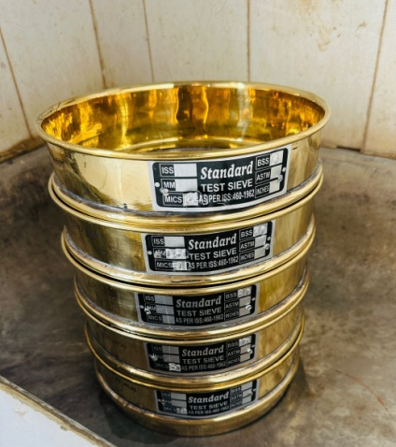
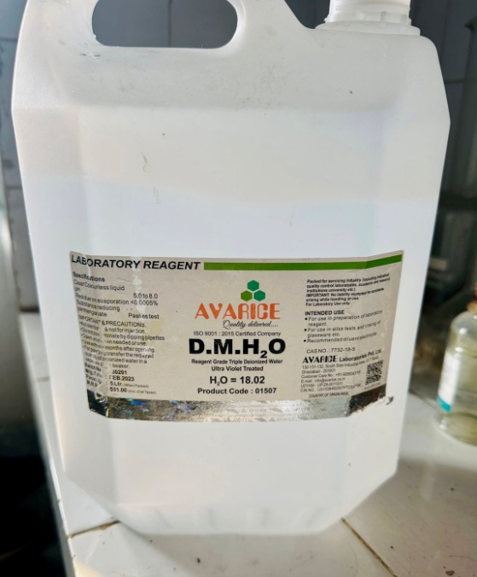
Step II Wet Sieving Inlet and outlet samples poured through a stacked arrangement of 1 mm, 500 µm, 250 µm, 150 µm and 75 µm) stainless steel mesh sieves. Samples were rinsed with squirt bottle filled with distilled water to transfer all residual solids to the sieves. This process also removed the salts from the field sample. Process was repeated again and again. Sieves were rinsed thoroughly using distilled water. It was ensured that all material has been well washed, drained, and sorted.

Step III Transfer Sieved Solids
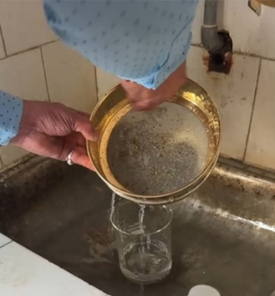
Tared weight of a clean and dry 500-mL beaker to the nearest 0.1 mg. (a) was taken.
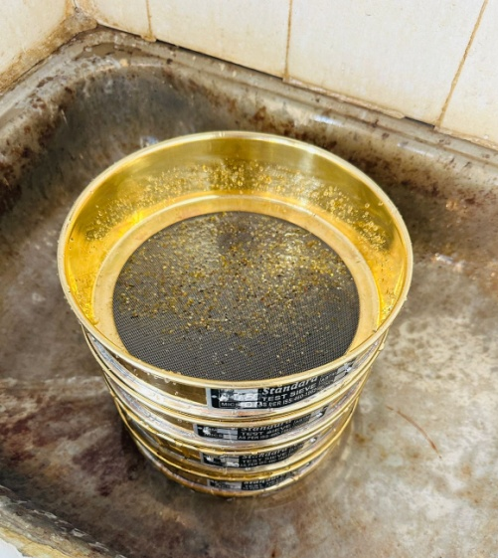
Then solids collected in the 0.25-mm, 0.150mm and 75 micron sieves were collected into the tared beaker using a spatula and minimal rinsing with a squirt bottle containing distilled water.
It was ensured that all solids were transferred into the beaker.
Then beaker was dried in oven at 90ºC for 24 hours or longer to sample dryness (Figure 6).

Step IV Determine the Mass of Total Solids
Determined the mass of the beaker with dried solids using an analytical balance to the nearest 0.1 mg. (b)
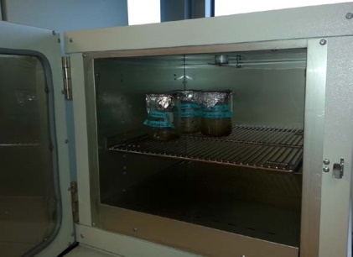
Subtracted the mass of the Tared beaker (a) to provide the mass of total solids (c) collected on the sieve. (Formula: b – a = c).This is the mass of all microplastics and natural materials.

Figure 6. Sieved samples are dried in an oven to determine dry weight.

Step V Wet Peroxide Oxidation (WPO)
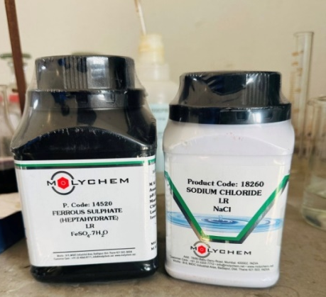
CAUTION: This mixture is highly reactive. Please review and follow your laboratory safety practices and policies for handling this mixture before completing this analysis.Figure 7. Addition of ironsulfate solution catalyzes thereaction. Figure 8. Addition of hydrogen peroxide oxidizes natural organic material.
20 mL of aqueous 0.05 M Fe(II) solution added to the beaker containing the 0.25 mm size fraction of collected solids. 20 mL of 30% hydrogen peroxide added. Mixture was allowed to stand on lab bench at room temperature for five minutes prior to proceeding to the next step. Then a stir bar was added to the beaker and coveedr with a watchglass.
It was heated to 75ºC on a hotplate. As the gas bubbles were observed at the surface, beaker was removed from the hotplate and it was placed in the fume hood until boiling subsides. For precautionary measures distilled water was added to slow the reaction as reaction appears to overflow the beaker.
Then again solution was heated to 75ºC for an additional 30 minutes. Now there was no natural organic material was visible, but if it appears then by adding another 20 mL of 30% hydrogen peroxide is sufficient to completely remove it . Whole process should be repeated until no natural organic material is visible.
After this 6 g of salt (NaCl) per 20 mL of sample to increase the density of the aqueous solution was added (~5 M NaCl). And mixture was again heated to 75ºC until the salt dissolved.

Step VI Density Separation
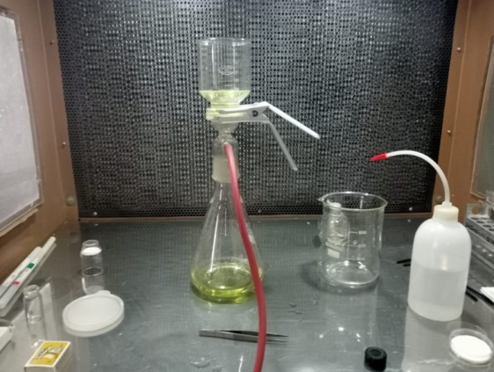
Whole wet peroxide ( WPO) solution from step was sent to the density separator. WPO beaker was rinsed with distilled water to transfer all remaining solids to the density separator.
It was covered loosely with aluminium foil so that it can allow -solids to settle overnight. Settled solids were visually inspected for any microplastics. If any are present, drain the settled solids from the separator and remove microplastics using forceps. Drain settled solids from the separator and discard. floating solids were collected in a clean custom sieve (Figure 9). Then the sample was preserved in 4 mL capacity glass vial.

FFFfigure 9. A sample is depicted in a glass funnel to separate plastic.

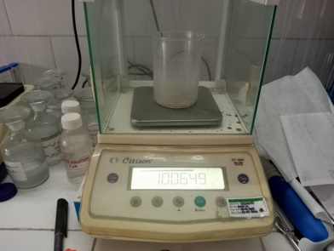
Step VII Gravimetric Analysis
Weigh the mass of the vial and microplastics to the nearest 0.1 mg. (e)
Subtract the mass of the tared vial (d) to provide the mass of microplastics (f) collected on the sieve. (Formula: e-d=f)* See Appendix 5.1.1 for formulae. This is the mass of all microplastics.

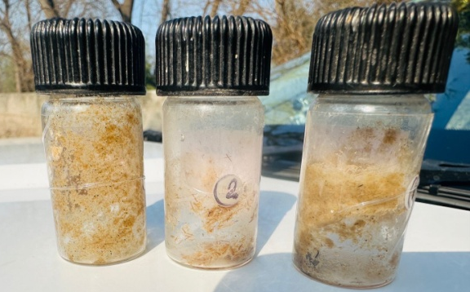
Figure 4 Microplastics in influent and effluent sample
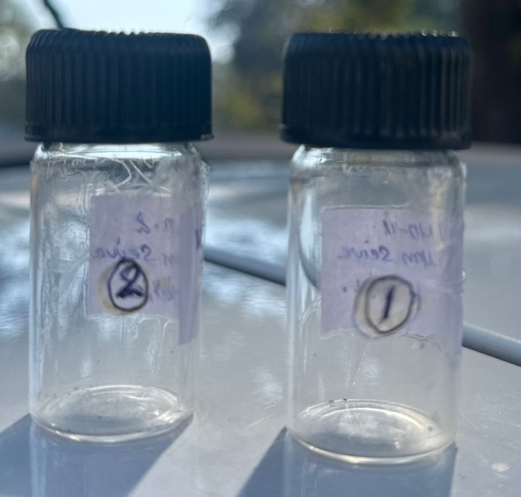

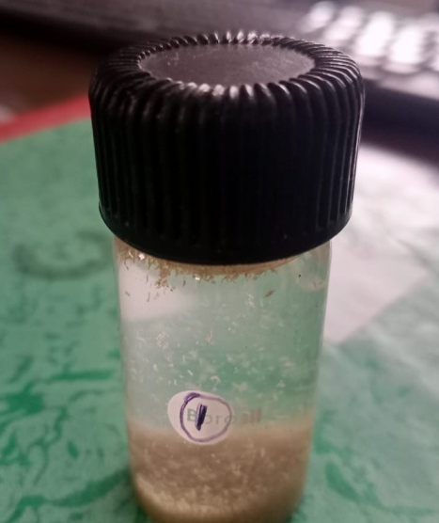
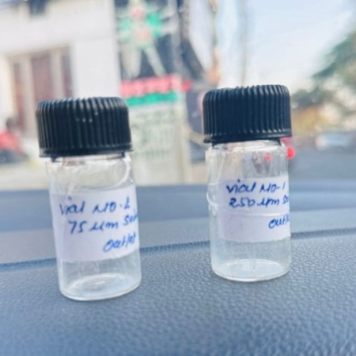

MP’s Recovery microplastics analysis, It is difficult to identify the types of microplastics, and the pretreated samples may contain substances other than microplastics, so the accuracy is low The chemical analysis usually starts with a liquid sample that is prepared differently depending on its origin. This sample is filtered onto an IR-transparent substrate and measured in its entirety by FTIR imaging to capture all particles present on the filter. The Chemical Image is then analyzed automatically with a robust machine. Following table represent the data of microplastics collected from Samples taken on November 2023 and march 2024, this data represent the abovementioned steps taken to extract Microplastics in influent and effluent samples :-

Table -1 Result after extraction of November 2023 Samples
Sr. No. | Description |  | 52 MLD STP Weight in Gms | 4.5 MLD STP Weight in Gms
Sr. No. | Inlet Water Sample
1 | Tare weight of Beaker No. 1 ( a1) |  | 99.143 | 98.120
2 | Tare weight of Beaker No. 2 ( a2) |  | 100.489 | 99.150
3 | Tare weight of Beaker No. 3 ( a3) |  | 98.653 | 98.753
4 | Total weight of Beaker No.1 with Organic matter 250 µm (b1) |  | 99.656 | 98.710
5 | Total weight of Beaker No.2 with Organic matter 150 µm (b2) |  | 100.649 | 99.510
6 | Total weight of Beaker No.3 with Organic matter 75 µm (b3) |  | 98.88 | 99.100
 | Mass of all microplastics and natural materials. (Formula: b – a = c)
1 | Beaker No. 1 Weight or Total organic matter |  | 0.513 | 0.590
2 | Beaker No. 2 Weight or Total organic matter |  | 0.16 | 0.360
3 | Beaker No. 3 Weight or Total organic matter |  | 0.227 | 0.347
 | After wet Peroxide Oxidation (WPO) and After Desity Separation (Weight of Organic Matter + MPs)
1 | Weight of Vial after digestion including microplastics inBeaker No. 1 with cap 250 µm (e1) |  | 16.703 | 16.720
2 | Weight of Vial after digestion including microplastics Beaker No. 1 with cap 150 µm (e1) |  | 16.364 | 16.530
3 | Weight of Vial after digestion including microplastics Beaker No. 2 with cap 75 µm (e2) |  | 16.572 | 16.595
4 | Tare weight of Vial from Beaker No. 1 with cap (d1) |  | 16.208 | 16.270
5 | Tare weight of Vial from Beaker No. 2 with cap (d2) |  | 16.276 | 16.298
6 | Tare weight of Vial from Beaker No. 3 with cap (d3) |  | 16.411 | 16.385
 | Weight of Microplastic
 | Preparation of Sample for Microscopic Exam
 | Subtract the mass of the tared vial (d) to provide the mass of microplastics (f) collected on the sieve. (Formula: e-d=f)
1 | Tare weight of Vial No. 1 with beaker No - 250 µm MP (f1) |  | 0.495 | 0.450
2 | Tare weight of Vial No. 2 with beaker No- 150 µm MP (f2) |  | 0.088 | 0.232
3 | Tare weight of vial No. 3 with beaker No - 75 µm MP (f3) |  | 0.161 | 0.210
 | Outlet 52 MLD
 | 2. Result after Extraction :-
 | Outlet Water Sample :-
1 | Tare weight of Beaker No. 1 ( a1) |  | 98.036 | 99.180
2 | Tare weight of Beaker No. 2 ( a2) |  | 99.275 | 100.203
3 | Tare weight of Beaker No. 3 ( a3) |  | 97.315 | 98.895
4 | Total weight of Beaker No.1 with Organic matter 250 µm (b1) |  | 98.23 | 99.295
5 | Total weight of Beaker No.2 with Organic matter 150 µm (b2) |  | 99.45 | 100.340
6 | Total weight of Beaker No.3 with Organic matter 75 µm (b3) |  | 97.524 | 99.090
 | Mass of all microplastics and natural materials. (Formula: b – a = c)
1 | Beaker No. 1 Weight or Total organic matter |  | 0.194 | 0.115
2 | Beaker No. 2 Weight or Total organic matter |  | 0.175 | 0.137
3 | Beaker No. 3 Weight or Total organic matter |  | 0.209 | 0.195
 | After wet Peroxide Oxidation (WPO) and After Desity Separation
 | Weight of Organic Matter + MPs
 | Total weight of Vial after Digestion with MP’s
1 | Vial weight from Beaker No. 1 with cap 250 µm (e1) | 16.453 |  | 16.385
2 | Vial weight from Beaker No. 1 with cap 150 µm (e1) | 16.364 |  | 16.450
3 | Vial weight from Beaker No. 2 with cap 75 µm (e2) | 16.597 |  | 16.503
4 | Tare weight of vial from Beaker No. 1 with cap (d1) | 16.45 |  | 16.350
5 | Tare weight of vial from Beaker No. 2 with cap (d2) | 16.356 |  | 16.425
6 | Tare weight of vial from Beaker No. 3 with cap (d3) | 16.586 |  | 16.489
 | Weight of Microplastic
 | Preparation of Sample for Microscopic Exam
 | Subtract the mass of the tared vial (d) to provide the mass of microplastics (f) collected on the sieve. (Formula: e-d=f)
1 | Total Weight of Vial No. 1 with beaker No - 250 µm MP (f1) | 0.003 |  | 0.035
2 | Total Weight of Vial No. 2 with beaker No- 150 µm MP (f2) | 0.008 |  | 0.025
3 | Total Weight of vial No. 3 with beaker No - 75 µm MP (f3) | 0.011 |  | 0.014

Result after extraction of March 2024 Samples
Sr. No. | Description |  | 52 MLD STP Weight in Gms | 4.5 MLD STP Weight in Gms
Sr. No. | Inlet Water Sample
1 | Tare weight of Beaker No. 1 ( a1) |  | 99.250 | 98.758
2 | Tare weight of Beaker No. 2 ( a2) |  | 99.750 | 98.290
3 | Tare weight of Beaker No. 3 ( a3) |  | 98.670 | 99.170
4 | Total weight of Beaker No.1 with Organic matter 250 µm (b1) |  | 99.656 | 99.398
5 | Total weight of Beaker No.2 with Organic matter 150 µm (b2) |  | 100.649 | 98.530
6 | Total weight of Beaker No.3 with Organic matter 75 µm (b3) |  | 98.88 | 99.345
 | Mass of all microplastics and natural materials. (Formula: b – a = c)
1 | Beaker No. 1 Weight or Total organic matter |  | 0.513 | 0.640
2 | Beaker No. 2 Weight or Total organic matter |  | 0.16 | 0.240
3 | Beaker No. 3 Weight or Total organic matter |  | 0.227 | 0.175
 | After wet Peroxide Oxidation (WPO) and After Desity Separation
 | Weight of Organic Matter + MPs
 | Total weight of Vial after Digestion with MP’s
1 | Vial weight. from Beaker No. 1 with cap 250 µm (e1) |  | 16.725 | 16.574
2 | Vial weightt. from Beaker No. 1 with cap 150 µm (e1) |  | 16.355 | 16.426
3 | Vial weight. from Beaker No. 2 with cap 75 µm (e2) |  | 16.510 | 16.460
4 | Vial Tare weight. from Beaker No. 1 with cap (d1) |  | 16.350 | 16.310
5 | Vial Tare weight. from Beaker No. 2 with cap (d2) |  | 16.258 | 16.288
6 | Vial Tare weight. from Beaker No. 3 with cap (d3) |  | 16.385 | 16.345
 | Weight of Microplastic
 | Preparation of Sample for Microscopic Exam
 | Subtract the mass of the tared vial (d) to provide the mass of microplastics (f) collected on the sieve. (Formula: e-d=f)
1 | Total Weight. of Vial No. 1 with beaker No - 250 µm MP (f1) |  | 0.375 | 0.264
2 | Total Weight of Vial No. 2 with beaker No- 150 µm MP (f2) |  | 0.097 | 0.138
3 | Total Weight. of vial No. 3 with beaker No - 75 µm MP (f3) |  | 0.125 | 0.115
 | Outlet 52 MLD
 | 2. Result after Extraction :-
 | Outlet Water Sample :-
1 | Tare weight. of Beaker No. 1 ( a1) |  | 97.850 | 98.120
2 | Tare weight. of Beaker No. 2 ( a2) |  | 98.895 | 98.689
3 | Tare weight. of Beaker No. 3 ( a3) |  | 98.250 | 98.170
4 | Total wt.of Beaker No.1 with Organic matter 250 µm (b1) |  | 98.024 | 98.255
5 | Total weight. of Beaker No.2 with Organic matter 150 µm (b2) |  | 99.051 | 98.788
6 | Total weight. of Beaker No.3 with Organic matter 75 µm (b3) |  | 98.429 | 98.255
 | Mass of all microplastics and natural materials. (Formula: b – a = c)
1 | Beaker No. 1 Weight or Total organic matter |  | 0.174 | 0.135
2 | Beaker No. 2 Weight or Total organic matter |  | 0.156 | 0.099
3 | Beaker No. 3 Weight or Total organic matter |  | 0.179 | 0.085
 | After wet Peroxide Oxidation (WPO) and After Desity Separation
 | Weight of Organic Matter + MPs
 | Total weight of Vial after Digestion with MP’s
1 | Vial weight. from Beaker No. 1 with cap 250 µm (e1) | 16.251 |  | 16.358
2 | Vial weight. from Beaker No. 1 with cap 150 µm (e1) | 16.356 |  | 16.586
3 | Vial weight. from Beaker No. 2 with cap 75 µm (e2) | 16.608 |  | 16.219
4 | Vial Tare weight. from Beaker No. 1 with cap (d1) | 16.240 |  | 16.345
5 | Vial Tare weight. from Beaker No. 2 with cap (d2) | 16.350 |  | 16.570
6 | Vial Tare weight. from Beaker No. 3 with cap (d3) | 16.590 |  | 16.210
 | Weight of Microplastic
 | Preparation of Sample for Microscopic Exam
 | Subtract the mass of the tared vial (d) to provide the mass of microplastics (f) collected on the sieve. (Formula: e-d=f)
1 | Total Weight. of Vial No. 1 with beaker No - 250 µm MP (f1) | 0.011 |  | 0.013
2 | Total Weight of Vial No. 2 with beaker No- 150 µm MP (f2) | 0.006 |  | 0.016
3 | Total Weight. of vial No. 3 with beaker No - 75 µm MP (f3) | 0.018 |  | 0.009

Step VIII Techniques used
FTIR Spectroscopy- FTIR spectroscopy is a non-destructive testing method that analyzes a polar functional group such as a carbonyl group by using the degree of scattering of a substance, using infrared rays of a specific wavelength . FTIR spectroscopy can quickly measure all the frequencies of the infrared source at the same time through pretreated filter paper.
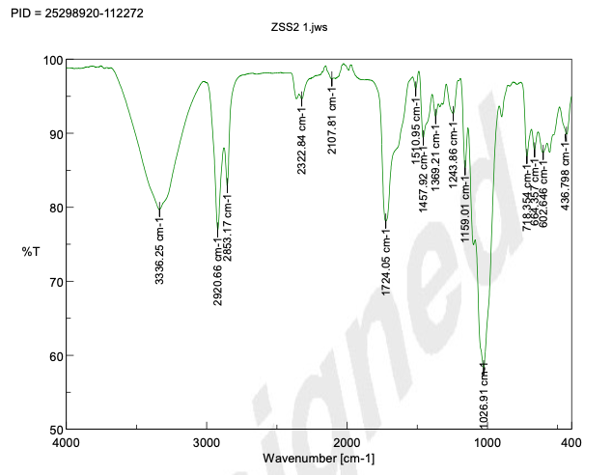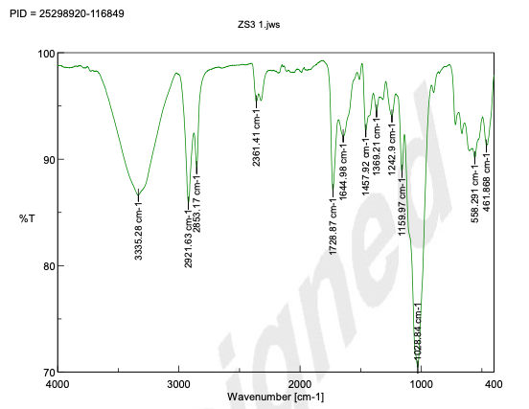

Figure 5 FTIR Test Result

Figure 6 FTIR Test result
SEM Analysis- The application of optical and electron (SEM/EDS) microscopy on the analysis and characterization microplastics was done.
Figure 8,9,10,11,12, SEM Test Results

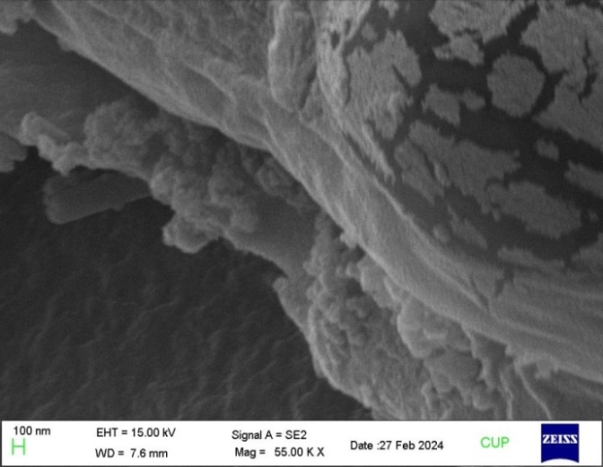
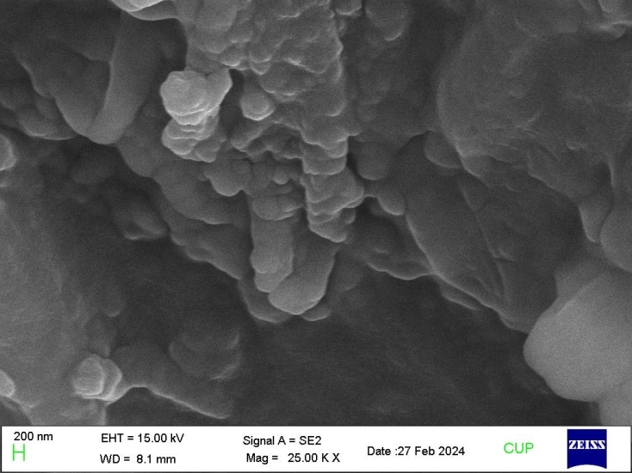

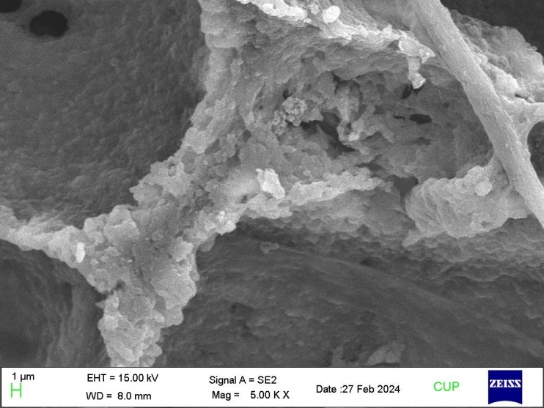
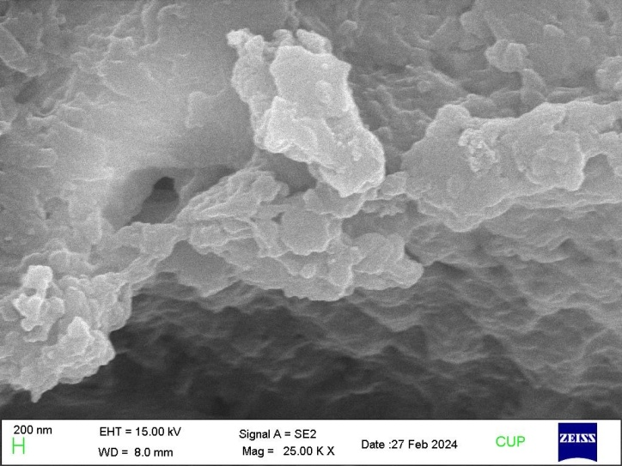
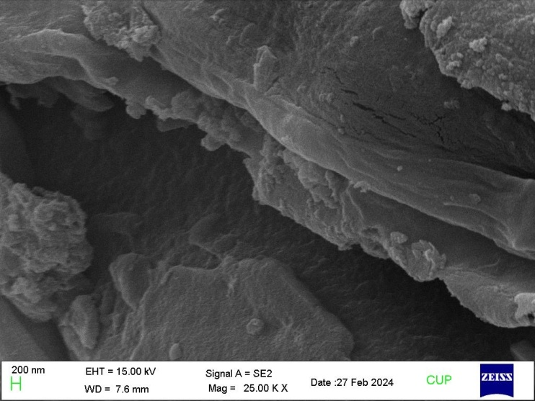

Result - Removal Efficiency of STP’s-
STP’s Removal efficiency was counted from above table by using below mentioned formulae. (Table 1) were applied to calculate microplastic material loading, where influent loading is equal to CMP;infl Qinfl and loading. Microplastic loads entering WWTPs in sewage influent and discharged from WWTPs in treated effluents . Differences in MP concentrations in final effluents are as per below :-
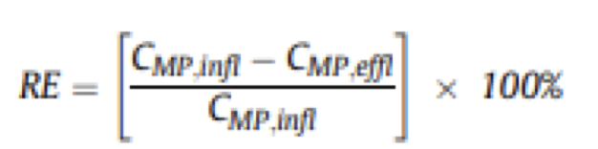

Sr. No. | Month | Size | 52 MLD STP |  |  | 4.5 MLD STP
Sr. No. | Month | Size | Microplastics extracted from Inffluent Sample | Microplastics extracted from Effluent Sample | Microplastics Removal Efficiency of STP's ( in %age) | Microplastics extracted from Inffluent Sample | Microplastics extracted from Effluent Sample | Microplastics Removal Efficiency of STP's
1 | Nov-23 | 250µm | 0.495 | 0.003 | 99.39 % | 0.495 | 0.003 | 99.39 %
 |  | 150µm | 0.088 | 0.008 | 90.91 % | 0.088 | 0.008 | 90.91 %
2 | Mar-24 | 250µm | 0.375 | 0.011 | 97.07 % | 0.264 | 0.013 | 95.07 %
 |  | 150µm | 0.097 | 0.006 | 93.81 % | 0.138 | 0.016 | 88.40 %

Conclusion
The efficiency of removing microplastics in both wastewater treatment plants found above 90%. Higher removal efficiency observed in the present study at the STP’s employing primary clarification suggests that retrofitting secondary plants with primary clarifiers could improve microplastic removal, while also likely improving treatment of other contaminants of concern. Upgrading plants to include primary clarification is dependent on site-specific factors, such as existing plant design, service composition, service population, cost, and co-benefits which have to be considered before investments in capital improvements occur. The high loading of microplastics into wastewater treatment plants presents a point of intervention at the level of the individual consumer. Typical WWTP processes are divided into preliminary treatment, primary treatment, secondary treatment, and tertiary treatment. Preliminary treatment consists of a screen and a sedimentation tank, mainly removing large and large plastics. Primary treatment mainly consists of aeration and sedimentation, and it removes light plastics or heavy plastics by skimming and sedimentation. Secondary treatment is mainly biological treatment to remove organic material. Biological treatment consists of an anaerobic tank, anoxic tank, an aerobic tank, and a settling tank, and most of the microplastics >500 μm are removed. Tertiary treatment is mainly used as an option in WWTPs and consists of a process of removing phosphorus and nitrogen by using chemicals. At this time, it is possible to increase the removal rate of microplastics by using several coagulants

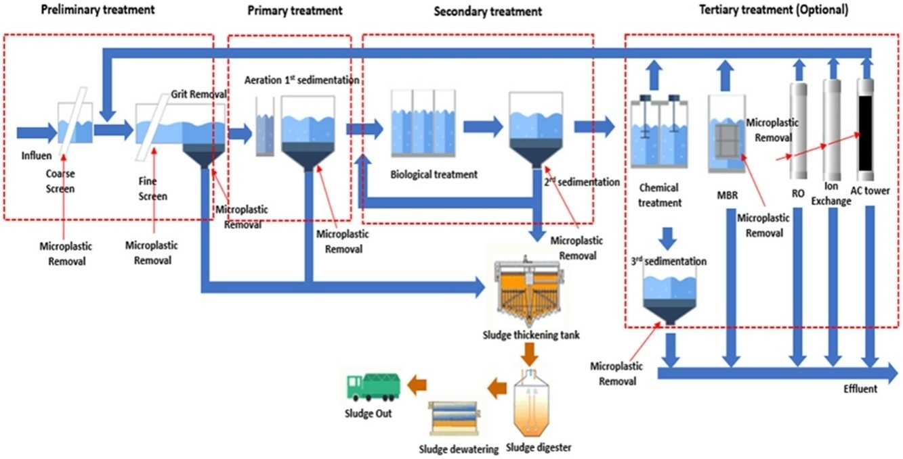
Figure 9 Microplastic-removal process in STP

References
- Akyildiz, S.H.; Bellopede, R.; Sezgin, H.; Yalcin-Enis, I.; Yalcin, B.; Fiore, S. Detection and Analysis of Microfibers and Microplastics in Wastewater from a Textile Company. Microplastics 2022, 1, 572–586. https://doi.org/10.3390/ microplastics1040040
- •Khan, L.; Ghias, S.; Zafar, M.I.; Alhodaib, A.; Fatima, H.; Ur-Rehman, T.; Waseem, A.; Howari, H. Exploration of microplastic pollution with particular focus on source identification and spatial patterns in riverine water, sediment and fish of the Swat River, Pakistan. RSC Adv. 2022, 12, 9556–9566
- •Ziajahromi, S.; Neale, P.A.; Rintoul, L.; Leusch, F.D.L. Wastewater treatment plants as a pathway for microplastics: Development of a new approach to sample wastewater-based microplastics. Water Res. 2017, 112, 93–99.
- •Tirkey, A.; Upadhyay, L.S.B. Microplastics: An overview on separation, identification and characterization of microplastics. Mar. Pollut. Bull. 2021, 170, 112604.
- •Castelluccio, S.; Alvim, C.B.; Bes-Piá, M.A.; Mendoza-Roca, J.A.; Fiore, S. Assessment of Microplastics Distribution in a Biological
- Wastewater Treatment. Microplastics 2022, 1, 141–155.
- •Cristaldi, A.; Fiore, M.; Zuccarello, P.; Conti, G.O.; Grasso, A.; Nicolosi, I.; Copat, C.; Ferrante, M. Efficiency of Wastewater Treatment Plants (WWTPs) for Microplastic Removal: A Systematic Review. Int. J. Environ. Res. Public Health 2020, 17, 8014.
- •Murphy, F., Ewins, C., Carbonnier, F., Quinn, B., 2016. Wastewater treatment works (WwTW) as a source of microplastics in the aquatic environment. Environ. Sci. Technol. 50 (11), 5800–5808.
- •Gasperi, J., Wright, S.L., Dris, R., Collard, F., Mandin, C., Guerrouache, M., Langlois, V., Kelly, F.J., et al., 2018. Microplastics in air: are we breathing it in? Curr. Opin. Environ. Sci. Health 1, 1–5.•Murphy, F., Ewins, C., Carbonnier, F., Quinn, B., 2016. Wastewater treatment works (WwTW) as a source of microplastics in the aquatic environment. Environ. Sci. Technol. 50 (11), 5800–5808.
- •Gasperi, J., Wright, S.L., Dris, R., Collard, F., Mandin, C., Guerrouache, M., Langlois, V., Kelly, F.J., et al., 2018. Microplastics in air: are we breathing it in? Curr. Opin. Environ. Sci. Health 1, 1–5.
- Huerta Lwanga, E., Gertsen, H., Gooren, H., Peters, P., Sala ́nki, T., van der Ploeg, M., Besseling, E., Koelmans, A.A., et al., 2017. Incorporation of microplastics from litter into burrows of lumbricus terrestris. Environ. Pollut. Part A 220, 523–531.
- •Larissa Vuori et al. 2021 Journal University of Helsinki How to remove microplastics in wastewater? A cost effectiveness analysis University of Helsinki: Helsingin Yliopisto, PL 27 (Latokartanonkaari 5), 00014 Helsinki, Finland
- •Mohammad R Alrbaihat et al. 2022 Eco-friendly microplastic removal through physical and chemical techniques: a review. Ann Adv Chem. 2023; 7: 014-024.
- •Padervand M, Lichtfouse E, Robert D, Wang C. Removal of microplastics from the environment. A review. Environ Chem Lett. 2020; 18: 807-828. doi: 10.1007/s10311-020-00983-1.
- •Faure F, Demars C, Wieser O, Kunz M, de Alencastro LF. Plastic pollution in Swiss surface waters: nature and concentrations, interaction with pollutants. (Special Issue: Microplastics in the environment.). Environ Chem. 2015; 12: 582–591.
- •Li J, Liu H, Paul Chen J. Microplastics in freshwater systems: A review on occurrence, environmental effects, and methods for microplastics detection. Water Res. 2018 Jun 15;137:362-374. doi: 10.1016/j. watres.2017.12.056. Epub 2017 Dec 28. PMID: 29580559.
- •Lei wang Yi Liu, Bei Wang, Vince Pileggi, Sheng Chang 2022 Methods to recover and characterize microplastics in wastewater treatment plants 2666-0164/© 2022 The Authors. Published by Elsevier Ltd
- •M. Lares, M.C. Ncibi, M. Sillanp ̈a ̈a, M. Sillanp ̈aa ̈, Occurrence, identification and removal of microplastic particles and fibers in conventional activated sludge process and advanced MBR technology, Water Res. 133 (2018) 236–246.
- S. Sujathan, A.K. Kniggendorf, A. Kumar, B. Roth, K.H. Rosenwinkel, R. Nogueira, Heat and bleach: a cost-efficient method for extracting microplastics from return activated sludge, Arch. Environ. Contam. Toxicol. 73 (4) (2017) 641–648.
- •Kenda colney, Allan Clum, Jestine Deepe, Haven Lane, Barbara Beckingham Wastewater treatment plants as a source of microplastics to an urban estuary: Removal efficiencies and loading per capita over one year 2589-9147/© 2019 The Authors. Published by Elsevier Ltd.
- •Browne, M.A., Crump, P., Niven, S.J., Teuten, E., Tonkin, A., Galloway, T., Thompson, R., 2011. Accumulation of microplastic on shorelines worldwide: sources and sinks. Environ. Sci. Technol. 45, 9175e9179.
- •Seidensticker, S., Zarfl, C., Cirpka, O.A., Fellenberg, G., Grathwohl, P., 2017. Shift in mass transfer of wastewater contaminants from microplastics in presence of dissolved substances. Environ. Sci. Technol. 51, 12254e12263.
- •Angel Negrete Velasco, Stéphan Ramseier Gentile, Stéphane Zimmermann, Philippe Le Coustumer, Serge Stoll 2023 contamination and removal efficiency of microplastics and synthetic fibres in a conventional drinking water treatment plant in Geneva, Switzerland 0048-9697/© 2023 The Authors. Published by Elsevier B.V.
- •Brander, S.M., Renick, V.C., Foley, M.M., Steele, C., Woo, M., Lusher, A., Carr, S., Helm, P., Box, C., Cherniak, S., Andrews, R.C., Rochman, C.M., 2020. Sampling and quality assur- ance and quality control: a guide for scientists investigating the occurrence of microplastics across matrices. Appl. Spectrosc. 74, 1099–1125.
- •Hidalgo-Ruz, V.; Gutow, L.; Thompson, R. C.; Thiel, M. Microplastics in the marine environment: A review of the methods used for identification and quantification. Environ. Sci. Technol. 2012, 46 (6), 3060−3075.
- •Cole, M.; Lindeque, P.; Halsband, C.; Galloway, T. S. Microplastics as contaminants in the marine environment: A review. Mar. Pollut. Bull. 2011, 62, 2588−2597..

