VisionDrive: Smart Traffic Analysis with YOLOv7 and DeepSORT

Jagdish Pimple¹⁺, Mohit Agarwal², Dipmala Kathale³, Kajal Matte⁴, Rutuja Hande⁵, Shruti Jiwane⁶
¹Assistant Professor, Department of Information Technology, St. Vincent Pallotti College of Engineering and Technology, Nagpur
²Associate Professor, School of Computer Science Engineering and Technology, Bennett University, Greater Noida
^{3,4,5,6} Student of Department of Information Technology, St. Vincent Pallotti College of Engineering and Technology, Nagpur

ABSTRACT
This research introduces a novel vehicle division mechanism intended for dynamic metropolitan settings. Modern technology, including deep learning, computer vision, and real-time warning systems, reduces traffic, enhances road safety, and effectively manages unanticipated situations. A strong vehicle instance segmentation model that can recognize cars in real-time from many sources is first developed using the YOLO technique. In the next round, the cars are tallied and a predetermined threshold is established. If there are more cars in the video or image than a preset threshold, the system will identify this and assume that traffic is heavy. During the last stage, users receive information on congestion analysis and anomaly identification through user-friendly interfaces. This article aims to modernize traffic control by merging cutting-edge technologies with all-encompassing techniques to deliver a responsive, safe, and efficient urban transportation experience.
KEYWORDS: YOLOv7, DeepSORT, OpenCV, Object Detection, Multiclass Segmentation, Object Counting.
- INTRODUCTION
The goal of this research is to address the challenges posed by dynamic metropolitan settings by designing an improved vehicle segmentation system that incorporates cutting-edge technologies. Using the YOLO and DeepSORT techniques, the initial stage focuses on creating a strong vehicle instance segmentation model for real-time vehicle recognition in images or video streams. In addition to classifying vehicles, the study employs multi-class segmentation to examine the road infrastructure comprehensively. The next objective is to look into traffic congestion, and identify bottlenecks using estimates of optical flow and density, and utilize deep learning algorithms to discover anomalies. In the last phase, customers will be able to access segmentation data, congestion analysis, and abnormality detection using intuitive interfaces that provide real-time traffic notifications.
- PROBLEM STATEMENT
The problem statement for this paper is
2.1 Traffic Management Complexity: In India, managing traffic is a difficult and time-consuming process that calls for creative solutions to address a range of issues.
2.2 Road Accidents: Traffic management at accident scenes is a major concern for law enforcement. Road accidents are a frequent occurrence.
2.3 VIP Movement: When VIPs are moved along particular routes, it might impede normal traffic flow and cause delays.
2.4 Road barriers: Roadside barriers such as fallen trees are common and require quick handling to allow traffic to flow again.
- PROPOSED SYSTEM
Real-time video recording at traffic lights is facilitated by the installation of high-resolution cameras as part of the proposed intelligent traffic monitoring system. Modern machine learning and computer vision algorithms classify vehicles, giving special attention to three-, four-, and five-wheelers. Continuous real-time density estimations inform a deep learning-based traffic jam detection system. Predetermined thresholds are exceeded, which causes alerts to sound.
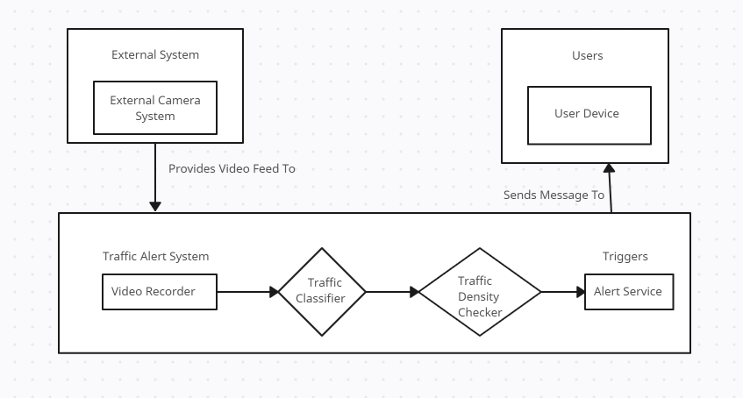
Fig. 1. Data Flow of Proposed System
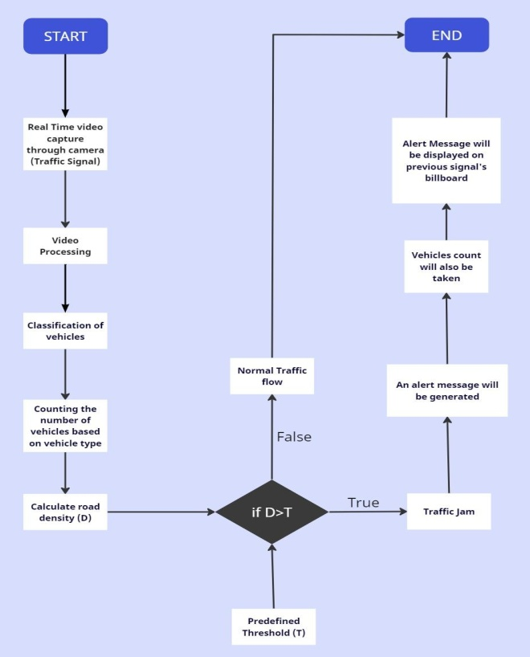
Fig. 2. Work Flow of Proposed System
- METHODOLOGY USED
- The study paper's method merged YOLOv7 (You Only Look Once version 7) with DeepSORT (Deep Simple Online and Realtime Tracking) for real-time video surveillance and alarm systems in traffic control.
- Because the contemporary object identification algorithm YOLOv7 is so good at recognizing and classifying objects in each frame of the real-time video feeds, it was deployed.
- Moreover, DeepSORT was employed to monitor and maintain the identity of objects identified across a sequence of frames.
- IMPLEMENTATION RELATED WORK
We use the YOLOv7 algorithm for real-time video object detection in the suggested system. Pedestrians, vehicles, and other items are all recognized by the algorithm. Following detection, each identified object class's instances are counted by the system, which then shows the counts on the screen. The technology precisely counts various vehicles and human kinds, providing useful information for traffic management and study.
5.1 Model Architecture and Versions: We used YOLOv7 as our main object recognition framework because of its excellent accuracy and real-time capabilities. Furthermore, we combined YOLOv7 and the DeepSORT algorithm for object tracking.
5.2 Model Evaluation: We used common measures, such as precision, recall, and F1-score for object detection, to assess the effectiveness of our YOLOv7 + DeepSORT implementation.
5.3 Comparisons and Baselines: We examined how our model performed in comparison to SSD, Faster RCNN, and YOLOv4 baseline models. The comparison demonstrated how much more accurate and effective our suggested method is.
Models | Accuracy | Frame Size | AP^{val} | AP^{val}₅₀
YOLOv7 | 92.86% | 640 | 51.2% | 69.7%
YOLOv4 | 43.5% | 640 | 49.7% | 68.2%
SSD | 79.8% | 512 | 28.8% | 48.5%
Faster RCNN | 83.92% | 600 | 39.8% | 59.2%
Table No. 1: Comparison of different models with YOLOv7

- RESULT AND DISCUSSION
The research paper "Innovative Approaches to Traffic Control: Systematic Review of Deep Learning in Real-Time Signal Video Monitoring & Alerts" was created to examine and evaluate the application of deep learning techniques in real-time traffic signal video monitoring and warning systems. The report offers a comprehensive summary of the advancements, challenges, and potential future paths in this sector. All things considered, the systematic review provides valuable insights into the current status of deep learning applications in traffic control, setting the stage for future research and development in this rapidly advancing field.
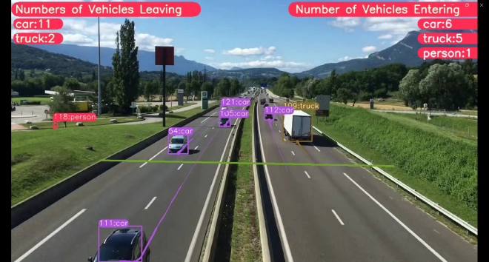
Fig. 3. Vehicle counting from video dataset 1
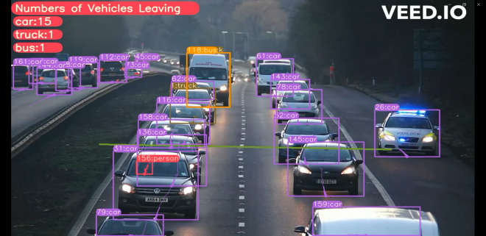
Fig. 4. Vehicle counting from video dataset 2
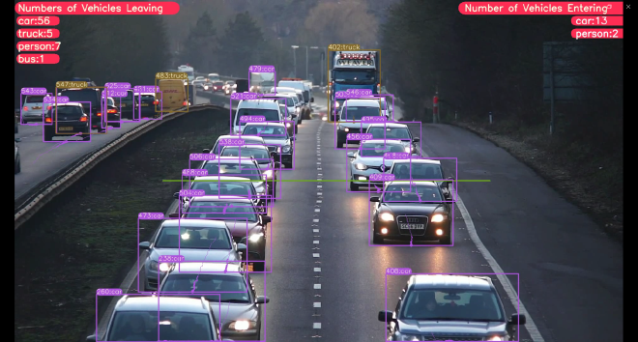
Fig. 5. Vehicle counting from video dataset 2
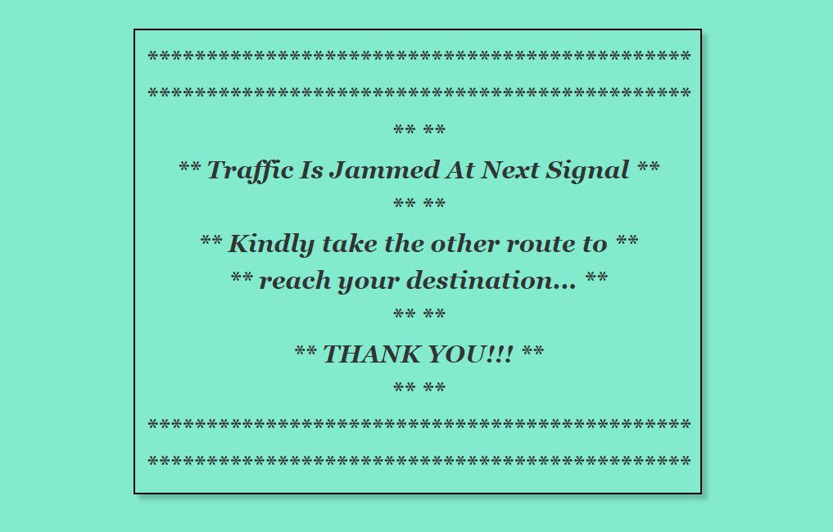
Fig. 6. Alert message on Billboard

- CONCLUSION
Using the YOLO algorithm-based vehicle detection and traffic monitoring system has led to the advancement of intelligent transportation systems. Accurate vehicle classification and counting, road density calculation, and real-time traffic congestion detection all contribute to a comprehensive understanding of road conditions. Our real-time alert system helps drivers and pedestrians make more informed decisions about their travel plans and routes by providing them with timely information. This ultimately improves traffic management and reduces congestion.

REFERENCES
- Shoeb Ahmed, “Object Tracking with DeepSORT”, Feb 2023
- Abhijeet Pujara, Mamta Bhamare, “DeepSORT: Real Time & Multi-Object Detection and Tracking with YOLO and TensorFlow”, Nov 2022
- tchanchou costel, JIANG XIN, WANG YU, ZHENG RUI, “YOLO Based Multi-Objective Vehicle Detection and Tracking”, Aug 2022
- Vladimir Shepelev, Alexandr Gushkov, A. V. Gritsenko, Dmitry Nevolin, “Assessing the Traffic Capacity of Urban Road Intersections”, Jul 2022
- Hengyuan Zhang, Suyao Zhao, Ruiheng Liu, Wenlong Wang, Yixin Hong, Runjiu Hu, “Automatic Traffic Anomaly Detection on the Road Network with Spatial-Temporal Graph Neural Network Representation Learning”, Jun 2022
- Sneha George, Ayana Sudhan, Jeleetta Shajan, Sreelakshmy A R, Jerit Richa Joy, “Traffic Sign Board Recognition And Voice Alert System”, May 2022
- Syed Yusuf, Abdumalik Aldawasari, Riad Souissi, “Automotive Parts Assessment: Applying Real-time Instance-Segmentation Models to Identify Vehicle Parts”, Feb 2022
- Yunhao Du, Zhicheng Zhao, Yang Song, Yanyun Zhao, Fei Su, Tao Gong, Hongying Meng, “StrongSORT: Make DeepSORT Great Again”, Feb 2022
- Soumyadip Dhar, Malay Kundu, “Accurate multi-class image segmentation using weak continuity constraints and neutrosophic set”, Nov 2021
- Manoj Kumar, Kranti Kumar, Pritikana Das, “Study on road traffic congestion: A review”, Jun 2021

Ahmad Bahaa Ahmad, Takeshi Tsuji, “Traffic Monitoring System Based on Deep Learning and Seismometer Data”, May 2021
- Dr. A. Ravi, R. Nandhini, K. Bhuvaneshwari, J. Divya, K.Janani, “Traffic management using Machine Learning Algorithm”, Apr 2021
- Nikhil S. Rajguru, Gopal D. Upadhaye, “Implementation paper of Traffic Signal Detection and Recognition using Deep Learning”, Apr 2021
- Ajao Lukman, Jonathan Kolo, “In-Vehicle Traffic Accident Detection and Alerting System Using Distance-Time Based Parameters and Radar Range Algorithm”, Oct 2020
- Hyoung Jeong Jeon, Jincheol Lee, Keemin Sohn, “Artificial intelligence for traffic signal control based solely on video images”, Nov 2017
- Shubhangi M. Deshmukh, Bhairavi N. Savant, “Traffic congestion alerting system”, Aug 2016
- Satya Priya Biswas, Paromita Roy, Nivedita Patra, Amartya Mukherjee and Nilanjan Dey, “Intelligent Traffic Monitoring System”, Jul 2015

