ANALYSIS OF A G+11 STRUCTURE CONSIDERING 4 DIFFERENT DIAPHRAGM IRREGULARITY CONDITIONS UNDER SEISMIC LOAD USING ETABS

Bhumesh Thakre¹ and Hitesh Kodwani²
¹M.Tech Scholar, Civil Engineering Department, SAM college of engineering and technology, Anand nagar, Bhopal, Madhya Pradesh 462001, India
²Assistant Professor, Civil Engineering Department, SAM college of engineering and technology, Anand nagar, Bhopal, Madhya Pradesh 462001, India
Abstract
Many buildings in the present scenario have irregular configurations both in elevation and plan. This in future may be subject to devastating earthquakes. It is necessary to identify the performance of the structures to withstand disaster for both new and existing buildings. Now a days openings in the floors is common for many reasons like stair cases, lighting architectural etc., these openings in diaphragms cause stresses at discontinues joints with building elements. Discontinuous diaphragms are designed without stress calculations and are thought-about to be adequate ignoring any gap effects. Earthquakes are natural dangers under which catastrophes are primarily caused by destruction or fall of structures. In the current situation, the majority of buildings are planned and erected on the premise of looks which occurs to disregard the underlying concepts of earthquake resistance, where researchers come across several buildings having uneven shapes both in height and plan.
The present work cites to portrait the behaviour of G+11 multi storeyed with diaphragm having opened under non-linear static (Pushover) analysis utilizing ETABS to achieve these outcome various models with various proportion of diaphragm openings are analyzed and contrasted for seismic parameters like maximum story displacement, base shear, maximum story drifts, as well as pushover results.
Keywords:Diaphragm Discontinuity, Pushover Analysis, Maximum Story displacement, Base Shear
Introduction:
In multi-storied framework structure, damages from earthquake usually starts at sites of structural flaws present in the horizontal load bearing frames. This behavior of multi-storey framework structures during powerful seismic movements relies on the arrangement of mass, rigidity, strength in both the vertical as well as horizontal lines of buildings. In few instances, these vulnerabilities may be caused by gaps in rigidity, strength or bulk along the diaphragm. Such gaps between diaphragms often are linked with abrupt changes in the frame shape along length of the structure. Structural engineers have acquired trust in the construction of structures in which the divisions of mass, rigidity and strength are largely consistent. There is a less trust about the construction of buildings having uneven physical shapes (diaphragm discontinuities) (diaphragm discontinuities).

Objectives of the Research
● To develop the RC framed structural model with varying percentage of diaphragm discontinuities.
● To study the influence of varying percentages of shear walls on performance of RC framed structural model with diaphragm discontinuities.
● To investigate variation in storey drifts, story displacements, base shear and story shear under the earthquake load and gravity loads.
● To formulate recommendations for choosing diaphragm discontinuity based on the results of the analysis performed.
● The models have developed as per static analysis as per IS 1893-2016 (Part 1).

Review of Literature Survey
Amruta Murali and Reni Kuruvilla (2023) research paper presented the seismic behaviour of a 20 storied building with different slab openings using response spectrum analysis in ETABS. The analysis was considered on parameters such as base shear,and story drift and compare them with the regular model.
Results stated that the story drift reduced for slab opening at the center up to 53.22% compared to the corner and 64.19 % compared to the periphery position for 1% of slab opening. The base shear reduced for slab opening at the center upto 46.64 % compared to the corner and 58.91% compared to the periphery position for 1% of slab opening. Slab opening at the center was found to be more effective in resisting lateral forces. The base shear of the regular building was less compared to the base shear values of the diaphragm having openings. Maximum story drift of a regular building was less compared to the maximum story drift values of the diaphragm having an opening.
Y. Nanda Kishore et.al (2023) objective of the research paper was to investigate the behaviour of G+15 multi storeyed with diaphragm having opened under non-linear static (Pushover) analysis utilizing ETABS to achieve these outcome various models with various proportion of diaphragm openings were analyzed and contrasted for seismic parameters like maximum story displacement, base shear, maximum story drifts, as well as pushover results.
Modal Analysis results stated that there are some unusual modes when diaphragm discontinuity modelled. However, the mass participation for those modes is found to be negligible. Provision of diaphragm opening alters the seismic behavior of the buildings. Models with symmetrical opening in both directions expressed similar response for all the parameters while models with change in the symmetry behaved different.
Steps of the Modelling and Analysis
Step 1: Research paper from different authors was summarized in this section who have focused towards analyzing multi storey high rise structures considering seismic loads with different zones and different condition in diaphragm irregularity.
Step 2: In order to initiate the modelling of the case study, firstly their’s need to initialize the model on the basis of defining display units on metric SI on region India as ETABS supports the building codes of different nations. The steel code was considered as per IS 800:2007 and concrete design code as per IS 456:2000.
Step 3: ETABS provides the option of modelling the structure with an easy option of Quick Template where the grids can be defined in X, Y and Z direction. Here in this case, 6 bays in considered in both X and Y direction with a constant spacing of 4m making the model symmetrical in nature. G+11 storey structure is considered with typical storey height of 3 m and Bottom storey height of 3 m.
Step 4: Next step is to define the material properties of concrete and steel. Here in this case study, M30 concrete and rebar HYSD 415 is considered and its predefined properties are available in the ETABS application.
Step 5: Defining section properties for Beam, Column. Beam size of 450x300mm, Column size of 500x300mm and Slab size of 200 mm is considered in the study.
Step 6: Assigning Fixed Support at bottom of the structure in X, Y and Z direction in both the considered cases.
Step 7: Defining Load cases for dead load, live load and seismic analysis for X and Y Direction.
Step 8 Defining Seismic Loading as per IS 1893: 2016 Part I.

Table 1: Geometrical descriptions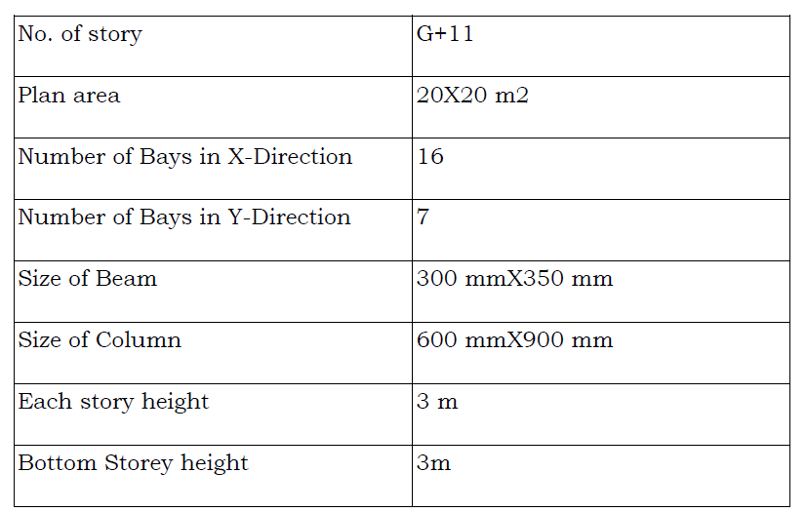

Analysis Results

Displacement

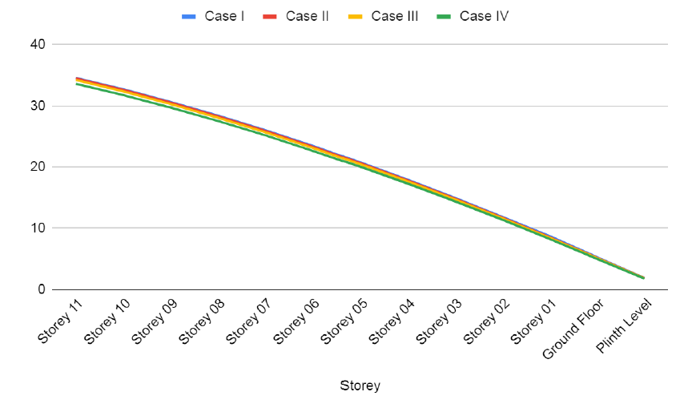
Inference- Story displacement is the absolute value of displacement of the storey under action of the lateral forces. One can expect higher total displacement values as we move up the structure. Marginal differences were visible on the values of storey displacement as the results proved that all the case structures were found stable and while comparison storey displacement was marginally lower for case IV with wider opening diaphragm when compared to case I of conventional structure.

Storey Shear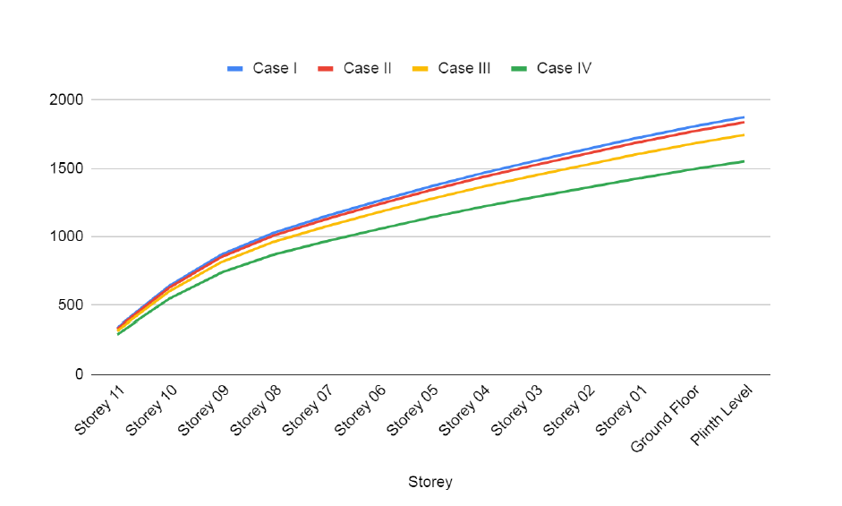
Inference- Storey shear is the lateral force acting on a storey due to the forces such as seismic and wind force. Buildings having lesser stiffness attract lesser storey shear and vice versa. storey Shear was the least for Case IV due to wider opening of the diaphragm followed by Case III, Case II and conventional structure.

Overturning Moment
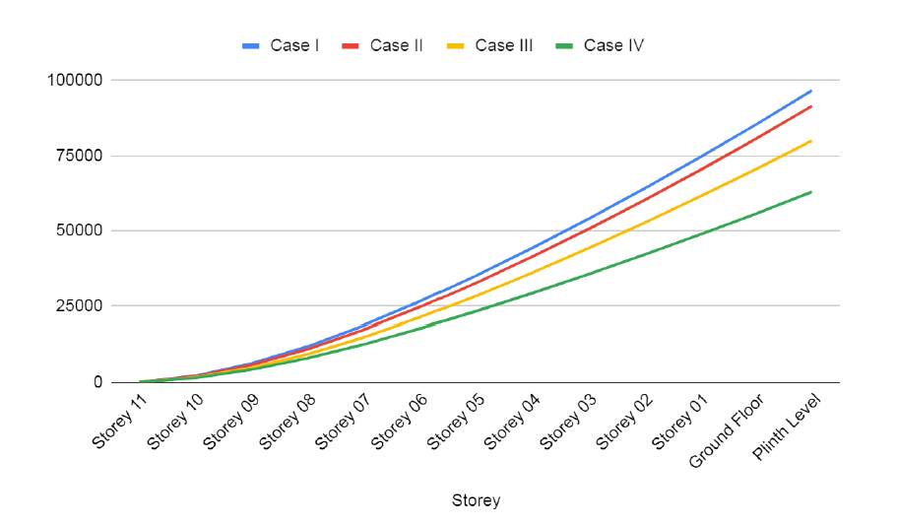
Inference- Overturning moments are those applied moments, shears, and uplift forces that seek to cause the footing to become unstable and turn over. Resisting moments are those moments that resist overturning and seek to stabilize the footing. These overturning checks are performed for overturning about each edge of the footing. The overturning moment was found to be lower for the structure with wider opening of diaphragm as in this study, the case IV had the maximum opening of diaphragm so the overturning moment was the least when compared to other cases and above all the conventional structure as stated Case I.

Conclusion
Storey displacement
Story displacement is the absolute value of displacement of the storey under action of the lateral forces. One can expect higher total displacement values as we move up the structure. Marginal differences were visible on the values of storey displacement as the results proved that all the case structures were found stable and while comparison storey displacement was marginally lower for case IV with wider opening diaphragm when compared to case I of conventional structure.
Storey Shear
Storey shear is the lateral force acting on a storey due to the forces such as seismic and wind force. Buildings having lesser stiffness attract lesser storey shear and vice versa. storey Shear was the least for Case IV due to wider opening of the diaphragm followed by Case III, Case II and conventional structure.
Base Shear
Base shear is an estimate of the maximum expected lateral force on the base of the structure due to seismic activity. It is calculated using the seismic zone, soil material, and building code lateral force equations. Notations in IBC/UBC are used in mathematical equations. Base Shear performance point was evaluated where Case II proved to be the structurally sound in comparison to other three cases by 8.9%.
Overturning Moment
Overturning moments are those applied moments, shears, and uplift forces that seek to cause the footing to become unstable and turn over. Resisting moments are those moments that resist overturning and seek to stabilize

References

Hema Mukundan and S.Manivel, [Effect of Vertical Stiffness Irregularity on Multi-Storey Shear Wall-framed Structures using Response Spectrum Analysis], International Journal of Innovative Research in Science, Engineering and Technology, Vol. 4, Issue 3, March 2015.
2. Y. Nanda Kishore, Dr. Vaishali G Ghorpade and Dr. H.Sudarsana Rao, [Effect of Diaphragm Openings in Multi-Storied RC Framed Buildings using Pushover Analysis], Multidisciplinary Journal of Educational Research, 2023.
3. Babita Elizabath Baby and Sreeja S, [Analysis of Buildings with Slab Discontinuity], International Journal of Science and Research (IJSR), Volume 5 Issue 9, September 2016.
4. Shaikh Mohammad Azhar Nizamoddin and Hamane A.A., [Effect of Diaphragm Discontinuity of RC Structure with Different Percentage of Diaphragm Discontinuities], International Research Journal of Modernization in Engineering Technology and Science, Volume:04/Issue:08/August-2022, ISSN: 2582-5208.
5. Md Faisal Zia and Rajiv Banerjee, [Seismic Impact of Re-entrant Corner with Opening in Diaphragm on RC Building], International Journal of Recent Technology and Engineering (IJRTE) ISSN: 2277-3878, Volume-9 Issue-1, May 2020.
6. Akshay Nagpure and S. S. Sanghai, [Seismic Response of Irregular Building on Sloping Ground], International Journal of Advanced
60

Research in Engineering and Technology (IJARET) 4 Volume 12, Issue 5, May 2021, pp. 181-202.
7. Anjeet Singh Chauhan and Rajiv Banerjee, [SEISMIC RESPONSE OF IRREGULAR BUILDING ON SLOPING GROUND], International Journal of Advanced Research in Engineering and Technology (IJARET) 4 Volume 12, Issue 5, May 2021, pp. 181-202.
8. Amaranth Dodamani and Sujeet Patil, [Seismic Analysis of Multi Storied Building with Diaphragm Discontinuity], International Research Journal of Engineering and Technology (IRJET), Volume: 07 Issue: 09 | Sep 2020.
9. Mohini R Bhanwase and Y. P. Pawar, [Seismic Performance of Multistoried Building with Diaphragm Discontinuity], International Journal for Scientific Research & Development| Vol. 8, Issue 8, 2020 | ISSN : 2321-0613.
10. Sagar P. Khunt and Malay D. Shukla, [Performance Based Seismic Design of Multistorey RCC Buildings with Re-entrant Corner Combine Diaphragm Discontinuity], IJARIIE-ISSN(O)-2395-4396, Vol-8 Issue-3 2022.

