SMART CANE WITH OBSTACLES DETECTION
Ms.S.Thangamani M.Tech(IT),PhD
Assistant Professor
Information Technology
Nandha Engineering College
Erode
thangamaniselvamit@gmail.com

Ranjana V
Information Technology
Nandha Engineering College
Erode
ranjananithya@gmail.com
Thilaga S
Information Technology
Nandha Engineering College
Erode
thilagasengottaiyan@gmail.com
Umamakeswari R
Information Technology
Nandha Engineering College
Erode
umamakeswari.182002@gmail.com

Abstract— The project describes ultrasonic blind walking stick with the use of Arduino. According to World Health Organisation, 30 million peoples are permanently blind and 285 billion peoples with vision impairment. If u notice them, you can very well know about it they can’t walk without the help of other. One has to ask guidance to reach their destination. They have to face more struggles in their life daily life. Using this blind stick, a person can walk more confidently. This stick detects the object in front of the person and give response to the user by vibrating. So, the person can walk without any fear. This device will be best solution to overcome their difficulties. Generally, blind people use a traditional cane (known as white cane) for moving from one place to another. Activities like walking down the road, knowing and recognizing the presence of an obstacle in front of them, reading road signs etc. We represent a model of walking stick for blind people. This consists of GPS module, GPS Antenna, Arduino, ultrasonic sensor and buzzer. This stick can detect place and obstacles. The system employs a point-by-point approach to analyze the surrounding environment, providing real-time feedback to the user. Blind people consists of a large group of people in our society. Losing their eyesight has caused them inconvenience in performing daily tasks. Hence, smart cane had been developed in order to increase the life quality of a blind person. The purpose of this project is to design a smart cane with ultrasonic sensor and global system for mobile (GSM) for the blind. This embedded system mainly has mobility. For mobility system, it is equipped with ultrasonic sensor, HCSR04 and vibrating motor. Ultrasonic sensor will send the trigger pulse to detect obstacles. When an obstacle is detected, signals will be sent to vibrating motor and activate it. The vibrating motor will vibrate with different strengths according to the distance of the obstacle. The microcontroller used in this embedded system is Arduino UNO. The prototype of smart cane was built to increase the mobility of the blind people.
Keywords— Signal processing, Internet of things, Ultrasonic sensor, visual impaired people
I. Introduction
People with visual impairments are the people who find it hard to recognize the smallest element with healthy eyes. Globally, 32.4 million people were blind in 2010, and that 191 million people had moderate and suffered from vision impairment. The issues with visual impairment lie in the difficulties in self-navigation in unfamiliar outdoor environments. Use of the traditional cane, guide dogs and mobility training are included in expertise and supports considered by professional working in the field of orientation and mobility to help visionless people. Typically, users tap the cane from left to right and as far ahead as the cane’s length. The tapping technique help users to recognize the ground surface in the user’s environment. However, the problem with the standard white cane is that it has a limited detection range of obstacles at only a distance equals to the cane’s length. Thus, this restricts the users’ walking speed and leads the users to assess approaching obstacles outside of the range unconfidently. Additionally, outdoors could also be a dangerous place for individuals with visual impairment. This study provides another piece of work and future research direction by providing an alternative solution in the smart cane body of knowledge and development. The proposed smart cane integrates two different devices which are obstacle detection, and GPS module to monitor the visually impaired location. Furthermore, this study contributes to improving the protection and safety of its user while navigating an outdoor and unfamiliar area.
  - INTERNET OF THINGS
The Internet of things (IoT) describes devices with sensors, processing ability, software and other technologies that connect and exchange data with other devices and systems over the Internet or other communications networks. The Internet of things encompasses electronics, communication, and computer science engineering. "Internet of things" has been considered a misnomer because devices do not need to be connected to the public internet; they only need to be connected to a network and be individually addressable. There are a number of concerns about the risks in the growth of IoT technologies and products, especially in the areas of privacy and security, and consequently there have been industry and government moves to address these concerns, including the development of international and local standards, guidelines, and regulatory frameworks. Because of their interconnected nature, IoT devices are vulnerable to security breaches and privacy concerns. At the same time, the way these devices communicate wirelessly creates regulatory ambiguities, complicating jurisdictional boundaries of the data transfer.
It embodies a network where interconnected devices communicate among themselves and with the cloud. The technology fosters seamless communication between various devices, enabled by affordable computer chips and high-speed telecommunication. This technological evolution has led to an extensive network with billions of internet-connected devices. Consequently, common place items like vacuums, vehicles, and machinery are now equipped with sensors capable of gathering data and executing intelligent responses to user input. This connectivity facilitates enhanced functionality and smarter operations for everyday objects, transforming them into responsive entities capable of collecting and processing data for improved user experiences and operational efficiency.

1.1.1 ARDUINO
Arduino is an open-source electronics platform based on easy-to-use hardware and software. It consists of a microcontroller board and a development environment that allows users, from hobbyists to professionals, to create interactive electronic projects. Developed in 2005 by a team of engineers at the Interaction Design Institute Ivrea in Italy, Arduino has since grown into a global community and ecosystem.
At the heart of Arduino is the Arduino board, which typically features an Atmel AVR microcontroller and a set of digital and analog input/output pins. These pins can be programmed to interact with various electronic components such as sensors, motors, LEDs, and more. Arduino boards come in different shapes and sizes, catering to different project requirements and levels of expertise.
One of the key features of Arduino is its simplicity and accessibility. The Arduino software, known as the Integrated Development Environment (IDE), provides an easy-to-use platform for writing, compiling, and uploading code to the Arduino board. The code, written in C/C++, is called a "sketch" in the Arduino environment, and it follows a simple structure with setup and loop functions. This simplicity lowers the barrier to entry for beginners while still allowing for more advanced programming techniques as users gain experience.
Arduino's versatility lies in its ability to interface with a wide range of electronic components and peripherals. This flexibility enables users to create projects spanning various domains, including robotics, home automation, wearable technology, Internet of Things (IoT), and more. Whether it's building a weather station, controlling lights and appliances remotely, or prototyping a new gadget, Arduino provides a platform for experimentation and innovation.
The Arduino community plays a significant role in the platform's success. With forums, online tutorials, and collaborative projects, users can easily find support and inspiration for their projects. Additionally, the open-source nature of Arduino encourages collaboration and the sharing of knowledge and resources. This collaborative spirit has led to the development of countless libraries, shields (add-on boards), and third-party accessories that extend the capabilities of Arduino.
Arduino's impact extends beyond hobbyist projects into education and professional prototyping. Many educational institutions incorporate Arduino into their curriculum to teach electronics, programming, and problem-solving skills. Its affordability and ease of use make it an ideal tool for introducing students to the world of electronics and engineering. Moreover, Arduino's rapid prototyping capabilities make it popular among designers, engineers, and makers for quickly iterating and testing ideas.
In recent years, Arduino has expanded its offerings to cater to specific needs and applications. For example, the Arduino Uno remains a popular choice for general-purpose projects, while the Arduino Nano and Arduino Mega offer compactness and additional features, respectively. Additionally, specialized variants like the Arduino Due, which features a more powerful microcontroller, cater to projects requiring higher computational capabilities.
Furthermore, Arduino has embraced emerging trends such as wireless communication and connectivity. Boards like the Arduino MKR1000 and Arduino Nano 33 IoT include built-in Wi-Fi and Bluetooth capabilities, making them suitable for IoT applications. These advancements position Arduino as a versatile platform for creating connected devices and exploring the possibilities of the digital world.

1.1.2 ULTRASONIC SENSOR
An ultrasonic sensor is an instrument that measures the distance to an object using ultrasonic sound waves. An ultrasonic sensor uses a transducer to send and receive ultrasonic pulses that relay back information about an object’s proximity. An ultrasonic sensor is a device that measures the distance to an object by emitting high-frequency sound waves and analyzing the time it takes for the waves to bounce back after hitting the object. These sensors are commonly used in various applications such as robotics, automotive, industrial automation, and healthcare.
The basic principle behind ultrasonic sensors is the use of sound waves beyond the range of human hearing, typically above 20 kHz. They consist of a transmitter, which emits ultrasonic waves, and a receiver, which detects the waves after they bounce off an object. The distance to the object can be calculated based on the time difference between the emission and reception of the sound waves, using the speed of sound in the medium.
Ultrasonic sensors can operate in two modes: proximity sensing and distance measuring. In proximity sensing mode, the sensor detects the presence of an object within a certain range without measuring the exact distance. This mode is often used for obstacle detection in robotics and automation. In distance measuring mode, the sensor calculates the distance to the object with high accuracy. This mode is achieved by measuring the time it takes for the sound waves to travel to the object and back.
By knowing the speed of sound in the medium, usually air, the distance can be calculated using the formula:
Distance = (Speed of Sound × Time) / 2
Where the time is the round-trip time for the sound waves.
Ultrasonic sensors come in various types and configurations, including single transducer and dual transducer designs. Single transducer sensors use the same transducer for both emitting and receiving ultrasonic waves, while dual transducer sensors have separate transducers for transmitting and receiving.
One of the key advantages of ultrasonic sensors is their ability to work in various environmental conditions, including darkness, smoke, fog, and dusty environments, where optical sensors may struggle. They are also relatively inexpensive and easy to use compared to other distance sensing technologies like LIDAR.
However, ultrasonic sensors have limitations. They may have reduced accuracy at very close distances or when dealing with soft or irregular surfaces that absorb or scatter sound waves. Additionally, they can be affected by ambient noise and interference from other ultrasonic devices operating nearby.

    - RADIO FREQUENCY TRANSMITTER AND RECEIVER
Radio frequency (RF) transmitters and receivers are fundamental components of modern communication systems, enabling the wireless transmission and reception of information over vast distances. These devices play a crucial role in various applications, including telecommunications, broadcasting, radar systems, remote control systems, and wireless networking.
RF transmitters convert electrical signals into electromagnetic waves, which can then be propagated through space. These waves carry information encoded in their amplitude, frequency, or phase. The transmitter's main components include an oscillator, modulator, power amplifier, and antenna. The oscillator generates the carrier wave at the desired frequency, while the modulator imposes the information signal onto the carrier wave. The power amplifier boosts the signal strength to achieve the desired transmission range, and the antenna radiates the signal into space.
The modulation process is crucial for encoding information onto the carrier wave. Common modulation techniques include amplitude modulation (AM), frequency modulation (FM), and phase modulation (PM). In AM, the amplitude of the carrier wave varies in accordance with the modulating signal. FM varies the frequency of the carrier wave, while PM modifies the phase. Each modulation scheme offers advantages and is suitable for specific applications.
On the other hand, RF receivers are responsible for capturing and demodulating electromagnetic waves to extract the original information signal. The receiver's key components include an antenna, RF amplifier, mixer, local oscillator, demodulator, and audio amplifier. The antenna captures the incoming RF signals and feeds them to the RF amplifier, which amplifies weak signals to a usable level. The mixer combines the incoming signal with a locally generated oscillator signal to convert the RF signal to a lower intermediate frequency (IF) signal, which is easier to process.
The demodulator then extracts the original information signal from the modulated carrier wave using techniques inverse to those employed by the transmitter. For example, in AM demodulation, the envelope of the modulated signal is detected to recover the original waveform. In FM demodulation, the frequency variations of the carrier wave are translated into amplitude variations of the demodulated signal. Once the information signal is recovered, it is amplified by an audio amplifier for further processing or conversion into audio output.
Both transmitters and receivers must operate within specific frequency bands allocated by regulatory bodies to avoid interference with other users and ensure efficient spectrum utilization. These bands range from very low frequencies (VLF) to extremely high frequencies (EHF) and beyond. Different applications require different frequency bands based on factors such as propagation characteristics, transmission range, and regulatory constraints.
Advancements in RF technology have led to the development of sophisticated transmitters and receivers with enhanced performance, reliability, and functionality. For instance, software-defined radio (SDR) platforms utilize digital signal processing techniques to perform modulation, demodulation, and signal processing tasks in software, offering flexibility and reconfigurability.
II. Literature Survey
A deal of research has been performed to improve autonomy of visually impaired people and specially their ability to explore the environment. Wearable systems have been developed based on new technologies: laser, sonar or stereo camera vision for environment sensing and using audio or tactile stimuli for user feedback. Some early examples about those systems can be illustrated by the C-5 Laser Cane based on optical triangulation to detect obstacles up to a range of 3.5 m ahead. It requires environment scanning and provides information on one nearest obstacle at a time by means of acoustic feedback. The laser system measures the distance to the obstacle and a sound tone proportional to this distance is played. This system developed in the 70’s is the precursor of a large series of devices trying to remove the cane of the blind user. More recent development using stereoscopic cameras coupled with a laser pointer and audio system have been developed at the University of Verona. One of the main interests here consists in the translation of the 3D visual information into relevant stereoscopic audio stimuli. The sound generated on ear phones simulates a distant noise source according to the position of the obstacle. Development of an Intelligent Guide-Stick for the Blind 2001 IEEE Sung Jae Kang1, Young.
Ho, Kim1, In Hyuk Moon2, There are many guidance systems for visually impaired travelers to navigate quickly and safely against obstacles and other hazards faced. Recent statistical data reported that there were 46,000 blind persons in Korea, 1999. In general, the blind travels using a white cane or carries a guidance dog. But, the guidance dog is very expensive for the blind and hard to maintain. Therefore, most blind use white canes without the information of environmental situation. The most important function for blind persons is to get information on the shape of the road and the position of obstacles when they are in unknown places. With this information, they need to arrive at their destinations, avoiding unexpected obstacles. Many robot technologies have been applied to guide the blind and some are commercially available. Optical Device Indicating a Safe Free Path to Blind People IEEE2012Joselin Villanueva, Student Member, IEEE, and Rene FarcyWALKING safely and confidently without any human assistance in urban or unknown environments is a difficult task for blind people.
III. Related Work
A Nava let was created by Shov let, and a multipurpose wearing pc that detects obstacles was placed inside the house. It was based on two things; the ﬁrst one was that it would sound different for different interruptions. One volume was to move forward, and another one was when it faced hindrance. Moreover, the second one was if the blind man stands in the wrong place, the intelligent stick will warn him about his position. The research work could not satisfy users for the lack of necessary features.
A research work described a white cane with space measurement. It was complex but time-saving technology. The stick could produce different types of vibration on
IoT-Based Smart Blind Stick various modes. Various vibration moods could identify the obstacle variations. It warned blind people for getting ready at the time of danger. However, it contained a drawback. It had data security issues. This cane had no remote detection feature. Another research work described an intelligent white cane that was suitable inside the room. But it could not identify the outdoor obstructions. The features were limited.
Two authors proposed an innovative blind stick technique called an intelligent walking stick for the visually impaired. The group built up a stick for outwardly hindered people that helped the individual by providing an alert. But it could not send notiﬁcations like navigation or voice message alerts. The features were limited and could not fulﬁll user’s demand.
Another bright stick of tiny size proposed an effective wearable device for tracking the route. Moreover, the cane could tell the user in advance about the path. If an obstacle was detected in walking the road, then it could suggest a safe shortcut route. Undoubtedly, it was a time-saving feature. And the authors planned to attach a camera to see the way. This paper introduced a plan that paved the way to monitor blind people in real-time. But the implementation was expensive, and it could not draw the attention of users.
Another research work mentioned a smart walking cane that provided advance notiﬁcations using infrared sensors. If obstacles were detected in front of the stick, it could warn the blind man through the vibration signal. However, the cane could only detect the front obstacles but produced no warning at the time of danger. Moreover, there contained a limitation for IR sensors. For example, it could not detect distant objects efﬁciently.
Most of the research work related to the blind stick showed unsatisfactory performances when tested. Besides, the previous results did not suggest any solution while losing the stick and network failure. Those drawbacks paved the way for us to rethink a bright blind stick that will be more accurate in detecting obstacles. Therefore, we have introduced a solution against the stick losing. Our implementation has worked out successfully, and we have described the performances elaborately in the result section.
Wan-Jung Chang et al. engineered a state-of-the-art wearable smart glass and a smart stick for front aerial object detection and fall avoidance system deployed on a cloud based mobile device application.
Sreenu et al. implemented a hybrid approach using two ultrasonic sensors to determine the presence of inclined upward staircases programmed a mobile software application to read 3D data obtained from mobile vision to estimate the dimensions of potential objects ahead.
E. Cardillo et al. tested the workability of electromagnetic sensor to assist the optically impaired in movement by mounting a white cane presented a substructure of context aware maneuver considering the sematic effect of the objects surrounding the user environment.
Md. Milon Islam carried out a full-fledged review study of about 100-odd papers in this discipline. Dianne, Richard and Ryo designed a haptic technology covering deeper areas of importance of blind individuals. Liupeng et al. presented research on large sized vehicles and vessel containers for trail guidance during logistics constructed a guidance system based on mobile Kinect and electrode grid.
Rakia et al. proposed a detection algorithm using Khon Vagarious function abnormality. Villanueva and Farcy designed a travel centric assistive tool worked on light-emitting diode and photodiode.
Presently, artificial intelligence methodologies are tried on ordinary walking canes to make smart walking canes For instance, M. Gupta et al. constructed a clever assistance aid that utilized artificial intelligence and sound echo sensors to assist in navigation.
Using the same technology object recognition and object detection were executed. Pruthvi et al. proposed a cane that adopted a very well-known deep learning module called You Only Look Once to carry out object classification and detection. In present time, numerous preceding works of this discipline have been looked over for strolling and navigational purposes.
As adduce, S. Lian et al. proposed a design in which a wearable smart glass was chosen a primary assist for outdoor travel. The presented designed has executed by adding an ultrasonic sensor with a depth sensor. In addition to this, they later altered and redesigned a sub landing routing stratagem the aided the optically impaired in tackling through obstacles and guided them from point A to B safely.
Aladren et al. in this work, presented an assistive navigational gadget based on a custom RGB-Depth image sensor benefiting wider angles and colour correct data for determining a hurdle free pathway for the user. Croce et al. developed a universal navigation structure in which a mobile phone was confederated with an inertial assessment sensor and a camera.

IV. SMART CANE WITH OBSTACLES DETECTION
The primary goal of this venture is to outline a smart stick to enhance the portability of a visually impaired person and to actualize a route framework. To expand the versatility capacity, ultrasonic sensor is utilized to detect deterrents and alarm the visually impaired individuals through vibration Global system for mobile is used to give the information to a known person if blind person is in trouble.
Technology keeps surprising us with it is rapid and huge development that serves community in many sectors. Blind important part of society, and we must stand with him and we share in difficulties it faces, our belief in the principle of one body to understand our concern. The project scope consists of two parts, hardware and software design. For hardware part, it mainly consists of ultrasonic sensors, global positioning system, vibrating motor, speaker, Arduino UNO, Bluetooth module, LED indicator, LDR and other components to make RF sender and receiver circuits. For software part, C programming language (Arduino language) is used to control the hardware input and output, and an Android application is designed to help the user to set the path and send it to the Arduino for further processing.
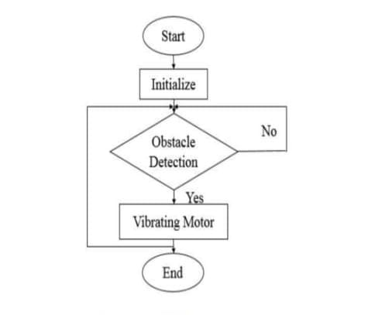
Fig.1 Normal Flow Diagram

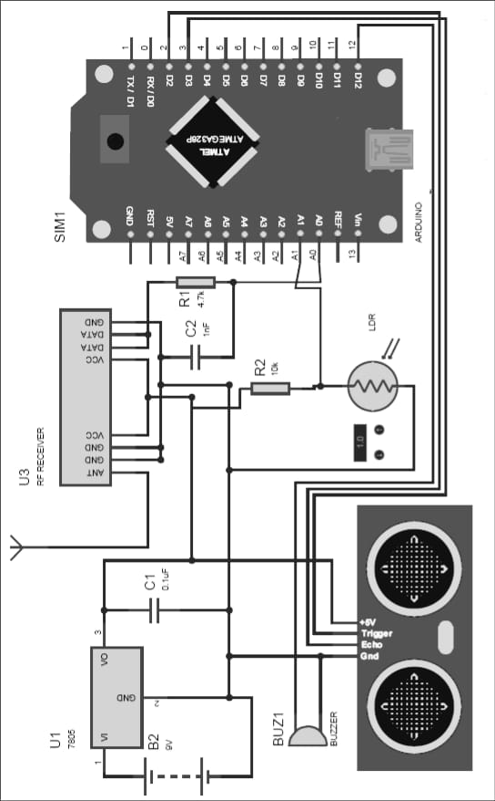
Fig.2 Block Diagram
Connection of ultrasonic sensor and microcontroller :
Setting up your Arduino project involves carefully connecting each component to ensure proper functionality. Begin by establishing the connections for the ultrasonic sensor: the VCC pin should be linked to the Arduino's 5V output, while the GND pin connects to the Arduino's ground. The TRIG pin should be connected to digital pin 12 (D12), and the ECHO pin to digital pin 11 (D11). Next, wire the buzzer by connecting its red wire to digital pin 8 (D8) and its black wire to the GND pin on the Arduino. For the vibrator motor, connect pin 1 to digital pin 7 (D7) and pin 2 to the Arduino's GND pin.

To power the circuit, use a 9-volt battery. Connect the battery's positive (RED) wire to one terminal of a toggle switch. Then, connect the battery's negative (BLACK) wire to the negative (-) terminal of a DC male power jack. Link the other terminal of the toggle switch to the positive (+) terminal of the DC male power jack. This setup allows you to easily control the power supply to the circuit using the toggle switch.

Once all the connections are made, you'll have a functional Arduino project ready for programming and experimentation. Ensure all connections are secure to prevent any loose wires or potential short circuits.

1. Selecting the Components: Choose an ultrasonic sensor compatible with your microcontroller. Common ultrasonic sensors include the HC-SR04, which operates at 5V and has four pins: VCC, Trig (trigger), Echo, and GND.

2. Wiring the Hardware: Connect the VCC pin of the ultrasonic sensor to the microcontroller's 5V pin and the GND pin to the microcontroller's ground pin. Connect the Trig pin to a digital output pin on the microcontroller and the Echo pin to a digital input pin.

3. Writing the Code: Write the code to control the ultrasonic sensor. This typically involves sending a trigger signal, measuring the time until the echo signal returns, and then calculating the distance based on the speed of sound.

4. Initializing the Pins: In the code, initialize the digital pins used for the trigger and echo signals as output and input, respectively.

5. Triggering the Sensor: Send a short pulse (typically 10 microseconds) to the trigger pin to start the measurement.

6. Measuring the Echo: Measure the time it takes for the echo signal to return to the microcontroller. This can be done using functions like pulseIn() in Arduino or similar methods in other microcontroller platforms.

7. Calculating Distance: Calculate the distance based on the time it took for the echo signal to return. Since the speed of sound is known (~343 meters per second at room temperature), you can use the formula Distance = (Time * Speed of Sound) / 2.

8. Handling Errors: Account for any potential errors in the measurements, such as signal noise or outliers, by implementing error-checking mechanisms in the code.

9. Testing and Calibration: Test the setup and calibrate if necessary to ensure accurate distance measurements.

10. Integration: Integrate the ultrasonic sensor into your larger project, whether it's a robot, proximity sensor, or any other application requiring distance measurement.

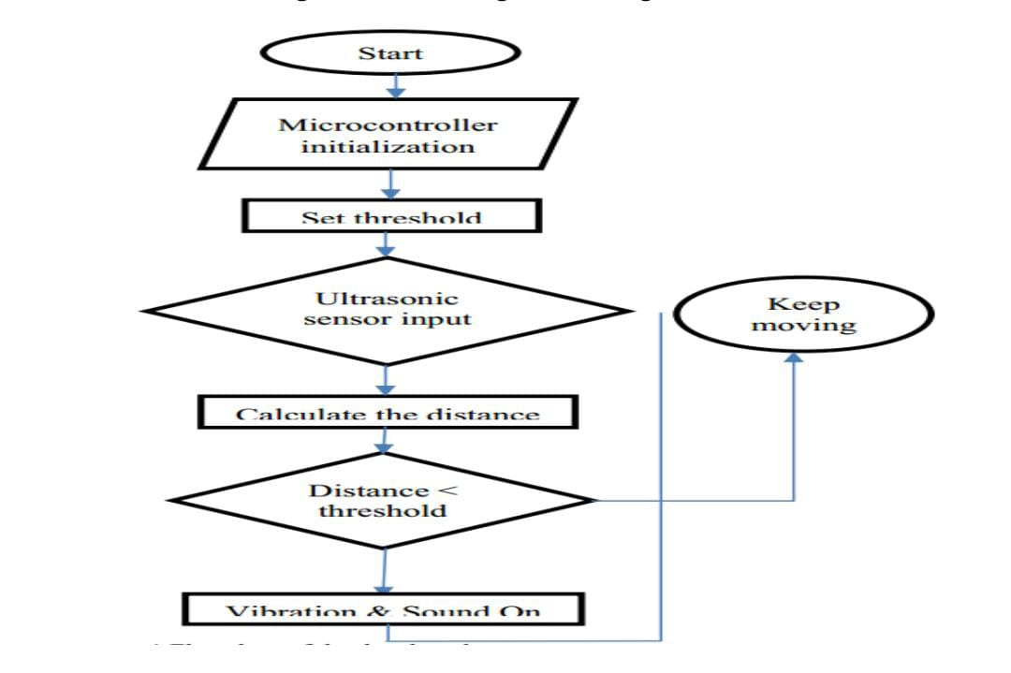
Fig.3 Work Flow Diagram

V. Results And Discussion
Functionality testing was carried out to determine the effectiveness of the proposed study. Ten participants took part in the functionality test, which comprises of two parts. In the functionality testing, there were two parts. The first part of the testing involved the detection testing with the ultrasonic sensor. The second part was the water detection testing with a water sensor. In these testing, both hardware were exposed to conditions and approximate readings were taken for measurement illustrates the path the respondents went through for functionality testing.

Obstacle Detection Test The sensor was tested when participants walked with the beginning distance between object was 100 cm, 80 cm, 60 cm and lastly 50 cm. As mentioned earlier, the sensor was set to detect the obstacles within 50 cm. As illustrated in Table, when the participants walk from 100 cm to 60 cm, the sensor was unable to detect the object in front of them. When they reached the distance 50 cm, the sensor was able to detect an object but not particularly accurate. This was due to different ways of participants walked. In-depth, since the participants were imitated as blind people and their eyes were blindfolded, they did not walk in a straight direction towards the object.

By having this test, the project can have an imprecise distance value to be set in the Arduino sketches. After considering the project's constraints with more calculation for sensor best distance to work with, it was decided for the sensor to start its reading in less than 50 cm inclusively with an obstacle in front at the sensor. Error! Reference source not found. visualizes how the respondents have been tested for distance detection.

VI.Conclusion
In the conclusion, this project comprises of some hardware parts like GSM module, ultrasonic sensor, Arduino UNO, and vibrator. Programming used in Arduino is visual basic. We can also use c/c++ as the programming in Arduino UNO. There are two primary objectives of the project first one is to enhance the mobile capability and second one is to inform the known person through the message if the person is in danger zone. To increase the mobile capacity of the impaired person, vibrator and ultrasonic sensor are used. If any object is exist in front of the blind person then he will recognize the obstacle before getting touch. It is suitable to travel in the unknown environment for the blind person and enhance the safety. By implementing this an impaired person can move to an unfamiliar environment without any human guidance. The blind people can move more positively and independently. It sends the message to a registered mobile number if the blind person is in a danger. The hardware and software of the project had been successfully integrated and worked to meet the requirements. The prototype of a smart cane is built and the function meets the objectives of this project. The equipment and programming of the venture had been effectively coordinated and attempted to meet the necessities. The model of the smart stick is built and the functionality capacity meets the main motive of the project.

Reference
[1] Bourn, R. R., Flaxman, S. R., Braithwaite, T., Cicinelli, M. V., Das, A., Jonas, J. B., & Naidoo, K. (2017). Magnitude, temporal trends, and projections of the global prevalence ofblindness and distance and near vision impairment: a systematic review and meta-analysis. The Lancet Global Health, 5(9), e888 e897.
[2] Riazi, A., Riazi, F., Yoosfi, R., & Bahmeei, F. (2016). Outdoor difficulties experienced by a group of visually impaired Iranian people. Journal of current ophthalmology, 28(2), 85-90.
[3] Kim, S. Y., & Cho, K. (2013). Usability and design guidelines ofsmart canes for users with visual impairments. International Journal of Design, 7(1), 99-110.
[4] World Health Organization. (2018). WHO world report on vision. Retrieved from www.who.int/blindness/visionreport/Consultation-draft-World-report-onvision.docx
[5] Boyce, T., & Boyce, T. (2011). Falls-costs, numbers and links with visual impairment. RNIB. Also see Age UK and the College of Optometrists: The Falls Omnibus Survey.
[6] Lacey, G., Dawson-Howe, K. M., & Vernon, D. (1998). Personal Adaptive Mobility Aid for the Infirm and Elderly Blind.
[7] Lloyd, J. K., Budge, R. C., Stafford, K. J., & La Grow, S. (2009). A focus group discussion on using guide dogs. International Journal of Orientation & Mobility, 2(1), 52-64.
[8] Lloyd, J. K., La Grow, S. J., Stafford, K., & Budge, R. C. (2008). The guide dog as a mobility aid part 2: perceived changes to travel habits. International Journal of Orientation & Mobility, 1, 34-45
[9] Tennessee Council of the Blind. (2009). the history of the white cane. Retrieved October 13, 2018, from http://www.acb.org/tennessee/white_cane_history.html
[10] Forth-Ports. (2011). Getting About. Retrieved from http://www.tobyfreeman.com/projects/forthside/gettingAbout.htmR. Bailis, M. Ezzati, and D. M. Kammen, "Mortality and greenhouse gas impacts of biomass and petroleum energy futures in Africa," Science, vol. 308, no. 5718, pp. 98-103, 2005.
[11] Lakshmi S, Priya & Kalpana. (2014). Intelligent white cane to aid visually impaired. International Journal of Advanced Research in Electronics, Communication & Instrumentation Engineering and Development, 2(2), 2933.
[12] Gbenga, D. E., Ibrahim, A., S., & Adekunle, A. L. (2017). Smart Walking Stick for Visually Impaired People Using Ultrasonic Sensors and Arduino. ISSN International Journal of Engineering and Technology (IJET) ISSN (Print International Journal of Engineering and Technology, 9(5), 2319-8613. https://doi.org/10.21817/ijet/2017/v9i5/170905302
[13] Nada, A., Mashelly, S., Fakhr, M. A., & Seddik, A. F. (2015, April). Effective fast response smart stick for blind people. In Proceedings of the second international Conference on Advances in bioinformatics and environmental engineering–ICABEE.
[14] Sushrut A., Hitesh K., Ishita J., Vikas G. B. (2018). Smart cane for visually impaired people. International Journal of Advance Research, Ideas and Innovations in Technology, 4(2) www.IJARIIT.com.
[15] Alshbatat, N., & Ilah, A. (2013). Automated Mobility and Orientation System for Blind or Partially Sighted People. International Journal on Smart Sensing &Intelligent Systems, 6(2).
[16] Dixon, Gregory L., and Katherine Davis. "Peace Corps in Special Education and Rehabilitation. Case Study CS-2. Appropriate Technologies for Development." (1981).
[17] Tielsch, James M., Jonathan C. Javitt, Anne Coleman, Joanne Katz, and Alfred Sommer. "The prevalence of blindness and visual impairment among nursing home residents in Baltimore." New England Journal of Medicine 332, no. 18 (1995): 1205-1209.
[18] Welsh, R. L. and Blasch, B. B. Foundations of orientation and mobility. American Foundation for the Blind New York. 1980.
[19] Joffee, E., and C. H. Rikhye. "Orientation and mobility for students with severe visual and multiple impairments: A new perspective." Hand in Hand: Selected Reprints and Annotated Bibliography on Working with Students who are Deaf-blind 2 (1995).
[20] Adhe, Shubham, Sachin Kunthewad, Preetam Shinde,and Mrs VS Kulkarni. “Ultrasonic Smart Stick for Visually Impaired People.” Dimension 45, no. 20 (2015): 15mm
[21] Sangami, A., M. Kavithra, K. Rubina, and S. Sivaprakasam. “Obstacle Detection and Location Finding For Blind People.”
[22] Cost Efficient Autonomous Navigation System (E-Cane) for visually impaired human beings by Apan Dastider, Bivas Basak, Md. Safayatullah, Celia Shahnaz, Shaikh Anowarul Fattah, Department of Electrical and Electronic Department, Bangladesh University of Engineering and Technology, Dhaka-1205, Bangladesh.
[23] Sound and touch based smart cane: Better walking experience for visually challenged by Rajesh Kannan Megalingam, Aparna Nambissan, Anu Thambi from Amrita Vishwa Vidyapeetham, Kollam, published by 2014 IEEE Canada International Humanitarian Technology Conference - (IHTC).

