Design of High-Performance Full Adder Using 32n CNTFET
Based FS-GDI Technology

K. Uday Sai¹, B. Madhava Rao², K. Devendra Achari³, P. Venkata Mahalaxmi⁴, Mr. S. Rambabu⁵
¹²³⁴ IV B. Tech, Department of ECE, Santhiram Engineering College
⁵ Assistant Professor, Department of ECE, Santhiram Engineering College

Abstract - Addition is a vital arithmetic operation and acts as a building block for synthesizing all other operations. A high-performance adder is one of the key components in the design of application specific integrated Circuits. Thus it allows designer for further advancement of the circuits with improvement in characteristic such as robust, compact, efficient, including scalabilities. Carbon Nanotube Field Effect Transistor (CNTFET) is come into use as substitute of CMOS innovation for planning circuits in the arising innovation. In which, High-Performance Full Adder is designed with full swing AND, OR and XOR gates Using 32nm CNTFET Based FS-GDI Technology to alleviate threshold voltage problem which is commonly encountered in Gate Diffusion Input (GDI) logic. The main purpose of which is to provide high speed and low power consumption with full voltage swing. The performance of the proposed designs is compared with the other full adder designs, namely CMOS, CPL, hybrid and GDI through HSPICE simulations using 32 nm technology models. And found that, modern full adder cell shows the improvement in terms of power dissipation, delay and power-delay product (PDP).
Keywords: CMOS, CNTFET, Gate diffusion input logic design, full swing-GDI, Full adder, GDI based full adder.
I. INTRODUCTION
Very Large Scale Integration, or VLSI for short, is an area of electronics dedicated to the design, fabrication, and application of integrated circuits (ICs) with a very high transistor count on a single chip. These integrated circuits are essential parts of contemporary electronic gadgets, which include computers, cell phones, automobile systems, and medical equipment.Integrated Circuits (ICs): Condensed configurations of coupled transistors, resistors, capacitors, and other electronic parts on a single semiconductor material, usually silicon, are known as integrated circuits. VLSI entails creating these ICs with a very high degree of integration during design and fabrication.
Transistors and Technology Scaling: Transistors are the essential components of electronic circuits, and VLSI technology significantly depends on them. Technology scaling, or the steady decrease in transistor size over time, is the result of technological breakthroughs. More transistors may be crammed into a single chip because to this scaling, which enhances functionality and performance.
Design Levels: There are various abstraction levels at which VLSI design takes place, such as:
Level of Logic Gates: Consists of merging transistors
Transistor Level: This refers to the design of individual transistors and the connections between them.
Logic Gates Level: This level involves putting transistors together to make basic digital building blocks and logic gates.
Functional Blocks Level: Consists of designing more substantial functional blocks, like memory units, multiplexers, and adders.
System Level: Consists of combining different functional components to form a whole system.

II. EXISTING METHODS
CMOS Technology: CMOS stands for Complementary Metal-Oxide-Semiconductor. It is a type of technology used in the manufacturing of computer processors, memory chips, and other digital devices. CMOS technology uses a combination of metal, oxide, and semiconductor materials to create electronic circuits that are low-power and highly reliable
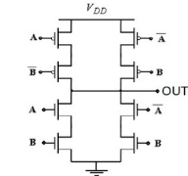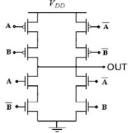
Fig 1: circuits for XOR Fig 2: circuits for XNOR

Transmission gate : An analog gate that functions similarly to a relay, a transmission gate (TG) can conduct in both directions and be blocked by a control signal at nearly any voltage potential. This switch operates on CMOS technology, where NMOS passes a strong 0 but a weak 1 and PMOS passes a strong 1 but a poor 0. PMOS and NMOS operate in parallel. A transmission gate is essentially composed of two field-effect transistors (FETs), where the substrate terminal.
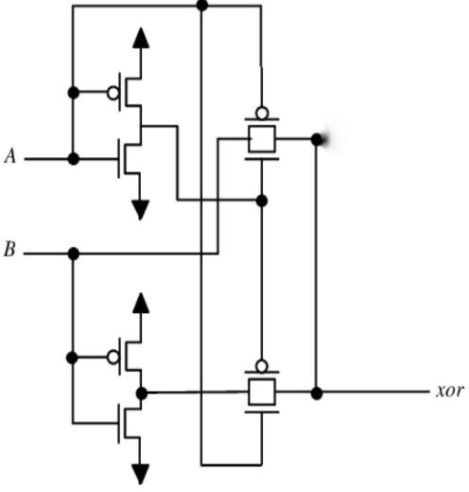
Fig 3: XOR circuit using transmission gates

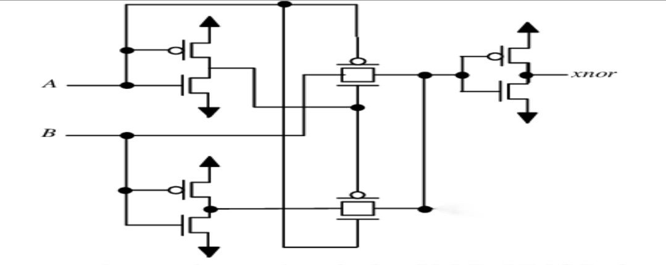
Fig 4: XNOR circuit using transmission gates.

CPTL: Complementary Pass-transistor Logic (CPL) is a different circuit approach that can significantly reduce the complexity of full-CMOS pass-gate logic circuits. Using a purely nMOS pass-transistor network for the logic operations rather than a CMOS. TG network is the fundamental concept of CPL. Every input signal and its inverse must be supplied. The circuit also generates complimentary outputs that are utilized by CPL stages that come after. All inputs are applied in complementary form. Therefore, complimentary inputs, a nMOS pass transistor logic network to produce complementary outputs, and CMOS output inverters to restore the output signals make up the basic components of the CPL circuit.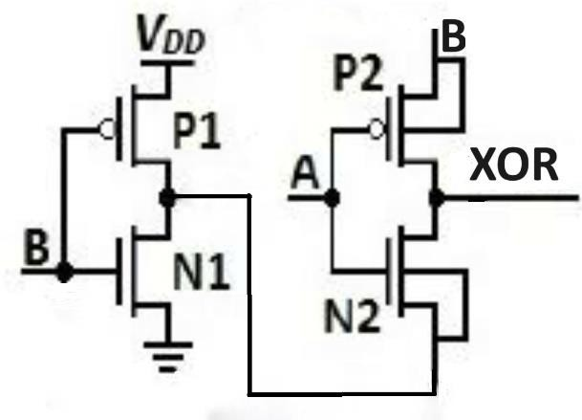

Fig 5 XOR circuits using complementary pass transistor logic
GDI Technology: The GDI technique can be used to create low-power digital circuit designs that need less transistor usage by allowing for minimum chip space, low power consumption, and delay. The foundation of the GDI approach is the usage of a straightforward cell. Across a broad range of applications, the GDI approach enables the development of complicated logic functions with just two transistors. The CMOS inverter and the GDI standard cell are nearly identical. For example, the standard cell can be randomly biased in contrast to a CMOS inverter because it is coupled to the two terminals, N and P. Representation of the GDI cell. When it comes to flexibility, the GDI design outperforms the CMOS design. A GDI cell has three inputs. The second input, P, was linked to the source/drain of the PMOS transistor, and the final input, N, was connected to the source/drain of the NMOS transistor. The G indicates the gate input of the PMOS and NMOS transistors, where the input switching signal has been applied. The input terminal N is connected to the body of an NMOS transistor, and the input terminal P is connected to the body of a PMOS transistor.
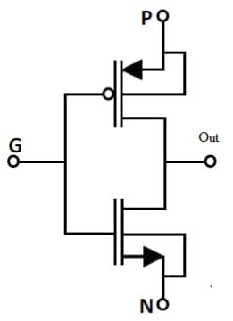
Fig 6 : The GDI basic cell
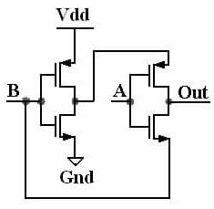
Fig 7: Circuit for GDI XOR.
Fig8: Circuit for GDI XNOR.
By comparing the delay and average powers of the XOR and XNOR using various techniques we get the comparison table as
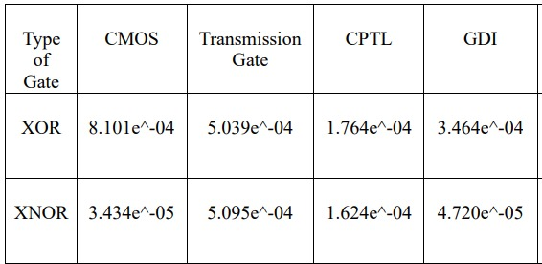
Table 1
From the above table we can state that the delay and average power decreases while using GDI technology, so designing a full adder using GDI technology.
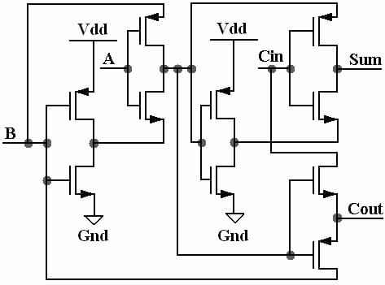
Fig 9: circuit depicts the full adder using GDI technology.
Though the delay and average power is decreased we have some disadvantages like
- Low noise margin.
- Higher leakage current.
- More prone to difference in process.
To avoid the above discussed problems we introduced CNTFET into the GDI technology.
III. PROPOSED TECHNOLOGY
CNTFET: Rather than using bulk silicon, as in the conventional MOSFET construction, as the channel material, a carbon nanotube field-effect transistor (CNTFET) uses a single carbon nanotube (CNT) or an array of carbon nanotubes. Since the initial demonstration of CNTFETs in 1998, there have been significant advancements.
The Schottky barrier at the source and drain of CNT–metal contacts, which are composed of metals such as silver, titanium, palladium and aluminium, is caused by the disparate work functions of the metal and the CNT. The carrier transport over the metal-CNT interface is dominated by quantum mechanical tunneling through the Schottky barrier, even though, like Schottky barrier diodes, the barriers would have limited this FET to transporting only one type of carrier.
The gate field can readily thin CNTFETs so that a significant current contribution is obtained through tunnelling through them. Because CNTFETs are ambipolar, they can be injected with either electrons or holes, or both at once. As a result, the Schottky barrier's thickness becomes important.
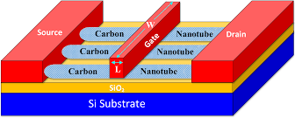
Fig 10: CNTFET
So designing a full adder by implementing CNTFET based GDI technology the circuit is as shown below.
Proposed Full Adder:
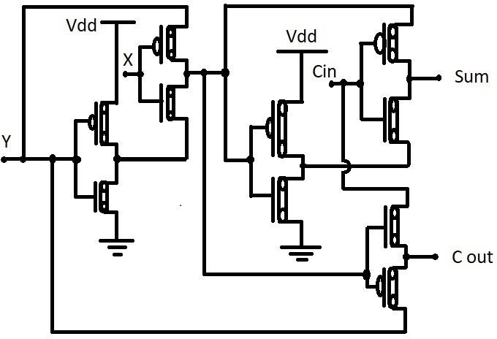
Fig 11: full adder is designed based on the CNTFET based FS-GDI technology.

The above full adder is designed based on the CNTFET based FS-GDI technology.
The above full adder circuit provides the following advantages like
- Higher speed.
- Low power.
- Reduced short channel effect.
By comparing the delay and average power of the full adders designed by various technologies we can form a table as shown
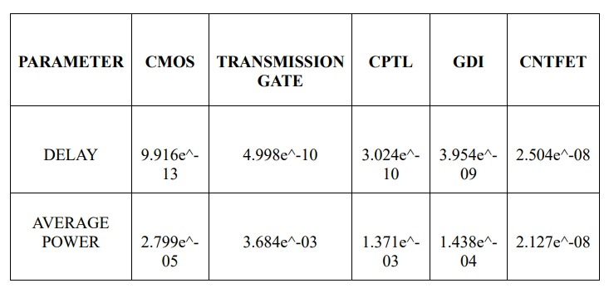
Table 2: Comparisons of various methods
And transforming them into the decimal values and plotting into the graph we acquire as follows.

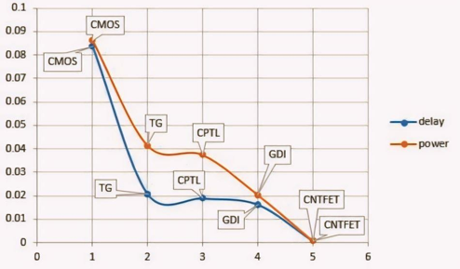
Graph 1

And the comparison of their power delay product can be represented in the form of a graph like as shown.

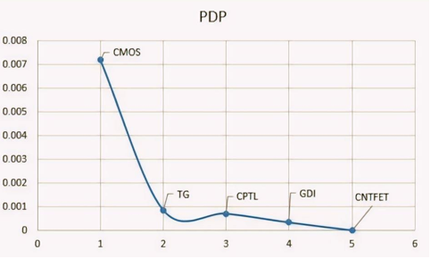
Graph 2

From the above graphs it can be said that the delay, average power and power delay product values of the full adder designed by using CNTFET technology are low when compared to the other existed technologies.

IV. CONCLUSION
Hence we can conclude that the proposed full adder designed using CNTFET based FS-GDI technology has less delay, average power dissipation and low power delay product. Addition is a fundamental arithmetic operation that serves as a foundation for all subsequent operations. A high-performance adder is a critical component in the design of applicationspecific integrated circuits. Thus, it enables designers to progress circuits by improving characteristics such as robustness, compactness, efficiency, and scalability. Carbon Nanotube Field Effect Transistor (CNTFET) is being used as an alternative for CMOS innovation for planning circuits in emerging innovation. The High-Performance Full Adder features full swing AND, OR, and XOR gates. Using 32nm CNTFET-Based FS-GDI Technology to address the threshold voltage issue that is frequently faced in Gate Diffusion Input (GDI) circuitry. The proposed designs' performance is compared to existing complete adder designs, including CMOS, CPL, hybrid, and GDI, using HSPICE simulations using 32 nm technology models. And discovered that current complete adder cells perform better in terms of power dissipation, delay, and power-delay product (PDP).

V. REFERENCES
1. M. Shoba, R. Nakkeeran, "GDI based full adders for energy efficient arithmetic applications", Engineering Science and Technology, an International Journal, vol. 19, no. 1, pp. 485–496, Mar. 2016.

2.K. Srilatha, P. Ishwarya and Avireni Srinivasulu, “Carbon Nano Tube Field Effect Transistor based BBL-PTL full adders with level restorer structures”, Int. Journal of Nanoelectronics and Materials (IJNeaM), Article in press, 2017, ISSN: 1985-5761, e-ISSN: 2232-1535.

3. P. Ahmed, Sri. Kusupati Naga Koushil Reddy et al., "Low-Power High-Performance Optimization of Full Adders in CNFET and MGFET Technology", International Journal of Research in Electronics and Computer Engineering, vol. 6, no. 4, pp. 304-310, 2018.

4. S. P. Gaikwad, S. Kondakinda and H. Upadhyay, "Single Bit Low- Power High-Speed Full Adder", Journal of VLSI Design Tools & Technology, vol. 7, no. 3, pp. 55-60, 2017.

5. K. S. Jitendra et al., "A low force - fast CNTFETs based full adder cell with flood recognition", Mic. Nano., vol. 11, no. 1, pp. 80-87, 2019.

6. G. Ali et al., "A new low-power Dynamic-GDI full adder in CNFET technology", Integration, 2021.

