ANALYSIS OF A 3 DIMENSIONAL BUILDING FRAME CONSIDERING BASE ISOLATION USING ETABS
Mitali Mahale¹ and Hitesh Kodwani²
¹M.Tech Scholar, Civil Engineering Department, SAM college of engineering and technology, Anand nagar, Bhopal, Madhya Pradesh 462001, India
²Assistant Professor, Civil Engineering Department, SAM college of engineering and technology, Anand nagar, Bhopal, Madhya Pradesh 462001, India
Abstract
The concept of isolator in building at base level reduces the possibility of resonance pf the structure and increases the time period of the structure giving rise to better seismic performance of the building. This study is performed for comparing the effectiveness of fixed base and base isolated multistoreyed RC framed building.
In case of dynamic analysis of tall buildings, the various important dynamic characteristics of tall building namely, the natural frequency (ω, radians/second) or simply time period (T, seconds),lateral displacement, base shear and overturning moment of tall buildings using ETABS software. In this research, an approximate procedure is generated to perform the seismic analysis of simple and tubular tall building system with base isolation (lead-rubber bearings) system and the outcome compared with the results obtained without base isolation (lead-rubber bearing) of tall buildings. Base isolation system is basically a passive control device which decouples the super structure from substructure resting ground motion by insinuating structural elements with low horizontal stiffness between the structure and foundation. This analysis of G+10 rigid joint plane RCC frame has for two cases. First case is simple RCC frame with fixed base and second case was RCC frame with base isolation (LRB). The effectiveness of base isolation in every cases is compared with simple frame and tubular system cases. This analysis is done by using ETABS software and for design purpose of base isolated system 1893:2002 (part 1) and for seismic design of isolated structures
Keywords—Isolater, Time Period, Base Isolation, Etabs, Lead Rubber Bearing.

INTRODUCTION
Due to a lack of space in urban areas, vertical growth has resulted in the development of low-rise, medium rise, and tall buildings. These buildings are usually made of framed structures. They are loaded vertically and laterally. The plan is administered by sidelong loads brought about by wing and tremors instead of vertical burdens. Structures intended to endure vertical burdens will be unable to endure horizontal burdens. The sidelong loads are the most significant on the grounds that, dissimilar to vertical burdens, which are supposed to increment straightly with level, parallel burdens are profoundly factor and quickly increment with level. Vertical-planned designs will be unable to endure horizontal burdens. Since, dissimilar to vertical burdens, which are supposed to increment straightly with level, sidelong loads are profoundly factor and quickly increment with level, they are the most significant. These sidelong powers make the edge influence. There have been a few occurrences of structures flopping in seismically inclined regions since they were not intended to endure quake loads. These responses feature the significance of concentrating on the impacts of parallel burdens. The casing activity got by the cooperation of chunks, bars, and segments, or an unadulterated unbending edge framework, is inadequate. For structures taller than 15 to 20 (50m to 60m), the edge alone is deficient to give the expected parallel firmness. The structure avoids exorbitantly because of the shear taking part of redirection brought about by the bowing of segments and section.
Objectives of the Research
This work incorporates 25 story steel working in the square, roundabout, hexagonal, and octagonal arrangement setup with the cylinder in the cylinder framework by giving lead elastic bearing at the foundation of each model. In light of the most extreme response on the section of each model, LRBs were planned physically to detach the establishment from the foundation. Time history investigation was done by taking El-Centro quake ground shaking records. The targets of this work include:
● To carry out modeling and analysis of fixed base and isolated base buildings by using E-TABS software and compared their results, to identify the effectiveness of isolation system.
● To evaluate story displacement in case of multi-story building structures.
● Characterizing base-isolation structures and the study for the parameters influencing its behavior during earthquake.
● To carry out comparison between fixed base and base isolated building on the basis of their dynamic properties like reaction, base shear, story drift, translation and rotation at different mode and story acceleration.

Review of Literature Survey
Fevzi Saritas et.al (2023) in the examination paper, creator assessed the seismic execution of a 14 Story tall structure with twist mode through push-over investigation including nonlinear time history investigations. The harm states of RC primary individuals are characterized considering the Eurocode definitions and general execution appraisals of the structure have been assessed likewise. Lead elastic orientation have been utilized for base disengagement framework. By utilizing an adequate number of elastic direction, the prevailing twist mode (first free vibration mode) has been moved to higher modes. Different seismic tremor records have been utilized in non-direct powerful examination to assess the constructive outcomes of the course.
Results uncovered that legitimate course of action of elastic heading in the underlying arrangement of the ground floor can successfully work on the powerful way of behaving of an elevated structure with torsional unsteadiness to accomplish better seismic execution. The torsional
A. Dost and A. K. Chaudhary (2021) objectives of the research paper was to analyze three model of high-rise buildings (i.e., G+15, G+20, G+25) storeys against seismic forces and wind loads based on IS 1893(Part 1):2002 using ETABS software. The member forces are calculated using load combinations according to IS 456: 2000's Limit State Method. According to IS 875(Part 1, Part 2):1987, the structure is subjected to dead load, self-weight, and live load.
The result shows that lateral displacement is influenced by the height/number of storeys and geometry of the structure, as structural irregularities in a building reduce the stability of the structure against seismic forces and loads, as well as, lateral displacement is affected by shear

METHODOLOGY
The RC buildings are subjected to dynamic load of earthquake. Analysis of seismic isolation system was analyzed by response spectrum method. However the building subjected to dynamic load. The response spectrum method can also be applied for lateral load analysis, hence 3 D analysis is carried out using ETAB software. Firstly RC building analyzed for the first case fixed base then for second case analyzed by providing instead of fixed base rubber base isolator are placed in between the superstructure and substructure. Then compare their results to check the effectiveness of isolator. In accordance with these design aims, the following aims should be undertaken:
1. Compute the dimensions of the isolators that will result in the desired period shift for reducing the earthquake forces
2. Determine the damping ratio of the isolator such that the displacement of the structure can be controlled within the design limit.
3. Assigning properties of bearings and different element of building for earthquake zone V. 4. Comparing results for earthquake zone V for fixed base and base isolated RC buildings.
STEPS:
Step 1: Research paper from different authors was summarized in this section who have focused towards analyzing multi storey high rise structures considering seismic loads with different zones and soil condition

Step 2: In order to initiate the modelling of the case study, firstly their’s need to initialize the model on the basis of defining display units on metric SI on region India as ETABS supports the building codes of different nations. The steel code was considered as per IS 800:2007 and concrete design code as per IS 456:2000.
Step 3: ETABS provides the option of modelling the structure with an easy option of Quick Template where the grids can be defined in X, Y and Z direction. Here in this case, 6 bays in X direction and 4 bays in Y direction with a constant spacing of 4.5m in X direction and 5m in Y direction making the model symmetrical in nature. G+10 storey structure is considered with typical storey height of 3 m and Bottom storey height of 3 m.
Step 4: Next step is to define the material properties of concrete and steel. Here in this case study, green concrete and rebar HYSD 550 is considered and its predefined properties are available in the ETABS application.
Step 5: Defining section properties for Beam, Column. Beam size of 350x300mm, Column size of 400x400mm and Slab size of 125 mm is considered in the study.
Step 6: Assigning Fixed Support at bottom of the structure in X, Y and Z direction in both the considered cases.
Step 7: Defining Point Spring Properties and assigning joint mass for Isolation in X, Y and Z direction
Step 8: Defining Load cases for dead load, live load and seismic analysis for X and Y Direction.
TABLE 1: GEOMETRICAL DESCRIPTION:
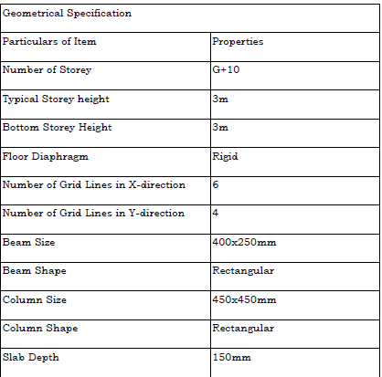

ANALYSIS RESULTS
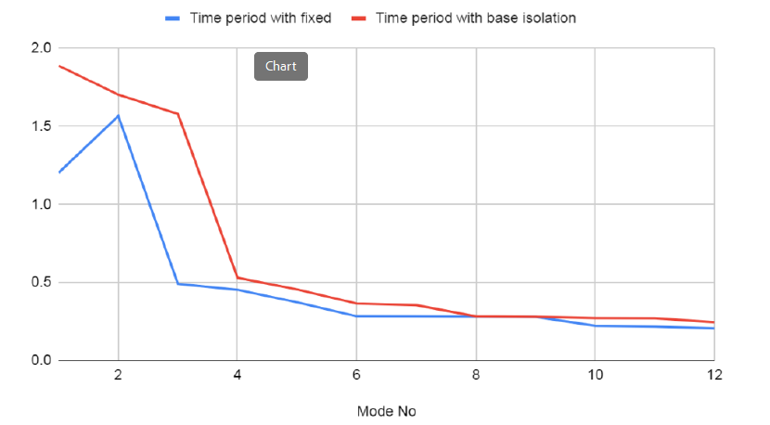
Inference- The natural period of a building is simply a time taken by it to undergo one complete cycle of oscillation. It is observed that time period of the fixed base structure for different modes is lesser than that of the structure which is base isolated structure.
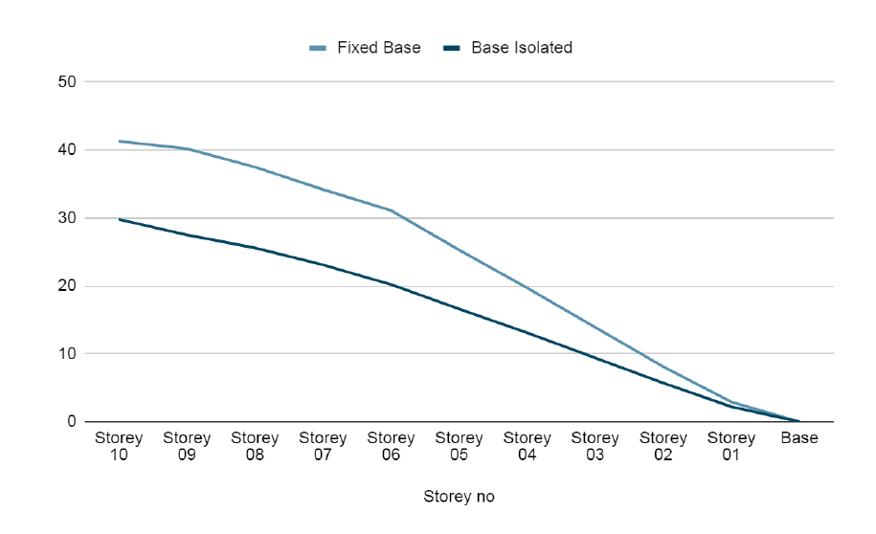
Inference- Lateral displacement is important when structures are subjected to lateral loads like earthquake and wind loads. Lateral displacement depends on height of structure and slenderness of the structure because structures are more vulnerable as height of building increases by becoming more flexible to lateral loads. Lateral displacement was 12.98% higher

Shear Force:
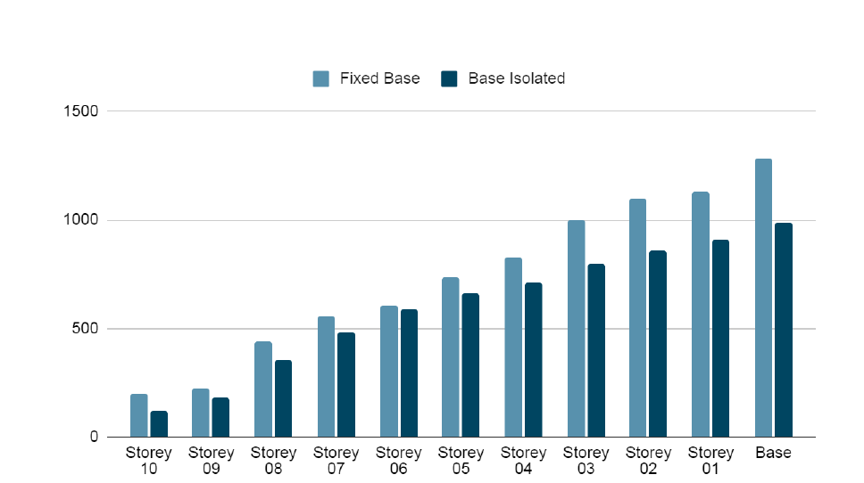
Inference- It is the lateral force acting on a storey due to the forces such as seismic and wind force. Buildings having lesser stiffness attract lesser storey shear and vice versa. Storey shear was 29.8% higher at the top storey of structure with fixed base when compared to structure with base isolated structure.

Conclusion:
In this research, an approximate procedure is generated to perform the seismic analysis of simple and tubular tall building system with base isolation (lead-rubber bearings) system and the outcome compared with the results obtained without base isolation (lead-rubber bearing) of tall buildings. Base isolation system is basically a passive control device which decouples the super structure from substructure resting ground motion by insinuating structural elements with low horizontal stif ness between the structure and foundation. This analysis of G+10 rigid joint plane RCC frame has for two cases. First case is simple RCC frame with fixed base and and second case was RCC frame with base isolation (LRB). The effectiveness of base isolation in every cases was compared with simple frame and tubular system cases and conclusion
Storey Shear
It is the lateral force acting on a storey due to the forces such as seismic and wind force. Buildings having lesser stiffness attract lesser storey shear and vice versa. Storey shear was 29.8% higher at the top storey of structure with fixed base when compared to structure with base isolated structure.
Base Shear
Base shear is the force that is generated at the base of the structure especially due to seismic forces. Base shear was 29.71% on higher side for structure with fixed base when compared to structure with isolated base damping system.

Reference

1. Fevzi Saritas, Idris Bedirhanoglu, Arova Konak and Mehmet Salih Keskin, [Effect of Seismic Isolation on the Performance of High-Rise Buildings with Torsional Instability], Sustainability 2023, 15, 36.
2. Nagalakshmi.P, Poojashree. B. S and Vidya .B. R, [Seismic Analysis of Building using E-Tabs], International Journal of Engineering Research & Technology (IJERT), 2019, ISSN: 2278-0181.
3. Sanivarapu Chandra Harsha Reddy and TheegelaMahendhar, [Seismic isolation of high-rise RC building using lead rubber isolator], International Journal of Advance Research, Ideas and Innovations in Technology, Volume 5, Issue 3, 2019, ISSN: 2454-132X.
4. Nithin A V and Jayalekshmi R, [Seismic Analysis of Multi Storey RC Buildings supported on Single and Combined Base Isolation Systems], International Journal of Scientific & Engineering Research Volume 8, Issue 11, November-2017, ISSN 2229-5518.
5. Rohan G Raikar, Dr.Shivakumara Swamy, Dr. S Vijaya and M. K Darshan, [Seismic Analysis of Framed R.C. Structure with Base Isolation Technique using E-Tabs], International Journal of Trend in Scientific Research and Development (IJTSRD) Volume 4 Issue 5, July-August 2020, ISSN: 2456 – 6470.
6. N Murali Krishna and Md Masihuddin Siddiqui, [Non Linear Time History Analysis of Building with Seismic Control Systems], International Journal of Science Technology & Engineering | Volume 2 | Issue 08 | February 2016, ISSN: 2349-784X.
60

7. Vivek Kumar and Dr. Kailash Narayan, [Seismic Analysis of Moment Resisting R.C. Frame with Base Isolation using Pushover Analysis in ETABSv17.], Journal of Emerging Technologies and Innovative Research (JETIR), June 2019, Volume 6, Issue 6, ISSN-2349-5162.
8. Shaikh Tabassum Sayyad and Vijaykumar Bhusare, [Effectiveness of Base Isolator in High Rise Building for Different Soil Conditions using FEM], International Journal of Scientific Development and Research (IJSDR), July 2016 IJSDR | Volume 1, Issue 7, ISSN: 2455-2631.
9. Suman Verma, Dr. Manish Sakhlecha and Dr. Alok Kumar Jain, [Seismic Retrofitting by Base Isolation and Analysing Through ETABS], International Journal of Trend in Research and Development, Volume 7(5), Sep – Oct 2020, ISSN: 2394-9333.
10. Sushil P. Lipte, Dr. V. R. Rathi and Dr. P. K. Kolase, [Seismic Response Control of RC Building by using Base Isolation System], International Journal of Management, Technology And Engineering Volume 8, Issue IX, SEPTEMBER/2018 ISSN NO : 2249-7455.

