A THESIS

on

Impact of Digital Marketing On Consumer Behaviour

Submitted for partial fulfillment of the requirements for the award of the degree

of

Masters of Business Administration

by

Prajjwal Srivastava

(22GSOB2010155)

Under the guidance of

Prof. Neerav Verma


Galgotias University, Uttar Pradesh – 203201

2023-24
CERTIFICATE

This is to certify that the thesis entitled “Impact of Digital Marketing On Consumer Behaviour submitted by Prajjwal Srivastava , bearing Registration Number 22GSOB2010155, is a record of an original work done by him/her under my guidance and supervision. The thesis has not formed the basis for the award of any other degree, diploma, or similar title to any candidate. The work embodied in this thesis is original and has been carried out by the candidate under my supervision. The thesis is fit for submission for examination and meets the institutional standards.

Signature of the Supervisor

Professor Neerav Verma

School of Business Introduction

ACKNOWLEDGEMENT

I would like to express my sincere gratitude to all those who have helped me in the completion of this thesis on " Impact of Digital Marketing On Consumer Behaviour”
First and foremost, I would like to thank my supervisor Prof. Neerav verma , for her in valuable guidance, support, and encouragement throughout the course of this study. His expertise and insights have been instrumental in shaping this thesis.
I would like to extend my heartfelt thanks to my family and friends for their unwavering support and encouragement throughout this journey.
Lastly, I would like to thank Galgotias University for providing me with the opportunity to undertake this study and for the resources and facilities extended to me.

Prajjwal Srivastava - 22GSOB201155

Table of content
S.no. | Chapter Name | Page No.
1 | Introduction | 05-15
2 | Literature Review | 16-20
3 | Research Methodology | 21-27
4 | Digital Marketing and consumer behaviour | 28-34
5 | Data analysis and interpretation | 35-59
6 | Conclusion | 60-62
7 | Bibilography | 63-65

CHAPTER-1
INTRODUCTION
All businesses in the world have to embrace marketing as a way of life. Marketing encompasses more than just selling products to make money—it also involves meeting customer needs. These days, modern marketing is essential. It speaks of the recognition of the customers' needs and planning the activities to live up to their expectations. According to Mahatma Gandhi, a customer is a valuable guest who presents a business with the chance to serve them. In order to improve customer satisfaction, the current business must prioritize the idea of "consumer delight." In contemporary marketing activities, consumers' needs are identified with respect to goods and services, and goods are obtained from suppliers through ownership transfers. Finding out what customers want, when they want it, where they want it, and for what price is the process that leads to their satisfaction. Production, product, sales, marketing, and societal marketing are the five main facets of marketing.
Since sales of the goods produced should be the ultimate goal of production, distribution is crucial. From production to sale, a combination and systematized setup are needed for this. Product, price, place, and promotion, also known as E. Jerome Mc Cathy's "marketing mix," are the tactical or operational components that are framed to make this task easier. The choices made for the product comprise creating, labeling, packaging, guarantee and warranty, product returns, and all the processes involved in a product's life cycle. Decisions about prices are made based on pricing methods, techniques, price establishment, discounts, allowances, and terms of payment. This is a very important choice because it has to satisfy the customer and increase revenue for the company. The goal of promotion is to increase product sales. Taking into account the competitors, it focuses on the promotional mix, channel, and message frequency. Place, the fourth P in the mix, denotes the market or region where the sale must be made. Later, in 1981, Booms & Bitner created an expanded marketing mix that included three more Ps: process, people, and physical. The procedure consists of all the actions taken to deliver the goods to the customers. Individuals within the company and clients are referred to as 107 to whom the services are being provided. The physical evidence, or the seventh P, consists of the observed physical objects as well as the interior and external environments, signage, symbols, and other physical elements. Every company's success primarily depends on its marketing mix, which must be carefully created by examining consumer demands, rival companies' marketing strategies, and industry comparisons.
DIGITAL MARKETING:
Consumers' obsession with brands has been disrupted by digital media. The 21st-century consumer is an active participant in any given economy. They are referred to as the "King of the Market" because producers would not be motivated to produce without their demand. Conventional marketing structures and tactics are becoming outdated due to the rapid changes in the field of economics. The conventional marketing approaches are no longer viable. Therefore, instead of using any traditional, labor-intensive process, marketers had to advocate for digital marketing as a more sustainable option.
Digital marketing has been regarded as a novel approach to marketing and has given businesses new avenues for business development. Digital marketing activities facilitate fast and geographically-independent direct communication between advertisers and potential customers. One of the greatest ways to get through the clutter and communicate with customers directly is through digital marketing, according to recent reports. The purchasing and selling of goods, information, and services through computer networks or the internet is known as digital marketing. Technologies related to the internet and electronic commerce are revolutionizing supply chains, customer bases, revenue streams, business models, and the overall economy. Every industry in the New Economy is witnessing the emergence of new business models. Online shoppers are thrilled with the quick delivery and easy payment options, which increase customer confidence. Jobs and marriage-related classifieds have been the most successful to successfully migrate to the internet. Electronics and white goods are two of the more popular categories that online retailers are now promoting. Intangible assets like people, brands, relationships, knowledge, and systems are becoming more important in these emerging models.
CONSUMER ATTITUDE ABOUT DIGITAL MARKETING:
The goal of this study is to understand how consumers feel about digital marketing. The survey's findings indicated that consumers had a favorable attitude toward online buying. Customers who use digital marketing cannot touch or see the products before making a purchase. Since the quality of the goods acquired through internet marketing is a top priority, marketers need to make sure that the products they deliver to customers meet their expectations and live up to their promises. Customers' other attitudes are related to product availability, satisfaction, and convenience. These elements demonstrate that marketing offers customers convenience, which online shoppers prefer because it eliminates the need for them to make the effort to visit the store and make their purchases. We can draw the conclusion that consumers have a generally positive attitude toward digital marketing. Online marketing has enormous potential in the future, and more and more companies will add online platforms to give their customers access to longer retailer's shelves. To survive over time, they will need to provide value to the customers, though.
Targeted consumers can be effectively reached with promotional, personalized offerings and pertinent marketing messages through digital marketing.

DIGITAL MARKETING ADVANTAGES:

Empowering impact
Because the Internet can penetrate the market and the operational capacity of small and medium-sized enterprises (SMEs), the introduction of benefited digital marketing has an impact on businesses, particularly small ones. (2020, Clement). Actually, the internet has created a more democratic environment where marketing has been reorganized to allow even small businesses to compete fairly and market their products on a much larger scale (Armstrong, Kotler, Harker, & Brennan, 2018). It's also important to keep in mind that, according to Poon and Jevons (1997), "the Internet generated unprecedented opportunities for small businesses to engage in national and international marketing campaigns which couldn't be achieved due to the enormous amount of capital they needed."

Removal of geographical obstacles
The elimination of all geographical restrictions from the purchasing and selling process is just one of the primary benefits of digital marketing. Thus, the Internet can reach any location in the world at a very slow speed. Due to the high cost of traditional advertising, global exposure was previously only accessible to large multinational corporations. However, with the development of affordable internet technology, small businesses can now benefit from this kind of exposure, as different customer classes around the world can now access the Internet.

Economic effectiveness
One more advantage of internet marketing over more resourceful conventional marketing and ad networks is cost savings. Online marketing is clearly more affordable and can achieve the same results for a much smaller sum of money. (Godess & Mayzlin, 2004; Tan et al., 1997; Warren, Davies, & Brown, 2008; Bell & Loane, 2010; Buhalis & Law, 2008). For instance, it's evident that putting up an online advertisement is far less expensive than running one in a newspaper or on a billboard. Due to the significantly lower cost of a virtual presence when networking with other businesses and interacting with customers, internet marketing enables businesses to keep their revenue streams intact and produces highly valued quality.

Manageability
The ability to monitor campaigns is another aspect of internet marketing. In fact, one of digital marketing's most valuable assets is its trackability (Buttle & Maklan (2019). It is possible to calculate anything that occurs on the website. This makes it simple to figure out how many times a particular advertisement is clicked, as well as how many people visit the website. By keeping track of the quantity of visitors to their website, marketers are able to monitor and evaluate their actions. According to Chaffey et al. (2009), businesses can use the website to determine the effectiveness of their advertising as well as the kinds of customers who are interested in their products and where and how they are interested in them.
Because the internet is still the most transparent platform, the ability to track online customers "increases vividly." Real-time profiling and website log analysis track the quantity of users accessing each page, the order of previously visited pages, the date and time of access, the amount of time spent browsing, the links clicked, and other details." Greene and Granitz (2003).

Integration-Required Channel for Integrated Digital Marketing Strategy:
The following are some real-world instances of how the internet can be utilized as an integrated communication tool to support a multi-channel customer journey:

- Customers can respond to offers and promotions published in other media by using the internet as a direct response tool.
- The website may incorporate a callback or direct response feature.
Even if the purchase is not made through the website, it can still be supported by the internet. For instance, Dell encourages consumers to call a call center representative to place their order by prominently posting a phone number on their website. invites clients to place their orders by calling a call center representative. Benefits of this include Dell being able to track sales that originate partially from the website based on the number of callers on this line and being less likely to lose business from customers who are concerned about the security of online ordering. This is known as mixed mode buying because it takes into account how a customer switches between channels during the purchasing process. Designing online marketing communications requires careful consideration of this important factor: the customer should be assisted in switching between channels.
- To provide what Seybold (1999) refers to as a "360 degree view of the customer," customer information provided on the website needs to be integrated with other databases containing customer and order information, such as those accessed by call center employees.
- Customer service can benefit from the usage of the internet. For instance, before calling customer service, users are advised to review a list of frequently asked questions (FAQ) compiled from prior customer inquiries on easy Jet (www.easyjet.com), which processes more than half of its orders electronically.

Industry restructuring:

Disintermediation and reintermediation are two fundamental ideas in industry restructuring that any business creating a digital marketing plan should take into account. While defining their company's communications strategy, marketers must answer questions like "Which intermediaries should we represent on?" and "How do our offerings compare to those of competitors in terms of features, benefits, and price?" to ensure that the company is represented appropriately on these intermediary sites.

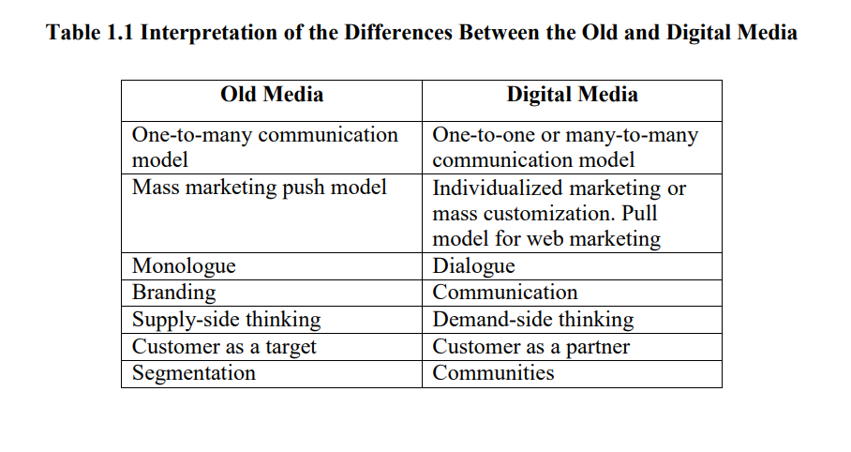

WEBSITE MARKETING STRATEGIES:
Businesses are grouping their clientele and sending messages specifically to each group. When businesses use the web, the sizes of these targeted groups may be smaller; in certain situations, only one customer may be targeted at a time. Recent studies on user behavior on websites have even offered suggestions for how websites should react to users who visit them at different times and with different needs. Through the sale of advertising on their websites, businesses generate revenue in this way.
The majority of businesses refer to the set of components they employ to accomplish their objectives for promoting and selling their goods and services as the "marketing mix." A company refers to the specific marketing mix it chooses to employ as its marketing strategy. A business's marketing plan is a crucial instrument that combines with its online presence to communicate the brand to both present and potential clients.
Any method of getting the word out about the product is considered promotion. There are a plethora of new opportunities to connect with both current and potential customers on the internet. Businesses can use email and other online channels to have meaningful conversations with their customers.
Marketing managers had long-held fantasies of a future where all consumers could get exactly what they wanted, when they wanted it, thanks to instant deliveries. The need to have goods and services accessible in numerous locations is the issue of place. Since the beginning of commerce, businesses have struggled to get the right products to the right places at the right time to sell them. While it can't address every issue related to logistics and distribution, the internet can be a valuable resource. Digital goods, like software, music, videos, ebooks, news, and information, can be provided virtually instantaneously on demand via the internet. Businesses who sell goods that need to be shipped have discovered that the internet provides them with far superior shipment tracking.

CUSTOMER-BASED MARKETING STRATEGIES: The internet provides a platform for sophisticated forms of communication between buyers and sellers. Online communication structures have the potential to grow significantly more sophisticated than those found in conventional mass media, like broadcast and print advertising. When a business goes online, it can make a website that is adaptable enough to satisfy the requirements of a wide range of users.
Companies can design their websites to specifically cater to the needs of different kinds of customers, rather than viewing them as collections of products.

DIFFERENT MARKET SEGMENTS COMMUNICATION:
Finding prospective client groups is only the beginning of the sales process. The choice of communication media to convey the marketing message is a crucial and equally significant aspect of any marketing strategy. Businesses can use building construction and floor plan design to communicate a lot of their messages in the real world. For instance, banks have historically been located in sizable, imposing structures that give onlookers a clear view of the main safe and its thick, robust door. The physical manifestations of strength and dependability that banks use to communicate a key aspect of their service offerings is the assurance that a customer's money is safe and secure with them.
Businesses can use building construction and floor plan design to communicate a lot of their messages in the real world. For instance, banks have historically been located in sizable, imposing structures that give onlookers a clear view of the main safe and its thick, robust door. The physical manifestations of strength and dependability that banks use to communicate a key aspect of their service offerings is the assurance that a customer's money is safe and secure with them.
TRUST AND MEDIA CHOICE:
The internet is a vast intermediate platform that lies between personal interaction and mass media. Many of the benefits of in-person sales as well as the financial advantages of mass media can be obtained by interacting with potential clients online. Figure 1.5 compares the three information dissemination models based on trust, an additional crucial factor.

Even though mass media has the lowest level of trust, a lot of businesses still use it effectively. The vast audiences of mass media allow for the dispersion of the cost of advertising among a multitude of people. For instance, making a television advertisement may cost several hundred thousand rupees, but millions of people will see it. As a result, advertising costs very little per view. Many businesses find mass media advertising appealing due to its low cost.

Businesses can leverage the internet to reap some of the advantages of individual contact, while avoiding some of the expenses related to that strategy. The majority of experts concur that it is preferable to implement the trust-based personal contact selling model online. rather than using the online mass marketing strategy.
New avenues for personal and business communication have been made possible by the internet. On a website, users can share their opinions and invite others to comment. Web logs, also referred to as blogs, are a kind of website that have given voice to strongly held political, religious, and other opinions. A few retailers have been experimenting with blogs as a supplementary communication tool in recent years. These retailers believe that by including blogs on their websites, they will be able to personalize their online stores and provide visitors with an incentive to visit even in the absence of sales. Companies can use blogs as an example of how to use the web to communicate in a way that is more akin to the high-trust personal contact mode of communication than the low-trust.

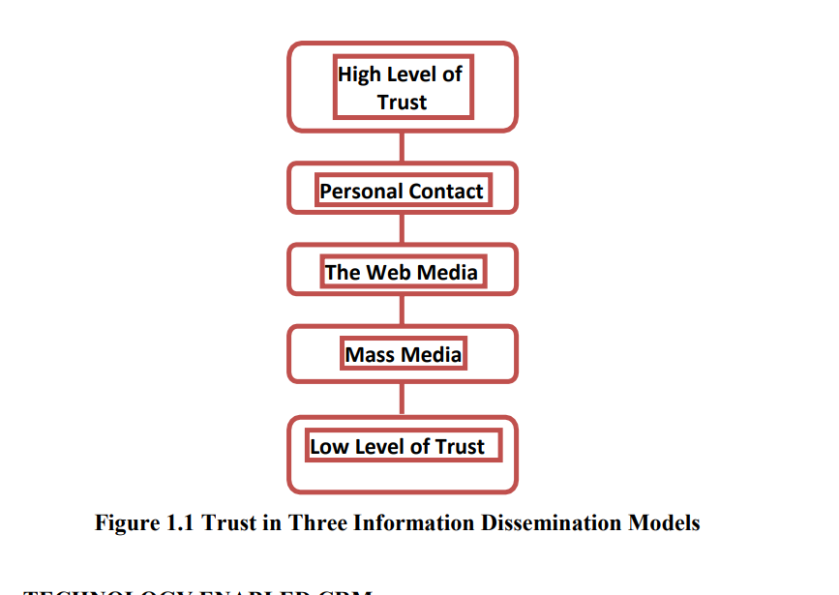

CRM TECHNOLOGICALLY ENABLED:
Due to the web's two-way communication capabilities and traceable connection technology, businesses are able to obtain a great deal more customer data. behavior and recommendations compared to what they can obtain with micromarketing techniques. Businesses can now measure a wide range of events that occur when consumers and future customers research products and services and make decisions about what to buy. A click stream is the collection of data that a website can obtain about its visitors.

When marketing and selling online, the concept of technology-enabled relationship management has become feasible. When a business gathers comprehensive data about a client's needs, preferences, and purchasing habits, it can use that data to customize its entire relationship with that customer, including terms, promotions, price, and product features. This is known as technology-enabled relationship management.
Most businesses currently use technology-enabled relationship management concepts to manage customer relationships, but they can also be used to manage relationships with vendors, employees, and other stakeholders. Customer relationship management (CRM), technology-enabled CRM, or electronic customer relationship management (eCRM) are thus common names for technology-enabled relationship management. The seven dimensions of the customer interaction experience are listed in Table 1.2, along with an explanation of how each dimension is different between traditional seller-customer interactions and technology-enabled relationship management.

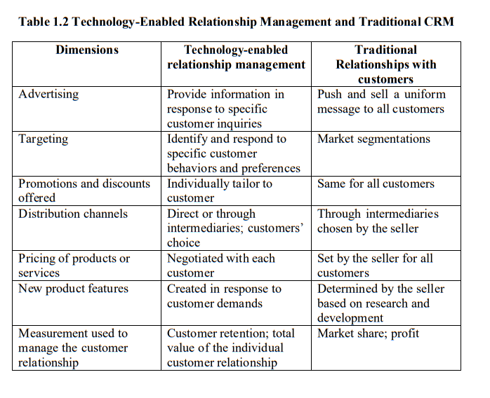
Business Patterns for Digital Marketing:

The Structural Basis It is extremely difficult to comprehend, let alone predict, strategic moves in an unstable market. Students, investors, consultants, and working managers all encounter difficulties when attempting to analyze a dynamic market environment. Volatility in the market makes it harder for managers to see the big picture. Managers should ponder the following queries as the surroundings shift.

- Are we allocating our resources to suitable business ventures?
- Will there ever be financial gain from these opportunities?
- Are we pursuing these opportunities with the appropriate business model?
Managers of old economy companies require the appropriate tool more than ever in the current environment to support and enhance their effectiveness when making significant strategic decisions, allocating limited resources, and managing risk. And why? Because new, web-enabled businesses are starting to take comparatively small portions of the markets held by large, established economy companies, ranging from consumer goods to industrial manufacturing. Because of this, these businesses are beginning to recognize the threat posed by e-business and are moving toward more effective digital strategies that focus on streamlining information flow, integrating value chains, and optimizing customer experiences.

MANAGING RISK
It is obvious that a revolution that is altering the business landscape is just getting started. There will be extreme optimism during certain moments, as with any revolution. One thing is certain, though: e-business is opening up new opportunities for businesses that are willing to adapt. There will be times of extreme pessimism when 122 skepticism rules, but there will also be moments when the potential reveals itself. This same revolution poses a destabilizing threat to the status quo of business as usual for other companies. After everything is said and done, a few significant corporate winners will join the ranks of the world's top businesses.
A cracker is a tech-savvy individual who leverages their expertise to acquire unapproved access to computer or network systems, usually with the goal of stealing data or causing damage to the data, the software of the system, or even the hardware of the system.
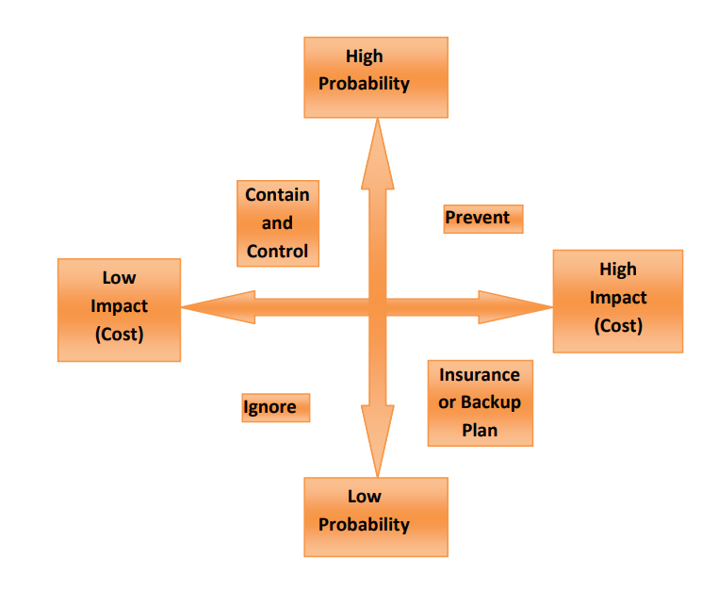

FIGURE 1.3 MANAGING RISK
The word "hacker" was first used to characterize a committed programmer who took pleasure in creating intricate code that pushed the boundaries of technology. While computer professionals still use the term "hacker" positively, sometimes even complimenting those who use it, the term is typically used by the media and the general public to distinguish between bad and good hackers. Organizations need to assess risks, decide how to safeguard assets that are under threat, and figure out how much it will cost to protect those assets in order to put in place a good security scheme. Rather than the costs of protection, the main focus of risk management protection is on the crucial issues of identifying the threats and figuring out how to protect assets from those threats.

SECURITY POLICY AND INTEGRATED SECURITY:
A security policy should be in place for any organization that wants to safeguard its assets related to electronic commerce. A written document that outlines which assets to safeguard, why they should be safeguarded, who is in charge of ensuring that they are protected, and what behaviors are acceptable and unacceptable is known as a security policy. Physical security, network security, access authorization, virus prevention, and disaster recovery are the main topics covered by the policy. The policy is a living document that changes over time and that the business and security officer need to review and update on a regular basis.
Organizations are required by both defense and commercial security guidelines to safeguard assets against unauthorized disclosure, alteration, or destruction. However, because military applications emphasize the separation of multiple levels of security, military security policy is different from commercial policy. Typically, corporate information is categorized as "public" or "company confidential." The standard security policy pertaining to proprietary company data is uncomplicated: disclose no proprietary company data to third parties.
The process of developing a security policy for an organization starts with deciding which assets need to be shielded from what threats. For instance, a business that keeps track of its clients' credit card numbers may determine that those details are an asset that needs to be secured from prying eyes. Next, the company needs to decide who should be able to access different areas of the system. The organization then ascertains what resources are available to safeguard the assets that have been identified. With the knowledge it now possesses, the organization drafts a formal security policy. Lastly, the company invests money in developing or purchasing hardware, software, and physical barriers that carry out the security policy.

In the event that an organization's security policy prohibits unauthorized access to customer data, such as credit card numbers and credit histories, it will need to procure or develop software that ensures complete confidentiality for customers engaging in electronic commerce. A thorough security plan should authenticate users and safeguard the privacy, availability, and integrity of the system. These objectives should be chosen in order to meet the requirements listed in Table 1.4 when drafting a security policy for an online business. A minimum degree of acceptable security is provided by these requirements for the majority of electronic commerce operations.

Figure 1.4 SECURITY POLICY AND INTEGRATED SECURITY
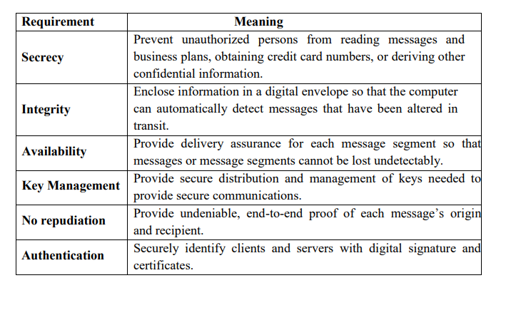
The electronic conduit connecting buyers and sellers is the internet. The internet was not intended to be a secure communication medium, and this is the most crucial thing to keep in mind. Even though the internet originated in a military network, no meaningful security features were intended to be included in that network. It was intended to offer redundancy in the event that a communications line or lines were severed. Put another way, the intention behind the packet-switching architecture of the internet was to offer a variety of alternate routes for the transmission of vital military data. Sensitive information sent by the military is always encrypted to ensure that the contents of all communications, even those that are intercepted, remain confidential. The security of communications between the military's forerunners and the internet.

The internet hasn't really changed much from its early, unsafe form. Internet message packets take an unforeseen route from a source node to a destination node. A packet travels via numerous bridge computers on the network prior to arriving at its destination. Every time a packet is sent between the same source and destination points, the path may change. It is feasible for an intermediary to read, modify, or even remove packets since users have no control over the path and are unaware of the whereabouts of their packets. That is, threats to confidentiality, integrity, and necessity can affect any message that is transmitted over the internet.

ASPECTS OF DIGITAL MARKETING:
To achieve their goals, marketers can use a wide range of digital tools, strategies, and aspects. Every tool or component has a unique set of advantages. For instance, some components aim to attract or acquire new clients, whereas others, like email, are helpful for upselling goods to existing clients.

These are some of the various facets of digital marketing:

- SEO stands for search engine optimization.: Customers can find your company's website among thousands of others thanks to SEO. Companies must improve their online content so that search engines will favor it and display it as one of the top results. It is the method by which customers find your company's website when looking for any goods or services.
- Online advertising is a strategy aimed at characterizing markets through unique online platform actions. It's a marketing tactic that uses the Internet, or World Wide Web, to drive traffic to websites and provide relevant customers with useful information.
- Email marketing: This is the practice of sending a sales message to a prospective or existing customer with the goal of fostering trust, loyalty, or brand awareness. The aim is to strengthen a business's relationship with both present and past clients, encouraging client loyalty and bringing in new business. Its purpose is to persuade present clients to buy something right away.

CONCLUSION:

Digital marketing has grown to be a crucial component of many companies' marketing plans. These days, even a small business owner can use digital marketing because it is both affordable and simple. Numerous restrictions, including those related to company size, location, physical availability, promotions, etc., may be lifted by it. There is a very effective and affordable way for him or her to sell their goods or services. The business could carry out its promotional efforts using both offline and online media. When used properly, digital marketing can help businesses grow. In order to increase incentives, companies should employ more creative approaches and strategies that take into account the various media that are available. Companies ought to make an effort to identify the best course for boosting digital marketing.

According to the study, digital marketing is currently the most popular.Fast and affordable methods of selling goods and services, as well as marketing initiatives that affect consumer choices. The numerous elements of internet marketing have impact the purchasing habits of customers. The study recommended gathering and appropriately applying customer feedback in the appropriate manner. Give the customer excellent service both before and after the purchase.

CHAPTER-2
LITERATURE REVIEW

This is the stage of the research process where a survey of the body of existing literature has been conducted. It is widely accepted that without conducting thorough research, no work can truly envision and soundly complete. what is current in relation to it at this point. This study of previously established, pertinent knowledge in the field allows one to openly observe what has already been illuminated and what is still hidden from view. We can move forward sensibly and firmly after learning what has previously been studied and what has been portioned out. There are incredibly few direct studies that are available for this topic. Actually, no research on this subject has been done in the chosen area up to this point. A thorough understanding of the crucial elements that are significant to the study is required for research. The relevant literature that was available for study proved to be very helpful in determining the methodology and in providing insight into the main goals of the investigation. In India, digital marketing is still in its infancy, and not many studies have been conducted to examine how customers in the country accept and use digital marketing. Although there aren't many studies on digital marketing in the Indian context, theoretical investigation based on various foreign studies. As previously mentioned in the study is limited to just two aspects of digital marketing within the framework of consumer behavior, as discussed in the previous chapter. This chapter has listed every option that is studies that are relevant to the subject and can be traced. Numerous studies have been conducted in this field to date, some of which are discussed below:

- According to Royle & Laing (2014), there are five levers in digital marketing: attract, engage, retain, learn, and relate. Getting and guiding people to a website or webpage where sales are made is the attract portion. The most often used tools in digital marketing are brand recall, search engine listing, enough bandwidth, promotions, piggyback advertising, affiliate programs, and banner ads. The term "engage" refers to 133 customer interest and participation in order to achieve an interaction or transaction. The most popular tools in this area of digital marketing are forums, discussion groups, creative programming, transaction capabilities, informative and useful content, luck draws, and contests. The goal of the retainment phase is to keep present clients faithful to the business or brand. The most popular tools in this area of digital marketing are dynamic content, quick information loading times, security measures, privacy statements, links to related websites, loyalty programs, lowering switching costs through communities, offering online order tracking, and interactive utilities. The learn component involves identifying and understanding consumer behavior in order to accomplish goals. The most often used tools in this area of digital marketing are information capture, webpage tracking devices, feedback via online surveys, feedback through open-ended survey forms, gathering data about potential new customers, cookies, virtual focus groups, and supporting chart groups. The relate portion deals with using the knowledge gained from the preceding stage to build the value chain.

- Vikash Kumar and Vinod (2017) to determine how customers feel about making purchases online. After conducting a factor analysis to understand consumer perception, it was discovered that the most significant factor—since it is intangible—is product quality, which is followed by product availability, convenience, and customer satisfaction. Customers view online shopping favorably and establish a solid foundation for it.

- Senthilkumar (2017)conducting a study with Karur district respondents. The findings have shown that the main elements influencing customer satisfaction were product expertise, safe transactions, individualized attention, dependability, and service support.
According to their scores on attitude, satisfaction, and decision, respondents in cluster one are referred to as moderators,) those in cluster two are referred to as shopping specialists, and those in cluster three are considered no voice (i.e., new entrants). The study also found that gender, family members, and educational background have positive influences. The study comes to the conclusion that online shopping will be successful in this cutthroat market if security and safety are guaranteed.

- Savita Maan et al. (2017) investigated the reasons why young people make online purchases. According to the research, Indian youth prefer to shop only for time-saving and convenient reasons, followed by trendy and fashionable purchases. Additional reasons to shop online include the wide range of products available, the simpler checkout process, the offers made, and the comprehensive product information. The study ends with recommendations for online marketers to offer more variety and trendier, fashion-focused products.

- Balamurugan and colleagues (2017) evaluated the influence of individual factors that influence consumers' decision to make an online purchase. The consumer's purchase decision is influenced by five factors: individual factors, functional value, conditional value, emotional value, and epistemic value. For customers to be persuaded to shop online, they must be identified, and web stores must be involved.

- Sanjeev Prashar et al. (2017) used the Stimulus Output Response (S-O-R) model in a study to determine the impact of online shopping values and cues on consumers' purchasing behavior. notion. The organism is the satisfaction of the web, the response is the intention to make a purchase, and the shopping values have been viewed as the internal and external 135 motivations, respectively. The findings of the analysis indicate that the hedonic shopping value and web entertainment are the primary factors that impact website satisfaction, while the informativeness of the website and the utilitarian shopping value have a less significant impact.

- Shukla Rajeev K (2016). There has been a noticeable difference in the delivery time, friend recommendations, value for money, and product return policies. Male respondents' purchasing behavior is influenced by the duration of product delivery. The female respondents believed that the challenges associated with returning goods, Equated Monthly Installment (EMI) facilities, and referrals from friends influenced their purchasing decisions.

- Vaynerchuk (2011) asserts that since social media involves human interactions (such as positive and negative reviews and word-of-mouth), it is impossible to quantify social media marketing for return on investment (ROI). SMCM uses fan data to improve the company's return on investment. Fedotova (2015) asserts that content customized for big data can boost brand exposure, boost fan engagement, and open up new business prospects.

- Using purchase intention, Yi Jin Lim et al. (2016) evaluated the variables influencing online shopping behavior. It has been investigated the relationship between online shopping behavior through online purchase intention, subjective norms, and perceived usefulness. The results show a strong correlation between purchase intention and online shopping behavior, with subjective norms and purchase intention following closely behind. There is a weakly positive correlation found on the path connecting subjective norm, perceived usefulness, and online shopping behavior. The analysis demonstrates the growing influence of online shopping behavior and purchase intention.

- Yashwant Singh Thakur and Ajay Kumar (2016). According to the study, the most compelling factor is searching for information because it is the least expensive way to learn about product details like availability, price, and guarantee. The ease of accessibility and the lack of traffic jams, crowds, and long lines at the counter to make payments make convenience the second motivating factor for online shopping. The number of happy customers will rise when more people are aware of these factors.

- Sharma, Ajay Kumar, and others (2016). The company's marketing strategies, delivery methods, product diversity, and browsing speed are all factors that the teens have seen as influencing their online purchases. Teenagers are known to avoid impulsive purchases, and the real market is recognized to be the online one.

- In Gangtok, Sikkim, Debarun Chakraborty (2016) investigated the variables influencing online shoppers' decisions. Four factors have been identified as highly influential: products are available around-the-clock, reasonable prices at the doorstep, ease of cancellation or return, and time savings. Customers also perceive risk regarding their privacy and security, as well as when they physically inspect the products they have purchased.

- In 2016, Ather Akhlaq and Ejaz Ahmed evaluated Pakistani consumers' gender-related online shopping characteristics. Variations have been observed in the way that enjoyment is perceived and the legal system. Women like to shop online, and if there are any issues, they would rather shop in a secure setting with legal protections. Women shop online for entertainment purposes and do so in a safe virtual environment.

- Dharvish, Zahra Alipur, and others (2016). According to the study, the marketing mix, subjective norms, and perceived risk have the biggest effects on online buyers' behavioral intentions and actions.

- Vibhava Srivastava (2016) to investigate the aspects of service quality. The constructs that have been measured include efficiency, system availability, fulfillment, privacy, and responsiveness in relation to the intention to shop online. The intention to prefer online shopping is positively influenced by the system availability and the fulfillment variables.
In different e-service quality assessments, the other constructs—efficiency, privacy, and responsiveness—are regarded as inferior.

- Sivasundaram et al., (2016) to determine the elements influencing and reducing the practice of online shopping. The variables are categorized into two groups: those that increase online shopping behavior and those that decrease it. The greatest contributing factor is the product's door delivery, while the lowest contributing factor is the ability to multitask. In a similar vein, the unboxed product received the lowest ranking and lack of actual shopping experience the highest rank in the curtailing variables. The online shopping habits of consumers in both urban and rural areas are distinct.

- Balamurugan et al., Rangasamy Natarajan (2015). The study was carried out among Coimbatore's educational establishments. The intention to purchase online is positively correlated with perceived risk, product attributes, and ease of use. When it comes to online purchases, gender matters more than age or income.

- Neha Dixit (2015) investigated the degree to which consumers accepted online shopping using factors such as e-advertisements, product reliability and inquiry, website design, and nature. According to the respondents, the most crucial elements influencing their decision to make an online purchase are e-advertising, website design and nature, product dependability, and inquiry. Those in the younger age group who responded showed a slow transition towards online shopping.

- A study was carried out by Muhammad Khyzer Bin Dost et al. (2015) to investigate the relationship and influence of factors on consumer behavior with regard to online shopping. The study takes into account factors like privacy, convenience, variety of products, trust, and time. The findings show that trust and convenience have a greater influence on them, as they prefer online shopping when they shop from home and prefer cash on delivery. The influence of privacy on the purchasing decisions of consumers is not greater.

- In 2015, Vidya Shree conducted a comparison of consumer preferences over online marketing websites such as Flipkart, Jabong, Amazon, Snapdeal, Myntra, and Fashion and You. The study found that consumers have a positive influence over payment methods, return policies, privacy policies, delivery times, and the most frequently purchased product being clothing. The study also found that 139 percent of people prefer traditional shopping, which cannot be completely avoided.

- In 2015, Ajay Kumar Chaudhary and Bharat Dadhich carried out a study on a broad range of variables influencing Chandigarh residents' online buying habits. The study has taken into account and assessed the various risks associated with online shopping in conjunction with consumer online shopping behavior. The four elements of product risk, financial risk, convenience risk, and return policy have a big influence on consumers' purchasing decisions. The study's conclusion offers recommendations for steps that online retailers can take to mitigate these risks associated with shopping online.

- Amaravathi and Anand Shankar Raja (2015) evaluated the inclination of consumers towards e-commerce. The dependent variable in this case is the variable technology; the independent variable is the online purchase motivation; the mediating variable is the demographic constructs. The relationship between technology and motivation for online shopping is influenced by factors such as gender and occupation, according to the study. Online shopping is more popular than traditional retail because it offers a host of advantages and benefits.

- Hani A. Jawa and Kamelia Chaichi (2015) evaluated the elements affecting the online shoppers' behavior in Saudi Arabia. Convenience, trust, and promotion were found to have no effect on consumer behavior with regard to online shopping. The quality factor alone influences how consumers behave when they shop online. It is suggested that future research take into account other factors associated with online shopping.

- Indrajit Ghosal and Debansie Chatterjee (2015). The study has evaluated the demographic factors influencing online shopping. The frequency of online purchases and internet possession are more influenced by gender. The respondents feel favorably about shopping online. Given that women shop online more frequently than men do, there should be a greater focus on the female market.

- OVAM Sridevi and BVR Naidu (2015). An empirical investigation was carried out using samples gathered from the East and West Godavari districts to examine how rural consumers perceive OS. Customers consider factors like selection, preference, riskiness, sufficiency and security, and cash on delivery to be important. In addition to a variety of demographic considerations, online shopping is important for residents of rural areas.

OVERVIEW OF THE LITERATURE REVIEW:

The overview of the body of research indicates unequivocally that, as a result of the internet, consumer behavior has changed significantly over the years, giving rise to new marketing scenarios. Conversely, companies are also getting ready to deal with the situation. Generally speaking, the research that is currently available indicates that 169 consumer behaviors were impacted by internet marketing. Given the broad nature of digital marketing, this study focuses on particular subfields within the field that are being investigated, such as digital word-of-mouth marketing (D-WOMM) and online ad banners.

CHAPTER-3
RESEARCH METHODOLOGY
Research aims to uncover new facts related to the process of dynamic changes in society, not just to update existing knowledge and revise existing facts. A methodology is a set of procedures and guidelines that make data collection and analysis easier. It offers the starting point for selecting a strategy based on the topic's definition, concepts, data, and theories (Hart, 1998).
This research study aims to assess the state of digital marketing and consumer attitudes in India today and forecast future developments based on the findings of that assessment. This thesis's title makes it very evident that it is a descriptive research study. Research studies that are descriptive in nature are conducted "in order to accurately portray the characteristics of a particular individual, situation, or group. "Descriptive research studies include those that make specific predictions and that describe facts and characteristics about people, groups, or situations. A descriptive study aims to characterize current circumstances and viewpoints. "Some researchers conducting qualitative research have been influenced by the general view of descriptive research as a lower level form of inquiry to claim methods they are really not using and not to claim the method they are using: namely, qualitative description" (Sandelowski, 2000). The researcher suggested using the qualitative descriptive study method, which is "the method of choice when straight descriptions of phenomena are desired," because the main goal of this study was to comprehend and examine how digital marketing functions in Indian contexts (Sandelowski, 2000).
The investigator has endeavored to approach the research from a qualitative standpoint. According to Zimmer and Dominick (2011), the term "qualitative" describes "a general philosophy and approach to research; a research methodology and a specific set of research techniques." The present investigation endeavors to place the results in the context of an interpretive framework. Descriptive survey research was utilized to identify consumer online behavior as well as their opinions and reactions regarding digital marketing.

RESEARCH METHOD
The research methods and research design used in this study—a mixed research method combining qualitative and quantitative techniques—will be covered in this chapter. In studies carried out concurrently or sequentially, the mixed method approach gathers, examines, and triangulates data that includes non-numerical text (qualitative) and numerical (quantitative) information. Qualitative research offers insights and understanding of the problem setting. Interpretative phenomenological analysis was used in the qualitative portion of the research methodology. According to Smith et al. (2009), p. 11, this approach "provides us with a rich source of ideas about how to examine and comprehend live experiences." This approach allowed to understands and analyze in a deeper way, which will be explained in Chapter 5, by analyzing online behavior of the consumer and their attitudes.

The necessity of research:
This study aims to represent the current state of market research regarding consumer attitudes from the perspective of the marketer. The challenges facing marketers are obstacles and possibilities to draw customers' attention to their brand. On the other hand, as technology advances and consumer behavior shifts dramatically, marketing professionals face increasingly difficult situations. The internet has been a communication tool for traditional marketing companies with their clientele. Furthermore, the majority of people are becoming more active in the digital sphere, making them desirable targets for marketing initiatives given the possibility of obtaining demographic and geographic information as well as personal information. This study aims to demonstrate how, in the current era, people are increasingly reliant on the internet and use it as their main information source. Digital marketing uses a variety of techniques to draw in customers, such as banner ads and user-generated product reviews and ratings, or digital word-of-mouth (DWOM). These are the two widely used digital marketing tools that influence customer behavior.
which causes a significant shift in customer behavior and presents challenges for marketing staff because of the constantly shifting customer demographics in terms of 173 product-related attributes, attitudes, and perceptions, among other things. Everything becomes like the pre- and post-eras of digital marketing, as though they are the two poles of a single coin. In the pre-era, marketing scenarios related to consumer behavior were completely different from those in the post-era, which is the current period of consumer behavior. In this case, the marketing staff must conduct a situational analysis to determine the precise factors influencing consumer behavior patterns.
To demonstrate how digital marketing has affected consumer behavior, a study titled "Digital Marketing and Its Impact on the Consumer Behavior-A Study with Special Reference to Select Cities" is necessary. Though these strategies are still used in the market and some companies may still employ the traditional theories, it appears that traditional marketing techniques on consumer behavior are static instruments that are rarely used in the digital age. However, now is the moment to comprehend the dimensions that represent the state of consumer behavior as it stands right now. An effort will be made to present various facets or dimensions of digital marketing and how it affects customers.
RESEARCH GAP:
To identify the research gap, over a hundred articles about digital marketing and online transactions have been gathered and examined. A research gap is an area or set of unanswered questions in a particular field of study. Most of the research reviews focus on the following topics: consumer attitude toward online digital marketing, consumer perception, consumer satisfaction, gender influences over online purchases, demographic factors involved in digital marketing, and factors 174 that influence digital marketing. Drawing from the results of earlier studies, the subsequent research question is formulated. When conducting a conventional transaction, the
When a person visits a store to choose or buy a product, they do so with the intention of being satisfied. They only make additional purchases if they are the place of purchase. When using digital marketing to shop, the customer buys the product online via websites. Understanding the web-related features that prompted him or her to shop online from the website is crucial. Expectations regarding the merchandise and the website that the customer uses to shop will be specific. Additionally, when a product is ordered, the customer's satisfaction with the website and the product is confirmed when it is delivered and the product is seen in person.
Customer satisfaction is a non-verbal concept, and since websites are growing at an exponential rate, marketing firms face a monumental challenge in achieving it. Customer delight rather than simple satisfaction is the ultimate goal. Online marketing firms must also look into what customers think of their websites, as well as what they expect from them and how reliable they are. Additionally, this study will provide recommendations and ideas for new websites regarding which elements should be prioritized. This research evaluates the features of the product and the website because it is a crucial aspect of digital marketing.
SUMMARY OF THE PROBLEM:
The customers' minds are still closed off to us; they are like a sealed "black box." According to John E. G. Bateson, "We can watch inputs into the box and the decisions that come from it, but we can never know how the act of processing inputs truly happens." Because consumers behave and act differently depending on the situation, studying consumer behavior and attitude is much more complex. Because it addresses a range of levels of factors, including social, psychological, cultural, and personal ones, consumer attitude is described as dynamic and continuous. The dynamic nature of consumer behavior makes it extremely difficult for marketers to comprehend and create products. Therefore, it's critical to comprehend the customer 175 and generate products and services that meet or exceed the needs of the customer. Using the internet is a must these days. Every person depends on technology for their survival in one way or another. According to a UN report, 39% of the 830 million young people who use the internet are from China and India.
Digital marketing is the process of selling and purchasing goods online by individuals. It has progressed from production to this point. Because online shopping follows a similar pattern to offline shopping, the procedure entails going to a website, choosing a product, placing an order, and completing payment by agreeing to the terms and conditions. The introduction of smartphones featuring 3G and 4G capabilities has led consumers to favor online shopping. When making an online purchase, a rudimentary understanding of internet usage is frequently enough.
According to a Counterpoint - Economic Times report, one in three smartphones in India are sold online, making it the country with the second-largest smartphone user base in the world. As a result, consumers' preferences have shifted from offline to online shopping, which attracts customers of all ages and saves time and money. According to a survey done in Tier I and Tier II cities by Google and Forrester, there will be 40 million women among the 100 million Indians who shop online by 2018. The shift in consumer behavior toward online shopping has begun with those who previously valued the tactile experience of a product.
Online retailers have begun to draw in customers by offering a plethora of deals and features akin to in-store shopping, along with convenient return and purchase options, allowing customers to make purchases while still at their physical locations. The Association of Chamber of Commerce (ASSOCHAM) and PricewaterhouseCoopers (Pwc) have identified factors that contribute to the growth of e-commerce. These include aggressive merchandising, discounts, growing brand loyalty, and an increase in the use of smartphones and tablets by consumers. These days, it's not unusual to see offline customers checking the prices of the goods they plan to purchase in-store online. This knowledge helps him or her recognize the value of the thing. Online buying has upgraded consumer knowledge about products, enabling them to make well-informed choices. At this point, the buyer has begun contrasting. The combined use of traditional and online shopping channels has led to 176 online purchases. People are moving from traditional to online shopping due to changes in their purchasing behavior, convenience, and access to reference materials.
QUESTIONS FOR RESEARCH:
The purpose of the following research questions is to determine the current state of digital marketing. A study framework is developed based on these questions. The reason behind the recent glamour attached to digital marketing is a significant issue that the current research attempts to address. In the process of trying to find the answers, another question will surface: what categories of respondents, in terms of their socioeconomic and demographic characteristics, prefer online shopping? It is also investigated if there is a major cause. Additionally, it is necessary to investigate and analyze the product factors that affect purchases made through e-commerce platforms. Furthermore, this study looks for the elements on websites that draw in customers. Moreover, an effort is made to determine.

Hypothesis:

H: 1. There is no connection between gender and being aware of digital marketing strategies.
H:2 There is no connection between the impact of consumer attitude in digital marketing and gender.
H:3 There is no connection between being older and being aware of digital marketing.
H:4 The influence of consumer attitude and age do not correlate.
H: 5 Sharing experiences through PRR (product reviews ratings) and gender are unrelated.
H:6 Age and experience sharing through PRR have no correlation.
H: 7 There is no correlation between the influence of consumer attitude as measured by PRR and gender.
H: 8 Age and the influence of consumer attitude through PRR are unrelated.

PURPOSE OF THE STUDY:
The purpose of this research study was to learn more about Indian consumers' attitudes and how digital marketing functions. The study focused on outlining the different variables involved in digital marketing, consumer attitudes, and their interactions with one another. It also examined how these variables and their interactions affected how consumers processed online marketing messages. The study's primary goals were:
- To investigate the connection between consumer attitude and digital marketing.
- To ascertain Indian consumers' perceptions of digital marketing.
- To evaluate the connection between consumer satisfaction with digital marketing and attitude and demographic and socioeconomic factors.
- To research the aspects of the product that affect digital marketing.
- To ascertain the potential of digital marketing in India going forward.
- To investigate Indian consumers' awareness of digital marketing.
- To examine how digital marketing affects decisions about what to buy.

RESEARCH DESIGN:
A research study's research design serves as a guide or blueprint for its execution. It outlines the process necessary to gather the data required to organize or resolve research problems. For the purpose of this thesis, which investigates how consumers behave and feel about digital marketing tools, in particular online advertising and user-generated product ratings and reviews. The interpretative methodological tradition is used in this study to explain a social phenomenon. In-depth interviews conducted as part of the qualitative method and a survey study using a list of questionnaires as part of the quantitative method make up the research design. The qualitative study's conclusions aid in the structured questionnaire's revision and redesign.
Three stages make up this study: a review of the literature, a qualitative investigation, and a quantitative investigation. The use of secondary sources during the literature survey phase is covered in the first section of the study. A summary of pertinent research issues that were further developed into research questions was the output of this phase. In-depth interviews were used in the second section of the research study to investigate the research questions using a qualitative methodology. The quantitative study is the third phase of the investigation. This research phase collected data from the consumer sample in order to test the conclusions of the qualitative study. A structured questionnaire that was created during the second research phase was used in the quantitative phase.
Phase 1: Survey of Literature:
In this stage of the research study, the body of knowledge and earlier studies on the subject have been reviewed, which has prompted the formulation of research questions and hypotheses for additional investigation. The gathering of research data from secondary sources has been done during this stage of the study. Throughout this stage of the investigation, numerous scholarly and commercial sources have been consulted. This section of the study facilitates the study's design and outline. It is now simpler and quicker to comprehend the entire research topic and research work thanks to the assistance of numerous literature reviews. During this stage, every available platform or source—including journals, articles and e-articles, books and e-books, online theses from previous research, and the web—has been used to obtain information. In this stage, the research gap in the previous studies has been identified. The sources that were used to obtain the secondary data are listed below.
- Books, conferences, proceedings, dissertations, abstracts, research projects, theses, international and national journals, online websites, magazines, institutions, etc.
Phase 2: Comparative Analysis:

This is the study's second phase. The chosen method for examining the suggested research questions is the qualitative research study. During this stage, the sample respondents were interviewed in-depth to collect qualitative data. It was assumed that this research instrument would be suitable for comprehending the behavior of consumers. September 2016 is when the qualitative study's fieldwork was carried out. The research questions were developed with the first phase's output findings in mind in order to assess their potential impact on consumers' decision-making processes when making purchases. These results are useful in creating models of consumer behavior patterns and, ultimately, in formulating survey questions. The open-ended question interview format and face-to-face conversational interview style have been chosen as the interviewing methodology. The sample size of 20 respondents was selected at random to conduct the qualitative study. Every respondent is from a different Indian city. The sample's 180 demographic characteristics are divided into four categories: 18–25 years old, 26–35 years old, 36–45 years old, and 45 years and older.

Phase Three: Analytical Research:

This is the third stage of the study; from September 2020 to January 2021, a quantitative analysis of internet users was carried out. This is an in-person survey that was carried out using a list of questionnaires that had been revised and altered in light of the findings from the first two stages. The surveys are self-administered, and a small number of standard questions have been included from previous research. Both closed-ended and open-ended questionnaire formats have a framework. Only a small number of them had options that were chosen in accordance with the qualitative results. Before going live, the questionnaire underwent a pilot project. The objective of this portion of the study was to gather quantitative data that could be combined with the qualitative data during the interpretation phase. The qualitative study reveals the consumer behavior and attitudes toward online ad banners, product reviews, and ratings. This quantitative study's feature is its cross-sectional descriptive investigation of consumer behavior that was revealed by the qualitative study.

SAMPLING PROCEDURE:

A list of questionnaires was used to conduct a face-to-face field survey for the quantitative research study. Screening questions have been used to filter the respondents' eligibility. There are 800 respondents in India that make up the sample. The sample, which consists of internet users older than 181, was chosen at random.

Location and duration of the survey:

The survey was conducted solely in public areas of various Indian cities where a constant stream of people is present. The data collection process involved conducting a survey that lasted five months, from September 2020 to January 2021. The survey has only been conducted in English.

DATA COLLECTION AND PRESENTATION:

The questionnaire contains both open-ended and closed-ended questions. Respondents were free to skip the survey with a note of gratitude if, at any point during the study, they felt uncomfortable, uninterested, or wanted to stop participating. The incomplete data sheets were not taken into account for the analysis, nor were they included in the 800-person sample size. Even though the instructions were explained at the outset of the survey, respondents were welcome to ask for clarification if they had any questions. The questionnaire is kept as clear and uncomplicated as possible, free of all kinds of ambiguities, technical terms, metaphorical phrases, spelling, and grammar errors. The 5-point scale is used for the majority of the questionnaire. After the survey was finished, the manually collected data—that is, the data on paper—was entered into the SPSS program.

DATA ANALYSIS:

The gathered data was analyzed using the statistical package for social science (SPSS 22 version) and Microsoft Excel, enabling computations and graphical displays of the outcomes.

CHAPTER-4
DIGITAL MARKETING AND CONSUMER BEHAVIOUR
Digital marketing
Digital marketing is the type of advertising that uses all electronic mediums for the purpose of reaching consumers and promoting brands. It utilizes electronic devices, such as game consoles, cell phones, and personal computers. "The use of digital technology to create an integrated, targeted, measurable communication that helps to acquire and retain customers for building deeper relationship with them" is how the Digital Marketing Institute (DMI) defines digital marketing.
More than ever, consumers are in charge. They can shop for goods all over the world and around the clock from the comfort of their homes, circumvent middlemen and distribution outlets, bid on various marketing offerings, and use "intelligent agents" to find the best prices for goods or services.
More products and services than ever before are available for marketers to offer.
The process of digitizing information allows vendors to alter their offerings and charge fair prices for them. In a similar vein, it allows marketers to alter promotional messaging meant for a large audience. For example, Amazon.in notifies previous book buyers through personalized emails about recently released books; the recommendations are based on the interests of the targeted customer as determined by their previous purchases.
Customers and marketers are progressively interacting and exchanging instantaneously. In traditional advertising, a large sum of money is spent by the marketer to reach a large number of potential customers through a mass medium. The marketer then evaluates the effectiveness of the messages through follow-up sales or market research. Conversely, digital communication allows for a two-way interactive exchange in which customers can respond to a marketer's message instantly by, for example, clicking on links within a website or even by visiting another website. As a result, instead of depending on feedback that is received later or sales data that is gathered after the fact, marketers can quickly assess the success of their promotional messaging.
AVAILABLE WITH DIGITAL MARKETING: Enhanced Pricing The intriguing aspect of digital marketing is that since products are sold straight from the manufacturer or seller and don't pass through any middlemen, it allows for lower prices and the best deals to be found from online retailers. The majority of internet retailers provide rebates and discount coupons. Aside from this, even if an online retailer purchases from a store abroad, they are only obligated to collect sales tax if they maintain a physical presence in our state.

Variety: A variety of goods and brands from various vendors are available in one location. It is possible to follow contemporary global trends without having to pay for airfare. The minute shop online is not constrained by location and allows customers to purchase from merchants located across the nation or even the globe. More colors and sizes are available in these stores than in your local area. Aside from that, how many times have you paid a local store and discovered that the product you needed was out of stock? Certain online retailers possess the capability to receive orders without inventory and dispatch them sequentially as soon as the stock arrives.
Send Gifts: Purchasing gifts online for friends and family is convenient. simple, wherever they may be staying. Currently, there's no need to give a detached explanation for missing out on gifts on milestones like wedding anniversaries. Celebrate Mother's Day, Valentine's Day, your birthday, etc.
Comparison of Prices: We can compare prices and conduct research on products and reasonable prices thanks to online retailers. Online retailers also allow customers to share information and reviews with other customers who have used their products or services directly.
Crowds: Only during special occasions and festivals, can the crowds be quite unbearable. Most of the time, crowds make shopping difficult. When it comes to finding a parking spot close to where you want to shop and returning to your car with full shopping bags, crowds also pose an issue.
Compulsive Shopping: Due to salespeople's persuasive tactics, most people who go shopping eventually wind up purchasing unnecessary items. Occasionally, even compromising on options due to the limited selection in those stores
Trading of Old or Unused Items: Online stores make it possible to purchase and sell used or old items at a discount. This is the greatest option compared to physical stores for anyone looking to purchase antiques.
Effectiveness and Cost-Effectiveness: Digital marketing is said to be less costly than traditional, customary, and conventional marketing. Due to the fact that startups wishing to conduct business online can do so without having to invest in opening new locations to sell goods and services. Additionally, both new and established businesses can lower some of their expenses, such as the price of printing brochures, pamphlets, or catalogs to introduce new products and services to the market. Additionally, since the majority of services and communications are conducted online, businesses can cut staff in certain departments, which lowers overhead expenses.
Global Reach and Access: People can visit websites from anywhere in the world as long as they have an Internet connection thanks to the information technology era. For businesses that conduct digital marketing in addition to conducting business online, this feature becomes advantageous. During that time, the recipients can learn about businesses, their products, and services, make purchases or establish connections with other people, and so forth. Businesses can use the Internet to start marketing campaigns and promotions, and anyone with access to the website can view it from anywhere in the world. Due to the expansion of the market, having an online presence can give businesses the opportunity to reach a larger audience than they would with offline marketing.
Time: The public has constant access to the websites of the companies throughout the entire day, seven days a week. One benefit of digital marketing is the availability of email, auto responders, and frequently asked questions (FAQ). It facilitates time savings. for the time of business employees as well as for customers who search for the answers to some frequently asked questions.
Space: Businesses can store an infinite amount of information about their brands on the Internet, along with their products and services and other essential data like press releases, reports, videos, financial data, and banner ads. Businesses can store as much data as they like, and hosting a website only costs a small amount of money each month.
Interactivity: Online marketing has the potential to increase communication between businesses and customers. The public can comment on products and services by leaving a message on the websites. People are able to ask questions of businesses and receive prompt, courteous responses. The public can concentrate on the particular information they wish to view on a website as opposed to general information from television advertisements about businesses, products, and services. Businesses can learn more about their prospects and customers by conducting research and surveys on their websites. Companies, for example, would like to know who visits their websites, what information they are looking for, what interests them, and what kinds of products and services they like and dislike, along with the reasons behind their preferences.

DIGITAL MARKETING LIMITATIONS:
Information: The internet is regarded as a vast and comprehensive source of information. It is updated daily and at all times by people from all over the world. Therefore, the company website needs to be updated frequently and efficiently to avoid falling behind the websites of its rivals. Products and services should be updated and varied in order to keep up with current trends, particularly in the fashion industry. The Internet has made it possible for the general public to view multiple websites simultaneously, compare prices, and learn about new products and services. If the company's product or service details are out of date and do not offer competitive pricing, it.
Security: There are still a number of security issues in the dot.com world. populations using the Internet, ranging from the general public to government organizations. It is something that consumers and businesses must deal with. An enterprise should employ a variety of techniques to safeguard its data from viruses and other cyberattacks, such as encrypting it, keeping it in multiple safe locations, and so forth. There are numerous well-known accounts on the Internet of payment process fraud. This is the reason why many online addressees are reluctant to make online payments.
Digital marketing channels for communication:
Every single company wants to aim for the common goal of making their marketing objectives successful. Everyone wants to improve their current relationships with customers, build new ones, increase sales, and establish themselves as industry leaders. A business can achieve optimal results by integrating traditional and Internet marketing strategies. However, Digital Marketing 192 is also a potent tool that can optimize efficiency in the online setting. Because digital marketing strategies are structured with these channels in mind, marketing channels are just as important in digital marketing as they are in traditional marketing. Search engine marketing (SEM), search engine optimization (SEO), email, social media, content, events, websites, and ad banners are the most often used digital marketing channels.
SEO stands for search engine optimization: According to Awad (2007), a search engine is a website or database that has the tools to create statistics and databases and searches its contents for "keywords" that describe what the user is looking for. On the Internet, search engine optimization, or SEO, is a well-known and widely used term. According to Charlesworth (2009), 178, it is also defined as "the process of making a website visually appealing to a search engine by providing its code and content in a way that the search engine will take up and address a specific review from a (human) searcher."
E-MAIL MARKETING: The content of this email is typically created for commercial, endorsement, and promotional purposes; occasionally, it just contains news. For example, an online user will receive emails with news about any product or field they are interested in and have signed up for on the website. The user has the option to unsubscribe from receiving such emails if they so choose. One of the most important tools in digital marketing is email marketing. Although it is experiencing a crisis due to the ongoing spam attack, it is still an important tool for digital marketers, especially when it comes to maintaining ongoing relationships with current customers and prospects who have made the decision to receive information.
SOCIAL MEDIA MARKETING: Using social networking websites as a marketing tool is known as social media marketing, or SMM for short. Creating content for users to share on social media is the aim of social media marketing (SMM), which helps businesses reach a wider audience and increase brand awareness. Social media optimization is one of the key components of SMM (SMO). Similar to SEO, social media optimization (SMO) is a tactic used to attract remarkable and fresh visitors to a website. SMO can be divided into two categories: sharing buttons and encouraging social media activity through tweets, status updates, blog posts, and the addition of social media links to content, such as RSS feeds.
Content marketing is a strategic marketing approach that involves producing and disseminating valuable, consistent, and relevant content to attract and hold the attention of a specific audience and ultimately encourage profitable customer action. Although the value of excellent content has always been understood, Google and other search engines now rank pages according to the quality of their content.
SMART PHONE APPS: With the ability to improve a business's bottom line, mobile apps are revolutionizing how brands interact with consumers. A recent study from Iowa State University found a direct correlation between app use and purchase activity: users who find an app to be more engaging will spend more money. Globally, smartphones have become a widely preferred option for mobile phones. Feature phones cannot match the advanced services that smartphones can offer. They have also altered how users distribute and search for information. Using smartphones and the Internet, businesses and consumers can share information at any time and from any location. Consequently, the proliferation of smartphones has brought about revolutionary shifts in consumer behavior.
BANNER ADVERTISING DIGITALLY: A web banner, also known as a banner ad, is a type of online advertising that is provided by an ad server. This internet advertising technique results in the implanting of an promotion onto a webpage. By linking to the advertiser's website, it is intended to increase traffic to a website. As the advertiser examines their log files, they discover that a user has clicked on an ad banner to leave the content site and visit the advertiser's website instead. The most common forms of website advertising are image-based rather than text-based displays that run across the top or bottom of a page or down the left or right sidebar. Banner advertising's goal is to either attract attention to a brand or to promote it.
Marketing through digital word-of-mouth (D-WOMM): WOM is tailored to the culture of the digital network. Word-of-mouth advertising is a very effective form of advertising. It possesses an exponential influence that is overtly enhanced by the network economy's significance and online communication channels. Referrals are nothing new. People have been discussing products, services, brands, and their feelings, experiences, and needs on a regular basis. New types of online communities were created as a result of the introduction of social media and interactive, which also improved the function, trends, and effects of word-of-mouth communication.
Product reviews provide thorough remarks, explanations, or assertions regarding goods and services reviewed by other customers. Typically, this kind of content has a longer format and offers in-depth analysis. Product evaluations also appear as reviews from experts, in which case the information is regarded as edited or professional.
Product and service ratings are the users' evaluations of value, typically expressed as numbers (or stars) or as positive (thumbs up) or negative (thumbs down) ratings. This is the most condensed form of product evaluation, and it is shown as a cumulative value in figures.
User recommendations are a condensed form of client endorsements regarding goods or services. They typically offer individualized perspectives devoid of in-depth analysis.
A CONSUMER'S LEGAL VIEW OF THE DIGITAL WORLD:
The ease with which users can access content is one of the main advantages of the digital environment. Content from individuals, public and private sectors, and nonprofit organizations, among others, is included in this. While the primary focus of this study is not the legal implications for consumers in the digital environment, it is nonetheless important to note some of the surrounding aspects.
Digital Payment Access: About 48% of Indian internet shoppers have fallen victim to retail fraud, according to the 2017 Asia Pacific Fraud Insights Report. The government, corporations, and people all took notice of the report. Stricter regulations are required for payment access in the digital sphere, and the government must take decisive action to address this problem.
INACCURATE, DAMAGED, OR FAULTY PRODUCTS WHEN PURCHASING ONLINE:
Because products aren't physically available for purchase when making an online purchase, Customers are depending on the pictures that are posted on the websites. Nonetheless, it has been noted that online shoppers frequently receive damaged or incorrect merchandise instead of what they ordered. Government action is required due to the legal implications for the return, refund, or exchange policies on digital platforms.
PERSONALITY OF CONSUMER RELATING TO DIGITAL MARKETING:
The field of consumer attitude is a part of a marketing strategy that emerged in the late 1950s. Initially, marketers realized they could sell more products more easily if they produced only the products they were certain consumers would buy. Rather than trying to persuade customers to purchase what the company already produced, marketing-oriented firms discovered that it was easy to produce the products they had first determined through research were in high demand. The needs and wants of the customer became the company's main priority. Consumer behavior is defined as "the mental and emotional processes and the observable behavior of consumer during searching for" by James F. Engel, Roger D. Blackwell, and Paul W. Minored.
BUYING DECISION PROCEDURE: Every consumer goes through a number of stages in the decision-making process when making a purchase (Einhorn and Hogart, 1981; Engel et al., 1986; Huber, 1980; Humphreys and Berkley, 1983; Carroll and Johnson, 1990). The five stages of the model used in this thesis are as follows: identification of a physical need or a desire to own a product (Payne et al., 1978); information search regarding availability, price, warranty, technical features, etc. (Bettman, 1979; Bettman et al., 1998); assessment of alternatives through brand, model, or product attribute comparisons; purchase decision to complete the financial transaction (Johnson and Payne, 1985); post-purchase behavior in which the evaluation of the purchase results in satisfaction or dissatisfaction with product 200 Performance (Green and Wind, 1975; Nisbett and Wilson. (Leavitt et al., 1981) Low-involvement enerally linked to impulsive buying and heavy involvement with pricey goods and services, like consumer durables (Day and Ash, 1979; Oliver (1979)
DEFINITION OF TERMS: Because this thesis studies two broad topics, namely consumer behavior and digital marketing, it is necessary to condense the study by focusing on two areas or channels of digital marketing: online banner advertising and digital word-of-mouth (D-WOM), as well as the stages of the purchase decision process and consumer attitude from the consumer behavior subject to examine the influence on consumer behavior.
- Banner advertising: The study's first section focuses on an as-yet-unanswered question: Does banner advertising influence consumers' decision-making processes when making purchases? Specifically, the websites or web pages are not mentioned in the advertisement banner. This implies that the location of the Ad 201 banner on websites is taken into account when determining its influence on user behavior.

- Digital word-of-mouth marketing (D-WOMM): Product reviews, ratings, and user recommendations are examples of digital word-of-mouth marketing that have been taken into consideration in this section of the study. The significance of user reviews and ratings within this ecosystem of websites that correspond to users' search habits when looking for DTP information will be examined in this thesis.

- Search engine optimization (SEO): SEO helps potential clients find your company's website among thousands of others. Companies must improve their online content so that search engines will favor it and display it as one of the top results. It is the method by which customers find your company's website when looking for any goods or services.

- Social Media: These are the ads that users are shown on social media platforms. Advertisers analyze the information that users regularly store on social media, such as their preferences, gender, and age. Advertisers typically utilize user demographic data to tailor their ads appropriately.

CHAPTER-5
DATA ANALYSIS AND INTERPRETATION
Qualitative and quantitative information about consumer attitude and digital marketing
Qualitative Data: The relationship between consumer attitude and digital marketing. The research design and data collection techniques for the two studies were covered in the previous chapter; these chapters will present the findings. This chapter is divided primarily into two sections: the quantitative study is represented in the second section, and the qualitative study is represented in the first.
Section 1: Overview of Qualitative Research
A few significant variables and findings from the respondents of the research study's sample population are acknowledged in this section. The research findings from a qualitative study with 20 respondents will be presented in this section. The data was gathered through a process of in-depth interviews that explored research-based questions. The non-numerical data used in qualitative techniques cannot be calculated. Qualitative data is gathered through depth interviews, semi-structured interviews, and structured interviews. This study explains how online advertisements affect consumers' attitudes and how those attitudes affect their purchasing behavior. The findings will be evaluated in relation to the pertinent areas that are also critically important to help consumers make wise decisions more successfully.
Qualitative Research - Experiments
Twenty responders made up the sample for this section of the study. The screening questions were used to narrow down the responses. The duration of the interviews varied based on the activities and involvement of the respondents. The September 2020 qualitative study was carried out. When asked if they would like to be audio recorded, most respondents said yes, but a small percentage said no.
The Sample's Demographic Details
Four age groups were used to categorize the study sample. Participants in the first age group ranged in age from 18 to 25, those in the second age group from 26 to 35, those in the third age group from 36 to 45, and those in the fourth age group from 46 and beyond.
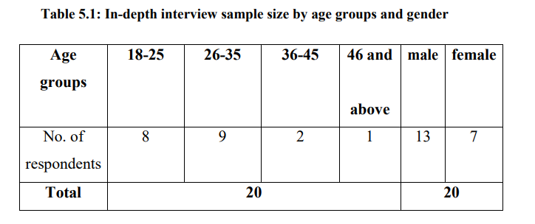
It was assumed that there would be a notable variation in internet usage across age groups in relation to the age differentiation among respondents. Those between the ages of 18 and 45 use the internet more frequently than those 46 and older. As a result, consumers are exposed to these types of online content more frequently. Online content such as ad banners and DWOMM may therefore influence consumers' purchasing decisions and attitudes to varying degrees. Moreover, there was a gender distribution within the sample.
Qualitative Data: The responses' various remarks and opinions regarding digital marketing and their mindset will be examined in this section. First research question: Users are constantly drawn to digital marketing and online advertisements. Age group of female respondents: 26–35 years. Yes, each time I access a website. The website has a wide variety of advertisements. I find some advertisements to be appealing, while others are not. These advertisements typically provide 206 details about deals and discounts, which I find to be really helpful.
Conclusion:
In response to the question of whether or not advertisements and digital marketing consistently grab users' attention, it has been determined that most respondents are aware of digital marketing in one way or another. The respondents have outlined several specific reasons for paying attention to it, including its content, images, sizes, allocations, etc. However, comments such as those made by respondents indicating that online advertisements and digital marketing divert attention away from the browser could be a plausible explanation for those who are not paying attention. Additionally, it was concluded from the comments that the representation of women in the digital banner draws attention to it, which raised serious concerns about the digital banner about.

Summary of findings:

- This section has addressed a number of queries regarding online advertising and digital marketing, including the following:
- Online advertising and digital marketing give consumers vital information.
- The attitude of consumers is influenced by digital marketing.
- The consumer's attention is drawn to online advertisements primarily by their size, content, images, and messages.
- Not a single respondent has ever bought a product as a result of an online advertisement.
- Several respondents have, however, made purchases as a result of online advertisements.

Introduction: The quantitative research data of 800 respondents, gathered from an online survey of internet users in several Indian cities, is thoroughly examined in this chapter. 18 years of age or older. Before the survey was launched, the questionnaire underwent a pilot study.
Display of the gathered information:
This study includes 800 respondents from various Indian cities. After the respondent's data is filtered to show their age groups, genders, levels of education, and occupations, the data is gathered.

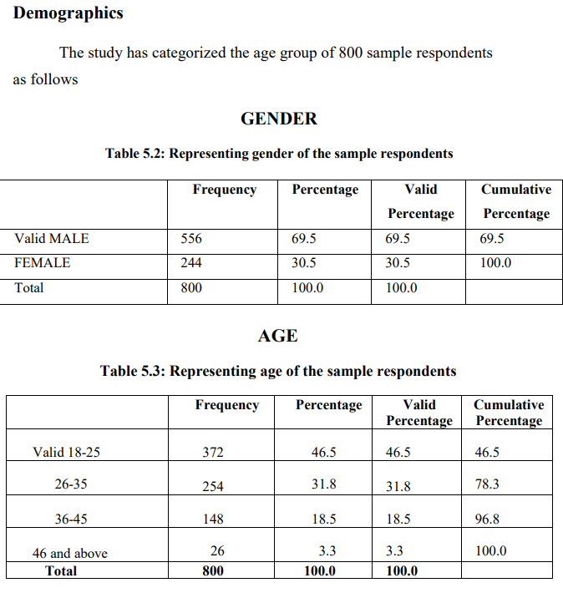
FINAL VERDICT
The following was the sample structure for this survey. The age group that represented 46 and above, or 3.3% of all respondents, was least represented, with respondents aged 18 to 25 making up the majority of respondents, or 46.5% of all respondents. 30.5% of respondents are female, and 69.5% of respondents are male. The majority of respondents had graduate-level education, the second majority indicated undergraduate education, meaning that many undergraduate students fall into this category, and the least number of respondents had a Ph.D. Students made up the majority of participants, followed by employees in second place and housewives and those with rental income in the last group of respondents. These indicators all clearly show that respondents' diversity is quite high. The results will be presented in the next section.
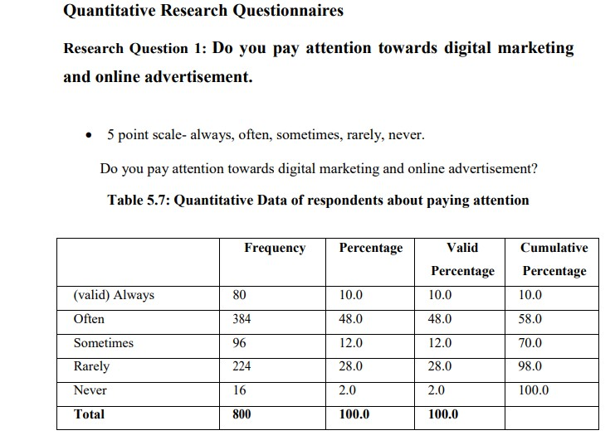

The respondents have been asked about whether they pay attention towards digital marketing and online advertisement. From the above table, it has been 212 observed that about 10% of respondents answer that they always pay attention towards digital marketing and online advertisement, whenever it does appear on the Web Pages. About 48% of the respondents have answer that they often pay attention towards online advertisement. Around 12% of the respondents have answer that sometimes they pay attention towards digital marketing and online advertisement, whenever it display on the WebPages. About 28% of the respondents have answer that they rarely pay attention towards digital marketing and online advertisement. whenever it does appears and only 2% of the respondents have answer that they never pay any attention towards
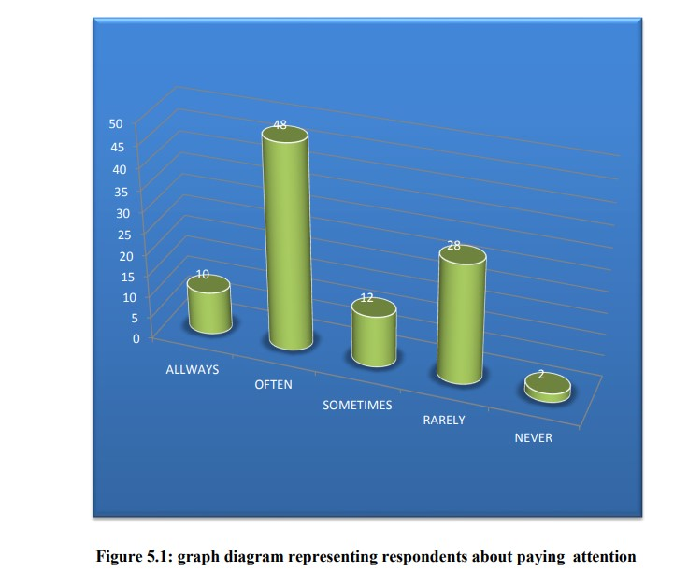
In the age of digital world, it has been witnessed that the appearance of online advertisement on margins of the websites or Web Pages has been increased drastically over a decade period of time and it becomes one of the most popular tool of digital marketing for having its special feature of interactivity which is a big disadvantage of 0 5 10 15 20 25 30 35 40 45 50 ALLWAYS OFTEN SOMETIMES RARELY NEVER 10 48 12 28 2 213 traditional marketing.
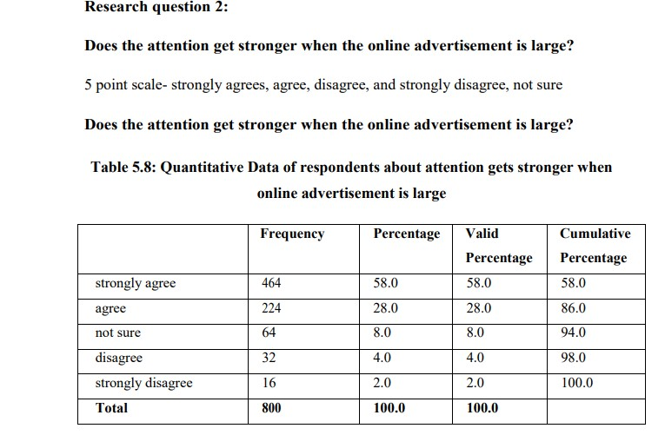

When an online advertisement is large, respondents are asked if they notice a stronger level of attention. According to the above table, 28% of respondents agreed with the question, while 58% of respondents strongly agreed that a large online advertisement increases their attention. Only 2% of respondents indicated that they strongly disagreed with the statement that a large advertisement banner attracts more attention. Approximately 4% of respondents disagreed with this statement. Furthermore, 8% of the respondents said they were unsure of their response.

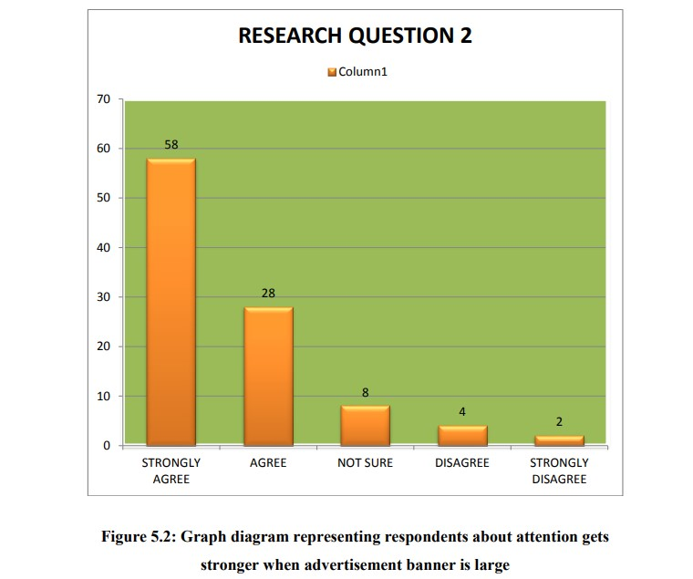
Respondents do concur that drawing attention to an advertisement depends in large part on the size of the banner. Thus, it is acceptable to justify the efficacy of advertisements. banner that takes up more space. Here, advertisers can maximize by utilizing large ad banners that may draw users in and encourage impulsive purchases.

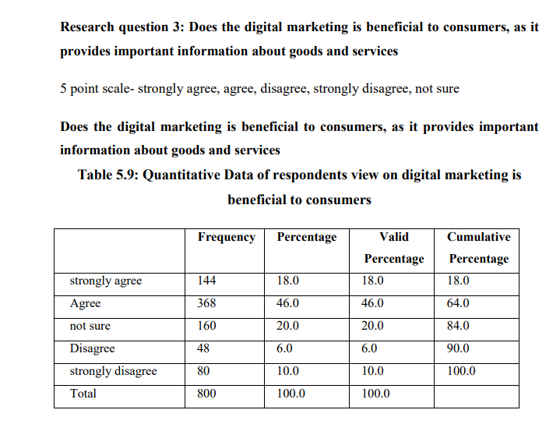

The question of whether digital marketing benefits consumers because it gives them access to crucial information about products and services was posed to the respondents. Of all respondents, about 18% strongly agreed with the statement, and about 46% agreed that consumers benefit from digital marketing because it gives them access to crucial information about products and services. However, 20% of respondents disagree with the statement, 6% strongly disagree with the statement, and 10% of all respondents indicated they were unsure about the statement.

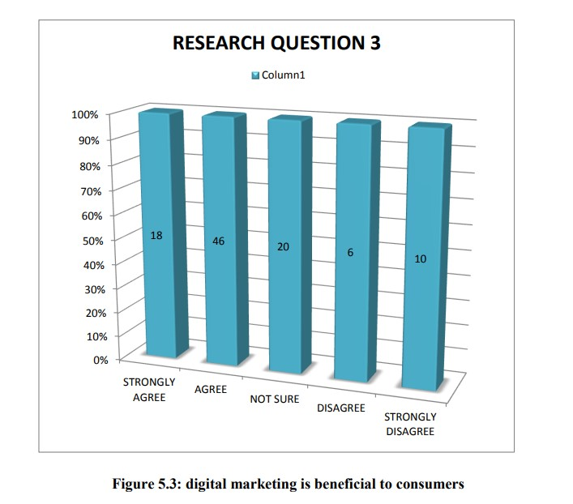

This was a crucial research question since it tries to find out what people really think about digital marketing and whether they think it's beneficial or not. Nonetheless, the aforementioned figure makes it abundantly evident that the majority of respondents agreed with the assertion that consumers benefit from digital marketing because it offers crucial information about products and services. One of the most complete and useful tools available to marketers for informing final consumers about their goods or services is digital marketing. However, a sizable portion of all respondents indicated that they disagreed with the statement and thought that digital marketing did not benefit consumers. Perhaps these respondents.

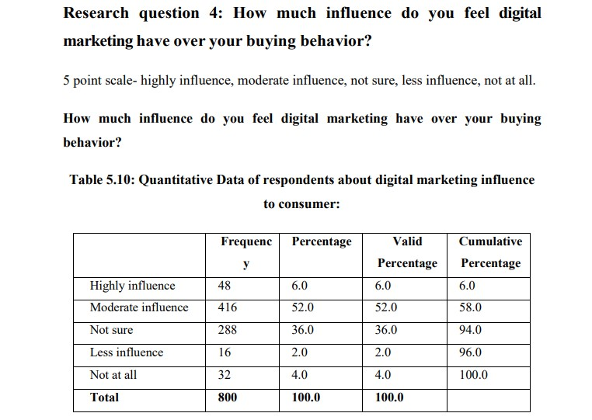

- How much of an influence do you feel that digital marketing has on you, the respondents were asked?
possess control over your purchasing habits. A little over 6% of all respondents indicated that they believed digital marketing had a significant impact on their purchasing decisions, but 52% of those surveyed indicated that digital marketing had a moderate impact on their purchasing decisions. About 36% of respondents said they were unsure whether digital marketing had an impact on consumers' purchasing decisions. Merely 2% of the entire sample indicated that they believed digital marketing had less of an impact on their purchasing decisions. However, a mere 4% of participants indicated that digital marketing had no impact whatsoever on their purchasing decisions.

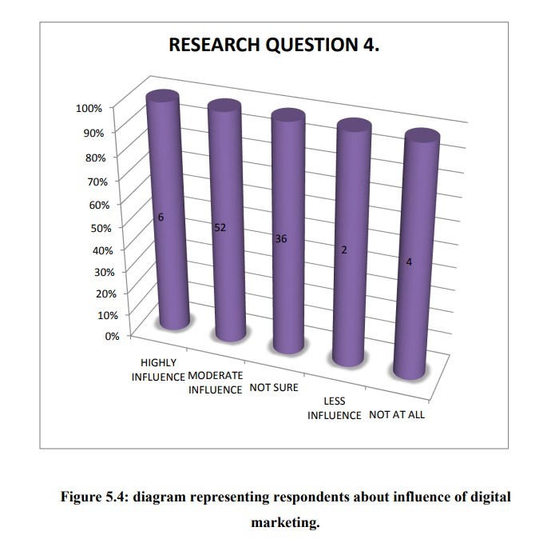
Consumers are attempting to engage with brands in different ways now than they were a few years ago. The old-fashioned marketing approach is becoming less effective every day. Digital marketing strategies revolutionize the advertising industry in today's globalized and competitive world by enabling interactive relationships with customers through visually appealing advertisements and messages. Power relationships are created between businesses and their customers through digital marketing. The traditional advertisement does not allow for much interaction between the brand and the customer. However, the idea of an advertisement has evolved thanks to digital marketing, which increases product exposure when internet users view the advertisement. The majority of respondents had influence over the online advertisement, according to the survey results.

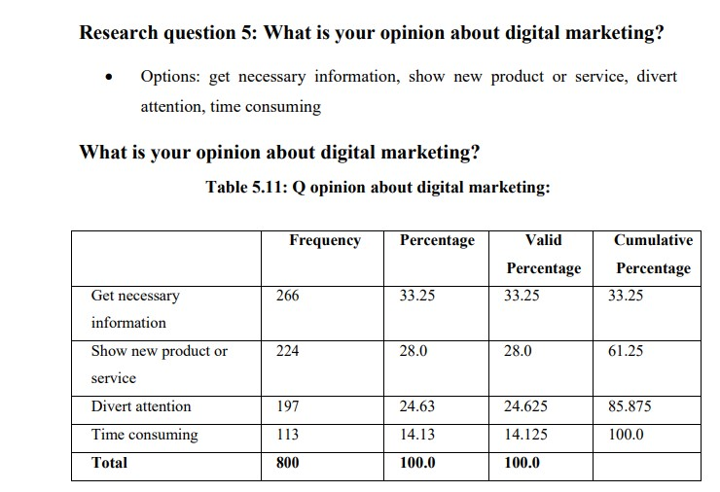

According to the above table, roughly 33.25 percent of all respondents indicated that they hold the view that digital marketing gives essential information, while 28% of respondents said that it displays new products or assistance. In contrast, 14.13% of respondents said that digital marketing takes a lot of time, while 24.625% of all respondents said that it takes their focus away from the browser.
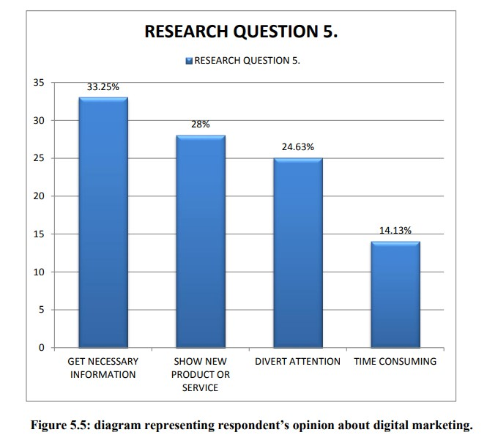
Due to a deficiency of knowledge regarding digital marketing, the respondents' initial responses are typically neutral, blank, or even negative. Respondents to this survey acknowledged both the advantages and disadvantages of digital marketing. This seems to have potential and worth for digital marketing, and it investigates the factors that influence user attraction to online marketing. The majority of participants in this survey acknowledged that they had positive opinions about digital marketing. It supports marketers' efforts to draw customers by promoting new products and disseminating important information. Promoting a product with a target audience that pays close attention to what is advertised is crucial. Additionally.
Display of the gathered information:
135 The results gathered from 800 respondents are presented in this study. The information is
obtained solely following the respondents' filtering.
Demographics: The age groups, genders, levels of education, and occupations of the sample respondents were already described in the previous chapter. Nonetheless, since the sample respondents are identical in D-WOMM and digital marketing, both study areas. Therefore, the respondent's demographic details are not reiterated in this chapter.

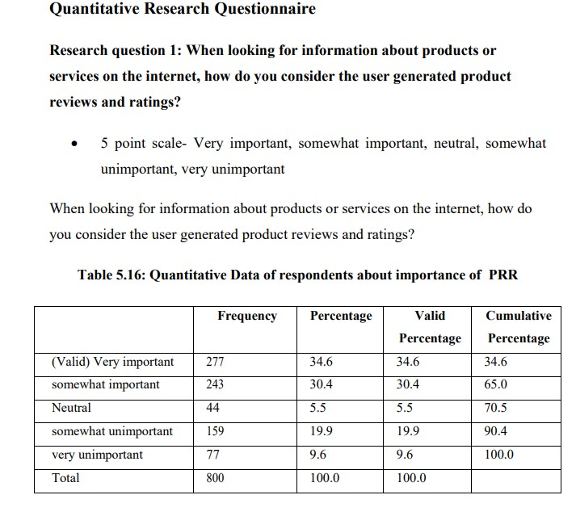
When searching the internet for information about goods or services, the respondents were questioned about how they viewed user-generated product reviews and ratings. Of all respondents, about 34.6% indicated that they thought of users. rated and reviewed products as highly significant, while 30.4% of respondents thought they were only marginally significant. About 5.5% of respondents said they find user-generated product reviews and ratings to be neutral, 19.9% said they find them to be somewhat unimportant, and just 9.6% of all respondents said they find user-generated product reviews and ratings to be extremely unimportant when searching the internet for information about goods or services.

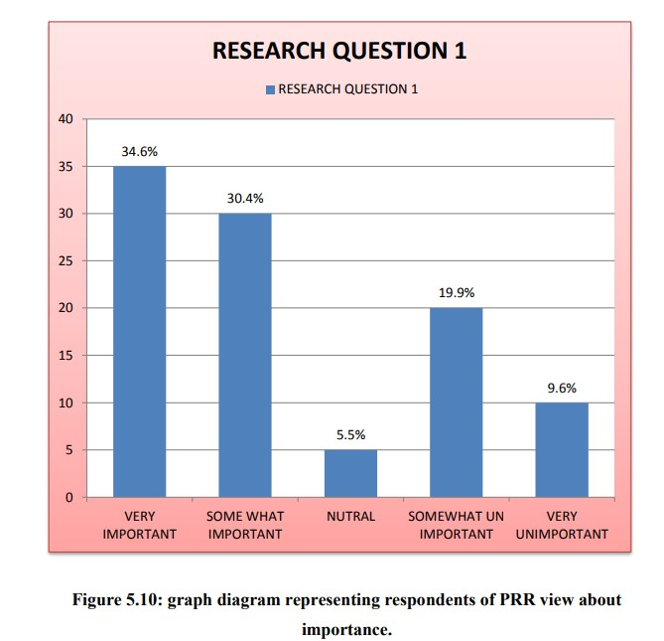
The above diagram makes it abundantly evident that the majority of respondents view user-generated product reviews and ratings as a highly significant source when researching products or services online because they offer a comprehensive picture of the goods or services. Users have created content in the form of ratings and reviews based on their experiences using the goods or services; this content may be derived from their emotions and may be favorable or negative. However, a very small percentage of all respondents think that when looking for information about goods or services online, user-generated product reviews and ratings are irrelevant. Even the qualitative results.
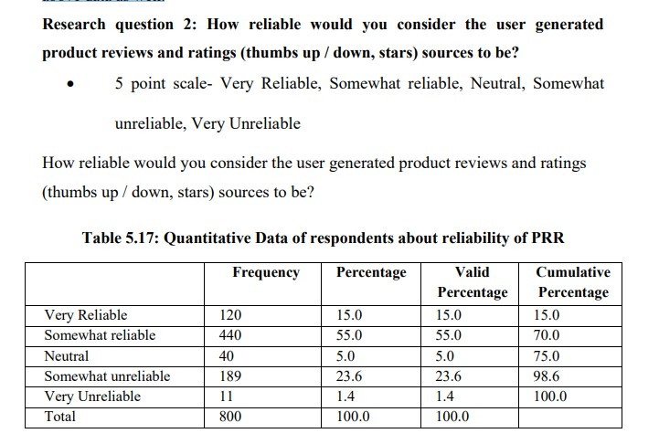

Respondents were questioned about the validity of user-generated product reviews and ratings expressed as stars or thumbs up/down. About 15% of all respondents think it is extremely dependable, and 55% have provided some sort of response. Approximately 5.0% of respondents consider the source of product reviews and ratings to be neutrally reliable. Only 1.4% of respondents overall indicated that user-generated product reviews and ratings are extremely unreliable, compared to roughly 23.6% of respondents who gave the somewhat reliable response in 138 cases.

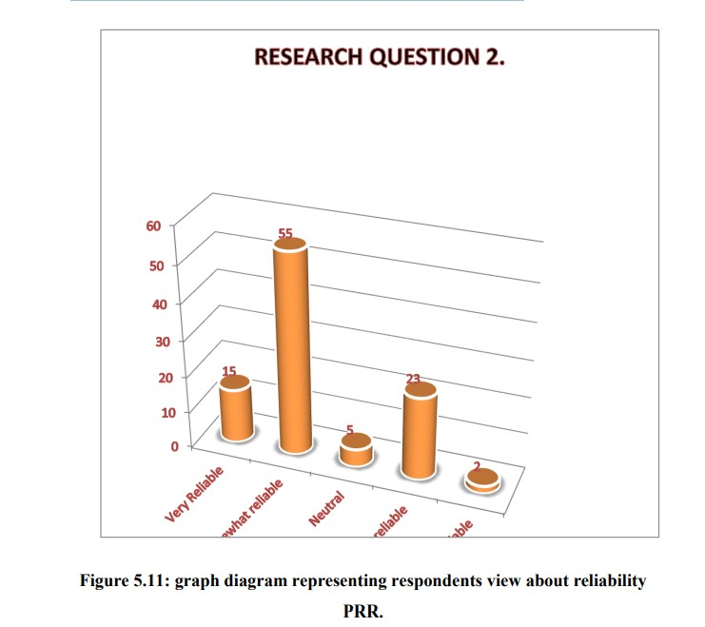

The aforementioned data makes it abundantly evident that most respondents do, when looking for information about goods or services online, regard user-generated product reviews and ratings as a trustworthy source. Simultaneously, a minor yet significant segment of the participants expressed no opinion regarding the user-generated product evaluations and rankings. The above figure's result is nearly identical to the qualitative findings, which indicate that a larger percentage of respondents think the information is trustworthy. Nonetheless, the qualitative and quantitative study's reflections verified that users' generated product reviews and ratings are regarded as trustworthy sources of data.

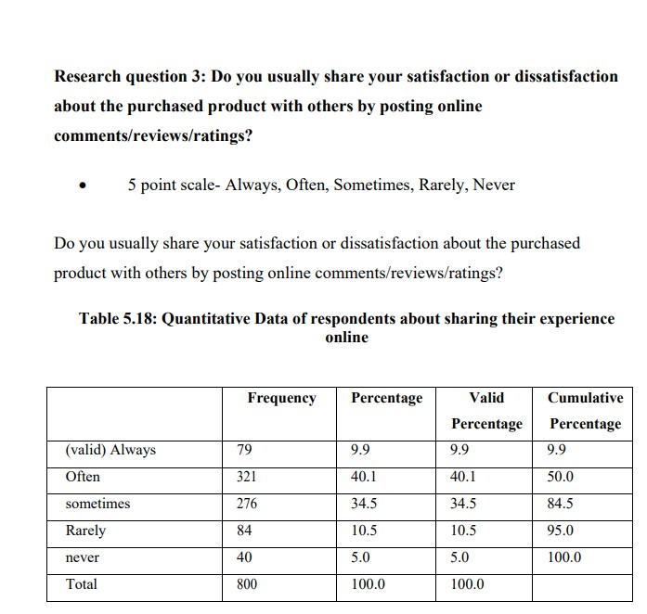
The respondents were asked if they typically share their satisfaction or dissatisfaction about the purchased product with others by posting online comments, reviews, or ratings, as can be seen in the above table. About 40.1% of respondents frequently post online comments, reviews, and ratings to share their satisfaction or dissatisfaction about the purchased product, accounting for approximately 9.9% of all respondents who always post about their satisfaction or dissatisfaction about the purchased product. A little over 34.5% of respondents said they occasionally post comments, product reviews, or ratings online, 10.5% said they do so infrequently, and 5.0% said they never do so regarding their happiness or discontent with a purchase they have made.

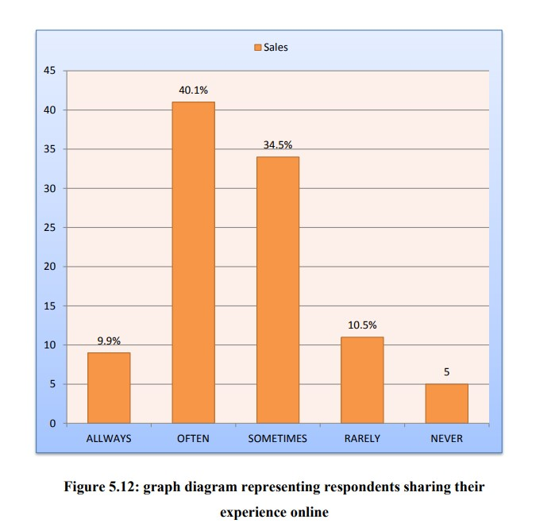

Based on the aforementioned figure, it is evident that most respondents express their satisfaction or dissatisfaction with the purchased product to others through online comments, reviews, and ratings. This suggests that customers are highly engaged in sharing their opinions about the goods and services. Right now, the most common means of communication for expressing feelings of satisfaction or dissatisfaction are product reviews and ratings. These findings suggest that some committed customers who were willing to invest the necessary time and energy to leave comments or product reviews may be motivated by their dissatisfaction, as many respondents to the qualitative study claim to participate in the ratings and reviews of products because they are unhappy.

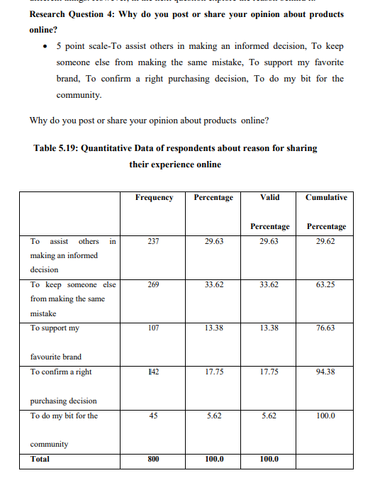
We have asked the respondents from the above table why they share or post. thoughts regarding products that are available online. A total of 29.63% of respondents have provided information in their responses to help others make an informed decision, and 33.62% of the Respondents provided their answers in an effort to prevent others from making the same error.
About 17.75% of respondents said they answered in order to confirm that they made the right purchase, 13.38% of respondents said they answered in order to support their favorite brand, and only 5.62% of all respondents said they answered in order to give back to the community by posting or sharing their opinions about products online.

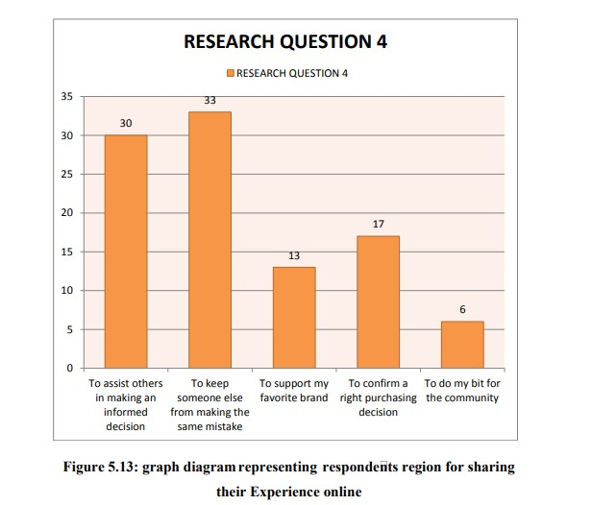

The answers to this question's available options primarily indicate whether posting online product reviews is motivated by customer satisfaction or dissatisfaction. Pleasingly, the reasons for sharing reviews of products on the internet were primarily identified as preventing others from making the same mistake and helping them make an informed choice. Only a small percentage of respondents have the intention of supporting their preferred brand and confirming that they made the right purchase, and even fewer of those who post an evaluation of user-generated product reviews and ratings do so with the intention of taking ethical, social, and community considerations into account. Nonetheless, these numbers represent the qualitative conclusions of the participants, as the vast majority of them state that they post.

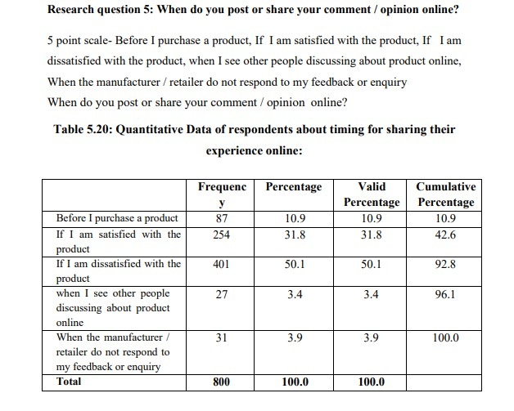
The above table shows that the respondents were questioned regarding when they posted or
comment or voice your opinion online. Roughly 10.9% of all respondents indicated that they typically share their thoughts or comments online prior to making a purchase, whereas
Only 3.4% of respondents responded when they saw other people talking about the product online, and 3.9% of all respondents responded when the retailer or manufacturer did not reply to their feedback or inquiry. Of the respondents, 31.8% posted their comments or opinions online if they were satisfied with the product, and approximately 50.1% responded if they were not.

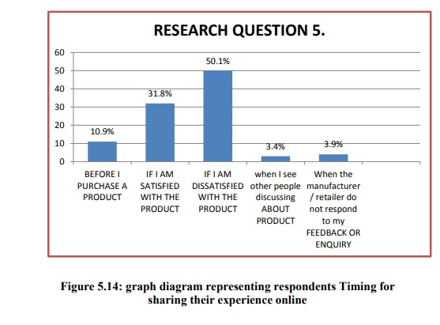
The above figure indicates that the question has provided a wealth of information. A comparatively small percentage of respondents assessed products prior to purchase, whereas the majority of respondents preferred to share their thoughts, opinions, or purchasing decisions after making a purchase. The aforementioned data clearly shows that post-purchase dissatisfaction is a more powerful motivator for evaluations than satisfaction. The aforementioned data also shows that respondents who leave reviews after using a product indicate that customers are highly engaged in post-purchase behavior, which is consistent with the qualitative research findings regarding post-purchase behavior.

HYPOTHESIS ANALYSIS :

The foundation for deriving research conclusions is provided by the research hypothesis.

supposition H: 1. The list of hypotheses that this research study used to verify is provided below.
H0: There's no connection between gender and being aware of digital marketing.

Do you keep up with gender cross-tabulation in digital marketing?

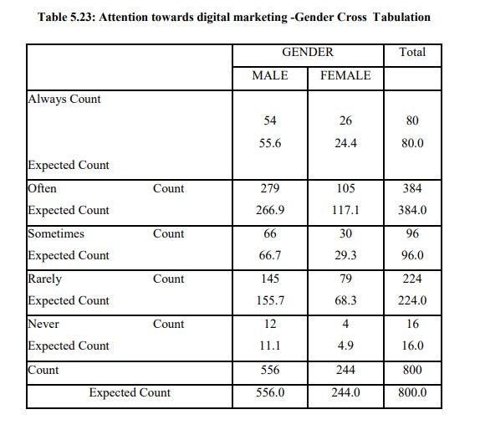
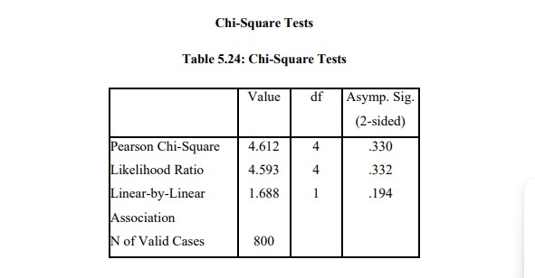

Interpretation:

The aforementioned table shows that gender and paying attention to digital marketing are not significantly correlated. As a result, the alternative hypothesis (H1) is rejected and the null hypothesis (H0) is accepted.

H2: There is no connection between the impact of consumer attitude in digital marketing and gender.

To what extent do you think digital marketing influences your purchasing decisions ?

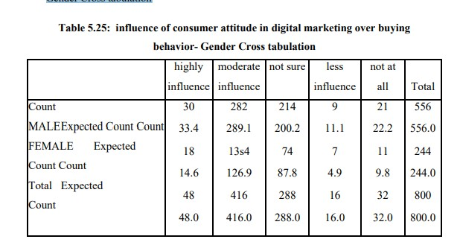

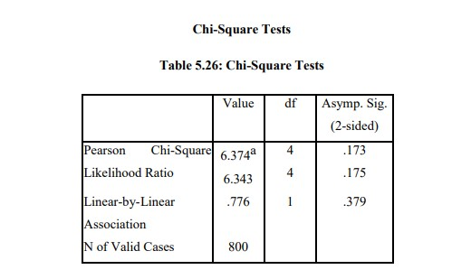
CHAPTER-6
CONCLUSION
Customer involvement (standard of living, values and needs, Brand conscious, commitment to a products/ brand, reduce materialism and corruption of societal values, positive attitude more favorable about the product impulsive buying , brand‟s image and influences the purchase, impacts on societal, political and economic conditions) has no influence due to the media effectiveness on consumer decision making.
H1: The respondents' emotional influences on the media's ability to influence consumers' decisions are not statistically significant. The effectiveness of the media in influencing consumer decision-making is unaffected by emotional factors (such as the effect of emotional advertisement and emotional appeal).
H2 - The respondents' satisfaction with the media's effectiveness in influencing consumer decision-making is not statistically significant.
Due to the media's influence on consumers' decision-making, customer satisfaction with advertisements (awareness of the brand, association with the brand, image about the brand, and perceived quality) had an impact.
FINAL COMMENTS
The current study comes to the conclusion that the value of advertisements, the impact of media sources, social influence, and brand equity through advertisements were significant factors in media effectiveness. The way that advertisements influence the decision-making process of customers is greatly influenced by the brand equity that is created through them. The advertisement value, media sources, and social influence were significantly influenced by the customer's age, marital status, occupation, income, and level of education.
Urban, semi-urban, and rural consumers all take into account brand image and popularity, availability, and quality when making purchasing decisions, despite the respondents' varied motivations. The main media that influence consumers' decisions are television, the internet, Facebook, blogs, twitter, newspapers, magazines, and FM radio.
This study established a connection between the impact of advertisements, media influences, brand equity, advertisement value and culture, and social influence on consumer purchase decisions in Dindigul District . The respondents' preferred representations of the advertising values were the educational value, the suggestive value, and the sentimental value.
The advertisement is primarily influenced by the following elements: voice/music, animation, color, celebrity, and message/theme. Because of this, those who create advertisements and advertising agencies may take the influencing factors very seriously in an effort to outbid rivals and draw in more consumers to their brands and products.
As a result, the study's significant conclusions are listed below:
- Consumers had a very high level of awareness about advertising. Businesses should be aware of this for communication purposes.
- Use of newspapers and televisions: In order to reach the greatest number of readers and viewers, planners should also make use of these media.
- Customers enjoyed media because of their favorable attributes. These factors—high-quality audio and video, message clarity, and associated costs—should be considered, particularly in advertising campaigns.
- Customers required a message that was clear. To increase the efficacy of an advertising campaign, media planners should provide information on features, costs, advantages, applications, and 285 instances where the information should be used.
- The goal of advertising was to increase usage. To effectively contribute to target achievement, the objectives should be reviewed periodically.
- The advertising message was primarily biased. The media planner should provide a two-sided message when it is necessary and not harmful.

GOVERNMENTAL REPERCUSSIONS
The findings led to the elimination of the following recommendations. According to the study, there is a connection between the impact of advertisements on consumer purchase decisions in Dindigul District and the media, social influence, advertisement value and culture, and advertisement influence. These results highlight the significance of brand awareness; the more crucial factors to take into account when evaluating the impact of advertising are perceived quality, culture, and value.
Urban respondents stated that "the brand/product needs more advertisement for the cell phone," with semi-urban respondents following suit. "Cosmetics" is the brand/product that requires more marketing. According to respondents from rural areas, "Medicine, health, and hygiene" is a product or brand that requires more advertising. The most popular medium among both urban and semi-urban consumers is television. Rural customers, however, like FM radio. Therefore, if advertisers are choosing different media to reach different customers in different residence places, they must target their advertisement based on their residents.
The primary goal of the advertisement for respondents who are urban or semi-urban is to "create awareness." Rural respondents claimed that advertisements are "misleading." Customers in urban and semi-urban areas have positive opinions about the advertisement, while customers in rural areas have negative opinions about the 286 advertisement. Therefore, in order to change the negative opinions of the rural customers, the advertising agencies must raise positive awareness among them.
Price, availability, good word of mouth, prior experience, shopkeeper advice, trail, product quality, brand reputation, and dependability were the main reasons for choosing a specific brand. These are the elements that each of the three resident customers will consider when making their purchase decision. Therefore, when creating their advertisement, advertisers need to pay more attention to these factors.
Customers in urban, semi-urban, and rural areas have distinct perceptions of media advertisements. The degree to which their customers interacted with the advertisements also varied. Semi-urban customers were impressed by the brand's advertisement, and urban customers think that "brand advertisement" leads to positive image. However, rural consumers are perplexed by the brand's distinctive advertising. Occasionally, consumers' decisions are conflicted by different advertisements for the same brand and similar advertisements for brands or products that are similar. To resolve this issue, advertising agencies must offer a distinct advertisement for brands that are comparable.
Semi-urban respondents remember the advertisement for its "caption/slogan," while urban respondents remember it for its "illustration." Still, the advertisement's "Message" is what the rural respondents remembered about it. As a result, it gives advertisers precise guidance on "where to focus" and "what to focus" in order to reach every consumer. A specific customer segment is absent from the advertisement if any of the aforementioned components are missing.
FUTURE RESEARCH SCOPE
Future research will build upon the current study. Potential avenues for future research include looking into Tamilnadu's advertising sector. Future research may concentrate on a comparative analysis of Tamilnadu's various mass media platforms. It is possible to research customer satisfaction and its effects on the advertising sector. In the Dindigul District, the current study examines the relationship between advertisement influence, media influence, brand equity, 288 advertisement value and culture, social influence, and advertisement impact on consumer purchase decisions.
Just the direct effect is the subject of this study. The study of the direct and indirect effects of media influences, advertisement values and cultures, and the impact of advertisements on consumer purchase decisions in Tamilnadu, India, may be expanded in the future. Future research may concentrate on the numerous facets of children, digital advertising, and ad agencies in the near future due to the industry's explosive growth.

BIBILOGRAPHY
- Kotler, P., & Keller, K. L. (2016). Marketing Management (15th ed.). Pearson Education.
This textbook provides foundational concepts of marketing management, with insights into how digital tools are reshaping marketing strategies.
- Ryan, D. (2016). Understanding Digital Marketing: Marketing Strategies for Engaging the Digital Generation (4th ed.). Kogan Page.
This book explains digital marketing techniques and how they influence consumer interactions, behavior, and purchasing decisions.
- Smith, A. N., Fischer, E., & Yongjian, C. (2012). How does brand-related user-generated content differ across YouTube, Facebook, and Twitter? Journal of Interactive Marketing, 26(2), 102-113.
This article explores how consumer behavior varies across different digital platforms, providing insights into platform-specific marketing strategies.
- Hajli, N. (2014). A study of the impact of social media on consumers. International Journal of Market Research, 56(3), 387-404.
Hajli discusses the transformative effect of social media on consumer behavior, particularly through the lens of social networking sites.
- Lee, M., & Youn, S. (2015, June). Examining the impact of push notifications on consumer behavior and marketing outcomes. Paper presented at the International Conference on Digital Marketing and Consumer Engagement, Lisbon, Portugal.
This conference paper explores how push notifications can modify consumer behavior and the implications for digital marketing campaigns.
- Chaffey, D. (2021, March 8). How digital marketing affects consumer behavior. Smart Insights. Retrieved from https://www.smartinsights.com/digital-marketing-strategy/online-consumer-behavior/
An online article that outlines several ways digital marketing has changed consumer behavior, including through customization and personalization strategies.
- Statista. (2023). Impact of digital advertising on consumer purchase behavior. Retrieved from https://www.statista.com/statistics/
Statista provides statistical data and analysis on how digital advertising influences consumer purchase decisions across different demographics and markets.
- McKinsey & Company. (2019). Digital Marketing's impact on consumer behavior. McKinsey Global Institute.
This industry report offers insights from a consultancy perspective, examining how digital marketing tools and analytics transform consumer engagement and buying patterns.
- Federal Trade Commission. (2021). Consumer responses to digital marketing strategies.
A government report that provides analysis on consumer protection and behavior in the digital marketing context.
- Harvard Business Review. (2018). Case study: The impact of targeted advertising on consumer purchasing behavior.
A detailed case study that examines the effectiveness of targeted digital advertising on consumer purchasing decisions, with real-life examples from major brands.
- Tuten, T. L., & Solomon, M. R. (2020). Social Media Marketing (3rd ed.). Sage Publications.
This book delves into how social media marketing influences consumer preferences and behaviors, emphasizing strategy development and implementation.
- Larson, R., & Draper, S. (2020). Digital Marketing Essentials. Stukent.
An essential guide that covers the basics of digital marketing with updated strategies and technologies influencing consumer behaviors online.
- Kumar, V., & Rajan, B. (2018). Social coupons as a marketing strategy: A multifaceted perspective. Journal of the Academy of Marketing Science, 46(1), 58-81.
This article examines how digital coupons via social platforms impact consumer purchasing behavior and loyalty.
- De Pelsmacker, P., Van Tilburg, S., & Holthof, C. (2018). Digital marketing strategies based on the e-consumer behavior model. Journal of Marketing Communications, 24(4), 369-385.
Provides insights into how consumer behavior theories adapt and apply in digital contexts, helping marketers to better tailor their strategies.
- Zhao, Y., & Bacao, F. (2017, September). How mobile marketing influences consumer decision-making. Paper presented at the Annual International Conference on Digital Business, Madrid, Spain.
Discusses the increasingly significant role mobile marketing plays in influencing consumer decisions in the digital age.
- Marketing Week Reporters. (2022, July 5). Understanding the digital consumer. Marketing Week. Retrieved from https://www.marketingweek.com/understanding-digital-consumer/
An article discussing the latest trends and behaviors of consumers in the digital space, emphasizing the changes and continuities post-COVID-19.
- Forbes Agency Council. (2022, May 10). How digital marketing is influencing consumer behavior. Forbes. Retrieved from https://www.forbes.com/sites/forbesagencycouncil/
Expert insights on how digital marketing campaigns and tactics are evolving in response to shifting consumer behaviors.
- Deloitte. (2020). Digital media trends, 5th edition.
Analyzes consumer responses to the evolving digital media landscape, including attitudes towards digital advertising and online privacy.
- European Commission. (2021). Impact of digital marketing on consumer rights within the EU.
Explores how digital marketing practices affect consumer rights and behaviors within the European Union, providing policy recommendations.
- Harvard Business Review. (2019). Case study: Digital marketing and consumer engagement in luxury industries.
Analyzes how luxury brands utilize digital marketing to enhance consumer engagement and drive brand loyalty.
- Chaffey, D., & Ellis-Chadwick, F. (2019). Digital Marketing (7th ed.). Pearson Education.
This comprehensive text provides detailed information on strategies and tools used in digital marketing, examining how they impact consumer behavior.
- Hollensen, S. (2018). Digital Marketing: A Relationship Approach. Pearson.
This book offers a relationship-centric view of digital marketing, focusing on how digital strategies create consumer engagement and loyalty.
- Grewal, D., Bart, Y., Spann, M., & Zubcsek, P. P. (2020). Mobile advertising: A framework and research agenda. Journal of Interactive Marketing, 49, 1-16.
Discusses the effectiveness and challenges of mobile advertising, analyzing its influence on consumer decisions and behavior.
- Edelman, D. C., & Singer, M. (2015). Competing on customer journeys. Harvard Business Review, 93(11), 88-100.
Offers a conceptual framework for understanding the digital consumer journey and how companies can strategically influence it.
- Kim, R., & McMillan, S. J. (2019, August). Implications of Smart Technology on Consumer Behavior. Paper presented at the Annual International Conference on Business and Technology, Chicago, Illinois.
Explores how smart technologies and IoT are reshaping consumer behavior and the implications for digital marketing strategies.
- Nielsen, J. (2023, January 30). The future of personalized marketing. Nielsen Blog. Retrieved from https://www.nielsen.com/us/en/insights/article/
This blog post discusses advancements in data analytics and machine learning that are transforming personalized marketing tactics.
- Content Marketing Institute. (2021, April 8). How content marketing influences consumer behavior. Retrieved from https://contentmarketinginstitute.com/2021/04/content-marketing-influences-consumer-behavior/
Examines the role of content marketing in influencing consumer behavior and decision-making processes.
- Accenture. (2021). Life Reimagined: Mapping the motivations that matter for today’s consumers.
Accenture’s report explores how consumer motivations and behaviors have shifted in the digital era, providing guidance for marketers.
- U.S. Department of Commerce. (2022). Consumer behavior in the digital economy.
This government report provides insights into how digital technologies are transforming consumer behaviors in the United States.
- Harvard Business Review. (2020). Case study: Omnichannel marketing and consumer behavior in retail.
Reviews how an omnichannel approach affects consumer shopping behaviors, with a focus on integration between digital and physical retail experiences.

