A REVIEW OF STUDENT DATA ANALYSIS USING QR-CODE.
Ashiya Niyaj Mulla, Rutuja Pramod Suryawanshi, Teja Sanjay Koli, Aishwarya Suresh Rupe,Ms.S.M.Kuwarkar.
Department of Diploma Computer Engineering, Third Year, Sharad Institute Of Technology, Polytechnic Yadrav, Icahlkaranji.
Lecturer, Department Of Diploma Computer Engineering, Sharad Institute Of Technology, Polytechnic Yadrav, Ichalkaranji.
Abstarct: A modern application has been designed to streamline a process of tracking student attendance recording marks and control formal and educational information using QR codes all student is provided with a unique id card that includes a QR code teachers can effortlessly record attendance and input marks by simply scanning the students id cards in front of a webcam this system captures and stores data including attendance records marks and official and academic information all organized by date the maintenance on student data be the analytic aspect of evaluating student act with recent times student data has been manually maintained and updated in the colleges server this task requires meticulous attention and accuracy with no room for error the previous systems used for tracking attendance were inefficient in terms of processing time and lacked precision. the student data analysis using qr code system has been involve to address these drawback and facilitate extensive student data operation daily presenty be promptly put down also modernize in the article by the admin when a students id card is scanned the application retrieves the corresponding details from the database ensuring a seamless and technical procedure for contol student data

I.INDRODUCTION

The analysis of student data is analytic component for the positive result of any operation be it an academic institution or a public or private sector entity the ability to effectively manage and harness the developing of individuals within the operation especially students can significantly influence its future success therefore a robust student data analysis system is important in pursuing desired goals
To achieve these goals there’s a clear need for a semi-automated system that can mitigate the opposition connected with human data management enter the student data analysis using qr code system that offers a solution to these issues with this system users simply scan their unique qr codes and their data is seamlessly stored in a database for future reference this streamlined approach ensures accurate attendance tracking without any complications or errors

QR-Code:
The quick response code often referred to as QR-code is a two-dimensional barcode that was created by denso wave in japan back in 1994 QR-codes are constructed in a grid format with rows also columns of black and white squares and they be specifically designed to be take by mobile one of the key features of QR codes is their capacity to store major amount of data add numbers alphanumeric characters also more this creativity has give to their widespread adoption across the globe furthermore the growing popularity of smartphones equipped with software capable of scanning QR codes has significantly boosted their use in telecommunications and various applications.

LITERATURE SURVEY

Student’s Attendance System Using QR Code.
Muhamad Alfie Yazid Mohd Nasir , Normah Zakaria , Norhasyimah Hamzah , Siti Nur Kamariah Rubani , Arihasnida Ariffin have developed a software that is based on a QR-Code. The students QR-Code is scanned and save the attendance in the database.

School Bus Tracking And Security System.
S.Sangita, S.KrishnaPriya, Ms.S.Janani, has developed a system recommends a SMS based application which consist parents to track their children location in real time initially the detail of the student are collected and stored in database. The details are converted into QR-Code. And embedded with children Identity Card. When the children enters the bus, the QR-Code is scanned by the mobile application and the timing, stop details will be send the parent as notification. Later on, when the bus gets started, the GPS in the mobile phone is turned & send the location updates to the parent to easily track the bus location.

QR-Code Attendance System With SMS Notification.
Shrusti Kulkarni, Sahana Patil, Soumya Patil has developed this application incorporates an innovative viewpoint using an esp32-based web camera during a registration process the students image is captured also then save in the database along with their pertinent personal information to calculate attendance the system captures the students image and relevant details are retrieved from the database.

PROBLEM STATEMENT.

In the past members used to mark their attendance on paper which sometimes led to the risk of losing those records making it difficult to properly track student presency to address is issue each student is now assigned a unique barcode id which serves as a reliable means of identifying and recording student presenty based application ensures that faculty and admin can access it securely using their respective login ids and passwords.

The software has been implement to give students department staff with a user-friendly tool for track student all data both students also faculty can generally access this application to obtain student data records to do so each paticular is provided with a individual login id and password ensuring protect personalized access to the application features

PROPOSED SYSTEM.

The application diligently monitors and maintains a complete record for each student encompassing several features such as attendanc midterm also semester marks involvement in extracurricular activities occurrences of educational eficiencies like drops or ATKT also their personal information this meticulous tracking spans from a students initial year in the institution to their final year facilitating a extensive an arrange student data control approach.

This suggest application are student data analysis using qr code is a cornerstone for maintaining comprehensive records of every student within a single integrated platform central to this project is utilization of QR codes which be machine clear codes locates as distinct design

SYSTEM DESIGN.

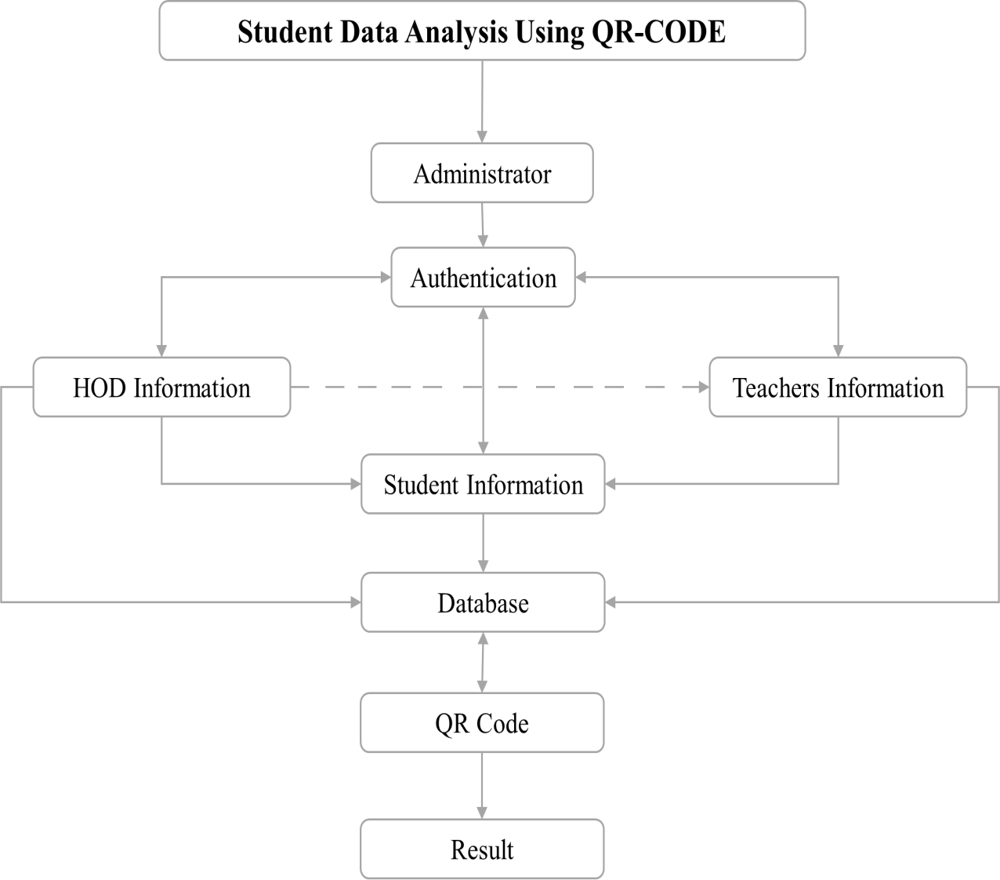

- Administrator: Admin is domain on a system the admin assumes a important role in the extensive control also error of in whole application this wield the control to define user roles also request fine-tune system configurations also uphold is most major concept of application protection also unity
- Authentication module:In the section of a system oversees how people get into this application its responsible for letting both teachers and students sign in as well as handling instances where passwords need to be improved or if someone has forgotten their password its main job is to make sure that single right member this whom are authorized can use the application
- HOD Module: The HOD feature empowers hods the ability into input also revise faculty details they can also allocate teachers to particular compartment also inspect details relevant into their respective compartment here functionality be involved in a crucial part in ensuring level also efficient departmental admin
- Teacher Module:Faculty can use here module to add also update a fresher details it recognize faculty to control fresher information and are involved in a key part into fresher record protection
- HOD – Teacher :Both faculty and head of department hod possess a capability be input fresher information record attendance and keep track on daily presence records additionally they share the responsibility of entering test marks into the web application this implies that both roles hold authority also perform essential functions concerning student management within the system
- Database:Database perform be a main hub on all details within be software it safely houses customer profiles student particulars attendance logs exam scores and other vital data this safeguards data accessibility and maintains its accuracy and reliability
- QR Code: Scan the qr code students gain quick entrance be private details stored in a system this offers them the hassle-free technique be review this records also guarantees swift safe and convenient access to their data
- Result: The system likely incorporates a module for overseeing and presenting student outcomes this functionality empowers both faculty also department heads to input also distribute exam scores simplifying the process of monitoring and communicating student advancements

OUTPUT
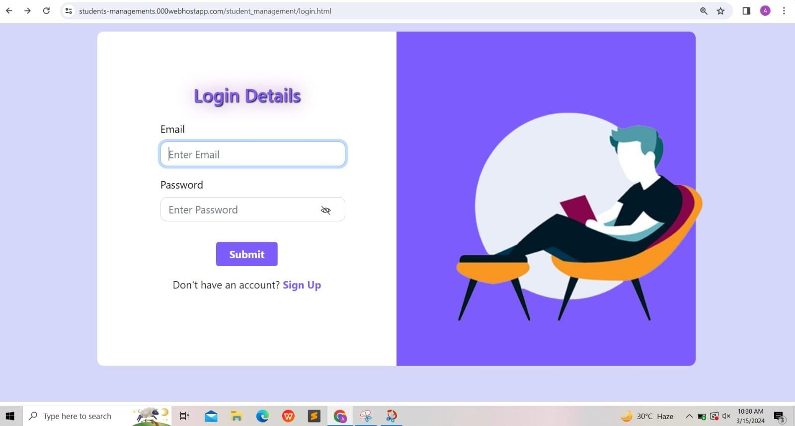
Fig 1:Login Page

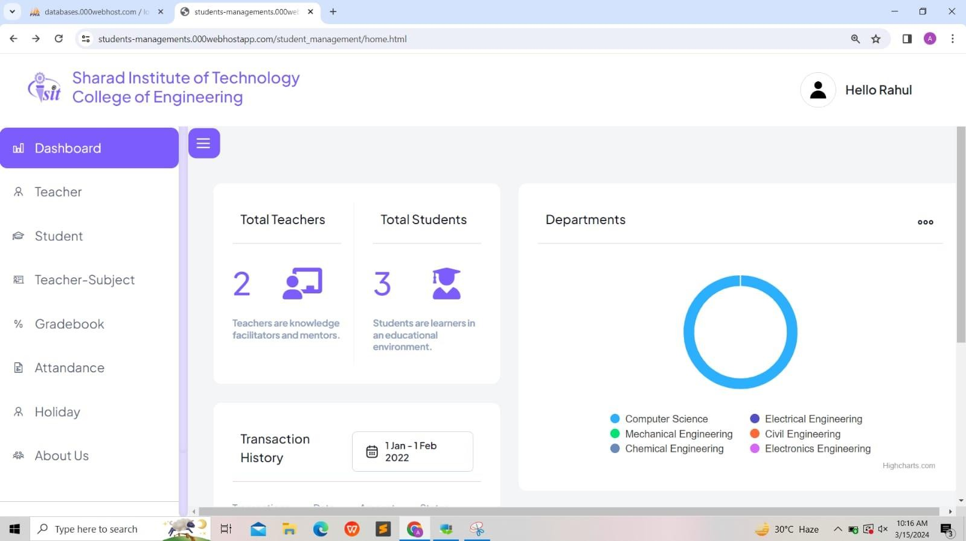
Fig 2: Dash-Board

RESULT

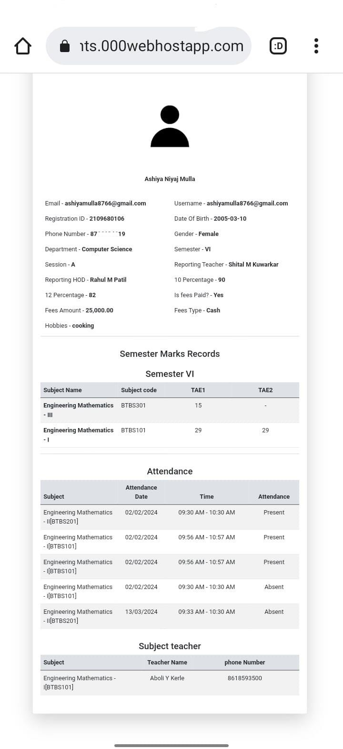

- CONCLUSION.

This paper introduces a program leveraging qr codes for student tracking and monitoring the system crafted by the researchers highlights an automated approach to overseeing all student details through the integration of monitoring technology us extend our heartfelt gratitude to all those who contributed to the successful completion of this project a special acknowledgment goes to our final year project guide ms sm kuwarkar be her personal support in coordinating also ensuring the projects success additionally we would like to express our thanks and appreciation for the support provided by the panel during our project presentation

REFERENCES.

Alsagoff, S. A. (2002). Ilmu Pendidikan: Pedagogi, Kuala Lumpur: Longman (Malaysia) Sdn Bhd. CetakanPembaharuan.
Ahmad, D. J., Goolamally, N. (2008). Pentadbiran dan PengurusanSistem Pendidikan Malaysia Ke Arah Pendidikan Berkualiti. Open University Malaysia.
Arsathamby, Veloo& Ng, Kim, C. (2014). Jenis amaran dan faktorpontengsekolahdalamkalanganpelajarsekolahmenengah di Sabah. Dimuatturun di: http://apjee.usm.my/APJEE_29_2014/Art%208(125-140)%20.pdf
Ashaari, O. (1998). Peranan, tugas dan tanggungjawab guru di sekolah. Kuala Lumpur: Utusan Publication.
Asmat, Z. (2009). Sistem Maklumat Dan Peminjaman Tesis Di Pusat SumberFakulti Sains Komputer Dan Maklumat, UTM. LaporanProjek Sarjana Muda, UniversitiTeknologi Malaysia
Awang, D. (2004). RekabentukIndustri Dalam KejuruteraanMekanikal. Conference on Engineering Education (CEE 2004), (Rajah 2), 1–6.
Chen, T. E. (2009). SistemPengesanankehadiranPelajarMenggunakanTeknologiKod Bar. LaporanProjek Sarjana Muda. UniversitiTeknologi Malaysia.
Hasmin, A. I. (2008). SistemKehadiranPelajarMenggunakanTeknologi Cap Jari. Tesis Sarjana Muda. UniversitiTeknologi Malaysia.
Hussein, N. A. (2005). Smart Attendant. LaporanProjek Sarjana Muda, Kolej UniversitiTeknologi Tun Hussein Onn.

