Implementing Machine Learning To Predict Shipping Cost On Freight Brokerage Platforms
KRISHNAMOORTHY S ¹, MONISH RAJ K ², MITHUN S K ³
Panimalar Engineering College
Department Of Artificial Intelligence And Data Science
Bangalore Trunk Road, Varadharajapuram, Poonamallee, Chennai – 600 123.

ABSTRACT

Using a freight brokerage platform to set shipping costs can be challenging if there isn't a precise cost standard. Setting rates can also be challenging for transport brokers who abuse their dominant position in the industry to demand exorbitant commissions. Moreover, since there isn't a quantified. In terms of worker input and fare policy, fares are undervalued. Car owners thus labor for less money than their labor is worth. This study determines the primary factors influencing the shipping cost setting and provides the suggested shipping cost as determined by a machine learning-based pricing prediction model. Four algorithms were used to build the cost prediction model: XG Boost, Light GBM, deep neural network, and multiple linear regression. selected as the model with the fastest speed of processing and the highest power of explanation. Furthermore, taking into account practical usage patterns, the range of the estimated shipping costs has been determined. The dataset was classified using the K-fold cross-validation method, and the confidence interval was utilized to calculate the range of the anticipated shipping costs. This research has the potential to enhance utilization rates and determine the cost of shipping on freight brokerage platforms.

Keywords: Machine Learning , Shipping Cost , Freight , Price Prediction , Prediction Interval

1. INTRODUCTION
The logistics market is active and there is a rise in online transactions. The number of logistics facilities has risen, and the package forwarding industry has grown larger. The total amount of general freight has been steadily rising as of 2020 . The use of roads for domestic freight transportation has been highlighted, despite the COVID-19 outbreak. Following the COVID-19 outbreak, there was an increase in the volume of traffic for small- and medium-sized truckers uses for freight transportation between January and August 2020 as compared to 2019. As a result, road-based domestic freight transit is crucial for growing the logistics industry. However, the domestic freight sector lacks a precise guideline for shipping expenses. Currently, only vehicle mass and distance are taken into account for determining shipping prices. This research uses data from a freight brokerage website to present a machine learning-based shipping cost prediction solution for a domestic freight transportation scenario. Further more demonstrated is the ability of predictive models to accurately determine shipping costs; the best predictive model is presented by comparing their predictive power. For six months, we used freight brokerage platform data pertaining to transportation. New elements were added, and different preprocessing techniques were used, in order to determine the main factors. To identify the key components, step selection and correlational analysis were employed. Next, we used a machine learning technique to create a fare prediction model based on the derived factors. We employed the following machine learning algorithms: extreme gradient boosting (XG Boost) regression, deep neural networks (DNNs), multiple linear regression (MLR), light gradient boosting machine (Light GBM) regression, deep neural networks (DNNs), and extreme gradient boosting (XG Boost) regression. In comparison to the XG Boost model, the Light GBM model shortens the learning curve. We offer a technique for determining the range of anticipated fares while taking into account reasonable usage patterns; the user should be shown the fares as a range rather than a single amount. K-fold cross-validation was used to create a total of 30 training sets. For every iteration, we forecasted the test set based on our training sets. An appropriate fare range was supplied, along with a confidence interval that was produced based on the assumption that the 30 determined forecast values followed a normal distribution. The predictive model's performance evaluation index was determined using R-squared.

2. LITERATURE REVIEW

2.1 ML AND ITS APPLICABILITY IN POLICY DECISION MAKING:
The study of machine learning (ML) is a quickly developing field of computer algorithms that aim to mimic human intelligence by absorbing information from their environment. The focus of machine learning techniques is on how computers replicate and carry out human learning behaviors in order to gather fresh data and improve prediction accuracy over time. ML models, a branch of AI, combine several ideas by taking use of the quick rise in of information. One essential machine learning function is classification or predictive analytics. ML's core principle is to use computer algorithms to comprehend and gain knowledge from data. Machine learning algorithms generate predictions and generalize previously learned information when faced with fresh data, which facilitates the process of generating judgments in novel contexts. One of the most important computational tools for the decision-making process is machine learning (ML), which offers improved organization operations at the local, state, and federal levels by establishing correlations between data inputs and decision outputs. The commercial and economic spheres benefit from the application of machine learning (ML) in policy making. Consider a procurement policy that bases choices on objectives, principles, risk, and assurance. ML can help local policymakers create and implement policies that will support the expansion of small and medium-sized businesses. Further more , investigated the creation of the supply chain and transportation policies by logistics services to accomplish their goals within the COVID-19 pandemic's current operational constraints.

2.2 Logistics And Supply Chain And The Application Of Ml:
The integration of machine learning to supply chain management and logistics has been becoming increasingly prevalent in recent years. Researchers have employed a range of ML technologies in different contexts. Many machine learning algorithms focus mostly on prediction. Furthermore, a number of articles in the field of logistics and supply chain offer a survey of some of the most important studies that give a thorough rundown of current machine learning-based algorithms and show how accurate their predictions are compared to those of classic prediction techniques. The results of models developed by utilizing the predictive potential of machine learning can help supply chain managers make more precise judgments. Additionally, there has been little progress in the field of supply chain management and logistics with the DEA model and ML method.

3. DYNAMIC PRICING
A pricing approach known as "Dynamic Pricing" modifies a product's or service's price in real time in response to supply and demand. Dynamic pricing is used in the freight brokerage sector to maximize load allocations and carrier selection according to market conditions. Freight brokerages can implement dynamic pricing with the aid of generative AI, which analyzes data from multiple sources, including carrier capacity, demand patterns, and transportation expenses.
For instance, generative AI is used by logistics technology business Transfix to optimize price and load allocations according to market conditions. Their artificial intelligence (AI) driven platform constantly modifies prices based on supply and demand by analyzing data from multiple sources, including traffic patterns and weather forecasts. Transfix is therefore able to provide clients attractive improve carrier utilization rates.

4. FREIGHT MATCHING
The process of matching available cargoes with available carriers is known as freight matching. Due to the manual search for available carriers and pricing negotiations required by freight brokerages, this approach has historically been laborious and ineffective. However, by automating the procedure and offering real-time visibility into carrier availability and cost, generative AI can completely change the way freight brokerages carry out freight matching.
For example, the logistics technology company Convoy, a logistics technology business, matches available loads with available carriers using generative AI, taking into account variables like availability, capacity, and geography. Shippers are able to trace their shipments in real-time and receive updates on delivery schedules and locations thanks to their AI-powered technology, which also offers real-time visibility into carrier performance.

5. REALTIME VISIBILITY
In the freight brokerage business, real-time visibility is becoming more and more crucial as clients want more information about the whereabouts and status of their shipments. By evaluating data from several sources, including GPS tracking devices and weather sensors, generative AI can revolutionize the way freight brokerages give real-time visibility by providing real-time updates on shipment positions, delivery timeframes, and any potential delays or interruptions. For instance, generative AI is used by logistics technology business Uber Freight to give shippers real-time visibility into their shipments, enabling them to track their shipments and get updates on arrival schedules and locations. Additionally, predictive analytics is offered by their AI-powered platform, which enables shippers to plan ahead for possible delays or disruptions and modify their operations accordingly.

6. MARKET TRENDS
The application of generative AI in the freight brokerage sector is expanding quickly, and current market trends suggest that this trend will continue to change the way freight brokerages handle real-time visibility, freight matching, and dynamic pricing. A McKinsey & Company analysis projects that by 2023, the application of AI in logistics would have grown by 45%, mostly due to the usage of generative AI. Furthermore, as businesses look to streamline their processes and adjust to shifting market conditions, the COVID-19 epidemic has expedited the adoption of generative AI in the freight brokerage sector. For instance, during the first six months of the pandemic, the logistics technology company Loads mart had a 360% spike in freight traffic on its AI-powered platform as customers used it to swiftly and effectively discover suitable carriers.

7. WHAT AFFECTS SHIPPING FREIGHT COSTS?
Freight expenses, by definition, have a significant effect on both customer satisfaction and profit margins. Shipping freight costs are still unstable and difficult to control due to demand from e-commerce shipping, same-day and next-day delivery services, and other market factors.

Weight and Dimension
Oversized and overweight loads usually incur more costs due to the specialized handling they require in shipping.

Freight Type and Class
Hazardous materials, reefer cargo, and other specialty freight classes and types are more expensive to transport.

Distance Shipped
It goes without saying that it is important to keep in mind that shipping costs increase with distance.

- Type of Destination
Delivery costs may also increase due to drop-off sites because residential and business needs vary.

- Shipping Mode
Rates for reefer trucks, dry vans, LTL, TL, and other shipping options also differ from one another.

- Fuel Costs and Mileage
Diesel fuel costs more and increases the cost of shipping, while consumer fuel prices rise and fall.

- Customs, Taxes, Surcharges
Carrying cargo entails extra costs for taxes, customs, tariffs, and other charges mandated by law.

- Equipment and Tools
Rates for equipment rentals may go up if a load need specific loading and unloading or other specialized services.

- Accessorial Charges
Carriers might or might not add additional fees and charges to the final freight invoices.

8. CONTEXT DESCRIPTION AND CHALLENGES:
Several techniques are used in the real-world scenario that serves as the basis for this study's estimate of the cost of a particular transportation path, or a route that connects an origin and a destination. These tools vary depending on a variety of variables, which include the mode of transportation (air, land, ocean, etc.); the services required (full or less than container load, country-specific charges, etc.); the costs associated with the mode of transportation (customs clearance, documentation, etc.); and the details pertaining to the mode of transportation (transit times, carrier name, vessel, demurrage and detention, etc.).Put another way, each tool only offers a portion of the total cost for the selected method; to determine the entire cost of transportation, charges from several tools must be combined at a later stage. Put another way, each tool only offers a portion of the total cost for the selected method; to determine the entire cost of transportation, charges from several tools must be combined at a later stage. It is imperative that data originating from various instruments be integrated automatically to prevent superfluous processing and human resource waste. This is not always simple to accomplish since, generally speaking, different software tools employ different data formats, and different branches or countries may have unique qualities that make it difficult for a single "universal" tool to exist. 'Low-risk' ticket prices for tender calls cannot be provided without a solid long-term cost estimate. Similarly, there is a dearth of methodologies and tools for determining the reason behind tender call success or failure, as well as for estimating the likelihood of success based on price offered. Lastly, managing pricing and tender selection policies is challenging. For example, how can managers set up a "optimal" portfolio of tenders and what prices can they offer during the associated bidding processes? (With the ultimate purpose of optimizing the anticipated long-term advantages and avoiding going above their service capacity). It is imperative that data originating from various instruments be integrated automatically to prevent needless processing and human resource waste. This is not always simple to accomplish since, generally speaking, different software tools employ different data formats, and different branches or countries may have unique qualities that make it difficult for a single "universal" tool to exist. Furthermore, a path's transportation expenses are only applicable for a limited time. As a result, they are useless for estimating how expenses will change over longer timeframes (such a year or more).
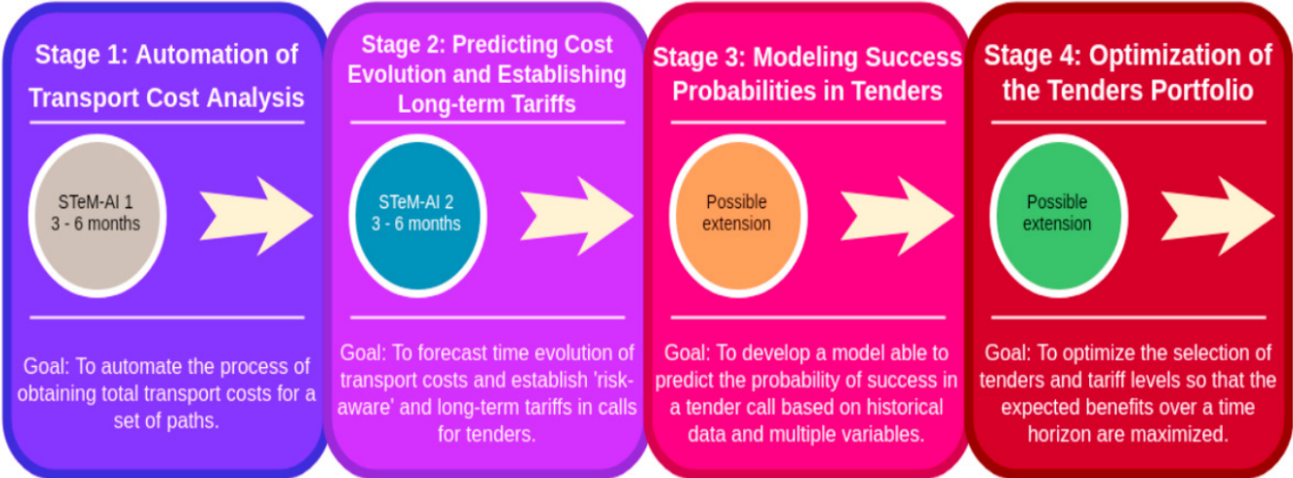

Fig.1 Different stages of the project

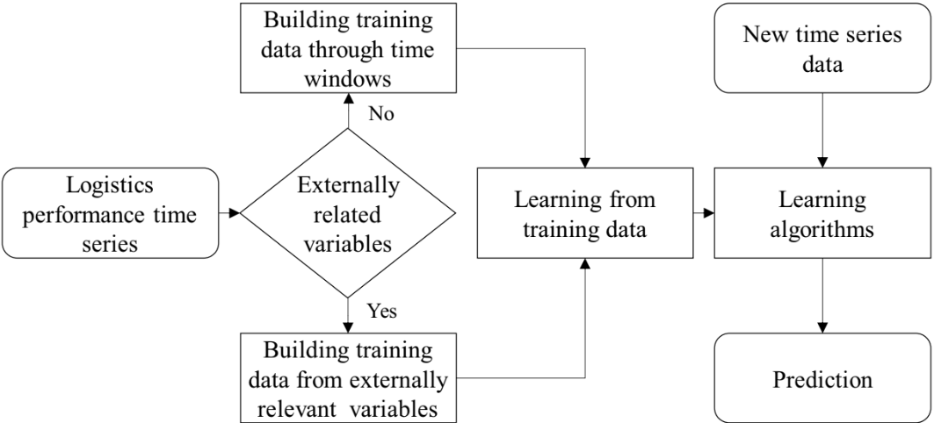

Fig.2 General predictive ML framework for logistics performance prediction.
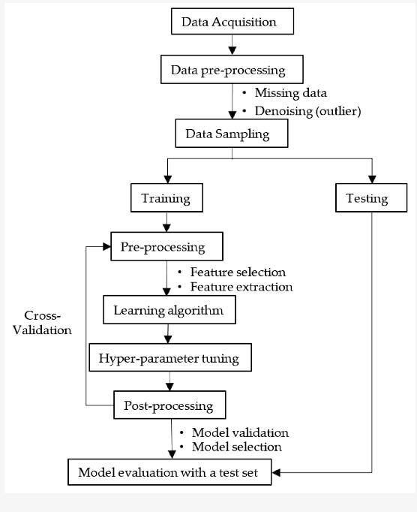

Fig.3 Flowchart Of Data Collection & Preprocessing

9. CONCLUSIONS AND FUTURE RESEARCH
The primary determinants of the shipping cost setting were identified in this work, and a machine learning-based price prediction model was constructed in order to address the issue of fare setting on a freight transportation brokerage platform in the absence of a standardized shipping cost. From a total of 73 parameters, including those gleaned from the freight brokerage process and environmental conditions like precipitation, the elements that influence the cost of transportation were chosen using correlational analysis and the stepwise technique. Environmental conditions, vehicle owner characteristics, and cargo characteristics were the factors that were chosen. A shipping cost prediction model was constructed using these variables, and each model's performance was contrasted. A shipping cost prediction model was constructed using these variables, and each model's performance was contrasted. "Freight weight," "loading/unloading location," and "loading/unloading time" were among the characteristics of the cargo. "Vehicle type" and "vehicle tonnage" were mentioned as attributes specific to the owner. One aspect of the environment was precipitation. The investigation's findings demonstrated that machine learning models DNN, XG Boost, and Light GBM outperformed conventional analysis techniques like linear regression. Out of all the models that were used, the Light GBM model demonstrated the highest prediction power. This study also looked into other variables that influence cost setting. The Light GBM model, which had the highest predictive power, was used for factor exploration. The greatest contributor to the cost setting was "linear distance," however other significant factors that were discovered to have an impact were "actual distance," "freight weight," and "vehicle tonnage." The variable "precipitation," which was supposed to have an impact on the shipping cost estimate, had no meaningful results. This is thought to be caused by the features of the freight market. Rainy days result in a decline in the volume of cargo movement in the real freight sector. These market circumstances are absent since the study's data are those of cargoes that have finished their freight journey. Major research-derived variables, however, may serve as a quantitative indicator for figuring out the cost of shipment. It is anticipated that doing this will address the issue of determining shipping costs based on shipper expertise. The appropriateness of the shipping prices should improve since variables that were not taken into account in the past may be in the future. Daily precipitation data were included in this study as an environmental element, but it was not possible to confirm a substantial association between precipitation and transportation costs. If more aspects that are representative of the real world are taken into account during research, a more realistic model might be produced. There are no case studies in the subject of shipping cost prediction, despite machine learning's stellar success in forecasting across a number of domains putting it in the spotlight. By applying a machine learning approach for fare prediction, this study developed a model with a high predictive capability. Because it takes into account more cargo attributes than the current freight rates, this model is more accurate. As a result, this model may be applied to future studies on cost prediction and to establish the standard shipping charges on platforms for freight transport brokerages. Certain elements, however, cannot be verified by data because the shipper's expertise determines the true cost of transportation. As such, the accuracy of the transportation cost prediction is limited. A more accurate model could be created, though, if additional variables are taken into account in subsequent studies and the model is developed. We will produce and examine relevant data in subsequent research by adjusting the environmental factor pre-processing technique. The environmental elements that affect shipping prices will also be determined by adding other components like "fuel cost" and "highway fee." To improve the accuracy of the model, it must also perform optimally in subsequent investigations. A range of fares are assigned to freight based on different attributes. If the shipping cost is estimated after the data are filtered and taken into account with regard for these data features, a more precise model might be constructed. For this choice problem, more sophisticated optimization techniques or metaheuristics could be investigated. The suggested method might be compared to metaheuristic or sophisticated optimization methods in subsequent studies.

10. REFERENCES
- “Predicting Future Demand Analysis in the Logistics Sector Using Machine Learning”, Erhan Hayta, Bunyamin Gencturk, Cuneyt Ergen and Murat Koklu, December 2023.
- “Utilizing machine learning on freight transportation and logistics applications", Kalliopi Tsolaki, Thanasis Vafeiadis, Alexandros Nizamis and Dimosthenis K. Ioannidis, June 2023.
- “Machine learning applications in supply chains: An emphasis on neural network applications”, Halima Bousqaoui,Said Achchab,Kawtar Tikito, February 2018.
- “Application of machine learning techniques for supply chain demand forecasting”, Real Carbonneau, Real Carbonneau , Rustam Vahidov, January 2019.
- “Detecting flight trajectory anomalies and predicting diversions in freight transportation”, Claudio Di Ciccio, Han van der Aa, Cristina Cabanillas , Jan Mendling, August 2016.
- “Machine Learning Models for Predicting Transportation Costs Inflated by Fuel Subsidy Removal Policy in Nigeria”, Okechukwu J. Obulezi, Eberechukwu Chinedu, Oramulu Oluchukwu Dorathy, Harrison O Etaga, September 2023.
- “Machine Learning Approaches for Ship Speed Prediction towards Energy Efficient Shipping”, Misganaw Abebe, Yongwoo Shin ,Yoojeong Noh, March 2020.
- “Predicting Delays in the Supply Chain with the Use of Machine Learning”, Dr. Sanjay Modak &Dr. Khalil Al-Husseini, January 2023.

- “Cost estimation and prediction in construction projects: a systematic review on machine learning techniques”, Sanaz Tayefeh Hashemi, Omid Mahdi Ebadati & Harleen Kaur,September 2020.
- “Application of machine learning approach for logistics cost estimation in panelized construction”, SangJun Ahn, Mohammed Sadiq Alta, SangUk Han, Mohamed Al-Hussein, November 2017.
- “Prediction of the Costs of Forwarding Contracts with Machine Learning Methods”, Stanisław Ka´zmierczak,2022.

