A STUDY AND IMPLEMENTING JUST-IN-TIME (JIT) PHILOSOPHY IN CONSTRUCTION INDUSTRIES
Ms. Swathi Lakshmi S, Post Graduate Student, M.E Construction Management, Department of Civil Engineering, Coimbatore Institute of Technology

KEYWORDS |  | ABSTRACT
Implement JIT, Challenges, benefits, and efficiency in the construction industry |  | The study on the implementation of Just-in-Time (JIT) philosophy in construction industries underscores the significance of adopting lean principles to enhance project efficiency, reduce delays, and improve quality. Through site visits, direct data collection, surveys, and SPSS analysis, key insights have been gathered, revealing both challenges and opportunities for JIT implementation. The findings of the study indicate a pressing need for improvement in material management, stock handling, and resource utilization within the construction industry. Delays, cost overruns, and quality issues are prevalent, highlighting the urgency for a transformative approach to project delivery. JIT implementation emerges as a viable solution, with clear benefits identified through data analysis and stakeholder feedback. By streamlining processes, minimizing waste, and synchronizing workflows, JIT has the potential to mitigate delays, reduce costs, and enhance overall project performance.  Recommendations for JIT implementation include the development of training programs, the establishment of partnerships with reliable suppliers, and the adoption of digital tools to facilitate JIT practices. These recommendations, coupled with ongoing monitoring and evaluation, are essential for ensuring the long-term success and sustainability of JIT implementation in construction industries. In conclusion, JIT implementation offers a pathway to address common challenges and drive continuous improvement in construction project management. By embracing JIT principles and leveraging insights from this study, construction companies can achieve timely project delivery, optimize resource utilization, and enhance stakeholder satisfaction, ultimately contributing to a more efficient and competitive construction industry landscape.

INTRODUCTION

The construction industry is mainly project-based, and renowned for being inefficient with low productivity, and to be an industry that often encounters difficulties with keeping time schedules due to delays during the construction period. Concerning construction management, the introduction of the Just-in-time (JIT) concept can be advantageous, when managing the logistics of the building materials and workforce on the building sites. The JIT philosophy was originally developed for the manufacturing industry, where it is a method of forwarding materiel or work from one process to the next, at the moment where it is required at the succeeding process. This reduces work-in-process inventory, and production cycle times since less time is spent on queuing before being processed and the reduction of flow variation, resulting in continuous ongoing improvements. There is a significant difference in how JIT is implemented in the construction industry compared to the manufacturing industry. This is because construction is a different type of production, which can more closely be resembled with product development, than with manufacturing. If not taking into account the industry of ‘assembly line housing’. In general, there is a far greater complexity and uncertainty in construction. JIT is a concept from the lean philosophy, and the goal of the JIT concept is to reduce, or ultimately eradicate, variations and waste. In the construction industry, this waste is waiting, storing inventory, and moving material.
CONCEPT OF JIT
Just in Time (JIT) production is a manufacturing philosophy that increases the speed of production. JIT Concept is, “Company produces only what is needed, when it is needed and in the quantity that is needed”. The company produces only what the customer requests, to actual orders, not to forecast. JIT can also be defined as producing the necessary units, with the required quality, in the necessary quantities, at the last safe moment. It means that the company can manage its resources and allocate them very easily.
Various Steps in the Implementation of JIT
Source identification: Just in Time means producing the right quantity of material at the right time. Not before or after the work. A large company has its source but the small construction industry is facing problems in material management. Vendor analysis: A vendor is an organization that supplies materials to a company. Vendor may be single or more, depending upon the company
JIT IN CONSTRUCTION
The Purpose of JIT is to reduce cost by eliminating waste related to material storage, but also labor time and transportation. There is a significant amount of value to gain by doing so, it has previously shown that approximately a third of the time a worker spends on the building site, is regarding the procurement of materials needed by him, which adds up to ten percent of the total building cost. The optimum concept that JIT is, will only increase supply costs marginally compared to the magnitude of waste eliminated, thus increasing productivity. The waste in the construction industry is somewhat identified and the introduction of JIT can be justified. However, the application of JIT in the construction industry is substantially different from that of the manufacturing industry, due to their different types of production, and because of the greater complexity and uncertainty in construction. Construction is best conceived as a product development process. The construction industry consists of building projects that are schedule-driven. A smooth workflow and a high work performance are achieved if the schedule is kept. However, that is often not the case with especially large-scale projects. Design modifications, slips in the deliveries, unforeseen complications, etc. are most likely to occur. The workflow can be shielded from some of these flow variations by keeping an inventory. At the Toyota plant, Ohno successfully minimized inventories between any process, thus also reducing the safety stock that allows the continuity of a process downstream, should any deliver variation occur.
BENEFITS OF JIT IN CONSTRUCTION
In addition to the previously discussed benefits of utilizing JIT,
1. Increasing the competitive advantage of firms in terms of consistently and continuously meeting costumer’s requirements.
2. Improving the quality of construction materials and components
3. Increase in productivity.
4. Reduced costs due to minimized inventories
5. Improved relationship with supplier
6. Work completed ahead of schedule
7. Improving the tidiness of the construction site
8. Elimination of site congestion and reduced inconvenience experienced by neighbors.
9. However, these possible benefits cannot be achieved without initial investments. For example, more advanced equipment and more skilled employees are required, if the setup time is to be reduced.
LITERATURE REVIEW
Ben Naylor et al.. have compared the lean and agile manufacturing paradigms, highlighting the similarities and their differences. A total supply chain perspective is essential and companies should be striving for legality, which is attained by carefully combining both lean and agile paradigms which shows the elimination of waste. Another author John.
Sullivan et al.., describe the large fixed costs of production are depreciation intensive because of huge capital investments made in high-volume operations. These fixed costs are spread over large production batch sizes to minimize the total unit costs of owning and operating the manufacturing system.
Rubio et al.., analyze a production-management model that considers the possibility of implementing a reverse-logistics system for remanufacturing end-of-life products in a lean production environment. Browning et al .., [9] show the implementation of lean principles and practices will reduce production costs.
Rong et al.., propose the formation of a one-piece flow production system based on the FACO method. They target the just-in-time aspect of the production system and provide a multi-objective evaluation model whose aim is to minimize cycle time, changeover count, cell load variation, and number of cells, and maximize the extent to which items are completed in a cell.
Pattanaik et al.., exercise an applied methodology for scientific, objective techniques that cause work tasks in a process to be performed with a minimum of non-value-adding activities resulting in greatly reduced wait time, queue time, move time, administrative time, and other delays.
JIT System: Concepts, Benefits, and Motivation in Indian Industries” by Dr. Sultan Singh, Dr. Dixit Garg. In this research paper, the general concept of JIT is given which includes the origin of this technique, what are the objectives of the JIT method, various advantages of JIT, and how the implementation process of the just-in-time technique can be done. The authors also discussed the spread of the JIT movement i.e. the flow of the applicability of the JIT technique through various industries hence in that section author concluded that it is not a technique or a set of techniques, but it is a philosophy or an overall approach in which both old as well as latest inventory control techniques are focused.
A study on different inventory management techniques in construction” by Kanani M A, Sharma N D, Kashiyani B K.: Authors said that the term inventory refers to the goods or materials utilized by a company for the reason of production and sale. It is usually the objects, which can be used as supportive materials to facilitate production. Nearly 60% of cash is allotted for the inventory in a venture. Inventory adds up one of the vital items of current assets, which lets in the smooth operation of the manufacturing and sale process of a firm. Inventory management is that aspect of current assets management, that is involved with preserving the most desirable funding in stock and making use of an effective control system so that it will limit the full inventory price. funding in stock absorbs a large portion of the running capital of a company and frequently it represents a large part of the whole property of a business.
Feasibility study of just-in-time inventory management on construction project” by Patil Y R, Patil D S. In this paper, authors found that for many years the traditional way of material delivery has been used in the construction industry. To stay alive in the new competitive market, many construction firms were looking to adopt new enterprise initiatives and consequently for this to occur businesses ought to strive to create highly satisfactory, low-cost products that can get to the customers in the minimum time possible. The just-in-time production system is one of these initiatives that focuses on cost reduction by cutting off non-value-added activities. Further in the paper authors have explained how the JIT method is used in a highway construction project where this project aims to complete 3.5 Km. as per the JIT plan. Positive results of the JIT plan were concluded after completion of the project.
The Applicability of Just-In-Time in United Arab Emirates Construction Projects” by Mohamed Ali and Dr. Salwa Beheiy. Some previous research papers in the context of the construction industry in the UAE show that delays and overruns in construction projects in the UAE are prevalent. Therefore, to find out the main reasons for delays in materials delivery to construction sites in the United Arab Emirates (UAE), and to discover the applicability of the Justin-Time (JIT) technique in the UAE construction culture to help to overcome materials delivery delays were the main aim and objective of this research paper. To achieve this target, a proper questionnaire regarding the many reasons for material delays and the applicability of just-in-time techniques in the construction industry was developed. The main aim of the JIT materials management system in construction projects is to optimize materials delivery timing and minimize inventory quantities. After running the analysis, one result extracted from the survey is that a large portion of respondents agreed that JIT can be applied to United Arab Emirates Construction Projects. This gives a positive sign that Just-in-Time (JIT) can assure construction fluidity in terms of managing the materials procurement process in construction projects.
Just in Time application and implementation for building material management” by Akintola Akintoye. In this paper, the author explained the JIT approach to total business functions in the form of a flow chart. After that an overview of JIT in which the main features of JIT such as minimum inventory, minimum work in progress, the relationship between the supplier and contractor, and quality management been discussed briefly. What type of material, who supplies this material, and what would be the best distribution system are the three prominent factors that need to be taken into account while checking the applicability of JIT to building material management. In the conclusion section of the paper, the authors stated that JIT implementation requires trust and discipline on the part of the contractor and supplier. And henceforth author gave the series of benefits of JIT such as improvement in communication, increment in inventory turnover, and building up long-term relationships with vendors.
The application of the Just-in-Time Philosophy in the Chinese Construction Industry” by Low Sui Pheng and Gao Shang. In this research paper, the authors have given an idea about the role of the construction industry in China. The main aim of the thesis was to propose proper recommendations for the strong implementation of the JIT technique within the Chinese construction industry. To achieve this goal authors have suggested the structure of study on JIT for the Chinese construction industry. The current condition of the construction industry in China concerning the productivity of the projects, quality aspects, and profitability has also been discussed in the paper. Also, the authors have explained the conclusion from three completed case studies. Those case studies are JIT in site layout, JIT in precast concrete construction, and ready mix concrete industry in China. The conclusions obtained have been taken into account to design the final framework for JIT implementation in the Chinese Construction industry. Hence in the final section of the paper authors have concluded that there is potential for JIT application in China’s construction industry having the proper assistance from the Chinese Government
PROBLEM STATEMENT
The Indian construction industry has great power to face the challenges before the world market, but for some reason, they fail to face these challenges. JIT means that during the flow process, the right material is produced in the proper amount and hence delivered at the right time. JIT practices can help the Indian construction industries to come to be more competitive in the global market. SCOPE
A Concept of Just in Time (JIT) Manufacturing uses a systems approach to develop and operate a construction system. It organizes the production process so that parts are available when they are needed within the necessary time at the right place for the construction industries.

RESEARCH GAP
From the obtained literature survey for the past decade, very few researchers state that critical factors like Vendors relationship, Labour cooperation, and top management involvement as well as their commitment could have been the reason for the non-implementation of JIT. If these were tried at the right level, then Indian industries would stand high in the global market.
Identifying research gaps in the context of implementing Just-in-Time (JIT) philosophy in construction industries requires a critical examination of existing literature and practical experiences. While JIT has been extensively studied and applied in manufacturing and other industries, its adoption and implications within the construction sector present distinct challenges and opportunities. Some potential research gaps in this area include:
Limited Empirical Studies:
Despite growing interest in applying JIT principles in construction, there is a scarcity of empirical studies that comprehensively examine its implementation and impact across different construction projects. Existing research often lacks in-depth analysis of real-world implementation challenges, success factors, and outcomes specific to construction contexts.
METHODOLOGY

Literature Review:

- Conduct a comprehensive review of existing literature on Just-in-Time (JIT) philosophy, its principles, methodologies, and applications in various industries.
- Explore relevant research articles, books, case studies, and industry reports to understand the theoretical foundations and practical implications of JIT in construction contexts.

Site Selection and Visits:
- Identify a diverse range of construction projects representing different scales, types, and geographical locations.
- Collaborate with construction firms and project managers to gain access to selected construction sites.
- Conduct site visits to observe ongoing construction activities, workflows, resource utilization, and supply chain dynamics.

Questionnaire Development:
- Develop a structured questionnaire to gather insights from stakeholders involved in construction projects, including project managers, contractors, subcontractors, suppliers, and laborers.
- Tailor the questionnaire to capture information on current practices, challenges, perceptions of JIT, and potential areas for improvement.

Data Collection:

- Administer the questionnaire to stakeholders during site visits, ensuring comprehensive coverage across different roles and responsibilities within construction projects.
- Collect quantitative data on key performance indicators such as project cost, schedule adherence, material waste, and inventory management.
- Supplement the quantitative data with qualitative insights gathered through interviews and observations during site visits.
Data Analysis:

- Utilize statistical analysis techniques to analyze quantitative data
- Employ qualitative analysis methods such as thematic coding and content analysis to identify recurring themes, patterns, and insights from interview transcripts and observation notes.
- Interpret the findings to identify common challenges, opportunities, and potential areas for JIT implementation within construction projects.

Evaluation of JIT Implementation:

- Assess the feasibility and potential benefits of implementing JIT principles in construction contexts based on the findings from the data analysis.
- Evaluate the anticipated impact of JIT on cost reduction, time management, resource utilization, and project deliverance.
- Consider factors such as organizational readiness, cultural barriers, and technological requirements for successful JIT implementation.

Recommendations and Conclusion:

- Synthesize the findings into actionable recommendations for construction firms seeking to implement the JIT philosophy in their operations.
- Provide insights on best practices, strategies, and implementation guidelines for integrating JIT principles into construction practices.
- Conclude the study by highlighting the importance of JIT implementation in construction industries and its potential to drive efficiency, reduce costs, and improve project outcomes.

DATA COLLECTION AND ORGANIZATION
- SPSS is often used as a data collection tool by researchers. The data entry screen in SPSS looks much like any other spreadsheet software. You can enter variables and quantitative data and save the file as a data file. Furthermore, you can organize your data in SPSS by assigning properties to different variables. For example, you can designate a variable as a nominal variable, and that information is stored in SPSS. The next time you access the data file, which could be weeks, months, or even years, you'll be able to see exactly how your data is organized.
DATA ANALYSIS :
DESCRIPTIVE STATISTICS

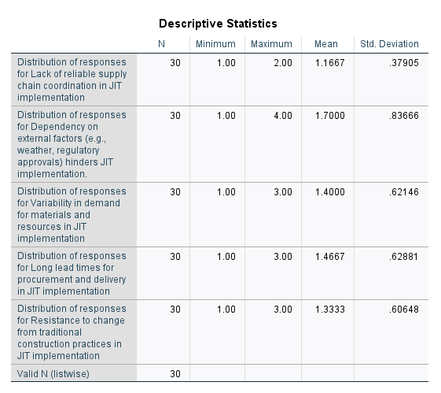

ANOVA RESULT:
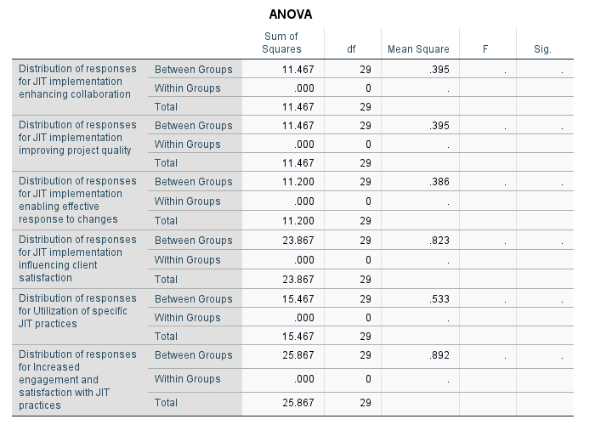

CONCLUSION
This study's findings highlight the complex and diverse aspects of implementing Just-In-Time (JIT) in building projects. Although supply chain coordination, external dependencies, and resistance to change present hurdles, the potential advantages of Just-in-Time (JIT) are clear: increased efficiency, decreased waste, and improved collaboration.
By conducting statistical analyses, including descriptive statistics, ANOVA, and correlation studies, researchers have obtained valuable information about the elements that affect the implementation of Just-in-Time (JIT) and its effects on project outcomes. These investigations have emphasized the need to comprehend stakeholder viewpoints, recognize crucial obstacles, and utilize correlations to create focused interventions.
In the future, stakeholders must embrace a comprehensive approach to Just-in-Time (JIT) deployment, effectively tackling obstacles while maximizing advantages. This involves creating customized approaches to minimize interruptions in the supply chain, promote cooperation, and address opposition to change. Moreover, cultivating a culture that prioritizes ongoing enhancement and knowledge acquisition is crucial for maximizing Just-in-Time (JIT) procedures and guaranteeing their enduring viability.
By adopting a data-driven approach to decision-making and utilizing the knowledge obtained from this study, stakeholders can better navigate the intricacies of implementing Just-in-Time (JIT) more efficiently. In conclusion, stakeholders may harness the full potential of Just-in-Time (JIT) methodology to completely transform construction project management. This will lead to increased innovation, improved project results, and an overall enhancement of the industry's performance.
REFERENCES

[1]. Dr. Sultan Singh, Dr. Dixit Garg, JIT System: Concepts, Benefits, and Motivation in Indian Industries, International Journal of Management and Business Studies, Volume: 01, Issue: 01, March 2011(ISSN: 2231-2463)
[2]. Flora Bamana, Nadia Lehoux, and Caroline Cloutier, Just in Time in Construction: Description and Implementation Insights, LC3, Heraklion, Greece, July 2017
[3]. Kanani, M. A., Sharma, N. D., & Kashiyani, M. B. K., A study on different inventory management techniques in construction, ISSN: 2394-1766, pp.1-6,2014
[4]. Patil Yogendra R., Patil Dhananjay S., Feasibility Study of Just in Time Inventory Management On Construction Project, International Research Journal of Engineering and Technology (IRJET), Volume: 02, Issue: 04, July-2015
[5]. Mohamed Ali and Dr. Salwa Beheiry, The Applicability of Just-In-Time in United Arab Emirates Construction Projects, Journal of Emerging Trends in Engineering and Applied Sciences (JETEAS) 6(2): 120-128 © Scholarlink Research Institute Journals, 2015 (ISSN: 2141-7016)
[6]. Akintola Akintoye, Just in Time application and implementation for building material management”, Construction management and economics (1995) 13, 105-113
[7]. Low Sui Pheng and Gao Shang, The application of the Just-in-Time Philosophy in the Chinese Construction Industry, Journal of Construction in Developing Countries, Vol. 16 (1), 91-111, 2011
[8]. Balu P, Moorthy R, Why Indian industries fail to implement JIT- an analysis, International Journal of Engineering Research & Technology (IJERT) Vol. 2 Issue 3, March - 2013

