Lalith Kumar. R Dr. Preeti Garg
PES2UG21BC061 Assistant Professor
PES University, Bangalore PES University, Bangalore
“TAX AVOIDANCE & EVASION AND IT’S EFFECT ON ECONOMIC DEVELOPMENT”

ABSTRACT:
Tax avoidance and evasion are persistent challenges that undermine the integrity of tax systems worldwide. This study investigates the prevalence and motivations behind these practices, focusing on responses gathered from Article ship students working in audit firms. Findings indicate that tax avoidance strategies are moderately common among individuals and businesses, driven by factors such as distrust in government spending, the desire to minimize tax burdens, and perceptions of unfair taxation. However, respondents believe that tax avoidance has only a negligible impact on government revenue. In contrast, tax evasion is viewed as exacerbating income inequality and is perceived to persist due to ineffective government measures. These findings underscore the need for more robust strategies to address tax evasion and promote equitable tax compliance, essential for fostering sustainable economic development.

Key Words: Taxation, Tax Avoidance, Taxation Perspectives.

1. INTRODUCTION:

Taxation serves as a fundamental pillar in the architecture of a nation's economy, providing the government with the necessary resources to finance public goods and services, redistribute wealth, and regulate economic activities. However, despite its pivotal role, the issue of tax avoidance and evasion has emerged as a significant challenge for both developed and developing economies worldwide. Tax avoidance refers to the legal utilization of tax laws and regulations to minimize tax liabilities, whereas tax evasion involves illegal methods to evade paying taxes owed to the government. The distinction between avoidance and evasion lies primarily in the legality of the actions taken.

Over the past few decades, the global landscape of taxation has undergone significant transformations, driven by globalization, technological advancements, and changes in regulatory frameworks. These changes have facilitated opportunities for individuals and corporations to engage in sophisticated tax planning strategies, often exploiting loopholes and inconsistencies in tax laws to reduce their tax burdens. Consequently, the prevalence of tax avoidance and evasion has raised concerns among policymakers, economists, and international organizations about its adverse effects on economic development.

The relationship between taxation and economic development is complex and multifaceted, influenced by various factors such as the structure of the tax system, enforcement mechanisms, institutional quality, and the overall business environment. While taxation is essential for financing public expenditures and promoting socioeconomic development, excessive tax burdens and inefficient tax systems can hinder investment, entrepreneurship, and economic growth. Moreover, tax evasion undermines the integrity of the tax system, erodes public trust in government institutions, and exacerbates inequality by allowing wealthy individuals and corporations to evade their fair share of taxes.

In recent years, the issue of tax avoidance and evasion has gained prominence on the global agenda, spurred by high-profile scandals, legislative reforms, and international initiatives aimed at combating tax evasion and promoting tax transparency. The Organization for Economic Cooperation and Development (OECD) and other international bodies have spearheaded efforts to address tax evasion through initiatives such as the Common Reporting Standard (CRS) and the Base Erosion and Profit Shifting (BEPS) project. These initiatives seek to enhance international cooperation, strengthen tax administration, and close loopholes that facilitate tax evasion and profit shifting by multinational corporations.

Despite these efforts, tax avoidance and evasion continue to pose significant challenges to governments worldwide, particularly in developing countries with weak institutional capacities and inadequate regulatory frameworks. In such contexts, the prevalence of informal economic activities, weak rule of law, and corruption further exacerbate the problem of tax evasion, depriving governments of much-needed revenue and undermining efforts to promote sustainable development.

Given the complexity and importance of the issue, there is a growing need for empirical research to understand the underlying drivers, consequences, and policy implications of tax avoidance and evasion on economic development. This study aims to contribute to the existing literature by examining the impact of tax avoidance and evasion on key macroeconomic indicators such as investment, economic growth, income inequality, and government revenue. By employing a mixed-methods approach combining quantitative analysis and case studies, this research seeks to provide insights into the mechanisms through which tax avoidance and evasion affect economic development outcomes across different countries and contexts.

In conclusion, addressing the challenge of tax avoidance and evasion is essential for fostering inclusive and sustainable economic development. By enhancing tax compliance, improving tax administration, and promoting international cooperation, governments can strengthen their revenue base, reduce inequality, and create a more conducive environment for investment and entrepreneurship. Through rigorous research and evidence-based policy interventions, policymakers can develop effective strategies to mitigate the adverse effects of tax avoidance and evasion and promote a fair and equitable tax system that supports long-term economic growth and development.

Despite the substantial efforts undertaken by governments and international organizations to combat tax avoidance and evasion, the magnitude of the problem remains daunting. Estimates suggest that trillions of dollars are lost annually due to tax evasion and aggressive tax planning strategies employed by individuals and corporations globally. The repercussions of this loss reverberate throughout the economy, hindering public investment in critical infrastructure, healthcare, education, and social welfare programs.

Furthermore, the prevalence of tax avoidance and evasion exacerbates fiscal imbalances, forcing governments to resort to alternative sources of revenue such as regressive consumption taxes or increased borrowing, which can further strain public finances and exacerbate debt sustainability concerns. Moreover, the erosion of the tax base undermines the progressivity of the tax system, disproportionately burdening low-income earners and exacerbating income inequality, which has been identified as a significant barrier to sustainable development.

The adverse effects of tax avoidance and evasion extend beyond economic considerations, posing significant challenges to governance, institutional integrity, and social cohesion. When individuals and corporations perceive that others are not paying their fair share of taxes, it erodes trust in the legitimacy of the tax system and undermines compliance efforts. This erosion of trust can have far-reaching implications, including reduced voluntary compliance, increased tax morale, and diminished social capital, which are essential for fostering cooperation and collective action in addressing societal challenges.

Moreover, the illicit financial flows associated with tax evasion have broader implications for global stability and development. These flows often involve money laundering, corruption, and organized crime, undermining the rule of law, fueling illicit activities, and impeding efforts to achieve sustainable development goals, such as poverty reduction, environmental sustainability, and social inclusion. Therefore, tackling tax avoidance and evasion is not only an economic imperative but also a moral and ethical imperative, essential for promoting fairness, transparency, and accountability in the global economy.

In light of these considerations, this study seeks to contribute to the existing body of knowledge on tax avoidance and evasion and its implications for economic development. By examining the micro and macroeconomic dynamics underlying tax behavior, this research aims to identify effective policy interventions to combat tax evasion, enhance tax compliance, and promote inclusive growth. Through a comprehensive analysis of the drivers, consequences, and policy responses to tax avoidance and evasion, this study seeks to inform evidence-based policymaking and contribute to the broader discourse on taxation, governance, and sustainable development.

In the subsequent sections of this paper, we will delve into a detailed review of the existing literature on tax avoidance and evasion, exploring theoretical frameworks, empirical evidence, and policy debates surrounding the issue. We will then outline the research methodology employed in this study, including data sources, analytical techniques, and case study selection criteria. Subsequent sections will present the findings of our analysis, discussing the implications for theory, policy, and practice. Finally, we will conclude with a summary of key findings, policy recommendations, and avenues for future research.

1.1 Background of the topic:
Tax avoidance and evasion refer to strategies individuals and businesses use to reduce their tax liabilities by exploiting legal loopholes (avoidance) or deliberately misrepresenting income or other financial information to tax authorities (evasion). These practices have existed for as long as taxes themselves. While tax avoidance is generally legal, tax evasion is illegal and punishable by law. Both practices have significant implications for economic development, as they can deprive governments of crucial revenue needed for public services and infrastructure.

1.2 Need/importance of the topic:
Tax avoidance and evasion undermine the integrity of tax systems, reduce government revenue, and create an unequal tax burden among citizens. This can hinder economic development by limiting the government's ability to fund essential services such as education, healthcare, and infrastructure. Moreover, when individuals and businesses avoid or evade taxes, it can erode trust in the fairness of the tax system and discourage compliance among honest taxpayers. Addressing these issues is essential for promoting sustainable economic growth and ensuring that the tax burden is distributed equitably.

1.3 Theoretical implication of the topic:
From a theoretical perspective, tax avoidance and evasion have several implications. They challenge the notion of tax fairness and equity, as those who engage in these practices often end up paying lower effective tax rates than those who comply with the law. This can lead to resentment and a sense of injustice among the general population. Additionally, tax avoidance and evasion can distort resource allocation by incentivizing activities that are driven by tax considerations rather than economic efficiency. This can result in misallocation of resources and inefficiencies in the economy.

1.4 Recent trends related to the topic:
In recent years, there has been increased global scrutiny and efforts to combat tax avoidance and evasion. International initiatives such as the Base Erosion and Profit Shifting (BEPS) project led by the OECD and the implementation of the Common Reporting Standard (CRS) for the automatic exchange of financial account information have aimed to address cross-border tax evasion and improve transparency. Many countries have also introduced measures to close loopholes and crack down on aggressive tax planning by multinational corporations. Additionally, technological advancements have enabled tax authorities to enhance their enforcement capabilities through data analytics and digital reporting systems. However, challenges remain, particularly regarding the enforcement of tax laws in an increasingly digital and globalized economy.

1.5 Tax System & Structure in India:
India's income tax system, regulated by the Income Tax Act of 1961 and overseen by the Central Board of Direct Taxes (CBDT), operates on a progressive scale. This means that as income levels rise, so do tax rates. The tax structure comprises several key components. First are the income tax slabs, which dictate the rates at which individuals are taxed based on their earnings. For instance, as of the latest revision, individuals below 60 years old are not taxed for income up to ₹2.5 lakh, but they are taxed progressively for higher earnings. Moreover, there are surcharges applicable to individuals with higher incomes, with rates varying depending on income slabs.

Additionally, a health and education cess of 4% is levied on the total income tax payable. The Income Tax Act also provides for various deductions and exemptions, such as those for investments in instruments like the Provident Fund and allowances. Capital gains from asset sales are subject to taxation, with rates differing for short-term and long-term gains. Corporate tax rates in India vary by company type and size, with domestic companies currently taxed at 25%. Finally, the Goods and Services Tax (GST) is a value-added tax levied on most goods and services for domestic consumption, applied at each stage of the supply chain. Given the dynamic nature of tax laws, individuals and businesses should remain updated and seek professional advice for specific tax matters.

2. LITERATURE REVIEW:

This paper provides a conceptual analysis of tax evasion and the generation of black money in India, focusing on the implications within the framework of income tax law. It explores the mechanisms, challenges, and potential solutions to combat these issues in the Indian context (Karan Singh, Dr. Vivek Agrawal, March 2018). This explores tax evasion as a significant impediment to economic development and growth. It examines its causes and proposes remedies. It underscores the importance of addressing tax evasion to foster sustainable economic progress. (V. Kalpana, May 2016). This paper investigates tax evasion in India and its ramifications on government revenue. Through empirical analysis, it examines the extent of tax evasion, its contributing factors, and proposes measures to mitigate (Dr. Devarajappa S, September 2017).
The issue of tax evasion and the generation of black money in India has been a subject of considerable concern, attracting the attention of scholars and policymakers alike. In a study conducted by Karan Singh and Dr. Vivek Agrawal in March 2018, a conceptual analysis of tax evasion within the framework of income tax law in India was undertaken. This research delved into the mechanisms, challenges, and potential solutions to combat tax evasion, recognizing its significant implications for the country's economic landscape. By focusing on the Indian context, the study provided insights into the specific challenges faced by the Indian tax system and underscored the importance of addressing tax evasion to facilitate sustainable economic progress.
Furthermore, V. Kalpana, in a paper published in May 2016, emphasized tax evasion as a substantial impediment to economic development and growth in India. Through a conceptual lens, this research explored the root causes of tax evasion and proposed remedies to mitigate its adverse effects. By highlighting the detrimental impact of tax evasion on the overall economic framework, the study underscored the urgency of implementing effective measures to curb evasion and promote a fair and transparent tax system conducive to sustainable development.
Dr. Devarajappa S, in a study conducted in September 2017, delved into the empirical analysis of tax evasion in India and its ramifications on government revenue. Through rigorous empirical analysis, this research aimed to quantify the extent of tax evasion, identify its contributing factors, and propose concrete measures to address the issue. By providing empirical evidence, the study contributed to a deeper understanding of the magnitude of tax evasion in India and underscored the importance of implementing policy interventions to safeguard government revenue and promote fiscal sustainability.
Collectively, these studies shed light on the multifaceted nature of tax evasion in India and its far-reaching implications for economic development. By offering conceptual analyses, empirical evidence, and policy recommendations, these studies underscored the urgency of addressing tax evasion to foster sustainable economic progress in India. Moreover, they highlighted the need for comprehensive and coordinated efforts from both policymakers and stakeholders to combat tax evasion effectively and promote a fair and transparent tax regime conducive to long-term growth and development.
This paper examines the dynamics of tax evasion, the effectiveness of amnesty schemes in curbing it, and the prevalence of black income. It explores theoretical frameworks, empirical evidence, and associated challenges in addressing these issues within the realm of fiscal policy and governance (Shikha Jha, 26 June, 2016). This paper conducts a comparative analysis of India's tax structure against other countries, examining key components such as tax rates, tax base, administrative efficiency, and compliance mechanisms. It aims to elucidate strengths, weaknesses, and potential areas for reform in India's taxation system (Mr. Nishant Ravindra Ghuge, 2016). Tax Avoidance, Evasion, and Administration by Joel explores strategies, legal loopholes, and governmental oversight in tax systems, offering insights into financial practices (Joel slemrod,2002).
In the realm of fiscal policy and governance, understanding the dynamics of tax evasion and the efficacy of amnesty schemes in mitigating it are crucial endeavors. Shikha Jha's examination, conducted in 2016, delves into these dynamics, drawing upon theoretical frameworks and empirical evidence. By exploring the nuances of tax evasion and the impact of amnesty schemes, Jha's work sheds light on the challenges faced by policymakers in addressing these issues effectively.
Moreover, Mr. Nishant Ravindra Ghuge's comparative analysis, also from 2016, offers valuable insights into India's tax structure in comparison to other countries. Ghuge's study meticulously examines key components such as tax rates, tax base, administrative efficiency, and compliance mechanisms. By elucidating the strengths and weaknesses of India's taxation system and identifying potential areas for reform, Ghuge's research contributes significantly to the discourse on tax policy and governance in India.
Additionally, Joel Slemrod's exploration of tax avoidance, evasion, and administration provides a comprehensive overview of the strategies, legal loopholes, and governmental oversight in tax systems. Published in 2002, Slemrod's work remains relevant in understanding the intricate mechanisms employed by individuals and corporations to minimize their tax liabilities. By offering insights into financial practices and the role of government in regulating tax compliance, Slemrod's research underscores the importance of effective tax administration in maintaining fiscal integrity and promoting economic development.
This study contrasts tax avoidance (legal) and evasion (illegal), exploring factors influencing the shadow economy, shedding light on economic behaviors. (Reinhard Neck, 2012). Analyzes international tax evasion and avoidance, focusing on India's context. Explores legal loopholes, strategies, and implications for taxation systems (Sury. M , 2017). Tax avoidance practices prevalent in developing economies countered by anti-avoidance measures. Phylls outlines both strategies, essential for equitable tax collection and economic development (Phyllis, 2011). Tax evasion illegally avoids paying taxes, impacting revenue and public services. Tax avoidance minimizes tax liability within legal bounds, affecting revenue collection and equity (Gurpreet Kaur, 2019). Tax evasion is illegal and deprives governments of revenue. Tax avoidance, though legal, reduces funds for public services, exacerbating inequality and undermining social welfare (Saloni doshi, 2020). Tax evasion in developing countries undermines vital public services and economic development, exacerbating inequality and hindering progress towards sustainable development goals (Syed, 1995).
Recent scholarly works have delved into the nuanced distinctions between tax avoidance, which operates within legal frameworks to minimize tax obligations, and tax evasion, which involves illegal means to evade taxes owed to the government. Reinhard Neck's study in 2012 provides a comprehensive analysis of these phenomena, highlighting the factors influencing the shadow economy and shedding light on the intricate economic behaviors surrounding tax practices.
Moreover, Sury M.'s research in 2017 zooms in on the global landscape of international tax evasion and avoidance, with a particular focus on the Indian context. Through meticulous examination, Sury explores the legal loopholes, strategies, and implications for taxation systems, offering valuable insights into the challenges faced by policymakers in curbing tax avoidance and evasion practices.
In a similar vein, Phyllis' work in 2011 underscores the importance of understanding both tax avoidance and evasion strategies, especially in the context of developing economies. By outlining anti-avoidance measures and strategies to counter prevalent tax avoidance practices, Phyllis emphasizes the significance of equitable tax collection mechanisms for fostering economic development and reducing inequality.
Gurpreet Kaur's research in 2019 further reinforces the distinction between tax evasion and avoidance, elucidating their respective impacts on government revenue and social welfare. While tax evasion deprives governments of much-needed revenue through illegal means, tax avoidance, though legal, diminishes funds available for public services, exacerbating inequality and undermining social welfare efforts.
Saloni Doshi's study in 2020 echoes these sentiments, emphasizing the detrimental effects of both tax evasion and avoidance on public services and equitable economic development. While tax evasion poses a direct threat to government revenue streams, tax avoidance indirectly hampers efforts to address social welfare needs, perpetuating disparities and hindering progress towards achieving sustainable development goals.
Syed's seminal work in 1995 further underscores the ramifications of tax evasion in developing countries, where the loss of revenue undermines vital public services and exacerbates inequality. The adverse effects of tax evasion on economic development underscore the urgent need for comprehensive strategies to combat illicit financial practices and promote equitable tax systems conducive to sustainable development.
In essence, these studies collectively emphasize the importance of understanding the complex interplay between tax avoidance, evasion, and economic development. By addressing the root causes of tax avoidance and evasion through targeted policy interventions and strengthening institutional capacities, governments can foster inclusive growth, reduce inequality, and advance progress towards sustainable development goals.
Examines tax evasion's economic impact in India, highlighting its consequences and potential implications for the economy (Dr. Mohmad Iqbal Darzi, 2018). Examine tax evasion's causes, effects on the shadow economy. Insights on its socio-economic impact and policy implications provided (Sahu Amit Kumar, Ms. Bhushan Mamta, 2014). Highlights complexities, enforcement gaps, and suggests tailored policy interventions for effective deterrence and compliance (Dr. Sandeep Raghuwanshi, 2019). This paper conducts a comparative analysis of India's tax structure against other countries, examining key components such as tax rates, tax base, administrative efficiency, and compliance mechanisms.
Tax evasion remains a critical issue in India's economic landscape, with far-reaching consequences for the economy, society, and governance. Dr. Mohmad Iqbal Darzi's study in 2018 provides a comprehensive examination of tax evasion's economic impact in India. Darzi highlights the detrimental effects of tax evasion on government revenue, fiscal deficit, and public services. Moreover, the study underscores how tax evasion distorts market competition, undermines the integrity of the tax system, and fosters a culture of non-compliance among taxpayers.
Building upon Darzi's work, Sahu Amit Kumar and Ms. Bhushan Mamta's research in 2014 delves deeper into the causes and effects of tax evasion in India, particularly its implications for the shadow economy. The study elucidates how factors such as complex tax regulations, high tax rates, and weak enforcement mechanisms contribute to the proliferation of the shadow economy, exacerbating tax evasion. Furthermore, Kumar and Mamta shed light on the socio-economic consequences of tax evasion, including reduced government revenue for essential public services, increased income inequality, and diminished trust in institutions.
Dr. Sandeep Raghuwanshi's study in 2019 further enriches our understanding of tax evasion in India by highlighting the complexities and enforcement gaps in combating this pervasive problem. Raghuwanshi underscores the need for tailored policy interventions that address the root causes of tax evasion while enhancing enforcement capabilities and promoting compliance. By adopting a multifaceted approach that combines regulatory reforms, technology-enabled solutions, and capacity building, policymakers can effectively deter tax evasion and foster a culture of tax compliance.
In addition to these seminal studies, a comparative analysis of India's tax structure against other countries offers valuable insights into the efficacy of existing tax policies and administrative mechanisms. By examining key components such as tax rates, tax base, administrative efficiency, and compliance mechanisms, policymakers can identify best practices and areas for improvement. This comparative analysis serves as a benchmark for evaluating India's tax system's strengths and weaknesses and informs evidence-based policy reforms aimed at enhancing revenue mobilization, promoting economic growth, and ensuring equitable tax compliance.
In conclusion, addressing tax evasion in India requires a comprehensive and holistic approach that tackles its underlying causes, strengthens enforcement mechanisms, and fosters a culture of tax compliance. By drawing upon insights from empirical research, policymakers can design targeted interventions that mitigate the adverse economic and social consequences of tax evasion while promoting sustainable and inclusive development. Through collaborative efforts between government agencies, civil society, and the private sector, India can realize its full revenue potential, bolster economic resilience, and foster a fair and transparent tax environment conducive to long-term prosperity.
It aims to elucidate strengths, weaknesses, and potential areas for reform in India's taxation system (Nagpal, 2011). This paper investigates tax evasion in India and its ramifications on government revenue. Through empirical analysis, it examines the extent of tax evasion, its contributing factors, and proposes measures to mitigate (Devamsh 2017). Tax avoidance practices prevalent in developing economies countered by anti-avoidance measures. Param outlines both strategies, essential for equitable tax collection and economic development (Param, 2012). This explores tax evasion as a significant impediment to economic development and growth. It examines its causes and proposes remedies. It underscores the importance of addressing tax evasion to foster sustainable economic progress. (Varun, 2016).
This paper conducts a comparative analysis of India's tax structure against other countries, examining key components such as tax rates, tax base, administrative efficiency, and compliance mechanisms. It aims to elucidate strengths, weaknesses, and potential areas for reform in India's taxation system (Arun, 2018). It explores theoretical frameworks, empirical evidence, and associated challenges in addressing these issues within the realm of fiscal policy and governance (Shyam, 2016).
The literature surrounding taxation in India encompasses a diverse range of perspectives, methodologies, and objectives. Nagpal (2011) focuses on elucidating the strengths, weaknesses, and potential areas for reform within India's taxation system. Through empirical analysis, Devamsh (2017) delves into the intricate dynamics of tax evasion in India, investigating its extent, contributing factors, and proposing measures to mitigate its adverse effects on government revenue.
Param (2012) contributes to the discourse by examining tax avoidance practices prevalent in developing economies, juxtaposed against anti-avoidance measures. The exploration of these strategies is deemed essential for ensuring equitable tax collection and fostering economic development. Additionally, Varun (2016) underscores the significance of addressing tax evasion as a significant impediment to economic progress, emphasizing the importance of implementing effective remedies to promote sustainable development.
Furthermore, Arun (2018) conducts a comparative analysis of India's tax structure vis-à-vis other countries, scrutinizing key components such as tax rates, tax base, administrative efficiency, and compliance mechanisms. This comparative approach sheds light on potential areas for reform within India's taxation system, offering valuable insights into optimizing tax policies to enhance economic growth and development.
In a broader theoretical context, Shyam (2016) explores the theoretical frameworks and empirical evidence associated with taxation issues within the realm of fiscal policy and governance. By addressing the associated challenges, this research aims to contribute to a deeper understanding of the complexities involved in crafting effective tax policies that align with broader economic objectives and governance principles.
Overall, this body of literature reflects the multifaceted nature of taxation in India, encompassing diverse perspectives, methodologies, and objectives aimed at informing policy debates, guiding reforms, and ultimately fostering sustainable economic development.

3. RESEARCH DESIGN:

3.1 STATEMENT OF THE PROBLEM:

Tax avoidance and evasion represent significant challenges to government’s worldwide, impacting economic development in various ways. Despite efforts to curb these practices, they persist and even evolve, posing threats to fiscal sustainability and social equity.

3.2 NATURE OF THE STUDY:

This research aims to investigate the relationship between tax avoidance/evasion and economic development. It will analyze the extent to which these practices hinder revenue generation for governments and potentially distort economic activities. The study will employ quantitative data analysis research methods to understand the various mechanisms and implications of tax avoidance/evasion on overall economic growth, investment, public services, and income inequality. It seeks to provide insights for policymakers, businesses, and individuals on how to address these issues and promote sustainable economic development.

3.3 NEED OF THE STUDY:

- Tax avoidance and evasion lead to significant revenue losses for governments.
- They create an unequal tax burden among citizens, eroding trust in the tax system.
- These practices distort economic incentives, leading to resource misallocation.

3.4 SCOPE OF THE STUDY:

This scope provides a structured outline for investigating the relationship between tax avoidance, evasion, and economic development, ensuring a comprehensive analysis while maintaining academic integrity.

3.5 OBJECTIVES OF THE STUDY:

- Identify the primary motivations driving individuals and businesses to engage in tax avoidance practices.
- Investigate public attitudes and perceptions towards tax avoidance and evasion and their
Implications for compliance.

- To explore case studies with different tax systems and enforcement strategies to understand their impact on economic development outcomes.

3.6 LIMITATION OF THE STUDY:

- Legal and ethical constraints restrict data access and analysis.
- Economic development is influenced by numerous external factors.
- Long-term effects are difficult to assess due to data limitations and lagged effects.
- Measurement errors and inaccuracies in data can affect findings.

3.7 RESEARCH METHODOLOGY:

- Population: 20 - 30

- Sample Design: Pi Chart
- Sample Size: 20 - 30
- Sampling Unit: Chartered Accountants & Article-ship Assistant
- Sampling Method: Purposive Sampling
- Method of Data Collection
- Primary Data: Questionnaire
- Secondary Data: Government Websites

- Instrument For Data Collection: Google Forms
- Testing Of Questionnaire: Chartered Accountants & Article-ship Assistant
- Data Analysis Techniques: Pi Chart Analysis

4. DATA PROCESSING & ANALYSIS

RESEARCH QUESTIONS:
1. To what extent do individuals or businesses engage in tax avoidance strategies?
2. What motivates individuals or businesses to engage in tax avoidance?
4. How do tax avoidance practices impact government revenue?
5. What are the perceived consequences of tax evasion on economic development?
6. How effective are current government measures in combating tax evasion?
7. To what extent do tax policies influence individuals or businesses to engage in tax evasion?
8. What are the perceived social and ethical implications of tax avoidance and evasion?
9. How do perceptions of tax fairness affect compliance with tax laws?
10. What measures could be implemented to reduce tax avoidance and evasion?

DATA ANALYSIS:
CHART NO. 1
TITLE OF THE CHART: Category of Responses

INTERPRETATION: The Responses for the Questionnaire was received majorly from the Article-shi p students followed by Candidates pursuing CA & finally by the CAs themselves.

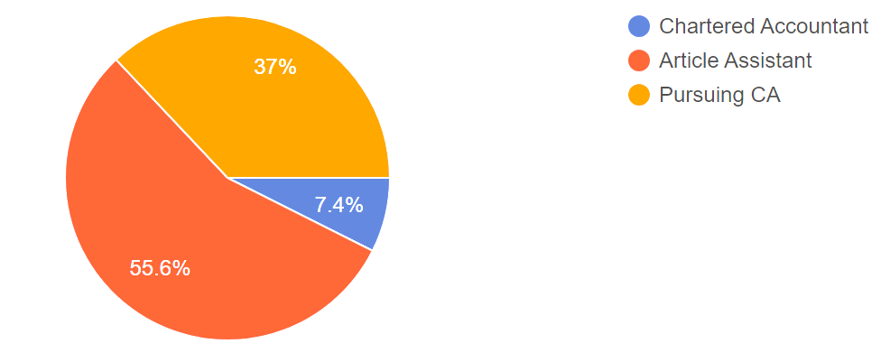
Fig No. 1

CHART NO. 2
TITLE OF THE CHART: Engagement Rate

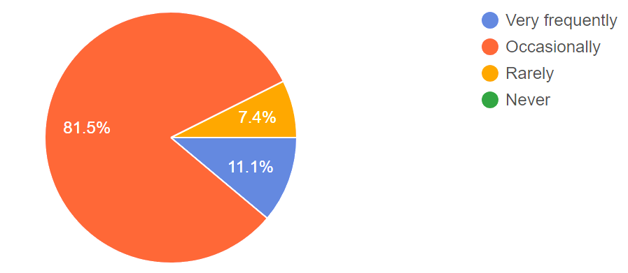

INTERPRETATION: The Responses received explains that the engagement rate in Tax Avoidance cases occur occasionally as one cannot be avoiding tax payment which would lead to penalty.

Fig No. 2

CHART NO. 3
TITLE OF THE CHART: Reason

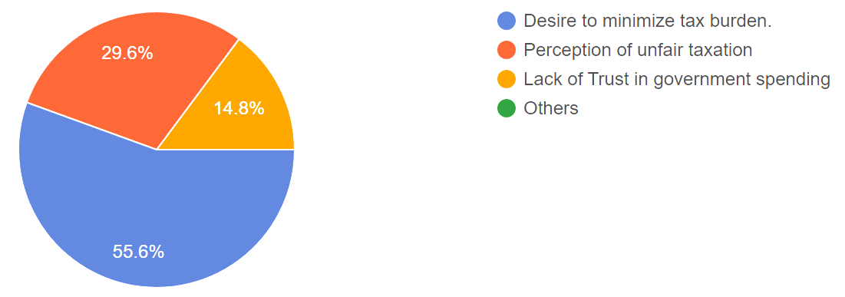

INTERPRETATION: The Responses received proves that the main reason for Avoiding Tax is to minimize one’s Tax Burden, as one can save a lot of money if he doesn’t Pay taxes & followed by peoples view on unfair taxation & finally the trust on government spending for the Well-being of the country.

Fig No. 3

CHART NO. 4
TITLE OF THE CHART: Impact

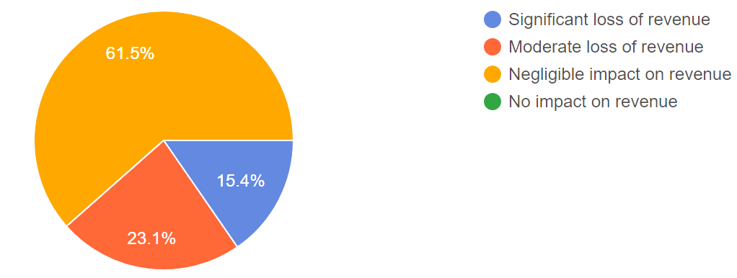

INTERPRETATION: The Responses received shows, there would barely be any impact for the govt’s revenue as Tax Avoidance occurs occasionally & not frequently.

Fig No. 4

CHART NO. 5
TITLE OF THE CHART: Consequences

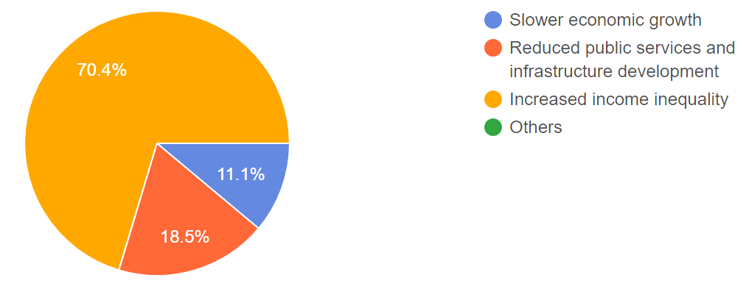

INTERPRETATION: The Major consequence from Tax Avoidance would be the rise of Income Inequality as When individuals or corporations evade taxes, it can result in a disproportionate burden on those who cannot evade taxes as easily, leading to a concentration of wealth among the affluent and widening disparities between the rich and the poor.

Fig No. 5

CHART NO. 6
TITLE OF THE CHART: Effective Rate

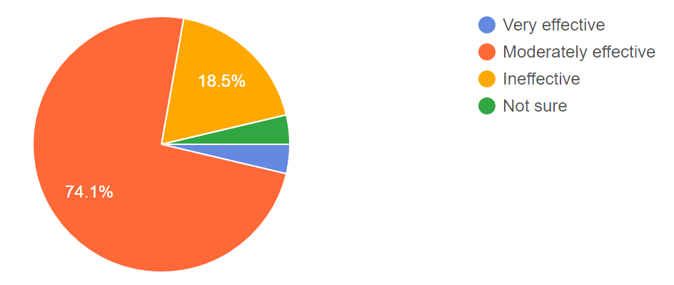

INTERPRETATION: The present Tax policies are Moderately effective which is driving individuals to Avoid Taxes occasionally via using the loopholes in the tax system. Whereas few of them believe, the present Policies are ineffective in controlling the Tax avoiding practices.

Fig No. 6

CHART NO. 7
TITLE OF THE CHART: Influence Rate

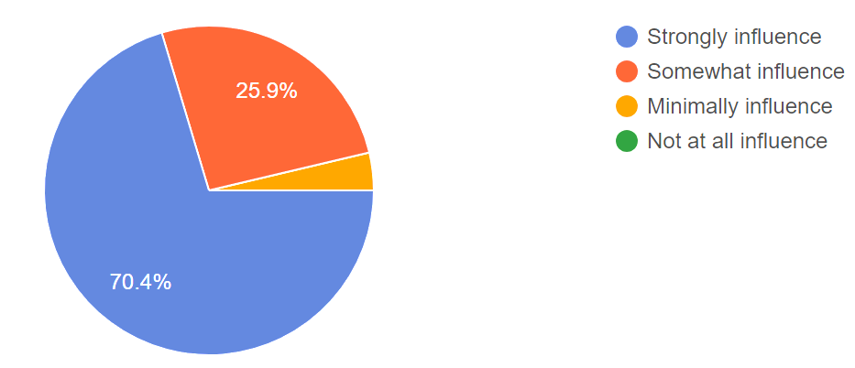

INTERPRETATION: The significant majority of respondents believe that tax policies strongly influence to engage in tax evasion. This suggests that respondents perceive tax policies as a major factor in influencing tax evasion behaviors. Whereas a considerable portion of respondents acknowledge the influence of tax policies on tax evasion, influence to a lesser extent.

Fig No. 7

CHART NO. 8
TITLE OF THE CHART: Implication of Avoidance

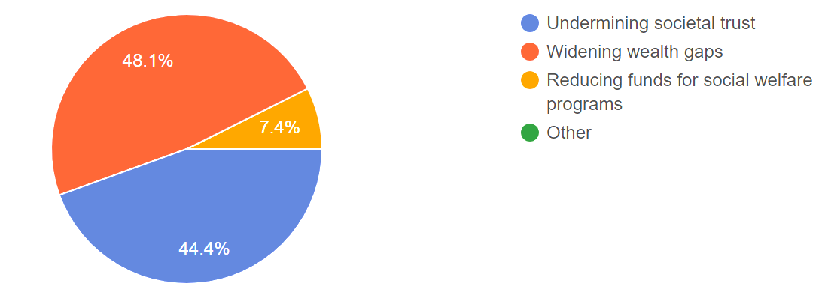

INTERPRETATION: The survey results highlight significant concerns regarding the perceived social and ethical implications of tax avoidance and evasion. The majority of respondents, 48.1%, emphasize the widening wealth gaps resulting from these practices, indicating a recognition of the exacerbation of inequality within society. Additionally, 44.4% of respondents identify the undermining of societal trust, suggesting that tax avoidance and evasion erode the foundations of trust

Fig No. 8

CHART NO. 9
TITLE OF THE CHART: Compliance Rate

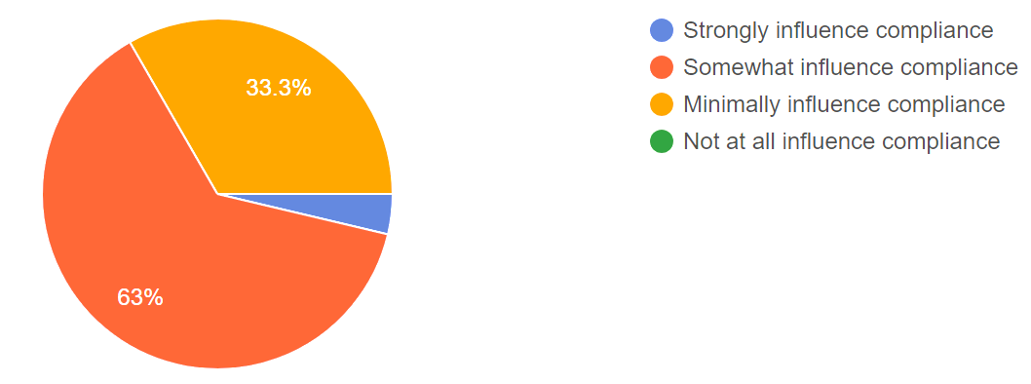

INTERPRETATION: The survey results indicate that perceptions of tax fairness have a significant impact on tax compliance, with the majority (67.3%) of respondents stating that it either strongly or somewhat influences compliance. This suggests that fairness perceptions are crucial for encouraging adherence to tax laws

Fig No. 9

CHART NO. 10
TITLE OF THE CHART: Measures

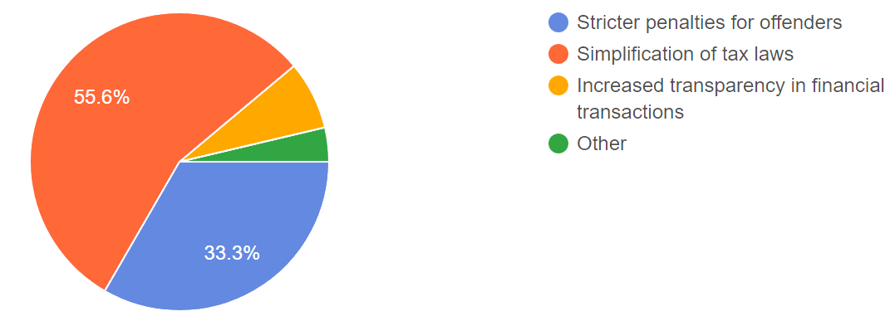

INTERPRETATION: The measures to reduce tax avoidance and evasion are seen as essential, with simplification of tax laws being the most favored solution (55.6%), followed by stricter penalties for offenders (33.3%). This highlights a call for clearer regulations and consequences to control non-compliance, potentially leading to a more equitable and effective tax system.

Fig No. 10

CHART NO. 11
TITLE OF THE CHART: Category of Responses

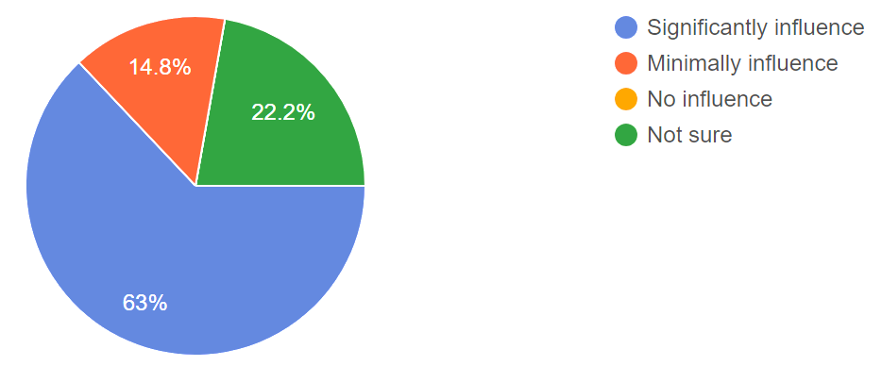

INTERPRETATION: The survey results indicate that a majority (63%) of respondents perceive these regulations to have a significant influence, suggesting awareness of their crucial role in shaping tax behaviors across borders. Additionally, a notable minority (14.8%) acknowledge a minimal impact, while a smaller portion (22.2%) believe these regulations have no influence. These findings underscore the complexity and importance of international tax frameworks in addressing global tax challenges and ensuring fair and transparent taxation practices.

Fig No. 11

DIRECT TAX COLLECTION (In Cr)
Financial Year | Corporate Tax (in Cr) | Personal Income Tax (in Cr) | Other Direct Tax (in Cr) | Total (in Cr)
2010-11 | 298688 | 146258 | 1049 | 445995
2011-12 | 322816 | 170181 | 990 | 493987
2012-13 | 356326 | 201840 | 823 | 558989
2013-14 | 394678 | 242888 | 1030 | 638596
2014-15 | 428925 | 265772 | 1095 | 695792
2015-16 | 453228 | 287637 | 1079 | 741945
2016-17 | 484924 | 349270 | 15624 | 849818
TABLE 1: DIRECT TAX COLLECTION

Source: Union Finance Accounts

Fig No. 12

INTERPRETATION: Upon analyzing the data presented in Table-1, it becomes evident that in the financial year 2010-11, income tax collection accounted for 51% of the corporate tax collection. However, by the financial year 2016-17, income tax collection increased to constitute 61% of corporate tax collection. This indicates a declining gap between corporate and income tax collections over the years, with income tax collection demonstrating a positive upward trend.

TABLE 2: DIRECT TAX – GDP RATIO PERCENTAGE

DIRECT TAX - GDP RATIO PERCENTAGE
Financial Year | Net collection of direct taxes | GDP Current Market Price | Direct tax GDP ratio | GDP growth rate
2010-11 | 445995 | 7674148 | 5.81% | 18.84%
2011-12 | 493987 | 9009722 | 5.48% | 17.40%
2012-13 | 558989 | 10113281 | 5.53% | 12.25%
2013-14 | 638596 | 11355073 | 5.62% | 12.28%
2014-15 | 695792 | 12541208 | 5.55% | 10.45%
2015-16 | 741945 | 13567192 | 5.47% | 8.25%
2016-17 | 849818 | 15183710 | 5.60% | 11.91%

Source: MOSPI

Fig No. 13

INTERPRETATION: The analysis of Table-2 suggests that the direct tax GDP ratio remains relatively stable from the financial year 2010-11 to 2016-17, indicating a consistent trend without significant fluctuations. However, during the same period, there was a decline in the GDP growth rate from 18.84% to 11.91% in the financial year 2016-17. This decline in GDP growth rate is reflected in the graph's movement, which adjusts accordingly to show the change in the economic trajectory.
RECENT CASES REGARDING TO TAX AVOIDANCES:
India has a comprehensive legal framework comprising the Income Tax Act, the Black Money (Undisclosed Foreign Income and Assets) and Imposition of Tax Act of 2015, the Foreign Account Tax Compliance Act, and Double Taxation Avoidance Agreements (DTAAs). Despite this, instances like those involving Lalit Modi, Vijay Mallya, Mehul Choksi, and Nirav Modi, who kept their assets abroad following frauds with various banks, have posed challenges for investigative agencies to take timely action.

Recently, the Income Tax department has taken new measures against jeweler Nirav Modi, a key figure in the Punjab National Bank fraud amounting to Rs 11,400 crores. Modi faces fresh charges under the anti-black money law for allegedly holding undisclosed assets abroad. This move expands the legal scope beyond the Income Tax Act of 1961 to address cases of overseas illegal assets more effectively.

MEASURES TAKEN TO COMBAT THE BLACK MONEY GENERARTION:
Government efforts to combat black money, particularly funds hidden abroad, involve various strategies. These encompass policy initiatives, robust enforcement actions, and the establishment of effective legislative and administrative frameworks. Key recent measures include:

1. Formation of a Special Investigation Team (SIT) on Black Money led by former Supreme Court Judges.

2. Establishment of a Multiagency Group (MAG) comprising officials from CBDT, RBI, ED, and FIU to investigate revelations from the Panama Papers.

3. Actively engaging with foreign governments to enhance information exchange under various agreements and conventions, including joining the Multilateral Competent Authority Agreement for Automatic Exchange of Information.

4. Passing the Black Money (Undisclosed Foreign Income and Assets) Act, 2015, amended after the Nirav Modi case, which imposes a 120% tax and penalty on undisclosed foreign assets, with provisions for up to 10 years of imprisonment.
5. Amending the Prevention of Money Laundering Act, 2002, to enable the attachment and confiscation of domestic property equivalent in value to assets held abroad.

6. Giving priority to investigating cases involving black money stashed abroad, with swift follow-up actions, including prosecutions.

7. The Income Tax Department's heightened focus on combating black money, evidenced by a significant increase in criminal prosecution proceedings and compounding of offenses in recent years.

These efforts underscore the government's commitment to tackling the issue of black money effectively through a comprehensive approach involving legal, administrative, and enforcement measures.

INTERPRETATION:
Tax avoidance strategies are occasionally engaged in by individuals or businesses, with responses indicating a moderate frequency of occurrence. The most common motivations for tax avoidance include a lack of trust in government spending, alongside a desire to minimize tax burdens and perceptions of unfair taxation. Tax avoidance practices are perceived to have a negligible impact on government revenue, with responses indicating that they do not significantly diminish government income.

The perceived consequences of tax evasion on economic development include increased income inequality, as respondents suggest that these practices contribute to widening wealth gaps. Current government measures to combat tax evasion are perceived as ineffective, with respondents expressing doubts about the efficacy of existing strategies.Tax policies are believed to strongly influence individuals or businesses to engage in tax evasion, indicating a significant role of government regulations in shaping tax behavior.

The social and ethical implications of tax avoidance and evasion are perceived to include widening wealth gaps, with concerns about the fairness of taxation and its impact on societal trust and social welfare programs.

Perceptions of tax fairness somewhat influence compliance with tax laws, suggesting that individuals' beliefs about the fairness of taxation affect their willingness to comply with tax regulations.

Respondents suggest that simplification of tax laws could be an effective measure to reduce tax avoidance and evasion, highlighting the importance of making tax regulations more accessible and understandable.

There is uncertainty about the extent to which international tax regulations impact tax avoidance and evasion, with respondents indicating a lack of clarity regarding the influence of global tax policies on tax behavior.

Tax avoidance strategies, while not uncommon, are occasionally employed by individuals or businesses, with responses indicating a moderate frequency of occurrence. Motivations for tax avoidance often stem from a lack of trust in government spending practices, alongside a desire to minimize tax burdens and perceptions of unfair taxation. Despite the prevalence of tax avoidance practices, they are generally perceived to have a negligible impact on government revenue, with respondents suggesting that they do not significantly diminish overall income.

In contrast, the perceived consequences of tax evasion on economic development are considered more severe. Respondents suggest that tax evasion contributes to increased income inequality, exacerbating existing wealth gaps within society. Moreover, there is a prevailing skepticism regarding the effectiveness of current government measures to combat tax evasion, with doubts expressed about the efficacy of existing strategies. This skepticism underscores the importance of addressing loopholes and weaknesses in tax enforcement mechanisms.

Tax policies play a significant role in shaping individuals' and businesses' decisions to engage in tax evasion. Respondents believe that complex and ambiguous tax regulations provide fertile ground for tax evasion practices to thrive. As such, there is a consensus among respondents that simplifying tax laws could be an effective measure to reduce both tax avoidance and evasion. Making tax regulations more accessible and understandable could enhance compliance and mitigate opportunities for tax evasion.
Furthermore, the social and ethical implications of tax avoidance and evasion are perceived to be significant. Beyond merely financial considerations, respondents express concerns about the widening wealth gaps resulting from these practices. The fairness of taxation is called into question, with implications for societal trust and the effectiveness of social welfare programs. Perceptions of tax fairness are shown to influence compliance with tax laws, indicating that individuals' beliefs about the equity of taxation significantly impact their willingness to adhere to tax regulations.

Despite the global nature of tax avoidance and evasion, there is uncertainty about the extent to which international tax regulations influence these behaviors. Respondents indicate a lack of clarity regarding the influence of global tax policies on tax behavior, highlighting the need for greater transparency and cooperation in international tax frameworks.

In summary, tax avoidance and evasion present complex challenges with multifaceted implications for economic development, income inequality, social welfare, and government revenue. Addressing these challenges requires a nuanced understanding of the motivations, consequences, and policy responses associated with tax avoidance and evasion. Through effective policy interventions, including simplifying tax laws, enhancing enforcement mechanisms, and fostering international cooperation, governments can mitigate the adverse effects of tax evasion and promote a fair and equitable tax system conducive to sustainable economic development.

5. FINDINGS

- Tax avoidance is perceived to occur occasionally, driven by the fear of penalties for non-compliance. Tax avoidance, often perceived as a strategic maneuver within legal boundaries, is commonly observed to occur sporadically among taxpayers. This behavior stems from the awareness of penalties associated with non-compliance, motivating individuals and businesses to engage in practices aimed at minimizing their tax liabilities. While tax avoidance may be viewed as a rational response to tax laws and regulations, its sporadic occurrence suggests that individuals and corporations weigh the potential risks and benefits before undertaking such actions

- Respondents cite minimizing tax burden as the primary motivation for tax avoidance, followed by concerns about unfair. Among the motivations driving tax avoidance, the primary objective identified by respondents is the desire to minimize tax burdens. Individuals and businesses seek to optimize their financial positions by employing legal means to reduce their tax liabilities, thereby maximizing their after-tax income. Additionally, concerns about the fairness of the tax system and doubts about the efficacy of government spending play significant roles in motivating taxpayers to engage in avoidance strategies. The perception of excessive or inefficient government spending may lead taxpayers to question the fairness of their tax contributions, prompting them to seek ways to minimize their obligations within the confines of the law.

- Taxation and doubts about government spending efficacy. Despite the occasional occurrence of tax avoidance, there is a prevailing belief among respondents that its impact on government revenue is relatively minimal. This perception may stem from the notion that tax avoidance represents a small fraction of overall tax evasion and non-compliance. Additionally, the sporadic nature of tax avoidance suggests that its effects on government revenue may be limited in scope, especially when compared to more systematic forms of tax evasion. However, it is essential to acknowledge that even sporadic instances of tax avoidance can cumulatively contribute to revenue losses over time, highlighting the importance of addressing such practices.

- Tax avoidance is believed to have minimal impact on government revenue due to its occasional occurrence. Respondents generally perceive current tax policies as moderately effective in deterring tax avoidance, albeit with certain loopholes that enable occasional instances of avoidance. . While these policies may succeed in capturing a significant portion of taxable income, the existence of loopholes allows savvy taxpayers to exploit gaps in the tax code to their advantage. Consequently, some respondents express skepticism about the overall effectiveness of existing policies in curbing tax avoidance practices, highlighting the need for comprehensive reforms to address loopholes and strengthen enforcement mechanisms.

- Current tax policies are deemed moderately effective, with loopholes driving occasional tax avoidances. However, some respondents believe these policies are ineffective in curbing tax avoidance practices. When considering potential solutions to address tax avoidance, respondents overwhelmingly favor the simplification of tax laws as the most effective approach. Simplifying the tax code can reduce ambiguity, minimize opportunities for manipulation, and enhance compliance among taxpayers. Additionally, stricter penalties for offenders are seen as a deterrent to tax avoidance, signaling the importance of clear regulations and consequences in shaping taxpayer behavior.

- Simplification of tax laws is favored as the most effective solution, followed by stricter penalties for offenders, suggesting a need for clearer regulations and consequences to enhance tax system effectiveness.

6. CONCLUSION & RECOMMENDATION:

CONCLUSION:

The aforementioned study indicates that income tax evasion has been widespread in India for a considerable period. Recognizing the detrimental consequences of tax evasion, it becomes incumbent upon each individual to aid the government by adhering to tax regulations and promptly fulfilling tax obligations. The study concludes that elevated tax rates, corruption within public institutions, varying tax rates, and ineffective tax administration are primary contributors to tax evasion. Furthermore, it suggests that direct taxes are perceived as more equitable and less burdensome on the poor in comparison to indirect taxes, fostering positive developments in tax compliance.

The survey findings offer valuable insights into perceptions surrounding tax avoidance and evasion, as well as the effectiveness of current tax policies and regulations. It's evident that tax avoidance is viewed as a significant issue, albeit occurring occasionally, driven primarily by a desire to minimize tax burdens and concerns about fairness and government spending. There's a consensus among respondents regarding the negative consequences of tax avoidance, including widening income inequality and erosion of societal trust. Additionally, the perceived influence of tax policies on tax evasion underscores the importance of effective regulation in shaping taxpayer behavior. However, there's also recognition of the complexity and importance of international tax frameworks in addressing global tax challenges.

The findings of this research shed light on the multifaceted nature of tax avoidance and its implications for both individuals and society at large. While tax avoidance practices are not uncommon, they are driven by a combination of factors including distrust in government spending, perceptions of unfair taxation, and the desire to minimize tax burdens. Despite their prevalence, tax avoidance strategies appear to have a limited impact on government revenue, suggesting a need for more effective enforcement measures. Moreover, there is a recognized link between tax evasion and increased income inequality, emphasizing the importance of addressing these issues to promote social equity. Overall, this study underscores the necessity for comprehensive policies aimed at reducing tax avoidance and evasion while fostering sustainable economic development and equitable distribution of resources.

After the above study, we can say that the tax evasion is prevalent in India since long. Having been aware of the ill effects of tax evasion, it becomes each one of our responsibility to support the government by complying with the tax procedures and pay taxes promptly. It concludes that high tax rates, corruption in public sector units, multiple tax rates and inefficient tax authorities are the main causes of tax evasion. It is found that the positive development on the assumption that direct taxes are more equitable in impact and poor as compared to indirect taxes

RECOMMENDATIONS:

- Enhance Transparency and Trust-Building Measures: Managers should prioritize transparency in financial dealings to build trust with stakeholders. Clearly communicating the organization's tax practices and adherence to legal standards can help alleviate concerns and reduce the temptation for tax avoidance. Transparency in financial dealings is crucial for building trust with stakeholders, including investors, customers, and the broader community. By openly communicating the organization's tax practices and adherence to legal standards, managers can alleviate concerns and reduce the temptation for tax avoidance. This entails providing clear and comprehensive disclosures regarding the company's tax planning strategies, including any tax incentives or deductions utilized. Moreover, openly addressing any past controversies or instances of aggressive tax planning can demonstrate a commitment to ethical conduct and accountability. To further enhance transparency, organizations can engage in dialogue with stakeholders through channels such as annual reports, investor presentations, and dedicated tax transparency reports. These communications should provide insights into the company's tax governance framework, risk management practices, and compliance efforts. By proactively engaging with stakeholders and soliciting feedback, companies can demonstrate their commitment to transparency and accountability in tax matters.

- Address Motivations for Tax Avoidance: Understanding the underlying motivations for tax avoidance, such as distrust in government spending and perceptions of unfair taxation, can inform managerial strategies. Engage with stakeholders to address concerns, advocate for fair tax policies, and demonstrate the positive impact of taxation on society. Understanding the underlying motivations for tax avoidance is essential for developing effective managerial strategies. Research suggests that factors such as distrust in government spending, perceptions of unfair taxation, and concerns about regulatory complexity can drive individuals and businesses to engage in tax avoidance practices. To address these motivations, managers can engage with stakeholders to identify and address their concerns regarding tax policies and practices.

- One approach is to advocate for fair and equitable tax policies that distribute the tax burden fairly and align with societal values. This may involve participating in policy discussions, lobbying for tax reforms, and supporting initiatives aimed at improving tax fairness and transparency. Additionally, managers can educate stakeholders about the positive impact of taxation on society, highlighting how tax revenues fund essential public services, infrastructure projects, and social welfare programs.

- Corporate Social Responsibility (CSR) Reporting: Incorporate tax transparency and responsible tax practices into corporate social responsibility reporting. Publicly disclose tax contributions, demonstrate commitment to ethical taxation, and engage with stakeholders on tax-related matters to foster accountability and trust. Incorporating tax transparency and responsible tax practices into corporate social responsibility (CSR) reporting can help organizations demonstrate their commitment to ethical taxation and accountability. CSR reporting provides a platform for companies to publicly disclose their tax contributions, policies, and practices, thereby promoting transparency and stakeholder engagement. In addition to disclosing tax payments and contributions, companies can use CSR reporting to outline their approach to tax planning, risk management, and compliance. This includes providing details on the company's tax strategy, principles guiding tax decision-making, and efforts to ensure compliance with tax laws and regulations. By integrating tax-related disclosures into CSR reports, companies can demonstrate their commitment to responsible tax practices and ethical conduct, thereby enhancing their reputation and building trust with stakeholders. Overall, by implementing these practical recommendations, organizations can contribute to fostering a culture of ethical taxation, mitigating the risks associated with tax avoidance, and promoting social and economic sustainability. Through transparency, dialogue, and responsible tax practices, companies can demonstrate their commitment to corporate citizenship and contribute to building a more equitable and prosperous society.

REFERENCES

Darzi, D. M. (2018). Tax Evasion in India: A Study of Its Impact on Economy. International Journal of Research in Engineering, IT and Social Sciences.
https://tinyurl.com/5xann8vr
doshi, S. (2020). Reasons and Impact of Tax Evasion and Tax Avoidance. Journal of Research.
https://tinyurl.com/yws2fach
Ghuge, N. R. (2016). A Comparative Study of Tax Structure of India with respect to other countries. Research Gate.
https://tinyurl.com/2rfvujh9
Jha, S. (2016). Tax evasion, amnesty schemes and black income: Theory, evidence and issues. Research Gate.
https://tinyurl.com/mrfncj4f
Kalpana, V. (May 2016). Tax Evasion - A Major Threat to Economic Development and Growth - Causes and Remedies. International Journal of Scientific Engineering and Research.
https://tinyurl.com/4m3h49r9
Karan Singh, D. V. (2018). Tax evasion & black money generation in India: A conceptual analysis with reference to income tax law. International Journal of Advanced Research and Development.
https://tinyurl.com/yc2c4fk9
Kaur, G. (2019). Tax Evasion and Tax Avoidance: Effects on the Internal Revenue. Gyan Management.
https://tinyurl.com/ys4ypvtp
M , S. (2017). International Tax Avoidance and Evasion with Special Reference to India. Journal of Indian Taxation.
https://tinyurl.com/2p8hfb3x
Neck, R. (2012). Tax avoidance versus tax evasion: on some determinants of the shadow economy. International Tax & Public Finance.
https://tinyurl.com/523pdh9t
Phyllis . (2011). Tax avoidance & anti-avoidance measures in major developing economies. Greenwood Publishment.
https://tinyurl.com/z9areyvs

Raghuwanshi, D. S. (2019). A COMPARATIVE STUDY OF THE TAX EVASION IN INDIA. AN INTERNATIONAL BILINGUAL PEER REVIEWED REFEREED RESEARCH JOURNAL.
https://tinyurl.com/yc8ue5sf
S, D. D. ( September 2017). TAX EVASION IN INDIA: A STUDY OF ITS IMPACT ON REVENUE OF THE GOVERNMENT. International Journal of Economic and Business Review.
https://tinyurl.com/y57bub4p
Sahu Amit Kumar, M. B. (2014). A study on tax evasion and shadow economy: causes and effects. International Multidisciplinary Research Journal.
https://tinyurl.com/y6m5xacu
slemrod, J. (2002). Tax Avoidance, Evasion, and Administration. Handbooks of public economics.
https://tinyurl.com/3sz26a8x
Syed. (1995). Tax Evasion: The Developing Country Perspective. Asian Development Review.
https://tinyurl.com/9b7dk5jx

