-Enhancing Educational Administration and
Academic Management: A Study of the School
Management System

Arjav Jain
dept. Computer Science Engineering
Acropolis Institute of Technology and Research
Indore,India
arjav.014@gmail.com

Balraj Singh Ranawat
dept. Computer Science Engineering
Acropolis Institute of Technology and Research
Indore, India
balrajranawat210111@acropolis.in

Aryan Gupta
dept. Computer Science Engineering
Acropolis Institute of Technology and Research
Indore, India
aryanguptacse1@gmail.com

Aryan Singh Thakur
dept. Computer Science Engineering
Acropolis Institute of Technology and Research
Indore, India
aryanthakur210060@acropolis.in

Abstract— This research paper introduces a novel approach to School Management Systems (SMS), addressing existing gaps in current systems. The proposed SMS emphasizes a comprehensive solution, focusing on student attendance and performance beyond traditional marks and assignments. By incorporating a seamless user interface and providing access to video lectures for each subject, the SMS aims to enhance the learning experience. Furthermore, the system includes intuitive attendance tracking and detailed performance assessment features, ensuring a holistic approach to academic operations. This research highlights the potential for SMSs to improve educational institutions' administrative tasks, communication, and academic performance, while also addressing the need for tracking missed lectures. The proposed SMS offers a more robust and comprehensive solution for managing educational institutions' administrative and academic needs.
Keywords— School Management System (SMS), Academic Management, Performance Evaluation, Missed Lectures, Attendance Tracking, Technology Acceptance Model (TAM).

Introduction
In an era marked by rapid technological advancement, educational institutions increasingly turn to digital solutions to streamline administrative processes, enhance communication, and improve academic operations. The School Management System (SMS) presented in this study represents a comprehensive web-based solution that effectively addresses these requirements. The primary goal of the SMS is to simplify the complex array of tasks associated with school administration while fostering seamless communication and collaboration among stakeholders. Traditional methods of managing student records, tracking attendance, assessing performance, and facilitating communication often prove laborious and inefficient. Moreover, these systems frequently overlook the need for tracking and providing access to missed video lectures, a critical aspect of modern education [1].
Overall, this research paper adds to the ongoing discussion on the role of technology in transforming educational administration and operational practices. By highlighting the benefits and challenges associated with implementing a web-based SMS, it seeks to inform future research and guide educational institutions in adopting innovative solutions to enhance operational effectiveness and improve the educational experience for all stakeholders.

PROBLEM FORMULATION
Educational institutions face numerous challenges in managing administrative tasks, facilitating communication, and effectively overseeing academic management. Traditional methods of record-keeping, attendance tracking, performance assessment, and communication often prove time-consuming, error-prone, and inefficient. Moreover, current systems do not provide a solution for tracking and providing access to missed video lectures, a significant gap in the current educational landscape. [2]
As a result, administrators, teachers, and students encounter obstacles that hinder productivity, transparency, and collaboration within the educational ecosystem. Addressing these challenges requires the development and implementation of a robust and integrated School Management System (SMS) that not only streamlines administrative processes, enhances communication, and facilitates academic management, but also incorporates a feature for tracking and providing access to missed video lectures.

LITERATURE REVIEW
School Management Systems (SMS) are integral to educational institutions, automating daily activities and improving efficiency. The shift from traditional to digital systems has been driven by the need for real-time information access. SMS implementation offers benefits like improved communication but also presents challenges like high costs and resistance to change.
The Technology Acceptance Model (TAM) and Change Management Theory provide valuable insights into the acceptance and successful implementation of SMS in schools.
- The Development and Application of Digitalized School Management System:
This composition proposes an empirical study analysis of academy operation and the development of a new system of academy governance that replaces the former primer system with the digital bone. The digitalization of the academy operation system in general bettered the school’s operation quality and made it easier for all druggies to do their jobs according to their separate situations and positions and store the academy’s database neatly and securely [3].
- Towards School Management System:
This exploration proves that a significant relationship exists between system quality and use, system quality and stoner satisfaction, information quality and use, information quality and stoner satisfaction, use and stoner satisfaction, use and individual impact and eventually stoner satisfaction and individual impact. The exploration findings show that preceptors’ perception of using the School Management System( SMS) told the success of the system itself. preceptors are the biggest druggies of SMS, which means the success of SMS depends on the preceptors. Although the findings show there were connections between the linked constructs, two were weak connections. preceptors ’ requirements are pivotal to be fulfilled because the system’s success depends on their satisfaction. unborn exploration might involve modifying the SMS to meet stoner satisfaction. exploration of the impact of SMS in perfecting academy operations needs to be carried out to prove the utility of SMS in managing schools [4].
- A Literature Survey on Student Profile Management System:
A study proposes a straightforward approach to Student Profiling. It offers services like online enrolment and student profile development, eliminating paperwork and streamlining the record-keeping process in educational institutions. The system decreases human mistakes, guarantees the consistency of information, and helps students identify their areas of strengths and weaknesses [5].
- Designing and Implementing e-School Systems:
The School Management System was designed and developed grounded on the requirements of the academy especially on its major deals Admission, Registration, Accounting, Student Information System, Grading, and Report Generation. Grounded on the antedating findings of the study, the repliers agreed that the developed school system was functional and lifted the sale process of the academy. The faculty and staff have served by making use of the system. The overall quality and performance of the system were veritably good in terms of functionality, usability, and trust ability [6].
- Management of Indian School Education System:
It's seen that in the environment of the operation of schools in India, most of writers have written about the planning function, followed by the Controlling function. veritably many have written about other functions of operation like Commanding, Coordinating and Organising. It's also seen that most of the studies are confined to primary and abecedarian education, with veritably many agitating secondary and elderly secondary education. The exploration is also confined to the states of UP, Kerala, Andhra, and Delhi, and numerous countries haven't been part of any study. The studies are also largely confined to the planning of the education system rather than the academy. There are veritably many studies on the organising function of education operation which will include reclamation of preceptors and staff, their styles of tutoring, the structure of schools, etc. Studies don’t include details of government secondary schools [7].
Despite extensive research on SMS, there is a lack of studies focusing on the long-term impact of these systems on student performance and parental involvement [8]. This review has provided an overview of the existing literature on SMS. The research paper will aim to address the identified gaps and contribute to the existing body of knowledge. The introduction of SMS in the late 2000s significantly improved data management [9]. Before SMS, schools lacked a central system to store and manage data. SMS has streamlined school operations, allowing massive amounts of data once categorized in many different programs to be compiled on a single platform. This has empowered schools to be more efficient. The recent pandemic has led to a shift in the education system context where most student-teacher interactions have occurred via the Internet [10].

PROPOSED METHODOLOGY
Our dynamic and personalized learning platform was developed using a process that includes many crucial elements intended to guarantee the effective use of data visualization and the utilization of the MERN (MongoDB, Express.js, React.js, Node.js) stack technology [11].
- Data Collection:
In this phase, data collection was conducted through both quantitative and qualitative methods. Quantitative methods involve numerical data that can be measured objectively, such as the number of clicks or assignment marks. Qualitative methods, on the other hand, involve gathering descriptive data that provides deeper insights into user preferences, motivations, and experiences, such as user feedback surveys or interviews [7] [6].
- Research Design:
This study adopts a mixed-methods research design to gather both quantitative and qualitative data. The quantitative aspect involves the collection and analysis of numerical data related to system usage, performance metrics, and user feedback. The qualitative component comprises interviews, surveys, and focus groups to explore user perceptions, preferences, and experiences with the School Management System (SMS).
- Data Analysis:
Quantitative data analysis involves descriptive statistics, such as frequency distributions, mean scores, and standard deviations, to summarize system usage patterns, performance indicators, and user satisfaction levels. Statistical techniques, such as correlation analysis, may be employed to identify relationships between variables.
- Triangulation:
Triangulation is employed to enhance the validity and reliability of the findings by corroborating evidence from multiple data sources and methods. The integration of quantitative and qualitative data allows for a comprehensive understanding of the SMS's impact on educational management practices and stakeholder experiences [12, 5].
Overall, This outlines the systematic approach employed to investigate the School Management System's effectiveness and user experiences, ensuring methodological rigour and ethical integrity throughout the research process.

IMPLEMENTATION
The procedure for gathering, processing, and feature extraction from the speech dataset for SMS is described in the implementation section. To ensure a flawless and pleasing user experience, we are executing various interactive features using Express.js capabilities:
- Attendance Tracking:
The Administrator can track the attendance mark the attendance and maintain the Compiled sheet of the attendance.
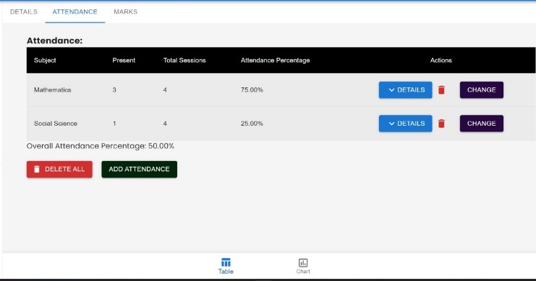

Fig. 1 Attendance marking
- Student Enrolment:
The administrator can enrol the student as well as the teacher for the school management, The admin provides the ID and pass to the student of each class based on the enrolment and adds the class teacher and subject for the respective year.
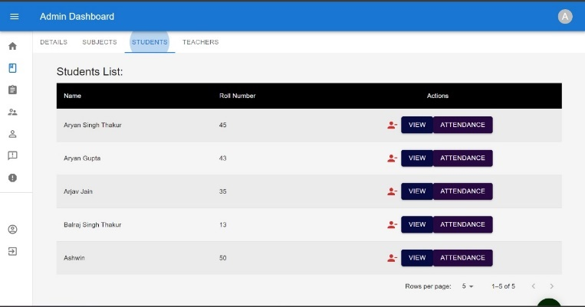

Fig. 2 Students Enroll
- Video Lectures:
The administrator can add the video lectures of each subject for each class student in case any student missed some lectures or was absent.
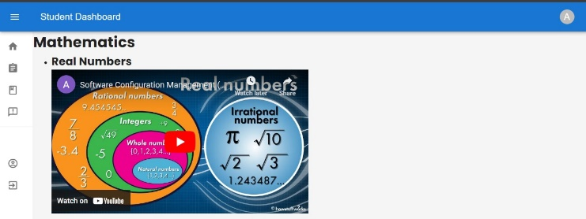

Fig. 3 Video Lectures
- Complaint and Notices:
The administrator can assist with students’ complaints, students can raise any complaint if they find, and the admin can publish notices daily.
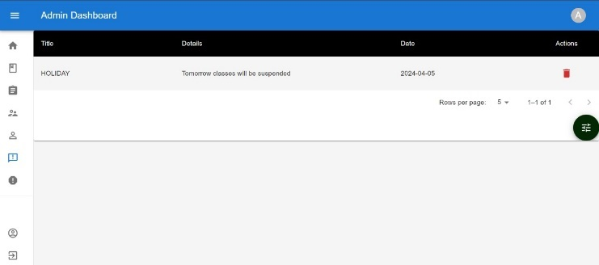

Fig. 4 Notices
- Teacher Enrolment:
The system typically includes a user role management feature that allows administrators to assign different roles and permissions to users. Administrators have the authority to assign the role of "teacher" to individuals within the system. Administrators have special privileges within the school management system that allow them to perform various administrative tasks, including teacher enrolment.
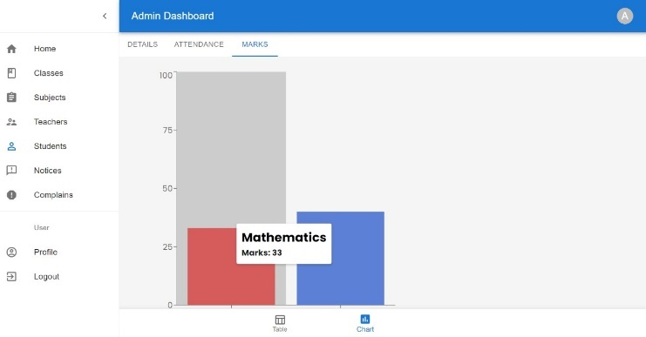

Fig. 5 Graphical Representation of Marks
- User Profile Management:
This feature allows Student to create and manage their profiles, providing essential information such as demographics, learning goals, and preferences.
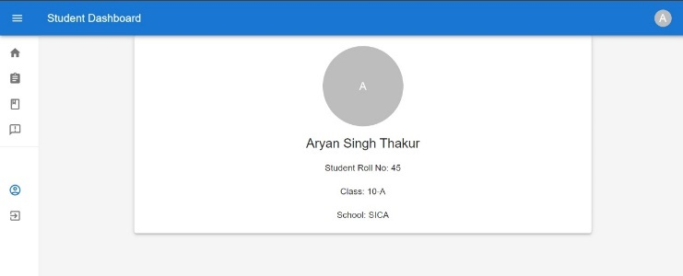

Fig. 6 Student Profile

RESULTS AND DISCUSSION
Our implemented School Management System (SMS) has shown promising results in streamlining school administrative tasks and enhancing the user experience.
Our SMS has significantly improved the efficiency of attendance tracking. The automated system has reduced manual errors and saved administrative time. The enrolment process has become more streamlined, with administrators able to assign IDs and classes to students efficiently [5].
The addition of video lectures has enhanced the learning experience, especially for students who missed classes. The system has provided a platform for students to voice their concerns, leading to increased student satisfaction. The notice publishing feature has ensured timely communication of important information. This feature has allowed students to personalize their profiles, leading to a more engaging user experience [2].
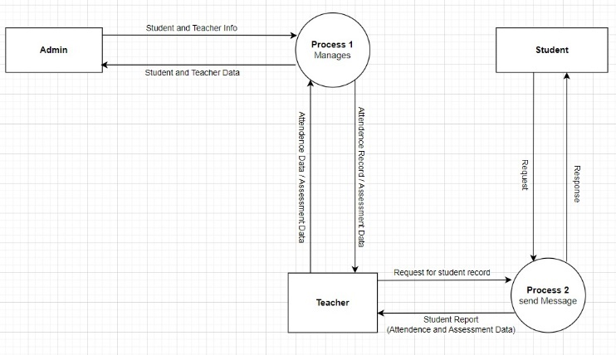

Fig. 7 DFD lvl.1 diagram
Compared to traditional systems, our SMS has shown improvements in terms of efficiency, communication, and user satisfaction. The positive results from our SMS implementation suggest that integrating such a system can significantly improve school management and enhance the educational experience. While our SMS has shown promising results, there are areas for improvement and expansion. Future work could focus on integrating more features such as a grading system, parent portal, etc [10].

CONCLUSION
The School Management System (SMS) presented in this research paper represents a significant advancement in educational technology, offering a comprehensive solution for streamlining administrative tasks, enhancing communication, and facilitating academic management within educational institutions [13]. Through a mixed-methods research approach combining quantitative analysis and qualitative insights, this study has provided a comprehensive evaluation of the SMS's effectiveness and user experiences.
The findings of this research demonstrate the considerable impact of SMS on educational management practices and stakeholder satisfaction. Quantitative analysis of system usage patterns, user satisfaction surveys, and performance metrics has highlighted the system's usability, reliability, and positive user perceptions. Qualitative insights from interviews, focus groups, and open-ended surveys have provided a rich contextual understanding of users' experiences, preferences, and recommendations for improvement.
In conclusion, the School Management System represents a valuable tool for modernizing educational administration, enhancing communication, and improving academic management practices [12]. By leveraging technology to streamline processes and empower stakeholders, the SMS contributes to the advancement of education and the enrichment of the learning experience for all involved.

Acknowledgement
We'd like to express our sincere gratefulness to all individuals and associations who contributed to the completion of this exploration paper on the School Management System( SMS).
First and foremost, we extend our sincere appreciation to Acropolis Institute of Technology and Research for granting us access to their installations and coffers, as well as for their cooperation and support throughout the exploration process. Without their backing, this study would not have been possible.
Our sincere thanks also go to the faculty and staff of Acropolis Institute of Technology and Research for their guidance and stimulants. Their moxie and support have been necessary in shaping the direction of our work.
References
[1] | M. Shah, “Impact of management information systems (MIS) on school administration: What the literature says.,” Procedia-Social and Behavioral Sciences, vol. 116, pp. 2799-2804, 2014.
[2] | L. a. M. R. B. Amon, “ Implementation of School-Based Management in Curriculum and Learning Processes,” Jurnal Pendidikan Dasar Dan Menengah (Dikdasmen), pp. 1-11, 2021.
[3] | M. F. G. A. K. R. S. D. A. K. Ius Rusnati, “The Development and Application of Digitalized School Management,” Multicultural Education, vol. 7, no. 6, pp. 1,14, 2021.
[4] | B. b. R. N. b. Haslina binti Hassan, “Towards School Management System(SMS),” Malaysian Online Journal of Educational Technology, vol. 2, no. 4, 2014.
[5] | A. A. P. S. R. Vishwajeet Pandey, “A Literature Survey on Student Profile Management System,” International Research Journal of Engineering and Technology (IRJET), vol. 09, no. 03, 2022.
[6] | N. T. B. K. M. V. C. G. A. L. M. M. M. L. E. L. Benzar Glen S. Grepon, “Designing and Implementing e-School Systems,” International Journal of Computing Sciences Research, vol. 06, pp. 792-808, 2021.
[7] | R. S. F. o. M. J. U. J. Moushumi Sarkar, “MANAGEMENT OF INDIAN SCHOOL,” Journal of Emerging Technologies and Innovative Research(JETIR), vol. 08, no. 01, 2021.
[8] | T. W. JOUR Frick, “Education Systems and Technology in 1990, 2020, and Beyond,” TechTrends, vol. 64, no. 5, pp. 693-703, 01 September 2020.
[9] | J. W. Guthrie, “The evolution of educational management: Eroding myths and emerging models,” Teachers College Record, vol. 91, no. 6, pp. 210-231, 1990.
[10] | M. J. Zieky, “So much has changed: How the setting of cutscores has evolved since the 1980s,” Setting performance standards Routledge., pp. 33-66, 2013.
[11] | L. O. V. V. L. G. I. &. K. M. G. Badru, “MERN stack web-based education management information systems for Pacific Island countries.,” SN Computer Science, vol. 4, no. 1, p. 70, 2022.
[12] | I. &. P. O. Blau, “e‐Leadership of school principals: Increasing school effectiveness by a school data management system.,” British Journal of Educational Technology, vol. 44, no. 6, pp. 1000-1011, 2013.
[13] | P. a. J. C. Hallinger, “Review of research on educational leadership and management in Asia: A comparative analysis of research topics and methods,1995-2012,” Educational management administration & leadership, vol. 43, no. 1, pp. 5-27, 2015.

