Attendance Management System Using Geofencing Technology

Mehraj Tamboli¹ ,Gitanjali Katore², Shivangi Patale³, Nestor Johnson Philips⁴
Dept of Electronics & Telecommunication
JSPM’s RSCOE Tathawade Pune, MS-India
Savitribai Phule Pune University, Pune
mehrajtamboli0908@gmail.com gitanjalikatore5050@gmail.com shivangipatale2002@gmail.com nestorjohnsonphilips@gmail.com

Abstract— In institutions it is considered an important to teachers to be actively involved in the attendance process to facilitate knowledge transfer. One common approach is for teachers to manually sign an attendance sheet. However a such sheets can easily be Lost. Moreover relying on paper based systems can lead to wasted time and hinder learning productivity in the classroom. While there are paperless attendance systems available, like Biometric or Android based solutions they often require hardware such as computers either RFID readers which can result in increased costs for both equipment and maintenance. Taking these factors into account our aim is to the tackle this issue by developing an attendance system that minimizes the need, for hardware and software requirements. We do this by improving the mobility of presenting attendance systems and leveraging both GPS and Geo Fence methods.
Keywords—Attendance process, Paperless attendance, GPS and GeoFence techniques, Mobility aspect, Hardware requirements, Learning productivity
- INTRODUCTION
In many institutions, universities, and colleges, the traditional techniques of keeping track of students' and teachers' attendance are still in use. These attendance systems have many drawbacks as they helps students in marking a fake attendance. All the attendance records are maintained and analyzed by the faculty members manually in the form of present or absent list taken by class teachers. If the sheet is lost or misplaced the attendance can't be restored easily, faculty have to take the attendance again where more of the chances of fake attendance are increased . There is no automatically restoring and analyzing of data ,Thus the geo attendance system which is based on geofencing technology will mark the attendance automatically by analyzing the students or teachers location in particular area and kept the records of the captured data. With geo attendance systems there is no need to analyze and maintain the sheets by faculty members for attendance purpose, hence this systems helps in maintaining the data in easiest way.
Recording information safely and efficiently as an instructor or representative isn't a job especially when dealing with devices at once. Educational institutions recognize the value of teachers actively participating in the learning process to enhance knowledge transfer. However monitoring teacher engagement is still a challenge, for universities. One straightforward method is to have teachers physically sign a participation form during scheduled lectures and other tasks.
The primary aim of this research is, to proof of how a mobile attendance app, developed using the geo fencing technology can accurately determine a persons precise location by utilizing GPS on their smartphone. The thought out design of this application system aims to enhance user experience and improve the efficiency of attendance tracking processes. The application we've created makes use of the features found in 4G Wi Fi and GPS technologies. Its specifically designed to work on the Android platform. Its main purpose is to provide an automated method, for tracking attendance distinguishing between "check in" and "check out" actions. By combining the power of GPS and Wi Fi4G this application ensures real time location data making attendance management an more reliable process. To sum up this application offers benefits, to administrators and employees for monitoring attendance. They can conveniently access, monitor and make changes to attendance data stored in a database through this system. By combining technology with geo fencing it presents a solution that minimizes the need for tedious manual work in traditional attendance tracking. As a result overall accuracy and efficiency, in attendance management are significantly improved.


Fig.1. The current built on hardware biometric attendance system

- LITERATURE SURVEY
To overcome the limitations of Principal Component Analysis this approach primarily relies on the efficiency of the HMM model. By utilizing this model it achieves face identification while reducing storage requirements and improving accuracy. However despite strategies to increase attendance the outcomes have been largely disappointing. Both attendance and these approaches suffer from a flaw – the possibility of activities that can lead to higher absence rates. Examine the use of mobile apps and cloud-based platforms for attendance monitoring. These solutions enable instructors to record attendance using tablets or smartphones, and the data is instantly linked to a central system that administrators can access. Examine how artificial intelligence (AI) and machine learning are being utilized to create predictive attendance systems that evaluate past attendance records to forecast future attendance trends and identify students who may be at risk of chronic absences. Examine Internet of Things (IoT)-based attendance systems that track instructor and student presence in classrooms using sensors and connectivity. Data is wirelessly transferred to a central database for analysis.
Examine research and initiatives that use GPS technology in attendance systems to monitor the whereabouts and attendance of teachers. Talk about the practical issues, restrictions, and accuracy of GPS-based attendance systems. Examine the literature on the integration of GSM (Global System for Mobile Communications) technology for communication and data transmission in attendance systems. Talk about the ways that GSM makes remote monitoring and real-time data transfer possible. Hybrid GPS-GSM Attendance Systems: Study studies and applications of GSM and GPS-based attendance systems that improve coverage and dependability. Talk about how the limits of particular technology are solved by these hybrid systems. Mobile Application Development: Examine previous research on creating Android apps that track attendance, paying particular attention to features, UI design, and GPS and GSM module integration.
In a research report they propose an attendance management technique called AMMoC.

- PROPOSED STRUCTURE
Designing an Android-based Geo-Attendance Management System involves several components:
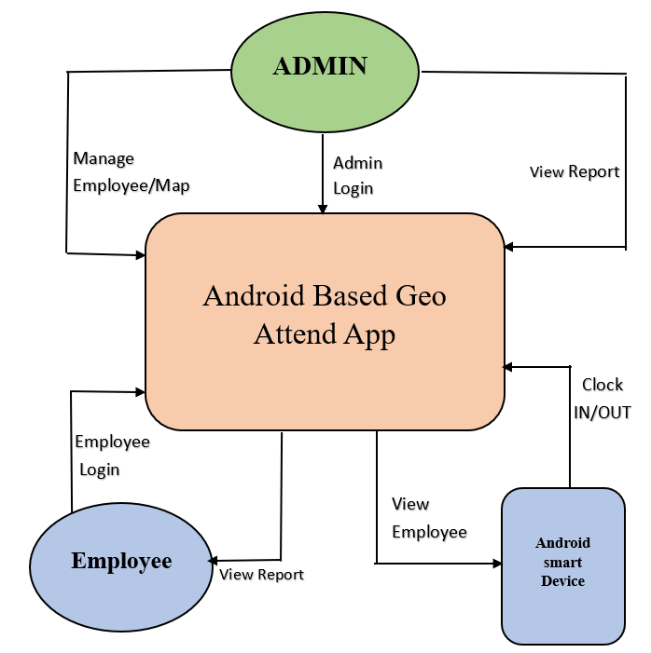
Fig.2. Block Diagram for System Architecture
a)User Interface: Create intuitive screens for users to mark attendance, view attendance history, and manage their profiles.
b)Authentication: Implement secure login methods like username/password, biometric, or two-factor authentication to ensure user identity.
c)Geo-location Services: Utilize GPS or geofencing APIs to capture accurate location data when employees mark attendance. Geofencing ensures attendance is recorded only within designated areas.
d)Database: Set up a robust database (SQL, Firebase, etc.) to store user profiles, attendance records, timestamps, and location data securely.
e)Attendance Marking: Develop features for users to mark attendance manually or automatically upon entering a predefined geofenced area.
f)Attendance History: Implement a feature for users and administrators to view attendance history, including dates, times, and locations of attendance marks.
g)Real-time Updates: Enable real-time syncing between the mobile app and the server to ensure attendance data is updated instantly.
h)Administrative Dashboard: Create a web-based dashboard for administrators to manage user accounts, generate attendance reports, and monitor attendance patterns.
i)Notifications: Implement push notifications to remind users to mark attendance and inform administrators of attendance anomalies.
j)Data Security: Implement encryption protocols and secure APIs to protect data transmission and storage.
k)Reporting: Develop customizable reporting features for administrators to analyze attendance data, track trends, and generate insights.
l)Offline Support: Ensure the app functions partially offline, allowing users to mark attendance even in areas with limited connectivity. Sync data when the connection is restored.
m)Compliance: Ensure the system complies with local regulations and data protection laws concerning employee attendance and location data.
n)Testing: Rigorous testing for functionality, security, and usability to identify and fix potential issues before deployment.
o)Documentation: Provide comprehensive documentation for users and administrators, explaining how to use the system effectively.
By considering these components, you can create a comprehensive and effective Android-based Geo-Attendance Management System.
Database
Fig.3. Architecture of attendance system

The system architecture of Android Based geo-attendance management is shown in fig.These system consists of three major sectors i.e.,Admin side , student or teacher login side and server .Admin can access the attendance sheet of every student or teacher for viewing purpose.Admin also add or remove the profiles from the databases acclording to new admissions or students or teachers who left the college.
The principle of geo attendance.Geo fencing technology is a kind of location based technology,through the aquisation of correct location in specific area with the hepl of GPS of the mobile phones.The main purpose of the geo fencing is to collect the information of the students and teachers to determine whether they are present into the classroom or not.
Flowchart and algorithm of the geo attendance management system is as follows

Fig.4. Flowchart of the user signup

Algorithm:

1)open the app on android mobile phone.
2)Enter your credentials to login into your account
3)If you don’t have an account, Then Sign up and login
again
4)For login, Authentication is done from Firebase.
5)Inside the My activity Clock in and Clock out is done
manually by using fingerprint Authentication process.
6)If Fingerprints matches and user location is in defined location then attendance is marked as present.

The working of the system is simple and easy to use and maintain. Also here GPS location plays very important roll in checking and capturing your location in given specific area for attendance purpose.

- Methodology:
Geofencing:
Geofencing technology is the best way to reshaping the attendance systems, offering a effective
way to track the attendance in various settings. The geofencing process starts with the setting up
virtual boundaries called geofences around the specific areas like school, colleges, offices or any
other sites where we want to apply the geo attendance systems. These boundaries are defined by
using GPS technology. GPS is Global Positioning System technology. GPS technology plays a very important roll in the geofencing technology for attendance systems, it provides an accurate location tracking within
the specific virtual areas like colleges, School or construction sites. When individuals with enters
in a specified areas with GPS enabled devises, Such as mobile phones or leave that specific areas
or boundaries, the GPS systems captured these movements. These data is used to record the
attendance of individuals automatically without human interference. Geofencing technology in geo attendance systems reduces the need for manual entry , fingerprint
authentication or card swapping, improves the accuracy and reduces the human efforts and
decrease the work of faculty coordinators who are taking care of attendances in colleges or
institutes. Attendance data is captured in real time manner and provides fast and easy
management for attendance systems
The second aspect of geofencing is the implementation of triggers. Such devices as smartphones with an Internet connection make it possible for the user to get an alert when their mobile gets to a preconfigured location. Also, they can initiate an activity targeted toward that device and so on.

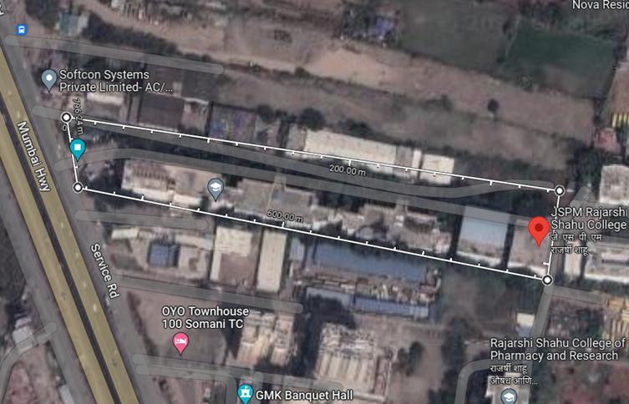
Fig.3. JSPM's RSCOE, Pune's Geofenced Area

- Snapshots Of Application:
i. Splash Screen ii. Login Page
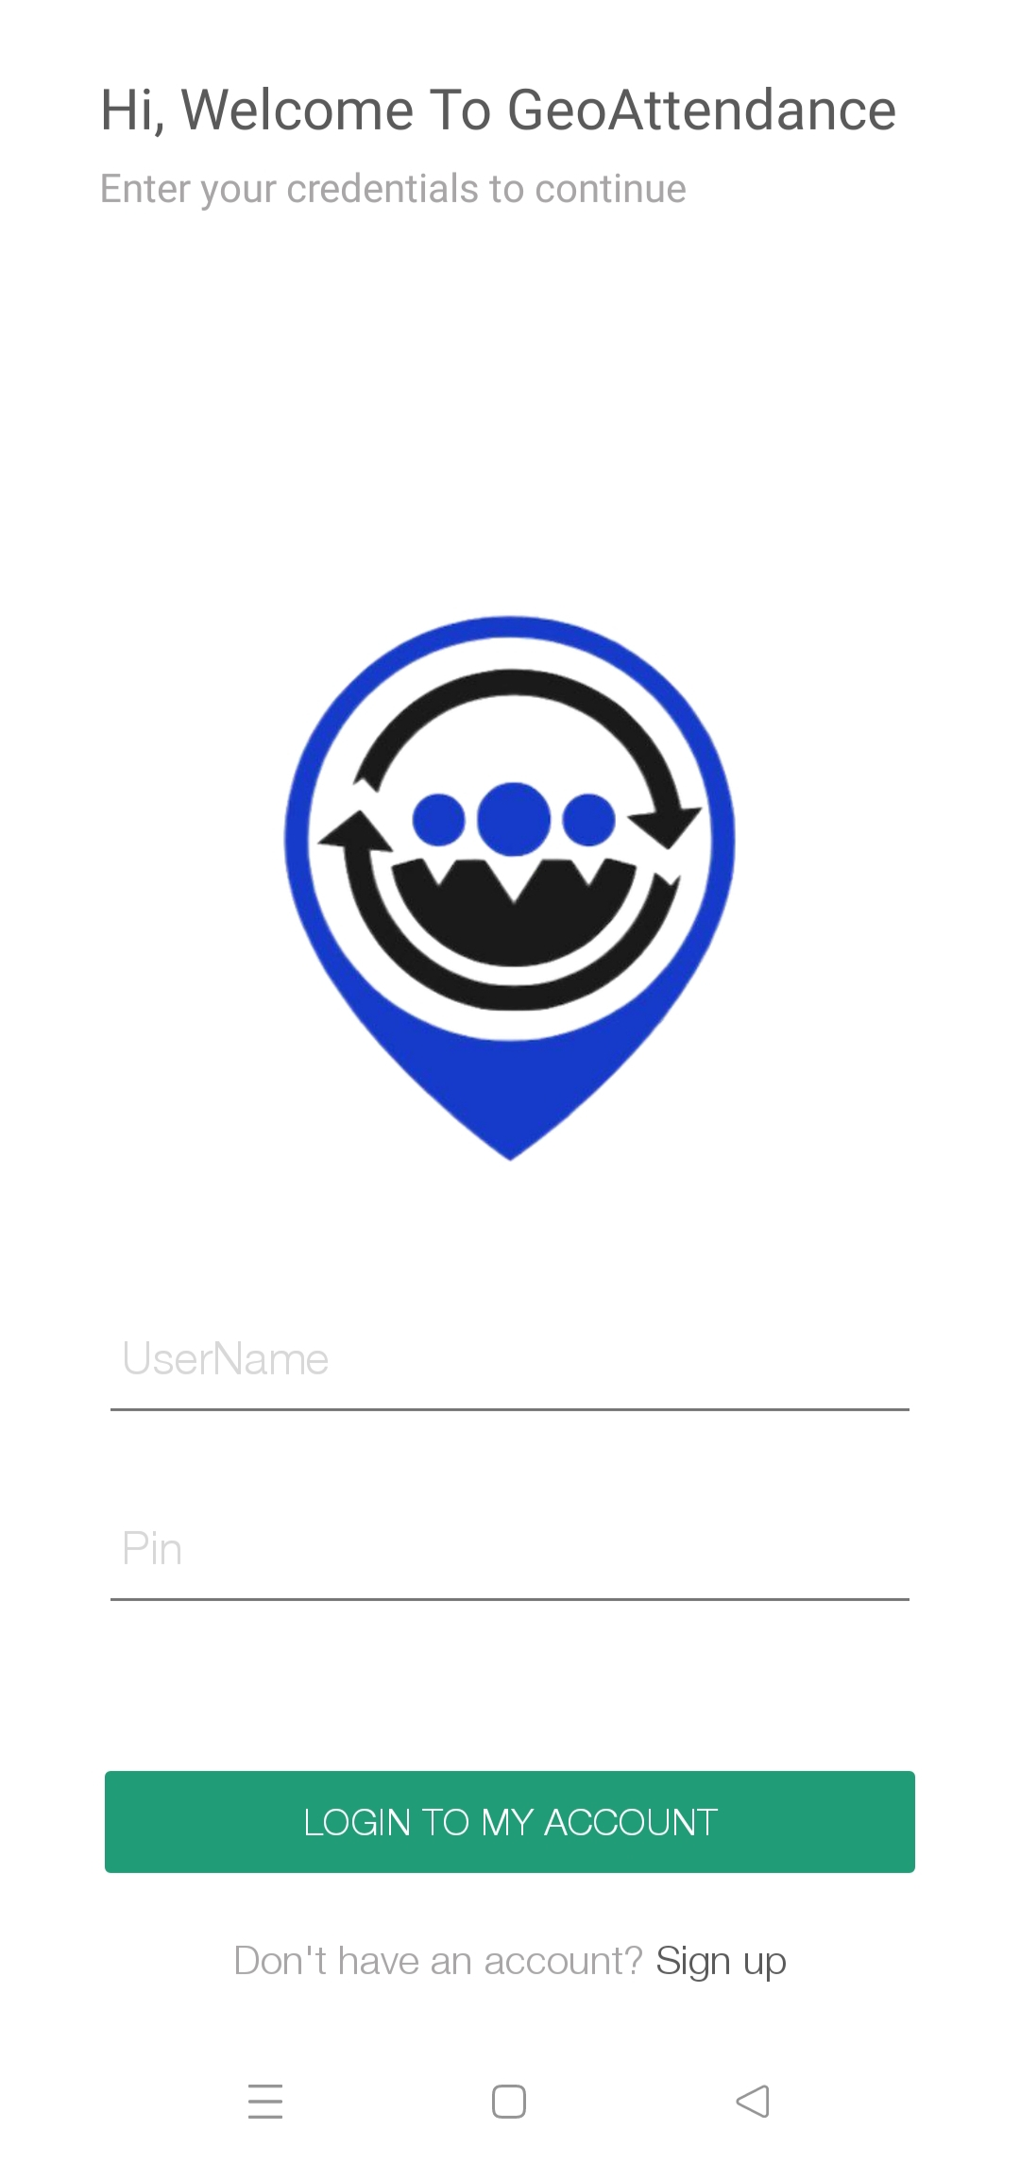


iii. Signup Page iv. User- Home
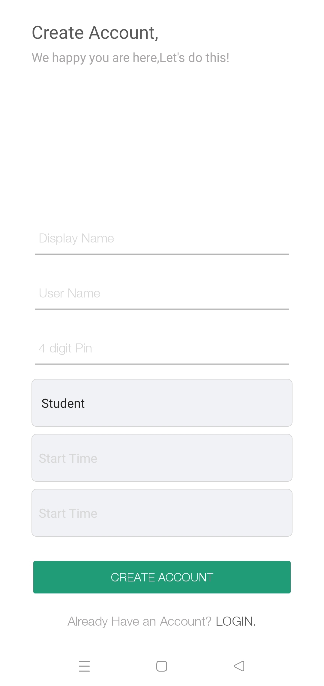
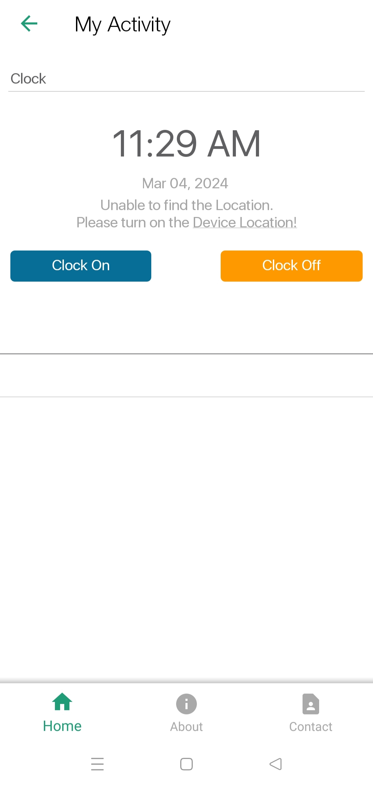

v. User- About vi. User- Profile
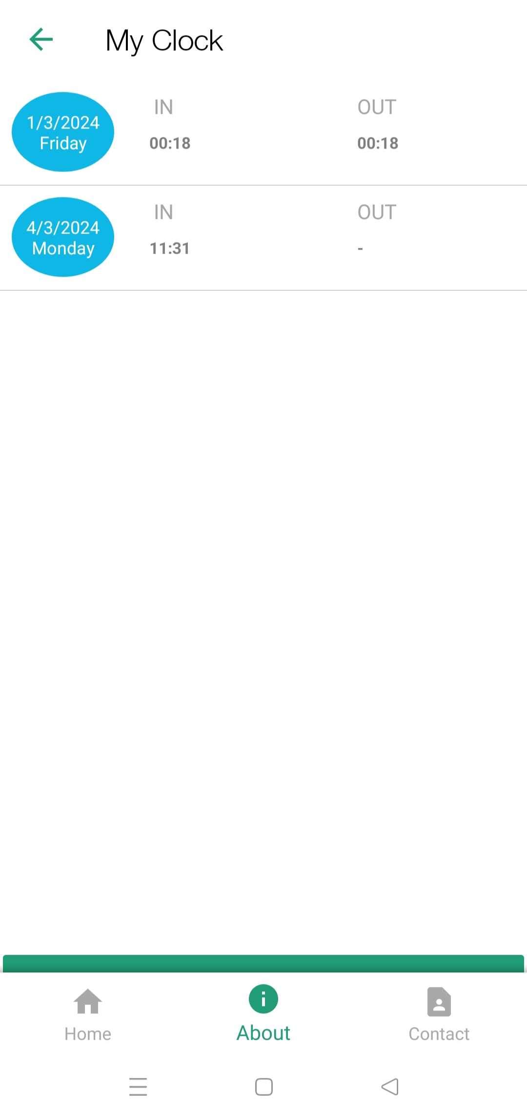
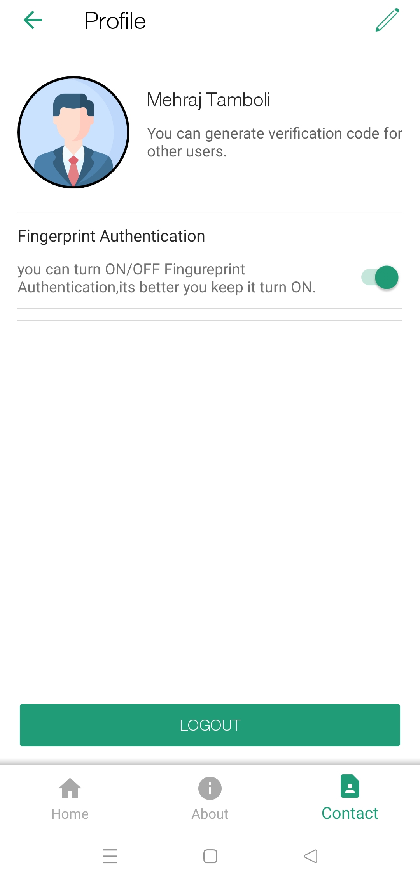

vii. Admin- List viii. Admin-
Student Wise
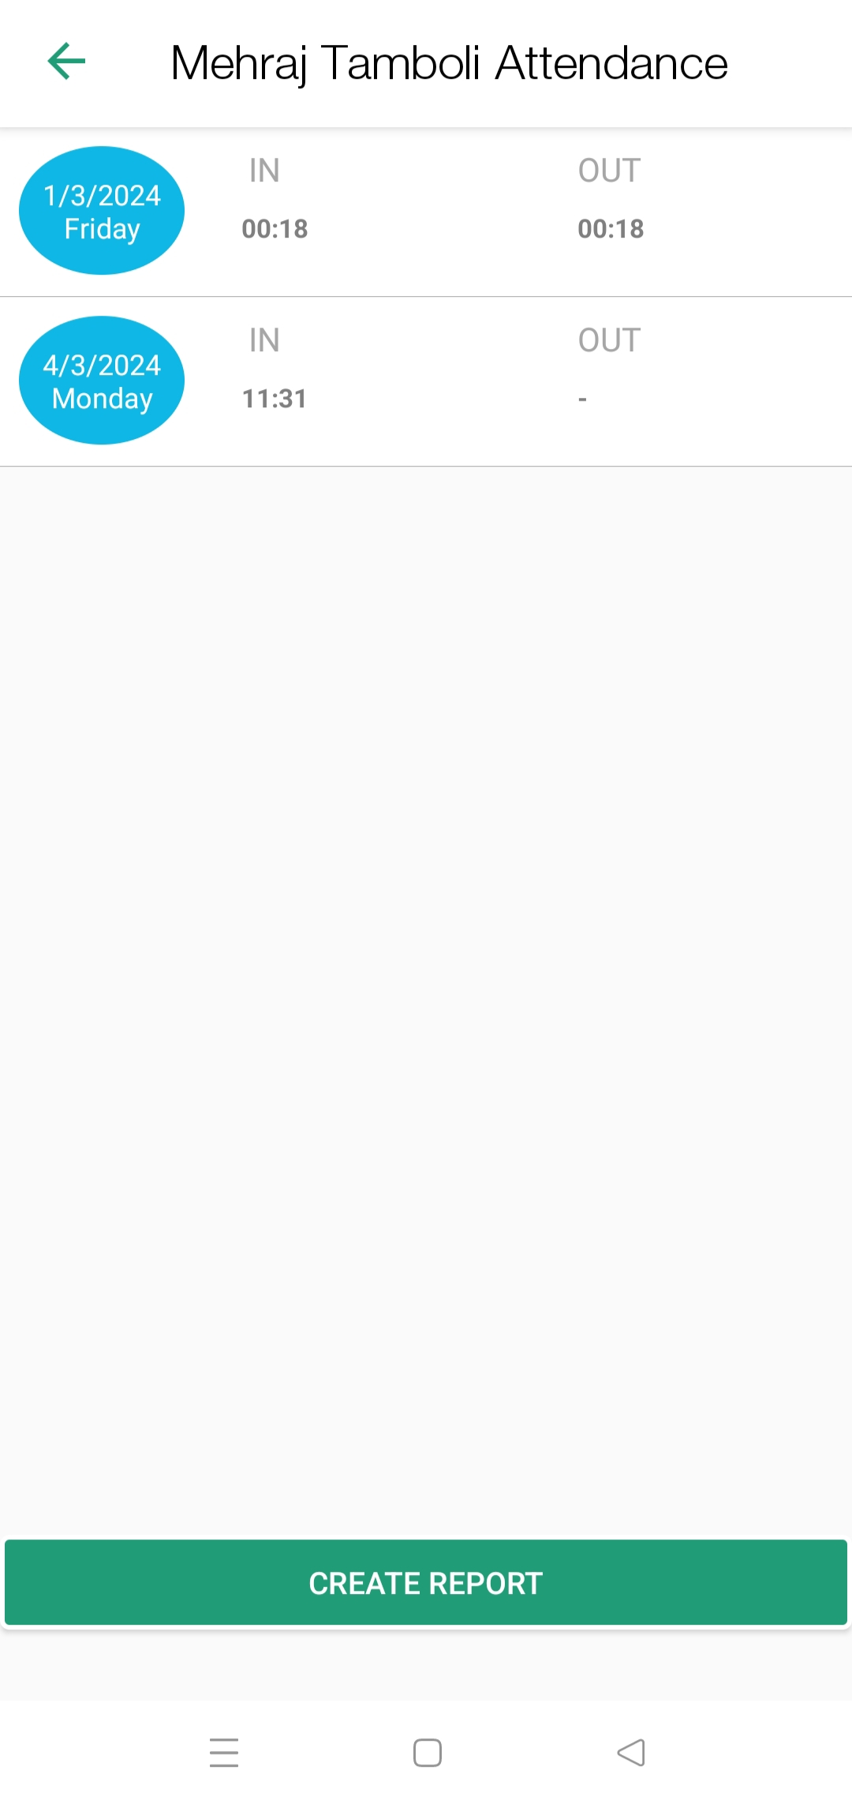
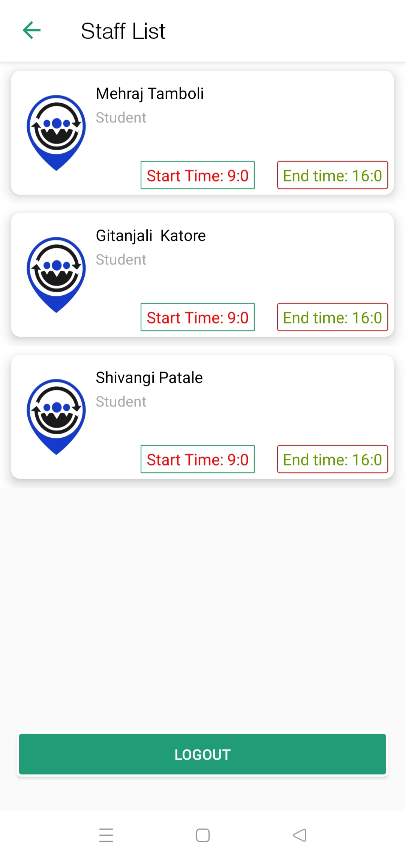

- CONCLUSION

A simple and user friendly solution, for tracking attendance in institutions is the Attendance System Using Geo Fencing Application, which operates on Android smartphones. This system effectively combines GPS, WiFi connections and a main server to streamline the attendance process.
The future plans for this application involve expanding its compatibility to include operating systems like Symbian, Blackberry and iOS. By doing a wider range of smartphone users will have access, to this convenient system. This expansion aims to cater to the needs of institutions by accommodating a student population in an increasingly mobile and digital world.

REFERENCES

- Gao, Zhigang, Yucai Huang, Leilei Zheng, Xiaodong Li, Huijuan Lu, Jianhui Zhang, Qingling Zhao, Wenjie Diao, Qiming Fang, and Jinglong Fang. "A student attendance management method based on crowdsensing in classroom environment." IEEE Access 9 (2021): 31481-31492.
- Yang, Hao, and Xiaofeng Han. "Face recognition attendance system based on real-time video processing." IEEE Access 8 (2020): 159143-159150.
- Yadav, Mayank, Anmol Aggarwal, and Nitin Rakesh. "Motion based attendence system in real-time environment for multimedia application." In 2018 8th International Conference on Cloud Computing, Data Science & Engineering (Confluence), pp. 332-336. IEEE, 2018.
- Noor, S. A. M., Zaini, N., Latip, M. F. A., & Hamzah, N. (2015). Android-based attendance management system. 2015 IEEE Conference on Systems, Process and Control (ICSPC). doi:10.1109/spc.2015.7473570.
- Isha Goel and Dilip Kumar. 2015. Design and Implementation of Android Based Wearable Smart Locator Band for People with Autism, Dementia, and Alzheimer. Advances in Electronics, vol. 2015, Article ID 140762.
- Zhaoxiang Zhang, Chao Wang and Yunhong Wang. "Video-Based Face Recognition: State of the Art,".
- Mrunmayee Shirodkar, Varun Sinha, Urvi Jain, bhushan Nemade. "Automated Attendance Management System Using Face Recognition". International Journal of Computer Applications.
- Ajinkya Patil, Mrundang Shukla. "Implementation of Classroom Attendance Based on Face recognition in Class". International Journal of Advances in Engineering and Technology, July 2014.
- Kandla Arora. "Real Time Application of Face Recognition Concept". International Journal of Soft Computing and Engineering. November 2012.
- Anil Yadav, Nitin Rakesh, Sujata Pandey, Rajat K Singh; " Development and Analysis of IoT Framework for Healthcare Application;" Advances in Computer and Computational Sciences; Springer, pg 149-158(2018)
- Nitin Rakesh; "Analysis of multi-sort algorithm on multi-mesh of trees (MMT) Architecture;" The Journal of Supercomputing, Springer Netherlands, Volume 57, Issue 3, pg 276-313(2011)
- Nitin Rakesh, Vipin Tyagi, "Linear network coding on multi-mesh of trees using all to all broadcast;" International Journal of Computer Science Issues; Volume 8, Issue 3, pg 462-471(2011)
- Abdul Rehman Khan, Nitin Rakesh, Abhay Bansal, Dev Kumar Chaudhary, "Comparative study of WSN Protocols (LEACH, PEGASIS and TEEN)" Image Information Processing (ICIIP); IEEE; pg 422- 427(2015)
- Kanika Agarwal, Nitin Rakesh, "Node Mobility Issues in Underwater Wireless Sensor Network;" Advances in Computer and Computational Sciences, Springer, Singapore, pg 293-303(2017).

