A BRIEF REVIEW FOR POWER QUALITY PROBLEMS EVALUATION, RELIABILITY, CONCERNS AND VARIOUS MITIGATION
Atul Kumar Dewangan¹, Dr. Mithlesh Singh²
¹PHD Scholar, Shri Rawatpura Sarkar University, Raipur
²HOD Shri Rawatpura Sarkar University Raipur, Chhattisgarh

---------------------------------------------------------------------***---------------------------------------------------------------------
Abstract - The issues of electricity quality and its reliability are the main drivers of our country's economy. The main objective of power system is to provide good quality of power supply to the consumers. The electrical energy used by the end users becomes comfort, loss reduction and affordable cost. This paper examines power quality problems and addresses this problem using various mitigation techniques in electrical power systems. This paper presents an overview of FACT devices such as DVRs, D-STATCOMs, and Auto-transformers in mitigating various power disturbances.

Key Words: Power Quality, FACTS Device, DVRs, Auto Transformer

- INTRODUCTION
Reliability and quality are two important aspects of any electrical power supply system. Power Reliability means 24 x 7 availability of the power supply, which defines the adequacy of the electrical system at all levels from generation to transmission to distribution.
However, power quality refers to both the degree of drift or distortion in the pure supply waveform and the continuity of supply. Any significant variation in magnitude, frequency, waveform, or symmetry of line voltages is a potential power quality problem. Ideally, a waveform should be smooth and free from interference.
But even the best power systems fluctuate, and all electrical equipment is susceptible to damage from those fluctuations. When exceptional of the electricity provided is deficient, its outcomes in overall performance degradation and decreased existence expectancy of an equipment.
We can therefore understand poor power quality as any power problem that manifests itself in voltage, current or frequency deviations that lead to failures, increased power losses or device malfunctions and thus cause economic losses. Poor electricity exceptional also can bring about issues with electromagnetic compatibility and noise.
Because of in today’s situation using energy is extra valuable to the consumer’s satisfaction. Good quality electrical power has the characteristics are, it must have a continuity of service (not be interrupted), It must have a very low Harmonic content, It must have a very low variation in the voltage magnitude, It must have very low transient voltages and currents.
With the increasing demand for high-quality, reliable electrical power and the increasing number of electrical loads, it is imperative today to maintain the quality of electricity among both customers and utility companies.
The high-quality sinusoidal waveform is produced at power stations. The widespread applications of power electronic based nonlinear devices as well as, the occurrence of faults cause deviation from pure sinusoidal waveform [1]. Customers need constant sine wave shape, constant frequency and symmetrical voltage with a constant root mean square (rms) value to continue the production. To satisfy these demands, the disturbances must be eliminated from the system. The typical power quality disturbances are voltage sags, voltage swells, interruptions, phase shifts, harmonics and transients [2].
The wide usage of nonlinear loads, such as personal computers, variable speed drives, UPS systems, and the other electronic equipment produce harmonics which represent a major problem in industrial and commercial power systems. The current harmonics are widely spread in industrial systems. These harmonics interact with system impedances and lead to voltage harmonics which badly affect the sensitive loads.
Electronic equipment is very sensitive loads against harmonics because their control depends on either the peak value or the zero crossing of the supplied voltage, which are all influenced by the harmonic distortion. These problems are facing electricity customers and suppliers so; one of the major concerns in electricity industry is power quality.
The main objective if this paper is
- To Study of the power quality issue, causes and its effect on power system network.
- To investigate the techniques to mitigate techniques for power quality problems causes issues.
- Comparative analysis the quality issue, causes, its effect and different mitigation techniques for each issue.
- To study and analyze the behavior of FACT devices in reducing the power quality issue.

2. SURVEY ON THE CAUSES OF POWER QUALITY PROBLEMS
The charts in Fig. 1 display the effects of a survey performed through the Chhattisgarh state energy Power company wherein each application employees and clients have been polled approximately what reasons energy best problems [3]. The utilities and customer’s views are regularly a good deal different. While each generally tend in charge approximately two-thirds of the activities on herbal phenomena (e.g., lightning), clients, a good deal extra often than software employees, suppose that the software is at fault.

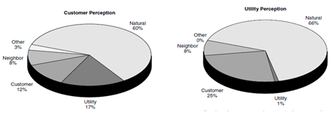
Fig – 1: Survey on the causes of power quality problems

- THE POWER QUALITY EVALUATION PROCEDURE
Figure 2 gives some general steps that are often required in a power quality check, as well as the key considerations that must be addressed at each step. This is the primary method of evaluating the problem or existing system that is being evaluated. When making measurements, it is important to record the effects of power quality variation at the same time so that problems can be linked to possible causes. Solutions need to be evaluated using a systems perspective, and both economics and technical limitations must be considered. Potential solutions are identified at all levels of the system, from utility supplies to end-use equipment being affected. Solutions that are not technically feasible are thrown away, and the remaining alternatives are compared on an economical basis. The optimal solution will depend on the type of problem, the number of end users to be affected and the possible solutions.

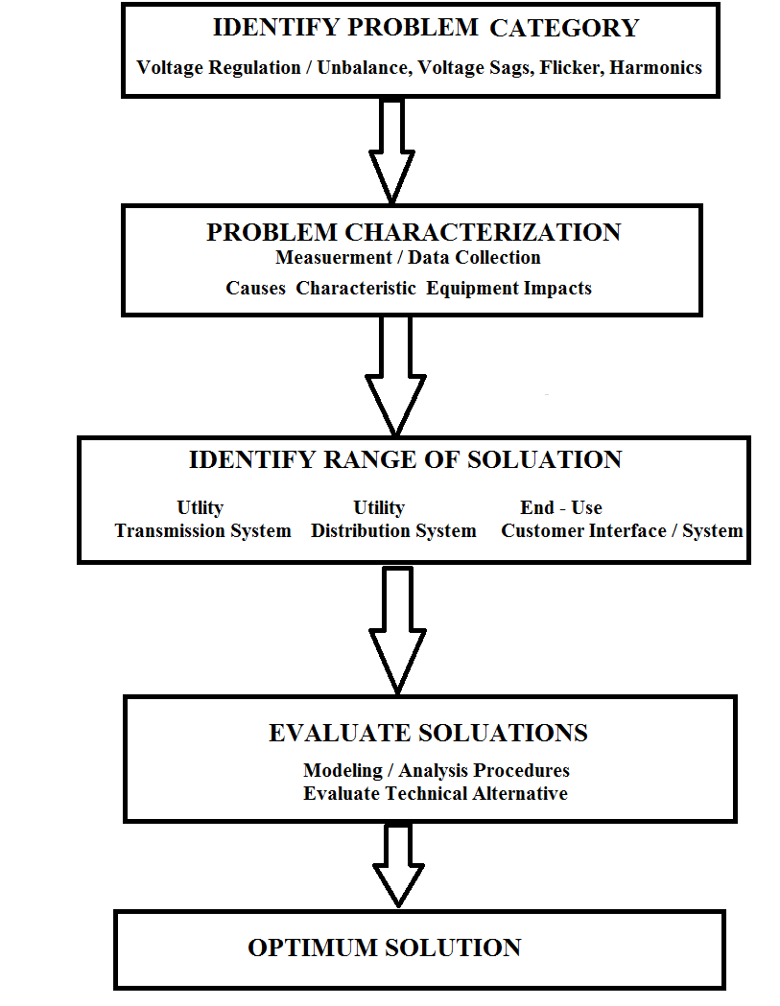

Fig – 2: Power Quality Evaluation Procedures

- POWER QUALITY AND RELIABILITY
Power quality and reliability cost the industry large amounts due to mainly sags and short-term interruptions with distorted and unwanted voltage wave forms. The main concern for the consumers of electricity is the reliability of supply. Here we define the reliability as the continuity of supply. Power first class and reliability fee the enterprise massive quantities because of especially sags and short time period interruption with distorted and undesirable voltage wave forms. The most important challenges for the purchasers of power is the reliability of supply
Fig - 3: Power Quality and Reliability

As shown in Fig.3, the problem of distribution lines is divided into two major categories. First group is power quality, second is power reliability. First group consists of harmonic distortions, impulses and swells. Second group consists of voltage sags and outages. Both the reliability and quality of supply are equally important. For example, a consumer that is connected to the same bus that supplies a large motor load may have to face a severe dip in his supply voltage every time the motor load is switched on. In some extreme cases even, we have to bear the black outs which is not acceptable to the consumers. There are also sensitive loads such as hospitals (life support, operation theatre, and patient database system), processing plants, air traffic control, financial institutions and numerous other data processing and service providers that require clean and uninterrupted power. In processing plants, a batch of product can be ruined by voltage dip of very short duration. Such customers are very wary of such dips since each dip can cost them a substantial amount of money. Even short dips are sufficient to cause contactors on motor drives to drop out.
As shown in Fig.3, the trouble of distribution strains is split into main categories. First group is power quality, second is power reliability. Second group includes harmonic distortions, impulses and swells. Second group includes voltage sags and outages.
Both the reliability and quality are similarly important.
For example, a client this is related to the identical bus that elements a massive motor load may also must face a extreme dip in his deliver voltage on every occasion the
motor load is switched on.
In a few excessive instances even, we have to undergo the black outs which is not suitable to the consumers. There also are sensitive loads which include hospitals, processing plants, air traffic control, economic establishments and server different statistic processing and service vendors that require smooth and uninterrupted electricity. In processing plants, a batch of product may be ruined through voltage dip of very brief duration.
Such clients are very cautious of such dips due to the fact every dip can fee them a great quantity of money. Even brief dips are enough to motive contactors on motor drives to drop out.
Stoppage in a portion of process can destroy the conditions for quality control of product and require restarting of production. Thus, in this scenario in which consumers increasingly demand the quality power, the term power quality (PQ) attains increased significance.
An interruption in a part of some process can destroy the conditions for quality control of the product and require resumption of production. As consumers increasingly demand quality electricity, the term power quality (PQ) assumes importance.
Transmission lines are exposed to the forces of nature. Even though the strength is the exceptional trouble distribution aspect perturbation, transmission strains often have an effect on the exception of the strength supplied. It remains to be said that even though maximum troubles related to transmission structures arise due to forces of nature or due to the interconnection of strength structures, individual customers are responsible for an additional large fraction of the troubles of power distribution structures.
- DEFINITION OF POWER QUALITY
Power Quality There are different definitions for power quality.
- According to Utility, power quality is reliability.
- According to load aspect, it is defined as the power supplied for satisfactory performance of all equipment i.e., all sensitive equipment. This depends upon the end user.
- According to end user point of view, it is defined as, “any power problem manifested in voltage, current, or frequency deviations that result in failure or mis operation of customer equipment”
- The IEC/IEEE defines power quality as under: [4]
In IEEE dictionary, power quality is defined as “the concept of powering and grounding sensitive equipment in a matter that is suitable to the operation of that equipment”.
IEC (International Electro technical Commission) “The characteristics of the electricity at a given point on an electrical system, evaluated against a set of reference technical parameters.”
Characteristics that affect power quality are voltage fluctuation, Harmonic distortion, voltage unbalance, flicker, supply interruptions, voltage sags, voltage swells and transients etc.
- POWER QUALITY (PQ) PROBLEMS
Power quality is obtaining increasing attention by the utilities, as well as by both industrial and commercial electrical consumers [5]. Power quality can be defined as having a bus voltage that closely resembles a sinusoidal waveform of the required magnitude. The users demand higher power quality to use more sensitive loads, to automate processes and improve quality. Some basic criterions for power quality are constant (rms) value, constant frequency, symmetrical three-phases, pure sinusoidal wave shape and limited THD. These parameter values should be kept between certain limits determined by standards, if the power quality level is considered to be high.
Power quality is acquiring growing interest via way of means of the utilities, in addition to via way of means of each commercial and industrial electric consumer [6]. Power quality may be described as having a bus voltage that carefully resembles a sinusoidal waveform of the desired magnitude.
The customers call for better power quality to apply grater touchy loads, to automate techniques and enhance fine. Some fundamental criterions for power quality are steady (rms) value, steady frequency, symmetrical three phases, natural sinusoidal wave form and constrained THD. These parameter values have to be saved among positive limits decided via way of means of standards, if the power quality stage is taken into consideration to be high.
The costly effects of power quality problems are most clearly seen in large industrial and commercial facilities when equipment or products suffer damage. Not only downtime cost for the affected equipment, but there are also repair and replacement time and costs.
In addition, loss of product means expensive rework, loss of productivity, and higher overhead costs. While most people think that power quality problems only affect sensitive electronic components, other aspects, in particular harmonic distortion, also affect normal loads such as motors, and transformers. The entire system, from transmission, to distribution, and utilization, is now subject to damage and destruction from various power quality phenomena.
The expensive outcomes of electricity quality troubles are maximum really visible in big commercialand industrial centers whilst device or merchandise go through harm.
Not most effective downtime fee for the affected device, however these also are restored and alternative time and costs.
In addition, lack of product manner costly rework, lack of productivity and better overhead costs
While maximum humans assume that electricity fine troubles most effective have an effect no touchy electronic components, different aspects, especially harmonic distortion, additionally have an effect on regular masses including motors, and transformer.
The whole system, from transmission, to distribution, and utilization, is now situation to harm and destruction from numerous power quality phenomena.
- POWER QUALITY CONCERNS
The interruption produces by primary sources of the power system. Some of affected sources are listed below. [ 7]
- Staring of large rating of motors.
- Sudden switching of (On/Off) loads
- Types of non-linear loads: an exponential raise noticed in nonlinear load in power distribution network due to advances in power electronics technology. At domestic level we use to appliances like computers, television, compact fluorescent tube light, Electronics choke and at industrial level, we are using un interrupted power supply, Switch mode power supply, variable speed drives, these all are sort of nonlinear loads.
- Furnace of arc, welding and lathe works
- Electromagnetic interference with cables
- Energy dissipated in huge of capacitor banks.
- Equipment’s of Information technology centers.
- Mostly used power electronic devices
- End consumer device end up extra touchy to power quality because of many microprocessors primally based totally controls
- Complexity of industrial processes: the re-startup is very costly.
- Large computer systems in many businesses facilities
- Power electronics device used for boosting device stability, operation and efficiency. They are important supply of terrible PQ and are susceptible to terrible PQ as well.
- Deregulation of the strength industry.
- Complex interconnection of systems, which leads to greater extreme effects if anyone aspect fails.
- Continuous development of high-performance equipment: Such equipment is more susceptible to power disturbances.
- POWER QUALITY CATEGORIES
The quality of the power is very sensitive among the producers and consumers of power. The strongest impact of various types of loads, such as linear and non-linear operation. The most common power quality problems are shown in terms of definition, various effects and control actions in Table 1.

Table 1: Definition, Various Effects
S. No. | Indices | Novelette | Impact
01 | Transient | Transients are sudden but significant deviations from normal voltage or current levels.  Transients typically last from 200 millionths of a second to half a second. | Lightning transient produced steep fronted wave on transmission line.  Travelling wave produced due to transient will shutter the insulations and week poles. Cause damage to windings of transformer and generator
02 | Voltage dip or Sag | The nominal voltage is derated in the range of 10% to 90%, and the duration is 0.5 cycles to 1 minute. | Feeder faults, operate large rating of motors and connecting of heavy loads
03 | Voltage swell | Increasing of nominal voltage range between 110 to 180% with the time duration of 0.5 cycle to few seconds. | Start/stop of heavy loads, badly dimensioned power sources, badly regulated transformers (mainly during off-peak hours).
04 | Voltage spike | Quick deviation of nominal values of voltage in the order several μs to ms | Detachment of heavy loads, lightening and switching
05 | Voltage flicker | Distortion of voltage variations in the range of 90 to 110%. | Switching of pulsating load and arc furnaces
06 | Voltage unbalance | A voltage variation in a three-phase system in which the three voltage magnitudes or the phase-  angle differences between them are not equal | Large single-phase loads (induction furnaces, traction loads), incorrect distribution of all single-phase loads by the three phases of the system (this may be also due to a fault).
07 | Under-voltage | Decreasing nominal voltage value in order to recovery of this value to take long period of time. | Wrong operation of tapping transformers
08 | Over-voltage | Increasing nominal voltage value in more than 110% within a 1 minute. | Switching off larger loads.
09 | Interruptions | Destruction of electrical supplies which classified in short term interruption duration of few milli seconds to 1 second.  Long term interruption duration of > 2 sec | Insulation flashover, lightning and striking of poles
10 | Frequency variation | The frequency variations within the permissible limits of ± 0.5Hz | Generator fails,  High demand and , decrease in turbine speed
11 | Harmonic distortion | Non- sinusoidal waves of voltage or currents distortion due to high value of frequency | Failure of governor operation, lathe works and arc furnaces.
- CLASSIFICATION OF POWER QUALITY MITIGATION TECHNIQUES
Power quality indices lead to losses in industries and utilities. In order to improve the energy quality, improving the function is crucial in order to remedy these problems. Completely removed but control within the prescribed limits. Some of the most common and recent trends in mitigation techniques followed by control measures are listed in Table 2

Table 2: Mitigation Techniques

S. No. | Name of Techniques | Features | Remarks
01 | CPS: Constant power supply | The supplying of power constantly generated, transmitted and distributed to requirement of loads | More reliable of the network. Minimize the losses in power network
02 | Modern Power electronic devices: | Implement these devices prevents the supply to sensitive equipments. Improve the power factor of the load. | Maintain the constant voltage in terms of sag, swell and over voltages
03 | UPS: Uninterruptible e power supply | UPS is major roles to continuous power supply to the load even the outages. The  Supplies power from batteries, capacitors and super conducting coils | Mainly used for long interruption, sag, swell and flickering of supply.
04 | DVR: Dynamic voltage restorer | Ability to control both real and reactive power in AC. Protect all type sources from the equipment’s | Protect against Frequency variation, voltage sag  and swell
05 | Filters: | It is mainly used for detect the undesirable voltage values and frequencies. Two types of filters namely active and passive filters. | Combination of both capacitor and inductor to eliminate high harmonic frequency, noise and distortion of ac signals
06 | Transformers | Transfer the electrical power from source to load. The types are star to star, delta to delta and zig-zag | Isolate the transformer under fault conditions. Reduce the harmonics from the load.
07 | SVC: Static var compensator  Two parts of SVC namely  TSR-Thyristor switched reactor  TSC-Thyristor switched capacitor. | The combination of capacitors and reactors which minimize the reactive power injection in the transmission lines. | Regulates the voltage flickering through heavy loads, Improve voltage regulation and efficiency of the transmission lines.
08 | UPFC-Unified Power Flow Controller | Used for real time control in AC transmission system. The new power electronic FACTS device helps to progress the power flow in the transmission lines | Regulate the 3-phase transmission line parameters of voltage, impedance and phase angle.
09 | Energy storage devices: | New power electronic technology is known as energy storage. Which is stored the energy in short period of time .The power delivered in disturbance of the system get restoration. The most popular devices are flywheels, super capacitors, battery storage systems (BES),capacitive energy storage system(CES) and super conducting magnetic storage system(SMES). | Regulated power in short period of time, Voltage sags and maintain the grid frequency.
10 | Soft computing techniques: | In recent days used to optimize the power quality problems are solved by this AI concepts. Automatically adjust the parameters to enhancement of improve the power quality to the equipment’s, manufactures and customers | Regulated the power, voltage profile, frequency and harmonic distortion in generation, transmission and distribution networks
11 | Renewable energy system | Spinning reserves capability in the power generating stations to mitigate the power quality issues. Also to improve the reliability in transmission line | Control the active and reactive power in the network.  Typical used in distributed generation and smart grid

- POWER QUALITY PARAMETERS AND MEASUREMENT DEVICES
The term of measurement is to improved performance of power quality in commercial, industrial customers. The Analysis Mitigation of power quality parameters and measurement devices described in table 3. The power quality measurement is best practice to identify suitable application of the specific and standard instrumentation. The power engineer has adequate skills to operate these devices. The time period of dimension is to progressed overall performance of strength first-class in commercial, commercial customers. The Analysis
Mitigation of power quality parameters and dimension devices defined in table 3.
Table 3: Power Quality Parameters and Measurement Devices
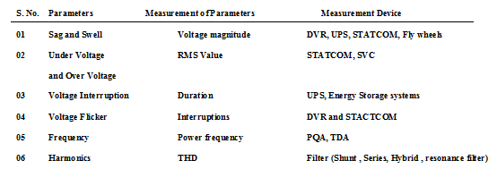
DVR: Dynamic Voltage Restorer
UPS: Uninterruptable power supply
STATCOM: Static compensator
PQA: Power quality analyzer
TDA: Transient disturbance analyzer
- Custom Power Devices
Innovative and traditional technology for the mitigation of electricity high satisfactory troubles. These are popular strategies to the mitigation of electricity high satisfactory troubles. One, termed load conditioning, it's far to ensure that the technique device is much less sensitive to disturbances, permitting it to experience via the disturbances. The different is to put in a line conditioning device that suppresses or counteracts the disturbances. Commercially to be had mitigation devices have a tendency to protect towards a collection of electricity high-satisfactory disturbances. Mitigation devices range in length and may be set up in any respect voltage ranges of a electricity system (HV, MV and LV). The mitigation device and factor of connection are selected in step with its financial feasibility and the reliability required. Innovative answers using power electronics (figure 4) are frequently carried out while fast response is critical for suppressing or counteracting the disturbances, at the same time as traditional devices (eg, switched capacitor banks) are properly suitable for regular country voltage regulation custom power devices may be used, at affordable cost, to provide excessive power quality and advanced electricity service. These custom power devices offer answers to electricity high satisfactory on the medium voltage distribution network level.

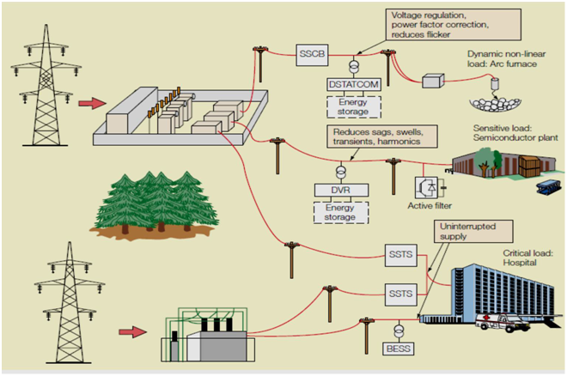
Fig – 4: Custom power devices

Table 4: The power quality problem areas and their possible solutions
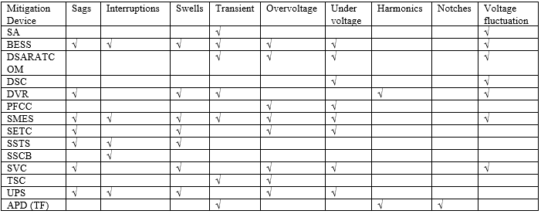

APF(TF) = Active power filter or tuned filter
BESS = Battery energy storage system
DSTATCOM = Distribution static synchronous compensator
DSC = Distribution series capacitor
DVR = Dynamic voltage resistor
PFCC = Power factor correction capacitor
SA = Surge arrester
SMES = Superconducting magnetic energy storage system
SETC = Static electronics tap changer
SSTS = Solid state transfer switch
SSCB = Solid state circuit breaker
SVC = Static var compensator
TSC = Thyristor switched capacitor
UPS = Uninterruptable power supply
- Conclusions
Among the different methods to mitigate the voltage sag, the use of FACT devices is the best method. The FACT devices like DVR, D-STATCOM are helpful in overcoming the voltage unbalance problems in power system. DVR is a series connected device and injects voltage to compensate the voltage imbalance. D-STATCOM is a shunt connected device and injects current into the system. These devices are connected to the power network at the point of interest to protect the critical loads. These devices also have other advantages like harmonic reduction, power factor correction. The research can further be extended to; Implementation of digital controllers to control the power electronic switches present in the device. To study the operation of the devices in mitigating other voltage problems that occurs in power system.

REFERENCES
- Bindeshwar Singh, Rajesh Kumar, “A comprehensive survey on enhancement of system performances by using different types of FACTS controllers in power systems with static and realistic load models” Energy Reports Volume 6, November 2020, Pages 55-79, Elsevier Ltd
- IEEE 100, The Authoritative Dictionary of IEEE Standard Terms, seventh edition, 2000, p. 234.
- C. Alvarez, J. Alamar, A. Domijan Jr., A. Montenegro, and Song, "An Investigationtowardnew technologies and issues in power quality, " in Proc. 9th Int. Conf Harmon. Qual. Power, vol. 2, 2000, pp. 444-449.
- M. Bollen, “Understanding Power Quality Problems– Voltage Sags and Interruptions”, IEEE Press Series on Power Engineering – John Wiley and Sons, Piscataway, USA (2000).
- J. Stones and A. Collinson, "Power quality, " Power Eng. Journal, vol.15, pp.58- 64, April 2001.
- M. H. J. Bollen, "What is power quality?" Electric Power Systems Research, vol.66, pp.5-14, July 2003.
- ArindamGhosh, Gerard Ledwich, "Power Quality Enhancement Using CustomPowerDevices" Kluwer Press, 2002.

BIOGRAPHIES

 | Atul Kumar Dewangan , Assistant professor in Electrical Engineering Department form Kirodimal Institute of Technology. At present Phd pursing in Electrical Engineering from Shri Rawat Pura Srkar University Raipur Chhattsigarh. Interested area are power system.
 | Dr. Mithilesh Singh, HOD Electrical Engineering Departments , Shri Rawatpura Sarkar University, Raipur, Chhattsigarh. , an experienced senior professional with a demonstrated history of working in the education and skilling domain. Served as resource person for different conferences

