A STUDY ON ASSET AND LIABILITY MANAGEMENT
1. Author: N.VASUDHA, Asst. Prof., Dept. of MBA, SANTHIRAM ENGINEERING COLLEGE, NANDYAL
2. Author: N. NAGA SURENDRA, Student of MBA, SANTHIRAM ENGINEERING COLLEGE, NANDYAL
ABSTRACT:
Asset liability management is concerned with strategic balance sheet management involving risks caused by changes in interest rates, exchanges rate, credit risks & the liquidity position of industry. Asset liability management is about management of net interest margin to ensure that its level & riskiness are compatibles with risk/return objectives of the industry.
Asset liability management is required to match asset liabilities and minimize liquidity as well as market risk. An effective asset liability management technique aims to manage the volume mix, maturity, rate, sensitivity, quality & liquidity of assets & liabilities as a whole so as to attain a predetermined acceptable risk/ reward ration.
REVIEW OF LITERATURE:
Asset liability management is concerned with strategic balance sheet management involving risk caused by changes in interest rate, exchange rate, credit risk and the liquidity position of industry. With profit becoming a key factor, it has now become imperative for industry to move towards integrated balance sheet management where components of balance sheet and its different maturity mix will be looked at profit angle of the industry .
Asset-Liability Management (ALM) can be termed as a risk management technique designed to earn an adequate return while maintaining a comfortable surplus of assets beyond liabilities. It takes into consideration interest rates, earning power, and degree of willingness to take on debt and hence is also known as Surplus Management.
The ALM process rests on three pillars:
- ALM information systems
- Management Information System
- Information availability, accuracy, adequacy and expediency
- ALM organizations
- Structure and responsibilities
- Level of top management involvement
- ALM process
- Risk parameters
- Risk identification
- Risk measurement
- Risk management
- Risk policies and tolerance levels.
ASSET LIABILITY COMMITTEE - ALCO:
Asset-Liability Committee (ALCO) is the top most committee to oversee implementation of ALM system, to be headed by CMD or ED. ALCO would consider product pricing for deposits and advances, the desired maturity profile of the incremental assets and liabilities in addition to monitoring the risk levels of the bank. It will have to articulate current interest rates view of the bank and base its decisions for future business strategy on this view.
The ALM desk consisting of operating staff should be responsible for analysing, monitoring and reporting the risk profiles to the ALCO.
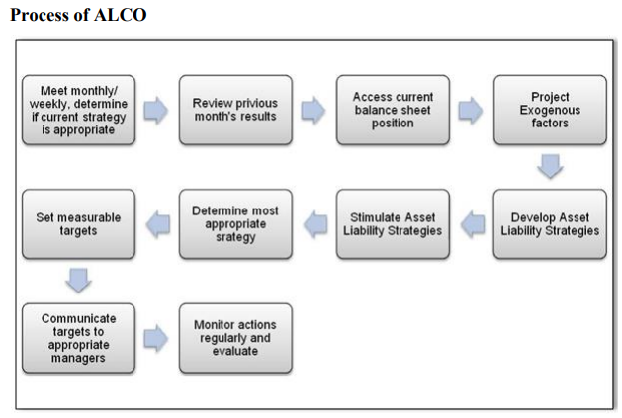
ASSET LIABILITY MANAGEMENT APPROACH ALM in its most apparent sense is based on funds management. Funds management represents the core of sound bank planning and financial management
Funds management has following three components:
- LIQUIDITY RISK MANAGEMENT: Bank‘s liquidity management is the process of generating funds to meet contractual or relationship obligations at reasonable prices at all times. New loan demands, existing commitments, and deposit withdrawals are the basic contractual or relationship obligations that a bank must meet
- ASSET MANAGEMENT: Many banks (primarily the smaller ones) tend to have little influence over the size of their total assets. Liquid assets enable a bank to provide funds to satisfy increased demand for loans. But banks, which rely solely on asset management, concentrate on adjusting the price and availability of credit and the level of liquid assets.
- LIABILITY MANAGEMENT: In the broadest sense liability management involves the planning and co-ordination of all the bank‘s sources of funds in order to maintain liquidity, profitability and safety to maintain long-term growth.
Objective of the Study:
- To study the concept of asset & liability management.
- To Study of comparison of asset & liability from balance sheet.
- To understand the Financial Statement
- To study reserves cycle of ALM under IDBI bank.
- To study functions and objectives of ALM committee.
Research methodology:
Research is a diligent and systematic inquiry or investigation in to a subject in order to discover or revise facts, theories, application etc. Methodology is the system of methods followed by particular discipline. Thus, research methodology is the way how we conduct our research.
Source of Data
The primary source for the study of project is based on secondary source collected
SECONDARY DATA COLLECTION
Collected from annual reports, journal, books and websites of the company
TOOLS USED :
- Annual report of the IDBI bank
- published report of the IDBI bank
- RBI guidelines for ALM
- RSA and RSL used for companies on of GAP analysis.

DATA ANALYSIS AND INTERPRETATION:
COMPARATIVE ASSET LIABILITY SHEET AS ON 31ST MARCH 2021-22
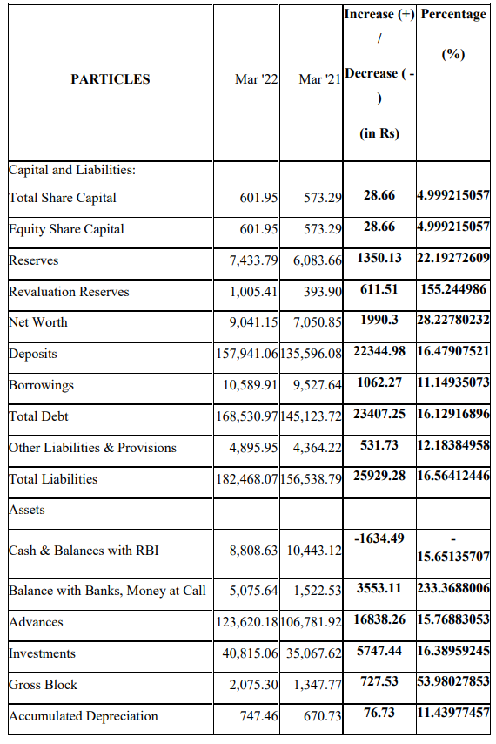
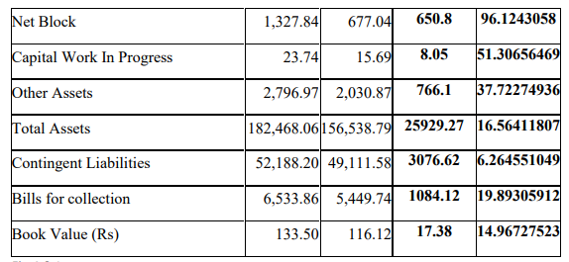
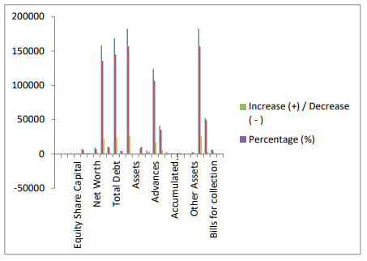
INTERPRETATION:
- The total liabilities for the year are Rs.25926.27 Cr
- The investments are for the year Rs.5747.44 Cr.
- Therefore the assets are more than the liabilities. So there is a positive gap of Rs.650.80 i.e. 96.12%
FINDINGS
1. AL technique is aimed to tackle the market risks. Its objective is to stabilize and improve Net interest Income (NII).
2. Implementation of ALM as a Risk Management tool is done using maturity profiles and GAP analysis.
3. ALM presents a disciplined decision making framework for s while at the same time guarding the risk levels.
4. There has been a small reduction in Gross Sales and with the performance of prefab Division the Gross Profit gap has narrowed and contributing. The Net Profit has increased considerably from 35.13 Cr in Last year to 145.98 Cr in year. The interest payment has increased by 987.36Cr in the Current year and the Profit before Tax at when compared to 65874.64 cr in Last year‘s.
5. The profit After Tax has come 5478.95 Cr to 62658.64 in Current year because of slope in Industry.
SUGGESTIONS
1. They should strengthen its management information system (MIS) and computer processing capabilities for accurate measurement of liquidity and interest rate Risks in their Books.
2. It is essential that remain alert to the events that effect its operating environment & react accordingly in order to avoid any undesirable risks.
3. IDBI bank requires efficient human and technological infrastructure which will future lead to smooth integration of the risk management process with effective business strategies.
CONCLUSION
Regular measurement and monitoring of the risk exposure is required. Operating within a dynamic environment, as the entity‘s risk tolerances and financial objectives change, the existing ALM strategies may no longer be appropriate. Hence, these strategies need to be periodically reviewed and modified. A formal, documented communication process is particularly important in this step. Financial objectives and risk tolerances are generally determined by senior management of an entity and are reviewed from time to time.
BIBLIOGRAPHY
BOOKS:
- Jain Rubber, Risk Management, Mc Graw Hill Publications, 8th Edition, Hyderabad,2015.
- Reichmann and Gustafson, Risk Management Insurance, 11th Edition sheriff / Thomson learning, New Delhi,2015.
- Moorad Choudhary, Bank Asset and Liability management-Strategy, Trading, Analysis. Wiley Finance. Publications, Hyderabad.2018
- M.Y.Khan - Indian financial system, 5 th Edition, Tata Mc Grawhill Publications, New Delhi,2018.
NEWS PAPERS:
- Economic times
- The Hindu
- •Business Standard
WEBSITES:
- www.IDBIap.in
- www.rbi.org.com
- www.google.com

