A STUDY ON FIXED ASSET MANAGEMENT
1. Author: A.ANITHA, Asst. Prof., Dept. of MBA, SANTHIRAM ENGINEERING COLLEGE, NANDYAL
2. Author: G.APSANA, Student of MBA, SANTHIRAM ENGINEERING COLLEGE, NANDYAL
Abstract: Fixed assets management is an accounting process that seeks to track fixed assets for the purposes of financial accounting, preventive maintenance, and theft deterrence.
According to International Accounting Standard (IAS), Fixed Assets are assets whose future economic benefit is probable to flow into the entity, whose cost can be measured reliably.
Fixed Asset management is crucial to the accounting process in any business. It can be difficult to find the time and the tools to devote the needed attention to assets that they deserve. The truth is that a company’s assets are the largest investments most companies make. Sound management of assets can yield substantial tax savings in depreciation deductions. Without thorough management of assets, the accuracy of financial reports will be threatened and there will be a negative impact on your bottom line. Establishing the highest standards of depreciation accuracy and best practices in fixed asset management will pay off in the form of savings and efficiency.
INTRODUCTION:
Fixed assets normally include items such as land and buildings, motor vehicles, furniture, office equipment, computers, fixtures and fittings, and plant and machinery. These often receive favourable tax treatment (depreciation allowance) over short-term assets.
Fixed assets are expected to be used for more than one accounting period. Fixed assets are generally not considered to be a liquid form of assets unlike current assets. Examples of common types of fixed assets include buildings, land, furniture and fixtures, machines and vehicles. The term 'Fixed Asset' is generally used to describe tangible fixed assets. This means that they have a physical substance unlike intangible assets which have no physical existence such as copyright and trademarks. Fixed assets are not held for resale but for the production, supply, rental or administrative purposes.
The market value of the fixed assets may change with the passage of time, but for accounting purpose it continues to be shown in the books in historical cost. The cost concept of accounting states that depreciation calculated on the basis of historical cost of old assets is usually lower than the amount calculated at current value/ replacement value. These results in more profits, which if distributed in full will lead to reduction in capital.
The accounting equation is the mathematical structure of the balance sheet. It relates assets, liabilities, and owner's equity:

Assets = Liabilities + Capital (where Capital for a corporation equals Owner's Equity)
Liabilities = Assets - Capital
Capital = Assets - Liabilities
That is, the total value of a firm’s Assets is always equal to the combined value of its "equity" and "liabilities."
Assets in Accounting are classified into
• Current Assets
• Fixed Assets
• Non-current Assets
• Collectible Assets
LIABILITIES: The second major content of the balance sheet is liabilities defined as the claims of outsiders that is, other than owners. The firms can borrow on a long-term basis from financial institutions/banks or through bonds/mortgages/debentures, and so on. The short-term borrowing may be in the form of purchase of goods and services on credit. These outside sources from which a firm can borrow are termed as liabilities. Depending upon the periodicity of the funds, liabilities can be classified into
• Long-term liabilities and
• Current liabilities
RESEACH METHODOLOGY
Research Design: Research design is some statement or specification of procedures for collecting and analysing the information required for the solution of some specific problem.
Data Collection Methods: The key for creating useful system is selectivity in collection of data and linking that selectivity to the analysis and decision issue of the action to be taken. The accuracy of collected data is of great significance for drawing correct and valid conclusions from the research Sources of Information: The sources of information are two types.
1. Primary Data
2. Secondary Data
1. Primary Data: The primary data is not included in this study, only secondary data is taken in to account since it is a comparative analysis.
2. Secondary Data: The data gathering method is adopted purely form secondary sources.

FIXED ASSETS TO NET WORTH RATIO: This ratio establishes the relationship between Fixed Assets and net worth. Net Worth = Share Capital + Reserves & Surplus + Retained Earnings.
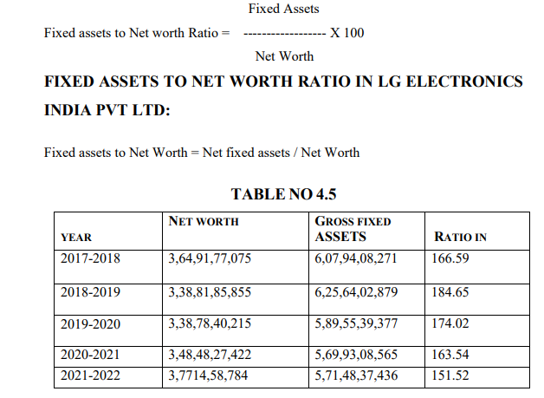
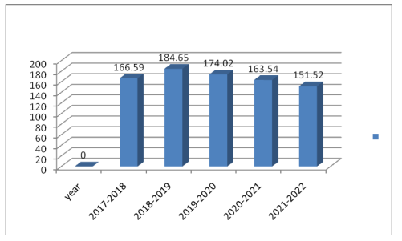
INTERPRETATION: From the above table of LG Electronics
• The Gross fixed to Net worth Ratio is fluctuating from year to year. In the year 2017-2018 the gross fixed assets to net worth ratio is 166.59, in the year 2017- 2022 the fixed assets to net worth to acquire the ratio is 151052.
• The average net worth to fixed assets ratio is Rs,3,53,62,97,870 or fixed assets average ratio is Rs. 5,92,90,99,306 the average percentage of fixed assets to net worth is 168.06.
• The highest ratio recorded in 2018-2019 at 184.65 the lowest ratio is recorded at 151.52 in the year 2021-2022.

FINDINGS
- From the above study we can find that Asset Management reports provide instant insight for tax planning, better use of existing assets and the purchase of future assets.
- The study states that fixed assets are not held for resale but for the production, supply, rental or administrative purposes. Assets that held for resale must be accounted for as inventory rather than fixed asset.
- The study states finds that economic life of the asset will be determined by such factors as technological progress and changes in demand.
- LG is the brand that is Delightfully Smart to resolve to relationship and to achieve the highest satisfaction for customers.
- Many dealers were facing the problem of after sale service because there is no follow up calls from LG.
- The top competitor of LG product in Hyderabad is Samsung.
- In Hyderabad area the performance of LG is in better position but the competitor also hold closer margin.
- There is high growth of sale in market due to booming in new technology and better service.
- Company should concentrate on long term assets are utilized for working capital problem will not arise in future.
SUGGESTIONS
- Company should maintain adequate ratios
- It is suggested to improve the position of the company by effective’s utilization of fixed assets.
- It should try to utilize the fixed assets to maintain maximum profit.
- LG should try new dealer who have the potential. So they can target more market.
- The marketing managers should make better relations with dealers and reputation of the company.
CONCLUSION
Customers are also now very choosy in buying the product and it is important for the company to make permanent customer of their brand. From the survey we can conclude that LG has captured maximum market share in every category. LG dominates CTV, LCD, and Refrigerator, and Washing machine, category. The Fixed asset management of the company is quite comfortable with a judicious mix of debt and equity. The overall assessment of financial statement signifies efficient utilization of the investments, loans and advances. The profitability of the company appears to be impressive, as judged by increase in reserves and surplus.

BIBLIOGRAPHY
Books:
- M.Y. Khan & P. K. Jain , Financial Management Fourth edition, published
by TATA McGraw HILL New Delhi: 2001.
- Prof. Satish Inamdar, Financial Management published by Symbiosis center for distance learning, Pune,2020
- M. Pandey, Financial Management Second edition published by TATA McGraw HILL publishing company. New Delhi: 2018.
- Sashi K Sharma, Gupta, Financial Management, 10th Edition, Cengage Publication, Hyderabad, 2020.
- Nirmal, Gupta, Financial Management, 12th Edition, Cengage Publication, Hyderabad, 2017.
Website
- www.google.com
- www.ask.com
- www.lg.com

