A STUDY ON INVESTIGATING THE UNDERLYING CAUSES OF REVENUE LEAKAGE IN HOSPITAL SYSTEM

Chapter- 1: INTRODUCTION :

- Background of the topic :
The background of a study investigating the underlying causes of revenue leakage in hospital systems encompasses the context and motivation behind the research initiative. Revenue leakage, characterized by the loss of potential revenue due to inefficiencies or inaccuracies in billing processes, poses a significant challenge for healthcare organizations worldwide. In the dynamic landscape of healthcare delivery, hospitals face mounting pressures to optimize financial performance while ensuring the delivery of high-quality patient care. However, revenue leakage undermines these objectives, compromising the financial sustainability and operational efficiency of hospital systems.

Against this backdrop, the study aims to delve into the root causes behind revenue leakage within hospital systems. It recognizes that addressing revenue leakage requires a thorough understanding of the multifaceted factors contributing to this phenomenon. These factors may include coding errors, incomplete documentation, delays in charge capture, non-compliance with regulatory requirements, and other operational inefficiencies. The study may contribute to theories related to regulatory compliance in healthcare. By uncovering areas of non-compliance contributing to revenue leakage, it can inform theoretical frameworks concerning regulatory adherence and enforcement mechanisms. Insights gained from the study may lead to the development of theoretical models that guide healthcare organizations in navigating complex regulatory environments while minimizing the risk of revenue loss due to non-compliance.

The motivation for conducting this study lies in the imperative to mitigate revenue leakage and strengthen revenue assurance practices within hospital systems. By identifying and addressing the underlying causes of revenue leakage, hospitals can enhance their financial integrity, optimize revenue capture, and safeguard their long-term sustainability. Moreover, improving revenue assurance practices can enable hospitals to allocate resources more effectively, invest in infrastructure and technology, and ultimately enhance the quality of patient care.

In summary, the background of the study underscores the pressing need to investigate the underlying causes of revenue leakage in hospital systems. By conducting rigorous research and analysis in this area, the study aims to provide valuable insights and recommendations for hospitals to enhance their revenue assurance practices and mitigate the impact of revenue leakage on their financial performance and operational efficiency.

- Need/importance of the topic:

- Financial Sustainability: Understanding the underlying causes of revenue leakage is crucial for ensuring the financial sustainability of hospital systems. By identifying and addressing revenue leakage, hospitals can optimize revenue capture and mitigate financial losses, thereby maintaining their ability to provide quality patient care and sustain operations.
- Quality Patient Care: Revenue leakage can impact the resources available for delivering quality patient care. Investigating its causes helps hospitals allocate resources more efficiently, ensuring that patients receive the necessary treatments, medications, and support services without compromising on quality.
- Operational Efficiency: Revenue leakage often results from inefficiencies in billing processes and revenue cycle management. By studying its underlying causes, hospitals can identify areas for improvement, streamline workflows, and enhance operational efficiency, ultimately reducing administrative burden and improving overall effectiveness.
- Data-Driven Decision Making: A comprehensive study on revenue leakage provides hospitals with valuable data and insights into their revenue cycle management practices. By analyzing the causes of revenue leakage, hospitals can make informed decisions and implement targeted interventions to optimize revenue capture and minimize financial losses.
- Resource Allocation: Revenue leakage can affect resource allocation within hospitals, potentially leading to budgetary constraints and resource shortages. By studying its underlying causes, hospitals can better allocate resources, ensuring that funds are allocated to areas where they are most needed to support patient care and operational activities.
- Risk Management: Revenue leakage poses a significant risk to the financial health of hospitals. Investigating its causes allows hospitals to assess and mitigate this risk more effectively, implementing strategies to prevent future revenue losses and safeguard the organization against financial instability.
- Stakeholder Confidence: Addressing revenue leakage demonstrates a hospital's commitment to financial transparency and accountability. By conducting a study on its underlying causes, hospitals can instill confidence in stakeholders, including patients, staff, investors, and regulatory agencies, who rely on accurate financial information.
- Competitive Advantage: Hospitals that effectively manage revenue leakage gain a competitive advantage in the healthcare marketplace. By optimizing revenue capture and minimizing financial losses, hospitals can allocate resources more strategically, invest in innovative technologies, and enhance service offerings, positioning themselves as leaders in the industry.
- Long-Term Sustainability: Ultimately, studying the underlying causes of revenue leakage is essential for the long-term sustainability of hospital systems. By addressing revenue leakage and implementing proactive measures to prevent future occurrences, hospitals can ensure their continued viability and ability to serve the needs of their communities for years to come.

- Theoretical implication :
Revenue leakage management theory offers significant theoretical implications for the healthcare sector, providing a framework to optimize financial performance while maintaining the quality and accessibility of care. By leveraging concepts such as market segmentation, demand forecasting, and price discrimination, healthcare providers can tailor pricing and service offerings to different patient segments, maximizing revenue while ensuring affordability and equity.

Theoretical models help providers optimize capacity utilization, appointment scheduling, and risk management strategies to meet fluctuating demand, minimize wait times, and mitigate financial risks associated with uncertainty. Furthermore, revenue management theory guides the measurement of performance metrics and ethical considerations, ensuring that revenue optimization efforts align with patient-centered care and ethical pricing principles. Overall, these theoretical implications inform strategies aimed at balancing financial sustainability with the delivery of high-quality, accessible healthcare services.

The study may offer theoretical insights into financial management practices specific to the healthcare sector. By identifying factors contributing to revenue leakage, it can inform theories related to budgeting, resource allocation, and revenue optimization strategies tailored to the unique challenges faced by hospitals. This could lead to the development of theoretical models that guide decision-making processes concerning financial management practices and resource utilization in healthcare settings.

From an organizational behavior perspective, the study can shed light on the behavioral aspects of revenue cycle management. Analyzing factors such as staff behavior, communication patterns, and organizational culture in the context of revenue leakage can provide insights into how these variables influence financial outcomes within hospitals. Theoretical implications may include understanding the role of organizational culture in promoting accountability and efficiency in revenue cycle management processes, as well as identifying strategies for fostering a culture of compliance with billing regulations and best practices.

A study on investigating the underlying causes of revenue leakage in hospital systems has broad theoretical implications across various domains, including healthcare management, financial management, organizational behavior, and regulatory compliance. By contributing to theoretical advancements in these areas, the study can inform future research, policy development, and practice in healthcare organizations, ultimately leading to improved financial sustainability and operational efficiency within hospital systems

- Recent trends :
Recent trends in revenue leakage management within the healthcare sector reflect a growing emphasis on data-driven decision-making, patient-centric approaches, and value-based care models. One prominent trend is the integration of advanced analytics and predictive modeling to forecast demand, optimize pricing, and improve resource allocation. Healthcare providers are increasingly leveraging electronic health records (EHRs), patient demographics, and clinical data to gain insights into patient preferences, utilization patterns, and clinical outcomes, enabling more precise revenue management strategies. Another significant trend is the shift towards patient-centered pricing models, where providers offer transparent pricing, bundled services, and flexible payment options to enhance patient satisfaction and financial transparency. Additionally, value-based care initiatives, such as accountable care organizations (ACOs) and bundled payment programs, incentivize providers to focus on improving patient outcomes and reducing costs, driving the adoption of innovative revenue management approaches that align financial incentives with quality care delivery. Furthermore, the COVID-19 pandemic has accelerated trends towards telehealth and virtual care models, prompting healthcare organizations to adapt revenue management strategies to accommodate remote consultations, digital health platforms, and reimbursement changes. Overall, recent trends in revenue management within the healthcare sector reflect a shift towards data-driven, patient-centric approaches that prioritize value, quality, and financial sustainability.

Chapter- 2: Literature review

- The role of overbilling in hospitals’ earnings management decisions , Jonas Heese 2018 , 27(5) : findings from the research shed light on the ethical dilemmas inherent in overbilling practices and their implications for patient care and trust. While hospitals may justify overbilling as a means of ensuring financial viability and sustaining essential services, such practices can erode public trust, undermine the integrity of the healthcare system, and compromise patient outcomes. Moreover, overbilling may disproportionately impact vulnerable patient populations, exacerbate healthcare disparities, and contribute to rising healthcare costs. research underscores the importance of transparency, accountability, and oversight mechanisms in mitigating the risks associated with overbilling and earnings management in hospitals. By promoting a culture of compliance, ethical leadership, and internal controls, healthcare organizations can deter fraudulent billing practices, detect irregularities, and safeguard the integrity of financial reporting processes. In conclusion, the findings from research on the role of overbilling in hospitals' earnings management decisions provide critical insights into the complex interplay between financial, regulatory, and ethical considerations in healthcare finance.

- Contextualist inquiry into IT-enabled hospital revenue cycle management , Vitali Mindel, Lars Mathiassen 2015 , 16(12) : the findings from a contextualist inquiry into IT-enabled hospital revenue cycle management offer valuable insights into the complex interplay between technology, organizational context, and performance outcomes. By embracing a nuanced understanding of these dynamics, healthcare leaders can craft tailored strategies to enhance revenue cycle efficiency, financial sustainability, and overall organizational resilience in an increasingly complex healthcare landscape. the findings from a contextualist inquiry into IT-enabled hospital revenue cycle management offer valuable insights into the complex interplay between technology, organizational context, and performance outcomes. By embracing a nuanced understanding of these dynamics, healthcare leaders can craft tailored strategies to enhance revenue cycle efficiency, financial sustainability, and overall organizational resilience in an increasingly complex healthcare landscape. the research underscores the importance of aligning IT-enabled revenue cycle management strategies with broader organizational goals and priorities. By adopting a strategic and holistic approach, healthcare providers can leverage IT systems to streamline administrative processes, enhance billing accuracy, accelerate revenue capture, and mitigate compliance risks. However, achieving such alignment requires proactive leadership, cross-functional collaboration, and ongoing performance monitoring to ensure the effective utilization of IT resources and the realization of intended benefits.

- Revenue management for outpatient appointments: joint capacity control and overbooking with class-dependent no-shows , Aaron Ratcliffe, Wendell Gilland, Ann Marucheck , 2012 ,24(7): the study reveals that optimal overbooking levels depend heavily on the characteristics of the patient population and historical attendance patterns. By analyzing class-dependent no-show rates, researchers identified that certain patient demographics or conditions might exhibit higher or lower rates of appointment attendance. Consequently, tailored overbooking strategies can be devised to mitigate revenue loss due to no-shows while minimizing the risk of appointment congestion. the research provides valuable insights into revenue management for outpatient appointments by elucidating the role of joint capacity control, overbooking, and class-dependent no-shows. By understanding the complex interactions among these factors, healthcare organizations can implement tailored strategies to optimize revenue generation while ensuring efficient resource utilization and patient satisfaction.

- Analyzing the Efficiency of Health Systems , Rahab Mbau 2022 ,21(8) : the research underscores the imperative of leveraging technology and innovation to drive efficiency gains within health systems. From electronic health records and telemedicine platforms to predictive analytics and artificial intelligence, technological advancements offer promising avenues for optimizing resource allocation, streamlining workflows, and improving patient outcomes. However, the adoption and integration of these innovations necessitate careful consideration of interoperability standards, data privacy concerns, and the equitable distribution of benefits across diverse populations. In conclusion, the findings from research analyzing the efficiency of health systems provide valuable insights into the complex drivers and determinants of performance. By unraveling the multifaceted interactions between inputs, processes, and outcomes, researchers offer actionable recommendations to policymakers, healthcare leaders, and practitioners seeking to enhance the efficiency, equity, and effectiveness of health systems worldwide.

- The Road Ahead and Challenges of Revenue Cycle Management In government hospitals , Zainab alradhi , 2023 ,11(6) : One significant finding revolves around the critical role of technology in modernizing and optimizing revenue cycle processes within government hospitals. While many private healthcare facilities have adopted advanced RCM systems and electronic health records (EHR) platforms to streamline billing, coding, and claims management, government hospitals often lag behind due to resource constraints, legacy systems, and bureaucratic hurdles. Consequently, researchers emphasize the urgent need for investment in IT infrastructure, staff training, and interoperable systems to enhance efficiency, accuracy, and transparency in revenue cycle operations. In conclusion, the findings from research on the road ahead and challenges of revenue cycle management in government hospitals underscore the need for concerted efforts to address systemic barriers, enhance technological infrastructure, strengthen financial stewardship, and promote stakeholder engagement. By embracing a holistic and collaborative approach, policymakers, healthcare leaders, and community stakeholders can chart a path towards sustainable and equitable RCM practices that ensure financial viability, optimize revenue capture, and uphold the mission of government hospitals in delivering high-quality, accessible healthcare services to all.

- Link Between Revenue Cycle Management, Profitability, and Not-for-Profit Hospitals' Ability to Grow Equity , Singh, Simone Rauscher PhD; Wheeler, John PhD ,2012 , 57(5) : One significant finding underscores the pivotal role of RCM in influencing the financial health and long-term viability of not-for-profit hospitals. Effective revenue cycle management encompasses a range of processes, including patient registration, insurance verification, coding, billing, claims processing, and collections. Researchers have demonstrated that streamlined RCM practices can enhance revenue capture, accelerate cash flow, reduce bad debt write-offs, and optimize reimbursement rates, thereby bolstering profitability and liquidity metrics essential for sustaining operations and funding strategic initiatives. he findings from research on the link between revenue cycle management, profitability, and not-for-profit hospitals' ability to grow equity underscore the complex interplay between financial performance, mission alignment, and societal impact in the healthcare sector. By adopting a holistic and mission-driven approach to financial management, not-for-profit hospitals can optimize revenue cycle processes, enhance profitability, and leverage financial surpluses to fulfill their charitable mission, promote community health, and advance health equity for all.

- Revenue-raising potential for universal health coverage , Inke Mathauer, Kira Koch, Samuel Zita, Alex Murray ,2019 ,97(9) : the research highlights the importance of progressive and equitable financing mechanisms in achieving UHC goals while minimizing the financial burden on vulnerable populations. Progressive taxation policies, which impose higher tax rates on individuals with greater income or wealth, can generate substantial revenue for healthcare without exacerbating socioeconomic inequalities. Similarly, social health insurance schemes that pool risks across the population and subsidize premiums for low-income households can promote solidarity and ensure access to essential health services for all, regardless of ability to pay. The findings from research on the revenue-raising potential for universal health coverage underscore the complexity and importance of financing mechanisms in achieving equitable access to healthcare for all. By adopting a multi-sectoral approach, embracing progressive taxation policies, strengthening governance structures, and promoting stakeholder engagement, governments can mobilize the resources needed to realize the vision of UHC and advance health equity, social justice, and human rights for individuals and communities worldwide.

- Does IT Improve Revenue Management in Hospitals , Kangkang Qi , Sumin Han ,202 ,21(6) : the research highlights the importance of continuous monitoring, evaluation, and adaptation of IT-enabled revenue management strategies to evolving healthcare dynamics and technological advancements. As healthcare finance landscapes evolve, hospitals must remain agile and responsive to emerging trends, regulatory changes, and market pressures. By leveraging data analytics, predictive modeling, and benchmarking tools, hospitals can identify opportunities for process improvement, optimize revenue cycle workflows, and drive sustainable financial performance in an increasingly competitive and complex healthcare environment. In conclusion, the findings from research on the impact of IT on revenue management in hospitals underscore the transformative potential of technology to enhance efficiency, accuracy, and compliance within the revenue cycle. By embracing IT-enabled solutions, hospitals can streamline administrative processes, improve revenue capture, and optimize financial performance while navigating regulatory complexities and safeguarding patient information privacy. However, successful IT adoption requires a strategic approach, ongoing investment, and organizational commitment to innovation, collaboration, and continuous improvement in revenue management practices.

- Equity of health sector revenue generation and allocation , Di McIntyre, Lucy Gilson, Nicole Valentine, N Soderlund ,1998 , 12 : the research underscore the importance of transparency, accountability, and participation in health sector revenue generation and allocation processes. By involving stakeholders, including civil society organizations, community representatives, and marginalized groups, in decision-making and resource allocation processes, governments can ensure that healthcare financing policies and priorities reflect the needs and preferences of the population. Additionally, transparent budgeting practices, public expenditure tracking systems, and independent oversight mechanisms can help prevent corruption, ensure efficient resource allocation, and promote trust and confidence in the health sector among citizens .In conclusion, the findings from research on the equity of health sector revenue generation and allocation highlight the importance of addressing disparities in healthcare financing to achieve universal health coverage and health equity. By adopting equity-oriented revenue generation and allocation strategies, governments can mobilize resources to ensure that all individuals have access to quality healthcare services regardless of their socioeconomic status, geographic location, or demographic characteristics. Moreover, promoting transparency, accountability, and stakeholder participation in healthcare financing processes can help build trust, promote social cohesion, and advance health equity within societies.

- A comparative analysis of revenue and cost-management strategies of not-for-profit and for-profit hospitals, Ramesh K Shukla, Jan Clement ,1997 ,42(1) : the research underscore the influence of regulatory environments, reimbursement structures, and market dynamics on revenue and cost-management strategies in not-for-profit and for-profit hospitals. For-profit hospitals may be more responsive to market forces and competitive pressures, adjusting pricing strategies and service offerings to maximize revenue capture and market share. In contrast, not-for-profit hospitals may face regulatory constraints and public scrutiny regarding pricing transparency, billing practices, and charity care obligations, which can impact revenue generation and cost-management decisions. Additionally, reimbursement mechanisms, such as prospective payment systems and value-based payment models, may incentivize different approaches to revenue and cost management across hospital sectors, influencing investment priorities, care delivery models, and financial performance outcomes. In conclusion, the findings from comparative analyses of revenue and cost-management strategies between not-for-profit and for-profit hospitals highlight the complex interplay of financial, regulatory, and organizational factors shaping healthcare delivery and financial sustainability.

- Scheduling, Revenue Management, and Fairness in an Academic-Hospital Radiology Division , Richard Baum MD 2014 , 21(10) : the research underscore the importance of fairness and equity in resource allocation and service delivery within radiology divisions. Radiological procedures are essential diagnostic tools that inform clinical decision-making and patient care across diverse medical specialties. As such, equitable access to radiology services is critical for ensuring timely diagnosis, treatment planning, and patient outcomes. Radiology departments must adopt transparent and equitable scheduling policies, prioritize medically necessary procedures, and implement mechanisms to address disparities in access to imaging services among different patient populations. Additionally, radiologists and healthcare administrators play a crucial role in advocating for policies and practices that promote fairness, inclusivity, and social justice in radiology service delivery. In conclusion, the findings from research on scheduling, revenue management, and fairness in an academic-hospital radiology division underscore the need to balance operational efficiency, financial sustainability, and patient-centered care principles in healthcare delivery.

- The revenue cycle: What it is, how it works, and how to enhance it , Marilyn Hart Niedzwiecki 2006 ,13(2) ; : Research exploring the revenue cycle provides a comprehensive understanding of its components, functions, and opportunities for improvement within healthcare organizations. The revenue cycle encompasses the entire process of generating revenue from patient services, starting from appointment scheduling and patient registration to coding, billing, claims submission, and reimbursement. One key finding emphasizes the interconnectedness of each stage within the revenue cycle and the critical role of efficient workflows, accurate documentation, and effective communication in maximizing revenue capture and financial performance. By optimizing revenue cycle processes, healthcare organizations can accelerate cash flow, reduce accounts receivable days, minimize claim denials, and enhance revenue integrity. Moreover, the research highlights the importance of leveraging technology, automation, and data analytics to streamline revenue cycle operations, identify revenue leakage points, and drive continuous improvement initiatives. By adopting a holistic approach to revenue cycle management and embracing best practices in scheduling, documentation, coding, billing, and reimbursement, healthcare organizations can enhance financial sustainability, optimize revenue performance, and improve the overall patient experience.

- Critical success factors for ERP implementation in a Fortis hospital: an empirical investigation , Poonam Garg and Divya Agarwal ,2014 ,27(14) : Research investigating critical success factors for Enterprise Resource Planning (ERP) implementation in a Fortis hospital provides valuable insights into the factors influencing the effectiveness and outcomes of ERP adoption in healthcare settings. One key finding underscores the significance of organizational readiness, leadership commitment, and stakeholder engagement as fundamental drivers of ERP implementation success. The study reveals that proactive leadership, strong organizational culture, and effective change management practices are essential for aligning ERP initiatives with strategic objectives, fostering staff buy-in, and overcoming resistance to change. Moreover, the research highlights the importance of comprehensive planning, project management, and resource allocation in mitigating implementation risks, ensuring system compatibility, and achieving project milestones on time and within budget. Additionally, findings emphasize the role of vendor selection, customization, and training in optimizing ERP functionality, usability, and user adoption rates. By addressing these critical success factors, Fortis hospital and other healthcare organizations can maximize the benefits of ERP systems, streamline operational workflows, improve data integrity, and enhance decision-making capabilities, ultimately driving organizational performance and patient outcomes.

- Earnings Management Using Real Activities: Evidence from Nonprofit Hospitals, Leslie G ,Kevin W Hee , 2011 ,86(5) : The research on earnings management using real activities, particularly within nonprofit hospitals, sheds light on the complex strategies employed by these institutions to influence financial reporting outcomes. One key finding suggests that nonprofit hospitals may engage in various maneuvers to manipulate real operational activities, such as patient volumes, service offerings, discretionary spending, and capital investments, to achieve specific financial targets or portray a desired financial image. By adjusting these tangible activities, nonprofit hospitals can potentially enhance reported revenues, minimize expenses, or inflate earnings, thereby potentially misleading stakeholders about the institution's financial health. This highlights the importance of transparency and accountability in financial reporting practices within nonprofit healthcare organizations, ensuring that stakeholders have accurate information to assess the institution's financial performance and operational efficiency.

- Iranian public hospitals' challenges regarding revenue deficits: A mixed-method study , Ali Sarabi-Asiabar, Saeide Alidoost, 2020 ,34(12) : The research on Iranian public hospitals' challenges concerning revenue deficits provides valuable insights into the complex factors influencing financial sustainability within the country's healthcare system. One notable finding from the study is the identification of various challenges contributing to revenue deficits in public hospitals. These challenges encompass a range of issues, including inadequate government funding, inefficient revenue collection mechanisms, reliance on out-of-pocket payments, and challenges with insurance reimbursement systems. Additionally, the study highlights organizational factors such as ineffective financial management practices, resource constraints, and administrative inefficiencies as further exacerbating revenue shortfalls. By uncovering these challenges through a mixed-method approach, the research underscores the need for comprehensive reforms and strategic interventions to address systemic issues and ensure the long-term financial viability of Iranian public hospitals.

- Do private hospitals outperform public hospitals regarding efficiency, accessibility, and quality of care , Niek W. Stadhouders, Eddy M. Adang ,49 (5) : The research comparing the performance of private hospitals to public hospitals across efficiency, accessibility, and quality of care yields insightful findings into the dynamics of healthcare delivery within different sectors. One significant finding is the nuanced relationship between private and public hospitals in terms of performance metrics. While private hospitals may demonstrate higher efficiency in certain areas due to their ability to operate with greater flexibility and autonomy, particularly in resource allocation and management, public hospitals often play a crucial role in ensuring accessibility and equity of care, especially for underserved populations. Additionally, the research highlights variations in quality of care between private and public hospitals, with factors such as patient demographics, case complexity, and funding sources influencing outcomes. Overall, the findings emphasize the importance of considering multiple dimensions of performance when evaluating healthcare systems and the need for targeted interventions to address disparities and optimize outcomes across both private and public sectors.

- Healthcare facilities maintenance management , Zahra Yousefli, Fuzhan Nasiri ,2017 ,15(4) : The research on healthcare facilities maintenance management provides valuable insights into the challenges, strategies, and best practices associated with maintaining the infrastructure and equipment essential for delivering high-quality healthcare services. One key finding from this research is the critical role of proactive maintenance practices in ensuring the operational efficiency, safety, and compliance of healthcare facilities. By implementing preventive maintenance schedules, routine inspections, and predictive maintenance technologies, healthcare organizations can minimize downtime, reduce equipment failures, and extend the lifespan of critical assets. Moreover, the research highlights the importance of strategic asset management, lifecycle planning, and budget allocation in prioritizing maintenance activities and optimizing resource utilization. Additionally, findings underscore the significance of regulatory compliance, infection control, and environmental sustainability considerations in healthcare maintenance management, necessitating collaboration between facility managers, clinical staff, and regulatory agencies to ensure compliance with industry standards and best practices. Overall, the research underscores the multifaceted nature of healthcare facilities maintenance management and the importance of adopting proactive, data-driven approaches to optimize performance, mitigate risks, and support the delivery of safe and effective patient care.

- Quality and revenue enhancement initiative for internal medicine practice , Rashmita Basu Ryan N. Schmidt , 2018 , 30(1) : The research on quality and revenue enhancement initiatives for internal medicine practice uncovers valuable insights into strategies aimed at improving both patient care quality and financial performance within healthcare organizations. A significant finding from this research is the identification of specific initiatives and interventions that have demonstrated success in simultaneously enhancing clinical outcomes and revenue generation within internal medicine practices. These initiatives often include implementing evidence-based clinical guidelines, care coordination protocols, and chronic disease management programs to optimize patient care quality, streamline workflows, and reduce healthcare costs. Additionally, findings suggest that incorporating value-based care models, population health management strategies, and alternative payment models can incentivize proactive preventive care, improve patient outcomes, and drive revenue growth through enhanced reimbursement for value-driven services. Moreover, the research highlights the importance of leveraging technology, data analytics, and performance metrics to monitor quality indicators, identify areas for improvement, and measure the impact of quality and revenue enhancement initiatives over time. By adopting a holistic approach that integrates clinical excellence with financial sustainability, internal medicine practices can enhance patient satisfaction, achieve better health outcomes, and ensure long-term viability in an increasingly value-focused healthcare landscape.

- Cost management strategy in healthcare: An examination of the effectiveness of quality improvement programs , Wadsworth , Eric B ,2007 , 15(7) :The research on cost management strategy in healthcare, specifically examining the effectiveness of quality improvement programs, provides valuable insights into the complex relationship between quality initiatives and financial outcomes within healthcare organizations. One key finding from this research is the positive impact of quality improvement programs on cost management. Quality improvement initiatives, such as Lean Six Sigma methodologies, evidence-based practice guidelines, and patient safety protocols, have been shown to enhance operational efficiency, reduce waste, and minimize errors, leading to cost savings and improved financial performance. Additionally, findings suggest that investments in quality improvement can yield long-term benefits by preventing adverse events, reducing readmissions, and improving patient outcomes, thereby mitigating the financial burden associated with suboptimal care. Moreover, the research highlights the importance of strategic alignment between quality improvement efforts and organizational goals, resource allocation, and performance metrics to maximize the effectiveness of cost management strategies. By prioritizing quality and adopting a systematic approach to continuous improvement, healthcare organizations can achieve better value for resources expended, optimize resource utilization, and ultimately enhance both the quality of care and financial sustainability.

- Contextualist Inquiry into Hospital Revenue Cycle Transformation, Vitali Mindel; Lars Mathiassen ,2015 ,48(21) : The research employing contextualist inquiry into hospital revenue cycle transformation uncovers valuable insights into the multifaceted factors influencing the process of revenue cycle change within healthcare organizations. A key finding from this research is the recognition of the complex interplay between organizational culture, leadership dynamics, technological infrastructure, and external factors in driving revenue cycle transformation initiatives. By adopting a contextualist approach, researchers reveal that successful revenue cycle transformation requires more than just implementing new technologies or streamlining processes; it necessitates a deep understanding of the unique organizational context, including cultural norms, power dynamics, and stakeholder perspectives. Moreover, findings highlight the importance of leadership commitment, staff engagement, and cross-functional collaboration in fostering a culture of continuous improvement and innovation to drive sustainable revenue cycle transformation. Additionally, the research underscores the need for flexibility, adaptability, and responsiveness to external changes, such as regulatory reforms, reimbursement policies, and market dynamics, in shaping revenue cycle strategies and practices. By embracing a contextualist perspective and addressing the diverse array of contextual factors influencing revenue cycle transformation, healthcare organizations can navigate complexity, leverage opportunities, and achieve meaningful improvements in financial performance, operational efficiency, and patient satisfaction.

- A Study Protocol to Assess the Pharmacy Revenue Leakage in Hospital , Shubhangi Bramhane and Bhargav Aditya Kumar ,2022 ,107 (1) : The research protocol aimed at assessing pharmacy revenue leakage in hospitals outlines a systematic approach to identifying and addressing financial inefficiencies within pharmacy services. A key finding from this protocol is the recognition of revenue leakage as a significant challenge within hospital pharmacy operations, potentially leading to missed revenue opportunities, billing errors, and financial losses. By establishing a structured methodology encompassing data analysis, process mapping, and stakeholder engagement, the research protocol aims to uncover underlying causes of revenue leakage and develop targeted interventions to mitigate these issues. Additionally, the protocol emphasizes the importance of collaboration between pharmacy staff, revenue cycle management teams, and financial analysts to ensure comprehensive assessment and effective resolution of revenue leakage issues. Through this approach, the research protocol seeks to improve revenue capture, enhance financial performance, and optimize pharmacy operations within hospital settings, ultimately supporting the sustainability and viability of healthcare organizations.
- Optimizing Revenue Cycle Management in Healthcare: A Comprehensive Analysis of the Charge Navigator System , Haritha Atluri , Bala Siva Prakash Thummisetti , 2023 , 7(7) : The research on optimizing revenue cycle management (RCM) in healthcare through a comprehensive analysis of the Charge Navigator System offers valuable insights into improving financial performance and operational efficiency within healthcare organizations. A key finding from this research is the effectiveness of the Charge Navigator System in streamlining charge capture processes, reducing billing errors, and optimizing revenue generation. By automating charge entry, coding validation, and charge reconciliation tasks, the Charge Navigator System improves accuracy and timeliness in revenue recognition, minimizing revenue leakage and maximizing reimbursement rates. Additionally, findings highlight the system's ability to provide real-time insights into revenue cycle performance metrics, enabling proactive decision-making and continuous process improvement initiatives. Moreover, the research underscores the importance of user training, system integration, and ongoing support in maximizing the benefits of the Charge Navigator System and ensuring its successful implementation across healthcare organizations. Through its ability to enhance revenue cycle efficiency and effectiveness, the Charge Navigator System serves as a valuable tool for healthcare organizations seeking to optimize financial performance, reduce administrative burden, and improve overall operational effectiveness in revenue cycle management.

- Earnings management in US Hospitals , Gang Nathan Dong ,2016 ,39(1): The research on earnings management in US hospitals by Gang Nathan Dong in 2016 provides significant insights into the financial practices of healthcare institutions, particularly concerning the manipulation of earnings. One key finding from this study is the prevalence of earnings management practices among US hospitals, highlighting the importance of financial performance in the healthcare industry. The research identifies various tactics used by hospitals to manage earnings, such as altering discretionary expenses, manipulating patient volumes, and adjusting accounting methods, to meet financial targets or project a favourable financial image. Additionally, the study underscores the implications of earnings management for financial transparency, regulatory compliance, and stakeholder trust within the healthcare sector. By shedding light on these practices, the research contributes to a deeper understanding of the financial dynamics within US hospitals and the challenges associated with maintaining integrity in financial reporting .The research also highlights the implications of earnings management for financial transparency, regulatory compliance, and stakeholder trust within the healthcare sector. While some degree of earnings management may be permissible within legal and accounting frameworks, excessive manipulation of financial statements can raise concerns about the accuracy and integrity of financial reporting. This can erode trust among investors, regulators, and the public, potentially leading to reputational damage and legal repercussions for hospitals found to engage in unethical or fraudulent practices. Moreover, earnings management practices may obscure the true financial health of hospitals, making it difficult for stakeholders to assess their performance accurately and make informed decisions.

- Revenue Generation and Follow-up for a Hand Trauma Program for Emergency Department Patients in an Inner-City Metropolitan Area , Nulty, Stephanie MD , 2023 ,7(11) : In the research conducted by Stephanie Nulty, MD, in 2023 on revenue generation and follow-up for a hand trauma program for emergency department patients in an inner-city metropolitan area, significant findings shed light on the financial aspects and patient outcomes of such a program. One key finding from the study is the potential for revenue generation through specialized programs targeting specific patient populations, such as those with hand trauma, within emergency departments. The research highlights how implementing a dedicated hand trauma program can lead to increased revenue by optimizing patient care pathways, enhancing diagnostic accuracy, and streamlining treatment protocols. By focusing on a specialized area of care, hospitals can attract patients seeking expertise in hand injuries, thereby increasing patient volumes and revenue generation opportunities. The findings from this research provide valuable insights into the financial implications and patient outcomes of implementing a hand trauma program within the emergency department of an inner-city metropolitan hospital. By focusing on revenue generation opportunities, optimizing follow-up care pathways, and addressing the unique needs of urban patient populations, hospitals can improve financial performance, enhance patient outcomes, and contribute to the overall well-being of their communities.

- Benefits and drawbacks of electronic health record systems , Nir Menachemi ,Taleah H Collum ,2011 , 4(13) : In the research conducted by Nir Menachemi and Taleah H. Collum on the benefits and drawbacks of electronic health record (EHR) systems, significant findings reveal the multifaceted impact of EHR adoption on healthcare delivery and organizational performance. One key finding from the study is the multitude of benefits associated with EHR systems. These systems offer improvements in efficiency through streamlined documentation processes, reduced paperwork, and enhanced accessibility to patient information. Moreover, EHRs facilitate care coordination and communication among healthcare providers, leading to better continuity of care and patient outcomes. Additionally, EHRs support evidence-based practice by providing clinicians with access to comprehensive patient data, decision support tools, and clinical decision-making aids, ultimately enhancing diagnostic accuracy and treatment effectiveness. In conclusion, the findings from this research provide valuable insights into the benefits and drawbacks of EHR systems in healthcare. While EHR adoption offers numerous advantages in terms of efficiency, care quality, and clinical decision support, healthcare organizations must address challenges related to workflow disruptions, data security, and financial costs to maximize the potential benefits of EHR implementation. By adopting a systematic approach to EHR adoption, healthcare organizations can optimize the use of technology to improve patient care, enhance organizational performance, and drive innovation in healthcare delivery.

Chapter- 4: RESEARCH DESIGN

- STATEMENT OF THE PROBLEM:
- What underlying factors contribute to revenue leakage in hospitals, such as inadequate documentation, inefficient workflows, or lack of staff training, and how can these root causes be addressed?
- How can hospitals engage patients in revenue cycle processes, such as upfront cost estimation and transparent billing practices, to ensure revenue integrity and reduce instances of underpayment or non-payment

- NATURE OF STUDY :
- Understanding the root causes of revenue leakage is crucial. Researchers investigate factors such as billing errors, coding discrepancies, insufficient documentation, inadequate charge capture, and ineffective reimbursement strategies.
- The study explores the role of technology in detecting and preventing revenue leakage. This includes assessing the effectiveness of revenue cycle management software, data analytics tools, automated auditing systems, and other technological solutions in identifying errors and improving revenue integrity
- Engaging patients in the financial aspects of their care can help prevent revenue leakage. The study evaluates strategies for improving patient communication, providing transparent billing information, and offering financial counseling services to ensure patients understand their financial responsibilities and options for payment.
- Researchers conduct risk assessments to identify vulnerabilities in the revenue cycle and develop mitigation strategies. This involves evaluating the financial risks associated with revenue leakage, such as coding errors, claim denials, and underpayments, and implementing controls to minimize these risks.

- NEED OF STUDY:
- Revenue leakage represents inefficiencies in revenue cycle processes, which can result in misallocation of resources and underutilization of available funds. By identifying and addressing revenue leakage, hospitals can optimize resource allocation, improve financial performance, and enhance operational efficiency.
- It can indirectly affect patient care quality and access to services. When hospitals experience financial constraints due to revenue losses, they may be compelled to reduce staffing levels, limit investments in medical equipment and technology, or cut back on essential services, ultimately compromising patient outcomes and satisfaction.
- Failure to accurately capture and bill for healthcare services can result in compliance violations and legal risks for hospitals. Revenue leakage may stem from coding errors, billing inaccuracies, or fraudulent activities, exposing hospitals to potential audits, investigations, fines, and legal penalties.
- Maintaining transparency and accountability in revenue management is essential for building trust with stakeholders, including patients, payers, regulators, and the public. Hospitals are expected to adhere to ethical and professional standards in their financial practices, including accurate billing, fair pricing, and responsible use of healthcare resources.

- SCOPE OF STUDY :
- Identify the primary sources of revenue leakage within the hospital's revenue cycle. This includes analyzing billing errors, coding discrepancies, missed charge capture, underpayments, denials, uncollected patient balances, and other factors contributing to revenue losses.
- Engaging patients in the financial aspects of their care can help prevent revenue leakage. The study should evaluate strategies for improving patient communication, providing transparent billing information, and offering financial counseling services to ensure patients understand their financial responsibilities and options for payment.
- Educating hospital staff about revenue cycle processes and compliance requirements is essential for reducing revenue leakage. The study should evaluate the effectiveness of training programs aimed at enhancing staff awareness of revenue leakage risks and promoting best practices in documentation, coding, and billing.
- Understanding the root causes of revenue leakage is crucial for developing targeted interventions. Researchers should investigate systemic issues such as inadequate documentation, coding errors, insufficient staff training, ineffective billing practices, and gaps in revenue cycle workflows.

- OBJECTIVE OF THE STUDY :
- Studying the Impact of Price Transparency and coding accuracy
- Understanding the Link between Patient Engagement, Satisfaction, and Financial Obligations

- LIMITATIONS OF THE STUDY:
- Healthcare data often contains sensitive information about patients, which raises concerns about privacy and confidentiality. Accessing and using patient data for research purposes must adhere to strict ethical and legal guidelines, which could limit the scope or depth of data analysis.
- The study's findings may be limited in their applicability to different healthcare settings or geographical regions. Variations in healthcare systems, patient populations, reimbursement mechanisms, and cultural factors can influence the transferability of findings beyond the study context.
- The study may face limitations due to the availability or quality of data. Healthcare data can be complex and heterogeneous, and there might be challenges in accessing comprehensive and accurate data on patient demographics, service utilization, billing, and reimbursement.
- Patient populations in healthcare settings can be diverse in terms of demographics, clinical characteristics, socioeconomic status, and healthcare needs. Variability in patient populations can introduce confounding factors and limit the generalizability of study findings.
- RESEARCH GAP :
- There's a need for more research focusing on revenue management strategies that prioritize patient satisfaction , price transparency and outcomes. While many studies address financial aspects, there's a gap in understanding how revenue management practices impact patient experience and quality of care
- Research Hypothesis:
- H1: Efficient capacity management practices, including optimized resource allocation , coding accuracy and appointment scheduling, will enhance operational efficiency and revenue optimization in healthcare organization
- Drafting of Questionnaire :
Patients Feedback:
1. How satisfied are you with the billing and payment process at our hospital?
- Very Satisfied
- Satisfied
- Neutral
- Dissatisfied
- Very Dissatisfied
- In your experience, do you believe the hospital effectively communicates financial information and charges related to your treatment?
- Yes, Always
- Yes, Sometimes
- No, Rarely
- No, Never
- Have you ever encountered unexpected charges or discrepancies in your hospital bills?
- Yes
- No
- How transparent do you find the hospital's billing practices regarding charges, fees, and insurance coverage?
- Very Transparent
- Transparent
- Neutral
- Not Transparent
- Not Sure
- Do you feel confident that the hospital is taking appropriate measures to prevent revenue leakage?
- Yes, Very Confident
- Yes, Somewhat Confident
- Neutral
- No, Not Confident
- No, Not at All Confident
- How would you rate the overall effectiveness of the hospital's strategy for preventing revenue leakage?
- Excellent
- Good
- Fair
- Poor
- Very Poor
- Have you ever been billed for services or procedures that you did not receive during your hospital visit?
- Yes
- No
- How satisfied are you with the hospital's responsiveness to addressing billing inquiries or concerns?
- Very Satisfied
- Satisfied
- Neutral
- Dissatisfied
- Very Dissatisfied
- Would you recommend our hospital to others based on your experience with billing and financial practices?
- Yes, Definitely
- Yes, Probably
- Not Sure
- No, Probably Not
- No, Definitely Not

Chart No : 1
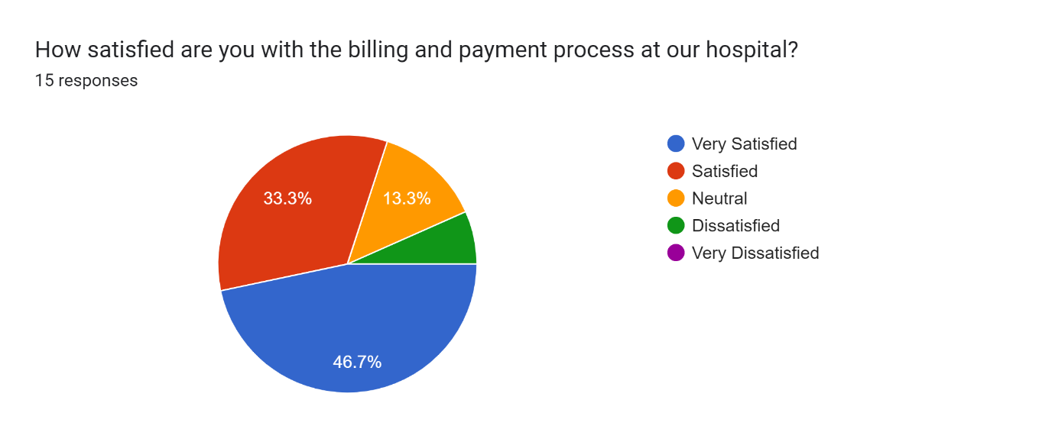

Interpretation:
Highly Satisfied: 46.7% respondents indicate they are highly satisfied, it suggests that they found the billing and payment process to be seamless, transparent, and easy to navigate. They likely experienced clear communication about charges, payment options, and any potential insurance coverage.
Satisfied: 33.3% have suggested that while there may have been minor issues or areas for improvement, overall, the billing and payment process met the respondent's expectations. They likely encountered few obstacles or frustrations and were generally content with the clarity and ease of the process. However, there may still be room for enhancements to further streamline the process and improve customer experience.
Neutral: 13.3% neutral response could indicate that the billing and payment process neither exceeded nor fell short of expectations. Respondents may have found the process to be functional but unremarkable, with no significant positive or negative experiences to highlight. This response could also suggest a lack of strong feelings or a limited understanding of the billing process.
Dissatisfied: 6.7% Dissatisfaction suggests that respondents encountered significant issues or frustrations with the billing and payment process. This could include difficulties understanding charges, confusion regarding insurance coverage, long wait times for assistance, errors in billing, or other issues that impacted their experience negatively. Dissatisfied respondents may feel that the process was overly complex, opaque, or unfair.

Chart No : 2
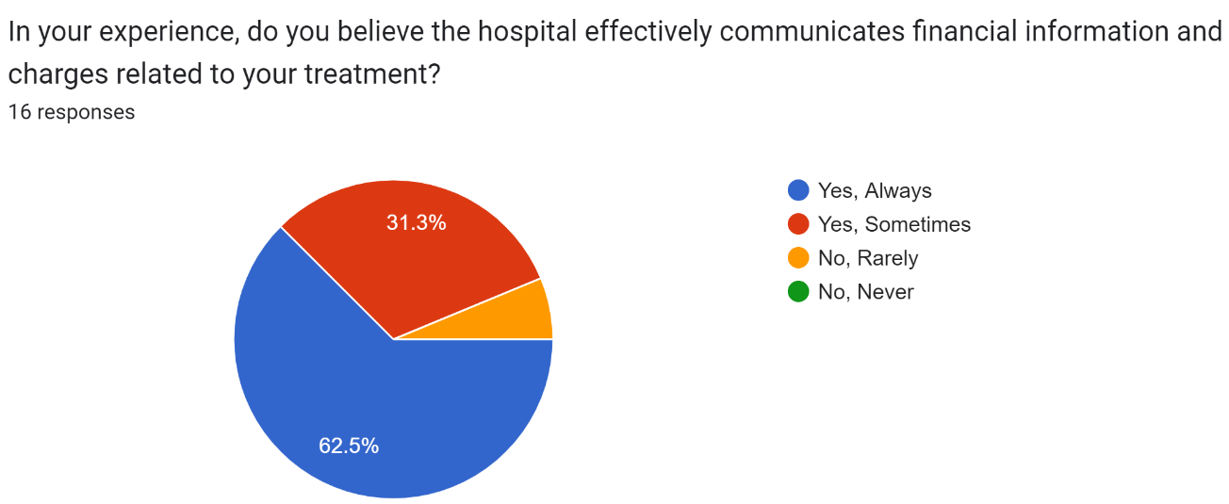
Interpretation:
62.5% of respondent believes the hospital consistently communicates financial information and charges related to their treatment effectively. They likely feel well-informed and satisfied with the clarity and transparency of the hospital's communication in this regard.
31.3% of respondent acknowledges that the hospital communicates financial information and charges related to their treatment adequately on certain occasions. However, there may be instances where communication is lacking or unclear, leading to occasional dissatisfaction or uncertainty.
6.3% of respondent feels the hospital rarely effectively communicates financial information and charges related to their treatment. They may perceive a significant lack of transparency or clarity in the hospital's communication efforts, resulting in frustration or dissatisfaction with the level of information provided.

Chart No : 3
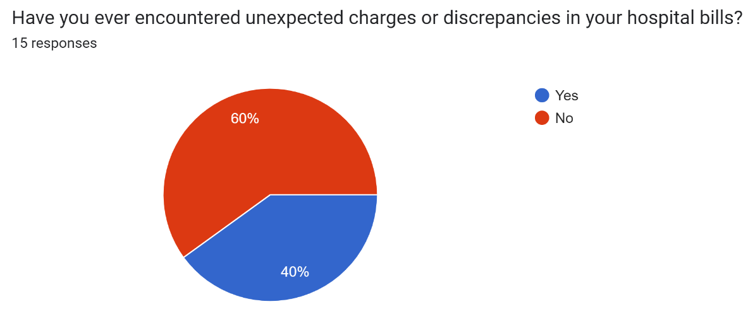
Interpretation:
40% of the respondent has encountered unexpected charges or discrepancies in their hospital bills at some point. They may have noticed charges that they didn't anticipate or discrepancies between what they expected to pay and what was actually billed.
40% of the respondent has not experienced any unexpected charges or discrepancies in their hospital bills. They may have found their bills to be accurate and in line with their expectations, without any surprises or inconsistencies.
Chart No 4

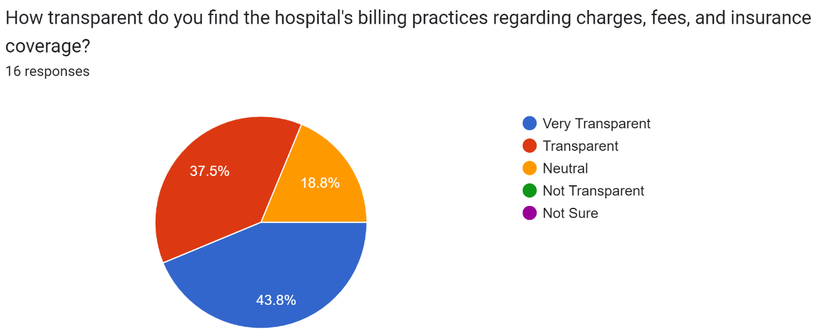
Interpretation:
43.8% of the respondent perceives the hospital's billing practices as highly transparent. They likely feel well-informed and confident about understanding the charges, fees, and insurance coverage associated with their healthcare services. They may appreciate clear explanations and documentation provided by the hospital.
37.5% of the respondent finds the hospital's billing practices to be generally transparent. They may feel adequately informed about most charges, fees, and insurance coverage aspects, although there may be occasional areas where clarity could be improved.
18.8% of response indicates a neutral stance regarding the transparency of the hospital's billing practices. The respondent neither perceives the practices as particularly transparent nor particularly opaque. They may not have strong feelings or experiences to sway their opinion in either direction.

Chart No :5
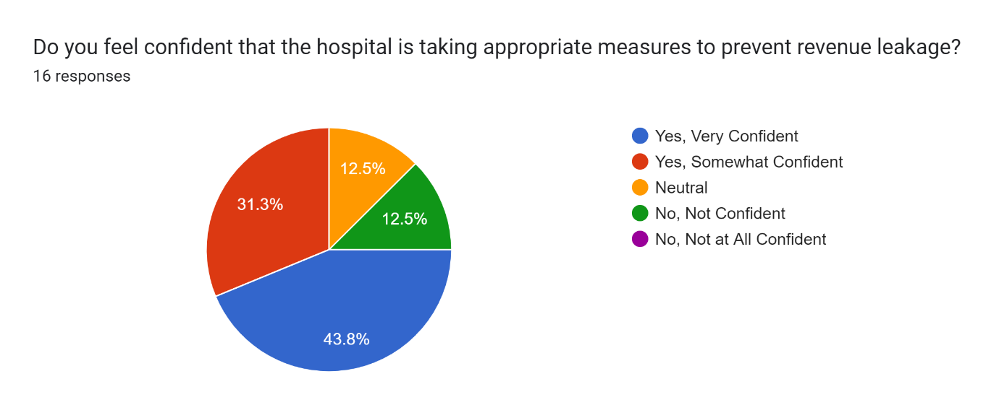
Interpretation:
43.8% of the respondent feels highly confident in the hospital's measures to prevent revenue leakage. They likely believe that the hospital has robust systems and procedures in place to minimize financial losses and ensure that all revenues are properly captured. They may trust the hospital's ability to effectively manage its finances.
31.3% of the respondent is somewhat confident in the hospital's efforts to prevent revenue leakage. They may have some trust in the hospital's processes but may also harbor some doubts or concerns about the effectiveness of these measures. They may feel that improvements could be made in certain areas.
12.5% of response indicates a neutral stance regarding confidence in the hospital's measures to prevent revenue leakage. The respondent neither feels particularly confident nor lacks confidence in the hospital's efforts. They may not have sufficient information or experiences to form a strong opinion on the matter.
12.5% of the respondent lacks confidence in the hospital's measures to prevent revenue leakage. They may have significant doubts about the effectiveness of the hospital's systems and procedures in capturing all revenues and minimizing financial losses. They may feel that the hospital needs to improve its practices in this area.
Chart no: 6
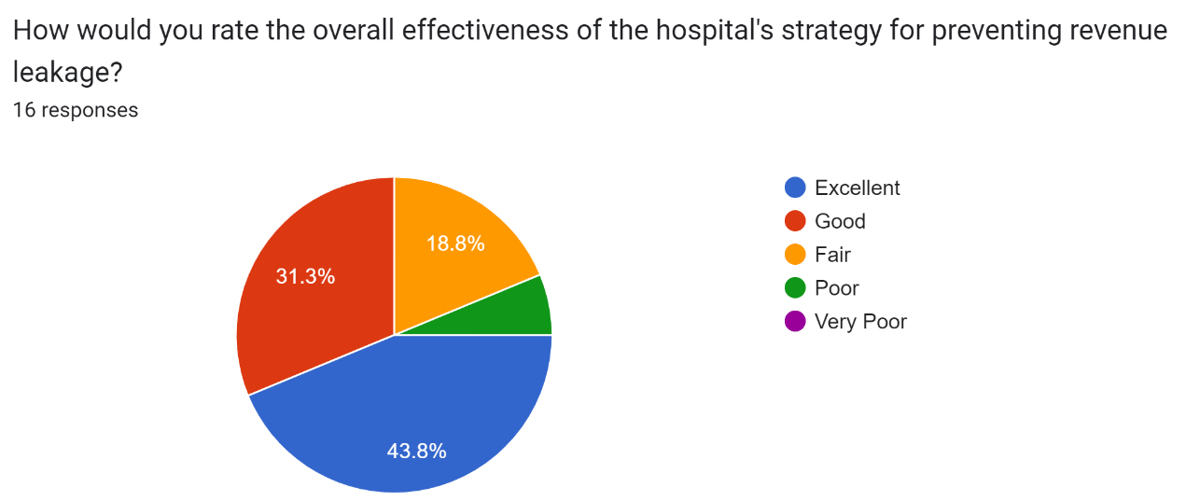
Interpretation:
43.8% of the respondent believes the hospital's strategy for preventing revenue leakage is outstanding in its effectiveness. They likely perceive the hospital's measures as highly successful, with minimal financial losses and a robust system in place to capture all revenues. They may view the hospital as a leader in this aspect of financial management.
31.3% of the respondent considers the hospital's strategy for preventing revenue leakage to be effective overall. They may believe that the hospital has solid processes and procedures in place to minimize financial losses, although there may be some areas where improvements could be made.
18.8% of the respondent views the hospital's strategy for preventing revenue leakage as average or acceptable but with room for improvement. They may feel that while the hospital has some measures in place, there are significant gaps or weaknesses that need to be addressed to enhance effectiveness.
6.3% of the respondent perceives the hospital's strategy for preventing revenue leakage as largely ineffective. They may believe that the hospital's current measures are insufficient or poorly implemented, resulting in significant financial losses or missed revenue opportunities.

Chart no: 7
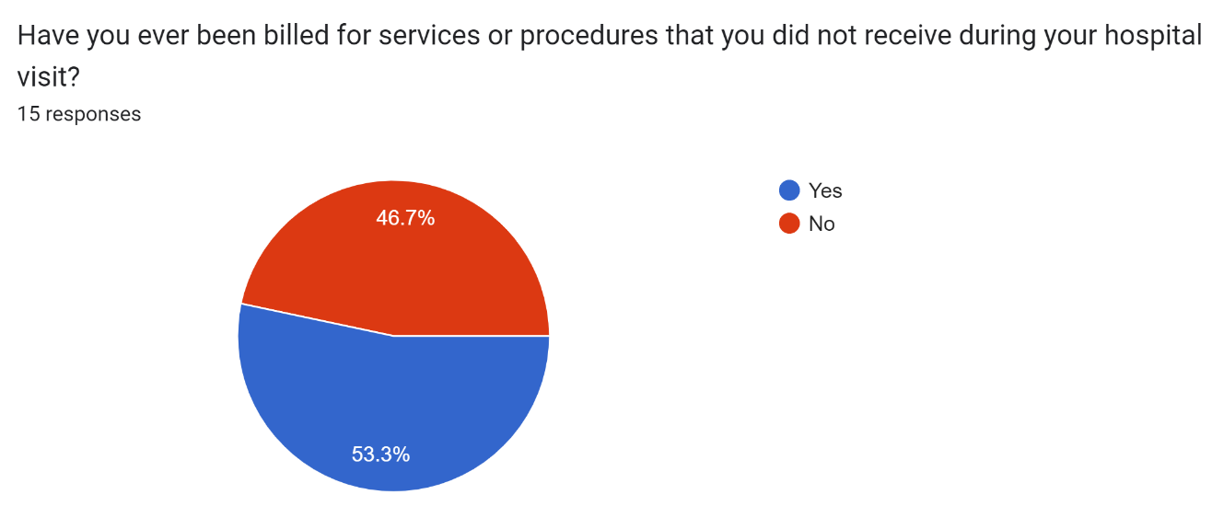
Interpretation:
53.3% of the respondent has experienced being billed for services or procedures that they did not actually receive during their hospital visit. They may have noticed inaccuracies in their bill or charges for treatments they did not undergo, which could indicate billing errors or discrepancies.
46.7% of the respondent has not been billed for any services or procedures they did not receive during their hospital visit. They may have found their bills to accurately reflect the services they received, without any instances of being charged for treatments they did not undergo.

Chart no:8
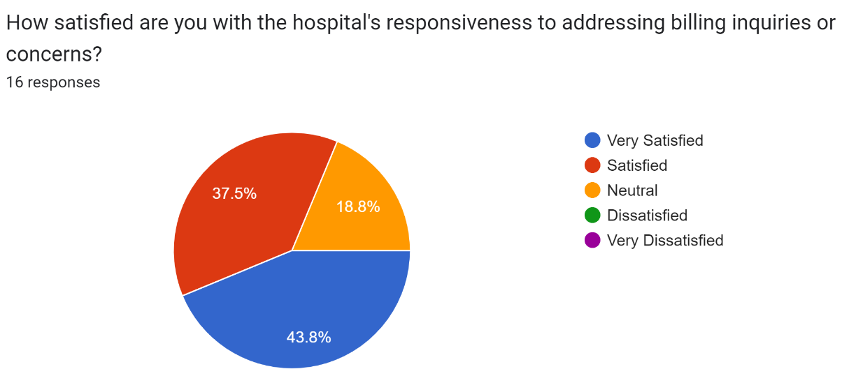
Interpretation:
43.8% of the respondent is highly satisfied with the hospital's responsiveness to addressing billing inquiries or concerns. They likely feel that the hospital promptly and effectively addresses any questions or issues they have regarding their bills. They may have had positive experiences with the hospital's billing staff or customer service representatives.
37.5% of the respondent is generally satisfied with the hospital's responsiveness to addressing billing inquiries or concerns. While they may not consider the hospital's performance perfect, they feel that their inquiries or concerns are adequately addressed in a timely manner, leading to overall satisfaction.
18.8% of responses indicates a neutral stance regarding satisfaction with the hospital's responsiveness to addressing billing inquiries or concerns. The respondent neither feels particularly satisfied nor dissatisfied with the hospital's performance in this regard. They may not have strong feelings or experiences to sway their opinion in either direction.

Chart no: 9
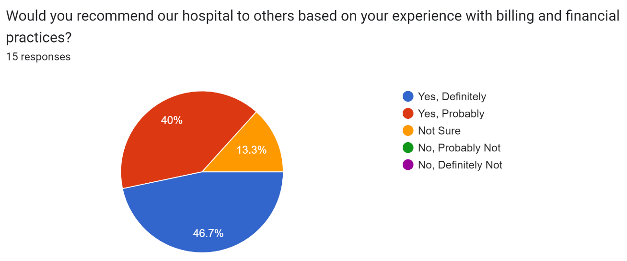
Interpretation:
46.7 of the respondent is highly likely to recommend the hospital to others based on their positive experience with billing and financial practices. They likely feel confident in the hospital's transparency, accuracy, and responsiveness regarding billing matters and believe that others would benefit from similar positive experiences.
40% of the respondent is inclined to recommend the hospital to others based on their generally positive experience with billing and financial practices. While they may not feel as strongly as those who selected "Yes, Definitely," they still believe that the hospital's billing practices are satisfactory and would likely warrant a recommendation.
13.3% of responses indicates uncertainty on the part of the respondent regarding whether they would recommend the hospital to others based on their experience with billing and financial practices. They may not have formed a clear opinion or may not feel confident enough in their experience to make a recommendation

FINDINGS :

What are the reasons behind price overrides in hospitals, and what measures can be taken to prevent them?

Price overrides in hospitals can occur due to a variety of reasons, each presenting unique challenges to accurate billing. One common cause is coding errors, where mistakes in assigning diagnosis or procedure codes lead to incorrect charges. These errors can arise from human oversight or lack of training among billing and coding staff. Additionally, the complexity of hospital billing systems contributes to overrides, with numerous rates, discounts, and negotiated prices that can be prone to errors or omissions. Discrepancies in negotiated rates with insurers further exacerbate the issue, as outdated or improperly recorded rates can result in incorrect billing amounts. Moreover, uninsured or underinsured patients often require price overrides due to charity care or financial assistance programs, highlighting the importance of clear policies and eligibility criteria in such cases. Out-of-network provider services within hospitals pose another challenge, as billing for these services may not always align with standard procedures, leading to overrides if not managed effectively. Finally, non-compliance with healthcare regulations and billing requirements can trigger penalties or fines, necessitating price overrides to rectify errors and ensure compliance.

To prevent price overrides, hospitals can implement several measures to enhance billing accuracy and efficiency. Regular training and education programs for billing and coding staff can help mitigate coding errors by promoting adherence to best practices and industry standards. Streamlining billing systems with automated validation processes can reduce the likelihood of errors associated with complex billing structures, ensuring that negotiated rates are accurately reflected in billing records. Furthermore, establishing clear processes for updating negotiated rates and conducting regular audits of billing practices can help identify and rectify discrepancies before they lead to overrides. Implementing transparent policies for charity care and financial assistance programs can also help ensure that eligible patients receive the appropriate support without necessitating price overrides. Improved communication and coordination between in-network and out-of-network providers can facilitate more accurate billing for services rendered by non-affiliated providers within the hospital. By implementing these proactive measures, hospitals can minimize errors and discrepancies in billing practices, ultimately enhancing overall financial integrity and patient satisfaction.

What factors contribute to the higher incidence of revenue leakage in hospital consumables, and what strategies can be implemented to mitigate this issue ?
The higher incidence of revenue leakage in consumables within the hospital setting can be attributed to several factors. Firstly, consumables are often used on a daily basis in large quantities, making it easier for discrepancies to go unnoticed amidst the volume of transactions. The nature of consumables, such as syringes, catheters, and nebulizer kits, makes them prone to misplacement, improper recording, or even unauthorized use, leading to potential revenue loss. The fast-paced and demanding environment of healthcare facilities can contribute to oversight or errors in documenting and billing for consumable items.

Secondly, the transient nature of consumables presents challenges in monitoring their usage accurately. These items are often single-use or disposable, making them more susceptible to misplacement, waste, or unauthorized use. Additionally, the decentralized nature of consumable management, with multiple departments and staff members involved in procurement, distribution, and usage, further complicates the tracking process and increases the risk of revenue leakage. To address and mitigate revenue leakage in consumables, hospitals can implement a multifaceted approach. Firstly, investing in advanced inventory management systems equipped with barcode scanning and real-time tracking capabilities can enhance visibility and control over consumable usage. These systems can automate inventory replenishment, flag discrepancies, and generate accurate billing records, reducing the likelihood of errors and leakage. Instituting stringent documentation protocols and standardized billing procedures can help ensure that all consumable items used in patient care are properly recorded and billed for. This may involve implementing electronic medical record systems integrated with billing software to streamline documentation and billing processes, thereby minimizing human error and oversight.

To mitigate revenue leakage in consumables, hospitals can implement several strategies. Firstly, enhancing inventory management systems can help track the usage of consumables more accurately, ensuring that each item is properly accounted for and billed accordingly. Regular audits of consumable stock levels and usage patterns can also help identify discrepancies and prevent potential revenue leakage. Secondly, implementing robust documentation processes, including real-time recording of consumable usage and charges, can minimize billing errors and ensure that all services provided are properly billed for. Furthermore, staff training and education programs can raise awareness about the importance of accurate billing practices and the potential impact of revenue leakage on the hospital's financial health. By implementing these measures, hospitals can strengthen their revenue management processes and reduce the incidence of leakage in consumables, ultimately improving financial performance and sustainability.

By implementing these measures, hospitals can strengthen their revenue management practices, reduce leakage in consumables, and safeguard their financial integrity while maintaining high standards of patient care.

What factors contribute to the higher incidence of revenue leakage in in-patient departments within hospitals compared to outpatient settings?
Revenue leakage within in-patient departments of hospitals often occurs due to a confluence of factors that distinguish these departments from outpatient settings. Firstly, the nature of in-patient services is inherently more complex. Patients admitted to in-patient departments typically require more intensive medical interventions, including surgeries, specialized treatments, and continuous monitoring. This complexity can lead to a higher likelihood of errors in coding, documentation, and billing, ultimately resulting in revenue leakage.

Moreover, in-patient departments tend to handle a higher volume of transactions compared to outpatient departments. The sheer volume of activities, coupled with the fast-paced environment and the urgency of patient care, can make it challenging to effectively track and manage revenue. This increases the risk of overlooking charges, under coding services, or inaccurately documenting patient encounters, all of which can contribute to revenue leakage.

Another contributing factor is the complexity of insurance reimbursement processes for in-patient services. Patients admitted to in-patient departments often have multiple insurance providers or government payers, each with its own set of rules, guidelines, and reimbursement models. Navigating these complexities while ensuring accurate coding and billing can be daunting, leading to errors or discrepancies that result in revenue leakage.
The length of stay for in-patients adds another layer of complexity to revenue management. Patients may experience changes in their condition, adjustments to their treatment plan, or extended hospital stays, all of which can impact billing accuracy. Careful monitoring and coordination are essential to capture all billable services and ensure accurate billing, but challenges in care coordination can lead to missed charges or billing errors, further exacerbating revenue leakage.

In-patient departments require significant resources, including staff, medical supplies, and equipment, to deliver comprehensive care. Inadequate resource allocation or inefficient resource utilization can impact revenue generation. For example, if resources are not effectively allocated to high-revenue-generating services or if equipment downtime leads to delays in patient care, it can result in missed revenue opportunities and contribute to revenue leakage.

Overall, the complexity, volume, and regulatory intricacies associated with in-patient services create inherent challenges in revenue management. Hospitals must implement robust processes, invest in training and technology, and foster a culture of accountability to minimize revenue leakage and optimize financial performance in in-patient departments.

What are the reasons contributing to Permanent Revenue loss if not identified in hospitals?

Permanent revenue loss if not identified in hospitals can occur due to a variety of factors that hinder accurate billing and revenue capture. One significant reason is missed charges, where billable services provided to patients are not properly recorded or billed. This may stem from oversight, incomplete documentation, or inefficiencies in charge capture processes, leading to revenue leakage that cannot be recouped once the opportunity is missed. Additionally, coding errors contribute to permanent revenue loss if not identified and corrected promptly. Inaccurate coding of diagnoses, procedures, or services can result in underbilling or overbilling, impacting the hospital's revenue stream. Incomplete documentation further exacerbates the issue, as inadequate recording of patient encounters or treatments may lead to services going unbilled. Delays in charge capture, whether due to administrative inefficiencies or system errors, also contribute to revenue loss, as billable services remain unrecorded for extended periods. Non-compliance with billing regulations and payer contracts can result in denied claims, penalties, or fines, further reducing revenue. Unbilled services represent missed revenue opportunities that compound over time, leading to permanent revenue loss if not identified and rectified.

To mitigate these risks, hospitals must implement robust revenue assurance processes, including regular audits, staff training, documentation improvement initiatives, and technology solutions to enhance charge capture accuracy and compliance. By addressing these factors proactively, hospitals can minimize permanent revenue loss and ensure financial sustainability in an increasingly complex healthcare landscape.

RECOMMENDATION :
The underlying causes of revenue leakage within the hospital system at Manipal Hospital, several recommendations have been formulated to address the identified challenges and enhance revenue management practices.
- Enhance Staff Training and Education: Develop comprehensive training programs for hospital staff involved in coding, documentation, and billing processes. Ensure that staff members are well-versed in coding guidelines, billing regulations, and insurance reimbursement procedures to minimize errors and discrepancies.
- Invest in Technology Solutions: Leverage advanced technology such as automated billing systems, electronic health records (EHRs), and revenue cycle management software to streamline revenue management processes. Automation can improve accuracy, efficiency, and productivity while reducing the risk of errors.
- Improve Care Coordination: Implement standardized protocols for communication and collaboration among multidisciplinary care teams to ensure accurate capture of billable services and timely billing. Foster a culture of collaboration and accountability to enhance care coordination practices.
- Conduct Regular Audits and Reviews: Establish a structured audit program to routinely monitor coding accuracy, documentation completeness, and billing compliance. Conduct regular reviews of revenue management processes to identify and address potential areas of leakage proactively.
- Foster a Culture of Continuous Improvement: Encourage open communication, solicit feedback from staff, and prioritize a commitment to excellence in revenue management. Foster a culture of transparency, accountability, and continuous learning to facilitate ongoing process optimization and performance enhancement.

For Patient Satisfaction:
- Improving patient satisfaction begins with creating a simple and convenient appointment booking process.
- Quicker check-in for appointments and shorter wait times
- Easy and Practical Payment Methods
- Good relationships with the staff and doctors
- With the help of healthcare administrative partners, streamline your billing process

Patient surveys :
When you ask patients for feedback about your company it accomplishes alot of things:
- It gives unhappy patients a chance to voice their frustration in words rather than deeds.
- It demonstrates to patients your dedication to their satisfaction.
- It reinforces positive thoughts about your company for anyone that gives you top reviews.

CONCLUSION :
In conclusion, the study on investigating the underlying causes of revenue leakage in hospital systems sheds light on a critical issue facing healthcare institutions worldwide. Through meticulous analysis and examination of various factors, including billing processes, coding errors, documentation deficiencies, and regulatory compliance, the research underscores the multifaceted nature of revenue leakage. By identifying and addressing these underlying causes, hospitals can optimize revenue streams, enhance financial sustainability, and improve overall operational efficiency. Moreover, the findings of this study underscore the importance of implementing robust revenue management strategies, leveraging technology solutions, and fostering a culture of accountability and continuous improvement within hospital systems. Ultimately, mitigating revenue leakage not only benefits the financial health of hospitals but also ensures that resources are allocated effectively to support the delivery of high-quality patient care.
P

