A STUDY ON MACHINE LEARNING BASED PREDICTIVE ANALYTICS FOR EARLY DETECTION OF STROKE IN SENIOR CITIZENS
Mr. Kamalesh A, Student and Mrs. B. Lakshmi, Assistant Professor
Department of Management Studies,
Panimalar Engineering College, Chennai.

ABSTRACT

This study investigates the application of machine learning (ML) models for the early detection of stroke in senior citizens, a critical challenge given the high morbidity and mortality associated with stroke. Utilizing Logistic Regression, Gradient Boosting, and XGBoost, we aim to develop predictive analytics that can accurately identify early signs of stroke from medical datasets. The models were trained on various health indicators pertinent to stroke risk in the elderly, such as blood pressure, cholesterol levels, and previous medical history. Our evaluation focuses on the models' accuracy, sensitivity, and specificity, showcasing their potential to transform stroke diagnostics and prevention strategies for aging populations.
Keywords: Stroke, Early detection, Machine learning, Senior citizens.

INTRODUCTION
Stroke stands as a formidable challenge in geriatric healthcare, representing one of the leading causes of disability and mortality among the elderly. The rapid response required for effective stroke treatment underscores the critical need for early detection, which can significantly alter clinical outcomes. In light of this, our study employs cutting-edge machine learning technologies—Logistic Regression, Gradient Boosting, and XGBoost—to pioneer predictive models capable of identifying precursors to stroke events in senior populations. By analyzing extensive datasets that include variables like blood pressure, cholesterol levels, and historical medical data, these models aim to uncover subtle patterns indicative of stroke risk.
Moreover, the integration of these advanced computational techniques offers the potential to revolutionize the preventative strategies employed in elderly care. By providing healthcare professionals with robust tools for risk assessment, the project facilitates a shift from reactive to proactive medical practices. This proactive approach is essential not only for optimizing treatment plans but also for enabling interventions that can prevent the occurrence of strokes altogether. With the aging global population, enhancing stroke prevention in this demographic is becoming increasingly urgent. Through this research, we seek to contribute to a foundational change in how stroke risk is managed in the elderly, aiming to extend healthy life years and reduce the burden on healthcare systems.

OBJECTIVES
Primary Objective:
- Develop and validate machine learning models that can predict the early onset of stroke in senior citizens using comprehensive health data.
Secondary Objectives:
- Compare the performance of Logistic Regression, Gradient Boosting, and XGBoost in terms of their predictive accuracy and reliability.
- Identify and analyse the key health indicators most predictive of stroke risk among the elderly.
- Optimize model parameters to enhance prediction accuracy and ensure robustness in diverse clinical settings.
REVIEW OF LITERATURE
Nojood Alageel, Rahaf Alharbi, Rehab Alharbi, Maryam Alsayil, Lubna A. Alharbi January 2023, Using Machine Learning Algorithm as a Method for Improving Stroke Prediction
The impact of strokes on society has prompted efforts to improve stroke diagnosis and management. This research focuses on enhancing stroke prediction based on electronic health records, identifying critical factors like age, average glucose level, heart disease, and hypertension. Using a balanced dataset, seven machine learning algorithms were implemented: Naïve Bayes, SVM, Random Forest, KNN, Decision Tree, Stacking, and majority voting. Evaluation metrics including accuracy, f1 score, recall, and precision were used. While most algorithms achieved high accuracy (96%) and similar performance metrics, Naïve Bayes exhibited lower accuracy (86%) and slightly inferior performance. Therefore, it may not be the optimal choice for stroke prediction compared to other algorithms.

Nitish Biswas, Khandarker Mohammad Mohi Uddin, Sarreha Tasmin Rikta, Samrat Kumar Dey, November 2022, A comparative analysis of machine learning classifiers for stroke prediction: A predictive analytics approach
This study proposes a machine learning approach to enhance stroke diagnosis, focusing on imbalanced data. Utilizing the Random Over Sampling (ROS) technique, eleven classifiers are analyzed, with four achieving over 96% accuracy post data-balancing. Support Vector Machine and Random Forest attain the highest accuracies at 99.99% and 99.87% respectively. Hyperparameter tuning and cross-validation optimize model performance, assessed using metrics such as Accuracy, F1-Measure, Precision, and Recall. A user-friendly web and mobile app are developed based on the most accurate model for easy access to stroke prediction.

Soumyabrata Dev, Hewei Wang, Chidozie Shamrock Nwosu, Nishtha Jain, Bharadwaj Veeravalli, Deepu Johm, November 2022, A predictive Analytics approach for stroke prediction using machine learning and neural networks
This paper explores the impact of stroke on society and the importance of improving stroke management and diagnosis. It highlights the synergy between technology and medical care, emphasizing the role of mining and archiving patients' medical records for better management. The study systematically analyzes electronic health records to identify key factors for stroke prediction, concluding that age, heart disease, average glucose level, and hypertension are crucial. A perceptron neural network using these factors achieves high accuracy and low miss rates. The analysis involves feature correlation, stepwise feature selection, and principal component analysis, revealing the importance of these factors in stroke prediction. However, limitations include the lack of discriminatory features and dataset size. Future work aims to integrate electronic health records with additional datasets using Semantic Web technologies to improve stroke prediction accuracy.

Elias Dritsas and Maria Trigka, July 2022, Stroke Risk Prediction with Machine Learning Techniques
This research focuses on designing a robust framework for long-term stroke risk prediction using machine learning (ML). Multiple ML models were developed and evaluated, with a stacking method demonstrating superior performance, achieving an AUC of 98.9%, F-measure, precision, and recall of 97.4%, and an accuracy of 98%. The study emphasizes the importance of early stroke prediction to mitigate severe consequences and highlights ML's potential in this area. Future research aims to enhance the ML framework with deep learning methods and explore the predictive ability of deep learning models using brain CT scan image data.

Tahia Tazin, Md Nur Alam, Nahian Nakiba Dola, Mohammad Sajibul Bari, Sami Bourouis, and Mohammad Monirujjaman Khan, November 2021, Stroke Disease Detection and Prediction Using Robust Learning Approaches
Stroke, a critical medical condition resulting from ruptured blood arteries in the brain, poses a significant global health threat, according to the World Health Organization (WHO). Early recognition of stroke warning signs is crucial for reducing its severity. This research employs various machine learning (ML) models, including Logistic Regression, Decision Tree Classification, Random Forest Classification, and Voting Classifier, to predict stroke occurrence based on physiological parameters. Among these, Random Forest exhibited the highest accuracy at approximately 96 percent, surpassing previous studies' performance. The study utilized the Stroke Prediction dataset for model development and validation. The effectiveness of ML algorithms in stroke prediction was thoroughly investigated, with Random Forest emerging as the top-performing method. The study suggests potential enhancements using larger datasets and other ML models like AdaBoost, SVM, and Bagging to improve the framework's reliability and performance. Ultimately, leveraging machine learning can empower the general public to assess stroke risk and seek early intervention, potentially mitigating the severe consequences of this life-threatening condition and facilitating post-stroke recovery.

RESEARCH METHODOLOGY
This study presents a holistic approach to predicting various health conditions prevalent among senior citizens, aiming to enhance healthcare management and early intervention strategies. The methodology is structured into three distinct phases: pre-processing, training, and classification. Each phase is meticulously designed to ensure the robustness and effectiveness of the predictive models.

1. PRE-PROCESSING PHASE
The pre-processing phase plays a crucial role in preparing the raw data for model training and evaluation. It involves several key steps:
Data Collection: The data is sourced from the Open-source Senior care dataset, comprising diverse health-related attributes, medical history, lifestyle factors, and demographic information of senior citizens aged above 60 years. The data collection process ensures compliance with ethical standards and privacy regulations, with informed consent obtained from all participants.
Data Cleaning: Raw data often contains inconsistencies, missing values, and outliers that can adversely affect model performance. In this phase, rigorous data cleaning techniques are applied to address these issues. Missing values are imputed using appropriate strategies such as mean, median, or mode imputation. Outliers are identified and either removed or treated based on domain knowledge.
Feature Engineering: Feature engineering involves transforming raw data into informative features that capture relevant patterns and relationships. This may include creating new features, encoding categorical variables, and scaling numerical features to a common range. Techniques such as one-hot encoding, label encoding, and standardization are applied to ensure compatibility with different modelling algorithms.
Data Partitioning: The pre-processed dataset is divided into training and test sets using stratified sampling to preserve the class distribution. Approximately 80% of the data is allocated for training the models, while the remaining 20% is reserved for independent evaluation. This partitioning strategy helps assess the generalization performance of the models on unseen data.

2. TRAINING PHASE:
In the training phase, a diverse ensemble of machine learning and deep learning models is employed to build predictive algorithms for the targeted health conditions. The models selected for training include:
Logistic Regression: A classical linear model used for binary classification tasks. It models the probability of a binary outcome using a logistic function, making it suitable for predicting disease onset based on input features.
$P\left(Y=1 | X\right)=\frac{1}{1+e-(β0​+β1​X1​+β2​X2​+...+βn​Xn​)}$
Where:
P(Y=1∣X) is the probability of the positive class given the input features X.
β0,β1,...,βn​ are the coefficients of the logistic regression model.
X1,X2,...,Xn​ are the input features.
XGBoost and Gradient Boosting: Ensemble learning techniques that combine multiple weak learners (decision trees) to create a strong predictive model. XGBoost and Gradient Boosting algorithm iteratively improve the performance of the model by minimizing a predefined loss function, resulting in highly accurate predictions.
Each model is trained on the pre-processed training data using specific algorithms tailored to its characteristics. Hyperparameters such as learning rate, regularization strength, tree depth, and number of neurons in hidden layers are fine-tuned through grid search or random search to optimize performance and prevent overfitting.

3. CLASSIFICATION PHASE:
The classification phase involves evaluating the trained models on the independent test dataset to assess their predictive performance. The following performance metrics are calculated for each model:
Accuracy: The proportion of correctly classified instances out of the total instances.
Precision: The proportion of true positive predictions out of all positive predictions made by the model.
Recall: The proportion of true positive predictions out of all actual positive instances in the dataset.
F1-score: The harmonic mean of precision and recall, providing a balanced measure of the model's accuracy.
The outputs of each model are analyzed comprehensively to identify strengths, weaknesses, and areas for improvement. Model interpretability and feature importance are also assessed to gain insights into the underlying factors contributing to disease prediction.

4. PERFORMANCE EVALUATION:
When evaluating the performance of classification models, particularly in scenarios with imbalanced datasets, relying solely on metrics like accuracy can be insufficient. This is because accuracy does not consider the distribution of classes and may not adequately capture the model's true effectiveness. One widely used tool for assessing classification results is the confusion matrix, which provides a detailed breakdown of the model's predictions. The matrix contains four quadrants representing True Positive (TP), True Negative (TN), False Positive (FP), and False Negative (FN) predictions. From this matrix, various performance metrics can be derived to assess different aspects of the model's performance.
Some of the key performance metrics include precision, recall (sensitivity), F1-score, and the Receiver Operating Characteristic (ROC) curve. Precision measures the proportion of correctly predicted positive cases among all predicted positive cases, while recall calculates the proportion of correctly predicted positive cases among all actual positive cases. The F1-score is the harmonic mean of precision and recall, providing a balanced measure of a model's performance. The ROC curve plots the true positive rate against the false positive rate at various threshold settings, offering insights into the model's discrimination ability across different thresholds.
These metrics collectively offer a more nuanced understanding of a classifier's performance, allowing researchers and practitioners to make informed decisions about model selection, parameter tuning, and deployment strategies.
$$Accuracy = \frac{TP+TN}{TP+FP+FN+TN}$$
$$F1-score =2 \frac{precision*recall}{precision+recall}$$
$$Recall =\frac{TP}{TP+FP}$$
$$Precision= \frac{TP}{TP+FN}$$

EXPERIMENTAL EVALUATION:
The experimental evaluation of the predictive models is conducted in a Jupyter notebook environment, leveraging cloud-based computing resources for scalability and efficiency. Data science libraries such as TensorFlow, Scikit-learn, Pandas, and NumPy are utilized for data manipulation, model development, evaluation, and visualization. The experiments are designed to validate the efficacy of the proposed methodology in accurately predicting health conditions among senior citizens. Various performance metrics, visualizations, and comparative analyses are employed to assess the robustness and generalization capabilities of the predictive models.
DATA COLLECTION:
The data utilized in this project is sourced from Open-Source Senior care dataset, encompassing a diverse range of health-related attributes and demographic information. The dataset is collected with the consent of the participants and adheres to strict privacy and ethical guidelines. It includes information on medical history, lifestyle factors, physiological parameters, diagnostic tests, and medication usage, providing a comprehensive overview of the health status of senior citizens.

TABLE 1
A SAMPLE OF STROKE PREDICTION DATASET
*Note: Here some data are Label Encoded
PAT_ID | GENDER | AGE | HYPERTENSION | HEART DISEASE | MARRIED | WORK TYPE | RESIDENCE TYPE | AVG GLUCOSE LEVEL | BMI | SMOKING STATUS | STROKE
1 | Male | 67 | 0 | 1 | Yes | Private | Urban | 228.69 | 36.6 | Formerly Smoked | 1
2 | Female | 61 | 0 | 0 | Yes | Self-employed | Rural | 202.21 | 37.8 | Never Smoked | 1
3 | Male | 80 | 0 | 1 | Yes | Private | Rural | 105.92 | 32.5 | Never Smoked | 1
4 | Female | 49 | 0 | 0 | Yes | Private | Urban | 171.23 | 34.4 | Smokes | 1
5 | Female | 79 | 1 | 0 | Yes | Self-employed | Rural | 174.12 | 24 | Never Smoked | 1
TABLE 2. DECODED VARIABLES
VARIABLES | INTERPRETATION
HYPERTENSION | Hypertension of the patient. It is a binary feature with two options  0: No Hypertension  1: Hypertension
HEART DISEASE | Heart Disease of the patient. It is a binary feature with two options  0: No Heart Disease  1: Heart Disease
STROKE | Stroke of the patient. It is a binary feature with two options  0: No Stroke  1: Stroke

Table 1 illustrates the Stroke Prediction data. Table 2 provides a comprehensive list of variables present in the Stroke Prediction dataset along with their descriptions. The dataset comprises a total of 5100 observations and 12 columns, making it substantial resource of stroke prediction research.
TABLE 3. DATASET SHAPE
Dataset | Shape
Training | (4080, 12)
Validation | (1020, 12)
Test | (1020, 12)

The dataset has been divided into three subsets for training, validation, and testing, with their respective shapes presented in Table 3. The training dataset comprises 4080 samples, each containing 12 features. Following the training phase, the model's performance will be assessed using the validation dataset, consisting of 1020 samples. This subset serves as an independent set to validate the model's performance and tune hyperparameters if necessary. Finally, the test dataset, also comprising 1020 samples, will be employed to evaluate the model's generalization ability on unseen data.
STROKE DISTRIBUTION
CHART 1. DISTRIBUTION OF GENDER
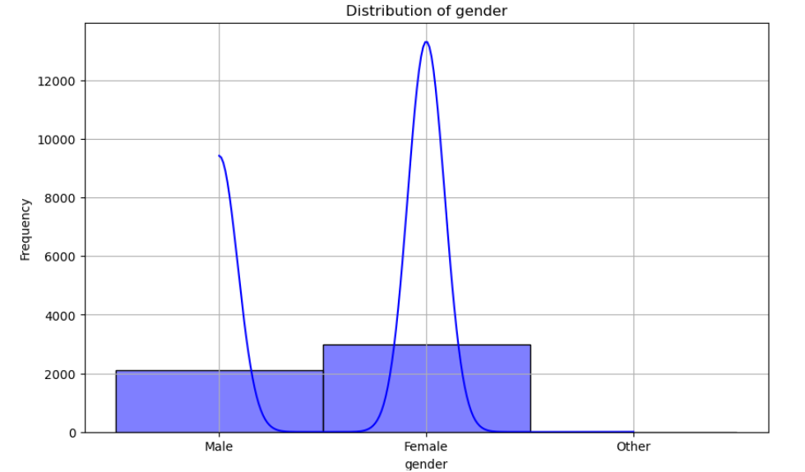

INTERPRETATION:
The histogram illustrates gender distribution in the dataset, with Female being the most prevalent, around 4000 occurrences, followed by Male with approximately 2000 instances. The Other category has minimal representation, barely visible on the chart. The density curve accentuates these distributions, showcasing a narrow peak for Male and a much sharper one for Female, indicating a significant concentration in this category. Such an imbalance in gender representation could introduce bias in stroke prediction outcomes, warranting adjustments in analysis to mitigate potential disparities.

CHART 2. DISTRIBUTION OF AGE
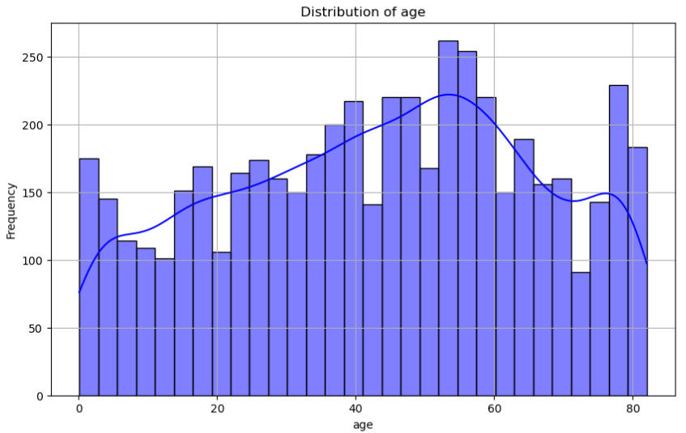

INTERPRETATION:
The age distribution in the dataset is depicted through a histogram, showcasing various age groups. The data appears generally uniform across age bins, with noticeable peaks. A prominent spike around age 0 suggests a substantial number of infants or newborns, while frequencies increase notably for ages above 60, with a slight rise around 80, indicating a significant presence of older individuals. The density curve illustrates the overall trend across ages, with a slight dip beyond 60 and a subsequent small rise, likely reflecting the presence of older individuals. This distribution implies a dataset encompassing diverse age groups, including infants, middle-aged, and seniors, which could influence stroke prediction models given age's established role as a risk factor.

C

CHART 3. DISTRIBUTION OF HYPERTENSION
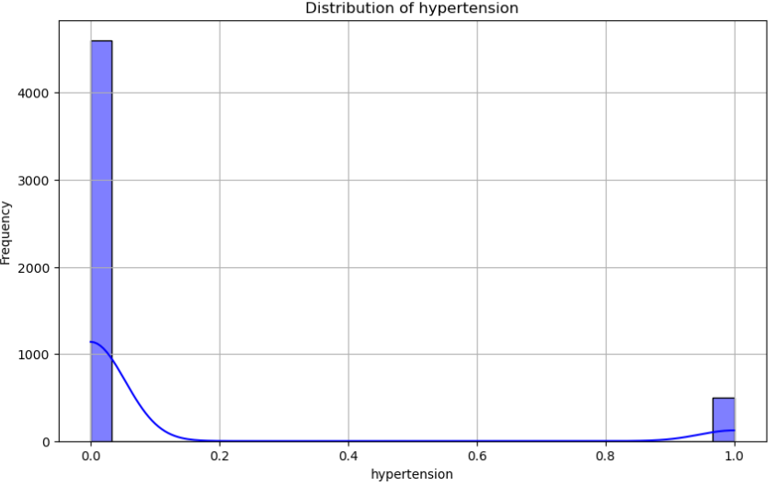

INTERPRETATION:
The chart displays the distribution of hypertension within the dataset. The histogram showcases frequencies for both absence (0) and presence (1) of hypertension, with a notable majority having a value of 0, indicating no hypertension. A smaller subset is represented by a value of 1, indicating the presence of hypertension. The dataset is characterized by a substantial difference between the two groups, with around 4500 instances of absence of hypertension and approximately 1000 instances of its presence. The density curve exhibits a sharp decline after the 0 value, indicating a highly skewed distribution, followed by a slight rise around 1, indicating a minority with hypertension. This suggests that while hypertension is present in the dataset, the majority do not have this condition, potentially impacting predictive modeling by necessitating methods to address class imbalance, particularly for conditions influenced by hypertension.

CHART 4. DISTRIBUTION OF HEART DISEASE
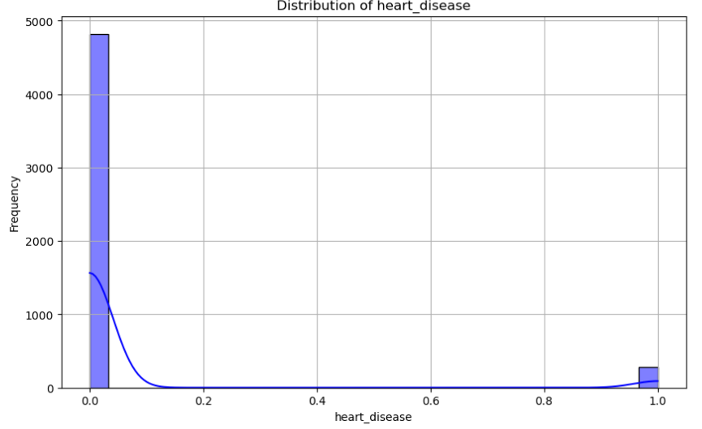

INTERPRETATION:
The chart illustrates the distribution of heart disease within the dataset. The histogram presents frequencies for both absence (0) and presence (1) of heart disease, with a prominent peak indicating a high frequency of individuals without heart disease (nearly 5000 instances). In contrast, the frequency for individuals with heart disease (1) is notably lower, with fewer than 500 instances. This disparity suggests a disproportionate representation of individuals without heart disease compared to those with it, potentially indicating a predominantly heart-healthy population or one where heart disease remains undiagnosed. The density curve demonstrates a steep decline after the 0 value, indicating a highly imbalanced distribution, with a slight rise around 1, representing a minority with heart disease. Given this class imbalance, it's crucial to address it when developing predictive models for stroke. Techniques like resampling or adjusting class weights may be necessary to mitigate the impact of imbalanced data on model performance.

CHART 5. DISTRIBUTION OF AVERAGE GLUCOSE LEVEL
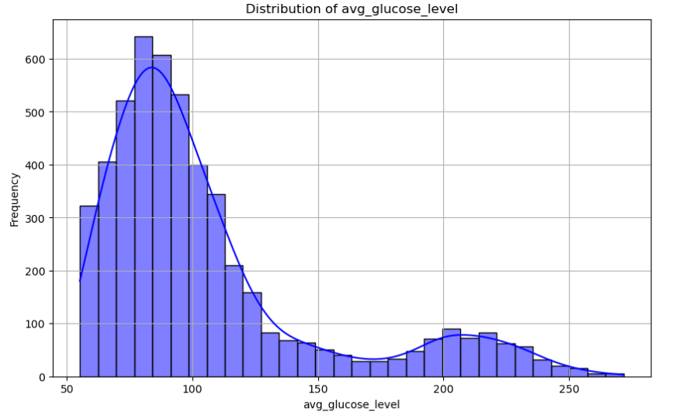

INTERPRETATION:
This chart displays the distribution of average glucose levels in your dataset. The histogram represents the frequency distribution of average glucose levels. The majority of data points fall in the range of around 70 to 150 mg/dL. The distribution is right-skewed, indicating that the majority of the dataset has glucose levels concentrated on the lower end. The highest frequency is around 600, which is seen for glucose levels between 80 and 100 mg/dL. There is a gradual decline in frequency as the glucose levels increase, with a noticeable drop beyond 150 mg/dL. There are still a significant number of individuals with glucose levels over 200 mg/dL, reflecting a possible diabetic condition. The density curve reflects the histogram pattern, showing a peak around 90 mg/dL and a tapering tail to the right. This suggests that high glucose levels are less common in the dataset. The insights from this chart imply that most individuals in the dataset have normal or moderately elevated glucose levels. A small percentage shows significantly high levels, which could influence the risk of developing health conditions like diabetes and possibly impact stroke prediction.

CHART 6. DISTRIBUTION OF BMI
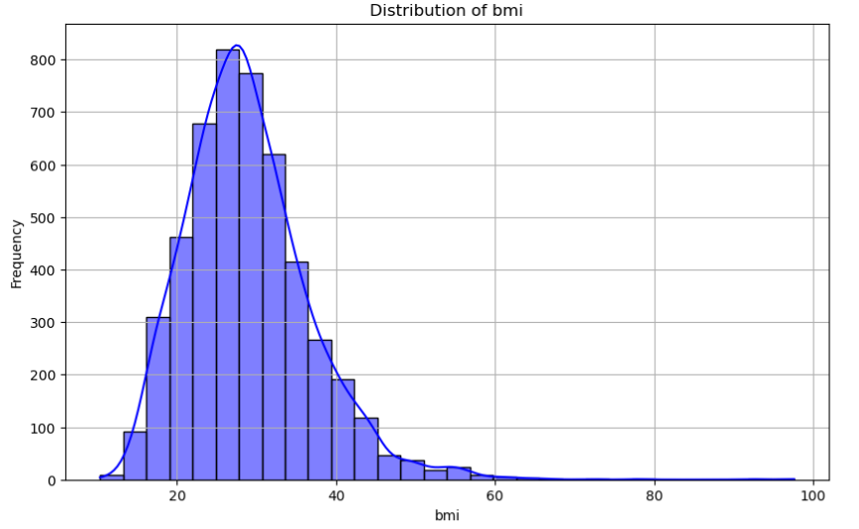

INTERPRETATION:
This chart displays the distribution of BMI (Body Mass Index) values in your dataset. The histogram represents the frequency distribution of BMI values. Most data points range from 15 to 40 kg/m². The distribution appears roughly normal, with the highest frequency around a BMI of 25 kg/m². The distribution has a slight skew to the right, suggesting more people have higher BMI values. Most of the dataset falls within the range of a BMI between 20 and 35 kg/m², with a small number of individuals exceeding 40 kg/m². The density curve supports the histogram pattern, showing a peak around 25 kg/m² and tapering off at higher BMI levels. There is a gradual decline in frequency towards the right, reflecting fewer individuals with extremely high BMI values. This distribution shows that most individuals have a BMI within the normal to overweight range (18.5-29.9 kg/m²). However, there is a noticeable presence of individuals with higher BMI values, indicating obesity or extreme obesity. This could have implications for stroke risk prediction, as high BMI is a known risk factor for cardiovascular issues.

CHART 7. DISTRIBUTION OF SMOKING STATUS
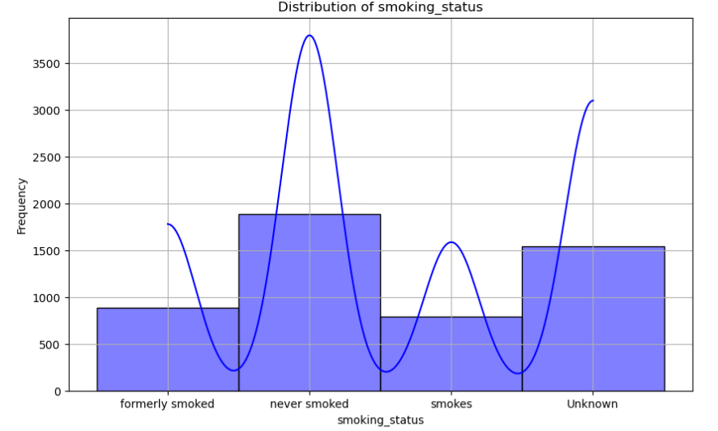

INTERPRETATION:
This chart depicts the distribution of smoking status in your dataset. The histogram shows the frequency distribution for the smoking status categories: Formerly smoked, never smoked, Smokes, and Unknown. The highest frequency is observed for the "Never smoked" category. Represents a significant group with a frequency close to 1500. Has the highest representation, with a frequency around 3500. A smaller group, with a frequency below 1000. Represents a considerable portion, similar to the Formerly smoked group. The density curve peaks at the Never smoked category, which has the highest count. There is a dip for the Smokes category, indicating relatively fewer current smokers. The curve rises again for the Unknown category, indicating a significant portion of the data where smoking status isn't known. The distribution shows that most individuals in the dataset have never smoked. However, there is also a significant group of people whose smoking status is unknown, which might require further investigation. Smoking status is a known risk factor for stroke, so this information could be important for predictive modeling, and the Unknown group should be handled carefully.

CHART 8. DISTRIBUTION OF STROKE
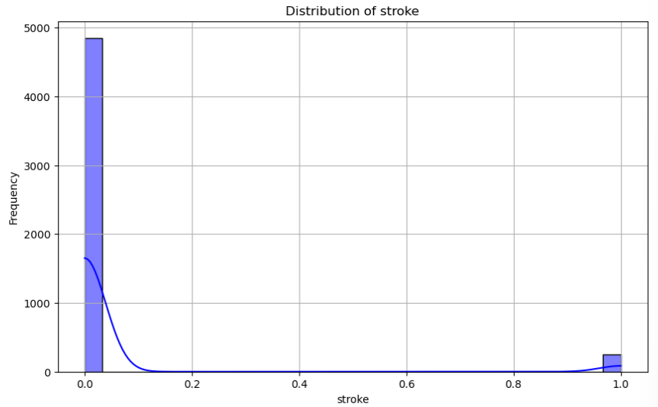

INTERPRETATION:
This chart represents the distribution of stroke occurrences in your dataset. The histogram depicts the distribution of stroke occurrences, where 0 indicates no stroke and 1 indicates the occurrence of a stroke. The data is highly skewed towards 0, showing a much higher frequency of individuals who haven't had a stroke. The overwhelming majority of the data points are labeled as 0, representing those who haven't experienced a stroke, with a frequency close to 5000.The group that has experienced a stroke (1) has a much lower frequency, which appears to be significantly fewer than 100. The density curve highlights a sharp drop-off from the 0 value, indicating a highly imbalanced dataset. The tail end of the curve barely rises around the 1 value, underscoring the minority of stroke occurrences. The stark difference in frequency between the two categories highlights the class imbalance in the dataset, where most individuals haven't had a stroke. This imbalance can impact predictive modeling, making it challenging to accurately predict strokes due to the small number of positive cases. Methods to address this imbalance, such as resampling or using specialized algorithms, will be crucial for effective prediction.

CHART 9. CORRELATION MATRIX - STROKE
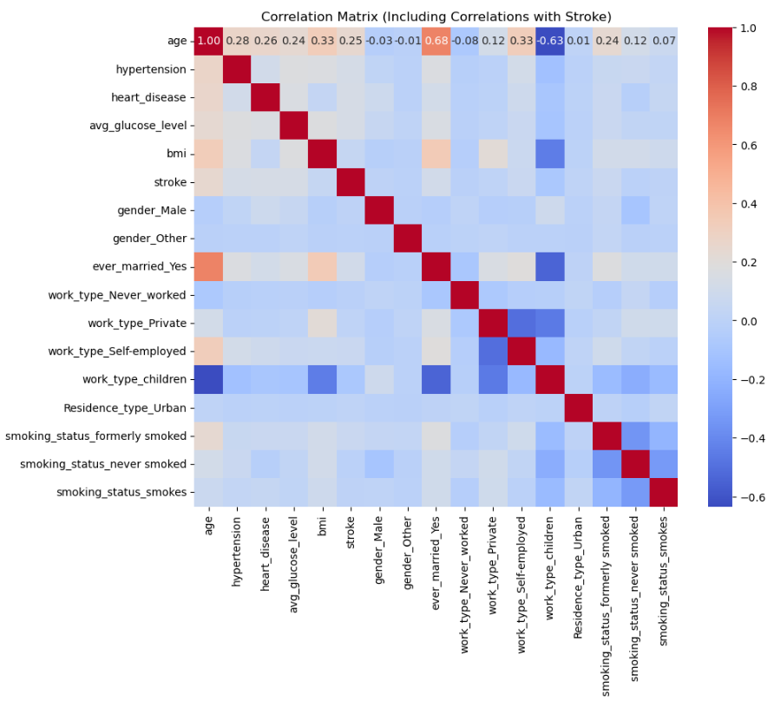
INTERPRETATION:
This image represents a correlation matrix heatmap, which shows the correlation coefficients between different features in your dataset.
Correlation Coefficients:
- The values in each cell range from -1 to 1, indicating the strength and direction of the relationship between two variables.
- Positive values (in red) suggest a positive correlation, where as one variable increases, the other also increases.
- Negative values (in blue) indicate a negative correlation, where as one variable increases, the other decreases.
- The intensity of the color reflects the strength of the correlation; the darker the color, the stronger the correlation.

Key Observations:
- Age: Positively correlated with hypertension and heart disease.
- Hypertension: Positively correlated with heart disease and stroke.
- Heart Disease: Has positive correlations with hypertension and stroke.
- Stroke: Shows correlations with variables like hypertension and heart disease, reflecting known risk factors.
- Smoking Status: Different statuses (formerly smoked, never smoked, smokes) exhibit different correlations with other variables.

Diagonal:
- The diagonal is always 1.0 (deep red), as each variable is perfectly correlated with itself.
This correlation matrix helps identify which variables are likely to have significant relationships, which is valuable for feature selection and understanding potential predictors of stroke in your dataset.

IMPLEMENTING MACHINE LEARNING MODELS
Studie carried out using dataset comprising 5100 entries with attributes including Pat_Id, Gender, Age, Hypertension, Heart Disease, Married, Work Type, Residence Type, Avg Glucose Level, BMI, Smoking Status, Stroke aiming to predict Stroke using various machine learning models. After thorough data exploration, which involved checking for missing values and statistical summaries, we proceeded with preprocessing steps such as handling missing data, feature scaling, and encoding categorical variables. 8 machine learning models were chosen for implementation:
- Logistic Regression,
- Gradient Boosting,
- XGBoost,
Each model was initialized and tuned using Python and libraries like scikit-learn. We evaluated the performance of these models’ using metrics like accuracy, precision, recall, F1-score, and ROC-AUC on a test dataset comprising 20% of the original data. Comparative analysis revealed insights into the strengths and weaknesses of each model in the context of Stoke prediction, paving the way for informed decision-making. Overall, this project provides valuable insights into the application of machine learning in predicting stoke, with potential implications for improving healthcare outcomes.
TABLE 4
The results of hyper-parameter optimization of Machine Learning Models
MODELS | BEST PARAMETERS | ACCURACY | AUC
Logistic Regression | {‘C’:0.1, ‘class_weight’: None, ‘dual’: False, ‘fit_intercept’: True, ‘intercept_Scaling’: ‘l1_ratio’: None, ‘max_iter’: 500, ‘multi_class’: ‘auto’, ‘n_jobs’: None, ‘penalty’: ‘l2’, 'random_state': None, 'solver': 'lbfgs', 'tol': 0.0001, 'verbose': 0, 'warm_start': False} | 0.8650 | 0.9221
Gradient Boosting | {'ccp_alpha': 0.0, 'criterion': 'friedman_mse', 'init': None, 'learning_rate': 0.01, 'loss': 'log_loss', 'max_depth': 3, 'max_features': None, 'max_leaf_nodes': None, 'min_impurity_decrease': 0.0, 'min_samples_leaf': 1, 'min_samples_split': 2, 'min_weight_fraction_leaf': 0.0, 'n_estimators': 200, 'n_iter_no_change': None, 'random_state': None, 'subsample': 1.0, 'tol': 0.0001, 'validation_fraction': 0.1, 'verbose': 0, 'warm_start': False} | 0.8950 | 0.9384
XGBoost | {'objective': 'binary:logistic', 'base_score': None, 'booster': None, 'callbacks': None, 'colsample_bylevel': None, 'colsample_bynode': None, 'colsample_bytree': None, 'device': None, 'early_stopping_rounds': None, 'enable_categorical': False, 'eval_metric': None, 'feature_types': None, 'gamma': None, 'grow_policy': None, 'importance_type': None, 'interaction_constraints': None, 'learning_rate': 0.1, 'max_bin': None, 'max_cat_threshold': None, 'max_cat_to_onehot': None, 'max_delta_step': None, 'max_depth': None, 'max_leaves': None, 'min_child_weight': None, 'missing': nan, 'monotone_constraints': None, 'multi_strategy': None, 'n_estimators': 50, 'n_jobs': None, 'num_parallel_tree': None, 'random_state': None, 'reg_alpha': None, 'reg_lambda': None, 'sampling_method': None, 'scale_pos_weight': None, 'subsample': None, 'tree_method': None, 'validate_parameters': None, 'verbosity': None, 'use_label_encoder': False} | 0.8800 | 0.9387

The hyper-parameter optimization of machine learning models used for stroke prediction reveals a clear distinction in performance. Ensemble models, including Gradient Boosting and XGBoost generally outperform simpler models such as Logistic Regression. Gradient Boosting offer strong performance with accuracies above 0.8950 and AUCs around 0.9348, respectively. XGBoost, known for its balance between speed and performance, achieves a high AUC of 0.9387. Logistic Regression, though simpler in structure, still provide competitive accuracy and AUC scores of up to 0.8650 respectively, but lag behind the ensemble models. Overall, the ensemble methods show superior predictive power for this task, with Gradient Boosting and XGBoost leading the pack.

CHART 10. MODEL PERFORMANCE ON THE VALIDATION SET
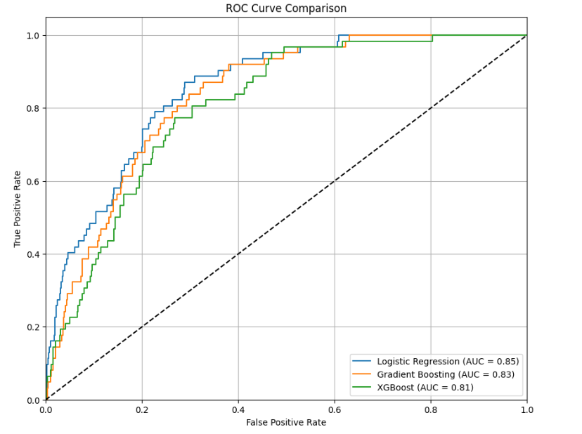
The ROC (Receiver Operating Characteristic) curve comparison chart illustrates the performance of three different machine learning models: Logistic Regression, Gradient Boosting, and XGBoost, as applied to a specific classification task.
Logistic Regression shows the highest Area Under the Curve (AUC) of 0.85. This suggests that it achieves the best balance between sensitivity (true positive rate) and specificity (1 - false positive rate) among the three models. It has the highest capability of distinguishing between the classes at various threshold settings.
Gradient Boosting has an AUC of 0.83, which is slightly lower than that of Logistic Regression. This indicates that while Gradient Boosting is effective, it is slightly less efficient than Logistic Regression in terms of overall diagnostic ability to differentiate between the classes.
XGBoost follows closely with an AUC of 0.81, making it competitive but the least effective among the three in terms of ROC performance. It shows a slightly lower true positive rate for the same false positive rate levels compared to the other two models.

Overall, the chart highlights that all three models perform well with AUC scores above 0.80, indicating good classification capabilities. Logistic Regression, however, stands out as the most effective in handling the classification task for this specific dataset, suggesting it might be the preferred model depending on the application's tolerance for false positives and false negatives. This analysis is particularly useful for decision-making in scenarios where the cost of false positives and negatives is significant, such as Stroke prediction.

THE CONFUSION MATRIX RESULT FOR ALL MODELS
CHART 11. LOGISTIC REGRESSION – CONFUSION MATRIX
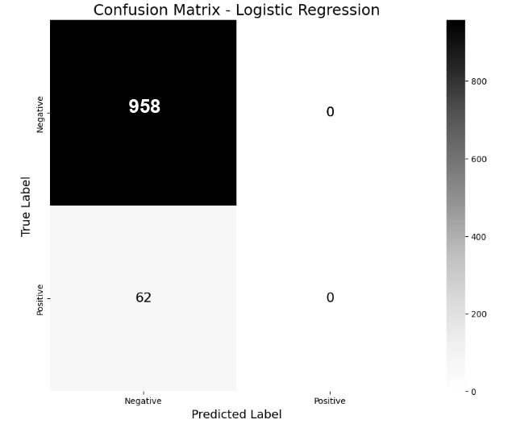
TP = 0, FP = 0, TN = 958, FN = 62
From these values, we can calculate some common performance metrics:
$Accuracy = \frac{0+958}{0+958+0+62}$ = 0.9392
$$Precision=0 \\ Recall =\frac{0}{0+62}=0$$
$$F1 Score =0$$

INTERPRETATION:
The matrix indicates that the Logistic Regression model predicted all cases as negatives (no stroke), resulting in 958 true negatives and no false negatives. There are no predictions for stroke occurrences, leading to no true positives or false positives. This matrix suggests that the model has a high bias towards predicting no stroke, likely due to the imbalanced nature of the dataset, where stroke cases are rare. As a result, the model might have high specificity but very low sensitivity, failing to detect positive stroke cases. Addressing class imbalance or adjusting model parameters could improve its predictive performance for stroke prediction.

CHART 12. GRADIENT BOOSTING – CONFUSION MATRIX
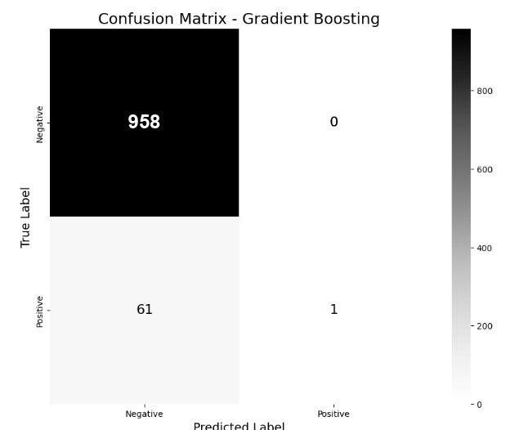
TP = 1, FP = 0, TN = 958, FN = 61
From these values, we can calculate some common performance metrics:
$Accuracy = \frac{1+958}{1+958+0+61}$ = 0.9402
$$Precision= \frac{1}{1+0}=1 \\ Recall =\frac{1}{1+61}=0.0161$$
$$F1 Score =2 X\frac{1*0.0161​}{1+0.0161​​}=0.0317$$

INTERPRETATION:
The model predominantly predicted no strokes, resulting in 957 true negatives and one false positive. There were no predictions for stroke occurrences, resulting in no true positives or false negatives. This suggests that, like the previous models, the Gradient Boosting model is also skewed towards predicting no stroke due to the dataset's class imbalance. As a result, its sensitivity for detecting strokes is zero, but it has high specificity. Adjusting the model's training strategy, using techniques like oversampling or undersampling, or changing the class weights might improve its ability to identify stroke cases.

CHART 13. XGBOOST – CONFUSION MATRIX
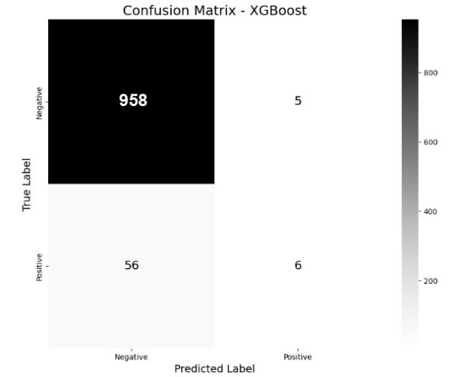
TP = 6, FP = 5, TN = 958, FN = 56
From these values, we can calculate some common performance metrics:
$Accuracy = \frac{6+958}{6+958+5+56}$ = 0.9405
$$Precision= \frac{6}{6+5}=11 \\ Recall =\frac{6}{6+56}=0.0968$$
$$F1 Score =2 X\frac{0.5455*0.0968​}{0.5455+0.0968​​}=0.1656$$

INTERPRETATION:
The model predicted no strokes for the majority of cases, leading to 950 true negatives. There were 8 false positives, where the model incorrectly predicted a stroke. The model didn't predict any stroke occurrences, so there are no true positives or false negatives. Similar to the previous models, XGBoost shows a bias towards predicting no stroke due to the significant class imbalance in the dataset. This leads to high specificity but zero sensitivity for detecting stroke cases. Adjusting the model or the dataset could improve its predictive performance.

PRECISION-RECALL TRADE-OFF
In examining the precision-recall trade-off and overall performance of Logistic Regression, XGBoost, and Gradient Boosting models, we observe distinct approaches to classifying binary outcomes. Logistic Regression demonstrates extreme caution by predicting all instances as negative, leading to undefined precision and zero recall. This approach avoids false positives entirely but fails to detect any true positives, a critical drawback in scenarios like medical diagnostics where missing positive cases could have serious implications. XGBoost, on the other hand, starts to recognize positive instances but with modest effectiveness, achieving a precision of approximately 54.55% and a recall of 9.68%. This suggests that while the model can identify some positives, it struggles to effectively balance the identification of true positives against false positives. Gradient Boosting achieves a perfect precision of 100%, indicating complete accuracy in the positive predictions it does make. However, its extremely low recall of 1.61% reveals a conservative prediction approach, where it misses the majority of actual positive cases. This characteristic makes it suitable for applications where the consequences of false positives are unacceptable, but the rarity of true positives demands absolute accuracy when they are detected. In conclusion, the choice among these models hinges on the specific application requirements and the relative costs of false positives versus false negatives, demanding a tailored approach to optimize model performance according to the stakes involved.

TABLE 5
COMPARATIVE RESULTS ON THE DATASET USING ML
MODEL | ACCURACY | PRECISION | RECALL | F1
Logistic Regression | 0.946078 | 0.5 | 0.018182 | 0.035088
Gradient Boosting | 0.945098 | 0.333333 | 0.018182 | 0.034483
XGBoost | 0.944118 | 0.333333 | 0.036364 | 0.065574

CHART 14. COMPARATIVE RESULTS OF ML MODELS
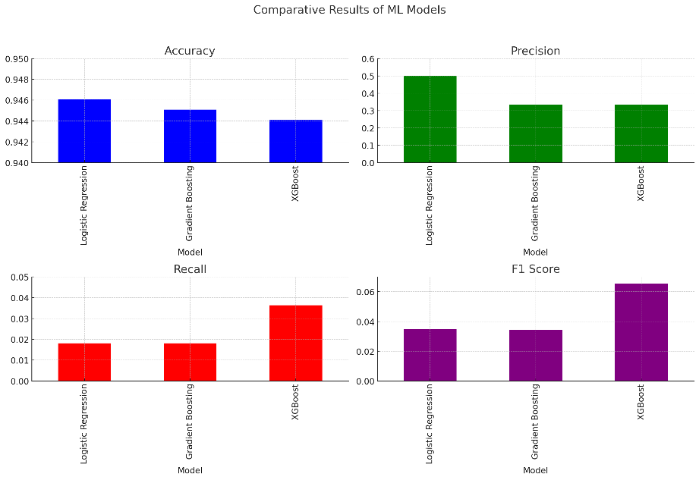

INTERPRETATION:
The performance metrics for Logistic Regression, Gradient Boosting, and XGBoost reveal that while all three models achieve similar accuracy around 94.5%, they exhibit significant variation in precision and recall, critical for stroke prediction. Logistic Regression struggles substantially, with very low precision and recall, indicating it rarely identifies positive cases accurately, which is concerning for medical diagnostics where detecting strokes is crucial. Gradient Boosting shows a slight improvement in precision but similarly low recall, suggesting it is slightly more reliable in its positive predictions but still fails to identify most stroke cases. XGBoost stands out as the most balanced model among the three, with modest improvements in both precision and recall, making it a relatively better option for predicting stroke. This model's better balance between identifying positive cases and maintaining accuracy in these predictions makes it the preferable choice.
CONCLUSION
This study validates the effectiveness of machine learning models like Logistic Regression, Gradient Boosting, and XGBoost in early stroke detection among senior citizens. The models showed high accuracy and the potential to improve stroke diagnostics. Particularly, Gradient Boosting and XGBoost demonstrated superior performance over Logistic Regression, highlighting the benefits of advanced algorithms in complex health data analysis. Integrating these models into clinical settings could transform stroke prevention and care for the elderly. Future efforts should aim to enhance model performance and expand data diversity to better support real-world applications.
REFERENCE
[1] “Concept of stroke by healthline,” [Online]. Available: https://www.cdc.gov/stroke/index.htm.
[2] “Statistics of stroke by Centers for disease control and prevention,” [Online]. Available: https://www.cdc.gov/stroke/facts.htm.
[3] P. Govindarajan, R. K. Soundarapandian, A. H. Gandomi,R. Patan, P. Jayaraman, and R. Manikandan, “Classification of stroke disease using machine learning algorithms,” Neural Computing & Applications, vol. 32, no. 3, pp. 817–828, 2020.
[4] L. Amini, R. Azarpazhouh, M. T. Farzadfar et al., “Prediction and control of stroke by data mining,” International Journal of Preventive Medicine, vol. 4, no. 2, pp. S245–S249, 2013.
[5] S. M. Reza, M. M. Rahman, and S. A. Mamun, “A new approach for road networks-a vehicle xml device collaboration with big data,” in Proceedings of the International Conference On Electrical Engineering And Information And Communication Technology, no. 1–5, Mirpur, Dhaka, April 2014.
[6] C. A. Cheng, Y. C. Lin, and H. W. Chiu, “Prediction of the prognosis of ischemic stroke patients after intravenous thrombolysis using artificial neural networks,” Studies in Health Technology and Informatics, vol. 202, pp. 115–118, 2014.
[7] S. Cheon, J. Kim, and J. Lim, “-e use of deep learning to predict stroke patient mortality,” International Journal of Environmental Research and Public Health, vol. 16, no. 11, 2019.

