A TIG WELDING PROCESS PARAMETER EXPERIMENTAL INVESTIGATION ON AL-ALLOY WELDMENTS
A. Sreekanth¹, B. V. Siva Prasad Reddy², Dr. Y. Hariprasada Reddy³
¹²³Department of Mechanical Engineering & Rayalaseema University College of Engineering

---------------------------------------------------------------------***---------------------------------------------------------------------
Abstract - Welding is a common practice in the aerospace, automotive, shipbuilding, and other industries nowadays. Tungsten Inert Gas (TIG) welding is a popular welding technique used for welding titanium, stainless steel, and aluminum alloys that are challenging to weld using conventional techniques. Aluminum alloys come in several series, including 5000, 6000, and 7000, among others, and might vary from one another depending on the alloying elements used. The 6000 and 2000 series of aluminum alloys are chosen for this task as the basic material because of its outstanding corrosion resistance, good extrusion, and widespread application in automotive and aerospace constructions. The effects of welding process variables, such as current, voltage, weld speed, and shielding gas flow rate, on the mechanical and metallurgical properties of the welded joints is crucial to overcoming issues that arise when welding aluminum alloys and other alloys together. A variety of mechanical and metallurgical tests must be carried out to determine the quality of the welded joints. An investigation of the mechanical properties of aluminum alloy will be conducted together with a weld trial to determine the combined influence of TIG welding process parameters. By altering the welding settings, the aluminum alloy plate can be welded.

Key Words: TIG welding machine, Radiography and Ultrasonic Test machine, Tensile strength, AL-Alloys.

1. INTRODUCTION
Aluminum and its alloys are used in fabrications because to its superior weldability, low weight, and resistance to corrosion. This promotes the use of aluminum and its alloy in the construction of ships, internal combustion engine parts, and the aerospace sector, among other applications. Aluminum can be joined via welding, which is the most common joining technique. Aluminum is frequently welded using metal inert gas welding (MIG) and tungsten inert gas welding (TIG). TIG welding is employed in this study because it has many benefits, including cleanliness, deposition rate, heat input, etc. By heating metals with an arc formed between a non-consumable tungsten electrode and the metals, tungsten inert gas welding, or TIG, melts and joins metals.
The TIG welding procedure is an arc welding method that creates a weld using a tungsten electrode that is not consumable. The shielding gas used to protect the weld region from the atmosphere is typically argon or helium, though occasionally a combination of the two is used. For correct welding, a filler metal may also be manually fed. During World War II, the GTAW, or TIG welding process, was created. The discovery of the TIG welding process made it possible to weld materials that were before problematic, such magnesium and aluminum. Today, a wide range of metals, including titanium alloy, aluminum alloy, stainless steel, mild steel, and high tensile steels, are used with TIG.

2. METHODOLOGY
2.1 Radiographic inspection
A non-destructive inspection technique called radiography testing, or radiography inspection, uses short wavelength electromagnetic radiation to pass through materials. Reduced thickness or lower material density areas allow more light to pass through them, reducing radiation absorption. On a photographic film (radiograph), the radiation creates a shadow image after passing through the substance. Slag and porosity, which have low absorption, show up as black patches on the produced film (radiograph). On the developed film, areas of high absorption (dense inclusions) show up as light areas. X-rays or gamma radiation are examples of lower energy radiation. When radioactive isotopes decay, gamma rays are released.

2.2 Eddy Current Testing
Electromagnetic forces are applied to rapidly impact two materials against one another in magnetic pulse welding. A capacitor bank is charged by a power source, and after the necessary quantity of energy is stored inside, it is instantly released into a coil. Eddy currents are created in the outer work piece, which in this case is a tube, by the discharge current's strong transient magnetic field inside the coil. The magnetic field on either side of this work piece is different in strength due to these eddy currents, which stop the magnetic field from diffusing through the outer work piece. The external and internal work pieces collision as a result of the difference creating a magnetic pressure.

2.3 Immersion of Ultrasonic Testing
Mechanical vibrations that are more frequent than sound waves are used in this testing technique. The object to be tested is exposed to an ultrasonic energy beam. With the exception of situations in which it is intercepted and reflected by a discontinuity, this beam passes through the object with little loss. The method employed is ultrasonic contact pulse reflection. A transducer is used in this system to convert electrical energy to mechanical energy. A high-frequency voltage excites the transducer, causing a crystal to mechanically vibrate. The source of ultrasonic mechanical vibration is the crystal probe. Vibrations like these enter the test piece through a coupling fluid known as a couplant, which is often an oily layer.

3. RESULTS AND DISCUSSIONS
3.1 General Consideration of Weld Parameter
Welding equipment MILLER 160 semiautomatic TIG equipment with direct current, power source with a 160 A capacity was used to join the stainless steel plates (type 304) of size 100 mm (length) 96 mm (width) 5 mm (height).
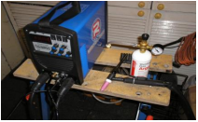
Fig 1. TIG Welding Machine
3.1.1 Deposition Rate:
Weld metal is deposited (melted) onto a metal surface at a rate known as the deposition rate of a welding consumable (electrode, wire, or rod). The rate of deposition is measured in kilograms per hour (kg/hr).The deposition rate is dependent on continuous operation; it is not adjustable for reasons such as machine modifications, chipping slag, cleaning spatter, or changing electrodes. The rate of deposition increases with an increase in welding current. The rate of deposition will grow in tandem with an increase in electrical stick out in the casing.
Table 1: Shows Deposition Rate (Kg/hr)

Experiment No | Deposition Rate |  | Deposition Mean Value | Deposition S/N Ratio
Experiment No | 1st Run | 2nd Run | Deposition Mean Value | Deposition S/N Ratio
1 | 0.257 | 0.249 | 0.253 | -11.941
2 | 0.140 | 0.149 | 0.145 | -16.815
3 | 0.093 | 0.098 | 0.096 | -20.409
4 | 0.140 | 0.151 | 0.146 | -16.761
Average |  |  | 0.64 | -65.926
Maximum |  |  | 0.096 | -20.409
Minimum |  |  | 0.253 | -11.941

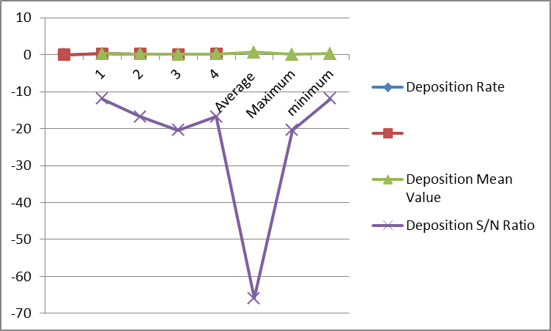
Fig 2. Deposition Rate chart (Kg/hr)

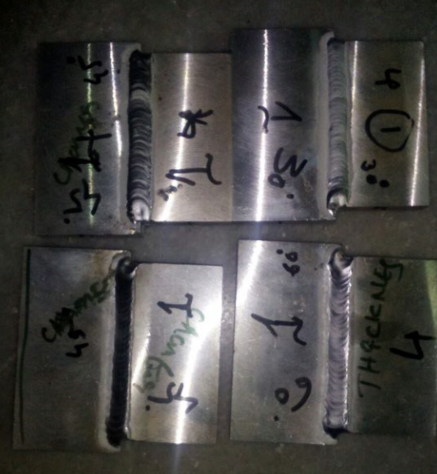
Fig 3. joining of weld plates by Tig welding

A semi-automated welding equipment with controllable welding parameters, including welding speed, current, and shielding gas flow rate, makes up the experimental setup. The outcomes of the experiments that were conducted in accordance with the previously described experiment design are listed below.
Table 2: Shows Deposition Rate (Kg/hr)

Run Order | Welding Speed (cm/min) | Current (Amps) | Gas flow rate (lit/min)
Run Order | S | I | F
1 | 25.0 | 274 | 15.0
2 | 22.5 | 259 | 15.0
3 | 20.0 | 274 | 20.0
4 | 22.5 | 259 | 20.0
5 | 22.5 | 274 | 17.5
6 | 22.5 | 259 | 17.5

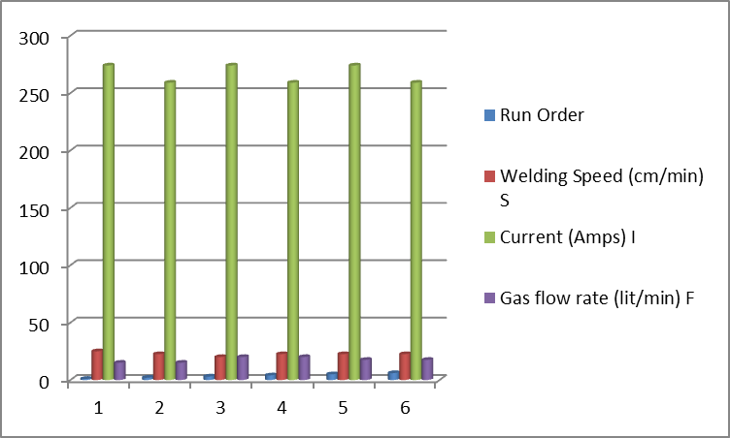
Fig 4. Welding parameters chart
Servo motors are utilized in experiments to sustain welding speed while the welding is being done. A manual torch that is held in the hand would make this very distinct. Because this machine is controlled automation, the speed can be directly set to a specified value when utilizing an automated TIG flame for welding.
The metal, lead, tin, or, more commonly, aluminum tube, is produced in excess of half a billion pieces annually in the United States alone, attesting to its adaptability and durability. It is currently packaged around the world.
An aluminum blank is the first step in the production of aluminum tubes. It is fed into the die's tool set, which extrudes it. The finished tube form is then approximately formed by this extrusion press.
The tube must then be trimmed on both the top and bottom ends to the desired length. We may now screw on the cap because the tube is threaded at this point. Aluminum undergoes a process that work-hardens it during extrusion, making it flexible during the following stage. This is carried out at roughly 460 degrees Celsius.
The following stage is the spray application of an interior lining, which is mostly utilized in the pharmaceutical sector. This serves as a protective barrier between the pharmaceutical or other product that needs to be packaged and the exposed aluminum for metal-sensitive items.

3.2 Ultrasonic Testing
Using water serving as a coolant and a probe with a frequency of 5 MHz and a focal length of 2", immersion ultrasonic C scan testing was performed. Aluminum has a sound wave velocity of 6300 m/s, while sound in water has a velocity of 1500 m/s. The distance in the water was 50.8 mm. The necessary data for the scan had been loaded using the Acq UT software. A 0.1 mm resolution scan was performed on the sample both along and across the joining. A 130 mm length of scanning along the y-axis and a 45 mm length of indexing along the x-axis were completed.

Table 3: NDT results for tube different voltages variations
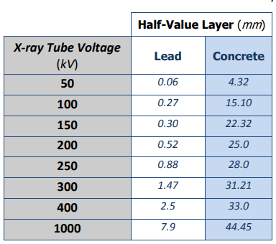
The closest point that NDT equipment can effectively test a tube or pipe is limited. They rely on electromagnetic or ultrasonic waves to pass through the pipe or tube, and the end signifies a sudden change in the wall's properties, which makes it challenging to interpret the test findings close to the pipe or tube end. By directing clockwise, counterclockwise, and transverse transducers toward a single point of entry, a new technology circumvents the traditional barriers. The receiver can precisely understand the data since there is no interference between the signals due to a scheduled delay based on the 1-kHz transmit frequency.

3.3 SEM Results
SEM results on fracture of weld zone at different bead angles of weld plates

Plate 1 at 30⁰:
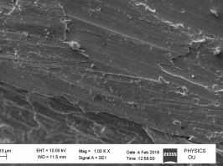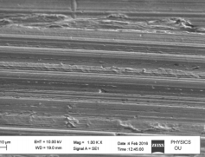
Fig 5a. Fig 5b.
Figures 5a. and 5b. SEM images taken at the fracture zone, which corresponds to the bed's 30⁰ tilt

Plate 2 at 45⁰:
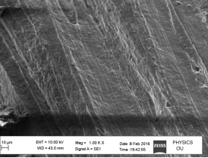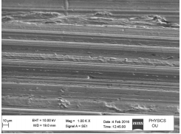
Fig 6a. Fig 6b.
SEM images taken at the fracture zone, which corresponds to the bed's 45⁰ angle

Plate 3 at 60⁰:
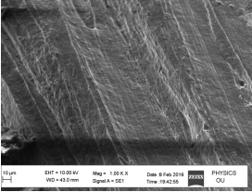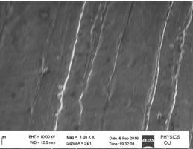
Fig 7a. Fig 7b.
SEM images taken at the fracture zone, which corresponds to the 60⁰ angle of the bed

Table 4: Tensile Strength of work pieces
Piece no. | Current(A) | Filler | Tensile Strength (MPa)
1 | 80 | 4043 | 87.98
2 | 80 | 4047 | 88.36
3 | 80 | 4047 | 89.8
4 | 80 | 4043 | 86.32
From the results of tensile testing at various parameters, it has been noted that welding using 4043 filler material produces better results than 4047. It is evident that the tensile strength improves as the current level rises. It might be the result of higher heat input, which raises the welding depth and could raise the tensile strength.

3.4 Radiography Test
Weld testing using X-rays from an X-ray tube or gamma rays from a radioactive isotope is the approach used here. Radiographic inspection of welds operates on the same fundamental premise as medical radiography. An image of the object's internal structure is deposited on a photographic film when penetrating radiation passes through a solid object—in this case, a weld rather than that portion of the human body. The object's density and thickness determine how much energy it absorbs. The radiography film will get exposed if energy is not absorbed by the object. When the film is developed, these areas will be dark. Sections of the film with lower energy exposure stay lighter.
Radiography Results for Aluminum Welded Plates
Plate 1 at 30⁰:


Fig 8a. 2 Pores per Sq. Inch


Fig 8b. 4 Pores per Sq. Inch

Plate 2 & 3 at 45⁰:

Fig 9a. 8 Pores Per Sq. Inch


Fig 9b. 16 Pores Per Sq. Inch
Plate 4 at 60⁰:

Fig 10a. 25 Pores per Sq. Inch
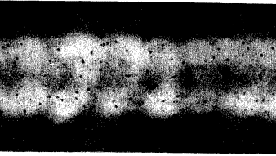
Fig 10b. 50 Pores per Sq. Inch

3.5 Load conditions:
Material | LOAD | Total deformation | max stress | max strain
Plate1 – 30⁰ | 60 | 0.13185 | 43.5 | 0.000201
Plate 2– 45⁰ | 60 | 0.4004 | 42.38 | 0.000616
Plate 3- 45⁰ | 60 | 0.38877 | 42.38 | 0.000599
Plate 4- 60⁰ | 60 | 0.8123 | 46.12 | 0.000852

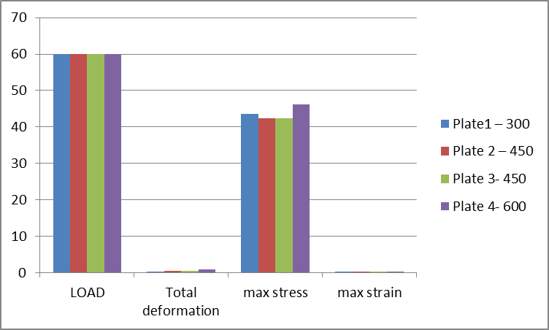
Fig 11. Load conditions chart

4. CONCLUSIONS

The following conclusion can be extracted from the aluminum plate TIG welding experiment. The weld joint's tensile strength or welding strength is determined by the filler material, welding current, and shielding gas flow rate, among other welding parameters. The weld joint's tensile strength rises as current increases. Nonetheless, there aren't many challenges when using ultrasonic testing to characterize materials. The specimen's tensile strength rises as current intensity does, reaching its maximum tensile strength of 125.72 MPa at the highest current intensity of 80 Ampere. The standard procedure for estimating and assessing the appropriateness of ultrasonic nondestructive testing (NDT) for material testing is to base the research on the different materials that are utilized.
The next step is to create the necessary tools and look into the issue of evaluating structural objects using the ultrasonic NDT method. The characteristics of welded specimens of Al alloy can be significantly impacted by welding faults such as porosity, which lowers the tensile strength. It is evident from earlier studies and the methods that have been examined that the straight probe is useful for detecting subsurface flaws, particularly cracks that run parallel to the front and rear surfaces of the test object, and that it is effective up to a certain thickness (such as the thickness of a pipe wall).

REFERENCES
1. Banerjee & BK Shah, ‘Characterization of Industrial Materials’, Material Characterization Techniques – Principals and Applications, Ed. G. Sridhar, S. Ghosh Chowdhary and N.G. Goswami, 1999, pp 1- 15
2. E.R. Generazio, ‘Ultrasonic attenuation measurements to determine onset, degree and completion of recrystallization’, Materials Evaluation, Vo. 46, August 1998, pp 1198-1203
3. G. Dobmann, et.al., ‘Non-destructive characterization of materials: A growing demand for describing damage and servicelife relevant ageing process in plant components’, Nuclear Engineering and Design, Vol. 171, 1997, pp-95-112
4. R.B. Thomson, ‘Laboratory Non-Destructive Evaluation technology material characterization’, Journal of Non Destructive Evaluation, Vol. 15, Nos. 3&4, 1996
5. Baldev Raj, et. al., ‘NDE methodologies for characterization of defects, stresses and microstructure in pressure vessels and pipes’, International Journal on Pressure Vessel and Piping, Vol. 73, Issue 2, Sept. 1997, pp 133 – 146
6. Proc. Workshop on ‘Testing and characterization of materials’, Convener D.N. Sah, IIM, Mumbai Chapter, 1990 7. Proc. Seminar on ‘Advances in NDT techniques for flaw and materials characterization’, Convener B.K. Shah, IIM, Mumbai Chapter, 1992
7. D.K. Bhattacharya, ‘Characterization of microstructure in steels by magnetic techniques – An overview’, ISNT Journal of Non-Destructive Evaluation, Vol. 17, No. 1, 1997
8. G. Dobmann, et., al., ‘Ageing material evaluation and studies by non-destructive techniques (AMES-NDT), A European Network Project’, Nuclear Engineering and Design, Vol. 206, 2001, pp 363-374
9. WA Theiner, et., al., ‘Non-destructive analysis of the structure of pressure vessel steels by micromagnetic testing techniques’, Nuclear Engineering and Design, Vol. 76, Issue 3, December 1983, pp 251-260
10. A.Vary , ‘Quantitative ultrasonic evaluation of mechanical properties of engineering materials’, NASA TM – 78905, 1978 13. H. Willems and K. Gobbeles, ‘Characterization of microstructure by backscatter ultrasonic waves’, Material Science, Vol. 15, Nov. Dec. 1981, pp 549-553
11. D.K. Mak, ‘Determination of grain size, hysterisis constant and scattering factor of polycrystalline material using ultrasonic attenuation’, Canadian Metallurgical Quarterly, Vol. 25, No.3, pp 253-255
12. R. D. Diamand, ‘Development of instrument for on-line measurement of grain size in copper alloys and stainless steels’, 21st Annual British Conference on NonDestructive Testing NDT 0 86, pp 225-242
13. A. Badidi Bouda, et. al., ‘Grain size influence on ultrasonic velocities and attenuation’, NDT & E International, Vol. 36, Issue 1, Jan 2003, pp 1-5

